Supplementary Table 1. Sample characteristics (n=373)
Variable | n (%) or mean ± SD
Adolescents' characteristics
Female, | 200 (53.62)
Age (years) | 13.50 ± 0.73
Grade
Seventh grade | 184 (49.33)
Eighth grade | 189 (50.67)
Single child
Yes | 119 (31.90)
No | 254 (68.10)
Parents' characteristics
Female | 290 (77.75)
Educational level
Compulsory education stage | 116 (31.10)
Bachelor's degree or below | 181 (48.53)
Bachelor's degree or above | 76 (20.38)
Average household income
≤￥6000 | 91 (24.40)
￥6001~￥15000 | 196 (52.55)
＞￥15000 | 86 (23.06)
￥Chinese yuan equals to approximately 0.14 U.S. dollar.
Supplementary Table 2. Comparison of models (ΔAICc < 2) for the prediction of adolescents' physical activity levels.
Model names | K | AICc | ΔAICc | Evidence ratio | CFI | R² | R²_{p} | R²_{adj} | R²_{baseline} | R²_{baseline.p}
Punishment, all
NULL | 6 | 731.23 | 0.00 | NA | 0.99 | 0.02 | 0.09 | 0.01 | <0.01 | NA
Punishment, boys
SQD | 6 | 393.23 | 0.00 | NA | 1.00 | 0.03 | 0.35 | <0.01 | 0.02 | 0.09
SSQD | 7 | 393.54 | 0.31 | 1.17 | 1.00 | 0.04 | 0.28 | 0.01 | 0.03 | 0.09
NULL | 5 | 394.15 | 0.92 | 1.58 | 0.00 | 0.01 | 0.69 | -0.01 | <0.01 | NA
RR | 7 | 395.02 | 1.79 | 2.45 | 0.00 | 0.03 | 0.44 | 0.00 | 0.02 | 0.19
Punishment, girls
SQD | 6 | 317.63 | 0.00 | NA | 1.00 | 0.07 | 0.01 | 0.05 | 0.01 | 0.14
NULL | 5 | 317.75 | 0.12 | 1.06 | 0.90 | 0.06 | 0.01 | 0.05 | <0.01 | NA
DIFF | 6 | 317.78 | 0.15 | 1.08 | 1.00 | 0.07 | 0.01 | 0.05 | 0.01 | 0.15
SRSQD | 8 | 318.46 | 0.83 | 1.51 | 1.00 | 0.09 | 0.01 | 0.06 | 0.03 | 0.14
SSQD | 7 | 318.71 | 1.07 | 1.71 | 1.00 | 0.08 | 0.01 | 0.05 | 0.02 | 0.20
RR | 7 | 318.94 | 1.31 | 1.93 | 1.00 | 0.07 | 0.01 | 0.05 | 0.01 | 0.22
Pressuring, all
SQD | 7 | 731.14 | 0.00 | NA | 1.00 | 0.03 | 0.07 | 0.01 | 0.01 | 0.14
NULL | 6 | 731.23 | 0.10 | 1.05 | 1.00 | 0.02 | 0.09 | 0.01 | <0.01 | NA
SSQD | 8 | 732.91 | 1.78 | 2.43 | 1.00 | 0.03 | 0.11 | 0.01 | 0.01 | 0.30
RR | 8 | 732.96 | 1.82 | 2.49 | 1.00 | 0.03 | 0.11 | 0.01 | 0.01 | 0.30
Pressuring, boys
SQD | 6 | 392.50 | 0.00 | NA | 0.93 | 0.03 | 0.27 | 0.01 | 0.02 | 0.06
RR | 7 | 393.86 | 1.36 | 1.98 | 0.79 | 0.03 | 0.31 | 0.01 | 0.03 | 0.11
SRSQD | 8 | 394.04 | 1.54 | 2.16 | 1.00 | 0.05 | 0.25 | 0.01 | 0.04 | 0.09
NULL | 5 | 394.15 | 1.65 | 2.28 | <0.01 | 0.01 | 0.69 | -0.01 | 0.00 | NA
SSQD | 7 | 394.38 | 1.88 | 2.56 | 0.42 | 0.03 | 0.36 | 0.00 | 0.02 | 0.14
Pressuring, girls
SRSQD | 8 | 317.06 | 0.00 | NA | 1.00 | 0.09 | <0.01 | 0.06 | 0.03 | 0.08
NULL | 5 | 317.75 | 0.69 | 1.41 | 0.78 | 0.06 | 0.01 | 0.05 | <0.01 | NA
RR | 7 | 318.09 | 1.02 | 1.67 | 0.94 | 0.08 | 0.01 | 0.05 | 0.02 | 0.15
Restriction, all
DIFF | 7 | 730.97 | 0.00 | NA | 1.00 | 0.03 | 0.07 | 0.01 | 0.01 | 0.13
NULL | 6 | 731.23 | 0.26 | 1.14 | 1.00 | 0.02 | 0.09 | 0.01 | <0.01 | NA
SSQD | 8 | 732.84 | 1.86 | 2.54 | 1.00 | 0.03 | 0.11 | 0.01 | 0.01 | 0.28
Restriction, boys
NULL | 5 | 394.15 | 0.00 | NA | 1.00 | 0.01 | 0.69 | -0.01 | <0.01 | NA
DIFF | 6 | 394.96 | 0.81 | 1.50 | 1.00 | 0.02 | 0.60 | -0.01 | 0.01 | 0.26
SQD | 6 | 395.75 | 1.60 | 2.23 | 1.00 | 0.01 | 0.74 | -0.01 | <0.01 | 0.47

Supplementary Table 2 Continued. Comparison of models (ΔAICc < 2) for the prediction of adolescents' physical activity levels.
Model names | K | AICc | ΔAICc | Evidence ratio | CFI | R² | R²_{p} | R²_{adj} | R²_{baseline} | R²_{baseline.p}
Restriction, girls
NULL | 5 | 317.75 | 0.00 | NA | 1.00 | 0.06 | 0.01 | 0.05 | <0.01 | NA
DIFF | 6 | 319.38 | 1.63 | 2.26 | 1.00 | 0.06 | 0.01 | 0.04 | <0.01 | 0.49
Disengagement, all
SRSQD | 9 | 724.95 | 0.00 | NA | 1.00 | 0.05 | 0.00 | 0.04 | 0.03 | 0.01
SRR | 9 | 725.00 | 0.05 | 1.02 | 1.00 | 0.05 | 0.01 | 0.04 | 0.03 | 0.01
SSQD | 8 | 725.84 | 0.89 | 1.56 | 0.97 | 0.05 | 0.01 | 0.03 | 0.02 | 0.01
DIFF | 7 | 726.10 | 1.15 | 1.78 | 0.86 | 0.04 | 0.01 | 0.03 | 0.02 | 0.01
SRRR | 10 | 726.74 | 1.79 | 2.45 | 1.00 | 0.05 | 0.01 | 0.03 | 0.03 | 0.01
Disengagement, boys
RR | 7 | 392.82 | 0.00 | NA | 1.00 | 0.04 | 0.22 | 0.01 | 0.03 | 0.07
SQD | 6 | 393.22 | 0.40 | 1.22 | 0.56 | 0.03 | 0.35 | <0.01 | 0.02 | 0.08
SSQD | 7 | 393.77 | 0.95 | 1.61 | 1.00 | 0.04 | 0.30 | 0.01 | 0.03 | 0.10
NULL | 5 | 394.15 | 1.32 | 1.94 | 0.00 | 0.01 | 0.69 | -0.01 | <0.01 | NA
SRR | 8 | 394.27 | 1.45 | 2.06 | 1.00 | 0.04 | 0.26 | 0.01 | 0.04 | 0.10
DIFF | 6 | 394.71 | 1.89 | 2.57 | 0.00 | 0.02 | 0.56 | -0.01 | 0.01 | 0.22
Disengagement, girls
DIFF | 6 | 310.90 | 0.00 | NA | 0.98 | 0.10 | <0.01 | 0.08 | 0.04 | <0.001
SRSQD | 8 | 312.20 | 1.30 | 1.91 | 1.00 | 0.11 | <0.01 | 0.09 | 0.05 | 0.01
Expectation, all
FULL | 11 | 663.78 | 0.00 | NA | 1.00 | 0.21 | <0.001 | 0.19 | 0.18 | <0.001
SRRR | 10 | 664.48 | 0.70 | 1.42 | 0.98 | 0.20 | <0.001 | 0.18 | 0.18 | <0.001
Expectation, boys
SRR | 8 | 345.20 | 0.00 | NA | 1.00 | 0.24 | <0.001 | 0.22 | 0.23 | <0.001
SRRR | 9 | 346.05 | 0.85 | 1.53 | 1.00 | 0.25 | <0.001 | 0.22 | 0.24 | <0.001
Expectation, girls
SRSQD | 8 | 274.63 | 0.00 | NA | 1.00 | 0.27 | <0.001 | 0.24 | 0.21 | <0.001
SRRR | 9 | 276.54 | 1.91 | 2.60 | 1.00 | 0.27 | <0.001 | 0.24 | 0.21 | <0.001
Facilitation, all
SRSQD | 9 | 670.03 | 0.00 | NA | 1.00 | 0.18 | <0.001 | 0.17 | 0.16 | <0.001
SRR | 9 | 670.55 | 0.52 | 1.30 | 1.00 | 0.18 | <0.001 | 0.17 | 0.16 | <0.001
Facilitation, boys
SRSQD | 8 | 361.21 | 0.00 | NA | 1.00 | 0.21 | <0.001 | 0.18 | 0.20 | <0.001
SRRR | 9 | 362.15 | 0.94 | 1.60 | 1.00 | 0.22 | <0.001 | 0.18 | 0.21 | <0.001
SRR | 8 | 362.63 | 1.42 | 2.03 | 0.98 | 0.20 | <0.001 | 0.18 | 0.20 | <0.001
Facilitation, girls
SRSQD | 8 | 291.74 | 0.00 | NA | 1.00 | 0.20 | <0.001 | 0.18 | 0.14 | <0.001
SRRR | 9 | 293.64 | 1.90 | 2.59 | 1.00 | 0.20 | <0.01 | 0.17 | 0.14 | <0.001
Supplementary Table 2 Continued. Comparison of models (ΔAICc < 2) for the prediction of adolescents' physical activity levels.
Model names | K | AICc | ΔAICc | Evidence ratio | CFI | R² | R²_{p} | R²_{adj} | R²_{baseline} | R²_{baseline.p}
Monitoring, all
SRSQD | 9 | 718.82 | 0.00 | NA | 1.00 | 0.07 | <0.01 | 0.05 | 0.05 | <0.001
Monitoring, boys
RR | 7 | 391.45 | 0.00 | NA | 0.69 | 0.05 | 0.14 | 0.02 | 0.04 | 0.03
SRSQD | 8 | 391.74 | 0.29 | 1.16 | 0.87 | 0.06 | 0.12 | 0.02 | 0.05 | 0.04
SRRR | 9 | 391.85 | 0.40 | 1.22 | 1.00 | 0.07 | 0.10 | 0.03 | 0.06 | 0.03
SRR | 8 | 392.13 | 0.68 | 1.41 | 0.79 | 0.06 | 0.14 | 0.02 | 0.05 | 0.04
DIFF | 6 | 392.76 | 1.31 | 1.93 | 0.20 | 0.03 | 0.30 | 0.01 | 0.02 | 0.06
Monitoring, girls
SRSQD | 8 | 311.07 | 0.00 | NA | 1.00 | 0.12 | <0.01 | 0.09 | 0.06 | 0.01
SRRR | 9 | 311.79 | 0.72 | 1.43 | 1.00 | 0.13 | <0.01 | 0.09 | 0.07 | 0.01
Non-directive support, all
SRSQD | 9 | 698.47 | 0.00 | NA | 1.00 | 0.12 | <0.01 | 0.10 | 0.10 | <0.001
SRR | 9 | 698.80 | 0.33 | 1.18 | 1.00 | 0.12 | <0.01 | 0.10 | 0.10 | <0.001
SRRR | 10 | 699.45 | 0.98 | 1.63 | 1.00 | 0.12 | <0.01 | 0.10 | 0.10 | <0.001
Non-directive support, boys
SRSQD | 8 | 369.23 | 0.00 | NA | 1.00 | 0.17 | <0.01 | 0.14 | 0.16 | <0.001
Non-directive support, girls
SRSQD | 8 | 303.43 | 0.00 | NA | 0.93 | 0.15 | <0.01 | 0.13 | 0.09 | <0.001
FULL | 10 | 303.95 | 0.52 | 1.30 | 1.00 | 0.17 | <0.01 | 0.13 | 0.11 | <0.001
SRRR | 9 | 305.17 | 1.75 | 2.39 | 0.92 | 0.15 | <0.01 | 0.12 | 0.09 | <0.001
DIFF | 6 | 305.28 | 1.85 | 2.52 | 0.79 | 0.13 | <0.01 | 0.11 | 0.07 | <0.001
Autonomy support, all
SRSQD | 9 | 673.91 | 0.00 | NA | 1.00 | 0.17 | <0.01 | 0.16 | 0.15 | <0.001
SRR | 9 | 675.55 | 1.65 | 2.28 | 0.98 | 0.17 | <0.01 | 0.16 | 0.15 | <0.001
SRRR | 10 | 675.59 | 1.68 | 2.32 | 1.00 | 0.18 | <0.01 | 0.16 | 0.15 | <0.001
Autonomy support, boys
SRR | 8 | 369.87 | 0.00 | NA | 1.00 | 0.17 | <0.01 | 0.14 | 0.16 | <0.001
SRSQD | 8 | 370.76 | 0.89 | 1.56 | 1.00 | 0.17 | <0.01 | 0.14 | 0.16 | <0.001
Autonomy support, girls
SRR | 8 | 284.49 | 0.00 | NA | 0.98 | 0.23 | <0.01 | 0.20 | 0.17 | <0.001
SRRR | 9 | 285.27 | 0.78 | 1.47 | 0.99 | 0.23 | <0.01 | 0.21 | 0.17 | <0.001
FULL | 10 | 286.12 | 1.63 | 2.26 | 1.00 | 0.24 | <0.01 | 0.21 | 0.18 | <0.001
K: Number of parameters; AICc: corrected Akaike Information Criterion; ΔAICc: the difference in AICc values between two or more models; Evidence ratio: Ratio of model weights of the best model compared to each other model; CFI: Comparative fit index; R²_{p}: p value for R²; R²_{adj}: adjusted R²; R²_{baseline}: baseline R²; R²_{baseline.p}: p value for baseline R²; SRSQD: shifted and rotated squared difference model; SRR: shifted rising ridge model; SRRR: rotated and shifted rising ridge model; FULL: polynomial model; RR: rising ridge model; DIFF: difference model; SSQD: shifted squared difference model; SQD: squared difference model; NULL: baseline model with no predictors. Model selected are bolded.

Supplementary Table 3. Model estimates of response surface analyses among 173 parent-son dyads and200 parent-daughter dyads
Parenting practices | Sample | Model | Polynomial regression slope |  |  |  |  |  | RSA coefficient |  |  |  |  |  |  |  | R² _{adj}
Parenting practices | Sample | Model | b₁ | b₂ | b₃ | b₄ | b₅ |  | a₁ | a₂ | a₃ | a₄ | a₅ | C | S | a₄'
Disengagement | Boys | DIFF | 0.08 | 0.08 | - | - | - |  | - | - | 0.16 | - | - | - | - | - |  | 0.01
Disengagement | Girls | DIFF | 0.12** | -0.12** | - | - | - |  | - | - | 0.23** | - | - | - | - | - |  | 0.09
Expectation | Boys | SRRR | -0.07 | 0.59*** | 0.26* | -0.29 | 0.08 |  | 0.52*** | 0.05 | -0.65*** | 0.63** | 0.17 | -1.87* | 1.75* | 0.33 |  | 0.22
Expectation | Girls | SRRR | -0.16* | 0.32*** | 0.21 | 0.05 | 0.00 |  | 0.16* | 0.26 | -0.47*** | 0.16 | 0.20 | -22.47 | -7.91 | 0.01 |  | 0.24
Facilitation | Boys | SRSQD | 0.08 | 0.36*** | 0.00 | -0.02 | -0.05 |  | 0.44*** | -0.08 | -0.28* | -0.03 | 0.05 | 3.62 | -0.23 | -0.20 |  | 0.18
Facilitation | Girls | SRSQD | -0.02 | 0.23*** | 0.06 | 0.00 | 0.00 |  | 0.21*** | 0.06 | -0.25*** | 0.06 | 0.06 | -1.42e^{5***} | 1.25*** | 0.04 |  | 0.18
Monitoring | Boys | SRSQD | 0.03 | 0.16* | 0.13 | 0.00 | 0.00 |  | 0.19 | 0.13 | -0.13 | 0.13 | 0.13 | -1.06e^{5*} | 0.77 | 0.22 |  | 0.02
Monitoring | Girls | SRSQD | -0.01 | 0.13* | -0.10** | 0.00 | 0.00 |  | 0.12* | -0.10** | -0.14 | -0.10** | -0.10** | 7.23e^{4*} | -1.01 | -0.10 |  | 0.09
Non-directive support | Boys | SRSQD | -0.06 | 0.29*** | 0.42* | 0.00 | 0.00 |  | 0.23 | 0.42* | -0.35* | 0.42* | 0.42* | -4.83e^{5**} | -3.14** | 0.04 |  | 0.14
Non-directive support | Girls | SRSQD | -0.06 | 0.21*** | -0.17* | 0.00 | 0.00 |  | 0.15* | -0.17* | -0.27*** | -0.17* | -0.17* | 1.50e^{5***} | -0.54 | -0.57 |  | 0.13
Autonomy support | Boys | SRR | 0.05 | 0.36*** | 0.07 | -0.14 | 0.07 |  | 0.41*** | - | -0.31* | 0.29 | - | -1.09 | - | - |  | 0.14
Autonomy support | Girls | SRR | -0.03 | 0.25*** | -0.05* | 0.11* | -0.05* |  | 0.22*** | - | -0.27*** | -0.22** | - | 1.27 | - | - |  | 0.20
Note: DIFF difference model; SRR shifted rising ridge model; SRRR rotated and shifted rising ridge model; SRSQD rotated squared difference model. The b₁ - b₅ are the coefficients in the polynomial regression equation of the corresponding model. The a1 coefficient (i.e., b₁ + b₂) represents the slope of the line of congruence (LOC); the a₂ coefficient (i.e., b₃ + b₄ + b₅) represents the linear or curvilinear shape of the line of congruence; the a₃ coefficient (i.e., b₁ - b₂) represents the slope of the line of incongruence (LOIC); the a₄ coefficient (i.e., b₃–b₄ + b₅) represents the linear or curvilinear shape of the line of incongruence. the a₅ coefficient (i.e., b₃ – b₅) represents whether the first principal axis (FPA) and LOC are equal. In the SRSQD model, the C coefficient (i.e., -1/2(b₂/b₅)) is a shifting constant applied to the X predictor. the S coefficient (i.e., -b₄/(2b₅)) is scaling factor for X. the a4' (i.e., b₃/S² − b₄/S + b₅) coefficient is the relevant index that tests for the presence of a misfit effect. Covariates adjusted for parent's gender and education, and adolescents' single child status. *p<0.05; **p<0.01; ***p<0.001

 | Parent-son dyads | Parent-daughter dyads
(a) | 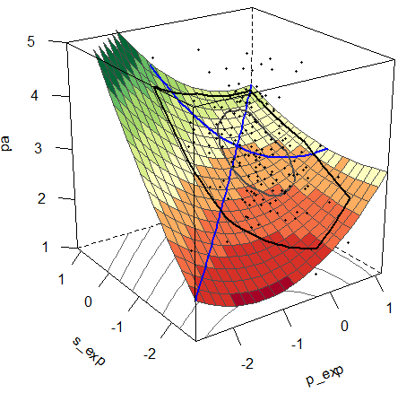 | 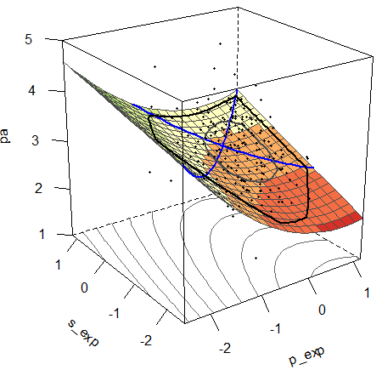
(b) | 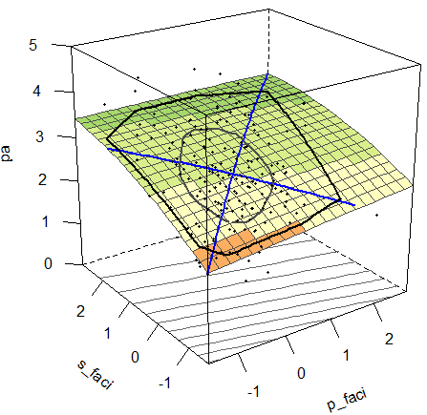 | 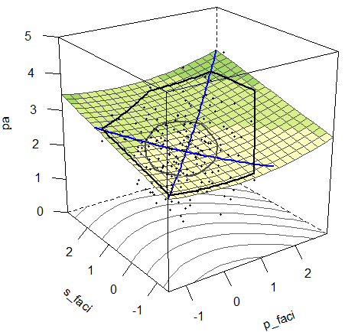
Supplementary Figure 1. Response surface plots of parent- and adolescent-reported physical activity parenting practices in explaining adolescent physical activity (pa). (a) plot of parent- and adolescent-reported expectation (p_exp, s_exp); (b) plot of parent- and adolescent-reported facilitation (p_faci, s_faci).

 | Parent-son dyads | Parent-daughter dyads
(c) | 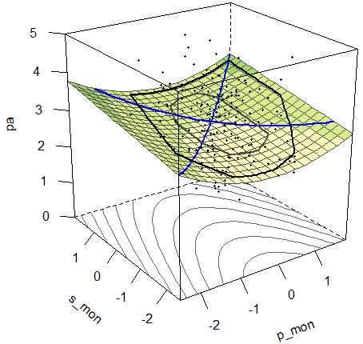 | 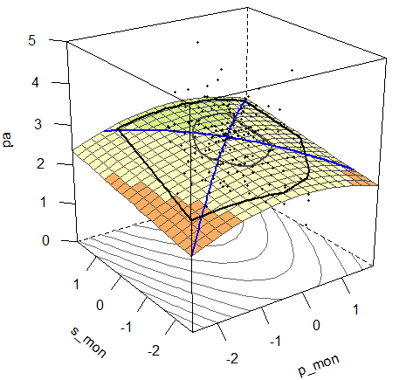
(d) | 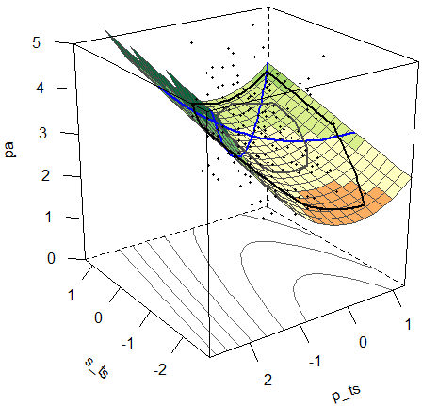 | 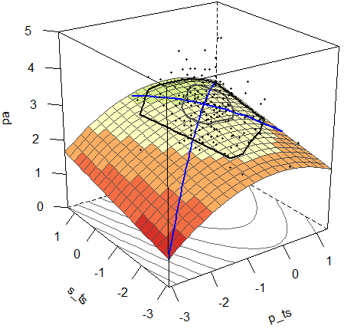
(e) | 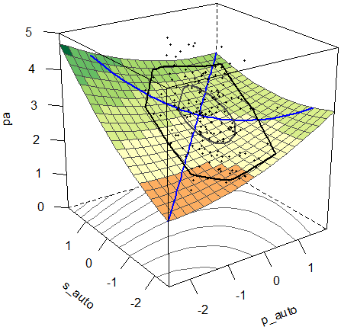 | 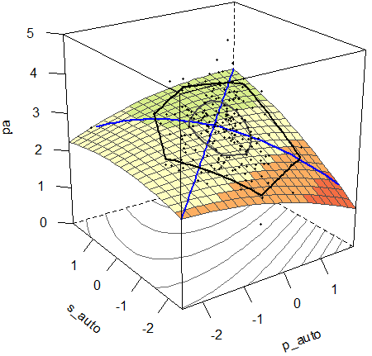
Supplementary Figure 1, continued. Response surface plots of parent- and adolescent-reported physical activity parenting practices in explaining adolescent physical activity (pa). (c) plot of parent- and adolescent-reported monitoring (p_mon, s_mon); (d) plot of parent- and adolescent-reported non-directive support (p_ts, s_ts); (e) plot of parent- and adolescent-reported autonomy support (p_auto, s_auto).
Appendix A
Physical Activity Parenting Practices Questionnaire for Chinese early adolescents
(Parent version)

Please carefully read each question and response options before selecting the most applicable answer.

The following questions ask whether you have done the following behaviors in the past three months.
- I arrange for my child when to be physical activities. Non-directive support_30
- I arrange for my child what physical activities to do. Non-directive support_31
- I spend time teaching my child a sport or sharing physical activity experiences. Autonomy support_64
- I participate in low intensity physical activities (such as walking, doing housework, etc.) with my child. Non-directive support_32
- I participate in moderate or high-intensity physical activities (such as playing ball, running, etc.) with my child. Non-directive support_33
- I do physical activities in front of my child. Non-directive support_36
- To encourage my child to be more physically active, I arrange my child to do activities with friends. Non-directive support_34

1-None in the past three months
2-1-3 times per month
3-1-2 times per week
4-3-4 times per week
5-At least 5 times per week

Does the following statements correspond to your expectations and requirements for your child?
- When the weather allows, I expect my child to play outside. Expectation_25
- I expect my child to participate in physical activity at least four days a week. Expectation_26
- I expect my child to do physical activities in his or her spare time. Expectation_27
- I expect my child to get excellent grades in physical education classes or have good sport performance. Expectation_28
- I expect my child to be interested in at least one type of physical activities or sports. Expectation_29

1-Completely disagree
2-Somwhat disagree
3-Neutral
4-Somewhat agree
5-Completely agree

The following questions ask whether you have done the following behaviors in the past three month.
- I restrict my child’s physical activity due to safety concerns. Restriction_37
- I restrict my child’s physical activity in afraid of disturbing neighbors. Restriction_38
- I restrict my child’s physical activity in afraid of disturbing sleeps. Restriction_39
- I restrict my child’s physical activity due to academic concerns, such as homework, take lessons after school, or exams. Restriction_40
- I keep track my child’s physical activity and remind him or her if the activity is not done. Monitor_41
- I remind my child to do physical activity when he or she has been sedentary for a long time. Monitor_42
- I supervise my child's physical activity to ensure that he or she completes the exercise task. Monitor_43
- I supervise my child's physical activity to ensure safety. Monitor_44
- I listen attentively when my child talks about physical activities. Autonomy support_66
- I asked my child to let me know what activities he or she would like to do. Autonomy support_67
- I involve my child in deciding which physical activity or sports he or she is enrolled in. Autonomy support_68
- When I discuss with my child when he or she should to be active, we can quickly agree on solution that we are both happy with. Autonomy support_69
- I make my child’s sport or physical activity participation a topic of family conversation. Autonomy support_62
- I praise my child for physical activity and provide positive feedback (like feedback on the progress he or she made). Autonomy support_70
- I have to nag or constantly remind my child to be physically active in his/her free time. Pressure_2
- I will get upset and angry at him/her if my child is not participating in physical activity in his or her free time. Pressure_3
- To help my child improve at sports or physical activity, I have to push him or her hard. Pressure_4
- I complain to my child when he or she is not active enough in order to get him or her to be more active. Pressure_5
- I tell my child that I am so happy when he or she participate in physical activities. Autonomy support_63
- In order to get my child to be more physically active in spare time, I scold him or her being too lazy. Pressure_6
- In order to motivate child to improve his or her physical activity, I say that his or her exercise performance is not good enough. Pressure_7
- In order to improve my child's sports skills, I say that other kids are better at sports. Pressure_9
- I make sure my child has the right place to do physical activities when he or she wants to, such as booking in advance. Facilitation_51
- I am not fully engaged in physical activities with my child due to other things, such as talking with others or using a phone. Disengagement_45
- I show my child good role models (e.g., people who are active, like athletes) to inspire him or her to be physically active. Autonomy support_59
- I tell my child interesting sports news or information (e.g., gaming events or athlete stories) to encourage him or her to be physically active. Autonomy support_60
- I take something away (e.g., dessert or pocket money) or cancel things that he or she wants to do (e.g., watching TV) if my child is not physically active in his or her free time. Punishment_10
- I threaten to take away privileges (e.g., dessert, pocket money, or video games) if my child refuses to do physical activity or sports. Punishment_11
- I punish my child, such as adding homework or housework, if he or she does not do physical activity in his or her free time. Punishment_12
- I threaten to punish child, such as adding homework or housework, if my child refuses to do physical activity or sports. Punishment_13
- I delay or cancel the plan to do physical activities with my child due to some reasons, such as fatigue, time conflicts, or poor weather. Disengagement_46
- I discuss the benefits of physical activity with my child. Autonomy support_61
- I refuse to do physical activities when my child invites me to exercise together, due to some reasons such as fatigue, time conflicts, or poor weather. Disengagement_47

1-Never
2-Rarely
3-Sometimes
4-Often
5-Very often

How much do you agree or disagree with each of the following statements?
- I make sure that my child has the physical activity or sport equipment to use when he or she wants to play outside (e.g., soccer balls, basketballs, or outdoor equipment). Facilitation_48
- I purchase sports-related products in order to promote my child's physical activity. Facilitation_49

1-Strongly disagree
2-Disagree
3-Neutral
4-Agree
5-Strongly agree

For the following statement, please select the most appropriate answer.
- I expect my child to be physically active for about… Expectation_24
- I don’t have an expectation
- 20 minutes per day
- 30 minutes per day
- 45 minutes per day
- At least 60 minutes per day

Appendix B
Physical Activity Parenting Practices Questionnaire for Chinese early adolescents
(Adolescent version)

Please carefully read each question and response options before selecting the most applicable answer.

The following questions ask whether you have done the following behaviors in the past three months.
- My parent(s) arrange for me when to be physical activities. Non-directive support_30
- My parent(s) arrange for me child what physical activities to do. Non-directive support_31
- My parent(s) spend time teaching me a sport or sharing physical activity experiences with me. Autonomy support_64
- My parent(s) participate in low intensity physical activities (such as walking, doing housework, etc.) with me. Non-directive support_32
- My parent(s) participate in moderate or high-intensity physical activities (such as playing ball, running, etc.) with me. Non-directive support_33
- My parent(s) do physical activities in front of me. Non-directive support_36
- To encourage me to be more physically active, My parent(s) arrange me to do activities with my friends. Non-directive support_34

1-None in the past three months
2-1-3 times per month
3-1-2 times per week
4-3-4 times per week
5-At least 5 times per week

Does the following statements correspond to your expectations and requirements for your child?
- When the weather allows, My parent(s) expect me to play outside. Expectation_25
- My parent(s) expect me to participate in physical activity at least four days a week. Expectation_26
- My parent(s) expect me to do physical activities in my spare time. Expectation_27
- My parent(s) expect me to get excellent grades in physical education classes or have good sport performance. Expectation_28
- My parent(s) expect me to be interested in at least one type of physical activities or sports. Expectation_29

1-Completely disagree
2-Somwhat disagree
3-Neutral
4-Somewhat agree
5-Completely agree

The following questions ask whether you have done the following behaviors in the past three month.
- My parent(s) restrict my physical activity due to safety concerns. Restriction_37
- My parent(s) restrict my physical activity in afraid of disturbing neighbors. Restriction_38
- My parent(s) restrict my physical activity in afraid of disturbing sleeps. Restriction_39
- My parent(s) restrict my physical activity due to academic concerns, such as homework, take lessons after school, or exams. Restriction_40
- My parent(s) keep track my physical activity and remind me if the activity is not done. Monitor_41
- My parent(s) remind me to do physical activity when I have been sedentary for a long time. Monitor_42
- My parent(s) supervise my physical activity to ensure that I complete the exercise task. Monitor_43
- My parent(s) supervise my physical activity to ensure safety. Monitor_44
- My parent(s) listen attentively when I talk about physical activities. Autonomy support_66
- My parent(s) asked me to let him (or her) know what activities I would like to do. Autonomy support_67
- My parent(s) involve me in deciding which physical activity or sports I would like to be enrolled in. Autonomy support_68
- When my parent(s) discuss with me when I should to be active, we can quickly agree on solution that we are both happy with. Autonomy support_69
- My parent(s) make my sport or physical activity participation a topic of family conversation. Autonomy support_62
- My parent(s) praise me for physical activity and provide positive feedback (like feedback on the progress that I made). Autonomy support_70
- My parent(s) have to nag or constantly remind me to be physically active in my free time. Pressure_2
- My parent(s) will get upset and angry at me if I am not participating in physical activity in my free time. Pressure_3
- To help me improve at sports or physical activity, my parent(s) have to push me hard. Pressure_4
- My parent(s) complain to me when I am not active enough in order to get me to be more active. Pressure_5
- My parent(s) tell me that he (or she) is so happy when I participate in physical activities. Autonomy support_63
- In order to get me to be more physically active in spare time, my parent(s) scold me being too lazy. Pressure_6
- In order to motivate me to improve my physical activity, my parent(s) say that my exercise performance is not good enough. Pressure_7
- In order to improve my sports skills, my parent(s) say that other kids are better at sports than me. Pressure_9
- My parent(s) make sure I have the right place to do physical activities when I wants to, such as booking in advance. Facilitation_51
- My parent(s) are not fully engaged in physical activities with me due to other things, such as talking with others or using a phone. Disengagement_45
- My parent(s) show me good role models (e.g., people who are active, like athletes) to inspire me to be physically active. Autonomy support_59
- My parent(s) tell me interesting sports news or information (e.g., gaming events or athlete stories) to encourage me to be physically active. Autonomy support_60
- My parent(s) take something away (e.g., dessert or pocket money) or cancel things that I wants to do (e.g., watching TV) if I am not physically active in my free time. Punishment_10
- My parent(s) threaten to take away my privileges (e.g., dessert, pocket money, or video games) if I refuses to do physical activity or sports. Punishment_11
- My parent(s) punish me, such as adding homework or housework, if I do not do physical activity in my free time. Punishment_12
- My parent(s) threaten to punish me, such as adding homework or housework, if I refuse to do physical activity or sports. Punishment_13
- My parent(s) delay or cancel the plan to do physical activities with me due to some reasons such as fatigue, time conflicts, or poor weather. Disengagement_46
- My parent(s) discuss the benefits of physical activity with me. Autonomy support_61
- My parent(s) refuse to do physical activities when I invites him (or her) to exercise together, due to some reasons such as fatigue, time conflicts, or poor weather. Disengagement_47

1-Never
2-Rarely
3-Sometimes
4-Often
5-Very often

How much do you agree or disagree with each of the following statements?
- My parent(s) make sure that I have the physical activity or sport equipment to use when I want to play outside (e.g., soccer balls, basketballs, or outdoor equipment). Facilitation_48
- My parent(s) purchase sports-related products in order to promote my physical activity. Facilitation_49

1-Strongly disagree
2-Disagree
3-Neutral
4-Agree
5-Strongly agree

For the following statement, please select the most appropriate answer.
- My parent(s) expect me to be physically active for about… Expectation_24
- I don’t have an expectation
- 20 minutes per day
- 30 minutes per day
- 45 minutes per day
- At least 60 minutes per day

SCORING

Scoring by averaging the items for each construct as follow:
CONTROL DOMAIN
- Pressure（7 items）27-30、32-34
- Punishment（4 items）39-42

STRUCTUTR DOMAIN
- Expectation（6 items）8-12、48
- Non-directive support（6 items）1、2、4-7
- Restriction（4 items）13-16
- Monitor（4 items）17-20
- Disengagement（3 items）36、43、45
- Facilitation（3 items）35、46、47

AUTONOMY SUPPORT DOMAIN
- Autonomy support（11 items）3、21-26、31、37、38、44

Appendix C
Physical Activity Questionnaire for Adolescents

We are trying to find out about your level of physical activity from the last 7 days (in the last week), please answer all the questions as honestly and accurately as you can.

1. In the last 7 days, during your physical education (PE) classes, how often were you very active (playing hard, running, jumping, throwing)? (Check one only.)
A. I don't do PE
B. Hardly ever
C. Sometimes
D. Quite often
E. Always

2. In the last 7 days, what did you do most of the time at recess? (Check one only.)
A. Sat down (talking, reading, doing schoolwork)
B. Stood around or walked around
C. Ran or played a little bit
D. Ran around and played quite a bit
E. Ran and played hard most of the time

3. In the last 7 days, what did you normally do at lunch (besides eating lunch)? (Check one only.)
A. Sat down (talking, reading, doing schoolwork)
B. Stood around or walked around
C. Ran or played a little bit
D. Ran around and played quite a bit
E. Ran and played hard most of the time

4. In the last 7 days, how many days right after school, did you do sports, dance, or play games in which you were very active? (Check one only.)
A. None
B. 1 time last week
C. 2 or 3 times last week
D. 4 times last week
E. 5 times last week

5. In the last 7 days, on how many evenings did you do sports, dance, or play games in which you were very active? (Check one only.)
A. None
B. 1 time last week
C. 2 or 3 times last week
D. 4 or 5 last week
E. 6 or 7 times last week

6. On the last weekend, how many times did you do sports, dance, or play games in which you were very active? (Check one only.)
A. None
B. 1 time
C. 2—3 times
D. 4—5 times
E. 6 or more times

7. Which one of the following describes you best for the last 7 days? Read all five statements before deciding on the one answer that describes you.
A. All or most of my free time was spent doing things that involve little
physical effort
B. I sometimes (1—2 times last week) did physical things in my free time (e.g. playedsports, went running, swimming, bike riding, did aerobics)
C. I often (3—4 times last week) did physical things in my free time
D. I quite often (5—6 times last week) did physical things in my free time
E. I very often (7 or more times last week) did physical things in my free time

References
Kowalski, K. C., Crocker, P. R. E., & Faulkner, R. A. (1997). Validation of the Physical Activity Questionnaire for Older Children. Pediatric Exercise Science, 9, 174-186.
Kowalski, K. C, Crocker, P. R. E., & Kowalski, N. P.(1997). Convergent validity of the Physical Activity Questionnaire for Adolescents, Pediatric Exercise Science, 9,342-352.

