De-normalizing Sugar-Sweetened Beverage Consumption: Effects of Tax Measures on Social Norms and Attitudes in the California Bay Area
Supplemental Material

Supplemental Table 1. City-wide and study characteristics by city and year, 2016-2019 and 2021

 | 2016 |  |  | Berkeley |  |  |  |  |  | Oakland |  |  |  | San Francisco |  |  |  | Richmond
 |  |  |  | City |  |  | Study |  |  | City |  | Study |  | City |  | Study |  | City |  | Study
 | Race/ethnicity
 | Black |  |  | 8% |  |  | 24% |  |  | 23% |  | 47% |  | 5% |  | 26% |  | 17% |  | 42%
 | Hispanic/Latinx |  |  | 11% |  |  | 11% |  |  | 26% |  | 36% |  | 15% |  | 43% |  | 45% |  | 31%
 | White |  |  | 55% |  |  | 49% |  |  | 29% |  | 6% |  | 41% |  | 17% |  | 18% |  | 14%
 | Asian |  |  | 20% |  |  | 8% |  |  | 16% |  | 5% |  | 34% |  | 6% |  | 16% |  | 5%
 | Other |  |  | 6% |  |  | 9% |  |  | 6% |  | 6% |  | 5% |  | 8% |  | 5% |  | 7%
 | Education
 | <High school |  |  | 4% |  |  | 4% |  |  | 18% |  | 23% |  | 12% |  | 18% |  | 22% |  | 11%
 | High school |  |  | 10% |  |  | 16% |  |  | 16% |  | 31% |  | 13% |  | 26% |  | 23% |  | 28%
 | Some college |  |  | 28% |  |  | 22% |  |  | 26% |  | 27% |  | 20% |  | 24% |  | 31% |  | 33%
 | College grad + |  |  | 58% |  |  | 58% |  |  | 39% |  | 19% |  | 56% |  | 32% |  | 23% |  | 29%
 | 2017 |  |  | Berkeley |  |  |  |  |  | Oakland |  |  |  | San Francisco |  |  |  | Richmond
 |  |  |  | City |  |  | Study |  |  | City |  | Study |  | City |  | Study |  | City |  | Study
 | Race/ethnicity
 | Black |  |  | 8% |  |  | 25% |  |  | 23% |  | 42% |  | 5% |  | 22% |  | 18% |  | 34%
 | Hispanic/Latinx |  |  | 11% |  |  | 13% |  |  | 26% |  | 38% |  | 15% |  | 43% |  | 48% |  | 35%
 | White |  |  | 54% |  |  | 41% |  |  | 29% |  | 10% |  | 40% |  | 20% |  | 17% |  | 17%
 | Asian |  |  | 21% |  |  | 11% |  |  | 16% |  | 4% |  | 34% |  | 7% |  | 13% |  | 7%
 | Other |  |  | 7% |  |  | 9% |  |  | 6% |  | 6% |  | 5% |  | 7% |  | 5% |  | 7%
 | Education
 | <High school |  |  | 4% |  |  | 4% |  |  | 18% |  | 22% |  | 11% |  | 22% |  | 23% |  | 10%
 | High school |  |  | 10% |  |  | 18% |  |  | 16% |  | 28% |  | 12% |  | 22% |  | 19% |  | 26%
 | Some college |  |  | 28% |  |  | 25% |  |  | 26% |  | 29% |  | 21% |  | 22% |  | 33% |  | 34%
 | College grad + |  |  | 58% |  |  | 54% |  |  | 40% |  | 21% |  | 56% |  | 34% |  | 25% |  | 30%
 | 2018 |  |  | Berkeley |  |  |  |  |  | Oakland |  |  |  | San Francisco |  |  |  | Richmond
 |  |  |  | City |  |  | Study |  |  | City |  | Study |  | City |  | Study |  | City |  | Study
 | Race/ethnicity
 | Black |  |  | 7% |  |  | 24% |  |  | 22% |  | 39% |  | 5% |  | 21% |  | 16% |  | 35%
 | Hispanic/Latinx |  |  | 12% |  |  | 14% |  |  | 26% |  | 47% |  | 15% |  | 46% |  | 40% |  | 34%
 | White |  |  | 52% |  |  | 44% |  |  | 30% |  | 5% |  | 40% |  | 18% |  | 19% |  | 19%
 | Asian |  |  | 22% |  |  | 10% |  |  | 16% |  | 3% |  | 34% |  | 9% |  | 20% |  | 6%
 | Other |  |  | 8% |  |  | 8% |  |  | 6% |  | 6% |  | 6% |  | 7% |  | 5% |  | 6%
 | Education
 | <High school |  |  | 4% |  |  | 4% |  |  | 17% |  | 31% |  | 10% |  | 23% |  | 18% |  | 12%
 | High school |  |  | 11% |  |  | 17% |  |  | 16% |  | 29% |  | 13% |  | 22% |  | 22% |  | 25%
 | Some college |  |  | 27% |  |  | 23% |  |  | 25% |  | 23% |  | 19% |  | 19% |  | 34% |  | 30%
 | College grad + |  |  | 58% |  |  | 56% |  |  | 42% |  | 16% |  | 58% |  | 35% |  | 26% |  | 33%
2019 |  | Berkeley |  |  |  |  |  | Oakland |  |  |  |  |  | San Francisco |  |  |  | Richmond
 |  | City |  |  | Study |  |  | City |  |  |  | Study |  | City |  | Study |  | City |  | Study
Race/ethnicity
Black |  | 7% |  |  | 22% |  |  | 22% |  |  |  | 41% |  | 5% |  | 26% |  | 18% |  | 42%
Hispanic/Latinx |  | 12% |  |  | 14% |  |  | 26% |  |  |  | 40% |  | 15% |  | 37% |  | 48% |  | 29%
White |  | 52% |  |  | 41% |  |  | 30% |  |  |  | 7% |  | 40% |  | 23% |  | 16% |  | 15%
Asian |  | 22% |  |  | 14% |  |  | 16% |  |  |  | 3% |  | 35% |  | 8% |  | 13% |  | 8%
Other |  | 7% |  |  | 9% |  |  | 6% |  |  |  | 9% |  | 5% |  | 6% |  | 6% |  | 6%
Education
<High school |  | 3% |  |  | 3% |  |  | 16% |  |  |  | 22% |  | 11% |  | 14% |  | 22% |  | 9%
High school |  | 11% |  |  | 17% |  |  | 16% |  |  |  | 31% |  | 13% |  | 25% |  | 23% |  | 34%
Some college |  | 26% |  |  | 23% |  |  | 24% |  |  |  | 26% |  | 19% |  | 24% |  | 27% |  | 30%
College grad + |  | 59% |  |  | 57% |  |  | 43% |  |  |  | 21% |  | 57% |  | 37% |  | 28% |  | 27%
2021 |  |  | Berkeley |  |  |  |  |  | Oakland |  |  |  | San Francisco |  |  |  | Richmond
 |  |  | City |  |  | Study |  |  | City |  | Study |  | City |  | Study |  | City |  | Study
Race/ethnicity
Black |  |  | 7% |  |  | 14% |  |  | 21% |  | 45% |  | 5% |  | 35% |  | 19% |  | 36%
Hispanic/Latinx |  |  | 12% |  |  | 20% |  |  | 26% |  | 31% |  | 16% |  | 28% |  | 40% |  | 28%
White |  |  | 52% |  |  | 41% |  |  | 30% |  | 9% |  | 37% |  | 17% |  | 21% |  | 18%
Asian |  |  | 22% |  |  | 13% |  |  | 16% |  | 5% |  | 35% |  | 10% |  | 13% |  | 8%
Other |  |  | 8% |  |  | 11% |  |  | 7% |  | 10% |  | 7% |  | 9% |  | 7% |  | 10%
Education
<High school |  |  | 3% |  |  | 2% |  |  | 15% |  | 16% |  | 10% |  | 9% |  | 17% |  | 9%
High school |  |  | 12% |  |  | 13% |  |  | 17% |  | 31% |  | 13% |  | 30% |  | 22% |  | 28%
Some college |  |  | 25% |  |  | 16% |  |  | 23% |  | 29% |  | 18% |  | 27% |  | 27% |  | 24%
College grad + |  |  | 59% |  |  | 69% |  |  | 46% |  | 24% |  | 59% |  | 34% |  | 34% |  | 39%

City estimates are pulled from the United States Census Bureau’s American Community Survey 1-year estimates.

Supplemental Table 2. Sensitivity analysis for adjusted change in perceived consumption of soda, sports drink, and fruit drink consumption (times per day), with Berkeley as a comparison city
City | Time period | Adjusted change in perceived consumption,ª  times per day (95% CI)
City | Time period | Soda | Sports drinks | Fruit drinks
Oakland^{b} | Tax implementation | -0.06 (-0.31, 0.20) | -0.36 (-0.61, -0.11)* | -0.16 (-0.41, 0.09)
San Francisco^{c} | Ballot passing | 0.24 (-0.06, 0.53) | 0.19 (-0.09, 0.47) | 0.26 (0.01, 0.52)*
 | Tax implementation | 0.12 (-0.13, 0.37) | 0.09 (-0.14, 0.33) | 0.09 (-0.12, 0.30)
ª Models adjust for gender, age, race/ethnicity, education, and SSB consumption, with a random intercept for neighborhood. Estimates reflect a comparison of differences in perceived consumption (how often respondents think others consume said beverages, times/day).
^{b} Oakland’s 2017-2021 post-tax implementation estimates are relative to 2016.
^{c} San Francisco’s 2017 post-ballot measure/pre-tax implementation estimates are relative to 2016, and the 2018-2021 estimates are the additional effect following the implementation of the tax.
* Results are significant; a 95% confidence interval does not include the null.

Supplemental Table 3. Sensitivity analysis for adjusted change in attitudes about the healthfulness of soda, sports drinks, and fruit drinks, with Berkeley as a comparison city
City | Time period | Adjusted change in attitudes about healthfulness of SSBsª  (95% CI)
City | Time period | Soda | Sports drinks | Fruit drinks
Oakland^{b} | Tax implementation | -0.16 (-0.36, 0.03) | -0.23 (-0.47, 0.01) | -0.15 (-0.40, 0.10)
San Francisco^{c} | Ballot passing | -0.10 (-0.33, 0.14) | -0.21 (-0.52, 0.10) | -0.15 (-0.47, 0.16)
 | Tax implementation | -0.19 (-0.38, 0.00) | -0.34 (-0.60, -0.08)* | -0.41 (-0.66, -0.15)*
ª Models adjust for gender, age, race/ethnicity, education, and SSB consumption, with a random intercept for neighborhood. Estimates reflect a comparison of differences in attitudes about the healthfulness of soda, sports drinks, and fruit drinks, on a scale from 1 (extremely unhealthy) to 7 (extremely healthy).
^{b} Oakland’s 2017-2021 post-tax implementation estimates are relative to 2016.
^{c} San Francisco’s 2017 post-ballot measure/pre-tax implementation estimates are relative to 2016, and the 2018-2021 estimates are the additional effect following the implementation of the tax.
* Results are significant; a 95% confidence interval does not include the null.

Supplemental Figure 1. Adjusted marginal social norms (perceived consumption) of SSBs (soda, sports drinks, and fruit drinks) by city and year (times/day)
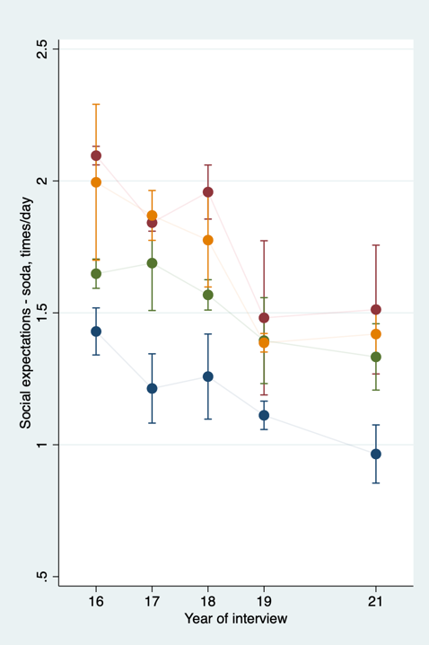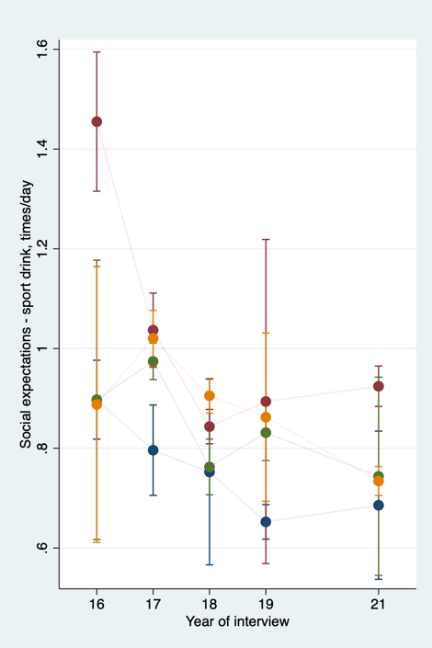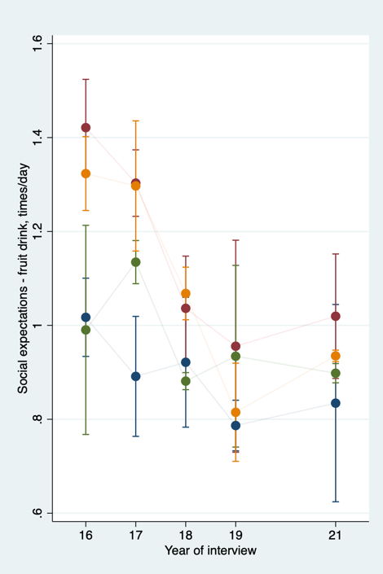
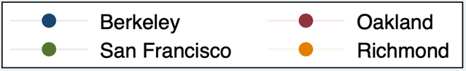
Models adjust for gender, age, race/ethnicity, education, and SSB consumption, with a random intercept for neighborhood and interaction between city and year as exposure. Estimates reflect adjusted marginal perceived consumption (how often respondents think others consume said beverages, times/day). Interaction between year and city is significant (p<0.001).

Supplemental Figure 2. Adjusted marginal attitudes about healthfulness of soda, sports drinks, and fruit drinks, by city and year
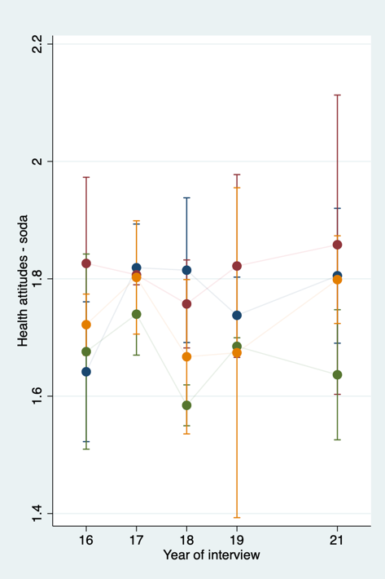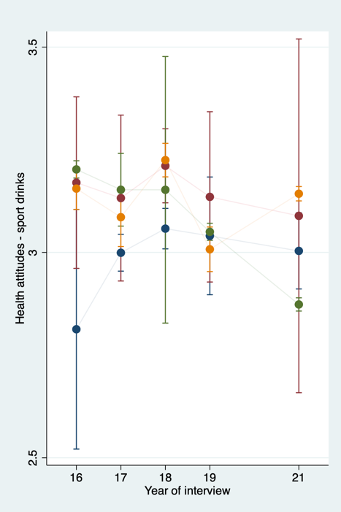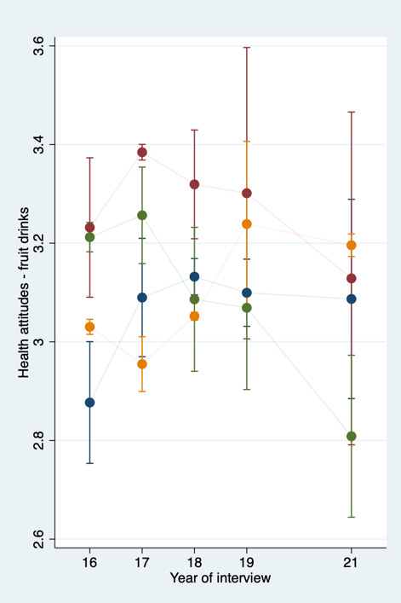
Models adjust for gender, age, race/ethnicity, education, and SSB consumption, with a random intercept for neighborhood and interaction between city and year as exposure. Estimates reflect adjusted mean attitudes about healthfulness of SSBs. Interaction between year and city is significant (p<0.001). Estimates are on a scale from 1 (extremely unhealthy) to 7 (extremely healthy).

