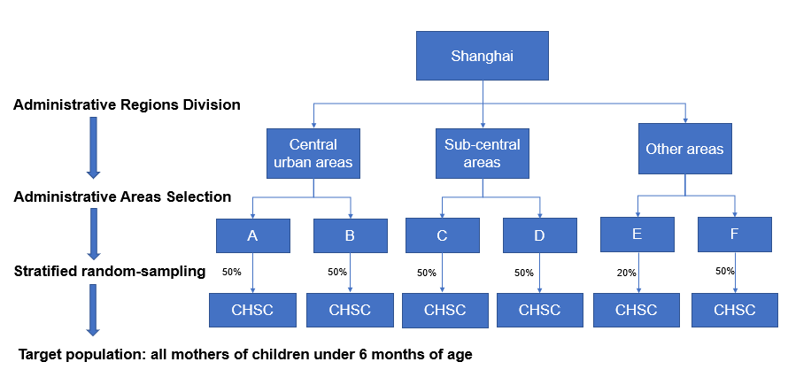

Supplementary figure 1. The Multi-stage probability sampling diagram

