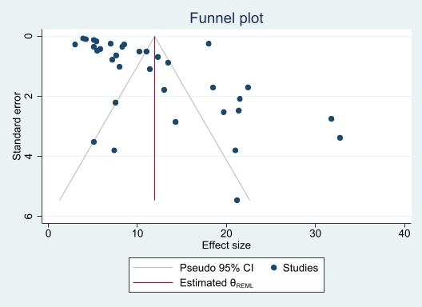

Supplementary Fig. 2 funnel plot for the overall prevalence of obesity.

