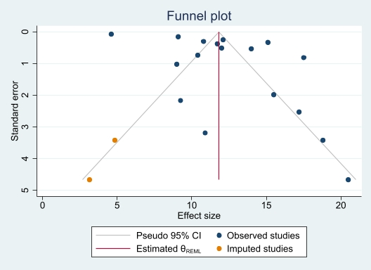

Supplementary Fig. 3 funnel plot for the prevalence of overweight among children and adolescents.

