Supplementary materials- Comparing the cost-benefit of breast cancer screening programs in rural and urban areas across four economic zones in China: a Markov modeling analysis
Contents
Supplementary materials- Comparing the cost-benefit of breast cancer screening programs in rural and urban areas across four economic zones in China: a Markov modeling analysis 1
Appendix Table 1. Consolidated Health Economic Evaluation Reporting Standards (CHEERS) checklist 2
Appendix Figure 1. Choices and results for both organized breast cancer screening and opportunistic case detection 6
Appendix Figure 2. The incidence of breast cancer in China 6
Appendix Table 2. Transition rate used in Markov model 7
Appendix Table 3. Age-specific progression and mortality rate of breast cancer 8
Appendix Table 4-1. Cost of screening (USD) (Eastern China) 9
Appendix Table 4-2. Cost of screening (USD) (Central China) 10
Appendix Table 4-3. Cost of screening (USD) (Western China) 11
Appendix Table 4-4. Cost of screening (USD) (Northeastern China) 12
Provincial mdeical service price 13
Appendix Table 5. Cost of treatment (USD) 14
Appendix Table 6. Utility score (QALYs) 15
Appendix Table 7. Sensitivity and specificity of screening methods 16
Appendix Table 8. Symptoms without screening and attendance rate of screening 17
Appendix Figure 3. Natural mortality rate used in Markov model 18
Appendix Table 9. GDP used in eight settings 19
Appendix Table 10. One-way sensitivity analysis 20
Appendix Table 11. Probabilistic sensitivity analysis 22
References 23

Appendix Table 1. Consolidated Health Economic Evaluation Reporting Standards (CHEERS) checklist
Section | Item No | Recommendation | Reported on page No/line No
Title and Abstract
Title | 1 | Identify the study as an economic evaluation or use more specific terms such as “cost-effectiveness analysis”, and describe the interventions compared. | Page 1
Abstract | 2 | Provide a structured summary of objectives, perspective, setting, methods (including study design and inputs), results (including base case and uncertainty analyses), and conclusions. | Page 1
Introduction
Background and objectives | 3 | Provide an explicit statement of the broader context for the study. | Page 2
Background and objectives | 3 | Present the study question and its relevance for health policy or practice decisions. | Page 2
Methods
Target population and subgroups | 4 | Describe characteristics of the base case population and subgroups analyzed, including why they were chosen. | Page 4
Setting and location | 5 | State relevant aspects of the system(s) in which the decision(s) need(s) to be made. | Page 4
Study perspective | 6 | Describe the perspective of the study and relate this to the costs being evaluated. | Page 5
Comparators | 7 | Describe the interventions or strategies being compared and state why they were chosen. | Page 4
Time horizon | 8 | State the time horizon(s) over which costs and consequences are being evaluated and say why appropriate. | Page 3
Discount rate | 9 | Report the choice of discount rate(s) used for costs and outcomes and say why appropriate. | Page 6
Choice of health outcomes | 10 | Describe what outcomes were used as the measure(s) of benefit in the evaluation and their relevance for the type of analysis performed. | Page 6
Measurement of effectiveness | 11a | Single study-based estimates: Describe fully the design features of the single effectiveness study and why the single study was a sufficient source of clinical effectiveness data. | Page 6
 | 11b | Synthesis-based estimates: Describe fully the methods used for identification of included studies and synthesis of clinical effectiveness data. | None defined
Measurement and valuation of preference-based outcomes | 12 | If applicable, describe the population and methods used to elicit preferences for outcomes. | Page 2
Estimating resources and costs | 13a | Single study-based economic evaluation: Describe approaches used to estimate resource use associated with the alternative interventions. Describe primary or secondary re- search methods for valuing each resource item in terms of its unit cost. Describe any adjustments made to approximate to opportunity costs. | None defined
 | 13b | Model-based economic evaluation: Describe approaches and data sources used to estimate resource use associated with model health states. Describe primary or secondary research methods for valuing each resource item in terms of its unit cost. Describe any adjustments made to approximate to opportunity costs. | Page 5
Currency, price date, and conversion | 14 | Report the dates of the estimated resource quantities and unit costs. Describe methods for adjusting estimated unit costs to the year of reported costs if necessary. Describe methods for converting costs into a common currency base and the ex- change rate. | Page 5
Choice of model | 15 | Describe and give reasons for the specific type of decision- analytical model used. Providing a figure to show model structure is strongly recommended. | Page 3
Choice of model | 15 |  | Figure 1-2＆Appendix Figure 1
Assumptions | 16 | Describe all structural or other assumptions underpinning the decision-analytical model. | Page 3
Analytical methods | 17 | Describe all analytical methods supporting the evaluation. This could include methods for dealing with skewed, missing, or censored data; extrapolation methods; methods for pooling data; approaches to validate or make adjustments (such as half cycle corrections) to a model; and methods for handling population heterogeneity and uncertainty. | None defined
Results
Study parameters | 18 | Report the values, ranges, references, and, if used, probability distributions for all parameters. Report reasons or sources for distributions used to represent uncertainty where appropriate. Providing a table to show the input values is strongly recommended. | Page 5-6
Study parameters | 18 |  | Supplement Table 6-19
Incremental costs and outcomes | 19 | For each intervention, report mean values for the main categories of estimated costs and outcomes of interest, as well as mean differences between the comparator groups. If applicable, report incremental cost-effectiveness ratios. | Page 9＆
Incremental costs and outcomes | 19 |  | Table 1
Characterizing uncertainty | 20a | Single study-based economic evaluation: Describe the effects of sampling uncertainty for the estimated incremental cost and incremental effectiveness parameters, together with the impact of methodological assumptions (such as discount rate, study perspective). | Page 13＆Appendix pp20-22
 | 20b | Model-based economic evaluation: Describe the effects on the results of uncertainty for all input parameters, and uncertainty related to the structure of the model and assumptions. | Page 13＆Appendix pp20-22
Characterizing heterogeneity | 21 | If applicable, report differences in costs, outcomes, or cost- effectiveness that can be explained by variations between subgroups of patients with different baseline characteristics or other observed variability in effects that are not reducible by more information. | Page 13＆Appendix pp20-22
Discussion
Study findings, limitations, generalizability, and current knowledge | 22 | Summarize key study findings and describe how they support the conclusions reached. Discuss limitations and the generalizability of the findings and how the findings fit with current knowledge. | Page 13
Other
Source of funding | 23 | Describe how the study was funded and the role of the fun- der in the identification, design, conduct, and reporting of the analysis. Describe other non-monetary sources of support. | Page 17
Conflicts of interest | 24 | Describe any potential for conflict of interest of study contributors in accordance with journal policy. In the absence of a journal policy, we recommend authors comply with International Committee of Medical Journal Editors recommendations. | Page 17
For consistency, the CHEERS Statement checklist format is based on the format of the CONSORT
statement checklist.
The ISPOR CHEERS Task Force Report provides examples and further discussion of the 24-item
CHEERS Checklist and the CHEERS Statement. It may be accessed via the Value in Health link or via the ISPOR
Health Economic Evaluation Publication Guidelines – CHEERS: Good Reporting Practices
webpage: http://www.ispor.org/TaskForces/EconomicPubGuidelines.asp
The citation for the CHEERS Task Force Report is:
Husereau D, Drummond M, Petrou S, et al. Consolidated health economic evaluation reporting standards
(CHEERS)—Explanation and elaboration: A report of the ISPOR health economic evaluations publication guidelines
good reporting practices task force. Value Health 2013;16:231-50[1].

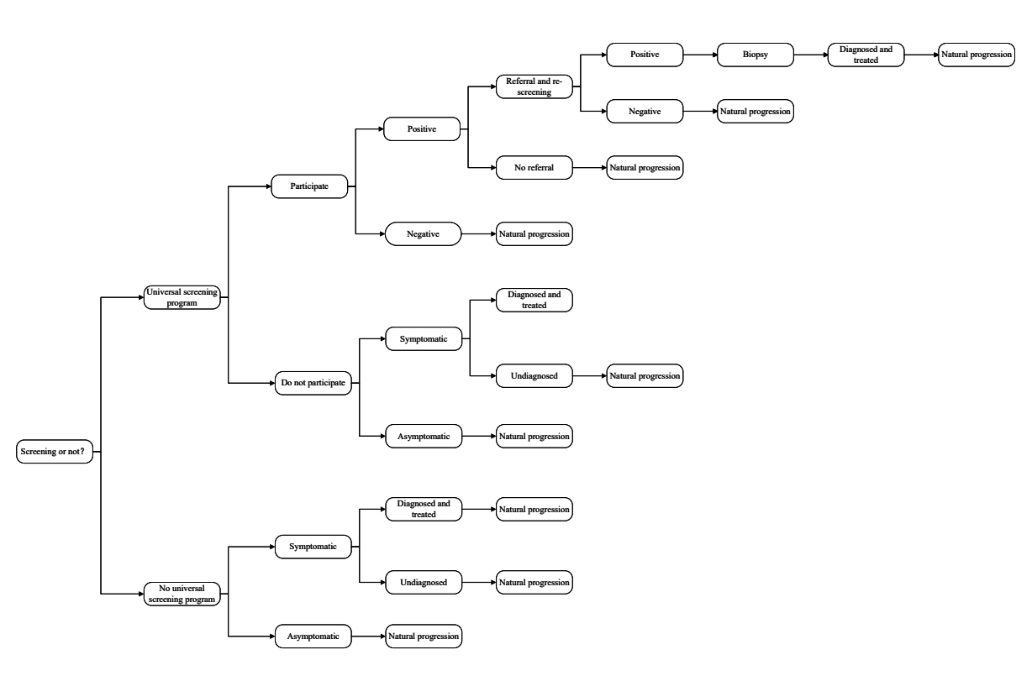

Appendix Figure 1. Choices and results for both organized breast cancer screening and opportunistic case detection
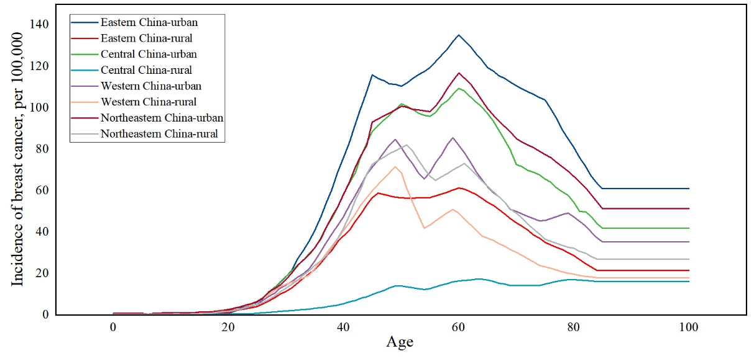

Appendix Figure 2. The incidence of breast cancer in China
Note: The incidence of breast cancer in the eight settings was collected from the China Cancer Registry Annual Report 2021[5]. However, this report did not include data on the incidence in northeastern China. Published literature indicated that the incidence in northeastern China closely resembled that of the entire country, so we used the national incidence as a substitute.

Appendix Table 2. Transition rate used in Markov model
Parameters | Base-case | Ranges for sensitivity analysis | Distribution for sensitivity analysis | References
Ratio of DCIS incidence to invasive breast cancer incidence | 12.00% | 9.60%-14.40% | Beta (263.88, 1935.12) | Sun L et al. (2018)[2]
RR of invasive cancer from DCIS | 202.00% | 161.60%-242.40% | Uniform (1.61, 2.42) | Sun L et al. (2018)[2]
From Stage I (age-specific)
To Stage II | Age-specific | Appendix Table 2 |  | Huang Y et al. (2020)[3]
To BC-related death | Age-specific |  |  | Huang Y et al. (2020)[3]
From Stage II (age-specific) | Age-specific |  |  | Huang Y et al. (2020)[3]
To Stage III | Age-specific |  |  | Huang Y et al. (2020)[3]
To BC-related death | Age-specific |  |  | Huang Y et al. (2020)[3]
From Stage III (age-specific) | Age-specific |  |  | Huang Y et al. (2020)[3]
To Stage IV | Age-specific |  |  | Huang Y et al. (2020)[3]
To BC-related death | Age-specific |  |  | Huang Y et al. (2020)[3]
From Stage IV to BC-related death (age-specific) | Age-specific |  |  | Huang Y et al. (2020)[3]
From Remission Stage I
To Local recurrence | 1.00% | 0.80%-1.20% | Beta (296.99, 29402.01) | Nguyen C P et al. (2018)[4]
To Distant recurrence | 0.00% | 0.00%-0.00% | Beta (300.00, 18749399.00) | Nguyen C P et al. (2018)[4]
From Remission Stage II/III |  |  |  | Nguyen C P et al. (2018)[4]
To Local recurrence | 1.80% | 1.44%-2.16% | Beta (294.58, 16071.08) | Nguyen C P et al. (2018)[4]
To Distant recurrence | 2.40% | 1.92%-2.88% | Beta (292.78, 11906.22) | Nguyen C P et al. (2018)[4]
From Local recurrence Stage |  |  |  | Nguyen C P et al. (2018)[4]
To Distant recurrence | 6.20% | 4.96%-7.44% | Beta (281.34, 4256.37) | Nguyen C P et al. (2018)[4]
To BC-related death | 1.30% | 1.04%-1.56% | Beta (296.09, 22479.84) | Nguyen C P et al. (2018)[4]
From Distant recurrence to BC-related death | 38.60% | 30.88%-46.32% | Beta (183.81, 292.39) | Nguyen C P et al. (2018)[4]
Note: DCIS: Ductal Carcinoma In Situ, RR: risk ratio, BC: breast cancer.

Appendix Table 3. Age-specific progression and mortality rate of breast cancer
Age | From Stage I to Stage II | From Stage II to Stage III | From Stage III to Stage IV | From Stage I to BC-related deaths | From Stage II to BC-related deaths | From Stage III to BC-related deaths | From Stage IV to BC-related deaths
<30 | 0.00% | 0.00% | 0.00% | 0.00% | 0.00% | 0.00% | 0.00%
30-34 | 78.61% | 32.33% | 25.13% | 0.04% | 0.05% | 0.05% | 18.35%
35-39 | 79.86% | 33.66% | 25.37% | 0.06% | 0.06% | 0.06% | 30.41%
40-44 | 79.09% | 34.56% | 22.45% | 0.08% | 0.09% | 0.09% | 31.80%
45-49 | 82.29% | 36.73% | 25.16% | 0.15% | 0.16% | 0.16% | 25.69%
50-54 | 83.75% | 35.15% | 24.76% | 0.22% | 0.24% | 0.24% | 26.05%
55-59 | 83.75% | 38.77% | 25.78% | 0.36% | 0.39% | 0.39% | 19.87%
60-64 | 79.18% | 34.63% | 25.13% | 0.67% | 0.69% | 0.69% | 12.00%
65-69 | 81.36% | 33.08% | 24.38% | 1.14% | 1.16% | 1.16% | 10.86%
70-74 | 78.09% | 33.26% | 23.87% | 1.98% | 2.01% | 2.01% | 10.88%
75+ | 77.33% | 31.34% | 30.34% | 3.60% | 3.63% | 3.63% | 10.31%

Appendix Table 4-1. Cost of screening (USD) (Eastern China)
Parameters | Base-case | Ranges for sensitivity analysis |  | Distribution for sensitivity analysis |  | References
Eastern China-urban
BSE | 0.75 | 0.60-0.90 |  | Gamma (300.00, 0.00) |  | Calculation
CBE | 4.71 | 3.77-5.65 |  | Gamma (300.00, 0.02) |  | Calculation
MAM | 24.43 | 19.54-29.32 |  | Gamma (300.00, 0.08) |  | Provincial medical service price
NIO | 76.13 | 60.90-91.36 |  | Gamma (300.00, 0.25) |  | Provincial medical service price
MRI | 14.77 | 11.82-17.72 |  | Gamma (300.00, 0.05) |  | Provincial medical service price
CTL | 54.39 | 43.51-65.27 |  | Gamma (300.00, 0.18) |  | Provincial medical service price
BM | 9.47 | 7.58-11.37 |  | Gamma (300.00, 0.03) |  | Provincial medical service price
CD | 18.81 | 15.05-22.58 |  | Gamma (300.00, 0.06) |  | Provincial medical service price
Biopsy | 15.41 | 12.33-18.50 |  | Gamma (300.00, 0.05) |  | Provincial medical service price
Eastern China-rural
BSE | 0.70 | 0.56-0.83 |  | Gamma (300.00, 0.00) |  | Calculation
CBE | 4.35 | 3.48-5.21 |  | Gamma (300.00, 0.01) |  | Calculation
MAM | 19.52 | 15.62-23.43 |  | Gamma (300.00, 0.07) |  | Provincial medical service price
NIO | 73.75 | 59.00-88.50 |  | Gamma (300.00, 0.25) |  | Provincial medical service price
MRI | 13.89 | 11.11-16.67 |  | Gamma (300.00, 0.05) |  | Provincial medical service price
CTL | 52.20 | 41.76-62.64 |  | Gamma (300.00, 0.17) |  | Provincial medical service price
BM | 8.85 | 7.08-10.62 |  | Gamma (300.00, 0.03) |  | Provincial medical service price
CD | 17.53 | 14.02-21.04 |  | Gamma (300.00, 0.06) |  | Provincial medical service price
Biopsy | 13.78 | 11.02-16.54 |  | Gamma (300.00, 0.05) |  | Provincial medical service price
Note: BSE: breast cancer self-examination, CBE: Clinician breast cancer examination, MAM: mammography, NIO: near-infrared optical mammography, MRI: Magnetic resonance imaging, CTL: Computed Tomography Laser Mammography, BM: B-Mode, CD: Color Doppler.

Appendix Table 4-2. Cost of screening (USD) (Central China)
Parameters | Base-case | Ranges for sensitivity analysis |  | Distribution for sensitivity analysis |  | References
Central China-urban
BSE | 0.57 | 0.45-0.68 |  | Gamma (300.00, 0.00) |  | Calculation
CBE | 3.54 | 2.84-4.25 |  | Gamma (300.00, 0.01) |  | Calculation
MAM | 10.87 | 8.70-13.04 |  | Gamma (300.00, 0.04) |  | Provincial medical service price
NIO | 66.17 | 52.94-79.41 |  | Gamma (300.00, 0.22) |  | Provincial medical service price
MRI | 6.47 | 5.18-7.77 |  | Gamma (300.00, 0.02) |  | Provincial medical service price
CTL | 18.19 | 14.56-21.83 |  | Gamma (300.00, 0.06) |  | Provincial medical service price
BM | 6.47 | 5.18-7.77 |  | Gamma (300.00, 0.02) |  | Provincial medical service price
CD | 12.33 | 9.87-14.80 |  | Gamma (300.00, 0.04) |  | Provincial medical service price
Biopsy | 22.24 | 17.79-26.69 |  | Gamma (300.00, 0.07) |  | Provincial medical service price
Central China-rural
BSE | 0.37 | 0.29-0.44 |  | Gamma (300.00, 0.00) |  | Calculation
CBE | 2.30 | 1.84-2.77 |  | Gamma (300.00, 0.01) |  | Calculation
MAM | 9.63 | 7.70-11.56 |  | Gamma (300.00, 0.03) |  | Provincial medical service price
NIO | 64.93 | 51.95-77.92 |  | Gamma (300.00, 0.22) |  | Provincial medical service price
MRI | 5.23 | 4.19-6.28 |  | Gamma (300.00, 0.02) |  | Provincial medical service price
CTL | 16.95 | 13.56-20.35 |  | Gamma (300.00, 0.06) |  | Provincial medical service price
BM | 5.23 | 4.19-6.28 |  | Gamma (300.00, 0.02) |  | Provincial medical service price
CD | 11.09 | 8.88-13.31 |  | Gamma (300.00, 0.04) |  | Provincial medical service price
Biopsy | 20.06 | 16.05-24.07 |  | Gamma (300.00, 0.07) |  | Provincial medical service price
Note: BSE: breast cancer self-examination, CBE: Clinician breast cancer examination, MAM: mammography, NIO: near-infrared optical mammography, MRI: Magnetic resonance imaging, CTL: Computed Tomography Laser Mammography, BM: B-Mode, CD: Color Doppler.

Appendix Table 4-3. Cost of screening (USD) (Western China)
Parameters | Base-case | Ranges for sensitivity analysis |  | Distribution for sensitivity analysis |  | References
Western China-urban
BSE | 0.61 | 0.49-0.73 |  | Gamma (300.00, 0.00) |  | Calculation
CBE | 3.82 | 3.06-4.59 |  | Gamma (300.00, 0.01) |  | Calculation
MAM | 16.07 | 12.85-19.28 |  | Gamma (300.00, 0.05) |  | Provincial medical service price
NIO | 66.11 | 52.89-79.34 |  | Gamma (300.00, 0.22) |  | Provincial medical service price
MRI | 11.03 | 8.82-13.23 |  | Gamma (300.00, 0.04) |  | Provincial medical service price
CTL | 18.18 | 14.54-21.81 |  | Gamma (300.00, 0.06) |  | Provincial medical service price
BM | 7.26 | 5.81-8.72 |  | Gamma (300.00, 0.02) |  | Provincial medical service price
CD | 15.12 | 12.10-18.14 |  | Gamma (300.00, 0.05) |  | Provincial medical service price
Biopsy | 15.81 | 12.64-18.97 |  | Gamma (300.00, 0.05) |  | Provincial medical service price
Western China-rural
BSE | 0.26 | 0.21-0.32 |  | Gamma (300.00, 0.00) |  | Calculation
CBE | 1.65 | 1.32-1.98 |  | Gamma (300.00, 0.01) |  | Calculation
MAM | 11.67 | 9.33-14.00 |  | Gamma (300.00, 0.04) |  | Provincial medical service price
NIO | 53.39 | 42.71-64.07 |  | Gamma (300.00, 0.18) |  | Provincial medical service price
MRI | 7.51 | 6.01-9.01 |  | Gamma (300.00, 0.03) |  | Provincial medical service price
CTL | 11.83 | 9.46-14.20 |  | Gamma (300.00, 0.04) |  | Provincial medical service price
BM | 4.43 | 3.55-5.32 |  | Gamma (300.00, 0.01) |  | Provincial medical service price
CD | 10.52 | 8.41-12.62 |  | Gamma (300.00, 0.04) |  | Provincial medical service price
Biopsy | 11.79 | 9.43-14.15 |  | Gamma (300.00, 0.04) |  | Provincial medical service price
Note: BSE: breast cancer self-examination, CBE: Clinician breast cancer examination, MAM: mammography, NIO: near-infrared optical mammography, MRI: Magnetic resonance imaging, CTL: Computed Tomography Laser Mammography, BM: B-Mode, CD: Color Doppler.

Appendix Table 4-4. Cost of screening (USD) (Northeastern China)
Parameters | Base-case | Ranges for sensitivity analysis |  | Distribution for sensitivity analysis |  | References
Northeastern China-urban
BSE | 0.42 | 0.33-0.50 |  | Gamma (300.00, 0.00) |  | Calculation
CBE | 2.59 | 2.08-3.11 |  | Gamma (300.00, 0.01) |  | Calculation
MAM | 16.91 | 13.53-20.29 |  | Gamma (300.00, 0.06) |  | Provincial mdeical service price
NIO | 63.79 | 51.03-76.55 |  | Gamma (300.00, 0.21) |  | Provincial mdeical service price
MRI | 12.51 | 10.01-15.02 |  | Gamma (300.00, 0.04) |  | Provincial mdeical service price
CTL | 40.35 | 32.28-48.42 |  | Gamma (300.00, 0.13) |  | Provincial mdeical service price
BM | 9.58 | 7.67-11.50 |  | Gamma (300.00, 0.03) |  | Provincial mdeical service price
CD | 19.84 | 15.87-23.81 |  | Gamma (300.00, 0.07) |  | Provincial mdeical service price
Biopsy | 19.84 | 15.87-23.81 |  | Gamma (300.00, 0.07) |  | Provincial mdeical service price
Northeastern China-rural
BSE | 0.35 | 0.28-0.42 |  | Gamma (300.00, 0.00) |  | Calculation
CBE | 2.20 | 1.76-2.63 |  | Gamma (300.00, 0.01) |  | Calculation
MAM | 13.92 | 11.13-16.70 |  | Gamma (300.00, 0.05) |  | Provincial mdeical service price
NIO | 60.80 | 48.64-72.95 |  | Gamma (300.00, 0.20) |  | Provincial mdeical service price
MRI | 9.52 | 7.62-11.42 |  | Gamma (300.00, 0.03) |  | Provincial mdeical service price
CTL | 37.36 | 29.88-44.83 |  | Gamma (300.00, 0.12) |  | Provincial mdeical service price
BM | 6.59 | 5.27-7.91 |  | Gamma (300.00, 0.02) |  | Provincial mdeical service price
CD | 16.85 | 13.48-20.21 |  | Gamma (300.00, 0.06) |  | Provincial mdeical service price
Biopsy | 16.85 | 13.48-20.21 |  | Gamma (300.00, 0.06) |  | Provincial mdeical service price
Note: BSE: breast cancer self-examination, CBE: Clinician breast cancer examination, MAM: mammography, NIO: near-infrared optical mammography, MRI: Magnetic resonance imaging, CTL: Computed Tomography Laser Mammography, BM: B-Mode, CD: Color Doppler.

Provincial mdeical service price
Considering the inclusion of several provinces medical service price, we provided examples of a subset. The sources and retrieval channels for other provinces followed a similar approach.
Anhui: https://www.ah.gov.cn/szf/zfgb/554165031.html
Hunan: http://ybj.hunan.gov.cn/ybj/first113541/firstF/f2113606/202211/t20221110_29122074.html
Jiangsu: https://si12333.cn/policy/mszbr.html
Liaoning: https://www.ykzxyy.cn/index.php?m=content&c=index&a=show&catid=73&id=1895
Yunnan: https://ylbz.yn.gov.cn/index.php?s=form&c=ylfwxm&m=page
Zhejiang: https://www.zjhospital.comcn/Upload/xmlist2023.pdf
Heilongjiang: http://www.zgyt.gov.cn/web/ytq/ydxx/-/articles/6756242.shtml
Henan: http://www.hnszsy.cn/detail/4099.html
Gansu: http://www.ningxian.gov.cn/jyj/xxgk/fdzdgknr/ywjy/content_20486
Guangxi: http://ybj.gxzf.gov.cn/xwdt/tzgg/t11063960.shtml
Guizhou:
http://www.gzhs.gov.cn/zwfw/bmlqfw/shbz/fwzn/yl_5059753/201601/t20160105_6251198.html
Inner Mongolia: http://www.nmgsyy.cn/tmpl/plate_page.html?id=169
Ningxia:
https://ylbz.nx.gov.cn/zfxxgk/fdzdgknr/tzgg/202212/t20221230_3900070.html
Qinghai: https://ybj.qinghai.gov.cn/2020-07/17/c_1126250188.htm
Shanxi: http://ybj.shaanxi.gov.cn/xwzx/ybyw/sybdt/15174.htm
Sichuan: https://ylbzj.sc.gov.cn/scsybj/nc010416/2023/4/12/8a49d73f67064dc4b94047cd616abb9e.shtml
Xizang: http://ylbzj.xizang.gov.cn/zwgk/zcwj/202110/P020211029651914105465.pdf
Xinjiang:
http://ylbzj.xinjiang.gov.cn/ylbzj/mlgkjgcg/202011/a1a27295afbe4500b015579d4c96af95.shtml
Yunnan:
https://www.yn.gov.cn/ztgg/lqhm/hmzc/yljk/202202/t20220215_236273.html?eqid=e5e675e400042068000000066459b96a
Chongqing: https://www.baidu.com/link?url=HZb7_9Xw7AWCc6f1JzzXbQ2Qsp2RF5rncVoiW4Q0MQtIHM-cwUBEPtrVf2ouCN62

Appendix Table 5. Cost of treatment (USD)
Parameters | Base-case | Ranges for sensitivity analysis | Distribution for sensitivity analysis | References
Eastern China
DCIS | 5608.33 | 4486.66-6729.99 | Gamma (300.00, 18.69) | Li H et al. (2013)[8]
Stage I (annual) | 8295.07 | 6636.06-9954.08 | Gamma (300.00, 27.65) | Liao X Z et al. (2018)[9]
Stage II (annual) | 8392.78 | 6714.22-10071.33 | Gamma (300.00, 27.98) | Liao X Z et al. (2018)[9]
Stage III (annual) | 10581.45 | 8465.16-12697.75 | Gamma (300.00, 35.27) | Liao X Z et al. (2018)[9]
Stage IV (annual) | 15926.12 | 12740.90-19111.35 | Gamma (300.00, 53.09) | Liao X Z et al. (2018)[9]
Central China
DCIS | 4533.94 | 3627.15-5440.73 | Gamma (300.00, 15.11) | Li H et al. (2013)[8]
Stage I (annual) | 6705.98 | 5364.78-8047.17 | Gamma (300.00, 22.35) | Liao X Z et al. (2018)[9]
Stage II (annual) | 6784.97 | 5427.98-8141.96 | Gamma (300.00, 22.62) | Liao X Z et al. (2018)[9]
Stage III (annual) | 8554.36 | 6843.49-10265.23 | Gamma (300.00, 28.51) | Liao X Z et al. (2018)[9]
Stage IV (annual) | 12875.15 | 10300.12-15450.18 | Gamma (300.00, 42.92) | Liao X Z et al. (2018)[9]
Western China
DCIS | 5558.36 | 4446.69-6670.03 | Gamma (300.00, 18.53) | Li H et al. (2013)[8]
Stage I (annual) | 8221.16 | 6576.93-9865.39 | Gamma (300.00, 27.40) | Liao X Z et al. (2018)[9]
Stage II (annual) | 8318.00 | 6654.40-9981.60 | Gamma (300.00, 27.73) | Liao X Z et al. (2018)[9]
Stage III (annual) | 10487.17 | 8389.74-12584.61 | Gamma (300.00, 34.96) | Liao X Z et al. (2018)[9]
Stage IV (annual) | 15784.22 | 12627.37-18941.06 | Gamma (300.00, 52.61) | Liao X Z et al. (2018)[9]
Northeastern China
DCIS | 2004.12 | 1603.30-2404.95 | Gamma (300.00, 6.68) | Li H et al. (2013)[8]
Stage I (annual) | 2964.23 | 2371.38-3557.07 | Gamma (300.00, 9.88) | Liao X Z et al. (2018)[9]
Stage II (annual) | 2999.14 | 2399.31-3598.97 | Gamma (300.00, 10.00) | Liao X Z et al. (2018)[9]
Stage III (annual) | 3781.26 | 3025.01-4537.51 | Gamma (300.00, 12.60) | Liao X Z et al. (2018)[9]
Stage IV (annual) | 5691.17 | 4552.93-6829.40 | Gamma (300.00, 18.97) | Liao X Z et al. (2018)[9]
Note: DCIS: Ductal Carcinoma In Situ.

Appendix Table 6. Utility score (QALYs)
Parameters | Base-case | Ranges for sensitivity analysis | Distribution for sensitivity analysis | References
No breast cancer | 0.95 | 0.76-1.00 | Beta (59.05, 3.11) | Brazier J et al (2002)[10]
DCIS | 0.90 | 0.72-1.00 | Beta (119.10, 13.23) | Trentham-Dietz A et al. (2018)[11]
Stage I | 0.73 | 0.58-0.88 | Beta (322.07, 118.52) | XY Wong (2019)[12]
Stage II | 0.73 | 0.58-0.88 | Beta (322.07, 118.52) | XY Wong (2019)[12]
Stage III | 0.60 | 0.48-0.72 | Beta (480.60, 321.74) | XY Wong (2019)[12]
Stage IV | 0.35 | 0.28-0.42 | Beta (777.25, 1430.84) | XY Wong (2019)[12]
Remission | 0.82 | 0.66-0.98 | Beta (215.18, 47.23) | Hayman J A et al. (1997)[13]
Local recurrence | 0.60 | 0.48-0.72 | Beta (475.80, 313.25) | Lloyd A et al. (2006)[14]
Distant recurrence | 0.62 | 0.50-0.74 | Beta (455.38, 279.10) | Lee J H et al. (2002)[15]
Disutility-false positives | 0.01 | 0.01-0.01 | Beta (1187.99, 117611.01) | Li L et al (2019)[16]
Note: DCIS: Ductal Carcinoma In Situ.

Appendix Table 7. Sensitivity and specificity of screening methods
Parameters | Base-case | Ranges for sensitivity analysis |  | Distribution for sensitivity analysis |  | References
Sensitivity
BSE | 20.00% | 16.00%-24.00% |  | Beta (959.80, 3839.20) |  | O Malley M S et al. (1987)[18]
CBE | 36.00% | 28.80%-43.20% |  | Beta (767.64, 1364.69) |  | Malmartel A et al. (2019)[19]
MAM | 80.50% | 64.40%-96.60% |  | Beta (233.20, 56.49) |  | Omranipour R et al. (2016)[20]
NIO | 81.60% | 65.28%-97.92% |  | Beta (219.98, 49.60) |  | Omranipour R et al. (2016)[20]
MRI | 71.00% | 56.80%-85.20% |  | Beta (347.29, 141.85) |  | Kriege M et al. (2006)[21]
CTL | 95.20% | 76.16%-100.00% |  | Beta (56.17, 2.83) |  | Jalalian A et al. (2017)[22]
BM | 93.70% | 74.96%-100.00% |  | Beta (74.66, 5.02) |  | Watanabe T et al. (2021)[23]
CD | 94.70% | 75.76%-100.00% |  | Beta (62.65, 3.51) |  | Watanabe T et al. (2021)[23]
Specificity
BSE | 78.00% | 62.40%-93.60% |  | Beta (263.22, 74.24) |  | Malmartel A et al. (2019)[19]
CBE | 78.00% | 62.40%-93.60% |  | Beta (263.22, 74.24) |  | Malmartel A et al. (2019)[19]
MAM | 73.30% | 58.64%-87.96% |  | Beta (319.67, 116.44) |  | Omranipour R et al. (2016)[20]
NIO | 57.80% | 46.24%-69.36% |  | Beta (505.82, 369.30) |  | Omranipour R et al. (2016)[20]
MRI | 90.00% | 72.00%-100.00% |  | Beta (119.10, 13.23) |  | Kriege M et al. (2006)[21]
CTL | 98.10% | 78.48%-100.00% |  | Beta (43.51, 0.84) |  | Jalalian A et al. (2017)[22]
BM | 61.50% | 49.20%-73.80% |  | Beta (461.38, 288.83) |  | Watanabe T et al. (2021)[23]
CD | 69.20% | 55.36%-83.04% |  | Beta (368.91, 164.20) |  | Watanabe T et al. (2021)[23]
Note: BSE: breast cancer self-examination, CBE: Clinician breast cancer examination, MAM: mammography, NIO: near-infrared optical mammography, MRI: Magnetic resonance imaging, CTL: Computed Tomography Laser Mammography, BM: B-Mode, CD: Color Doppler.

Appendix Table 8. Symptoms without screening and attendance rate of screening
Parameters | Base-case | Ranges for sensitivity analysis |  | Distribution for sensitivity analysis |  | References
Symptoms without screening
Stage I | 0.40% | —— |  |  |  | Sun L et al. (2018)[2]
Stage II | 1.40% | —— |  |  |  | Sun L et al. (2018)[2]
Stage III | 38.00% | —— |  |  |  | Sun L et al. (2018)[2]
Stage IV | 98.00% | —— |  |  |  | Sun L et al. (2018)[2]
Attendance rate
Eastern China-urban | 55.70% | 44.56%-66.84% |  | Beta (132.34, 105.26) |  | Chao Qin et al. (2021)[6]
Eastern China-rural | 60.70% | 48.56%-72.84% |  | Beta (117.29, 75.94) |  | Chao Qin et al. (2021)[6]
Central China-urban | 59.90% | 47.92%-71.88% |  | Beta (119.70, 80.13) |  | Chao Qin et al. (2021)[6]
Central China-rural | 64.90% | 51.92%-77.88% |  | Beta (104.65, 56.60) |  | Chao Qin et al. (2021)[6]
Western China-urban | 50.30% | 40.24%-60.36% |  | Beta (148.60, 146.82) |  | Chao Qin et al. (2021)[6]
Western China-rural | 55.30% | 44.24%-66.36% |  | Beta (133.55, 107.95) |  | Chao Qin et al. (2021)[6]
Northeastern China-urban | 55.30% | 44.24%-66.36% |  | Beta (133.55, 107.95) |  | Chao Qin et al. (2021)[6]
Northeastern China-rural | 60.30% | 48.24%-72.36% |  | Beta (118.50, 78.02) |  | Chao Qin et al. (2021)[6]
Proportion of referral compliance
Rescreening | 90.00% | 72.00%-100.00% |  | Beta (29.10, 3.23) |  | Dong B et al. (2021)[7]
Treatment | 95.00% | 76.00%-100.00% |  | Beta (24.00, 1.26) |  | Assumed
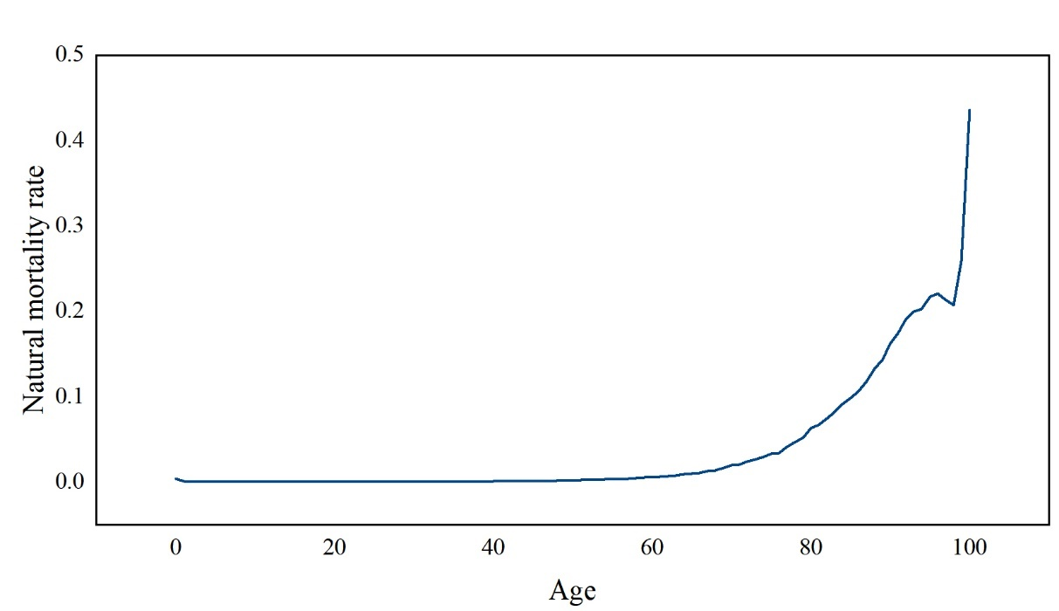

Appendix Figure 3. Natural mortality rate used in Markov model[17]

Appendix Table 9. GDP used in eight settings
Regions | Total GDP, CNY | Total population | Urbanization rate | Disposable income, urban, CNY | Disposable income, rural, CNY | One-time per capita GDP, urban, USD | One-time per capita GDP, rural, USD
Western China | 3.00E+13 | 3.83E+08 | 52.86% | 40582.6 | 15608.2 | 13435.74 | 5794.45
Central China | 3.00E+13 | 3.65E+08 | 59.71% | 40706.8 | 17857.5 | 12462.75 | 8102.47
Eastern China | 6.00E+13 | 5.64E+08 | 68.82% | 56378.3 | 23556.1 | 16566.96 | 15278.23
Northeastern China | 6.00E+12 | 9.85E+07 | 63.89% | 38224.6 | 18280.4 | 9123.93 | 7720.23
The calculation formula of eight settings per capita GDP:
$$The per capita GDP for rural settings$$
$$=total GDP in rural areas/total rural population$$
$$=\frac{total GDP}{\left(1+\text{urban to rural ratio of per capita disposable income}\right)\left(\text{the total population}\left(1-\text{urbanization rate}\right)\right)}$$
$$=\frac{\text{overall per capita national GDP}}{\left(\left(1+\text{urban to rural ratio of per capita disposable income}\right)\left(1-\text{urbanization rate}\right)\right)}$$
$$The per capita GDP for urban China$$
$$=\frac{\text{overall per capita national GDP}}{\left(1+\left(\frac{1}{\text{urban to rural ratio of per capita disposable income}}\right)\right)*\text{urbanization rate}}$$

Appendix Table 10. One-way sensitivity analysis
 |  |  | Eastern China-urban | Eastern China-rural | Central China-urban | Central China-rural | Western China-urban | Western China-rural | Northeastern China-urban | Northeastern China-rural
Base-case | One-time GDP |  | 35-70 (2) MAM+CTL | 40-70 (3) MAM+CTL | 35-70 (1) MAM+CTL | No screening | 35-70 (2) MAM+CTL | 40-65 (1) CBE+CTL | 40-70 (2) MAM+CTL | 40-65 (1) CBE+MRI
Base-case | Three-times GDP |  | 30-70 (1) MAM+CTL | 35-70(1) MAM+CTL | 30-70 (1) MAM+CTL | 50-70 (3) MAM+CTL | 30-70 (1) MAM+CTL | 20-75 (1) CBE+CTL | 30-70 (1) MAM+CTL | 30-70 (2) MAM+CTL
Transition rate | -20% | One-time | —— | —— | —— | —— | —— | —— | —— | 40-70 (1) CBE+MRI
Transition rate | -20% | Three-times | —— | —— | —— | 45-70 (3) MAM+CTL | —— | —— | —— | 35-70 (1) MAM+CTL
Transition rate | +20% | One-time | 40-70 (2) MAM+CTL | —— | —— | —— | —— | —— | —— | ——
Transition rate | +20% | Three-times | —— | —— | —— | —— | —— | —— | —— | ——
Sensitivity and Specificity | -20% | One-time | 45-65 (2) MAM+CTL | No universal screening | 40-70 (2) MAM+CTL | —— | 45-65 (3) MAM+CTL | No screening | 50-60 (5) MAM+CTL | No screenings
Sensitivity and Specificity | -20% | Three-times | 40-70 (1) MAM+CTL | 45-65 (2) MAM+CTL | 40-70 (1) MAM+CTL | No screening | 40-65 (1) MAM+CTL | 45-55 (2) MAM+CTL | 40-70 (2) MAM+CTL | 45-65 (2) MAM+CTL
Sensitivity and Specificity | +20% | One-time | 30-70 (1) 26 | 30-70 (1) 22 | 30-70 (1) MAM+CTL | 40-70 (1) BSE+MRI | 30-70 (1) CBE+CTL | 30-70 (1) CBE+CTL | 30-70 (1) CBE+MAM | 30-70 (1) CBE+MRI
Sensitivity and Specificity | +20% | Three-times | —— | 30-70 (1) MAM+CTL | 25-70 (1) MAM+CTL | 25-70 (1) BSE+MRI | —— | —— | —— | 30-70 (1) MAM+CTL
Attendance of screening | -20% | One-time | 40-70 (1) MAM+CTL | 45-65 (2) MAM+CTL | —— | —— | 40-65 (1) MAM+CTL | 40-60 (1) CBE+CTL | 40-70 (1) CBE+CTL | 45-65 (1) CBE+MRI
Attendance of screening | -20% | Three-times | —— | —— | 25-70 (1) MAM+CTL | 50-70 (2) CBE+CTL | —— | —— | —— | 40-70 (1) MAM+CTL
Attendance of screening | +20% | One-time | —— | —— | 30-70 (2) MAM+CTL | —— | —— | 30-65 (2) CBE+CTL | —— | ——
Attendance of screening | +20% | Three-times | —— | 30-70 (2) MAM+CTL | —— | 45-70 (5) MAM+CTL | —— | 30-70 (2) MAM+CTL | 30-70 (2) MAM+CTL | ——
Cost of screening | -20% | One-time | 40-70 (1) MAM+CTL | 40-70 (2) MAM+CTL | 30-70 (1) MAM+CTL | —— | 30-70 (2) MAM+CTL | 30-65 (1) CBE+CTL | —— | 40-70 (1) CBE+MRI
Cost of screening | -20% | Three-times | —— | 30-70 (1) MAM+CTL | 25-70 (1) MAM+CTL | 45-70 (3) MAM+CTL | —— | 30-70 (1) MAM+CTL | —— | 30-70 (1) MAM+CTL
Cost of screening | +20% | One-time | 40-70 (2) MAM+CTL | 45-65 (3) MAM+CTL | 30-70 (2) MAM+CTL | —— | 40-70 (2) MAM+CTL | 40-60 (1) CBE+CTL | 40-70 (1) CBE+MRI | ——
Cost of screening | +20% | Three-times | —— | 30-70 (2) MAM+CTL | —— | 50-70 (5) MAM+CTL | —— | —— | 35-70 (1) MAM+CTL | ——
Cost of treatment | -20% | One-time | —— | —— | —— | —— | —— | —— | —— | 40-70 (1) CBE+MRI
Cost of treatment | -20% | Three-times | —— | —— | —— | —— | —— | —— | —— | ——
Cost of treatment | +20% | One-time | —— | —— | —— | —— | —— | —— | —— | ——
Cost of treatment | +20% | Three-times | —— | —— | —— | —— | —— | —— | —— | ——
Utilities | -20% | One-time | 40-70 (2) MAM+CTL | 45-65 (3) MAM+CTL | 30-70 (2) MAM+CTL | —— | 40-70 (2) MAM+CTL | 203CBE+CTL | 40-70 (1) CBE+MRI | 45-65 (1) CBE+MRI
Utilities | -20% | Three-times | —— | 30-70 (2) MAM+CTL | —— | 50-70 (5) MAM+CTL | —— | —— | 35-70 (1) MAM+CTL | ——
Utilities | +20% | One-time | 40-70 (1) MAM+CTL | 40-70 (2) MAM+CTL | 30-70 (1) MAM+CTL | —— | 30-70 (2) MAM+CTL | 30-65 (1) CBE+CTL | —— | 40-70 (1) CBE+MRI
Utilities | +20% | Three-times | —— | 30-70 (1) MAM+CTL | 25-70 (1) MAM+CTL | 45-70 (3) MAM+CTL | —— | 30-70 (1) MAM+CTL | —— | 35-70 (1) MAM+CTL
Discount rate | 0% | One-time | 30-70 (1) MAM+CTL | 30-70 (2) MAM+CTL | 25-70 (1) MAM+CTL | 50-65 (5) MAM+CTL | 30-70 (1) MAM+CTL | 25-70 (1) CBE+CTL | 30-70 (1) MAM+CTL | 30-70 (2) MAM+CTL
Discount rate | 0% | Three-times | 25-70 (1) MAM+CTL | 25-70 (1) MAM+CTL | 25-70 (1) MAM+CTL | 30-70 (2) MAM+CTL | 25-70 (1) MAM+CTL | 25-70 (1) MAM+CTL | 25-70 (1) MAM+CTL | 25-70 (1) MAM+CTL
Discount rate | 8% | One-time | 40-70 (2) MAM+CTL | 45-65 (5) MAM+CTL | 35-70 (2) MAM+CTL | —— | 40-70 (1) CBE+CTL | 45-55 (1) CBE+CTL | 45-70 (1) CBE+MRI | 45-60 (1) CBE+MRI
Discount rate | 8% | Three-times | 35-70 (1) MAM+CTL | 35-70 (2) MAM+CTL | —— | 50-65 (5) MAM+CTL | 35-70 (1) MAM+CTL | 30-70 (1) CBE+CTL | 30-70 (2) MAM+CTL | 40-70 (2) MAM+CTL

Appendix Table 11. Probabilistic sensitivity analysis
 |  | Eastern China |  | Central China |  | Western China |  | Northeastern China
 |  | Urban | Rural | Urban | Rural | Urban | Rural | Urban | Rural
One-time GDP | No universal screening | 103 | 304 | 109 | —— | 84 | 203 | 226 | 534
One-time GDP | Status quo | 0 | 0 | 0 | 0 | 0 | 0 | 0 | 0
One-time GDP | Strategy recommended | 9897 | 9696 | 9891 | 10000 | 9916 | 9797 | 9774 | 9466
Three-times GDP | No universal screening | 0 | 0 | 0 | 921 | 0 | 0 | 0 | 0
Three-times GDP | Status quo | 0 | 0 | 0 | 0 | 0 | 0 | 0 | 0
Three-times GDP | Strategy recommended | 10000 | 10000 | 10000 | 9079 | 10000 | 10000 | 10000 | 10000

References:
1. Husereau D, Drummond M, Petrou S, Carswell C, Moher D, Greenberg D, Augustovski F, Briggs AH, Mauskopf J, Loder E: Consolidated health economic evaluation reporting standards (CHEERS)—explanation and elaboration: a report of the ISPOR health economic evaluation publication guidelines good reporting practices task force. VALUE HEALTH 2013, 16(2):231-250.
2. Sun L, Legood R, Sadique Z, Dos-Santos-Silva I, Yang L: Cost–effectiveness of risk-based breast cancer screening programme, China. B WORLD HEALTH ORGAN 2018, 96(8):568.
3. Huang Y, Li Q, Torres-Rueda S, Li J: The structure and parameterization of the breast cancer transition model among Chinese women. VALUE HEALTH REG ISS 2020, 21:29-38.
4. Nguyen CP, Adang EM: Cost-effectiveness of breast cancer screening using mammography in Vietnamese women. PLOS ONE 2018, 13(3):e0194996.
5. Jie He WW: China Cancer Registry Annual Report 2021: People's Medical Publishing House; 2021.
6. Qin C, Li J, Zheng Y, Wang F, Cao W, Xu Y, Yu Y, Zhao L, Yu X, Chen H: Analysis of screening compliance and related factors in high-risk populations of breast cancer in Chinese cities. 2021.
7. Dong B, Zou H, Mao X, Su Y, Gao H, Xie F, Lv Y, Chen Y, Kang Y, Xue H: Effect of introducing human papillomavirus genotyping into real-world screening on cervical cancer screening in China: a retrospective population-based cohort study. THER ADV MED ONCOL 2021, 13:17544325.
8. Li H, Huang Y, Huang R, Li JY: Standard treatment cost of female breast cancer at different TNM stages. Zhonghua Zhong liu za zhi [Chinese Journal of Oncology] 2013, 35(12):946-950.
9. Liao XZ, Shi JF, Liu JS, Huang HY, Guo LW, Zhu XY, Xiao HF, Wang L, Bai YN, Liu GX: Medical and non‐medical expenditure for breast cancer diagnosis and treatment in China: a multicenter cross‐sectional study. Asia‐Pacific Journal of Clinical Oncology 2018, 14(3):167-178.
10. Brazier J, Roberts J, Deverill M: The estimation of a preference-based measure of health from the SF-36. J HEALTH ECON 2002, 21(2):271-292.
11. Trentham-Dietz A, Ergun MA, Alagoz O, Stout NK, Gangnon RE, Hampton JM, Dittus K, James TA, Vacek PM, Herschorn SD: Comparative effectiveness of incorporating a hypothetical DCIS prognostic marker into breast cancer screening. BREAST CANCER RES TR 2018, 168:229-239.
12. Yi WX: Moving Towards a Personalized Approach to Breast Cancer Screening: Are We Ready? National University of Singapore (Singapore); 2019.
13. Hayman JA, Fairclough DL, Harris JR, Weeks JC: Patient preferences concerning the trade-off between the risks and benefits of routine radiation therapy after conservative surgery for early-stage breast cancer. J CLIN ONCOL 1997, 15(3):1252-1260.
14. Lloyd A, Nafees B, Narewska J, Dewilde S, Watkins J: Health state utilities for metastatic breast cancer. BRIT J CANCER 2006, 95(6):683-690.
15. Lee JH, Glick HA, Hayman JA, Solin LJ: Decision-analytic model and cost-effectiveness evaluation of postmastectomy radiation therapy in high-risk premenopausal breast cancer patients. J CLIN ONCOL 2002, 20(11):2713-2725.
16. Li L, Severens JL, Mandrik O: Disutility associated with cancer screening programs: a systematic review. PLOS ONE 2019, 14(7):e0220148.
17. Zhou S, Zou G, Chen X, Yu H, Wang J, Fang P, Song F: Educational attainment and mortality: results from the sixth population census in China. J GLOB HEALTH 2019, 9(2).
18. O'Malley MS, Fletcher SW: US Preventive Services Task Force. Screening for breast cancer with breast self-examination. A critical review. JAMA-J AM MED ASSOC 1987, 257(16):2196-2203.
19. Malmartel A, Tron A, Caulliez S: Accuracy of clinical breast examination’s abnormalities for breast cancer screening: cross-sectional study. EUR J OBSTET GYN R B 2019, 237:1-6.
20. Omranipour R, Kazemian A, Alipour S, Najafi M, Alidoosti M, Navid M, Alikhassi A, Ahmadinejad N, Bagheri K, Izadi S: Comparison of the accuracy of thermography and mammography in the detection of breast cancer. BREAST CARE 2016, 11(4):260-264.
21. Kriege M, Brekelmans CT, Obdeijn IM, Boetes C, Zonderland HM, Muller SH, Kok T, Manoliu RA, Besnard APE, Tilanus-Linthorst MM: Factors affecting sensitivity and specificity of screening mammography and MRI in women with an inherited risk for breast cancer. BREAST CANCER RES TR 2006, 100:109-119.
22. Jalalian A, Mashohor S, Mahmud R, Karasfi B, Iqbal Saripan M, Ramli AR: Computer-assisted diagnosis system for breast cancer in computed tomography laser mammography (CTLM). J DIGIT IMAGING 2017, 30:796-811.
23. Watanabe T, Yamaguchi T, Okuno T, Konno S, Takaki R, Sato M, Tsuruoka M, Shirai H, Ogawa Y, Ban K: Utility of B-mode, color doppler and elastography in the diagnosis of breast cancer: results of the CD-CONFIRM multicenter study of 1351 breast solid masses. Ultrasound in Medicine & Biology 2021, 47(11):3111-3121.

