Supplemental Materials
Figures
Fig. S1. Comparison of terpenes based on MetS and its components groups.
Fig. S2. Terpenes distribution ridge map and Spearman correlation matrix for various diagnostic components of MetS.
Fig. S3. Association of terpenes exposure with MetS components.
Fig. S4. Association between terpenes and MetS components estimated by Qgcmop.
Fig. S5. Association of terpenes with MetS and components estimated by BKMR.
Fig. S6. Mediation of HOMA-IR between terpenes exposure and MetS components.
Fig. S7. Mediating effects of TyG between terpenes exposure and MetS components.
Fig. S8. Restricted cubic spline figures of single terpenes exposure, HOMA-IR and MetS.
Fig. S9. Directed acyclic graph illustrating identification of potential confounders between terpenes, IR and MetS.

Tables
Table S1. Baseline characteristics of MetS and its components in terpene groups.
Table S2. Distribution and lower limit of detection of terpenes.
Table S3. Association of terpenes with MetS and its components.
Table S4. Posterior inclusion probability of terpenes in BKMR models.
Table S5. Association between terpenes and TyG*10.
Table S6. Association of TyG*10 and MetS and its components.
Table S7. Association between terpenes and MetS after considering working hours and current work industry.
Table S8. Association between terpenes and MetS after considering FBG and blood pressure .
Table S9. Association between terpenes and MetS after considering family history of diseases.
Table S10. Association between terpenes and MetS in participants without DM.
Table S11. Association between terpenes and MetS considering drug use.
Table S12. Association between terpenes and MetS in participants without drug use.
Table S13. 2010 US Census Bureau industry source codes.

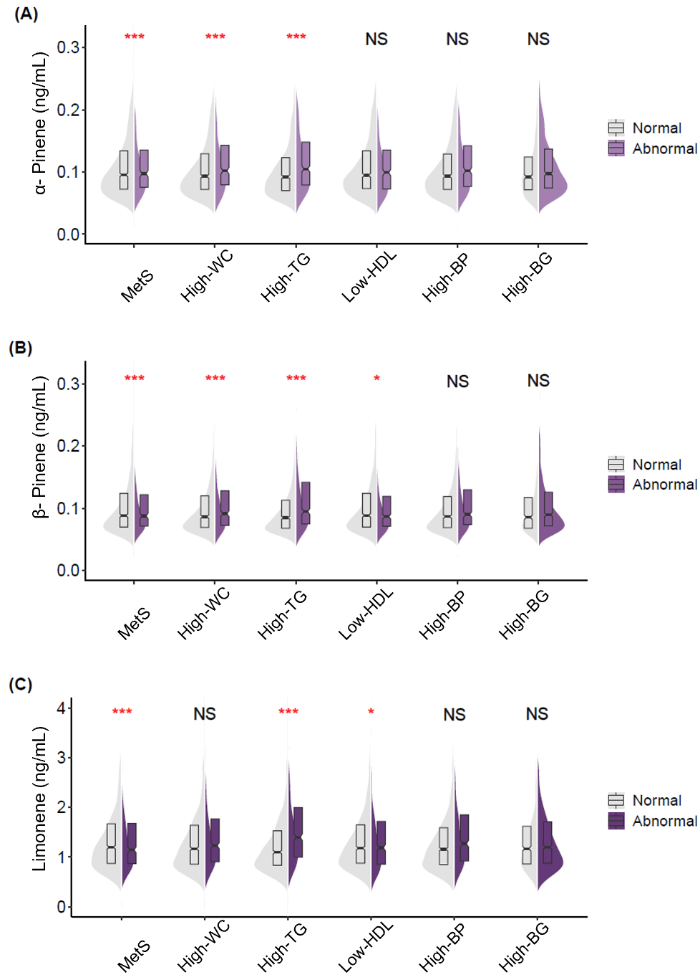
Fig. S1. Comparison of terpenes based on MetS and its components groups.
Abbreviation: MetS, metabolic syndrome; High-TG, triglycerides met MetS diagnostic standard; Low-HDL, low HDL-C met MetS diagnostic standard; High-WC, high waist circumference met MetS diagnostic standard; High-BP, high blood pressure met MetS diagnostic standard; High-BG, high fasting blood glucose met MetS diagnostic standard.
The horizontal axis divides continuous variables into two groups according to MetS diagnostic criteria, and the vertical axis is terpene serum concentration, including (A) α-pinene, (B) β-pinene and (C) limonene. Participants with LLOD were excluded before analysis. The grey shaded area represents the distribution of the normal group, while the different purple shaded area represents the distribution of the abnormal group. Each half of the violin plot contains a boxplot of the data. The short horizontal line in the middle represents the median, and the rectangles represent the interquartile range. The Kruskal-Wallis test was used to compare differences between groups. NS indicates no significance.
*P < 0.05, **P < 0.01, ***P < 0.001

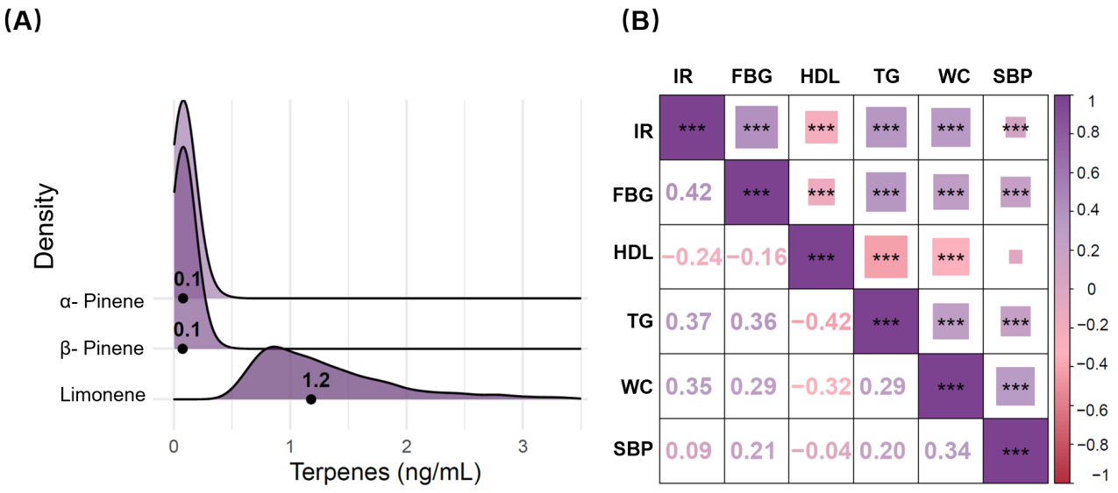
Fig. S2. Terpenes distribution ridge map and Spearman correlation matrix for various diagnostic components of MetS.
Abbreviation: IR, insulin resistance; FBG, fasting blood glucose; HDL, high-density lipoprotein cholesterol; TG, triglycerides; SBP, systolic blood pressure.
(A) The ridge map about distributions of terpenes. (B) Spearman correlation coefficients are shown on the bottom left. The rectangles on the top right indicate the degree of the correlation, with larger rectangle indicating stronger correlations. Purple indicates positive correlation while red indicates negative correlation. All correlations between various diagnostic components of MetS were statistically significant except for HDL and SBP.
*P < 0.05, **P < 0.01, ***P < 0.001

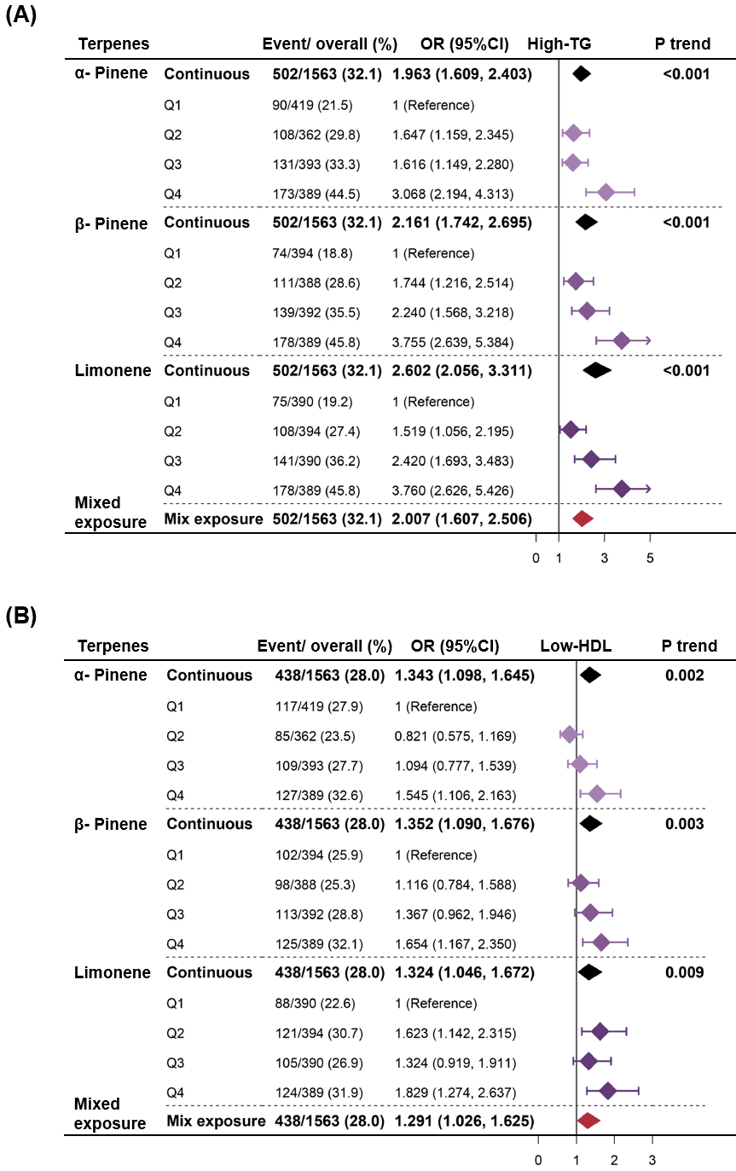
Fig. S3. Association of terpenes exposure with MetS components.

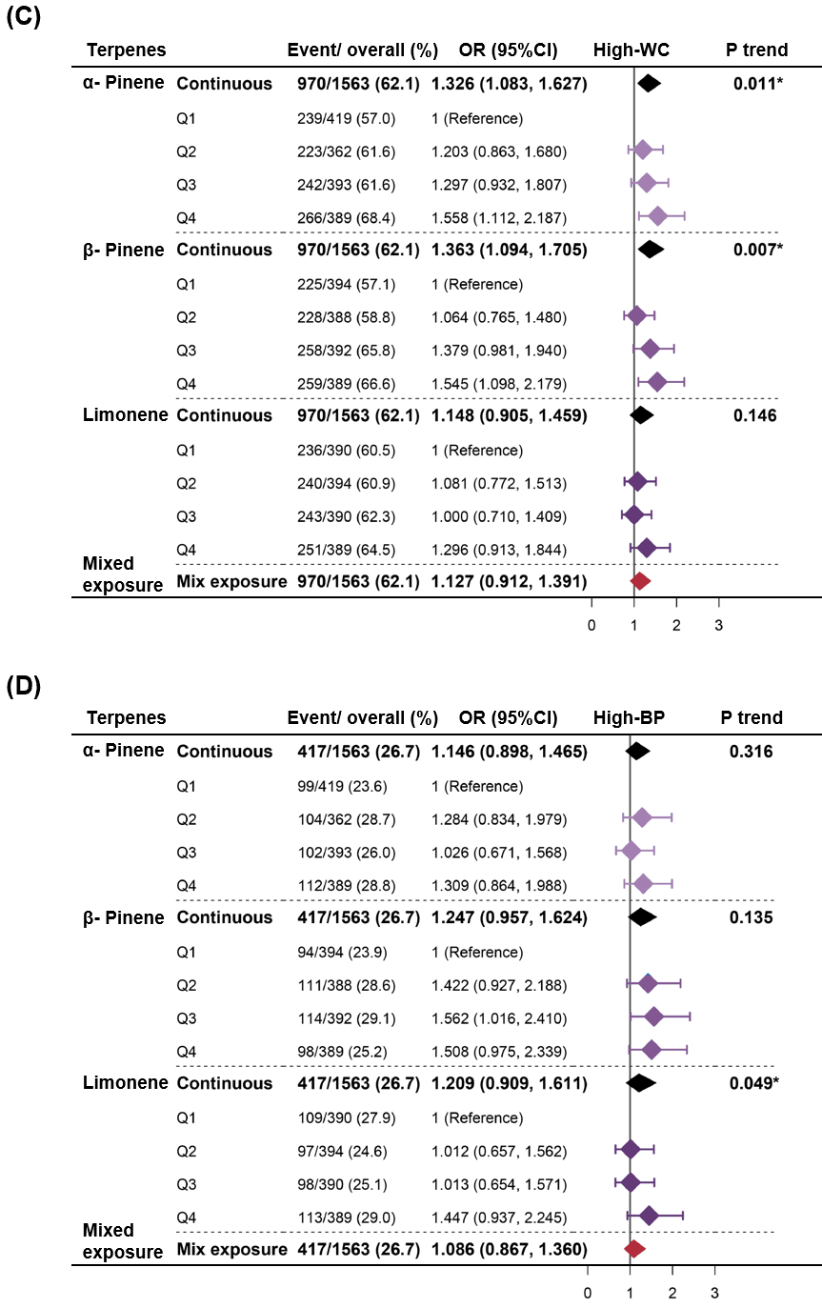

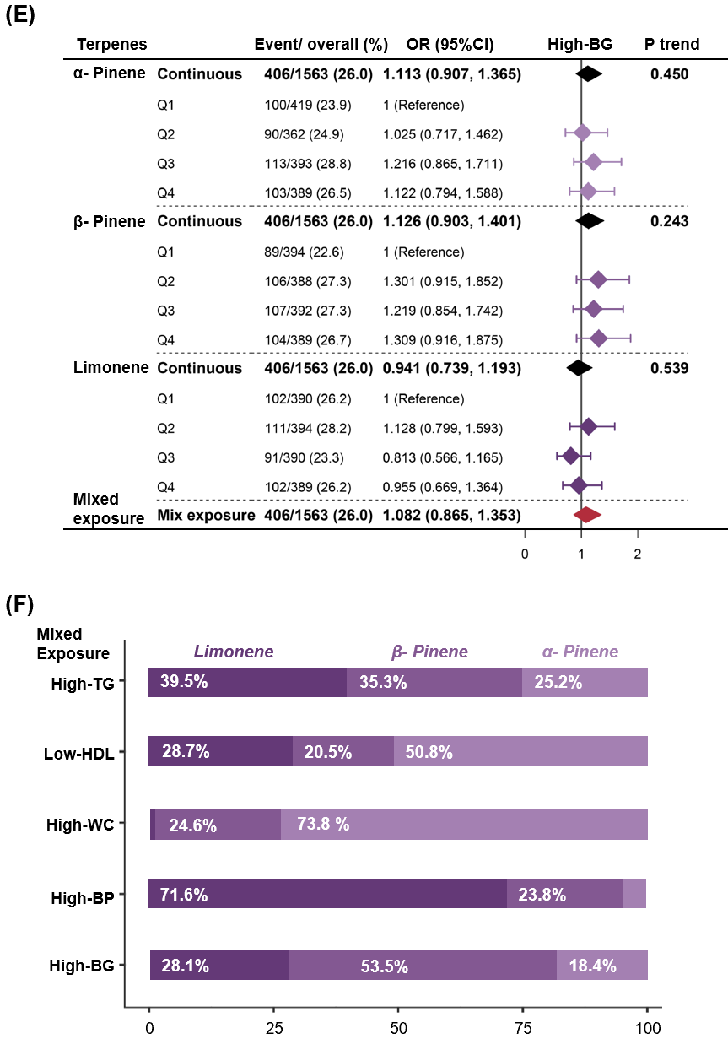
Abbreviation: MetS, metabolic syndrome; High-TG, triglycerides met MetS diagnostic standard; Low-HDL, low HDL-C met MetS diagnostic standard; High-WC, high waist circumference met MetS diagnostic standard; High-BP, high blood pressure met MetS diagnostic standard; High-BG, high fasting blood glucose met MetS diagnostic standard; OR, odds ratio; CI, confidence interval; Q: quartile.
(A-E) Forest plot of terpenes and MetS components, High-TG, Low-HDL, High-WC, High-BP and High-BG, with OR (95% CI) of terpene exposure (single and mixed) included. (F) Weights of each terpene in association with mixtures and MetS components analyzed by weighted quantile sum (WQS) models. Single terpene exposure was estimated by multivariate logistic regression models and mixed terpene exposure was estimated by WQS models.
Models were adjusted for covariates, including age (years, continuous), sex (female, male), race/ethnicity (non-Hispanic white, non-Hispanic black, other Hispanic, Mexican American, others), body mass index (BMI, kg/m², continuous), educational attainment (below high school, high school, or college or above), family poverty income ratio (PIR, continuous), serum cotinine (ng/mL, continuous), alcohol consumption (never drink before, none in the past year, less than 1 drink/ month, 1 to 3 drink per month, 1 to 3 drink per week, more than 4 drink per week), leisure-time physical activity (PA, no or unable, moderate, or vigorous), dietary fat intake (g/day, continuous), and low-density lipoprotein cholesterol (LDL-C, mmol/L, continuous). * P < 0.05.

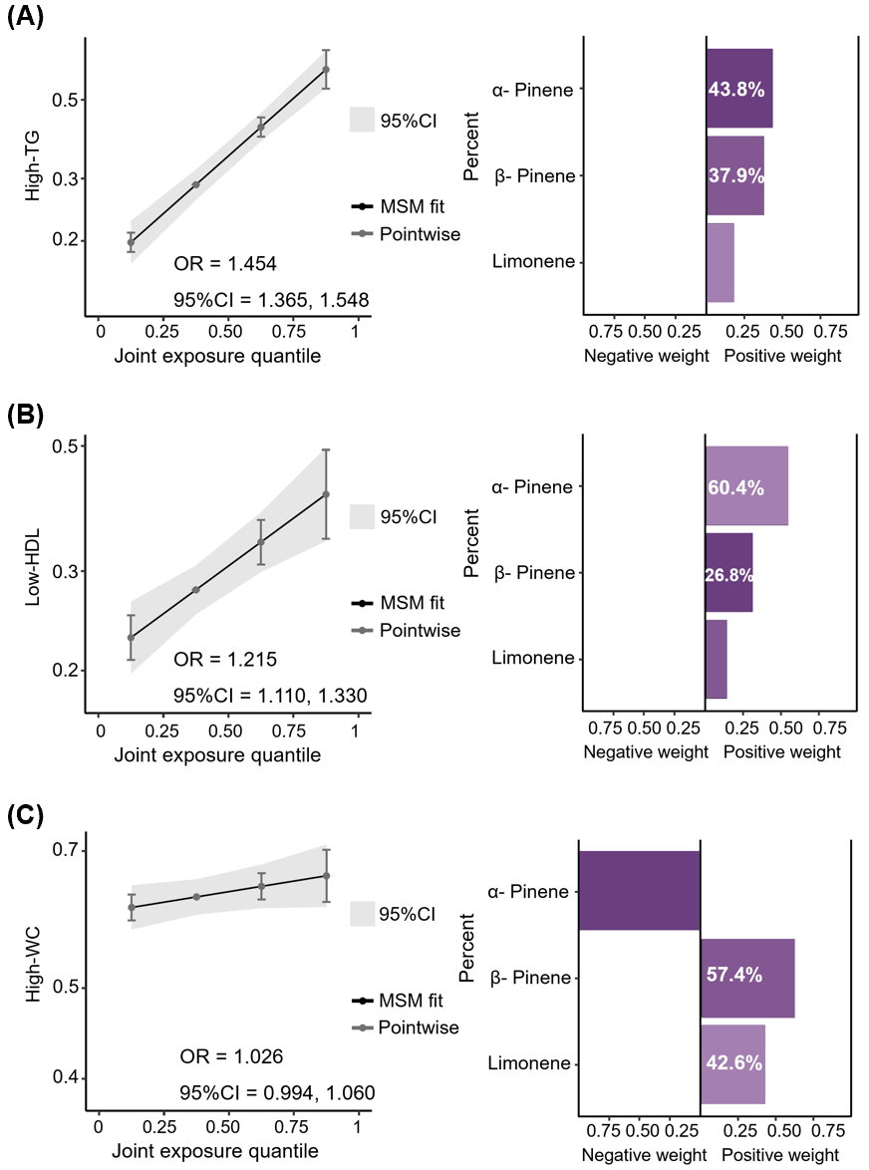
Fig. S4. Association between terpenes and MetS components estimated by Qgcmop.
Abbreviation: Qgcomp, quantile g-computation; MSM, marginal structural model; α- pinene; β-pinene, β- pinene; limonene, limonene; MetS, metabolic syndrome; High-TG, triglycerides met MetS diagnostic standard; Low-HDL, low HDL-C met MetS diagnostic standard; High-WC, high waist circumference met MetS diagnostic standard.
(A) Qgcomp analysis of terpenes and High-TG. (B) Qgcomp analysis of terpenes and Low-HDL. (C) Qgcomp analysis of terpenes and High-WC. Estimated the linearity of the total exposure effect of terpenes and weights corresponding to the proportion of the positive or negative partial effect of each terpene in the Qgcomp analysis.
Models were adjusted for covariates, including age, sex, race/ethnicity, BMI, educational attainment, PIR, serum cotinine, alcohol consumption, leisure-time PA, dietary fat intake, and LDL-C.

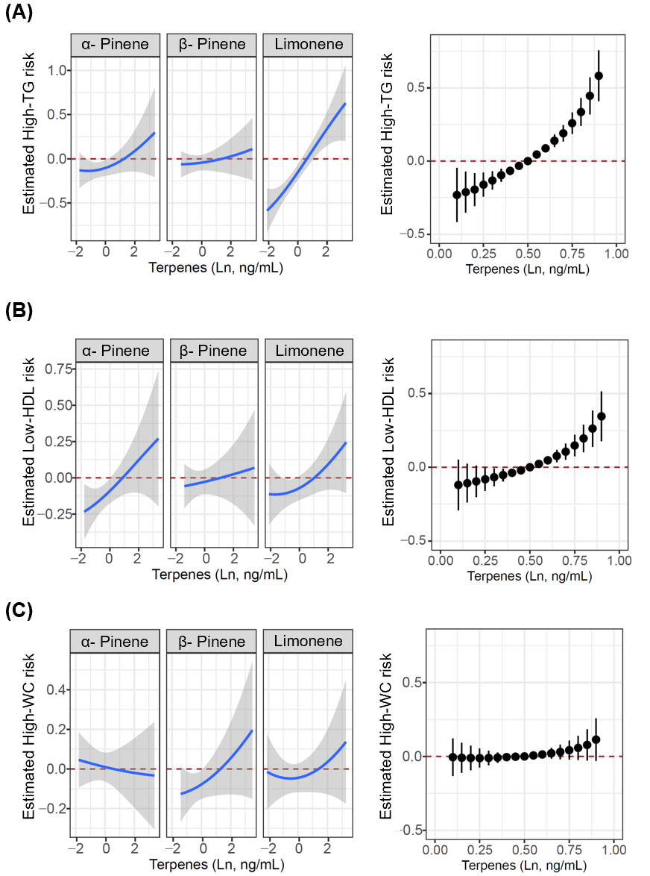
Fig. S5. Association of terpenes with MetS and components estimated by BKMR.
Abbreviation: BKMR, Bayesian Kernel machine regression; MetS, metabolic syndrome; High-TG, triglycerides met MetS diagnostic standard; Low-HDL, low HDL-C met MetS diagnostic standard; High-WC, high waist circumference met MetS diagnostic standard.
(A) BKMR analysis of terpenes and High-TG. (B) BKMR analysis of terpenes and Low-HDL. (C) BKMR analysis of terpenes and High-WC. Univariate exposure–response functions of each terpene and joint effect of mixed terpenes and MetS components were calculated by the BKMR models, which adjusted for covariates, including age, sex, race/ethnicity, BMI, educational attainment, PIR, serum cotinine, alcohol consumption, leisure-time PA, dietary fat intake, and LDL-C.

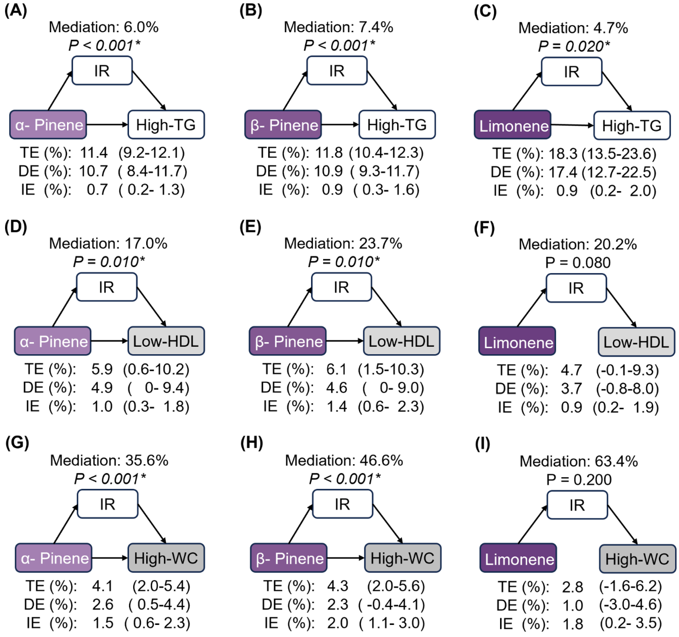
Fig. S6. Mediation of HOMA-IR between terpenes exposure and MetS components.
Abbreviation: MetS, metabolic syndrome; High-TG, triglycerides met MetS diagnostic standard; Low-HDL, low HDL-C met MetS diagnostic standard; High-WC, high waist circumference met MetS diagnostic standard; IR, insulin resistance; TE, total effect; DE, direct effect; IE, indirect effect.
The mediating effects of HOMA-IR (IR indicator) were assessed between terpenes and (A-C) High-TG, (D-F) Low-HDL and (G-I) High-WC. Models were adjusted for covariates, including age, sex, race/ethnicity, BMI, educational attainment, PIR, serum cotinine, alcohol consumption, leisure-time PA, dietary fat intake, and LDL-C. Statistically significant paths (P < 0.05*) are shown as solid lines with arrows. The proportion of mediating effects is also presented.
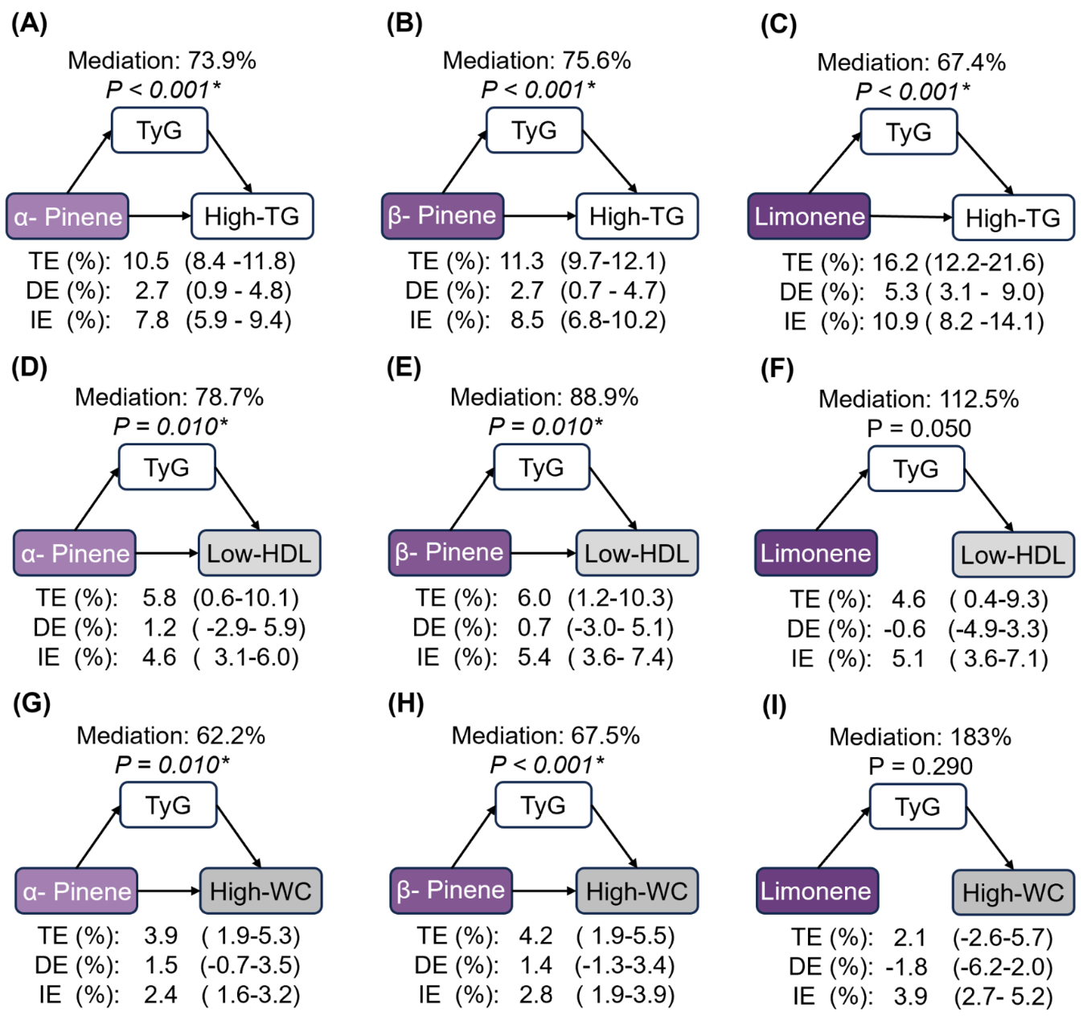
Fig. S7. Mediating effects of TyG between terpenes exposure and MetS components.
Abbreviation: High-TG, triglycerides met MetS diagnostic standard; Low-HDL, low HDL-C met MetS diagnostic standard; High-WC, high waist circumference met MetS diagnostic standard; TyG, Triglyceride/ Glucose index; TE, total effect; DE, direct effect; IE, indirect effect.
The mediating effects of TyG were assessed between terpenes and (A-C) High-TG, (D-F) Low-HDL and (G-I) High-WC. Models were adjusted for covariates, including age, sex, race/ethnicity, BMI, educational attainment, PIR, serum cotinine, alcohol consumption, leisure-time PA, dietary fat intake, and LDL-C. Statistically significant paths (P < 0.05*) are shown as solid lines with arrows. The proportion of mediating effects is also presented.
Fig. S8. Restricted cubic spline figures of single terpenes exposure, HOMA-IR and MetS.
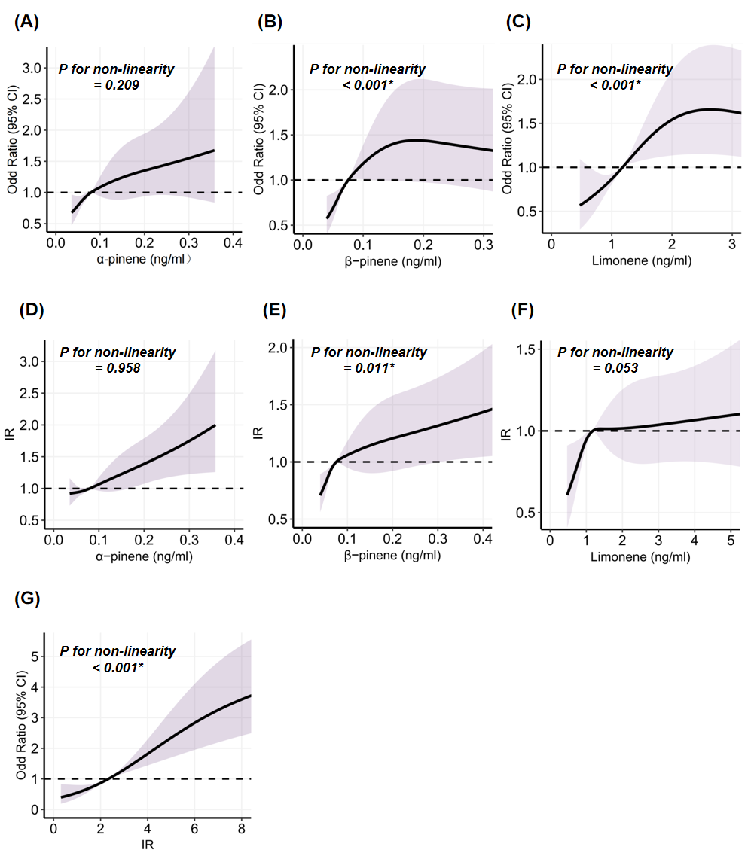
The RCS figure illustrates the relationships among terpenes and metabolic syndrome (MetS), terpenes and HOMA-IR, and HOMA-IR and MetS in detail. The p-value for non-linearity is less than 0.05, indicating the presence of a non-linear relationship. However, all three relationships show an upward trend, suggesting a positive association.

Fig. S9. Directed acyclic graph illustrating identification of potential confounders between terpenes, IR and MetS.
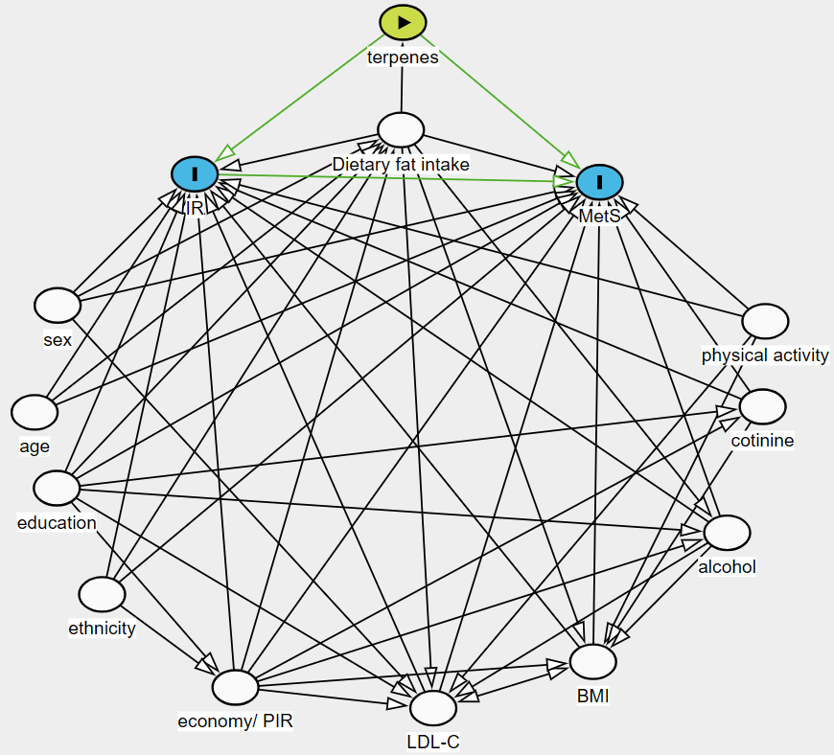
Abbreviation: PIR,poverty income ratio; LDL-C, Low-density lipoprotein cholesterol; BMI, body mass index; MetS, metabolic syndrome;IR, insulin resistance.
Directed acyclic graphs was used to determined adjusting variables.

Table S1. Baseline characteristics of MetS and its components in terpene groups.
 | Overall | Lower | Higher | P value
α-pinene (N) | 1563 | 782 | 781
MetS (%) | 447 (28.6) | 198 (25.3) | 249 (31.9) | 0.005
High-TG (%) | 502 (32.1) | 198 (25.3) | 304 (38.9) | < 0.001
Low-HDL (%) | 438 (28.0) | 203 (26.0) | 235 (30.1) | 0.078
High-WC (%) | 970 (62.1) | 463 (59.2) | 507 (64.9) | 0.023
High-BP (%) | 417 (26.7) | 203 (26.0) | 214 (27.4) | 0.557
High-BG (%) | 406 (26.0) | 190 (24.3) | 216 (27.7) | 0.145
TG, mmol/L | 0.94 [0.56, 1.47] | 0.84 [0.51, 1.26] | 1.07 [0.64, 1.66] | < 0.001
HDL-C, mmol/L | 1.36 (0.39) | 1.38 (0.38) | 1.34 (0.39) | 0.084
Waist, cm | 95.30 (17.39) | 94.18 (17.09) | 96.42 (17.63) | 0.011
SBP, mmHg | 119.49 (17.49) | 118.23 (16.75) | 120.75 (18.13) | 0.004
DBP, mmHg | 67.72 (12.37) | 66.84 (12.15) | 68.61 (12.52) | 0.005
FBG, mmol/L | 5.16 [4.77, 5.72] | 5.11 [4.73, 5.61] | 5.16 [4.77, 5.77] | 0.064
β-pinene (N) | 1563 | 782 | 781
MetS (%) | 447 (28.6) | 189 (24.2) | 258 (33.0) | < 0.001
High-TG (%) | 502 (32.1) | 185 (23.7) | 317 (40.6) | < 0.001
Low-HDL (%) | 438 (28.0) | 200 (25.6) | 238 (30.5) | 0.036
High-WC (%) | 970 (62.1) | 453 (57.9) | 517 (66.2) | 0.001
High-BP (%) | 417 (26.7) | 205 (26.2) | 212 (27.1) | 0.72
High-BG (%) | 406 (26.0) | 195 (24.9) | 211 (27.0) | 0.379
TG, mmol/L | 0.94 [0.56, 1.47] | 0.84 [0.50, 1.25] | 1.08 [0.65, 1.73] | < 0.001
HDL-C, mmol/L | 1.36 (0.39) | 1.37 (0.38) | 1.35 (0.40) | 0.354
Waist, cm | 95.30 (17.39) | 94.11 (17.42) | 96.49 (17.29) | 0.007
SBP, mmHg | 119.49 (17.49) | 118.97 (17.81) | 120.01 (17.17) | 0.241
DBP, mmHg | 67.72 (12.37) | 66.95 (12.29) | 68.50 (12.40) | 0.013
FBG, mmol/L | 5.16 [4.77, 5.72] | 5.11 [4.72, 5.61] | 5.16 [4.77, 5.77] | 0.041
limonene (N) | 1563 | 784 | 779
MetS (%) | 447 (28.6) | 197 (25.1) | 250 (32.1) | 0.003
High-TG (%) | 502 (32.1) | 183 (23.3) | 319 (40.9) | < 0.001
Low-HDL (%) | 438 (28.0) | 209 (26.7) | 229 (29.4) | 0.251
High-WC (%) | 970 (62.1) | 476 (60.7) | 494 (63.4) | 0.295
High-BP (%) | 417 (26.7) | 206 (26.3) | 211 (27.1) | 0.760
High-BG (%) | 406 (26.0) | 213 (27.2) | 193 (24.8) | 0.307
TG, mmol/L | 0.94 [0.56, 1.47] | 0.79 [0.51, 1.25] | 1.07 [0.66, 1.68] | < 0.001
HDL-C, mmol/L | 1.36 (0.39) | 1.38 (0.37) | 1.35 (0.40) | 0.147
Waist, cm | 95.30 (17.39) | 94.60 (17.82) | 96.01 (16.93) | 0.109
SBP, mmHg | 119.49 (17.49) | 118.36 (17.16) | 120.63 (17.76) | 0.010
DBP, mmHg | 67.72 (12.37) | 66.19 (12.39) | 69.26 (12.15) | < 0.001
FBG, mmol/L | 5.16 [4.77, 5.72] | 5.16 [4.77, 5.72] | 5.16 [4.77, 5.66] | 0.890
Abbreviation: N, number; MetS, metabolic syndrome; High-TG, triglycerides met MetS diagnostic standard; Low-HDL, low HDL-C met MetS diagnostic standard; High-WC, high waist circumference met MetS diagnostic standard; High-BP, high blood pressure met MetS diagnostic standard; High-BG, high fasting blood glucose met MetS diagnostic standard; Tg, triglycerides; HDL-C, high-density lipoprotein cholesterol; SBP, systolic blood pressure; DBP, diastolic blood pressure; FBG, fasting blood glucose.
Terpenes were divided into lower and higher groups according to the mean value. The values of lower and higher groups were [0.0354,0.0797) and [0.0797,0.9370] for α-pinene, [0.0396,0.0754) and [0.0754,2.1300] for β-pinene, and [0.115, 1.19) and [1.190,15.50] for limonene.

Table S2. Distribution and lower limit of detection of terpenes.
Terpene | Median | IQR | LLOD | LLOD ratio | Q1 |  | Q2 |  | Q3 |  | Q4
Terpene | (ng/mL) | (ng/mL) | (ng/mL) | (%) | Range | N | Range | N | Range | N | Range | N
α-Pinene | 0.080 | 0.035-0.116 | 0.050 | 26.8 | 0.0354 | 419 | [0.0501, 0.0796) | 362 | [0.0796, 0.117) | 393 | [0.117, 0.937] | 389
β-Pinene | 0.075 | 0.040-0.108 | 0.056 | 25.2 | 0.0396 | 394 | [0.0560, 0.0754) | 388 | [0.0754, 0.109) | 392 | [0.109, 2.130] | 389
Limonene | 1.180 | 0.870-1.670 | 0.162 | 0.1 | [0.115, 0.870) | 390 | [0.8700, 1.1900) | 394 | [1.1900, 1.680) | 390 | [1.680, 15.50] | 389
Abbreviation: LLOD, lower than LOD; IQR, interquartile range; Q, quartile.
The Q1 group was participants with serum terpenes lower than LLOD or lower than 25th of the value of terpenes, and the remaining participants were equally divided into Q2-Q4 groups according to the gradient of terpene concentration. In terms of limonene, since few participants had concentrations lower than LLOD (1 sample), participants were equally divided into Q1-Q4 groups.

Table S3. Association of terpenes with MetS and its components.
Characteristics | OR (95% CI) |  |  |  | P trend† | Continuous  (Log-transformed‡)
Characteristics | Q1 | Q2 | Q3 | Q4 | P trend† | Continuous  (Log-transformed‡)
MetS
α-pinene | 1 (Ref) | 1.511 (1.037, 2.208) | 1.369 (0.944, 1.990) | 2.030 (1.413, 2.930) | < 0.001* | 1.520 (1.228, 1.887)
β-pinene | 1 (Ref) | 1.560 (1.063, 2.296) | 1.802 (1.231, 2.650) | 2.395 (1.639, 3.520) | < 0.001* | 1.595 (1.270, 2.008)
limonene | 1 (Ref) | 1.636 (1.114, 2.411) | 1.462 (0.987, 2.172) | 2.700 (1.834, 4.008) | < 0.001* | 1.642 (1.281, 2.110)
Mix exposure |  |  |  |  |  | 1.454 (1.153, 1.833)
High-TG
α-pinene | 1 (Ref) | 1.647 (1.159, 2.345) | 1.616 (1.149, 2.280) | 3.068 (2.194, 4.313) | < 0.001* | 1.963 (1.609, 2.403)
β-pinene | 1 (Ref) | 1.744 (1.216, 2.514) | 2.240 (1.568, 3.218) | 3.755 (2.639, 5.384) | < 0.001* | 2.161 (1.742, 2.695)
limonene | 1 (Ref) | 1.519 (1.056, 2.195) | 2.420 (1.693, 3.483) | 3.760 (2.626, 5.426) | < 0.001* | 2.602 (2.056, 3.311)
Mix exposure |  |  |  |  |  | 2.007 (1.607, 2.506)
Low-HDL
α-pinene | 1 (Ref) | 0.821 (0.575, 1.169) | 1.094 (0.777, 1.539) | 1.545 (1.106, 2.163) | 0.002* | 1.343 (1.098, 1.645)
β-pinene | 1 (Ref) | 1.116 (0.784, 1.588) | 1.367 (0.962, 1.946) | 1.654 (1.167, 2.350) | 0.003* | 1.352 (1.090, 1.676)
limonene | 1 (Ref) | 1.623 (1.142, 2.315) | 1.324 (0.919, 1.911) | 1.829 (1.274, 2.637) | 0.009* | 1.324 (1.046, 1.672)
Mix exposure |  |  |  |  |  | 1.315 (1.051, 1.646)
High-WC
α-pinene | 1 (Ref) | 1.203 (0.863, 1.680) | 1.297 (0.932, 1.807) | 1.558 (1.112, 2.187) | 0.011* | 1.326 (1.083, 1.627)
β-pinene | 1 (Ref) | 1.064 (0.765, 1.480) | 1.379 (0.981, 1.940) | 1.545 (1.098, 2.179) | 0.007* | 1.363 (1.094, 1.705)
limonene | 1 (Ref) | 1.081 (0.772, 1.513) | 1.000 (0.710, 1.409) | 1.296 (0.913, 1.844) | 0.146 | 1.148 (0.905, 1.459)
Mix exposure |  |  |  |  |  | 1.127 (0.912, 1.391)
High-BP
α-pinene | 1 (Ref) | 1.284 (0.834, 1.979) | 1.026 (0.671, 1.568) | 1.309 (0.864, 1.988) | 0.316 | 1.146 (0.898, 1.465)
β-pinene | 1 (Ref) | 1.422 (0.927, 2.188) | 1.562 (1.016, 2.410) | 1.508 (0.975, 2.339) | 0.127 | 1.247 (0.957, 1.624)
limonene | 1 (Ref) | 1.012 (0.657, 1.562) | 1.013 (0.654, 1.571) | 1.447 (0.937, 2.245) | 0.054 | 1.209 (0.909, 1.611)
Mix exposure |  |  |  |  |  | 1.086 (0.867, 1.360)
High-BG
α-pinene | 1 (Ref) | 1.025 (0.717, 1.462) | 1.216 (0.865, 1.711) | 1.122 (0.794, 1.588) | 0.450 | 1.113 (0.907, 1.365)
β-pinene | 1 (Ref) | 1.301 (0.915, 1.852) | 1.219 (0.854, 1.742) | 1.309 (0.916, 1.875) | 0.243 | 1.126 (0.903, 1.401)
limonene | 1 (Ref) | 1.128 (0.799, 1.593) | 0.813 (0.566, 1.165) | 0.955 (0.669, 1.364) | 0.539 | 0.941 (0.739, 1.193)
Mix exposure |  |  |  |  |  | 1.082 (0.865, 1.353)
Abbreviation: MetS, metabolic syndrome; High-TG, triglycerides met MetS diagnostic standard; Low-HDL, low HDL-C met MetS diagnostic standard; High-WC, high waist circumference met MetS diagnostic standard; High-BP, high blood pressure met MetS diagnostic standard; High-BG, high fasting blood glucose met MetS diagnostic standard; Q: quartile, OR, odds ratio; CI, confidence interval.
The association between terpenes (single and mixed) and MetS and its components were assessed by multivariate logistic regression models while mixed terpene exposure was estimated by WQS models. Models were adjusted for covariates, including age, sex, race/ethnicity, BMI, educational attainment, PIR, serum cotinine, alcohol consumption, leisure-time PA, dietary fat intake, and LDL-C. The continuous terpenes were naturally logarithmical transformed. Refer to Table S2 for the quartile cut point settings of terpenes.
† The trend test for coefficients across four categories was conducted by using the median of terpenes for each category as a numeric variable.
‡ The natural log-transformed terpenes were used as a continuous variable to achieve a normal distribution of the independent variable.
* P < 0.05

Table S4. Posterior inclusion probability of terpenes in BKMR models.
Characteristics | Terpenes | conPIPs
MetS
 | α-Pinene | 0.036
 | β-Pinene | 0.028
 | Limonene | 0.987
High-TG
 | α-Pinene | 0.528
 | β-Pinene | 0.117
 | Limonene | 1.000
Low-HDL
 | α-Pinene | 0.679
 | β-Pinene | 0.315
 | Limonene | 0.246
High-WC
 | α-Pinene | 0.329
 | β-Pinene | 0.831
 | Limonene | 0.455
Abbreviation: BKMR, Bayesian Kernel machine regression; conPIPs, Conditional posterior inclusion probabilities; MetS, metabolic syndrome; High-TG, triglycerides met MetS diagnostic standard; Low-HDL, low HDL-C met MetS diagnostic standard; High-WC, high waist circumference met MetS diagnostic standard.

Table S5. Association between terpenes and TyG*10.
Terpenes | β (95% CI) |  |  |  | P trend† | Continuous  (Log-transformed‡)
Terpenes | Q1 | Q2 | Q3 | Q4 | P trend† | Continuous  (Log-transformed‡)
α-pinene | 1 (Ref) | 0.405(-0.486, 1.297) | 1.359 (0.479, 2.238) | 2.854 (1.968, 3.740) | < 0.001 | 1.917 (1.390, 2.445)
β-pinene | 1 (Ref) | 1.568 (0.685, 2.451) | 2.322 (1.430, 3.215) | 3.687 (2.786, 4.588) | < 0.001 | 2.232 (1.664, 2.801)
limonene | 1 (Ref) | 0.919 (0.031, 1.807) | 2.159 (1.259, 3.060) | 3.495 (2.579, 4.410) | < 0.001 | 2.505 (1.893, 3.117)
Mix exposure |  |  |  |  |  | 1.882 (1.301, 2.464)
Abbreviation: TyG, Triglyceride/ Glucose index, TyG was multiplied by 10 here; Q, quartile; β, the coefficient of liner regression; CI, confidence interval.
The association between terpenes and TyG*10 was assessed by multivariate liner regression models while mixed terpene exposure was estimated by WQS models. Models were adjusted for covariates, including age, sex, race/ethnicity, BMI, educational attainment, PIR, serum cotinine, alcohol consumption, leisure-time PA, dietary fat intake, and LDL-C.
† The trend test for coefficients across four categories was conducted by using the median of terpenes for each category as a numeric variable.
‡ The natural log-transformed terpenes were used as a continuous variable to achieve a normal distribution of the independent variable.
Table S6. Association of TyG*10 and MetS and its components.
Characteristics | OR (95% CI) |  |  |  | P trend† | Continuous  (TyG*10‡)
Characteristics | Q1 | Q2 | Q3 | Q4 | P trend† | Continuous  (TyG*10‡)
MetS | 1 (Ref) | 2.081 (1.154, 3.873) | 7.888 (4.541, 14.328) | 33.485 (18.985, 61.925) | < 0.001 | 1.249 (1.212, 1.289)
High-TG | 1 (Ref) | 7.125 (2.735, 24.389) | 40.000 (16.218, 133.150) | 702.529 (271.904, 2410.306) | < 0.001 | 1.593 (1.514, 1.683)
Low-HDL | 1 (Ref) | 1.559 (1.030, 2.364) | 3.417 (2.276, 5.176) | 8.880 (5.793, 13.794) | < 0.001 | 1.141 (1.116, 1.168)
High-WC | 1 (Ref) | 2.333 (1.662, 3.287) | 3.071 (2.144, 4.422) | 5.441 (3.688, 8.096) | < 0.001 | 1.093 (1.071, 1.116)
High-BP | 1 (Ref) | 0.803 (0.482, 1.339) | 1.552 (0.937, 2.589) | 2.397 (1.446, 4.012) | < 0.001 | 1.051 (1.028, 1.075)
High-BG | 1 (Ref) | 1.286 (0.844, 1.972) | 2.230 (1.476, 3.403) | 3.538 (2.334, 5.426) | < 0.001 | 1.076 (1.055, 1.097)
Abbreviation: MetS, metabolic syndrome; High-TG, triglycerides met MetS diagnostic standard; Low-HDL, low HDL-C met MetS diagnostic standard; High-WC, high waist circumference met MetS diagnostic standard; High-BP, high blood pressure met MetS diagnostic standard; High-BG, high fasting blood glucose met MetS diagnostic standard; TyG, Triglyceride/ Glucose index, TyG was multiplied by 10 here; Q, quartile; OR, odds ratio; CI, confidence interval.
The association between TyG*10 and MetS and its components was assessed by multivariate logistic regression models. Models were adjusted for covariates, including age, sex, race/ethnicity, BMI, educational attainment, PIR, serum cotinine, alcohol consumption, leisure-time PA, dietary fat intake, and LDL-C. Q, quartile; OR, odds ratio; CI, confidence interval.
† The trend test for coefficients across four TyG*10 categories (Q1, [68.5, 79.3); Q2, [79.3, 84.0); Q3, [84.0, 88.8), Q4, [88.8,120.3]) was conducted by using the median TyG*10 for each category as a numeric variable.
‡ TyG was multiplied by 10 as a continuous unit to achieve a normal distribution of the independent variable and makes the coefficient value more readable.
Table S7. Association between terpenes and MetS after considering working hours and current work industry.
Terpenes | OR (95% CI) |  |  |  | P trend† | Continuous  (Log-transformed‡)
Terpenes | Q1 | Q2 | Q3 | Q4 | P trend† | Continuous  (Log-transformed‡)
α-pinene | 1 (Ref) | 1.494 (1.020, 2.195) | 1.382 (0.947, 2.022) | 2.085 (1.439, 3.037) | < 0.001 | 1.577 (1.266, 1.969)
β-pinene | 1 (Ref) | 1.528 (1.035, 2.263) | 1.760 (1.194, 2.604) | 2.460 (1.666, 3.655) | < 0.001 | 1.659 (1.310, 2.104)
limonene | 1 (Ref) | 1.567 (1.060, 2.328) | 1.450 (0.972, 2.170) | 2.733 (1.841, 4.089) | < 0.001 | 1.708 (1.322, 2.212)
Mix exposure |  |  |  |  |  | 1.530 (1.199, 1.952)
Abbreviation: MetS, metabolic syndrome; Q, quartile; OR, odds ratio; CI, confidence interval.
The association between Terpenes (single and mixed) and MetS was assessed by multivariate logistic regression models and WQS models. In particular, models were further adjusted for work ≥35 hours per week (no or yes), current industry (22 levels, refer to Table S13). The remaining adjusted covariates included age, sex, race/ethnicity, BMI, educational attainment, PIR, serum cotinine, alcohol consumption, leisure-time PA, dietary fat intake and LDL-C.
† The trend test for coefficients across four categories was conducted by using the median of terpenes for each category as a numeric variable.
‡ The natural log-transformed terpenes were used as a continuous variable to achieve a normal distribution of the independent variable.
Table S8. Association between terpenes and MetS after considering FBG and blood pressure.
Terpenes | OR (95% CI) |  |  |  | P trend† | Continuous  (Log-transformed‡)
Terpenes | Q1 | Q2 | Q3 | Q4 | P trend† | Continuous  (Log-transformed‡)
α-pinene | 1 (Ref) | 1.513 (1.025, 2.239) | 1.320 (0.896, 1.948) | 1.894 (1.295, 2.782) | 0.003 | 1.433 (1.144, 1.798)
β-pinene | 1 (Ref) | 1.379 (0.925, 2.060) | 1.678 (1.134, 2.495) | 2.108 (1.423, 3.142) | < 0.001 | 1.498 (1.180, 1.903)
limonene | 1 (Ref) | 1.528 (1.026, 2.285) | 1.405 (0.935, 2.119) | 2.508 (1.677, 3.780) | < 0.001 | 1.602 (1.232, 2.085)
Mix exposure |  |  |  |  |  | 1.420 (1.110, 1.830)
Abbreviation: MetS, metabolic syndrome; FBG, fasting blood glucose; Q, quartile; OR, odds ratio; CI, confidence interval.
The association between terpenes (single and mixed) and MetS was assessed by multivariate logistic regression models and WQS models. In particular, models were further adjusted for FBG and blood pressure . The remaining adjusted covariates included age, sex, race/ethnicity, BMI, educational attainment, PIR, serum cotinine, alcohol consumption, leisure-time PA, dietary fat intake and LDL-C.
† The trend test for coefficients across four categories was conducted by using the median of terpenes for each category as a numeric variable.
‡ The natural log-transformed terpenes were used as a continuous variable to achieve a normal distribution of the independent variable.

Table S9. Association between terpenes and MetS after considering family history of diseases.
Terpenes | OR (95% CI) |  |  |  | P trend† | Continuous  (Log-transformed‡)
Terpenes | Q1 | Q2 | Q3 | Q4 | P trend† | Continuous  (Log-transformed‡)
α-pinene | 1 (Ref) | 1.475 (0.997, 2.185) | 1.311 (0.888, 1.937) | 1.867 (1.275, 2.744) | < 0.001 | 1.417 (1.131, 1.780)
β-pinene | 1 (Ref) | 1.384 (0.926, 2.073) | 1.676 (1.131, 2.495) | 2.090 (1.408, 3.120) | < 0.001 | 1.495 (1.176, 1.902)
limonene | 1 (Ref) | 1.544 (1.034, 2.313) | 1.423 (0.944, 2.152) | 2.595 (1.729, 3.928) | < 0.001 | 1.611 (1.238, 2.101)
Mix exposure |  |  |  |  |  | 1.350 (1.060, 1.720)
Abbreviation: MetS, metabolic syndrome; Q, quartile; OR, odds ratio; CI, confidence interval.
The association between terpenes (single and mixed) and MetS was assessed by multivariate logistic regression models and WQS models. In particular, models were further adjusted for family history of hypertension, CVD and DM. The remaining adjusted covariates included age, sex, race/ethnicity, BMI, educational attainment, PIR, serum cotinine, alcohol consumption, leisure-time PA, dietary fat intake and LDL-C.
† The trend test for coefficients across four categories was conducted by using the median of terpenes for each category as a numeric variable.
‡ The natural log-transformed terpenes were used as a continuous variable to achieve a normal distribution of the independent variable.

Table S10. Association between terpenes and MetS in participants without DM.
Terpenes | OR (95% CI) |  |  |  | P trend† | Continuous  (Log-transformed‡)
Terpenes | Q1 | Q2 | Q3 | Q4 | P trend† | Continuous  (Log-transformed‡)
α-pinene | 1 (Ref) | 1.706 (1.077, 2.716) | 1.644 (1.031, 2.635) | 2.187 (1.394, 3.460) | 0.002 | 1.530 (1.177, 1.995)
β-pinene | 1 (Ref) | 1.642 (1.015, 2.669) | 1.893 (1.188, 3.041) | 2.376 (1.498, 3.810) | < 0.001 | 1.586 (1.207, 2.086)
limonene | 1 (Ref) | 1.840 (1.113, 3.077) | 1.988 (1.203, 3.329) | 3.666 (2.234, 6.134) | < 0.001 | 1.961 (1.455, 2.651)
Mix exposure |  |  |  |  |  | 1.454 (1.153, 1.833)
Abbreviation: MetS, metabolic syndrome; DM, diabetes mellitus; Q, quartile; OR, odds ratio; CI, confidence interval.
The association between terpenes (single and mixed) and MetS was assessed by multivariate logistic regression models and WQS models in participants without DM (N = 1281). Models were adjusted for covariates, including age, sex, race/ethnicity, BMI, educational attainment, PIR, serum cotinine, alcohol consumption, leisure-time PA, dietary fat intake and LDL-C.
† The trend test for coefficients across four categories was conducted by using the median of terpenes for each category as a numeric variable.
‡ The natural log-transformed terpenes were used as a continuous variable to achieve a normal distribution of the independent variable.

Table S11. Association between terpenes and MetS considering drug use.
Terpenes | OR (95% CI) |  |  |  | P trend† | Continuous  (Log-transformed‡)
Terpenes | Q1 | Q2 | Q3 | Q4 | P trend† | Continuous  (Log-transformed‡)
α-pinene | 1 (Ref) | 1.628 (1.082, 2.457) | 1.450 (0.968, 2.180) | 1.945 (1.306, 2.911) | 0.004 | 1.466 (1.161, 1.854)
β-pinene | 1 (Ref) | 1.456 (0.957, 2.224) | 1.875 (1.241, 2.849) | 2.190 (1.450, 3.331) | < 0.001 | 1.563 (1.224, 1.997)
limonene | 1 (Ref) | 1.833 (1.202, 2.815) | 1.606 (1.045, 2.480) | 2.915 (1.912, 4.488) | < 0.001 | 1.651 (1.263, 2.163)
Mix exposure |  |  |  |  |  | 1.436 (1.146, 14.268)
Abbreviation: MetS, metabolic syndrome; DM, diabetes mellitus; Q, quartile; OR, odds ratio; CI, confidence interval.
The association between terpenes (single and mixed) and MetS was assessed by multivariate logistic regression models and WQS models. In particular, models were further adjusted for use of diabetes drugs, hypertriglyceridemia drugs and antihypertensive drugs. The remaining adjusted covariates included age, sex, race/ethnicity, BMI, educational attainment, PIR, serum cotinine, alcohol consumption, leisure-time PA, dietary fat intake and LDL-C.
† The trend test for coefficients across four categories was conducted by using the median of terpenes for each category as a numeric variable.
‡ The natural log-transformed terpenes were used as a continuous variable to achieve a normal distribution of the independent variable.
Table S12. Association between terpenes and MetS in participants without drug use.
Terpenes | OR (95% CI) |  |  |  | P trend† | Continuous  (Log-transformed‡)
Terpenes | Q1 | Q2 | Q3 | Q4 | P trend† | Continuous  (Log-transformed‡)
α-pinene | 1 (Ref) | 1.628 (1.082, 2.457) | 1.450 (0.968, 2.180) | 1.945 (1.306, 2.911) | 0.052 | 1.429 (1.006, 2.039)
β-pinene | 1 (Ref) | 1.456 (0.957, 2.224) | 1.875 (1.241, 2.849) | 2.190 (1.450, 3.331) | 0.008 | 1.584 (1.123, 2.240)
limonene | 1 (Ref) | 1.833 (1.202, 2.815) | 1.606 (1.045, 2.480) | 2.915 (1.912, 4.488) | < 0.001 | 1.973 (1.305, 2.977)
Mix exposure |  |  |  |  |  | 2.021 (1.427, 2.864)
Abbreviation: MetS, metabolic syndrome; DM, diabetes mellitus; Q, quartile; OR, odds ratio; CI, confidence interval.
The association between terpenes (single and mixed) and MetS was assessed by multivariate logistic regression models and WQS models in participants without drug use (diabetes drugs, hypertriglyceridemia drugs and antihypertensive drugs) (N = 845). Models were adjusted for covariates, including age, sex, race/ethnicity, BMI, educational attainment, PIR, serum cotinine, alcohol consumption, leisure-time PA, dietary fat intake and LDL-C.
† The trend test for coefficients across four categories was conducted by using the median of terpenes for each category as a numeric variable.
‡ The natural log-transformed terpenes were used as a continuous variable to achieve a normal distribution of the independent variable.

Table S13. 2010 US Census Bureau industry source codes.
Groups | Industry Group Title | 2010 Census Bureau Industry Classification Source Codes | Number
1 | Agriculture, Forestry, Fishing | 0170-0290 | 9
2 | Mining | 0370-0490 | 5
3 | Utilities | 0570-0690 | 7
4 | Construction | 0770 | 54
5 | Manufacturing: Durable Goods | 2470-3990 | 0
6 | Manufacturing: Non-Durable Goods | 1070-2390 | 38
7 | Wholesale Trade | 4070-4590 | 24
8 | Retail Trade | 4670-5790 | 93
9 | Transportation, Warehousing | 6070-6390 | 30
10 | Information Services | 6470-6780 | 0
11 | Finance, Insurance | 6870-6990 | 33
12 | Real Estate, Rental, Leasing | 7070-7190 | 13
13 | Professional, Scientific, Technical Services | 7270-7490 | 0
14 | Management, Administrative, Waste Services | 7570-7790 | 0
15 | Educational Services | 7860-7890 | 0
16 | Health Care, Social Assistance | 7970-8470 | 129
17 | Arts, Entertainment, Recreation | 8560-8590 | 24
18 | Accommodation, Food Services | 8660-8690 | 68
19 | Other Services | 8770-9190 | 31
20 | Private Household | 9290 | 0
21 | Public Administration | 9370-9590 | 27
22 | Armed Forces | 9670-9870 | 2

