Appendix Table 1
a. The minimum number for each quota in the first survey
Demographics | North | Northeast | East | Central | South | Southwest | Northwest
Age
18-29 | 23 | 15 | 57 | 30 | 23 | 28 | 13
30-39 | 23 | 16 | 59 | 31 | 23 | 29 | 14
40-49 | 24 | 16 | 59 | 32 | 24 | 30 | 14
50-59 | 23 | 15 | 57 | 31 | 23 | 29 | 13
≥60 | 27 | 18 | 68 | 36 | 27 | 34 | 16
Gender
Male | 61 | 41 | 153 | 82 | 61 | 77 | 36
Female | 59 | 39 | 147 | 78 | 59 | 73 | 34
Education
Primary or lower | 32 | 22 | 81 | 43 | 32 | 40 | 19
Junior high school | 47 | 31 | 117 | 62 | 47 | 59 | 27
Senior high school | 21 | 14 | 52 | 28 | 21 | 26 | 12
College or higher | 20 | 13 | 50 | 27 | 20 | 25 | 12
Residence
Urban | 73 | 48 | 182 | 97 | 73 | 91 | 42
Rural | 47 | 32 | 118 | 63 | 47 | 59 | 28
The quota sampling was used in this study, which five quotas, i.e., gender, age, education, urban/rural of residence, and region of residence, were pre-defined on the basis of their distribution in the Chinese general population. Statistics data of the Chinese general population were extracted from the China Statistical Yearbook (2020). When the statistical scale of the original data was not calculated as the general population aged ≥ 18 years, the data were adjusted based on the proportion of the population of each age to the total population in this study. N/A indicates that data was not included in the public available data source.

b The minimum number for each quota in the retest survey
Demographics | The minimum number
Age | 50 respondents each for 18-29, 30-39, 40-49, 50-59 and ≥60.
Gender | 50 respondents each for males and females.
Education | 50 respondents each for primary or lower, junior high school, senior high school and college or higher.
Urban/rural of residence | 50 respondents each for urban and rural.
Region of residence | 30 respondents each for Northeast and Northwest.  40 respondents each for North and South.  50 respondents each for Central and Southwest.  80 respondents for East.

Appendix Table 2 Hypothesized conceptual correlations between the CHROME-G, EQ-5D-5L and SF-6Dv2
CHROME-G | EQ-5D-5L |  |  |  |  | SF-6Dv2
CHROME-G | Mobility | Self-care | Usual activities | Pain/dis-comfort | Anxiety/  depression | Physical functioning | Role limitation | Social functioning | Pain | Mental health | Vitality
Pain |  |  |  | + |  |  |  |  | +
Fatigue |  |  |  |  |  |  |  |  |  |  | +
Appetite | - | - | - | - | - | - | - | - | - | - | -
Vision | - | - | - | - | - | - | - | - | - | - | -
Hearing | - | - | - | - | - | - | - | - | - | - | -
Sleeping | - | - | - | - | - | - | - | - | - | - | -
Mobility | +
Daily activities |  |  | +
Mood |  |  |  |  | + |  |  |  |  | +
Worry |  |  |  |  | + |  |  |  |  | +
Memory | - | - | - | - | - | - | - | - | - | - | -
Social interaction |  |  |  |  |  |  |  | +
“+” indicates that the two items are conceptually similar and “-” indicates that the two items are conceptually different.
Appendix Table 3 Number of sample screened
 | Invited | Refused | Mid-round opt-outª | Quota exclusion^{b} | Quality exclusion^{c} | Included
First survey | 3078 | 211 | 108 | 1717 | 42 | 1000
Retest survey | 594 | 15 | 26 | 164 | 11 | 378
ª “Mid-round opt-out” refers to the respondents who didn’t complete the survey and opted out.
^{b} “Quota exclusion” refers to the respondents who were excluded for noncompliance with the quota.
^{c} “Quality exclusion” refers to the respondents who were excluded for noncompliance with the quality control criteria.

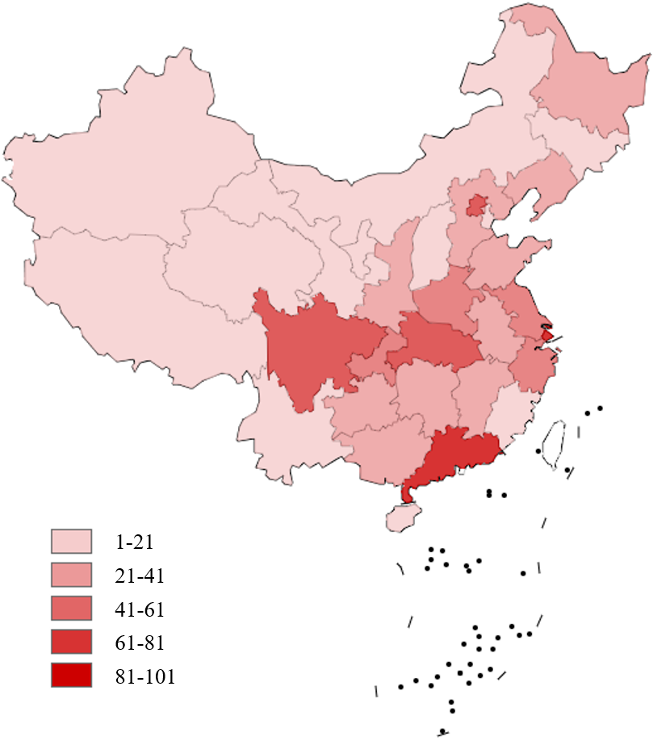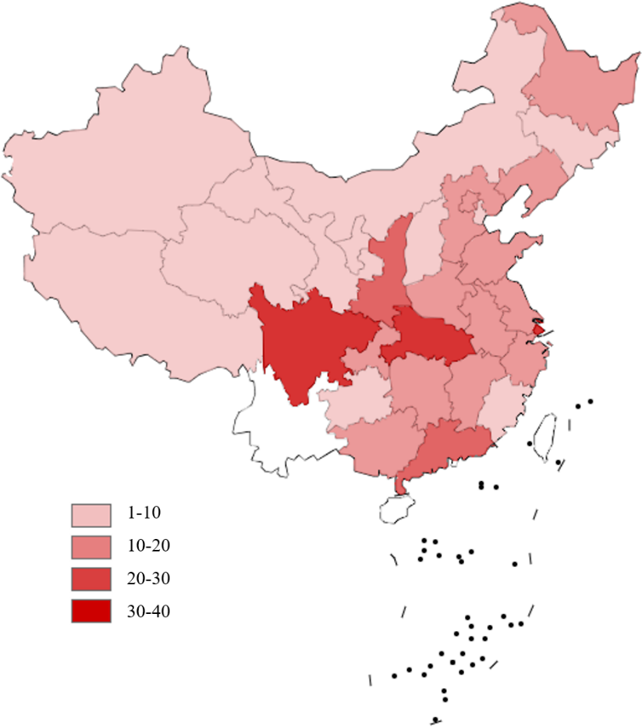
a Region distribution for the first survey (N=1000) b Region distribution for the retest survey (N=378)
Appendix Figure 1 Geographic distribution of the sample

Appendix Table 4 The health utility value of sample
 | Total sample (N=1000)  Mean ± SD | Retest sample (N=378)  Mean ± SD
EQ-5D-5L utility value (based on Luo et al., 2017 value set) | 0.891 ± 0.143 | 0.913 ± 0.096
EQ-VAS score in EQ-5D-5L | 77.3 ± 23.4 | 83.5 ± 18.3
SF-6Dv2 utility value (based on Wu et al., 2021 value set) | 0.697 ± 0.195 | 0.719 ± 0.149

Appendix Table 5 Feedback for the CHROME-G (N=1000)
 | Very easy | Easy | General | Difficult | Very difficult
Understanding | 527  (52.7%) | 386  (38.6%) | 58  (5.8%) | 27  (2.7%) | 2  (0.2%)
Completing | 490  (49.0%) | 436  (43.6%) | 61  (6.1%) | 13  (1.3%) | 0  (0.0%)

a Level sum score distribution of the CHROME-G

b Level sum score distribution of the EQ-5D-5L
c Level sum score distribution of the SF-6Dv2
Appendix Figure 2 Level sum score distribution of the three instruments (N=1000)

