Additional file 1
Table of contents
Figure A.1. Spatial distribution of the cognitive function scores and annual mean air pollutants in 2013, 2015, 2018.
Figure A.2. Spearman correlation analysis heat map of pollutants, meteorological conditions.
Table A.1 Regional distribution of the 28 provinces in China involved in the study.
Table A.2 Size of city administrative area in 2013 in which the sample is located.
Table A.3 Results of correlation analysis of PM_{2.5}, NO₂, O₃ and meteorological variables.
Table A.4 Results of sensitivity analyses with lag PM_{2.5}.
Table A.5 Results of sensitivity analyses with temperature and humidity nonlinearity.
Table A.6 Results of sensitivity analyses with age nonlinearity.
Table A.7 Results of sensitivity analyses with unpopulated-weighted PM2.5.
Table A.8 Results of sensitivity analyses for complete-case analysis with full adjustment for covariates.

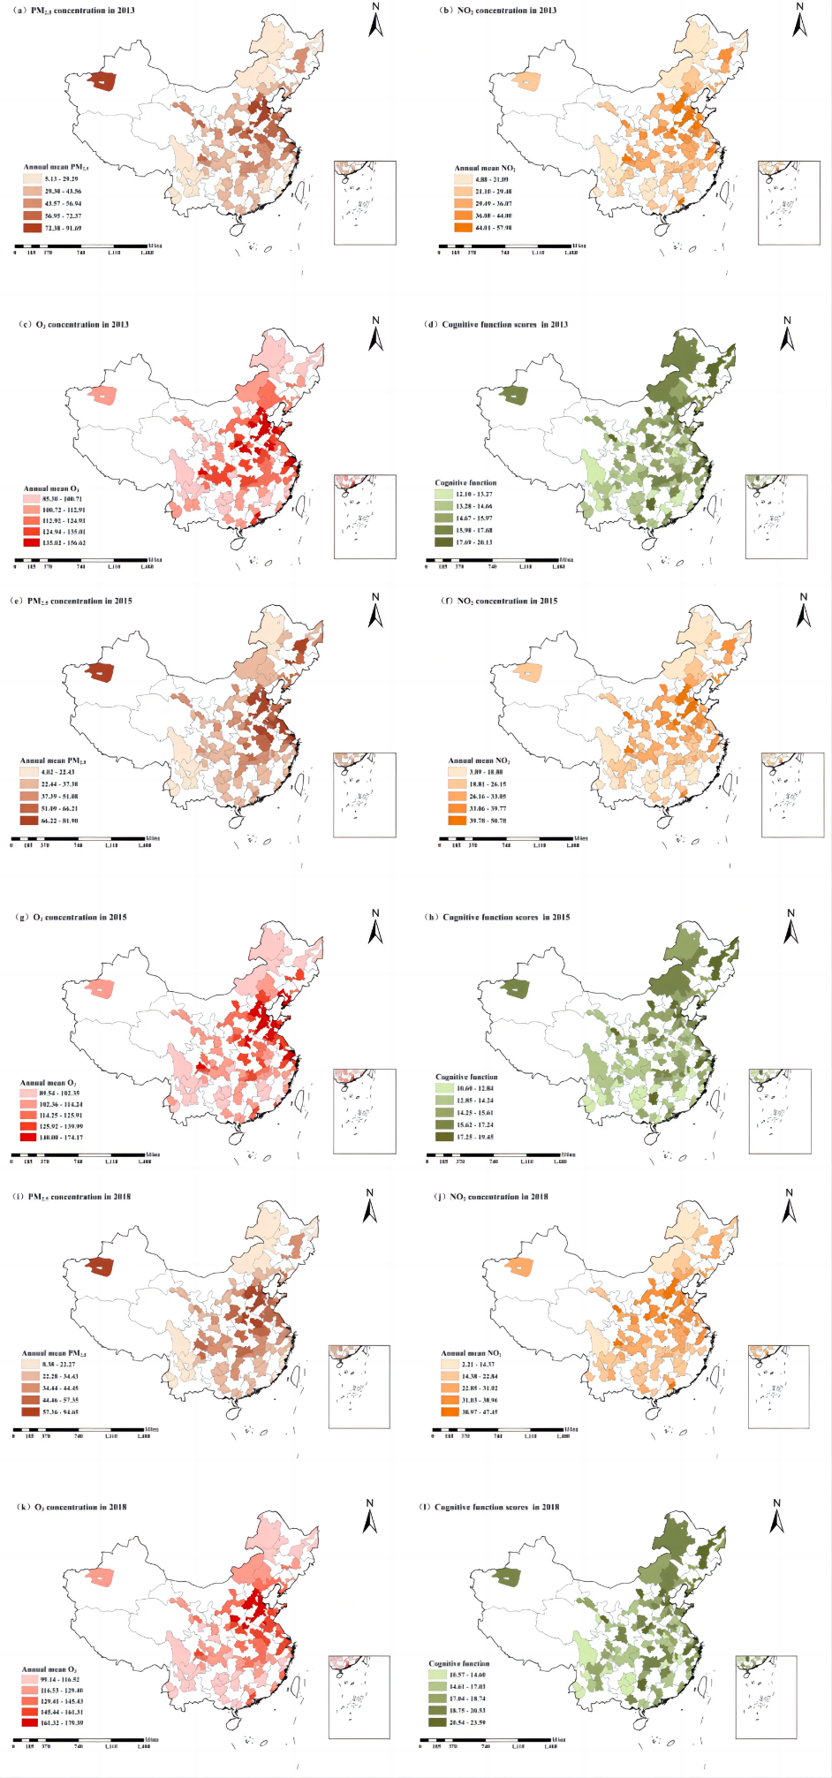
Figure A.1. Spatial distribution of the cognitive function scores and annual mean air pollutants in 2013, 2015, 2018.
Notes: White portion represents no data.

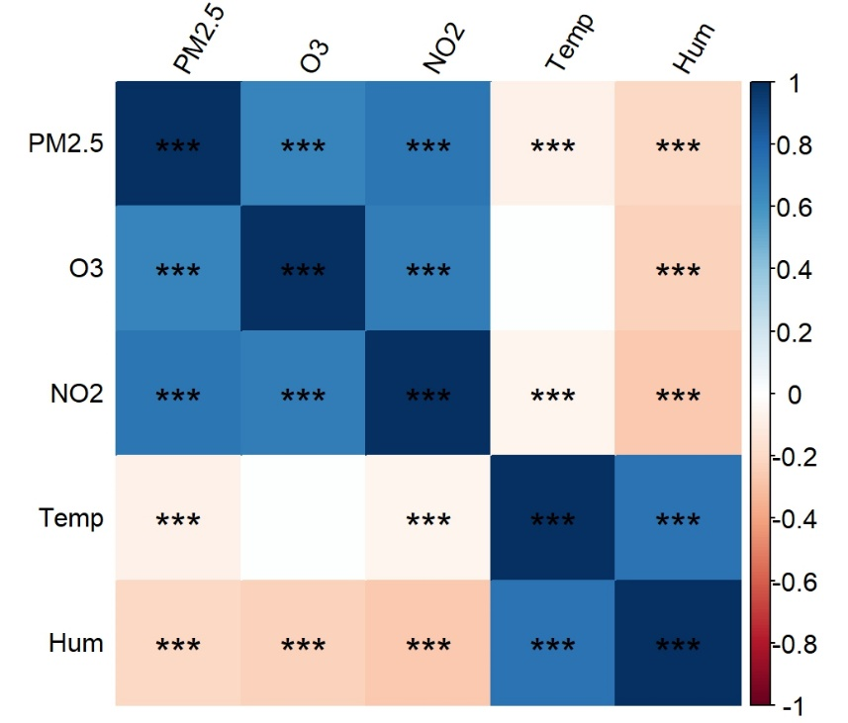
Figure A.2. Spearman correlation analysis heat map of pollutants, meteorological conditions.
Notes: Temp, average annual temperature; Hum, relative humidity; **P<0.01; ***P<0.001.

Table A.1 Regional distribution of the 28 provinces in China involved in the study.
Regions | Provinces
Eastern | Beijing, Tianjin, Hebei, Liaoning, Shanghai, Jiangsu, Zhejiang, Fujian, Shandong, Guangdong
Midland | Shanxi, Jilin, Heilongjiang, Anhui, Jiangxi, Henan, Hubei, Hunan
Western | Sichuan, Chongqing, Guizhou, Yunnan, Shaanxi, Gansu, Guangxi, Qinghai, Xinjiang, Inner Mongolia
Notes: No data available for Hainan, Ningxia, Tibet, Hong Kong, Macao and Taiwan.

Table A.2 Size of city administrative area in 2013 in which the sample is located.
City | Size (square kilometer) | City | Size (square kilometer)
Beijing | 16411 | Qingdao | 11282
Tianjin | 11917 | Zaozhuang | 4563
Shijiazhuang | 15848 | Weifang | 16143
Baoding | 20900 | Weihai | 5786
Chengde | 39735 | Linyi | 17191
Cangzhou | 14053 | Dezhou | 10356
Yangquan | 4570 | Liaocheng | 8984
Yuncheng | 14181 | Binzhou | 9660
Xinzhou | 25117 | Zhengzhou | 7446
Linfen | 20275 | Luoyang | 15236
Hohhot | 17186 | Pingdingshan | 7904
Chifeng | 90021 | Anyang | 7352
HulunBuir | 252777 | Jiaozuo | 4071
HingganLeague | 55131 | Puyang | 4136
XilingolLeague | 202600 | Xinyang | 15841
Dalian | 12574 | Zhoukou | 11961
Anshan | 9255 | Xiangyang | 19728
Benxi | 8411 | Jingmen | 12404
Jinzhou | 10047 | Huanggang | 17457
Chaoyang | 19698 | Enshi | 3972
Jilin | 27205 | Changsha | 11816
Siping | 14080 | Shaoyang | 20830
Harbin | 53068 | Yueyang | 14858
Qiqihar | 42469 | Changde | 18177
Jixi | 22531 | Yiyang | 12320
Jiamusi | 32704 | Loudi | 8117
Shanghai | 6340 | Guangzhou | 7434
Xuzhou | 11259 | Shenzhen | 1997
Suzhou | 8488 | Foshan | 3798
Lianyungang | 7615 | Jiangmen | 9505
Yancheng | 16972 | Maoming | 11426
Yangzhou | 6591 | Qingyuan | 19036
Taizhou, Jiangsu | 5787 | Chaozhou | 3146
Suqian | 8524 | Nanning | 22244
Hangzhou | 16596 | Guilin | 27850
Ningbo | 9816 | Yulin, Guangxi | 12824
Jiaxing | 3915 | Hechi | 33476
Huzhou | 5824 | Chongqing | 82374
Taizhou, Zhejiang | 9411 | Chengdu | 12133
Lishui | 17308 | Mianyang | 20248
Hefei | 11445 | Neijiang | 5385
Huainan | 2584 | Nanchong | 12477
Anqing | 15318 | Meishan | 7140
Fuyang | 9776 | Yibin | 13271
Suzhou | 9787 | Guangan | 6341
Lu'an | 18011 | Ziyang | 7960
Bozhou | 8374 | Tibetan Autonomous Prefecture of Garzê | 149700
Fuzhou | 13066 | Liangshan | 60400
Putian | 4131 | Qiandongnan Miao and Dong Autonomous Prefectur | 30282
Zhangzhou | 12554 | Qiannan Buyi and Miao Autonomous Prefecture | 26200
Ningde | 13452 | Kunming | 21012
Nanchang | 7402 | Baoshan | 19637
Jingdezhen | 5261 | Shaotong | 22440
Jiujiang | 19078 | Lijiang | 21219
Ganzhou | 39379 | Lincang | 23620
Jian | 25283 | Chuxiong | 4433
Yichun | 18669 | Baoji | 18117
Shangrao | 22791 | Weinan | 13134
Jinan | 8177 | Hanzhong | 27285
Yulin, Shaanxi | 43578 | Dingxi | 20330
Lanzhou | 13086 | Haidong | 13200
Zhangye | 41924 | Aksu | 14420
Pingliang | 11170

Table A.3 Results of correlation analysis of PM_{2.5}, NO₂, O₃ and meteorological variables

Variable | PM_{2.5} | O₃ | NO₂ | Temp | Hum
PM_{2.5} | 1
O₃ | 0.668*** | 1
NO₂ | 0.729*** | 0.697*** | 1
Temp | -0.077** | 0.008 | -0.051*** | 1
Hum | -0.209** | -0.224*** | -0.270*** | 0.737*** | 1
Notes: Temp, average annual temperature; Hum, relative humidity; **P<0.01; ***P<0.001.

Table A.4 Results of sensitivity analyses with lag PM_{2.5.}

Model | Variables | Beta | 95%CI | P-value
Primary model | PM_{2.5} | -0.260 | (-0.306, -0.215) | <0.001
Primary model | Social activeness | 0.289 | (0.233, 0.344) | <0.001
Primary model | PM_{2.5}*Social activeness | -0.018 | (-0.029, -0.006) | <0.001
Model_sens1 | PM_{2.5} | -0.198 | (-0.256, -0.140) | <0.001
Model_sens1 | Social activeness | 0.281 | (0.214 0.347) | <0.001
Model_sens1 | PM_{2.5}*Social activeness | -0.016 | (-0.030, -0.002) | <0.001
Notes: Primary model, PM_{2.5}+Social activeness+PM_{2.5}*Social activeness; Model_sens1, PM_{2.5} with a 1-year lag; CI, confidence interval.

Table A.5 Results of sensitivity analyses with temperature and humidity nonlinearity.

Model | Variables | Beta | 95%CI | P-value
Primary model | PM_{2.5} | -0.260 | (-0.306, -0.215) | <0.001
Primary model | Social activeness | 0.289 | (0.233, 0.344) | <0.001
 | PM_{2.5}*Social activeness | -0.018 | (-0.029, -0.006) | <0.001
Model_sens2 | PM_{2.5} | -0.239 | (-0.288, -0.187) | <0.001
Model_sens2 | Social activeness | 0.279 | (0.224, 0.334) | <0.001
Model_sens2 | PM_{2.5}*Social activeness | -0.017 | (-0.028, -0.006) | <0.05
Notes: Primary model, PM_{2.5}+Social activeness+ PM_{2.5}*Social activeness; Model_sens2, Models incorporating temperature and humidity as non-linear terms; CI, confidence interval.

Table A.6 Results of sensitivity analyses with age nonlinearity.
Model | Variables | Beta | 95%CI | P-value
Primary model | PM_{2.5} | -0.260 | (-0.306, -0.215) | <0.001
Primary model | Social activeness | 0.289 | (0.233, 0.344) | <0.001
 | PM_{2.5}*Social activeness | -0.018 | (-0.029, -0.006) | <0.001
Model_sens3 | PM_{2.5} | -0.261 | (-0.306, -0.215) | <0.001
Model_sens3 | Social activeness | 0.289 | (0.233, 0.344) | <0.001
Model_sens3 | PM_{2.5}*Social activeness | -0.018 | (-0.029, -0.006) | <0.05
Notes: Primary model, PM_{2.5}+Social activeness+ PM_{2.5}*Social activeness; Model_sens3, Models incorporating age as non-linear terms; CI, confidence interval.

Table A.7 Results of sensitivity analyses with unpopulated weighted PM_{2.5}.
Model | Variables | Beta | 95%CI | P-value
Primary model | PM_{2.5} | -0.260 | (-0.306, -0.215) | <0.001
Primary model | Social activeness | 0.289 | (0.233, 0.344) | <0.001
 | PM_{2.5}*Social activeness | -0.018 | (-0.029, -0.006) | <0.001
Model_sens4 | PM_{2.5} | -0.398 | (-0.435, -0.361) | <0.001
Model_sens4 | Social activeness | 0.322 | (0.271, 0.372) | <0.001
Model_sens4 | PM_{2.5}*Social activeness | -0.024 | (-0.034, -0.015) | <0.001
Notes: Primary model, PM_{2.5}+Social activeness+ PM_{2.5}*Social activeness; Model_sens3, unpopulated weighted PM_{2.5}; CI, confidence interval.

Table A.8 Results of sensitivity analyses for complete-case analysis with full adjustment for covariates.
Model | Variables | Beta | 95%CI | P-value
Primary model | PM_{2.5} | -0.260 | (-0.306, -0.215) | <0.001
Primary model | Social activeness | 0.289 | (0.233, 0.344) | <0.001
 | PM_{2.5}*Social activeness | -0.018 | (-0.029, -0.006) | <0.001
Model_sens | PM_{2.5} | -0.083 | (-0.120, -0.046) | <0.001
Model_sens | Social activeness | 0.237 | (0.188, 0.2866) | <0.001
Model_sens | PM_{2.5}*Social activeness | -0.015 | (-0.025, -0.005) | <0.001
Notes: Primary model, PM_{2.5}+Social activeness+ PM_{2.5}*Social activeness; Model_sens3, unpopulated weighted PM_{2.5}; CI, confidence interval.

