(a)
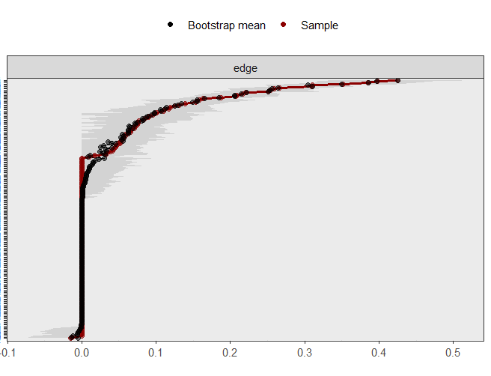

（b）
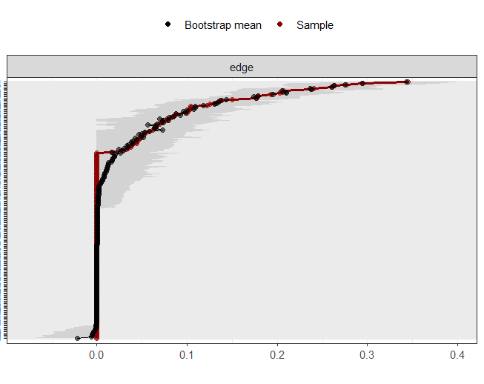

(c)
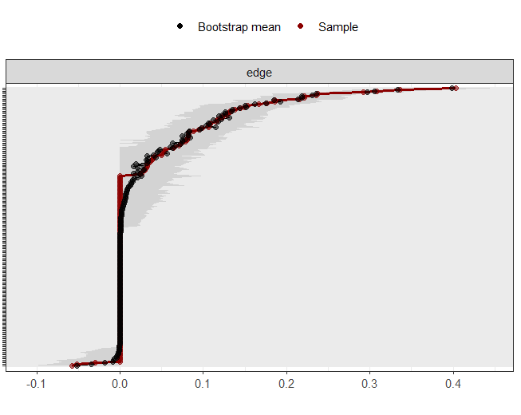
Fig. S1 The accuracy of edge weights in depression, anxiety, and sleep symptom networks of college students with different stress levels.
Note: (a) The accuracy test results of edge weights in the low-stress group symptom network;（b）The accuracy test results of edge weights in the medium-stress group symptom network；（c）The accuracy test results of edge weights in the high-stress group symptom network. The red line represents the edge weight value of the sample in this study, and the black line represents the average edge weight value evaluated by the self-service method. The grey area represents the confidence interval calculated by the self-service method. The abscissa represents the regularized partial correlation coefficient, and the ordinate represents the edge in the network.

(a)
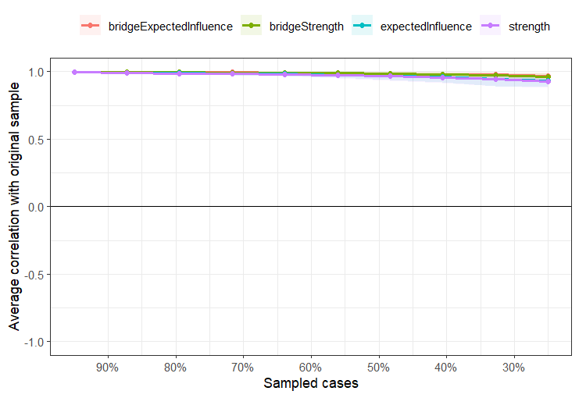

(b)
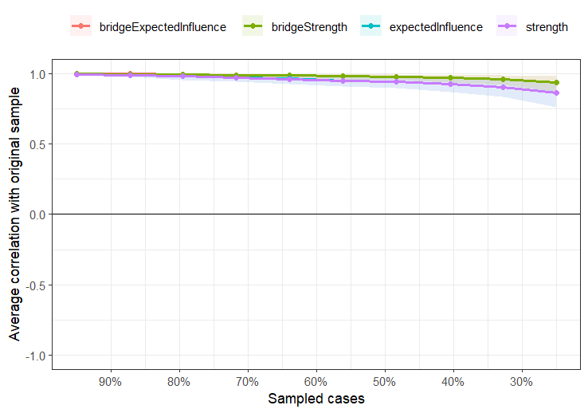

(c)
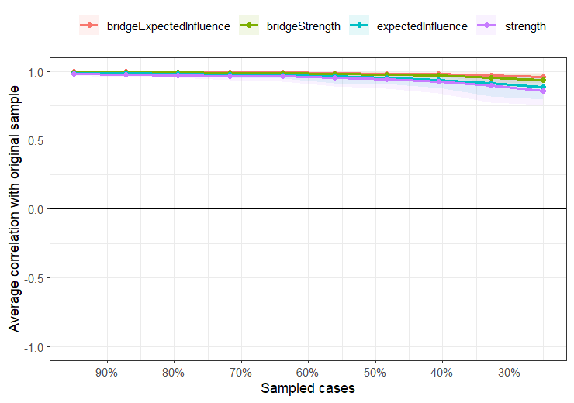
Fig. S2 Stability of centrality indices by case dropping subset bootstrap.
Note: (a) Stability test results of the low-stress group symptom network; (b) Stability test results of the medium-stress group symptom network;(c) Stability test results of the high-stress group symptom network. x-axis represents the percentage of cases of original sample used at each step. The y-axis represents the average of correlations between the centrality indices from the original network and the centrality indices from the networks that were re-estimated after dropping increasing percentages of cases. Each line indicates the correlations of strength, expected influence, bridge strength, bridge expected influence while areas indicate 95% CI.

