Supplemental Online Content
Epidemiological trends in gastrointestinal cancers and risk factors across U.S. states from 2000 to 2021: A systematic analysis for the Global Burden of Disease Study 2021
Authors:
Jiahao Jiang, Zhiqin Xie, Qingbin Wang, Bingkun Wang, Rong Huang, Weikai Xu, Changzhen Shang, Yajin Chen

Methods.
Fig. S1. Proportion of Incidence and Mortality of Gastrointestinal Cancers Among All Malignancies in the United States.
Fig. S2. Geographic Variation in Gastrointestinal Cancer Mortality Rates in the United States.
Fig. S3. Age and Sex Differences in Gastrointestinal Cancer Mortality in the United States.
Fig. S4. The age-standardized mortality rate of attributable risk factors by age group.
Fig. S5. Forecast of age-standardized incidence rate for liver cancer by etiology in the United States over the next 15 years.
Table S1. Annual Percentage Change of 50 States and the District of Columbia from 2000 to 2021.
Table S2. Annual percentage change in incidence and mortality rates by gender and age from 2000 to 2021.
Table S3. Annual percentage change of age-standardized incidence rates of liver cancer by etiology in the U.S. and across states from 2000 to 2021.
Table S4. BAPC model predictions for the next 15 years of changes in incidence number of gastrointestinal cancers in the U.S.
Table S5. BAPC model predictions for the next 15 years of changes in age-standardized incidence rates of gastrointestinal cancers in the U.S.
Table S6. BAPC model predictions for the next 15 years of changes in age-standardized incidence rates of liver cancer by etiology.

Methods.
Data Sources and Study Population
Cancer incidence and mortality data were obtained and compiled from population-based cancer registries, including the Surveillance, Epidemiology, and End Results (SEER) Program (www.seer.cancer.gov); the National Center for Health Statistics of the Department of Defense; and the International Agency for Research on Cancer (https://ci5.iarc.fr/ci5plus/). Identification of cancer risk factors was primarily based on previous relevant retrospective and prospective studies. Estimates of incidence and mortality for specific causes were generated by state, sex (male and female), and age (5-year groups, from <5 years to 95+ years). Detailed inclusion criteria for each data source can be found at (https://ghdx.healthdata.org/gbd-2021/sources). Estimation methods for incidence, mortality, and risk factors are available at (https://www.healthdata.org/gbd/methods-appendices-2021).

Definition of Tumors
Esophageal cancer is classified under ICD-10 code C15; gastric cancer under ICD-10 code C16; colorectal cancer includes ICD-10 codes C18–C21; liver cancer is categorized by ICD-10 codes C22.0–C22.8 and a proportion of C22.9; biliary cancer falls under ICD-10 codes C23–C24; and pancreatic cancer is designated by ICD-10 code C25.

Bias in Cancer Data
Bias in the data primarily arises from differences among various cancer registry databases. First, when classifying diseases by cancer type, different data sources use varying coding systems. The Global Burden of Disease (GBD) project remaps these codes to align with standardized classifications such as ICD-10. Fortunately, issues with ambiguous cancer coding often occur in low-SDI regions, while the quality of cancer statistics in the United States is relatively high. Second, the attribution of metastatic tumors to primary tumors at the site depends on the quality of the original data source.

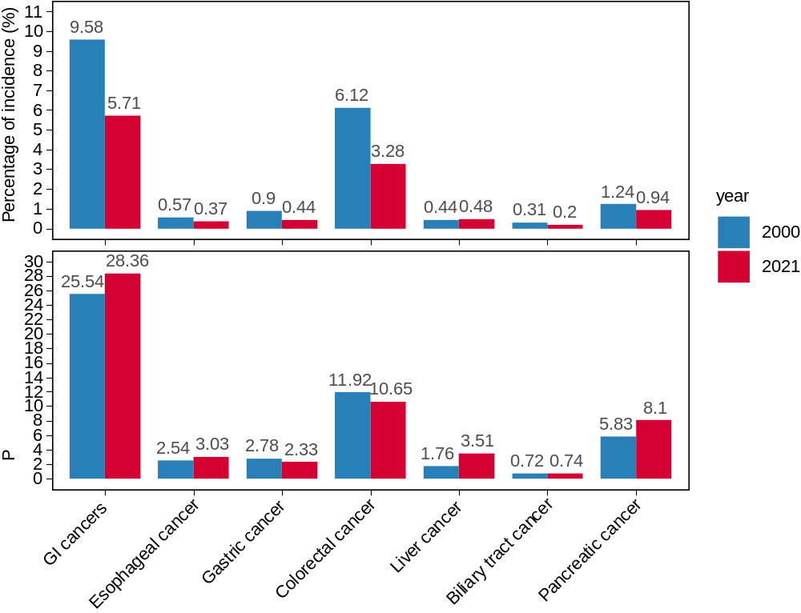
Fig. S1. Proportion of incidence and mortality of gastrointestinal cancers among all malignancies in the United States.

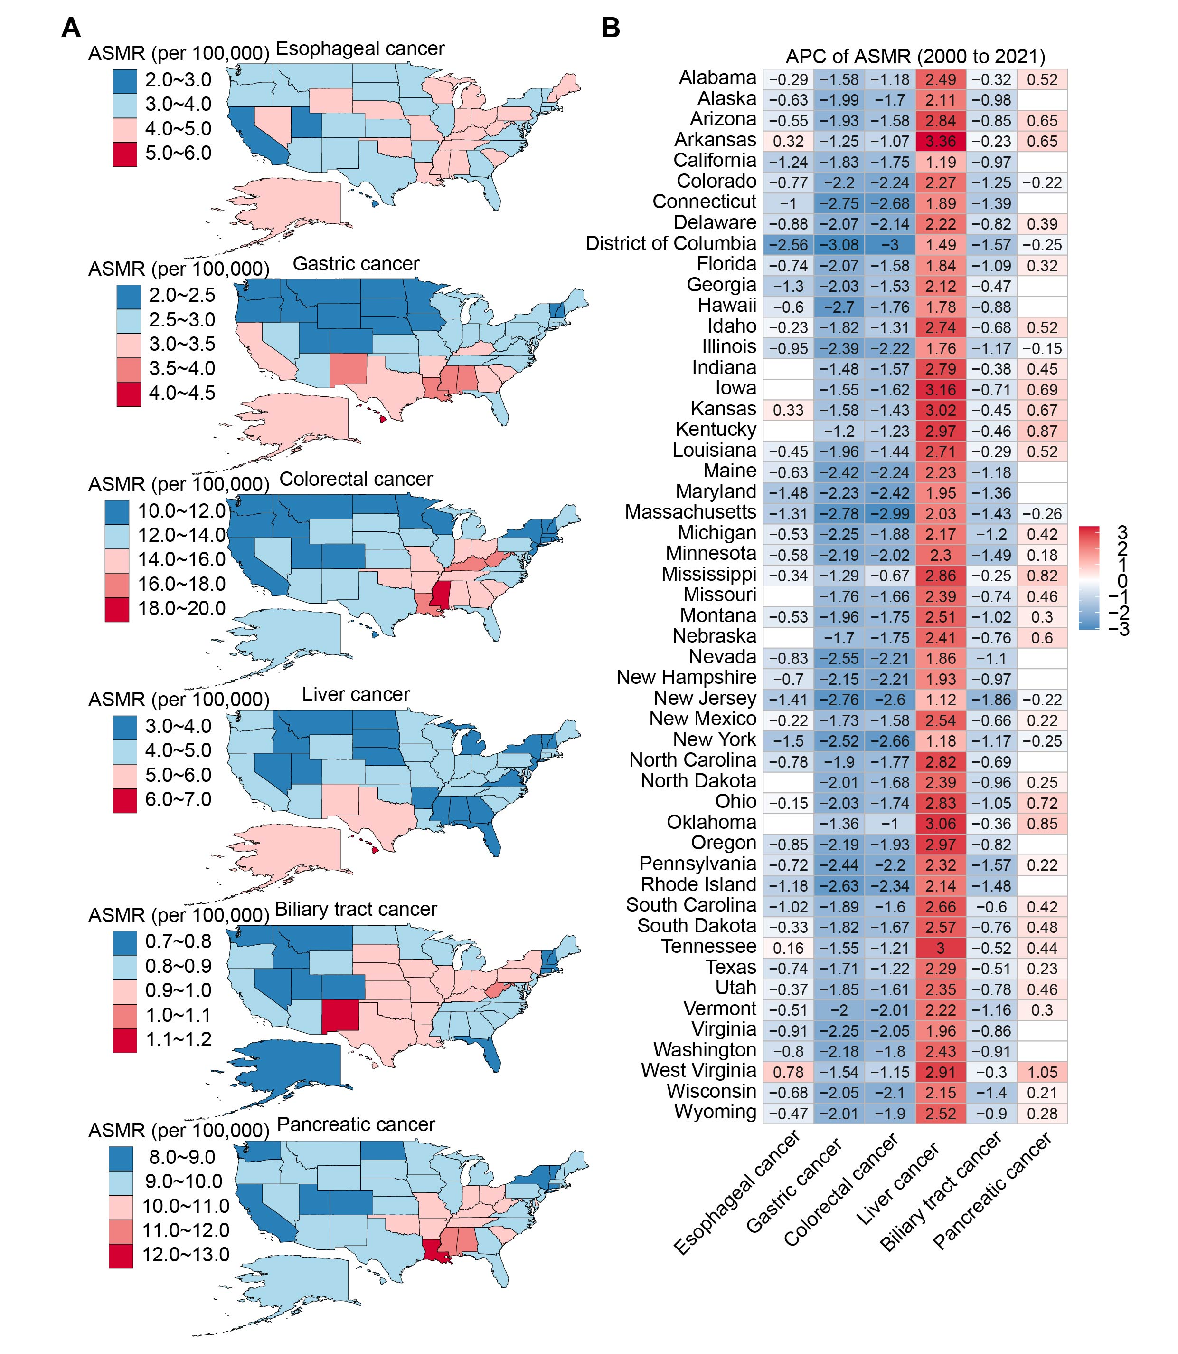
Fig. S2. Geographic variation in gastrointestinal cancer mortality rates in the United States.
(A) ASMR for gastrointestinal cancer by state in the United States in 2021. (B) APC in ASMR for gastrointestinal cancer by state from 2000 to 2021. ASIR: age-standardized incidence rate; APC: annual percentage change.

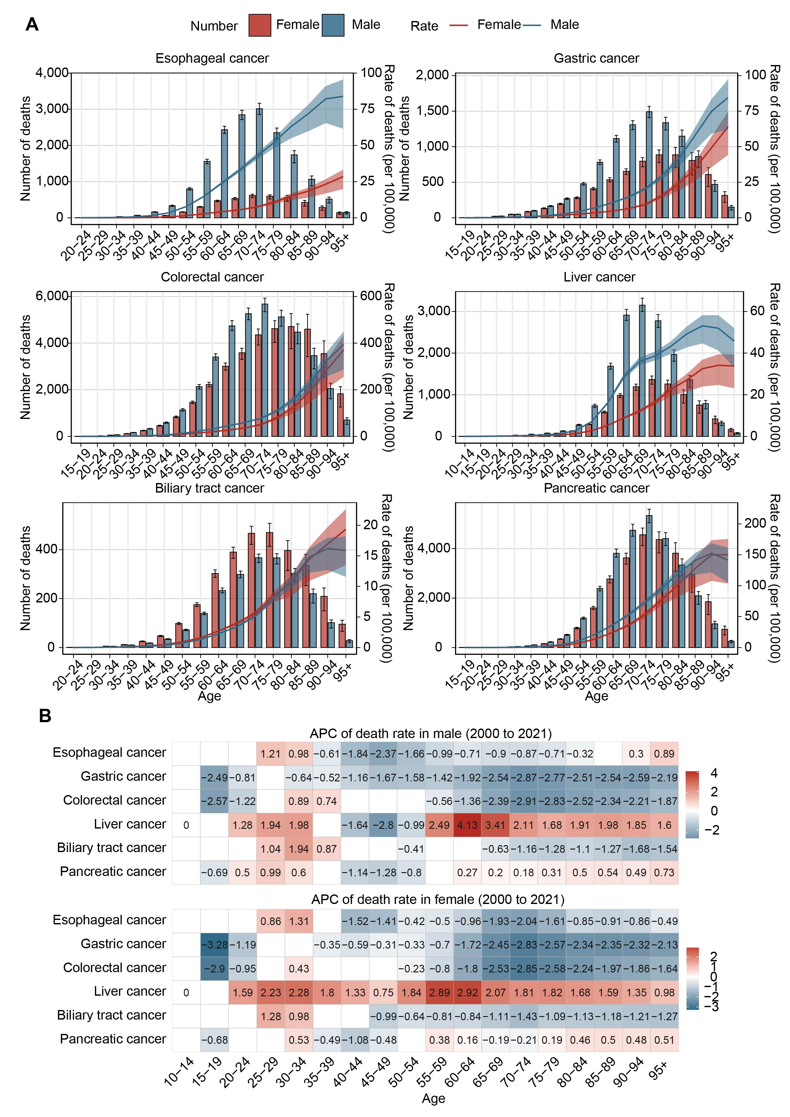
Fig. S3. Age and sex differences in gastrointestinal cancer mortality in the United States.
(A) The number and mortality rates of gastrointestinal cancers by age and sex in 2021. (B) Annual percentage change (APC) in mortality rates of gastrointestinal cancers by different sexes and age groups from 2000 to 2021. APC: annual percentage change.
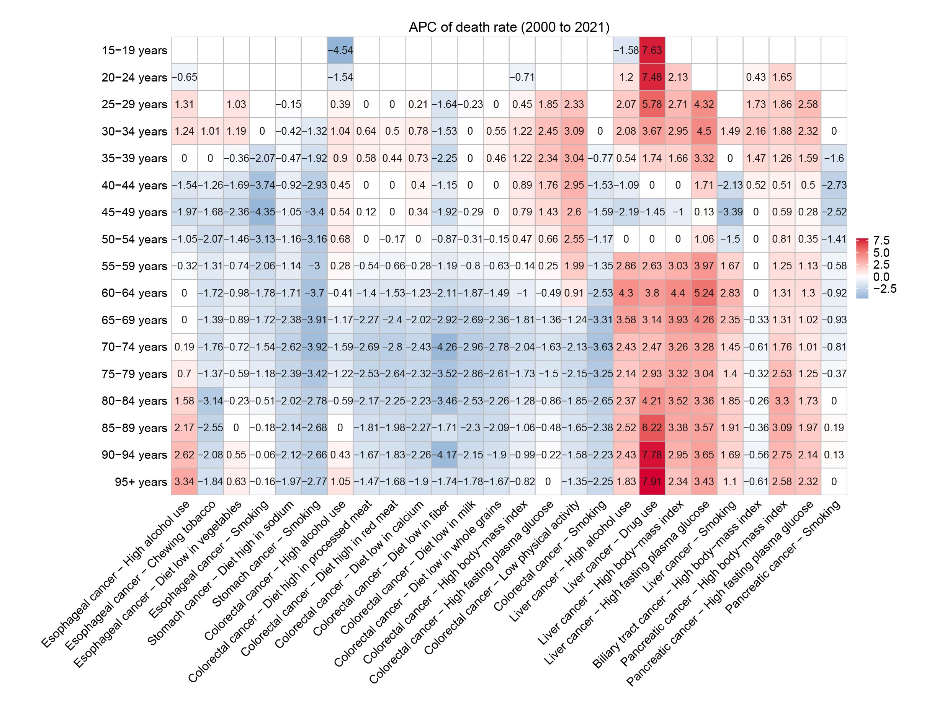
Fig. S4. The age-standardized mortality rate of attributable risk factors by age group.

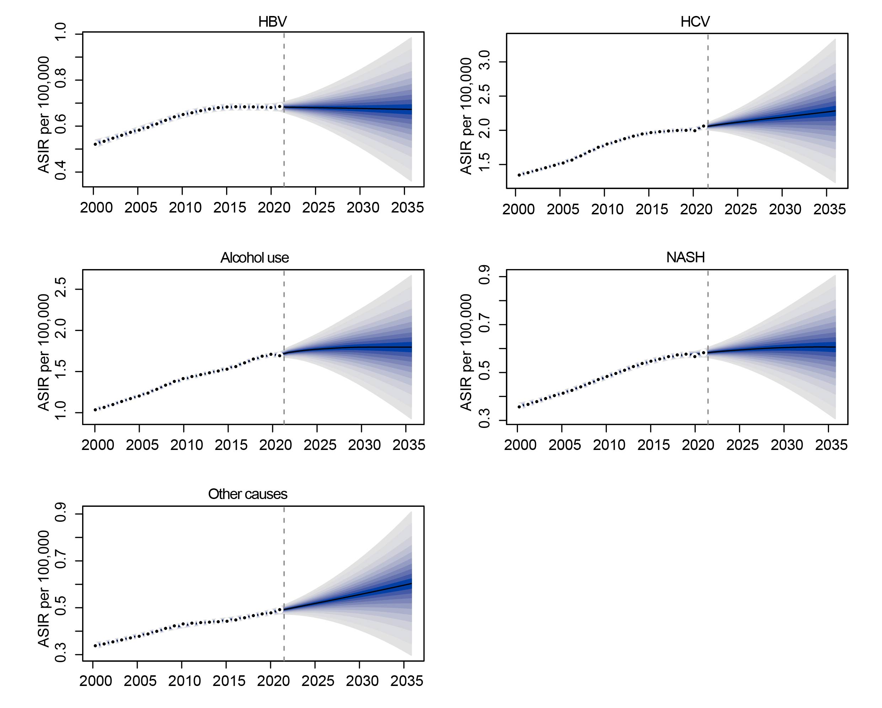
Fig. S5. Forecast of age-standardized incidence rates (ASIR) for liver cancer by etiology in the United States over the next 15 years. ASIR: age-standardized incidence rate.

Table S1. Annual Percentage Change of 50 States and the District of Columbia from 2000 to 2021
measure | location | Esophageal cancer | Gastric cancer | Colorectal cancer | Liver cancer | Biliary tract cancer | Pancreatic cancer
ASIR | Alabama | -0.29 (-0.43 to -0.14) | -1.29 (-1.42 to -1.17) | -0.74 (-0.87 to -0.62) | 2.52 (2.20 to 2.84) | -0.03 (-0.26 to 0.20) | 0.59 (0.47 to 0.71)
ASIR | Alaska | -0.50 (-0.72 to -0.28) | -1.57 (-1.79 to -1.35) | -1.15 (-1.33 to -0.97) | 2.46 (2.22 to 2.69) | -0.36 (-0.56 to -0.16) | 0.25 (-0.02 to 0.52)
ASIR | Arizona | -0.38 (-0.59 to -0.16) | -1.37 (-1.54 to -1.19) | -0.79 (-0.96 to -0.62) | 3.07 (2.89 to 3.25) | 0.03 (-0.25 to 0.31) | 0.78 (0.66 to 0.91)
ASIR | Arkansas | 0.31 (0.02 to 0.61) | -1.02 (-1.16 to -0.87) | -0.76 (-1.01 to -0.51) | 3.48 (3.29 to 3.67) | -0.02 (-0.29 to 0.24) | 0.70 (0.52 to 0.89)
ASIR | California | -1.15 (-1.27 to -1.03) | -1.45 (-1.57 to -1.34) | -0.84 (-0.94 to -0.74) | 1.23 (1.04 to 1.42) | 0.17 (-0.07 to 0.41) | -0.10 (-0.21 to 0.01)
ASIR | Colorado | -0.64 (-0.90 to -0.37) | -1.75 (-1.88 to -1.62) | -1.72 (-1.85 to -1.60) | 2.65 (2.46 to 2.83) | -0.59 (-0.78 to -0.40) | -0.09 (-0.26 to 0.08)
ASIR | Connecticut | -0.81 (-0.96 to -0.65) | -2.15 (-2.29 to -2.01) | -1.83 (-1.97 to -1.70) | 2.15 (1.92 to 2.38) | -0.37 (-0.57 to -0.16) | -0.13 (-0.35 to 0.10)
ASIR | Delaware | -0.69 (-0.86 to -0.52) | -1.52 (-1.70 to -1.34) | -1.41 (-1.60 to -1.21) | 2.46 (2.25 to 2.67) | 0.05 (-0.12 to 0.22) | 0.54 (0.39 to 0.69)
ASIR | District of Columbia | -2.31 (-2.63 to -1.99) | -2.37 (-2.62 to -2.11) | -1.80 (-2.08 to -1.52) | 1.85 (1.76 to 1.93) | -0.36 (-0.57 to -0.15) | -0.06 (-0.20 to 0.08)
ASIR | Florida | -0.67 (-0.80 to -0.55) | -1.73 (-1.92 to -1.54) | -1.05 (-1.16 to -0.94) | 1.95 (1.75 to 2.16) | -0.55 (-0.75 to -0.34) | 0.30 (0.20 to 0.39)
ASIR | Georgia | -1.07 (-1.19 to -0.96) | -1.36 (-1.55 to -1.18) | -0.72 (-0.86 to -0.59) | 2.74 (2.51 to 2.98) | 0.30 (0.10 to 0.49) | 0.31 (0.22 to 0.39)
ASIR | Hawaii | -0.44 (-0.70 to -0.18) | -2.31 (-2.43 to -2.19) | -1.14 (-1.35 to -0.93) | 1.97 (1.80 to 2.15) | -0.24 (-0.37 to -0.11) | 0.29 (0.05 to 0.53)
ASIR | Idaho | -0.16 (-0.32 to 0.00) | -1.48 (-1.61 to -1.35) | -0.83 (-0.98 to -0.68) | 2.73 (2.47 to 2.98) | -0.14 (-0.35 to 0.07) | 0.62 (0.40 to 0.85)
ASIR | Illinois | -0.77 (-0.89 to -0.66) | -1.82 (-1.94 to -1.69) | -1.40 (-1.50 to -1.30) | 2.00 (1.86 to 2.14) | -0.21 (-0.42 to 0.01) | 0.00 (-0.10 to 0.09)
ASIR | Indiana | 0.03 (-0.15 to 0.20) | -1.21 (-1.40 to -1.03) | -1.27 (-1.47 to -1.08) | 2.71 (2.62 to 2.79) | -0.12 (-0.36 to 0.11) | 0.50 (0.41 to 0.59)
ASIR | Iowa | 0.01 (-0.19 to 0.20) | -1.31 (-1.50 to -1.13) | -1.30 (-1.47 to -1.13) | 3.15 (2.94 to 3.36) | -0.28 (-0.55 to -0.02) | 0.68 (0.53 to 0.84)
ASIR | Kansas | 0.34 (0.16 to 0.51) | -1.34 (-1.57 to -1.12) | -1.12 (-1.27 to -0.96) | 3.23 (3.02 to 3.44) | -0.18 (-0.40 to 0.04) | 0.73 (0.57 to 0.89)
ASIR | Kentucky | -0.02 (-0.20 to 0.16) | -1.07 (-1.29 to -0.86) | -1.16 (-1.40 to -0.92) | 2.77 (2.51 to 3.02) | -0.51 (-0.71 to -0.30) | 0.82 (0.68 to 0.96)
ASIR | Louisiana | -0.49 (-0.69 to -0.29) | -1.73 (-1.90 to -1.56) | -1.02 (-1.21 to -0.84) | 2.60 (2.54 to 2.66) | 0.11 (-0.07 to 0.30) | 0.46 (0.29 to 0.64)
ASIR | Maine | -0.64 (-0.92 to -0.36) | -2.20 (-2.46 to -1.94) | -2.11 (-2.34 to -1.87) | 2.26 (2.04 to 2.47) | -1.04 (-1.25 to -0.83) | 0.06 (-0.08 to 0.20)
ASIR | Maryland | -1.32 (-1.50 to -1.14) | -1.68 (-1.80 to -1.55) | -1.63 (-1.78 to -1.48) | 2.07 (1.97 to 2.16) | -0.53 (-0.68 to -0.37) | 0.10 (-0.02 to 0.21)
ASIR | Massachusetts | -1.24 (-1.46 to -1.02) | -2.41 (-2.73 to -2.10) | -2.63 (-2.81 to -2.44) | 2.09 (1.74 to 2.43) | -0.91 (-1.10 to -0.72) | -0.18 (-0.32 to -0.05)
ASIR | Michigan | -0.56 (-0.70 to -0.42) | -1.95 (-2.06 to -1.83) | -1.35 (-1.46 to -1.23) | 2.03 (1.77 to 2.29) | -0.78 (-1.02 to -0.54) | 0.42 (0.29 to 0.56)
ASIR | Minnesota | -0.51 (-0.66 to -0.36) | -1.91 (-2.11 to -1.71) | -1.73 (-1.89 to -1.56) | 2.42 (2.22 to 2.63) | -0.98 (-1.17 to -0.79) | 0.29 (0.15 to 0.43)
ASIR | Mississippi | -0.29 (-0.52 to -0.07) | -0.99 (-1.17 to -0.81) | -0.22 (-0.40 to -0.03) | 3.01 (2.93 to 3.09) | 0.11 (-0.14 to 0.37) | 0.89 (0.68 to 1.11)
ASIR | Missouri | 0.20 (0.00 to 0.40) | -1.39 (-1.57 to -1.22) | -1.16 (-1.33 to -0.99) | 2.62 (2.34 to 2.91) | -0.28 (-0.55 to -0.01) | 0.56 (0.46 to 0.65)
ASIR | Montana | -0.48 (-0.67 to -0.29) | -1.68 (-1.82 to -1.53) | -1.45 (-1.64 to -1.25) | 2.75 (2.53 to 2.97) | -0.69 (-0.81 to -0.58) | 0.39 (0.21 to 0.57)
ASIR | Nebraska | -0.08 (-0.25 to 0.08) | -1.37 (-1.59 to -1.15) | -1.37 (-1.57 to -1.16) | 2.83 (2.39 to 3.26) | -0.32 (-0.49 to -0.15) | 0.70 (0.48 to 0.91)
ASIR | Nevada | -0.65 (-0.88 to -0.43) | -1.97 (-2.11 to -1.83) | -1.36 (-1.52 to -1.20) | 2.00 (1.77 to 2.22) | -0.20 (-0.32 to -0.08) | 0.05 (-0.15 to 0.24)
ASIR | New Hampshire | -0.63 (-0.81 to -0.45) | -1.83 (-2.05 to -1.62) | -1.91 (-2.15 to -1.67) | 2.01 (1.86 to 2.15) | -0.51 (-0.69 to -0.32) | 0.25 (0.08 to 0.41)
ASIR | New Jersey | -1.26 (-1.46 to -1.06) | -2.37 (-2.56 to -2.18) | -2.00 (-2.19 to -1.82) | 1.03 (0.83 to 1.24) | -0.92 (-1.10 to -0.75) | -0.16 (-0.28 to -0.04)
ASIR | New Mexico | -0.10 (-0.31 to 0.12) | -1.33 (-1.47 to -1.20) | -0.90 (-1.06 to -0.74) | 3.17 (3.11 to 3.23) | -0.16 (-0.32 to 0.00) | 0.32 (0.20 to 0.44)
ASIR | New York | -1.33 (-1.54 to -1.12) | -1.92 (-2.08 to -1.76) | -1.83 (-1.96 to -1.71) | 1.42 (1.04 to 1.79) | -0.22 (-0.41 to -0.03) | -0.10 (-0.22 to 0.02)
ASIR | North Carolina | -0.68 (-0.83 to -0.52) | -1.41 (-1.55 to -1.27) | -1.13 (-1.24 to -1.02) | 2.97 (2.79 to 3.15) | 0.08 (-0.12 to 0.27) | 0.22 (0.13 to 0.32)
ASIR | North Dakota | -0.16 (-0.39 to 0.07) | -1.80 (-1.98 to -1.62) | -1.53 (-1.78 to -1.28) | 2.61 (2.37 to 2.86) | -0.88 (-1.10 to -0.66) | 0.30 (0.10 to 0.50)
ASIR | Ohio | -0.20 (-0.30 to -0.09) | -1.78 (-1.95 to -1.61) | -1.48 (-1.64 to -1.31) | 2.95 (2.76 to 3.14) | -0.83 (-1.10 to -0.56) | 0.74 (0.65 to 0.84)
ASIR | Oklahoma | 0.16 (-0.14 to 0.46) | -1.19 (-1.38 to -1.00) | -0.79 (-1.02 to -0.56) | 2.95 (2.80 to 3.09) | -0.30 (-0.48 to -0.13) | 0.87 (0.68 to 1.07)
ASIR | Oregon | -0.74 (-0.90 to -0.59) | -1.82 (-1.99 to -1.65) | -1.52 (-1.71 to -1.33) | 3.26 (2.86 to 3.67) | -0.32 (-0.49 to -0.15) | 0.27 (0.06 to 0.47)
ASIR | Pennsylvania | -0.67 (-0.85 to -0.49) | -2.00 (-2.17 to -1.84) | -1.68 (-1.82 to -1.55) | 2.36 (2.22 to 2.51) | -0.98 (-1.32 to -0.64) | 0.31 (0.16 to 0.47)
ASIR | Rhode Island | -1.08 (-1.42 to -0.73) | -2.26 (-2.49 to -2.03) | -1.92 (-2.08 to -1.77) | 2.55 (2.42 to 2.69) | -0.90 (-1.06 to -0.74) | 0.22 (0.04 to 0.39)
ASIR | South Carolina | -0.89 (-1.03 to -0.76) | -1.39 (-1.55 to -1.22) | -0.89 (-1.03 to -0.75) | 2.93 (2.63 to 3.22) | 0.15 (-0.01 to 0.31) | 0.53 (0.42 to 0.65)
ASIR | South Dakota | -0.31 (-0.43 to -0.20) | -1.58 (-1.75 to -1.42) | -1.43 (-1.65 to -1.21) | 2.53 (2.43 to 2.63) | -0.56 (-0.83 to -0.28) | 0.54 (0.37 to 0.71)
ASIR | Tennessee | 0.21 (0.09 to 0.33) | -1.14 (-1.32 to -0.97) | -0.68 (-0.83 to -0.52) | 3.35 (3.04 to 3.66) | -0.01 (-0.28 to 0.27) | 0.54 (0.43 to 0.65)
ASIR | Texas | -0.69 (-0.77 to -0.62) | -1.33 (-1.51 to -1.15) | -0.62 (-0.76 to -0.49) | 2.27 (2.01 to 2.52) | -0.03 (-0.26 to 0.21) | 0.31 (0.21 to 0.41)
ASIR | Utah | -0.27 (-0.58 to 0.03) | -1.48 (-1.66 to -1.30) | -1.07 (-1.22 to -0.93) | 2.53 (2.17 to 2.89) | -0.25 (-0.46 to -0.04) | 0.60 (0.38 to 0.82)
ASIR | Vermont | -0.35 (-0.51 to -0.19) | -1.57 (-1.80 to -1.34) | -1.49 (-1.68 to -1.31) | 2.72 (2.40 to 3.05) | -0.44 (-0.68 to -0.20) | 0.43 (0.21 to 0.64)
ASIR | Virginia | -0.78 (-0.93 to -0.62) | -1.70 (-1.93 to -1.47) | -1.36 (-1.47 to -1.24) | 2.24 (1.97 to 2.52) | -0.04 (-0.29 to 0.21) | 0.16 (0.00 to 0.32)
ASIR | Washington | -0.76 (-1.01 to -0.50) | -1.75 (-1.93 to -1.58) | -1.16 (-1.28 to -1.03) | 2.55 (2.26 to 2.85) | -0.38 (-0.50 to -0.26) | -0.11 (-0.30 to 0.09)
ASIR | West Virginia | 0.81 (0.56 to 1.07) | -1.24 (-1.52 to -0.97) | -0.80 (-0.99 to -0.62) | 3.10 (2.86 to 3.35) | -0.06 (-0.24 to 0.12) | 1.13 (0.98 to 1.27)
ASIR | Wisconsin | -0.62 (-0.79 to -0.45) | -1.72 (-1.90 to -1.54) | -1.72 (-1.90 to -1.53) | 2.27 (2.16 to 2.37) | -0.95 (-1.10 to -0.81) | 0.29 (0.16 to 0.42)
ASIR | Wyoming | -0.31 (-0.59 to -0.03) | -1.55 (-1.71 to -1.40) | -1.29 (-1.52 to -1.06) | 2.86 (2.69 to 3.03) | -0.17 (-0.49 to 0.15) | 0.42 (0.32 to 0.53)
ASMR | Alabama | -0.29 (-0.43 to -0.15) | -1.58 (-1.73 to -1.44) | -1.18 (-1.31 to -1.04) | 2.49 (2.21 to 2.77) | -0.32 (-0.54 to -0.11) | 0.52 (0.40 to 0.64)
ASMR | Alaska | -0.63 (-0.85 to -0.41) | -1.99 (-2.20 to -1.79) | -1.70 (-1.86 to -1.54) | 2.11 (1.86 to 2.35) | -0.98 (-1.16 to -0.80) | 0.12 (-0.15 to 0.39)
ASMR | Arizona | -0.55 (-0.76 to -0.34) | -1.93 (-2.17 to -1.69) | -1.58 (-1.84 to -1.32) | 2.84 (2.58 to 3.09) | -0.85 (-1.24 to -0.46) | 0.65 (0.52 to 0.77)
ASMR | Arkansas | 0.32 (0.03 to 0.62) | -1.25 (-1.40 to -1.10) | -1.07 (-1.24 to -0.89) | 3.36 (3.11 to 3.61) | -0.23 (-0.47 to 0.00) | 0.65 (0.46 to 0.83)
ASMR | California | -1.24 (-1.36 to -1.11) | -1.83 (-2.00 to -1.67) | -1.75 (-1.88 to -1.62) | 1.19 (1.06 to 1.32) | -0.97 (-1.31 to -0.63) | -0.07 (-0.18 to 0.03)
ASMR | Colorado | -0.77 (-1.02 to -0.52) | -2.20 (-2.35 to -2.06) | -2.24 (-2.38 to -2.11) | 2.27 (2.06 to 2.47) | -1.25 (-1.46 to -1.05) | -0.22 (-0.38 to -0.05)
ASMR | Connecticut | -1.00 (-1.16 to -0.83) | -2.75 (-2.91 to -2.59) | -2.68 (-2.94 to -2.42) | 1.89 (1.71 to 2.07) | -1.39 (-1.57 to -1.21) | -0.18 (-0.38 to 0.01)
ASMR | Delaware | -0.88 (-1.04 to -0.71) | -2.07 (-2.28 to -1.86) | -2.14 (-2.41 to -1.87) | 2.22 (2.05 to 2.40) | -0.82 (-1.03 to -0.60) | 0.39 (0.24 to 0.54)
ASMR | District of Columbia | -2.56 (-2.88 to -2.24) | -3.08 (-3.37 to -2.79) | -3.00 (-3.30 to -2.70) | 1.49 (1.27 to 1.72) | -1.57 (-1.82 to -1.32) | -0.25 (-0.38 to -0.11)
ASMR | Florida | -0.74 (-0.84 to -0.63) | -2.07 (-2.31 to -1.83) | -1.58 (-1.75 to -1.40) | 1.84 (1.68 to 2.00) | -1.09 (-1.35 to -0.84) | 0.32 (0.23 to 0.41)
ASMR | Georgia | -1.30 (-1.38 to -1.21) | -2.03 (-2.15 to -1.91) | -1.53 (-1.63 to -1.42) | 2.12 (1.98 to 2.26) | -0.47 (-0.69 to -0.25) | 0.00 (-0.08 to 0.08)
ASMR | Hawaii | -0.60 (-0.85 to -0.34) | -2.70 (-2.84 to -2.56) | -1.76 (-1.95 to -1.57) | 1.78 (1.63 to 1.93) | -0.88 (-1.03 to -0.73) | 0.13 (-0.09 to 0.35)
ASMR | Idaho | -0.23 (-0.39 to -0.06) | -1.82 (-1.91 to -1.72) | -1.31 (-1.44 to -1.19) | 2.74 (2.44 to 3.04) | -0.68 (-0.89 to -0.47) | 0.52 (0.31 to 0.73)
ASMR | Illinois | -0.95 (-1.05 to -0.85) | -2.39 (-2.54 to -2.25) | -2.22 (-2.39 to -2.04) | 1.76 (1.55 to 1.97) | -1.17 (-1.37 to -0.96) | -0.15 (-0.25 to -0.05)
ASMR | Indiana | 0.03 (-0.14 to 0.20) | -1.48 (-1.68 to -1.29) | -1.57 (-1.78 to -1.36) | 2.79 (2.54 to 3.05) | -0.38 (-0.61 to -0.15) | 0.45 (0.36 to 0.55)
ASMR | Iowa | 0.01 (-0.18 to 0.20) | -1.55 (-1.76 to -1.34) | -1.62 (-1.79 to -1.45) | 3.16 (2.96 to 3.36) | -0.71 (-1.02 to -0.40) | 0.69 (0.53 to 0.84)
ASMR | Kansas | 0.33 (0.16 to 0.50) | -1.58 (-1.81 to -1.35) | -1.43 (-1.58 to -1.28) | 3.02 (2.84 to 3.21) | -0.45 (-0.63 to -0.27) | 0.67 (0.51 to 0.83)
ASMR | Kentucky | 0.10 (-0.08 to 0.28) | -1.20 (-1.40 to -1.01) | -1.23 (-1.42 to -1.03) | 2.97 (2.70 to 3.24) | -0.46 (-0.67 to -0.26) | 0.87 (0.74 to 1.00)
ASMR | Louisiana | -0.45 (-0.64 to -0.25) | -1.96 (-2.11 to -1.82) | -1.44 (-1.62 to -1.25) | 2.71 (2.45 to 2.97) | -0.29 (-0.53 to -0.04) | 0.52 (0.35 to 0.69)
ASMR | Maine | -0.63 (-0.90 to -0.36) | -2.42 (-2.72 to -2.12) | -2.24 (-2.49 to -1.98) | 2.23 (2.09 to 2.38) | -1.18 (-1.43 to -0.94) | 0.00 (-0.13 to 0.14)
ASMR | Maryland | -1.48 (-1.69 to -1.27) | -2.23 (-2.43 to -2.02) | -2.42 (-2.72 to -2.13) | 1.95 (1.77 to 2.12) | -1.36 (-1.67 to -1.06) | -0.06 (-0.15 to 0.04)
ASMR | Massachusetts | -1.31 (-1.52 to -1.10) | -2.78 (-3.13 to -2.43) | -2.99 (-3.23 to -2.74) | 2.03 (1.80 to 2.26) | -1.43 (-1.64 to -1.22) | -0.26 (-0.40 to -0.13)
ASMR | Michigan | -0.53 (-0.66 to -0.40) | -2.25 (-2.39 to -2.11) | -1.88 (-1.99 to -1.76) | 2.17 (1.99 to 2.36) | -1.20 (-1.43 to -0.98) | 0.42 (0.29 to 0.56)
ASMR | Minnesota | -0.58 (-0.70 to -0.46) | -2.19 (-2.43 to -1.95) | -2.02 (-2.21 to -1.84) | 2.30 (2.14 to 2.46) | -1.49 (-1.66 to -1.33) | 0.18 (0.05 to 0.31)
ASMR | Mississippi | -0.34 (-0.56 to -0.12) | -1.29 (-1.45 to -1.12) | -0.67 (-0.79 to -0.56) | 2.86 (2.74 to 2.97) | -0.25 (-0.43 to -0.07) | 0.82 (0.60 to 1.04)
ASMR | Missouri | 0.14 (-0.08 to 0.35) | -1.76 (-1.97 to -1.54) | -1.66 (-1.83 to -1.48) | 2.39 (2.17 to 2.61) | -0.74 (-1.04 to -0.44) | 0.46 (0.36 to 0.56)
ASMR | Montana | -0.53 (-0.72 to -0.34) | -1.96 (-2.13 to -1.79) | -1.75 (-1.94 to -1.56) | 2.51 (2.29 to 2.72) | -1.02 (-1.18 to -0.85) | 0.30 (0.13 to 0.48)
ASMR | Nebraska | -0.15 (-0.30 to 0.00) | -1.70 (-1.96 to -1.45) | -1.75 (-1.92 to -1.57) | 2.41 (2.12 to 2.70) | -0.76 (-0.95 to -0.57) | 0.60 (0.40 to 0.80)
ASMR | Nevada | -0.83 (-1.06 to -0.61) | -2.55 (-2.73 to -2.37) | -2.21 (-2.35 to -2.07) | 1.86 (1.65 to 2.08) | -1.10 (-1.29 to -0.91) | -0.11 (-0.31 to 0.09)
ASMR | New Hampshire | -0.70 (-0.87 to -0.53) | -2.15 (-2.42 to -1.88) | -2.21 (-2.50 to -1.92) | 1.93 (1.69 to 2.16) | -0.97 (-1.21 to -0.73) | 0.15 (-0.02 to 0.31)
ASMR | New Jersey | -1.41 (-1.60 to -1.23) | -2.76 (-2.97 to -2.55) | -2.60 (-2.77 to -2.42) | 1.12 (0.96 to 1.29) | -1.86 (-2.04 to -1.68) | -0.22 (-0.32 to -0.12)
ASMR | New Mexico | -0.22 (-0.43 to -0.01) | -1.73 (-1.89 to -1.58) | -1.58 (-1.71 to -1.45) | 2.54 (2.34 to 2.75) | -0.66 (-0.83 to -0.50) | 0.22 (0.10 to 0.35)
ASMR | New York | -1.50 (-1.69 to -1.32) | -2.52 (-2.73 to -2.30) | -2.66 (-2.83 to -2.49) | 1.18 (0.90 to 1.47) | -1.17 (-1.34 to -0.99) | -0.25 (-0.36 to -0.15)
ASMR | North Carolina | -0.78 (-0.92 to -0.64) | -1.90 (-2.10 to -1.70) | -1.77 (-1.98 to -1.57) | 2.82 (2.65 to 2.99) | -0.69 (-0.94 to -0.43) | 0.09 (-0.01 to 0.20)
ASMR | North Dakota | -0.16 (-0.38 to 0.07) | -2.01 (-2.18 to -1.84) | -1.68 (-1.90 to -1.46) | 2.39 (2.18 to 2.60) | -0.96 (-1.20 to -0.73) | 0.25 (0.05 to 0.45)
ASMR | Ohio | -0.15 (-0.27 to -0.04) | -2.03 (-2.22 to -1.84) | -1.74 (-1.90 to -1.58) | 2.83 (2.63 to 3.03) | -1.05 (-1.31 to -0.80) | 0.72 (0.62 to 0.82)
ASMR | Oklahoma | 0.20 (-0.13 to 0.52) | -1.36 (-1.52 to -1.20) | -1.00 (-1.19 to -0.81) | 3.06 (2.83 to 3.29) | -0.36 (-0.48 to -0.24) | 0.85 (0.65 to 1.05)
ASMR | Oregon | -0.85 (-1.01 to -0.69) | -2.19 (-2.36 to -2.02) | -1.93 (-2.07 to -1.79) | 2.97 (2.65 to 3.29) | -0.82 (-1.06 to -0.58) | 0.16 (-0.04 to 0.36)
ASMR | Pennsylvania | -0.72 (-0.90 to -0.54) | -2.44 (-2.65 to -2.23) | -2.20 (-2.36 to -2.04) | 2.32 (2.14 to 2.49) | -1.57 (-1.94 to -1.20) | 0.22 (0.08 to 0.37)
ASMR | Rhode Island | -1.18 (-1.52 to -0.83) | -2.63 (-2.87 to -2.39) | -2.34 (-2.49 to -2.19) | 2.14 (1.98 to 2.30) | -1.48 (-1.62 to -1.34) | 0.12 (-0.06 to 0.29)
ASMR | South Carolina | -1.02 (-1.16 to -0.88) | -1.89 (-2.05 to -1.72) | -1.60 (-1.74 to -1.46) | 2.66 (2.44 to 2.87) | -0.60 (-0.78 to -0.42) | 0.42 (0.31 to 0.52)
ASMR | South Dakota | -0.33 (-0.46 to -0.20) | -1.82 (-2.00 to -1.63) | -1.67 (-1.90 to -1.43) | 2.57 (2.38 to 2.76) | -0.76 (-1.03 to -0.49) | 0.48 (0.31 to 0.65)
ASMR | Tennessee | 0.16 (0.04 to 0.28) | -1.55 (-1.71 to -1.40) | -1.21 (-1.31 to -1.11) | 3.00 (2.75 to 3.25) | -0.52 (-0.78 to -0.26) | 0.44 (0.34 to 0.55)
ASMR | Texas | -0.74 (-0.82 to -0.66) | -1.71 (-1.89 to -1.53) | -1.22 (-1.32 to -1.12) | 2.29 (2.02 to 2.57) | -0.51 (-0.73 to -0.29) | 0.23 (0.14 to 0.32)
ASMR | Utah | -0.37 (-0.66 to -0.08) | -1.85 (-2.08 to -1.61) | -1.61 (-1.78 to -1.44) | 2.35 (2.07 to 2.64) | -0.78 (-0.98 to -0.59) | 0.46 (0.27 to 0.65)
ASMR | Vermont | -0.51 (-0.66 to -0.35) | -2.00 (-2.27 to -1.72) | -2.01 (-2.25 to -1.78) | 2.22 (1.96 to 2.48) | -1.16 (-1.43 to -0.90) | 0.30 (0.10 to 0.50)
ASMR | Virginia | -0.91 (-1.05 to -0.77) | -2.25 (-2.53 to -1.97) | -2.05 (-2.26 to -1.84) | 1.96 (1.76 to 2.17) | -0.86 (-1.17 to -0.55) | 0.02 (-0.13 to 0.17)
ASMR | Washington | -0.80 (-1.04 to -0.57) | -2.18 (-2.36 to -2.00) | -1.80 (-1.94 to -1.66) | 2.43 (2.14 to 2.71) | -0.91 (-1.10 to -0.72) | -0.12 (-0.30 to 0.06)
ASMR | West Virginia | 0.78 (0.53 to 1.03) | -1.54 (-1.79 to -1.29) | -1.15 (-1.30 to -0.99) | 2.91 (2.67 to 3.16) | -0.30 (-0.46 to -0.14) | 1.05 (0.90 to 1.20)
ASMR | Wisconsin | -0.68 (-0.83 to -0.52) | -2.05 (-2.25 to -1.84) | -2.10 (-2.31 to -1.88) | 2.15 (1.98 to 2.31) | -1.40 (-1.61 to -1.18) | 0.21 (0.09 to 0.32)
ASMR | Wyoming | -0.47 (-0.76 to -0.19) | -2.01 (-2.16 to -1.86) | -1.90 (-2.12 to -1.69) | 2.52 (2.39 to 2.66) | -0.90 (-1.16 to -0.64) | 0.28 (0.17 to 0.40)
ASIR, age-standardized incidence rate; ASMR, age-standardized mortality rate.

Table S2. Annual percentage change in incidence and mortality rates by gender and age from 2000 to 2021.
sex | measure | age | Esophageal cancer | Gastric cancer | Colorectal cancer | Liver cancer | Biliary tract cancer | Pancreatic cancer
male | incidence | 10-14 |  |  |  | 0.67 (0.58 to 0.76)
male | incidence | 15-19 |  | -1.92 (-2.20 to -1.64) | -1.98 (-2.46 to -1.49) | 0.67 (0.43 to 0.90) |  | -0.47 (-0.74 to -0.21)
male | incidence | 20-24 | -0.16 (-0.68 to 0.35) | -0.29 (-0.80 to 0.23) | -0.75 (-1.31 to -0.19) | 1.47 (1.21 to 1.73) | 0.49 (0.09 to 0.89) | 0.69 (0.27 to 1.10)
male | incidence | 25-29 | 1.42 (0.98 to 1.87) | 0.15 (-0.22 to 0.53) | 0.80 (0.35 to 1.24) | 2.30 (2.06 to 2.55) | 1.78 (1.45 to 2.10) | 1.15 (0.76 to 1.55)
male | incidence | 30-34 | 1.19 (0.73 to 1.64) | -0.26 (-0.57 to 0.06) | 1.41 (1.11 to 1.71) | 2.36 (2.18 to 2.55) | 2.63 (2.26 to 3.00) | 0.77 (0.41 to 1.14)
male | incidence | 35-39 | -0.42 (-0.87 to 0.03) | -0.14 (-0.43 to 0.16) | 1.22 (0.89 to 1.55) | 0.84 (0.51 to 1.17) | 1.64 (0.90 to 2.38) | 0.02 (-0.47 to 0.52)
male | incidence | 40-44 | -1.67 (-1.94 to -1.40) | -0.83 (-0.99 to -0.68) | 0.70 (0.51 to 0.89) | -1.15 (-1.32 to -0.98) | 0.58 (-0.03 to 1.20) | -0.98 (-1.24 to -0.71)
male | incidence | 45-49 | -2.18 (-2.38 to -1.97) | -1.30 (-1.45 to -1.15) | 0.55 (0.39 to 0.71) | -2.51 (-2.88 to -2.14) | 0.19 (-0.19 to 0.56) | -1.16 (-1.30 to -1.02)
male | incidence | 50-54 | -1.54 (-1.82 to -1.25) | -1.27 (-1.46 to -1.07) | 0.39 (0.23 to 0.55) | -0.73 (-1.77 to 0.31) | 0.14 (-0.12 to 0.39) | -0.71 (-0.95 to -0.47)
male | incidence | 55-59 | -0.87 (-1.09 to -0.65) | -1.08 (-1.27 to -0.90) | -0.11 (-0.29 to 0.06) | 2.60 (1.48 to 3.73) | 0.41 (0.19 to 0.63) | 0.10 (-0.07 to 0.27)
male | incidence | 60-64 | -0.60 (-0.69 to -0.52) | -1.59 (-1.80 to -1.37) | -0.93 (-1.13 to -0.74) | 4.35 (3.82 to 4.88) | 0.54 (0.26 to 0.81) | 0.34 (0.26 to 0.41)
male | incidence | 65-69 | -0.78 (-0.84 to -0.72) | -2.23 (-2.42 to -2.04) | -1.97 (-2.17 to -1.77) | 3.62 (3.31 to 3.93) | 0.01 (-0.33 to 0.34) | 0.27 (0.18 to 0.35)
male | incidence | 70-74 | -0.74 (-0.83 to -0.64) | -2.55 (-2.69 to -2.42) | -2.51 (-2.63 to -2.38) | 2.23 (1.98 to 2.47) | -0.53 (-0.73 to -0.32) | 0.24 (0.16 to 0.33)
male | incidence | 75-79 | -0.59 (-0.73 to -0.44) | -2.49 (-2.59 to -2.38) | -2.48 (-2.58 to -2.37) | 1.81 (1.67 to 1.95) | -0.66 (-0.84 to -0.49) | 0.37 (0.30 to 0.43)
male | incidence | 80-84 | -0.20 (-0.38 to -0.02) | -2.26 (-2.38 to -2.14) | -2.23 (-2.32 to -2.15) | 2.10 (2.03 to 2.17) | -0.49 (-0.71 to -0.26) | 0.59 (0.49 to 0.70)
male | incidence | 85-89 | 0.19 (0.01 to 0.37) | -2.27 (-2.44 to -2.11) | -2.07 (-2.19 to -1.95) | 2.44 (2.29 to 2.60) | -0.74 (-1.01 to -0.46) | 0.66 (0.49 to 0.83)
male | incidence | 90-94 | 0.37 (0.14 to 0.60) | -2.32 (-2.44 to -2.19) | -1.98 (-2.11 to -1.86) | 2.10 (1.86 to 2.35) | -1.14 (-1.38 to -0.89) | 0.63 (0.40 to 0.87)
male | incidence | 95+ | 1.00 (0.53 to 1.47) | -2.04 (-2.28 to -1.79) | -1.69 (-1.82 to -1.56) | 2.02 (1.83 to 2.22) | -1.06 (-1.39 to -0.74) | 0.81 (0.44 to 1.18)
female | incidence | 10-14 |  |  |  | 0.13 (-0.08 to 0.35)
female | incidence | 15-19 |  | -2.82 (-3.37 to -2.27) | -2.40 (-2.83 to -1.96) | 0.71 (0.60 to 0.82) |  | -0.46 (-0.92 to 0.01)
female | incidence | 20-24 | 0.24 (-0.20 to 0.68) | -0.75 (-1.24 to -0.26) | -0.38 (-0.88 to 0.11) | 2.06 (1.77 to 2.36) | 0.79 (0.52 to 1.06) | 0.50 (-0.04 to 1.04)
female | incidence | 25-29 | 1.20 (0.85 to 1.55) | 0.43 (0.03 to 0.84) | 0.46 (0.07 to 0.86) | 2.82 (2.59 to 3.05) | 1.92 (1.55 to 2.29) | 0.70 (0.18 to 1.23)
female | incidence | 30-34 | 1.65 (1.25 to 2.06) | 0.32 (-0.01 to 0.66) | 1.01 (0.60 to 1.43) | 3.04 (2.88 to 3.21) | 1.65 (1.13 to 2.16) | 0.77 (0.43 to 1.10)
female | incidence | 35-39 | -0.05 (-0.52 to 0.43) | -0.03 (-0.28 to 0.23) | 0.80 (0.57 to 1.02) | 2.28 (1.99 to 2.58) | 1.10 (0.55 to 1.66) | -0.28 (-0.66 to 0.11)
female | incidence | 40-44 | -1.20 (-1.60 to -0.80) | -0.30 (-0.47 to -0.12) | 0.53 (0.32 to 0.74) | 1.39 (1.22 to 1.57) | 0.05 (-0.41 to 0.52) | -0.88 (-1.14 to -0.62)
female | incidence | 45-49 | -1.13 (-1.46 to -0.80) | 0.02 (-0.16 to 0.20) | 0.45 (0.25 to 0.65) | 0.98 (0.68 to 1.28) | -0.39 (-0.75 to -0.03) | -0.30 (-0.64 to 0.04)
female | incidence | 50-54 | -0.19 (-0.43 to 0.05) | -0.01 (-0.21 to 0.19) | 0.28 (0.07 to 0.49) | 1.91 (1.40 to 2.41) | -0.22 (-0.53 to 0.08) | 0.20 (0.01 to 0.40)
female | incidence | 55-59 | -0.28 (-0.49 to -0.06) | -0.37 (-0.63 to -0.11) | -0.31 (-0.52 to -0.10) | 3.13 (2.67 to 3.59) | -0.27 (-0.49 to -0.05) | 0.47 (0.36 to 0.58)
female | incidence | 60-64 | -0.79 (-1.14 to -0.45) | -1.35 (-1.64 to -1.06) | -1.35 (-1.56 to -1.14) | 3.10 (2.81 to 3.40) | -0.35 (-0.59 to -0.11) | 0.24 (0.13 to 0.35)
female | incidence | 65-69 | -1.71 (-1.92 to -1.50) | -2.11 (-2.31 to -1.91) | -2.08 (-2.25 to -1.91) | 2.26 (2.07 to 2.44) | -0.64 (-0.88 to -0.40) | -0.10 (-0.16 to -0.03)
female | incidence | 70-74 | -1.83 (-1.98 to -1.69) | -2.52 (-2.66 to -2.37) | -2.44 (-2.57 to -2.30) | 1.94 (1.89 to 2.00) | -0.99 (-1.14 to -0.84) | -0.13 (-0.19 to -0.06)
female | incidence | 75-79 | -1.46 (-1.61 to -1.31) | -2.27 (-2.37 to -2.17) | -2.19 (-2.29 to -2.10) | 1.84 (1.79 to 1.89) | -0.64 (-0.75 to -0.53) | 0.26 (0.17 to 0.36)
female | incidence | 80-84 | -0.68 (-0.81 to -0.55) | -2.09 (-2.21 to -1.97) | -1.93 (-2.00 to -1.87) | 1.68 (1.60 to 1.76) | -0.70 (-0.89 to -0.50) | 0.57 (0.42 to 0.72)
female | incidence | 85-89 | -0.76 (-0.94 to -0.58) | -2.09 (-2.24 to -1.94) | -1.66 (-1.75 to -1.56) | 1.72 (1.49 to 1.95) | -0.79 (-0.91 to -0.67) | 0.64 (0.47 to 0.81)
female | incidence | 90-94 | -0.76 (-0.99 to -0.53) | -2.08 (-2.22 to -1.93) | -1.67 (-1.75 to -1.58) | 1.54 (1.36 to 1.71) | -0.74 (-0.92 to -0.56) | 0.60 (0.43 to 0.78)
female | incidence | 95+ | -0.34 (-0.62 to -0.06) | -1.98 (-2.17 to -1.79) | -1.46 (-1.55 to -1.36) | 1.11 (0.95 to 1.28) | -0.81 (-1.08 to -0.53) | 0.57 (0.36 to 0.79)
male | death | 10-14 |  |  |  | 0.29 (-0.12 to 0.70)
male | death | 15-19 |  | -2.49 (-2.82 to -2.17) | -2.57 (-3.06 to -2.07) | 0.07 (-0.37 to 0.51) |  | -0.69 (-0.96 to -0.42)
male | death | 20-24 | -0.35 (-0.87 to 0.17) | -0.81 (-1.28 to -0.35) | -1.22 (-1.69 to -0.76) | 1.28 (0.90 to 1.67) | -0.21 (-0.55 to 0.14) | 0.50 (0.09 to 0.91)
male | death | 25-29 | 1.21 (0.76 to 1.67) | -0.17 (-0.56 to 0.22) | 0.26 (-0.11 to 0.63) | 1.94 (1.60 to 2.28) | 1.04 (0.68 to 1.40) | 0.99 (0.61 to 1.36)
male | death | 30-34 | 0.98 (0.51 to 1.44) | -0.64 (-0.92 to -0.36) | 0.89 (0.63 to 1.15) | 1.98 (1.46 to 2.50) | 1.94 (1.51 to 2.38) | 0.60 (0.22 to 0.98)
male | death | 35-39 | -0.61 (-1.08 to -0.13) | -0.52 (-0.85 to -0.19) | 0.74 (0.39 to 1.08) | 0.36 (-0.28 to 0.99) | 0.87 (0.05 to 1.69) | -0.18 (-0.71 to 0.36)
male | death | 40-44 | -1.84 (-2.14 to -1.55) | -1.16 (-1.35 to -0.97) | 0.21 (-0.01 to 0.43) | -1.64 (-1.93 to -1.34) | 0.04 (-0.63 to 0.72) | -1.14 (-1.43 to -0.85)
male | death | 45-49 | -2.37 (-2.56 to -2.18) | -1.67 (-1.84 to -1.50) | 0.06 (-0.12 to 0.24) | -2.80 (-3.06 to -2.53) | -0.35 (-0.79 to 0.10) | -1.28 (-1.41 to -1.14)
male | death | 50-54 | -1.66 (-1.92 to -1.39) | -1.58 (-1.74 to -1.43) | -0.10 (-0.21 to 0.01) | -0.99 (-1.95 to -0.01) | -0.41 (-0.61 to -0.20) | -0.80 (-1.02 to -0.58)
male | death | 55-59 | -0.99 (-1.19 to -0.78) | -1.42 (-1.60 to -1.23) | -0.56 (-0.73 to -0.39) | 2.49 (1.39 to 3.59) | -0.21 (-0.43 to 0.01) | 0.04 (-0.11 to 0.20)
male | death | 60-64 | -0.71 (-0.79 to -0.64) | -1.92 (-2.19 to -1.66) | -1.36 (-1.61 to -1.11) | 4.13 (3.62 to 4.65) | -0.01 (-0.28 to 0.26) | 0.27 (0.20 to 0.34)
male | death | 65-69 | -0.90 (-0.98 to -0.83) | -2.54 (-2.79 to -2.29) | -2.39 (-2.64 to -2.14) | 3.41 (3.01 to 3.81) | -0.63 (-1.02 to -0.23) | 0.20 (0.11 to 0.29)
male | death | 70-74 | -0.87 (-0.97 to -0.76) | -2.87 (-3.05 to -2.69) | -2.91 (-3.05 to -2.76) | 2.11 (1.81 to 2.41) | -1.16 (-1.40 to -0.92) | 0.18 (0.09 to 0.27)
male | death | 75-79 | -0.71 (-0.84 to -0.58) | -2.77 (-2.90 to -2.63) | -2.83 (-2.96 to -2.71) | 1.68 (1.50 to 1.86) | -1.28 (-1.53 to -1.04) | 0.31 (0.25 to 0.36)
male | death | 80-84 | -0.32 (-0.49 to -0.16) | -2.51 (-2.66 to -2.35) | -2.52 (-2.63 to -2.42) | 1.91 (1.79 to 2.04) | -1.10 (-1.41 to -0.78) | 0.50 (0.41 to 0.58)
male | death | 85-89 | 0.07 (-0.09 to 0.22) | -2.54 (-2.75 to -2.33) | -2.34 (-2.49 to -2.19) | 1.98 (1.72 to 2.24) | -1.27 (-1.63 to -0.92) | 0.54 (0.40 to 0.69)
male | death | 90-94 | 0.30 (0.08 to 0.52) | -2.59 (-2.75 to -2.43) | -2.21 (-2.35 to -2.06) | 1.85 (1.60 to 2.09) | -1.68 (-1.90 to -1.45) | 0.49 (0.28 to 0.71)
male | death | 95+ | 0.89 (0.44 to 1.34) | -2.19 (-2.43 to -1.95) | -1.87 (-1.99 to -1.74) | 1.60 (1.27 to 1.93) | -1.54 (-1.81 to -1.26) | 0.73 (0.37 to 1.09)
female | death | 10-14 |  |  |  | -0.03 (-0.46 to 0.41)
female | death | 15-19 |  | -3.28 (-3.89 to -2.68) | -2.90 (-3.30 to -2.49) | 0.12 (-0.21 to 0.45) |  | -0.68 (-1.14 to -0.22)
female | death | 20-24 | -0.15 (-0.64 to 0.35) | -1.19 (-1.69 to -0.69) | -0.95 (-1.36 to -0.54) | 1.59 (1.09 to 2.09) | 0.05 (-0.32 to 0.43) | 0.33 (-0.19 to 0.85)
female | death | 25-29 | 0.86 (0.52 to 1.21) | 0.07 (-0.33 to 0.46) | -0.15 (-0.51 to 0.20) | 2.23 (1.83 to 2.62) | 1.28 (0.82 to 1.74) | 0.48 (-0.05 to 1.01)
female | death | 30-34 | 1.31 (0.86 to 1.76) | -0.10 (-0.46 to 0.27) | 0.43 (0.05 to 0.81) | 2.28 (1.78 to 2.79) | 0.98 (0.40 to 1.56) | 0.53 (0.19 to 0.87)
female | death | 35-39 | -0.34 (-0.87 to 0.19) | -0.35 (-0.62 to -0.07) | 0.24 (-0.02 to 0.50) | 1.80 (1.24 to 2.36) | 0.56 (-0.03 to 1.14) | -0.49 (-0.88 to -0.09)
female | death | 40-44 | -1.52 (-1.92 to -1.11) | -0.59 (-0.80 to -0.38) | -0.01 (-0.23 to 0.20) | 1.33 (0.94 to 1.72) | -0.53 (-1.06 to 0.01) | -1.08 (-1.36 to -0.80)
female | death | 45-49 | -1.41 (-1.71 to -1.11) | -0.31 (-0.51 to -0.10) | -0.07 (-0.22 to 0.07) | 0.75 (0.46 to 1.05) | -0.99 (-1.35 to -0.62) | -0.48 (-0.80 to -0.15)
female | death | 50-54 | -0.42 (-0.64 to -0.21) | -0.33 (-0.52 to -0.14) | -0.23 (-0.40 to -0.06) | 1.84 (1.33 to 2.34) | -0.64 (-0.97 to -0.32) | 0.09 (-0.09 to 0.28)
female | death | 55-59 | -0.50 (-0.72 to -0.28) | -0.70 (-1.00 to -0.40) | -0.80 (-1.08 to -0.53) | 2.89 (2.47 to 3.31) | -0.81 (-1.10 to -0.52) | 0.38 (0.27 to 0.50)
female | death | 60-64 | -0.96 (-1.34 to -0.58) | -1.72 (-2.07 to -1.37) | -1.80 (-2.07 to -1.52) | 2.92 (2.53 to 3.30) | -0.84 (-1.16 to -0.52) | 0.16 (0.03 to 0.29)
female | death | 65-69 | -1.93 (-2.17 to -1.68) | -2.45 (-2.70 to -2.20) | -2.53 (-2.77 to -2.30) | 2.07 (1.78 to 2.37) | -1.11 (-1.39 to -0.84) | -0.19 (-0.26 to -0.11)
female | death | 70-74 | -2.04 (-2.20 to -1.88) | -2.83 (-3.01 to -2.66) | -2.85 (-3.03 to -2.68) | 1.81 (1.65 to 1.97) | -1.43 (-1.61 to -1.26) | -0.21 (-0.28 to -0.15)
female | death | 75-79 | -1.61 (-1.75 to -1.48) | -2.57 (-2.68 to -2.45) | -2.58 (-2.69 to -2.47) | 1.82 (1.73 to 1.91) | -1.09 (-1.25 to -0.93) | 0.19 (0.10 to 0.27)
female | death | 80-84 | -0.85 (-0.96 to -0.74) | -2.34 (-2.49 to -2.19) | -2.24 (-2.34 to -2.14) | 1.68 (1.56 to 1.80) | -1.13 (-1.33 to -0.93) | 0.46 (0.33 to 0.59)
female | death | 85-89 | -0.91 (-1.07 to -0.75) | -2.35 (-2.53 to -2.17) | -1.97 (-2.10 to -1.85) | 1.59 (1.36 to 1.83) | -1.18 (-1.32 to -1.04) | 0.50 (0.36 to 0.65)
female | death | 90-94 | -0.86 (-1.07 to -0.65) | -2.32 (-2.49 to -2.15) | -1.86 (-1.97 to -1.74) | 1.35 (1.18 to 1.52) | -1.21 (-1.39 to -1.02) | 0.48 (0.32 to 0.64)
female | death | 95+ | -0.49 (-0.75 to -0.22) | -2.13 (-2.32 to -1.94) | -1.64 (-1.72 to -1.55) | 0.98 (0.76 to 1.21) | -1.27 (-1.60 to -0.94) | 0.51 (0.30 to 0.72)
ASIR, age-standardized incidence rate; ASMR, age-standardized mortality rate.

Table S3. Annual percentage change of age-standardized incidence rates of liver cancer by etiology in the U.S. and across states from 2000 to 2021.
measure | location | HCV | Alcohol | HBV | NASH | Other causes
ASIR | Alabama | 2.59 (2.21 to 2.97) | 2.67 (2.37 to 2.97) | 1.90 (1.61 to 2.18) | 3.01 (2.63 to 3.38) | 2.00 (1.71 to 2.29)
ASIR | Alaska | 2.44 (2.11 to 2.76) | 2.68 (2.48 to 2.89) | 2.14 (1.90 to 2.39) | 2.78 (2.56 to 2.99) | 2.10 (1.88 to 2.31)
ASIR | Arizona | 3.06 (2.78 to 3.33) | 3.62 (3.47 to 3.76) | 2.31 (2.19 to 2.43) | 3.52 (3.29 to 3.75) | 2.37 (2.21 to 2.54)
ASIR | Arkansas | 3.51 (3.23 to 3.79) | 3.78 (3.62 to 3.95) | 2.85 (2.65 to 3.05) | 3.95 (3.71 to 4.19) | 2.89 (2.77 to 3.01)
ASIR | California | 1.38 (1.16 to 1.60) | 1.45 (1.34 to 1.56) | 0.21 (-0.13 to 0.56) | 1.70 (1.48 to 1.91) | 0.44 (0.29 to 0.59)
ASIR | Colorado | 2.47 (2.17 to 2.76) | 3.17 (3.03 to 3.32) | 2.02 (1.82 to 2.22) | 2.94 (2.73 to 3.15) | 2.01 (1.88 to 2.14)
ASIR | Connecticut | 2.06 (1.75 to 2.38) | 2.42 (2.20 to 2.63) | 1.56 (1.37 to 1.75) | 2.65 (2.40 to 2.91) | 1.59 (1.41 to 1.77)
ASIR | Delaware | 2.41 (2.14 to 2.67) | 2.76 (2.52 to 3.00) | 2.17 (2.00 to 2.34) | 2.82 (2.59 to 3.05) | 2.06 (1.83 to 2.28)
ASIR | District of Columbia | 2.10 (1.90 to 2.30) | 2.10 (1.99 to 2.20) | 0.75 (0.59 to 0.91) | 2.10 (1.98 to 2.23) | 1.11 (0.97 to 1.25)
ASIR | Florida | 2.15 (1.93 to 2.38) | 2.18 (1.94 to 2.42) | 1.07 (0.88 to 1.25) | 2.53 (2.35 to 2.71) | 1.36 (1.10 to 1.62)
ASIR | Georgia | 2.73 (2.41 to 3.05) | 3.06 (2.83 to 3.30) | 1.96 (1.77 to 2.15) | 3.18 (2.92 to 3.43) | 2.08 (1.85 to 2.31)
ASIR | Hawaii | 1.99 (1.75 to 2.24) | 2.24 (2.07 to 2.42) | 1.49 (1.32 to 1.66) | 2.46 (2.27 to 2.65) | 1.48 (1.26 to 1.69)
ASIR | Idaho | 2.83 (2.50 to 3.16) | 2.87 (2.65 to 3.08) | 2.24 (1.93 to 2.56) | 3.13 (2.83 to 3.43) | 2.30 (2.08 to 2.52)
ASIR | Illinois | 2.03 (1.80 to 2.25) | 2.20 (2.10 to 2.31) | 1.32 (1.20 to 1.43) | 2.46 (2.31 to 2.62) | 1.50 (1.39 to 1.62)
ASIR | Indiana | 2.66 (2.51 to 2.82) | 3.09 (2.96 to 3.21) | 2.16 (2.04 to 2.28) | 3.05 (2.90 to 3.19) | 2.24 (2.14 to 2.34)
ASIR | Iowa | 3.09 (2.80 to 3.38) | 3.45 (3.27 to 3.63) | 2.67 (2.46 to 2.88) | 3.49 (3.27 to 3.71) | 2.63 (2.45 to 2.82)
ASIR | Kansas | 3.25 (3.00 to 3.50) | 3.63 (3.38 to 3.87) | 2.59 (2.34 to 2.85) | 3.69 (3.47 to 3.91) | 2.70 (2.50 to 2.89)
ASIR | Kentucky | 2.73 (2.42 to 3.04) | 3.18 (2.97 to 3.38) | 2.34 (2.04 to 2.65) | 2.98 (2.72 to 3.23) | 2.31 (2.11 to 2.51)
ASIR | Louisiana | 2.56 (2.48 to 2.64) | 3.06 (2.91 to 3.20) | 1.94 (1.88 to 2.00) | 3.03 (2.94 to 3.12) | 1.95 (1.78 to 2.11)
ASIR | Maine | 2.18 (1.91 to 2.46) | 2.48 (2.24 to 2.72) | 2.04 (1.86 to 2.22) | 2.64 (2.41 to 2.87) | 1.83 (1.63 to 2.04)
ASIR | Maryland | 1.95 (1.79 to 2.12) | 2.43 (2.36 to 2.49) | 1.45 (1.35 to 1.54) | 2.50 (2.37 to 2.64) | 1.48 (1.40 to 1.55)
ASIR | Massachusetts | 2.09 (1.70 to 2.49) | 2.25 (1.85 to 2.65) | 1.31 (1.01 to 1.60) | 2.68 (2.35 to 3.01) | 1.50 (1.20 to 1.79)
ASIR | Michigan | 2.13 (1.84 to 2.43) | 2.01 (1.78 to 2.25) | 1.42 (1.06 to 1.78) | 1.58 (1.34 to 1.83) | 1.83 (1.60 to 2.05)
ASIR | Minnesota | 2.49 (2.30 to 2.68) | 2.61 (2.33 to 2.89) | 2.22 (2.02 to 2.43) | 2.24 (2.09 to 2.39) | 2.28 (2.09 to 2.48)
ASIR | Mississippi | 3.01 (2.85 to 3.18) | 3.46 (3.35 to 3.58) | 2.38 (2.31 to 2.45) | 3.34 (3.21 to 3.48) | 2.41 (2.30 to 2.52)
ASIR | Missouri | 2.63 (2.31 to 2.95) | 2.93 (2.57 to 3.28) | 2.16 (1.89 to 2.42) | 2.97 (2.68 to 3.26) | 2.15 (1.85 to 2.45)
ASIR | Montana | 2.68 (2.36 to 2.99) | 3.11 (3.00 to 3.23) | 2.35 (2.09 to 2.63) | 3.11 (2.87 to 3.36) | 2.23 (2.04 to 2.43)
ASIR | Nebraska | 2.78 (2.28 to 3.29) | 3.09 (2.66 to 3.52) | 2.34 (1.92 to 2.76) | 3.21 (2.79 to 3.63) | 2.38 (2.00 to 2.76)
ASIR | Nevada | 2.13 (1.87 to 2.39) | 2.03 (1.78 to 2.29) | 1.39 (1.18 to 1.61) | 2.43 (2.18 to 2.68) | 1.54 (1.30 to 1.78)
ASIR | New Hampshire | 1.78 (1.57 to 1.99) | 2.24 (2.12 to 2.36) | 1.74 (1.57 to 1.91) | 2.46 (2.26 to 2.66) | 1.59 (1.49 to 1.70)
ASIR | New Jersey | 0.99 (0.73 to 1.24) | 1.23 (1.01 to 1.45) | 0.41 (0.26 to 0.55) | 1.54 (1.35 to 1.73) | 0.48 (0.25 to 0.71)
ASIR | New Mexico | 3.05 (2.93 to 3.17) | 3.62 (3.52 to 3.73) | 2.84 (2.79 to 2.90) | 3.49 (3.39 to 3.60) | 2.63 (2.50 to 2.76)
ASIR | New York | 1.37 (1.00 to 1.74) | 1.69 (1.31 to 2.07) | 0.62 (0.19 to 1.06) | 1.98 (1.64 to 2.33) | 0.89 (0.57 to 1.21)
ASIR | North Carolina | 2.93 (2.69 to 3.17) | 3.47 (3.28 to 3.66) | 2.23 (2.03 to 2.42) | 3.33 (3.15 to 3.51) | 2.30 (2.17 to 2.42)
ASIR | North Dakota | 2.40 (2.08 to 2.71) | 2.98 (2.73 to 3.22) | 2.42 (2.13 to 2.70) | 2.96 (2.73 to 3.20) | 2.25 (2.00 to 2.49)
ASIR | Ohio | 2.89 (2.64 to 3.14) | 3.24 (3.06 to 3.42) | 2.41 (2.21 to 2.61) | 3.32 (3.11 to 3.53) | 2.48 (2.28 to 2.68)
ASIR | Oklahoma | 2.92 (2.80 to 3.03) | 3.37 (3.09 to 3.65) | 2.27 (2.18 to 2.36) | 3.44 (3.35 to 3.54) | 2.37 (2.18 to 2.57)
ASIR | Oregon | 3.26 (2.78 to 3.73) | 3.77 (3.39 to 4.16) | 2.48 (2.03 to 2.94) | 3.50 (3.12 to 3.88) | 2.52 (2.13 to 2.90)
ASIR | Pennsylvania | 2.35 (2.12 to 2.59) | 2.65 (2.57 to 2.73) | 1.73 (1.57 to 1.89) | 2.78 (2.61 to 2.96) | 1.79 (1.66 to 1.92)
ASIR | Rhode Island | 2.47 (2.27 to 2.67) | 2.82 (2.68 to 2.97) | 2.01 (1.83 to 2.19) | 3.02 (2.88 to 3.16) | 1.94 (1.79 to 2.10)
ASIR | South Carolina | 2.93 (2.58 to 3.28) | 3.28 (3.01 to 3.55) | 2.28 (2.00 to 2.55) | 3.29 (3.01 to 3.58) | 2.32 (2.05 to 2.58)
ASIR | South Dakota | 2.48 (2.30 to 2.67) | 2.77 (2.65 to 2.89) | 2.16 (2.09 to 2.24) | 3.07 (2.93 to 3.21) | 2.19 (2.04 to 2.34)
ASIR | Tennessee | 3.31 (2.96 to 3.67) | 3.95 (3.65 to 4.26) | 2.75 (2.41 to 3.10) | 3.65 (3.32 to 3.97) | 2.71 (2.38 to 3.05)
ASIR | Texas | 2.52 (2.20 to 2.84) | 2.41 (2.21 to 2.62) | 1.43 (1.02 to 1.83) | 1.92 (1.64 to 2.21) | 1.68 (1.47 to 1.90)
ASIR | United States of America | 2.21 (1.97 to 2.46) | 2.49 (2.32 to 2.65) | 1.42 (1.20 to 1.65) | 2.56 (2.36 to 2.76) | 1.71 (1.54 to 1.87)
ASIR | Utah | 2.53 (2.11 to 2.95) | 2.89 (2.56 to 3.21) | 1.93 (1.51 to 2.35) | 2.98 (2.62 to 3.34) | 1.93 (1.60 to 2.27)
ASIR | Vermont | 2.53 (2.11 to 2.96) | 3.14 (2.79 to 3.48) | 2.37 (2.09 to 2.65) | 3.14 (2.82 to 3.46) | 2.16 (1.91 to 2.42)
ASIR | Virginia | 2.20 (1.86 to 2.54) | 2.58 (2.28 to 2.88) | 1.62 (1.35 to 1.90) | 2.68 (2.41 to 2.95) | 1.66 (1.43 to 1.89)
ASIR | Washington | 2.64 (2.25 to 3.03) | 2.80 (2.55 to 3.04) | 1.78 (1.48 to 2.08) | 3.09 (2.77 to 3.41) | 1.99 (1.73 to 2.26)
ASIR | West Virginia | 3.05 (2.73 to 3.37) | 3.39 (3.22 to 3.57) | 2.83 (2.59 to 3.06) | 3.29 (3.04 to 3.54) | 2.76 (2.58 to 2.95)
ASIR | Wisconsin | 2.24 (2.04 to 2.44) | 2.48 (2.39 to 2.57) | 1.79 (1.67 to 1.92) | 2.73 (2.59 to 2.87) | 1.76 (1.64 to 1.88)
ASIR | Wyoming | 2.73 (2.50 to 2.96) | 3.26 (3.13 to 3.39) | 2.43 (2.24 to 2.61) | 3.35 (3.17 to 3.53) | 2.35 (2.16 to 2.53)
ASIR, age-standardized incidence rate.

Table S4. BAPC model predictions for the next 15 years of changes in incidence number of gastrointestinal cancers in the U.S.
measure | year | Esophageal cancer | Gastric cancer | Colorectal cancer | Liver cancer | Biliary tract cancer | Pancreatic cancer
incidence | 2022 | 24386 | 28427 | 214675 | 32221 | 12949 | 61975
incidence | 2023 | 24822 | 28790 | 218668 | 33149 | 13211 | 63315
incidence | 2024 | 25276 | 29180 | 222911 | 34066 | 13493 | 64720
incidence | 2025 | 25740 | 29592 | 227491 | 34957 | 13788 | 66163
incidence | 2026 | 26197 | 30017 | 232405 | 35850 | 14086 | 67601
incidence | 2027 | 26623 | 30438 | 237417 | 36752 | 14381 | 68977
incidence | 2028 | 27041 | 30868 | 242553 | 37654 | 14683 | 70342
incidence | 2029 | 27475 | 31318 | 247966 | 38540 | 15001 | 71754
incidence | 2030 | 27919 | 31786 | 253766 | 39390 | 15329 | 73175
incidence | 2031 | 28356 | 32268 | 260013 | 40223 | 15660 | 74561
incidence | 2032 | 28768 | 32747 | 266516 | 41044 | 15988 | 75857
incidence | 2033 | 29172 | 33232 | 273237 | 41849 | 16322 | 77107
incidence | 2034 | 29593 | 33733 | 280296 | 42632 | 16671 | 78367
incidence | 2035 | 30029 | 34252 | 287852 | 43379 | 17031 | 79606
incidence | 2036 | 30468 | 34788 | 296048 | 44099 | 17398 | 80791

Table S5. BAPC model predictions for the next 15 years of changes in age-standardized incidence rates of gastrointestinal cancers in the U.S.
 |  | Esophageal cancer |  | Gastric cancer |  | Colorectal cancer |  | Liver cancer |  | Biliary tract cancer |  | Pancreatic cancer
measure | year | mean | sd | mean | sd | mean | sd | mean | sd | mean | sd | mean | sd
ASIR | 2022 | 4.187 | 0.056 | 5.054 | 0.068 | 38.341 | 0.567 | 5.664 | 0.081 | 2.192 | 0.036 | 10.323 | 0.109
ASIR | 2023 | 4.181 | 0.088 | 5.029 | 0.112 | 38.454 | 1.014 | 5.709 | 0.119 | 2.19 | 0.056 | 10.314 | 0.171
ASIR | 2024 | 4.176 | 0.127 | 5.007 | 0.165 | 38.593 | 1.572 | 5.749 | 0.166 | 2.19 | 0.081 | 10.307 | 0.248
ASIR | 2025 | 4.173 | 0.172 | 4.988 | 0.225 | 38.775 | 2.218 | 5.783 | 0.222 | 2.19 | 0.109 | 10.3 | 0.335
ASIR | 2026 | 4.17 | 0.22 | 4.971 | 0.291 | 39.006 | 2.945 | 5.815 | 0.284 | 2.191 | 0.141 | 10.291 | 0.433
ASIR | 2027 | 4.165 | 0.273 | 4.957 | 0.362 | 39.257 | 3.75 | 5.847 | 0.353 | 2.192 | 0.175 | 10.277 | 0.538
ASIR | 2028 | 4.16 | 0.33 | 4.944 | 0.438 | 39.514 | 4.626 | 5.877 | 0.427 | 2.194 | 0.212 | 10.26 | 0.651
ASIR | 2029 | 4.157 | 0.39 | 4.932 | 0.519 | 39.784 | 5.571 | 5.905 | 0.506 | 2.198 | 0.251 | 10.246 | 0.77
ASIR | 2030 | 4.157 | 0.453 | 4.923 | 0.604 | 40.085 | 6.586 | 5.928 | 0.59 | 2.203 | 0.293 | 10.232 | 0.896
ASIR | 2031 | 4.158 | 0.519 | 4.917 | 0.693 | 40.427 | 7.674 | 5.95 | 0.678 | 2.208 | 0.337 | 10.217 | 1.028
ASIR | 2032 | 4.159 | 0.589 | 4.912 | 0.787 | 40.791 | 8.834 | 5.973 | 0.771 | 2.215 | 0.383 | 10.198 | 1.165
ASIR | 2033 | 4.161 | 0.662 | 4.907 | 0.884 | 41.152 | 10.061 | 5.994 | 0.869 | 2.222 | 0.432 | 10.178 | 1.307
ASIR | 2034 | 4.166 | 0.738 | 4.904 | 0.985 | 41.509 | 11.353 | 6.015 | 0.97 | 2.23 | 0.483 | 10.16 | 1.455
ASIR | 2035 | 4.175 | 0.817 | 4.902 | 1.09 | 41.878 | 12.712 | 6.033 | 1.076 | 2.24 | 0.537 | 10.143 | 1.607
ASIR | 2036 | 4.185 | 0.9 | 4.903 | 1.199 | 42.276 | 14.147 | 6.052 | 1.185 | 2.25 | 0.593 | 10.125 | 1.764
ASIR, age-standardized incidence rate.

Table S6. BAPC model predictions for the next 15 years of changes in age-standardized incidence rates of liver cancer by etiology.
 |  |  | HBV |  | HCV |  |  | Alcohol |  |  | NASH |  |  | Other causes
measure |  | year | mean | sd |  | mean | sd |  | mean | sd |  | mean | sd |  | mean | sd
ASIR |  | 2022 | 0.682 | 0.015 |  | 2.069 | 0.036 |  | 1.732 | 0.032 |  | 0.585 | 0.013 |  | 0.496 | 0.012
ASIR |  | 2023 | 0.681 | 0.02 |  | 2.087 | 0.053 |  | 1.747 | 0.048 |  | 0.588 | 0.019 |  | 0.503 | 0.017
ASIR |  | 2024 | 0.681 | 0.027 |  | 2.104 | 0.075 |  | 1.759 | 0.067 |  | 0.591 | 0.025 |  | 0.511 | 0.023
ASIR |  | 2025 | 0.68 | 0.035 |  | 2.12 | 0.099 |  | 1.769 | 0.088 |  | 0.594 | 0.032 |  | 0.518 | 0.03
ASIR |  | 2026 | 0.68 | 0.043 |  | 2.135 | 0.127 |  | 1.776 | 0.112 |  | 0.596 | 0.041 |  | 0.525 | 0.037
ASIR |  | 2027 | 0.679 | 0.053 |  | 2.151 | 0.158 |  | 1.783 | 0.139 |  | 0.599 | 0.049 |  | 0.533 | 0.046
ASIR |  | 2028 | 0.678 | 0.063 |  | 2.165 | 0.191 |  | 1.789 | 0.167 |  | 0.601 | 0.059 |  | 0.54 | 0.055
ASIR |  | 2029 | 0.678 | 0.073 |  | 2.18 | 0.226 |  | 1.793 | 0.197 |  | 0.602 | 0.069 |  | 0.548 | 0.065
ASIR |  | 2030 | 0.677 | 0.084 |  | 2.193 | 0.263 |  | 1.796 | 0.228 |  | 0.604 | 0.08 |  | 0.556 | 0.076
ASIR |  | 2031 | 0.676 | 0.095 |  | 2.208 | 0.303 |  | 1.796 | 0.261 |  | 0.605 | 0.091 |  | 0.563 | 0.087
ASIR |  | 2032 | 0.675 | 0.107 |  | 2.223 | 0.345 |  | 1.797 | 0.295 |  | 0.606 | 0.102 |  | 0.571 | 0.099
ASIR |  | 2033 | 0.675 | 0.119 |  | 2.238 | 0.389 |  | 1.797 | 0.33 |  | 0.606 | 0.114 |  | 0.579 | 0.112
ASIR |  | 2034 | 0.674 | 0.132 |  | 2.252 | 0.435 |  | 1.798 | 0.367 |  | 0.607 | 0.127 |  | 0.587 | 0.126
ASIR |  | 2035 | 0.673 | 0.145 |  | 2.268 | 0.484 |  | 1.797 | 0.405 |  | 0.607 | 0.14 |  | 0.595 | 0.141
ASIR |  | 2036 | 0.673 | 0.159 |  | 2.284 | 0.535 |  | 1.797 | 0.444 |  | 0.606 | 0.153 |  | 0.603 | 0.156
ASIR, age-standardized incidence rate.

