Supplementary material:
Table S1. Specific baseline data for the training, validation and test sets（original data）
 | Group
Variable | Overall, N = 9,470¹ | Training & validation Set,  N = 7,576¹ | Test Set,  N = 1,894¹ | p-value²
Age, Median (IQR) | 63.000 (48.000 – 73.000) | 62.000 (49.000 – 73.000) | 63.000 (47.000 – 73.000) | 0.243
(Missing) | 1 | 0 | 1
Sex, n (%) |  |  |  | 0.934
1 | 4,748 (50) | 3,800 (50) | 948 (50)
2 | 4,722 (50) | 3,776 (50) | 946 (50)
Fallevent, n (%) |  |  |  | 0.617
0 | 9,240 (98) | 7,389 (98) | 1,851 (98)
1 | 230 (2.4) | 187 (2.5) | 43 (2.3)
Planned surgery, n (%) |  |  |  | 0.066
0 | 5,475 (58) | 4,416 (59) | 1,059 (57)
1 | 3,903 (42) | 3,088 (41) | 815 (43)
(Missing) | 92 | 72 | 20
History of falls, n (%) |  |  |  | 0.680
0 | 8,631 (91) | 6,901 (91) | 1,730 (91)
1 | 828 (8.8) | 667 (8.8) | 161 (8.5)
(Missing) | 11 | 8 | 3
Wheelchair, n (%) |  |  |  | 0.534
0 | 7,601 (80) | 6,071 (80) | 1,530 (81)
1 | 1,868 (20) | 1,504 (20) | 364 (19)
(Missing) | 1 | 1 | 0
Needs help to move, n (%) |  |  |  | 0.096
0 | 8,127 (86) | 6,524 (86) | 1,603 (85)
1 | 1,342 (14) | 1,051 (14) | 291 (15)
(Missing) | 1 | 1 | 0
Rehabilitation, n (%) |  |  |  | 0.115
0 | 9,216 (97) | 7,362 (97) | 1,854 (98)
1 | 249 (2.6) | 209 (2.8) | 40 (2.1)
(Missing) | 5 | 5 | 0
Laxative, n (%) |  |  |  | 0.177
0 | 7,800 (82) | 6,219 (82) | 1,581 (83)
1 | 1,664 (18) | 1,351 (18) | 313 (17)
(Missing) | 6 | 6 | 0
Remote caring system, n (%) |  |  |  | 0.772
0 | 9,391 (99) | 7,512 (99) | 1,879 (99)
1 | 75 (0.8) | 61 (0.8) | 14 (0.7)
(Missing) | 4 | 3 | 1
Cognitive dysfunction, n (%) |  |  |  | 0.823
0 | 9,231 (97) | 7,385 (97) | 1,846 (98)
1 | 237 (2.5) | 191 (2.5) | 46 (2.4)
(Missing) | 2 | 0 | 2
Sedative drugs, n (%) |  |  |  | 0.012
0 | 9,270 (98) | 7,430 (98) | 1,840 (97)
1 | 200 (2.1) | 146 (1.9) | 54 (2.9)
Hypnotic drugs, n (%) |  |  |  | 0.701
0 | 8,003 (85) | 6,397 (84) | 1,606 (85)
1 | 1,467 (15) | 1,179 (16) | 288 (15)
Psychotropic drugs, n (%) |  |  |  | 0.816
0 | 8,863 (94) | 7,088 (94) | 1,775 (94)
1 | 606 (6.4) | 487 (6.4) | 119 (6.3)
(Missing) | 1 | 1 | 0
Censor of bed, n (%) |  |  |  | 0.772
0 | 9,391 (99) | 7,512 (99) | 1,879 (99)
1 | 75 (0.8) | 61 (0.8) | 14 (0.7)
(Missing) | 4 | 3 | 1
Age group, n (%) |  |  |  | 0.063
1 | 2,501 (26) | 1,971 (26) | 530 (28)
2 | 2,538 (27) | 2,071 (27) | 467 (25)
3 | 2,440 (26) | 1,934 (26) | 506 (27)
4 | 1,990 (21) | 1,600 (21) | 390 (21)
(Missing) | 1 | 0 | 1
Inhibition, n (%) |  |  |  | 0.065
0 | 9,267 (98) | 7,424 (98) | 1,843 (97)
1 | 203 (2.1) | 152 (2.0) | 51 (2.7)
Adl_standing, n (%) |  |  |  | 0.121
0 | 1,480 (16) | 1,162 (15) | 318 (17)
1 | 7,987 (84) | 6,411 (85) | 1,576 (83)
(Missing) | 3 | 3 | 0
Adl_sitting, n (%) |  |  |  | 0.023
0 | 1,088 (11) | 842 (11) | 246 (13)
1 | 8,377 (89) | 6,729 (89) | 1,648 (87)
(Missing) | 5 | 5 | 0
Adl_dressing, n (%) |  |  |  | 0.039
0 | 1,763 (19) | 1,379 (18) | 384 (20)
1 | 7,704 (81) | 6,194 (82) | 1,510 (80)
(Missing) | 3 | 3 | 0
Adl_eating, n (%) |  |  |  | 0.017
0 | 1,371 (14) | 1,064 (14) | 307 (16)
1 | 8,096 (86) | 6,509 (86) | 1,587 (84)
(Missing) | 3 | 3 | 0
Adl_toileting, n (%) |  |  |  | 0.113
0 | 1,789 (19) | 1,407 (19) | 382 (20)
1 | 7,675 (81) | 6,164 (81) | 1,511 (80)
(Missing) | 6 | 5 | 1
Adl_evacuation, n (%) |  |  |  | 0.077
0 | 1,741 (18) | 1,366 (18) | 375 (20)
1 | 7,726 (82) | 6,207 (82) | 1,519 (80)
(Missing) | 3 | 3 | 0
Adl_washface, n (%) |  |  |  | 0.191
0 | 1,638 (17) | 1,291 (17) | 347 (18)
1 | 7,828 (83) | 6,281 (83) | 1,547 (82)
(Missing) | 4 | 4 | 0
Mmtright, n (%) |  |  |  | 0.264
0 | 777 (8.3) | 634 (8.4) | 143 (7.6)
1 | 8,638 (92) | 6,904 (92) | 1,734 (92)
(Missing) | 55 | 38 | 17
Mmtleft, n (%) |  |  |  | 0.526
0 | 796 (8.4) | 644 (8.5) | 152 (8.1)
1 | 8,625 (92) | 6,897 (91) | 1,728 (92)
(Missing) | 49 | 35 | 14
Eyesight group, n (%) |  |  |  | 0.407
0 | 4,502 (48) | 3,618 (48) | 884 (47)
1 | 4,956 (52) | 3,949 (52) | 1,007 (53)
(Missing) | 12 | 9 | 3
¹Median (IQR) or Frequency (%)
²Wilcoxon rank sum test; Pearson's Chi-squared test

Table S2. Description of the results of training & validation set data analysis （original data）
 | Group
Variable | Overall, N = 7,576¹ | Fall event=NO,  N = 7,389¹ | Fall event=YES,  N = 187¹ | p-value²
Age, Median (IQR) | 62.000 (49.000 – 73.000) | 62.000 (48.000 – 73.000) | 72.000 (60.500 – 78.000) | <0.001
Sex, n (%) |  |  |  | 0.574
1 | 3,800 (50) | 3,710 (50) | 90 (48)
2 | 3,776 (50) | 3,679 (50) | 97 (52)
Planned surgery, n (%) |  |  |  | <0.001
0 | 4,416 (59) | 4,283 (59) | 133 (72)
1 | 3,088 (41) | 3,037 (41) | 51 (28)
(Missing) | 72 | 69 | 3
History of falls, n (%) |  |  |  | <0.001
0 | 6,901 (91) | 6,761 (92) | 140 (75)
1 | 667 (8.8) | 620 (8.4) | 47 (25)
(Missing) | 8 | 8 | 0
Wheelchair, n (%) |  |  |  | <0.001
0 | 6,071 (80) | 5,971 (81) | 100 (53)
1 | 1,504 (20) | 1,417 (19) | 87 (47)
(Missing) | 1 | 1 | 0
Needs help to move, n (%) |  |  |  | <0.001
0 | 6,524 (86) | 6,413 (87) | 111 (59)
1 | 1,051 (14) | 975 (13) | 76 (41)
(Missing) | 1 | 1 | 0
Rehabilitation, n (%) |  |  |  | 0.083
0 | 7,362 (97) | 7,184 (97) | 178 (95)
1 | 209 (2.8) | 200 (2.7) | 9 (4.8)
(Missing) | 5 | 5 | 0
Laxative, n (%) |  |  |  | <0.001
0 | 6,219 (82) | 6,084 (82) | 135 (72)
1 | 1,351 (18) | 1,299 (18) | 52 (28)
(Missing) | 6 | 6 | 0
Remote caring system, n (%) |  |  |  | <0.001
0 | 7,512 (99) | 7,333 (99) | 179 (96)
1 | 61 (0.8) | 53 (0.7) | 8 (4.3)
(Missing) | 3 | 3 | 0
Cognitive dysfunction, n (%) |  |  |  | <0.001
0 | 7,385 (97) | 7,214 (98) | 171 (91)
1 | 191 (2.5) | 175 (2.4) | 16 (8.6)
Sedative drugs, n (%) |  |  |  | 0.094
0 | 7,430 (98) | 7,250 (98) | 180 (96)
1 | 146 (1.9) | 139 (1.9) | 7 (3.7)
Hypnotic drugs, n (%) |  |  |  | <0.001
0 | 6,397 (84) | 6,264 (85) | 133 (71)
1 | 1,179 (16) | 1,125 (15) | 54 (29)
Psychotropic drugs, n (%) |  |  |  | <0.001
0 | 7,088 (94) | 6,936 (94) | 152 (81)
1 | 487 (6.4) | 452 (6.1) | 35 (19)
(Missing) | 1 | 1 | 0
Censor of bed, n (%) |  |  |  | <0.001
0 | 7,512 (99) | 7,333 (99) | 179 (96)
1 | 61 (0.8) | 53 (0.7) | 8 (4.3)
(Missing) | 3 | 3 | 0
Age group, n (%) |  |  |  | <0.001
1 | 1,971 (26) | 1,945 (26) | 26 (14)
2 | 2,071 (27) | 2,042 (28) | 29 (16)
3 | 1,934 (26) | 1,872 (25) | 62 (33)
4 | 1,600 (21) | 1,530 (21) | 70 (37)
Inhibition, n (%) |  |  |  | 0.013
0 | 7,424 (98) | 7,246 (98) | 178 (95)
1 | 152 (2.0) | 143 (1.9) | 9 (4.8)
Adl_standing, n (%) |  |  |  | <0.001
0 | 1,162 (15) | 1,085 (15) | 77 (41)
1 | 6,411 (85) | 6,301 (85) | 110 (59)
(Missing) | 3 | 3 | 0
Adl_sitting, n (%) |  |  |  | <0.001
0 | 842 (11) | 795 (11) | 47 (25)
1 | 6,729 (89) | 6,589 (89) | 140 (75)
(Missing) | 5 | 5 | 0
Adl_dressing, n (%) |  |  |  | <0.001
0 | 1,379 (18) | 1,295 (18) | 84 (45)
1 | 6,194 (82) | 6,091 (82) | 103 (55)
(Missing) | 3 | 3 | 0
Adl_eating, n (%) |  |  |  | <0.001
0 | 1,064 (14) | 1,008 (14) | 56 (30)
1 | 6,509 (86) | 6,378 (86) | 131 (70)
(Missing) | 3 | 3 | 0
Adl_toileting, n (%) |  |  |  | <0.001
0 | 1,407 (19) | 1,321 (18) | 86 (46)
1 | 6,164 (81) | 6,063 (82) | 101 (54)
(Missing) | 5 | 5 | 0
Adl_evacuation, n (%) |  |  |  | <0.001
0 | 1,366 (18) | 1,280 (17) | 86 (46)
1 | 6,207 (82) | 6,106 (83) | 101 (54)
(Missing) | 3 | 3 | 0
Adl_washface, n (%) |  |  |  | <0.001
0 | 1,291 (17) | 1,213 (16) | 78 (42)
1 | 6,281 (83) | 6,172 (84) | 109 (58)
(Missing) | 4 | 4 | 0
Mmtright, n (%) |  |  |  | <0.001
0 | 634 (8.4) | 595 (8.1) | 39 (21)
1 | 6,904 (92) | 6,756 (92) | 148 (79)
(Missing) | 38 | 38 | 0
Mmtleft, n (%) |  |  |  | <0.001
0 | 644 (8.5) | 606 (8.2) | 38 (20)
1 | 6,897 (91) | 6,749 (92) | 148 (80)
(Missing) | 35 | 34 | 1
Eyesight group, n (%) |  |  |  | 0.293
0 | 3,618 (48) | 3,522 (48) | 96 (52)
1 | 3,949 (52) | 3,859 (52) | 90 (48)
(Missing) | 9 | 8 | 1
¹Median (IQR) or Frequency (%)
²Wilcoxon rank sum test; Pearson's Chi-squared test; Fisher's exact test

Table S3. Description of the results of training set data analysis using SMOTE-ENN
 | Group
Variable | Overall, N = 4,000¹ | Fall event=NO,  N = 2,000¹ | Fall event=YES,  N = 2,000¹ | p-value²
Age, Median (IQR) | 68.000 (54.000 – 76.000) | 63.000 (48.000 – 73.000) | 72.000 (62.000 – 78.000) | <0.001
Sex, n (%) |  |  |  | 0.054
1 | 1,955 (49) | 1,008 (50) | 947 (47)
2 | 2,045 (51) | 992 (50) | 1,053 (53)
Planned surgery, n (%) |  |  |  | <0.001
0 | 2,669 (67) | 1,213 (61) | 1,456 (73)
1 | 1,331 (33) | 787 (39) | 544 (27)
History of falls, n (%) |  |  |  | <0.001
0 | 3,305 (83) | 1,828 (91) | 1,477 (74)
1 | 695 (17) | 172 (8.6) | 523 (26)
Wheelchair, n (%) |  |  |  | <0.001
0 | 2,675 (67) | 1,616 (81) | 1,059 (53)
1 | 1,325 (33) | 384 (19) | 941 (47)
Needs help to move, n (%) |  |  |  | <0.001
0 | 2,909 (73) | 1,739 (87) | 1,170 (59)
1 | 1,091 (27) | 261 (13) | 830 (42)
Rehabilitation, n (%) |  |  |  | <0.001
0 | 3,844 (96) | 1,944 (97) | 1,900 (95)
1 | 156 (3.9) | 56 (2.8) | 100 (5.0)
Laxative, n (%) |  |  |  | <0.001
0 | 3,105 (78) | 1,669 (83) | 1,436 (72)
1 | 895 (22) | 331 (17) | 564 (28)
Remote caring system, n (%) |  |  |  | <0.001
0 | 3,908 (98) | 1,987 (99) | 1,921 (96)
1 | 92 (2.3) | 13 (0.7) | 79 (4.0)
Cognitive dysfunction, n (%) |  |  |  | <0.001
0 | 3,787 (95) | 1,953 (98) | 1,834 (92)
1 | 213 (5.3) | 47 (2.4) | 166 (8.3)
Sedative drugs, n (%) |  |  |  | 0.015
0 | 3,900 (98) | 1,962 (98) | 1,938 (97)
1 | 100 (2.5) | 38 (1.9) | 62 (3.1)
Hypnotic drugs, n (%) |  |  |  | <0.001
0 | 3,130 (78) | 1,701 (85) | 1,429 (71)
1 | 870 (22) | 299 (15) | 571 (29)
Psychotropic drugs, n (%) |  |  |  | <0.001
0 | 3,545 (89) | 1,885 (94) | 1,660 (83)
1 | 455 (11) | 115 (5.8) | 340 (17)
Censor of bed, n (%) |  |  |  | <0.001
0 | 3,908 (98) | 1,987 (99) | 1,921 (96)
1 | 92 (2.3) | 13 (0.7) | 79 (4.0)
Age group, n (%) |  |  |  | <0.001
1 | 788 (20) | 538 (27) | 250 (13)
2 | 840 (21) | 526 (26) | 314 (16)
3 | 1,185 (30) | 513 (26) | 672 (34)
4 | 1,187 (30) | 423 (21) | 764 (38)
Inhibition, n (%) |  |  |  | <0.001
0 | 3,858 (96) | 1,954 (98) | 1,904 (95)
1 | 142 (3.6) | 46 (2.3) | 96 (4.8)
Adl_standing, n (%) |  |  |  | <0.001
0 | 1,125 (28) | 293 (15) | 832 (42)
1 | 2,875 (72) | 1,707 (85) | 1,168 (58)
Adl_sitting, n (%) |  |  |  | <0.001
0 | 721 (18) | 226 (11) | 495 (25)
1 | 3,279 (82) | 1,774 (89) | 1,505 (75)
Adl_dressing, n (%) |  |  |  | <0.001
0 | 1,230 (31) | 353 (18) | 877 (44)
1 | 2,770 (69) | 1,647 (82) | 1,123 (56)
Adl_eating, n (%) |  |  |  | <0.001
0 | 865 (22) | 279 (14) | 586 (29)
1 | 3,135 (78) | 1,721 (86) | 1,414 (71)
Adl_toileting, n (%) |  |  |  | <0.001
0 | 1,305 (33) | 363 (18) | 942 (47)
1 | 2,695 (67) | 1,637 (82) | 1,058 (53)
Adl_evacuation, n (%) |  |  |  | <0.001
0 | 1,286 (32) | 351 (18) | 935 (47)
1 | 2,714 (68) | 1,649 (82) | 1,065 (53)
Adl_washface, n (%) |  |  |  | <0.001
0 | 1,179 (29) | 328 (16) | 851 (43)
1 | 2,821 (71) | 1,672 (84) | 1,149 (57)
Mmtright, n (%) |  |  |  | <0.001
0 | 595 (15) | 170 (8.5) | 425 (21)
1 | 3,405 (85) | 1,830 (92) | 1,575 (79)
Mmtleft, n (%) |  |  |  | <0.001
0 | 608 (15) | 167 (8.4) | 441 (22)
1 | 3,392 (85) | 1,833 (92) | 1,559 (78)
Eyesight group, n (%) |  |  |  | 0.011
0 | 1,964 (49) | 942 (47) | 1,022 (51)
1 | 2,036 (51) | 1,058 (53) | 978 (49)
¹Median (IQR) or Frequency (%)
²Wilcoxon rank sum test; Pearson's Chi-squared test

Table S4. Univariate analysis in the first step of screening for characteristic factors
Variable | Test | P-Value
Sex | Chi-Square | 0.625444722
Planned surgery | Chi-Square | 0.000239332
History of falls | Chi-Square | 4.47E-15
Wheelchair | Chi-Square | 4.97E-20
Needs help to move | Chi-Square | 2.54E-26
Rehabilitation | Chi-Square | 0.131419992
Laxative | Chi-Square | 0.000455974
Remote caring system | Chi-Square | 6.87E-07
Adl_sitting | Chi-Square | 1.42E-09
Adl_dressing | Chi-Square | 2.36E-21
Adl_eating | Chi-Square | 4.73E-10
Adl_toileting | Chi-Square | 4.43E-22
Adl_evacuation | Chi-Square | 2.07E-23
Adl_washface | Chi-Square | 2.66E-19
Mmtright | Chi-Square | 1.23E-09
Mmtleft | Chi-Square | 9.34E-09
Eyesight group | Chi-Square | 0.328974386
Cognitive dysfunction | Chi-Square | 3.50E-07
Sedative drugs | Chi-Square | 0.118770811
Hypnotic drugs | Chi-Square | 6.23E-07
Psychotropic drugs | Chi-Square | 1.15E-11
Censor of bed | Chi-Square | 6.87E-07
Age group | Chi-Square | 1.21E-10
Inhibition | Chi-Square | 0.012161001
Adl_standing | Chi-Square | 9.05E-23
Age | Mann-Whitney U | 8.43E-12

Table S5a. LASSO Selected Variables
Variable names | Minimum mean squared error | Minimum distance standard error
(Intercept) | -2.558 | -1.411
Planned surgery | -0.188 | -0.049
History of falls | 0.799 | 0.597
Wheelchair | 0.424 | 0.396
Laxative | 0.0 | 0.0
Remote caring system | 0.69 | 0.029
Cognitive dysfunction | 0.0 | 0.0
Hypnotic drugs | 0.452 | 0.294
Psychotropic drugs | 1.045 | 0.786
Age group | 0.298 | 0.24
Adl_standing | Chi-Square | 9.05E-23
Adl_standing | Chi-Square | 9.05E-23
Adl_standing | Chi-Square | 9.05E-23
Adl_standing | Chi-Square | 9.05E-23
Mmtright | 0.0 | 0.0
Mmtleft | 0.0 | 0.0

Table S5b. Hyperparameters for machine learning models
Model | Hyperparameters Tuned | Tuning Method | Best Parameters
RF | n_estimators (100), max_depth (10), min_samples_split (2), criterion (gini) | Grid Search with Cross-validation | n_estimators=100, max_depth=10, criterion=gini
LR | C (1.0), penalty (l2), max_iter (100) | Grid Search with Cross-validation | C=1.0, penalty=l2
XGB | n_estimators (100), learning_rate (0.1), max_depth (6) | Grid Search with Cross-validation | n_estimators=100, learning_rate=0.1, max_depth=6
GBDT | n_estimators (100), learning_rate (0.1), max_depth (3) | Grid Search with Cross-validation | n_estimators=100, learning_rate=0.1, max_depth=3
GNB | No hyperparameter tuning required (assumes default values) | Not applicable | Default parameters
MLP | hidden_layer_sizes (100), activation (relu), solver (adam) | Random Search with Cross-validation | hidden_layer_sizes=100, activation=relu
SVM | C (1.0), kernel (rbf), gamma (scale) | Grid Search with Cross-validation | C=1.0, kernel=rbf, gamma=scale
KNN | n_neighbors (5), weights (uniform), algorithm (auto) | Grid Search with Cross-validation | n_neighbors=5, weights=uniform

Table S6-a. Multi-model classification - Summary of training set results.
Classification model | AUC (95% CI) | Cutoff (95% CI) | Accuracy (95% CI) | Sensitivity (95% CI) | Specificity (95% CI) | Positive predictive value (95% CI) | Negative predictive value (95% CI) | F1-score (95% CI) | Kappa (95% CI)
XGBoost | 0.869 (0.857-0.881) | 0.509(0.490-0.528) | 0.784(0.781-0.787) | 0.754(0.727-0.780) | 0.814(0.792-0.836) | 0.803(0.789-0.817) | 0.768(0.754-0.782) | 0.777(0.769-0.785) | 0.568(0.561-0.574)
LR | 0.767 (0.751-0.784) | 0.529(0.464-0.595) | 0.709(0.704-0.714) | 0.647(0.586-0.709) | 0.771(0.707-0.834) | 0.744(0.709-0.778) | 0.689(0.668-0.709) | 0.689(0.669-0.709) | 0.418(0.408-0.428)
RF | 0.871 (0.859-0.883) | 0.508(0.481-0.535) | 0.784(0.782-0.787) | 0.74(0.716-0.763) | 0.829(0.808-0.850) | 0.813(0.799-0.827) | 0.761(0.750-0.773) | 0.774(0.767-0.781) | 0.569(0.563-0.574)
GBDT | 0.810 (0.795-0.825) | 0.515(0.491-0.538) | 0.741(0.735-0.746) | 0.699(0.679-0.718) | 0.783(0.768-0.797) | 0.763(0.755-0.771) | 0.722(0.712-0.732) | 0.729(0.720-0.738) | 0.481(0.470-0.492)
GNB | 0.762 (0.746-0.779) | 0.54(0.496-0.583) | 0.713(0.708-0.719) | 0.645(0.627-0.664) | 0.782(0.773-0.791) | 0.747(0.743-0.752) | 0.688(0.679-0.697) | 0.692(0.682-0.703) | 0.427(0.415-0.439)
MLP | 0.774 (0.758-0.790) | 0.539(0.501-0.577) | 0.715(0.707-0.723) | 0.659(0.628-0.689) | 0.771(0.737-0.804) | 0.743(0.723-0.763) | 0.694(0.682-0.705) | 0.697(0.686-0.709) | 0.429(0.413-0.446)
SVM | 0.777 (0.761-0.794) | 0.677(0.654-0.700) | 0.731(0.726-0.736) | 0.634(0.617-0.652) | 0.827(0.813-0.840) | 0.786(0.776-0.796) | 0.694(0.686-0.701) | 0.702(0.693-0.711) | 0.461(0.451-0.471)
KNN | 0.713 (0.699-0.726) | 0.2(0.200-0.200) | 0.691(0.688-0.694) | 0.428(0.421-0.434) | 0.954(0.951-0.958) | 0.903(0.897-0.909) | 0.625(0.622-0.628) | 0.58(0.574-0.586) | 0.382(0.376-0.388)

Table S6-b. Multi-model classification-validation set result summary.
Classification model | AUC (95% CI) | Cutoff (95% CI) | Accuracy (95% CI) | Sensitivity (95% CI) | Specificity (95% CI) | Positive predictive value (95% CI) | Negative predictive value (95% CI) | F1-score (95% CI) | Kappa (95% CI)
XGBoost | 0.847 (0.820-0.873) | 0.509(0.490-0.528) | 0.766(0.749-0.782) | 0.735(0.700-0.770) | 0.796(0.769-0.824) | 0.784(0.764-0.803) | 0.751(0.729-0.774) | 0.758(0.738-0.778) | 0.532(0.499-0.564)
LR | 0.765 (0.732-0.798) | 0.529(0.464-0.595) | 0.702(0.680-0.724) | 0.637(0.549-0.726) | 0.766(0.689-0.844) | 0.739(0.692-0.786) | 0.684(0.645-0.723) | 0.679(0.640-0.717) | 0.404(0.361-0.447)
RF | 0.850 (0.824-0.876) | 0.508(0.481-0.535) | 0.769(0.752-0.785) | 0.725(0.689-0.761) | 0.812(0.780-0.844) | 0.795(0.770-0.821) | 0.748(0.726-0.770) | 0.758(0.738-0.777) | 0.537(0.503-0.571)
GBDT | 0.797 (0.766-0.828) | 0.515(0.491-0.538) | 0.732(0.711-0.754) | 0.695(0.675-0.714) | 0.77(0.740-0.801) | 0.752(0.724-0.780) | 0.716(0.697-0.735) | 0.722(0.701-0.743) | 0.465(0.421-0.509)
GNB | 0.762 (0.729-0.795) | 0.54(0.496-0.583) | 0.707(0.679-0.735) | 0.64(0.603-0.678) | 0.773(0.734-0.813) | 0.74(0.704-0.775) | 0.683(0.658-0.708) | 0.686(0.656-0.716) | 0.414(0.359-0.469)
MLP | 0.771 (0.738-0.803) | 0.539(0.501-0.577) | 0.708(0.684-0.731) | 0.649(0.587-0.712) | 0.766(0.718-0.814) | 0.737(0.705-0.769) | 0.688(0.656-0.721) | 0.688(0.655-0.722) | 0.416(0.369-0.462)
SVM | 0.765 (0.732-0.798) | 0.677(0.654-0.700) | 0.725(0.704-0.745) | 0.628(0.599-0.657) | 0.822(0.807-0.836) | 0.778(0.758-0.799) | 0.689(0.669-0.708) | 0.695(0.670-0.720) | 0.45(0.409-0.490)
KNN | 0.703 (0.675-0.731) | 0.2(0.200-0.200) | 0.682(0.663-0.701) | 0.425(0.384-0.466) | 0.939(0.929-0.949) | 0.874(0.859-0.890) | 0.621(0.604-0.637) | 0.571(0.532-0.609) | 0.364(0.325-0.403)

Table S6-c. Summary of Mean z-values for DeLong's Test
Name | XGB | LR | RF | GBDT | GNB | MLP | SVC | KNN
XGB | NA | 6.865 | 1.278 | 5.69 | 6.899 | 6.547 | 7.027 | 11.136
LR | 6.865 | NA | 7.14 | 4.534 | 1.137 | 1.72 | 0.964 | 4.23
RF | 1.278 | 7.14 | NA | 5.911 | 7.214 | 6.816 | 7.271 | 11.603
GBDT | 5.69 | 4.534 | 5.911 | NA | 4.267 | 3.711 | 3.938 | 6.679
GNB | 6.899 | 1.137 | 7.214 | 4.267 | NA | 1.953 | 0.662 | 4.036
MLP | 6.547 | 1.72 | 6.816 | 3.711 | 1.953 | NA | 1.345 | 4.656
SVC | 7.027 | 0.964 | 7.271 | 3.938 | 0.662 | 1.345 | NA | 3.984
KNN | 11.136 | 4.23 | 11.603 | 6.679 | 4.036 | 4.656 | 3.984 | NA

Table S6-d. Summary of Mean p-values from DeLong’s Test
Name | XGB | LR | RF | GBDT | GNB | MLP | SVC | KNN
XGB | NA | 0.0 | 0.321 | 0.0 | 0.0 | 0.0 | 0.0 | 0.0
LR | 0.0 | NA | 0.0 | 0.0 | 0.509 | 0.174 | 0.475 | 0.001
RF | 0.321 | 0.0 | NA | 0.0 | 0.0 | 0.0 | 0.0 | 0.0
GBDT | 0.0 | 0.0 | 0.0 | NA | 0.0 | 0.01 | 0.004 | 0.0
GNB | 0.0 | 0.509 | 0.0 | 0.0 | NA | 0.168 | 0.601 | 0.003
MLP | 0.0 | 0.174 | 0.0 | 0.01 | 0.168 | NA | 0.273 | 0.0
SVC | 0.0 | 0.475 | 0.0 | 0.004 | 0.601 | 0.273 | NA | 0.003
KNN | 0.0 | 0.001 | 0.0 | 0.0 | 0.003 | 0.0 | 0.003 | NA

TABLE S7. Summary of Results for the Training, Validation, and Test Sets Using the Random Forest Machine Learning Approach
 | AUC (95% CI) | Cutoff (95% CI) | Accuracy (95% CI) | Sensitivity (95% CI) | Specificity (95% CI) | Positive predictive value (95% CI) | Negative predictive value (95% CI) | F1-score (95% CI)
Training | 0.814(0.802-0.827) | 0.518(0.509-0.528) | 0.720(0.719-0.722) | 0.685(0.669-0.702) | 0.757(0.742-0.772) | 0.747(0.740-0.755) | 0.697(0.691-0.704) | 0.714(0.709-0.720)
Validation | 0.781(0.740-0.822) | 0.518(0.509-0.528) | 0.691(0.678-0.703) | 0.659(0.638-0.681) | 0.723(0.696-0.750) | 0.715(0.697-0.732) | 0.670(0.658-0.683) | 0.685(0.672-0.698)
Test | 0.794 (0.769-0.819) | 0.52 | 0.714 | 0.719 | 0.708 | 0.719 | 0.708 | 0.719

Table S8. Meaning and interpretation of various performance metrics in machine learning classification tasks.
Metric | Significance | Interpretation
AUC | Measures the model's ability to discriminate between classes | AUC ranges from 0.5 (random) to 1 (perfect discrimination). Higher AUC indicates better overall performance.
Cutoff | Threshold value for classification | Determines the point at which predicted probabilities are classified as positive or negative.
Accuracy | Proportion of correctly classified instances | Accuracy = (TP + TN) / (TP + TN + FP + FN). High accuracy indicates a higher proportion of correct predictions.
Sensitivity (Recall) | Proportion of true positives correctly classified | Sensitivity = TP / (TP + FN). Measures how well the model identifies positive instances.
Specificity | Proportion of true negatives correctly classified | Specificity = TN / (TN + FP). Measures how well the model identifies negative instances.
Positive Predictive Value (Precision) | Proportion of true positives among positive predictions | PPV = TP / (TP + FP). Measures the accuracy of positive predictions.
Negative Predictive Value | Proportion of true negatives among negative predictions | NPV = TN / (TN + FN). Measures the accuracy of negative predictions.
F1-Score | Harmonic mean of precision and recall | F1 Score = 2 * (Precision * Recall) / (Precision + Recall). Balances precision and recall for imbalanced datasets.
Kappa | Measures the agreement between predicted and actual labels | Kappa measures inter-rater agreement, with 1 indicating perfect agreement and 0 indicating random agreement.
AUC (Area Under the ROC Curve); CI (Confidence Interval); FN (False Negative); FP (False Positive); NPV (Negative Predictive Value); PPV (Positive Predictive Value); ROC (Receiver Operator Characteristic); TN (True Negative); TP (True Positive)

Supplementary Figures
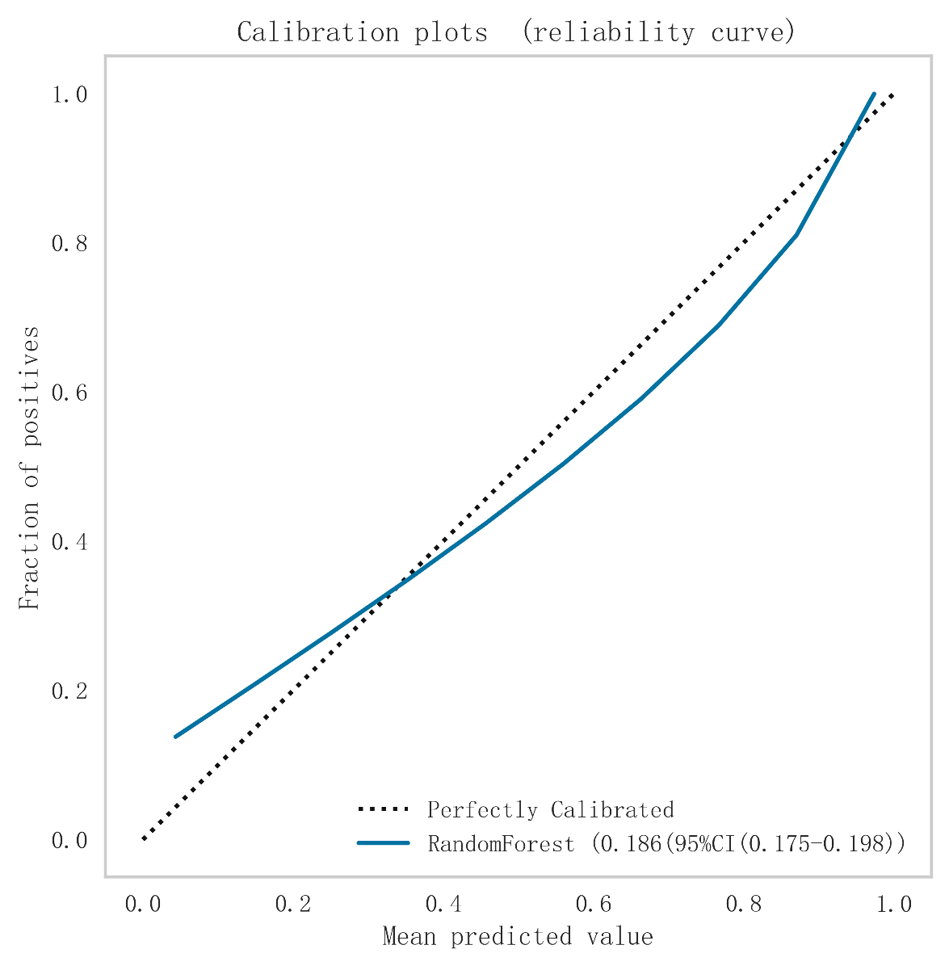
Figure S1a. Calibration plot for the Random Forest model. The solid blue line represents the model's predicted probabilities compared to actual outcomes, while the dashed line indicates perfect calibration. The closer the blue line is to the dashed line, the better the model is calibrated. The model's AUC is 0.186 (95% CI: 0.175–0.198).

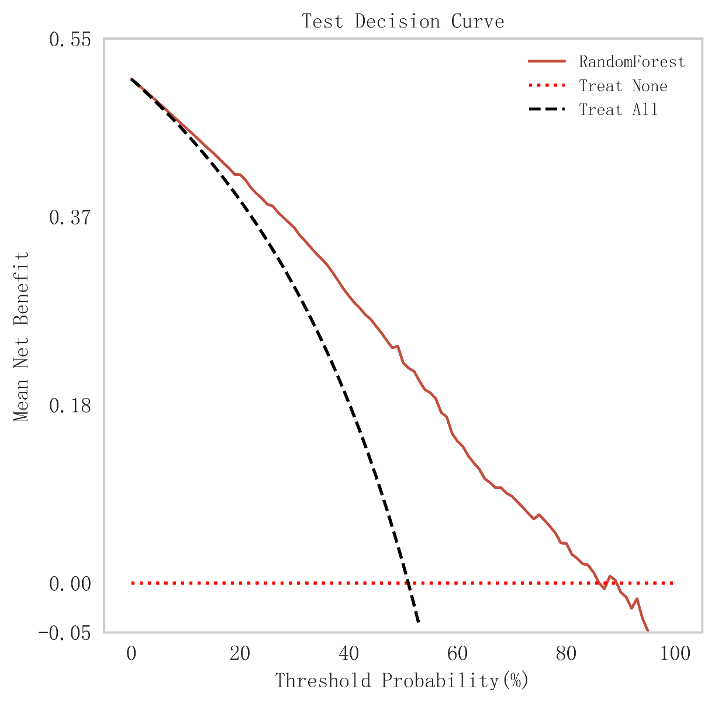
Figure S1b. Decision curve analysis for the Random Forest model. The solid red line represents the net benefit of the Random Forest model across different threshold probabilities. The dashed black line indicates the net benefit of treating all patients, while the dotted red line represents treating none. The Random Forest model provides higher net benefit compared to treating all or none across a wide range of threshold probabilities.

