Additional File 1
Young, Empowered & Strong (YES): A study protocol paper for a randomized controlled trial of an mHealth symptom monitoring and self-management intervention for adolescent and young adult (AYA) breast cancer survivors

Table of Contents:
- Young, Empowered & Strong (YES) recruitment flyer
- Young, Empowered and Strong (YES) old portal screenshots
- Young, Empowered and Strong (YES) new portal and app screenshots

Young, Empowered & Strong (YES) recruitment flyer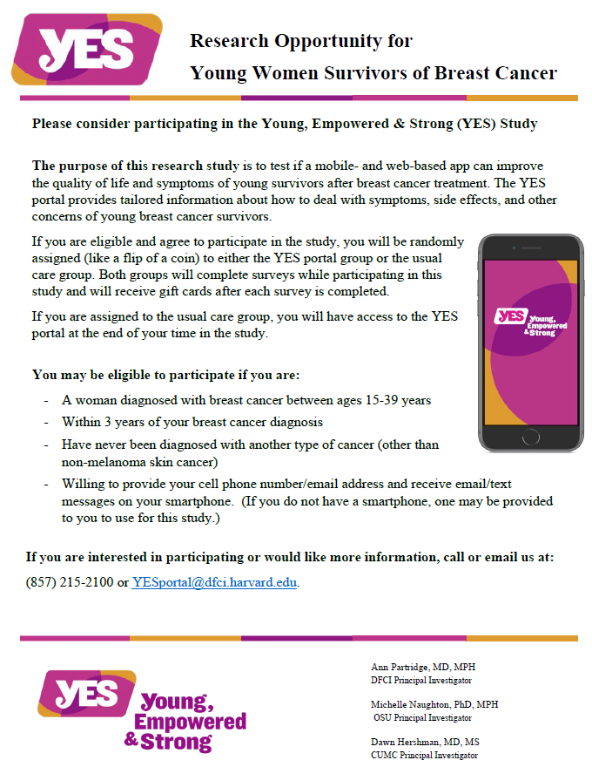

Young, Empowered and Strong (YES) old portal screenshots

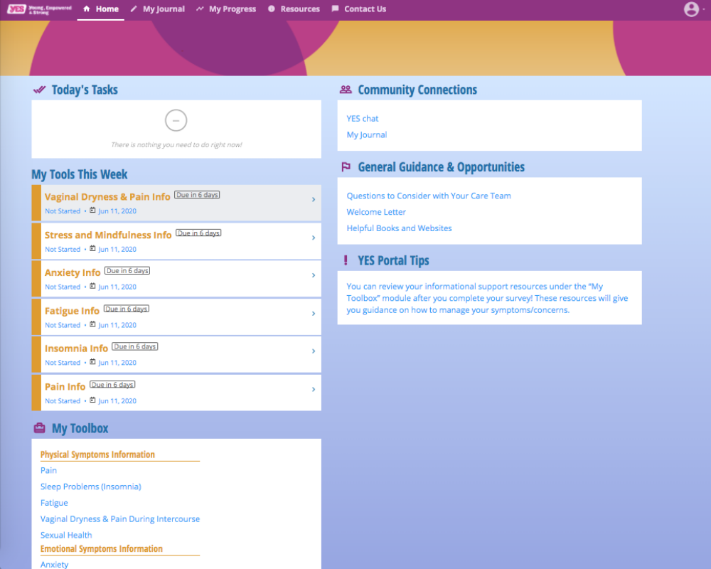

Young, Empowered and Strong (YES) new portal and app screenshots

