Additional File 1
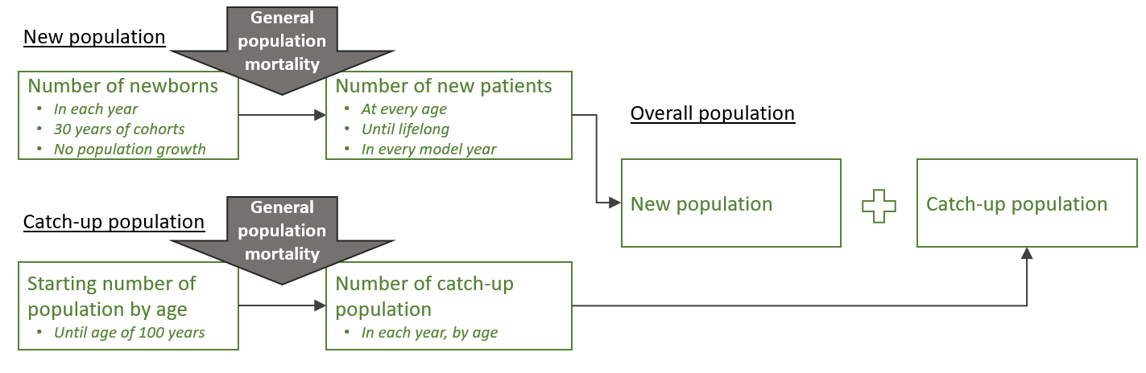
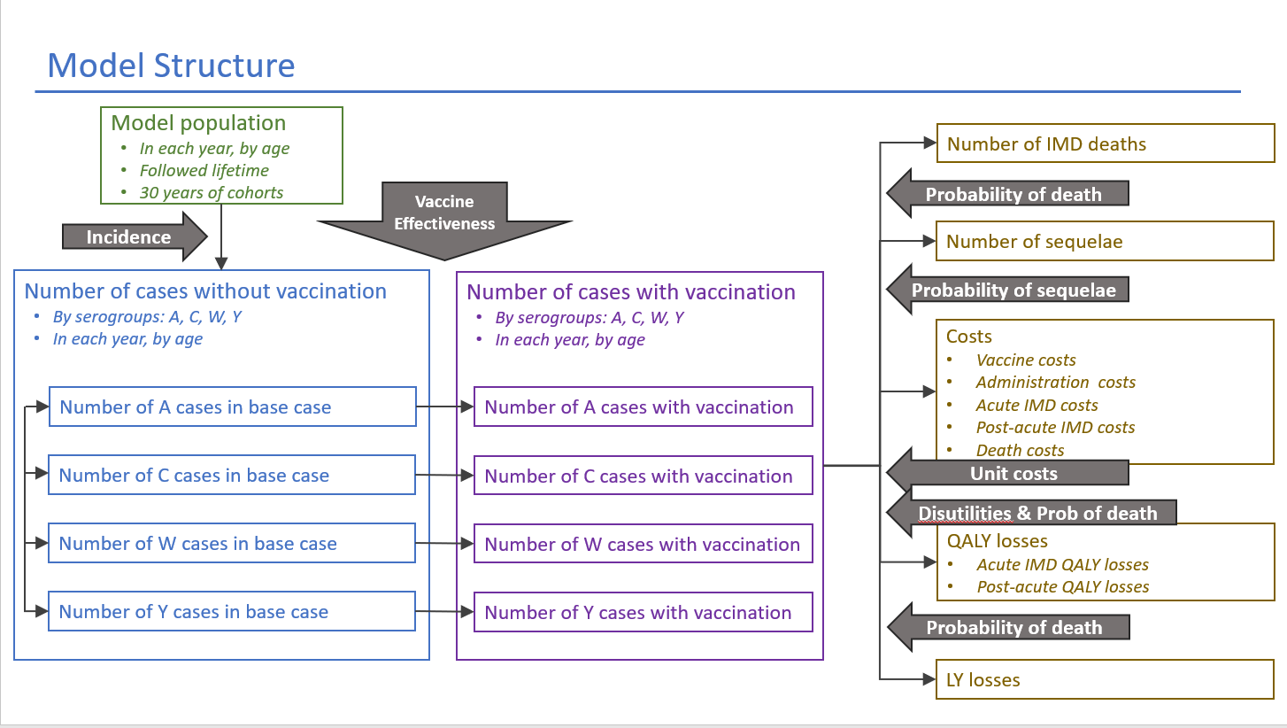
Figure A1. IMD Model Structure

Abbreviations: IMD = invasive meningococcal disease; LY = life year; QALY = quality-adjusted life year
Table A1. IMD Vaccination Strategies Explored
IMD Vaccination Strategies
MenC at 12 months of age (current and base-case comparison)
MenACWY at 12 months of age
MenC at 12 months and 13 years of age
MenC at 12 months and 16 years of age
MenC at 12 months and MenACWY at 13 years of age
MenC at 12 months and MenACWY at 16 years of age
MenACWY at 12 months and 13 years of age
MenACWY at 12 months and 16 years of age
MenC at 16 years of age
MenACWY at 16 years of age
Abbreviations: IMD = invasive meningococcal disease; MenACWY = meningococcal serogroup A, C, W, Y; MenC = meningococcal serogroup C
Table A2. German Population
Age | Population size
<1 year | 766,000
1 year | 764,000
2-4 years | 2,441,000
5-9 years | 4,155,000
10-14 years | 3,900,000
15-19 years | 3,954,000
20-24 years | 4,449,000
25-29 years | 5,016,000
30-59 years | 33,768,000
60+ years | 25,265,000
Source: | [1]

Table A3. IMD Serogroup Incidence Estimates
Age | Scenario 1 | Scenario 2 | Scenario 3 | Scenario 4
Age | High MenC** | High MenW*** | High MenY**** | High MenCWY
<1 year | 2.123 | 0.257 | 0.280 | High MenC, High MenW and High MenY incidence as in Scenario 1-3 are applied simultaneously
1 year | 2.138 | 0.130 | 0.000
2-4 years | 0.848 | 0.042 | 0.130
5-9 years | 0.395 | 0.010 | 0.030
10-14 years | 0.343 | 0.020 | 0.050
15-19 years | 0.740 | 0.067 | 0.340
20-24 years | 0.163 | 0.060 | 0.090
25-29 years | 0.050 | 0.040 | 0.020
30-59 years | 0.038 | 0.016 | 0.050
60+ years | 0.043 | 0.035 | 0.210
Source: | [2], query date: June 2023
Abbreviations: IMD = invasive meningococcal disease; RKI = Robert Koch-Institut; UK = United Kingdom
Note: Base case incidence values are averages of 10-year incidence, between 2010 and 2019
**High C incidences are averages of 2002–2005 values
***High W incidence is average of 2016-2018 values
**** High Y incidence values that were highest incidences across each age group from 2010–2019 were applied
Table A4. Vaccine Effectiveness
Population | MenC vaccine |  | MenACWY vaccine |  | Source
Population | Dose 1 | Dose 2 | Dose 1 | Dose 2 | Source
Toddler | 92% | 92% | 92% | 92% | Vesikari 2020[4], Ohm 2022[5]
Adolescent | 94% | 94% | 94% | 94% | Borja-Tabora 2020[6], Campbell 2022[7]
Abbreviations: MenACWY = meningococcal serogroup A, C, W, Y; MenC = meningococcal serogroup C

Table A5. Vaccine Effectiveness Inputs: Waning and Herd Effect
 | MenACWY vaccine | MenC vaccine | Source
Herd Effect*
Incidence multiplier | 50% | 50% | Carr et al, 2022 [8]
Annual Waning
Toddler | 22.12% | 22.12% | Vesikari 2020[4], Ohm 2022[5]
Adolescent | 5.85% | 5.85% | Borja-Tabora 2020[6], Campbell 2022[7]
Abbreviations: MenACWY = meningococcal serogroup A, C, W, Y; MenC = meningococcal serogroup C
Table A6. IMD Disease Manifestation Distribution
Manifestations | Distribution in Population (%)
Meningitis | 25.0%
Septicemia | 40.0%
Meningitis + Septicemia | 35.0%
Source: | RKI Data (2019)[3]
Abbreviations: RKI = Robert Koch-Institut
Table A7. IMD Case Fatality Rates by Age
Age | Case Fatality Rate
<1 year | 9.23%
1 year | 9.53%
2-4 years | 9.53%
5-9 years | 4.98%
10-14 years | 7.76%
15-19 years | 5.41%
20-24 years | 4.84%
25-29 years | 15.87%
30-59 years | 19.90%
60+ years | 28.22%
Source: Scholz 2022[9]
Abbreviations: RKI = Robert Koch-Institut
Table A8. Sequelae Rate
Sequelae | Probability of Sequelae | Source
Amputation | 1.26% | Viner et al. 2012[10]
Anxiety | 2.25% | Viner et al. 2012[10]
Arthritis | 7.47% | Cabellos et al. 2012[11]
Cognitive Impairment | 0.50% | Christensen et al. 2016[12]
Depression | 0.00% | Viner et al. 2012[10]
Hearing loss: Severe/Cochlear | 2.45% | Beck et al. 2021[13]
Hearing loss: Moderate/Bilateral | 3.80% | Beck et al. 2021[13]
Hearing loss: Impairment/Unilateral | 5.21% | Beck et al. 2021[13]
Migraine | 0.55% | Gottfredsson et al. 2011[14]
Motor Deficits | 0.77% | Scholz et al 2022,[9] Bettinger et al. 2013[15]
Neurological Disability | 1.79% | Scholz et al 2022,[9] Bettinger et al. 2013[15]
Renal Failure | 2.05% | Bettinger et al. 2013[15]
Seizure | 1.78% | Viner et al. 2012[10]
Skin Scarring | 6.39% | Bettinger et al. 2013[15]
Speech Problems | 3.56% | Viner et al. 2012[10]
Visual Impairment | 0.42% | Viner et al. 2012[10]
Note: duration of all sequelae is assumed to be lifelong
Table A9. Vaccine Cost Inputs
 | Vaccine Cost per Dose* | Administration Cost
MenACWY | € 34.11 | € 7.56
MenC | € 33.48 | € 7.56
Source | Stand Lauer-Taxe: 01.07.2023[16] | Associations of Statutory Health Insurance Physicians (Kassenärztliche Vereinigungen)
Abbreviations: MenACWY = meningococcal serogroup A, C, W, Y; MenC = meningococcal serogroup C
Note: based on 10-pack cost of NeisVac-C (€ 334.81) and Nimenrix (€ 341.14) valid from 01.07.2023[16]
Table A10. Acute IMD Cost Inputs
 | Meningitis | Septicemia | Meningitis + Septicemia | Source
Patient Healthcare Costs* | € 2590 | € 3909 | € 3647 | Huang 2020[17]
Patient Productivity Loss** | € 503 | € 503 | € 503 | Calculated based on Scholz 2022[9]
Caregiver's Productivity Loss*** | € 1,178 | € 1,178 | € 1,178 | Scholz 2022[9]
*Includes sum of overall IMD cost for <1 month and overall IMD costs - 1 month to 1 year that was assumed to be meningitis cost and was adjusted by cost ratios for septicemia and meningitis + septicemia, provided for each time period (<1 month and 1 month to 1 year).[17]
2016–2023 German inflation factor was applied[18]
** Sum of product of age-specific incidence (Table 2), population (Table A1) and acute care productivity losses of patient (if working) € 561.45 from Scholz 2022[9] applied to age 15 and above. 2015–2023 inflation[18] was applied to the cost.
*** Productivity losses for long-term acute care for family (if working), € 1,077.11 from Scholz 2022.[9] 2015–2023 inflation[18] was applied to the cost.
Table A11. IMD-related Death Cost Inputs
 | One-off Costs | Source
Medical Cost per Case | € 0 | Assumption
Lifetime productivity loss | € 948,145 | Calculated using 2022 average monthly salary (€ 4,105) [19] inflated to 2023[18] applied over 19 years
Caregiver's productivity loss | € 12,476 | Assuming 3-months productivity losses for caregivers. 2022 monthly salary (€ 4,105) [19] was inflated to 2023[18]
Table A12. Post-acute IMD Sequelae Patient Direct Cost
Sequelae | Patient Sequelae One Time Cost | Patient Sequelae Annual Cost
Amputation: Single limb | € 11,608 | € 2,640
Anxiety | € 0 | € 295
Arthritis | € 0 | € 5,031
Cognitive Impairment | € 2,101 | € 90
Depression | € 0 | € 508
Hearing loss: Adaptive listening strategies | € 51,177 | € 1,388
Hearing loss: Hearing aids | € 1,798 | € 1,469
Hearing loss: Cochlear implants | € 1,798 | € 1,469
Migraine | € 0 | € 0
Motor Deficits | € 486 | € 45
Neurological Disability | € 2,358 | € 133
Renal Failure | € 6,482 | € 4,656
Seizure | € 0 | € 4,959
Skin Scarring | € 2,195 | € 22
Speech Problems | € 2,057 | € 45
Visual Impairment | € 0 | € 812
Source of annual cost: 2017 arthritis cost derived from Schild 2021[20], costs of other sequelae (2015) were extracted from Scholz 2019[21] (“Direct medical costs – following years”). All costs were inflated to 2023.[18]
Source of one-time cost: Difference between annual cost after year 1 (“Direct medical costs – following years”) and first year cost (“Direct medical costs – 1st year”) from Scholz 2019.[21] 2015 costs were inflated to 2023.[18]
Note: zero costs were assumed for one-time cost of anxiety, arthritis, depression, migraine, seizure and visual impairment. Zero annual cost was assumed for migraine.
Table A13. Post-acute IMD Sequelae Patient and Caregiver Productivity Loss
Sequelae | Patient Productivity Loss | Caregivers Productivity Loss | Degree of Disability | Remaining productivity
Amputation: limb | € 9,293 | € 15,248 | 75 | 38.5%
Anxiety | € 5,681 | € 0 | 35 | 62.4%
Arthritis | € 4,321 | € 0 | 10 | 71.4%
Cognitive Impairment | € 6,014 | € 15,248 | 50 | 60.2%
Depression | € 5,681 | € 0 | 35 | 62.4%
Hearing loss: Adaptive listening strategies | € 9,293 | € 15,248 | 75 | 38.5%
Hearing loss: Hearing aids | € 4,080 | € 0 | 30 | 73.0%
Hearing loss: Cochlear implants | € 4,321 | € 0 | 10 | 71.4%
Migraine | € 0 | € 0 | 0 | 0%
Motor Deficits | € 9,973 | € 15,248 | 65 | 34.0%
Neurological Disability | € 9,670 | € 15,248 | 85 | 36.0%
Renal Failure | € 7,842 | € 15,248 | 60 | 48.1%
Seizure | € 9,973 | € 15,248 | 70 | 34.0%
Skin Scarring | € 2,418 | € 0 | 20 | 84.0%
Speech Problems | € 4,080 | € 0 | 25 | 73.0%
Visual Impairment | € 11,181 | € 15,248 | 100 | 26.0%
Source of degree of disability: Scholz 2019[21], assumption for arthritis and migraine.
Source of remaining productivity per loss of disability: Scholz 2019[21]
Patient productivity loss: product of (1- Remaining productivity) and patient long-term losses. Patient long-term losses were calculated as sum of product of age-specific incidence (Table 2) population (Table A1) and productivity losses of long-term care from Scholz 2022[9] applied to age 15 and above; the resulting productivity losses of long-term care was €13,811 (2015 Euros). 2015–2023 inflation[18] was applied to the cost.
Caregiver productivity loss: long-term caregiving cost from Scholz 2022[9] (€13,937) inflated to 2023. Caregiver productivity loss was assumed to be applicable to sequelae with disability degree greater or equal 50.
Table A14. Disutility Inputs during Acute IMD
Manifestations | Disutility
Meningitis | 0.400
Septicemia | 0.510
Meningitis + Septicemia | 0.510
Source: | Lecoq et al 2016[22]

Table A15. Disutility Inputs during Post-acute IMD
 |  | Patient | Caregiver* | Source of patient disutility
Patient without sequelae | Disutility | 0.03 | - | Koomen 2005[23]
Patient without sequelae | Duration | 9 years | - | Schmand 2010[24]
Caregivers after patient’s IMD death | Disutility | - | 0.07 | Song et al. 2010[25]
Caregivers after patient’s IMD death | Duration | - | 40 years | Assumption
Sequelae disutilities
Amputation: limb |  | 0.310 | 0.110 | Erickson 2001[26]
Anxiety |  | 0.250 | 0.110 | Saarni 2007[27]
Arthritis |  | 0.310 | 0.110 | Caban-Martinez et al. 2011[28]
Cognitive Impairment |  | 0.380 | 0.110 | Oostenbrink 2002[29]
Depression |  | 0.211 | 0.110 | Saarni 2007[27]
Hearing loss: Severe/Cochlear |  | 0.190 | 0.110 | Oostenbrink 2002[29]
Hearing loss: Moderate/Bilateral |  | 0.090 | 0.110 | Oostenbrink 2002[29]
Hearing loss: Impairment/Unilateral |  | 0.090 | 0.110 | Oostenbrink 2002[29]
Migraine |  | 0.186 | 0.110 | Xu et al 2011[30]
Motor Deficits |  | 0.330 | 0.110 | Oostenbrink 2002[29]
Neurological Disability |  | 0.250 | 0.110 | Stouthard 1997[31]
Renal Failure |  | 0.180 | 0.110 | Wyld 2000[32]
Seizure |  | 0.170 | 0.110 | Oostenbrink 2002[29]
Skin Scarring |  | 0.000 | 0.070 | Blakeney 1998[33]
Speech Problems |  | 0.220 | 0.110 | Al-Janabi 2016[34]
Visual Impairment |  | 0.740 | 0.110 | Brown 2001[35]
Abbreviation: IMD = invasive meningococcal disease; Source of caregiver sequelae disutility: Assumption

References
1. German Federal Statistical Office (Destatis): Prognose der Bevölkerungsentwicklung nach Alter -Table 0.15. 2023; [https://www.datenportal.bmbf.de/portal/de/K02.html]
2. Robert Koch-Institut: SurvStat@RKI 2.0. 2020; [https://survstat.rki.de/]
3. Robert Koch-Institut: Infektionsepidemiologisches Jahrbuch meldepflichtiger Krankheiten für 2019. 2020; [https://www.rki.de/DE/Content/Infekt/Jahrbuch/Jahrbuch_2019.pdf?__blob=publicationFile]
4. Vesikari T, Peyrani P, Webber C, Van Der Wielen M, Cheuvart B, De Schrevel N, Aris E, Cutler M, Li P, Perez JL: Ten-Year Antibody Persistence and Booster Response to MenACWY-TT Vaccine After Primary Vaccination at 1-10 Years of Age. Hum Vaccin Immunother 2020, 16(6):1280-1291.
5. Ohm M, Hahne SJM, van der Ende A, Sanders EAM, Berbers GAM, Ruijs WLM, van Sorge NM, de Melker HE, Knol MJ: Vaccine Impact and Effectiveness of Meningococcal Serogroup ACWY Conjugate Vaccine Implementation in the Netherlands: A Nationwide Surveillance Study. Clin Infect Dis 2022, 74(12):2173-2180.
6. Borja-Tabora CFC, Peyrani P, Webber C, Van der Wielen M, Cheuvart B, De Schrevel N, Bianco V, Aris E, Cutler M, Li P et al: A phase 2b/3b MenACWY-TT study of long-term antibody persistence after primary vaccination and immunogenicity and safety of a booster dose in individuals aged 11 through 55 years. BMC Infect Dis 2020, 20(1):426.
7. Campbell H, Andrews N, Parikh SR, White J, Edelstein M, Bai X, Lucidarme J, Borrow R, Ramsay ME, Ladhani SN: Impact of an adolescent meningococcal ACWY immunisation programme to control a national outbreak of group W meningococcal disease in England: a national surveillance and modelling study. Lancet Child Adolesc Health 2022, 6(2):96-105.
8. Carr JP, MacLennan JM, Plested E, Bratcher HB, Harrison OB, Aley PK, Bray JE, Camara S, Rodrigues CMC, Davis K et al: Impact of meningococcal ACWY conjugate vaccines on pharyngeal carriage in adolescents: evidence for herd protection from the UK MenACWY programme. Clin Microbiol Infect 2022, 28(12):1649 e1641-1649 e1648.
9. Scholz S, Schwarz M, Beck E, Meszaros K, Schneider M, Ultsch B, Greiner W: Public Health Impact and Cost-Effectiveness Analysis of Routine Infant 4CMenB Vaccination in Germany to Prevent Serogroup B Invasive Meningococcal Disease. Infect Dis Ther 2022, 11(1):367-387.
10. Viner RM, Booy R, Johnson H, Edmunds WJ, Hudson L, Bedford H, Kaczmarski E, Rajput K, Ramsay M, Christie D: Outcomes of invasive meningococcal serogroup B disease in children and adolescents (MOSAIC): a case-control study. Lancet Neurol 2012, 11(9):774-783.
11. Cabellos C, Nolla JM, Verdaguer R, Pelegrin I, Ribera A, Ariza J, Viladrich PF: Arthritis related to systemic meningococcal disease: 34 years' experience. Eur J Clin Microbiol Infect Dis 2012, 31(10):2661-2666.
12. Christensen H, Irving T, Koch J, Trotter CL, Ultsch B, Weidemann F, Wichmann O, Hellenbrand W: Epidemiological impact and cost-effectiveness of universal vaccination with Bexsero((R)) to reduce meningococcal group B disease in Germany. Vaccine 2016, 34(29):3412-3419.
13. Beck E, Klint J, Neine M, Garcia S, Meszaros K: Cost-Effectiveness of 4CMenB Infant Vaccination in England: A Comprehensive Valuation Considering the Broad Impact of Serogroup B Invasive Meningococcal Disease. Value Health 2021, 24(1):91-104.
14. Gottfredsson M, Reynisson IK, Ingvarsson RF, Kristjansdottir H, Nardini MV, Sigurdsson JF, Schneerson R, Robbins JB, Miller MA: Comparative long-term adverse effects elicited by invasive group B and C meningococcal infections. Clin Infect Dis 2011, 53(9):e117-124.
15. Bettinger JA, Scheifele DW, Le Saux N, Halperin SA, Vaudry W, Tsang R, Members of Canadian Immunization Monitoring Program A: The disease burden of invasive meningococcal serogroup B disease in Canada. Pediatr Infect Dis J 2013, 32(1):e20-25.
16. CGM Lauer: Herzlich Willkommen im CGM Lauer Kundun-Center. [https://portal.cgmlauer.cgm.com/LF/Seiten/Verwaltung/Kundencenter/1.aspx]
17. Huang L, Heuer OD, Janssen S, Hackl D, Schmedt N: Clinical and economic burden of invasive meningococcal disease: Evidence from a large German claims database. PLoS One 2020, 15(1):e0228020.
18. EUROSTAT: HICP (2015 = 100) - annual data (average index and rate of change) [prc_hicp_aind]. 2023 Average is June 2022 to May 2023. [https://ec.europa.eu/eurostat/web/hicp]
19. Federal Statistical Office of Germany: Earnings by economic branch and occupation. [https://www.destatis.de/EN/Themes/Labour/Earnings/Branch-Occupation/_node.html]
20. Schild M, Muller U, von Schenck U, Prieur S, Miller R: The burden of chronic pain for patients with osteoarthritis in Germany: a retrospective cohort study of claims data. BMC Musculoskelet Disord 2021, 22(1):317.
21. Scholz S, Koerber F, Meszaros K, Fassbender RM, Ultsch B, Welte RR, Greiner W: The cost-of-illness for invasive meningococcal disease caused by serogroup B Neisseria meningitidis (MenB) in Germany. Vaccine 2019, 37(12):1692-1701.
22. Lecocq H, Parent du Chatelet I, Taha MK, Levy-Bruhl D, Dervaux B: Epidemiological impact and cost-effectiveness of introducing vaccination against serogroup B meningococcal disease in France. Vaccine 2016, 34(19):2240-2250.
23. Koomen I, Raat H, Jennekens-Schinkel A, Grobbee DE, Roord JJ, van Furth M: Academic and behavioral limitations and health-related quality of life in school-age survivors of bacterial meningitis. Qual Life Res 2005, 14(6):1563-1572.
24. Schmand B, de Bruin E, de Gans J, van de Beek D: Cognitive functioning and quality of life nine years after bacterial meningitis. J Infect 2010, 61(4):330-334.
25. Song J, Floyd FJ, Seltzer MM, Greenberg JS, Hong J: Long-term Effects of Child Death on Parents' Health Related Quality of Life: A Dyadic Analysis. Fam Relat 2010, 59(3):269-282.
26. Erickson LJ, De Wals P, McMahon J, Heim S: Complications of meningococcal disease in college students. Clin Infect Dis 2001, 33(5):737-739.
27. Saarni SI, Suvisaari J, Sintonen H, Pirkola S, Koskinen S, Aromaa A, Lonnqvist J: Impact of psychiatric disorders on health-related quality of life: general population survey. Br J Psychiatry 2007, 190:326-332.
28. Caban-Martinez AJ, Lee DJ, Fleming LE, Tancredi DJ, Arheart KL, LeBlanc WG, McCollister KE, Christ SL, Louie GH, Muennig PA: Arthritis, occupational class, and the aging US workforce. Am J Public Health 2011, 101(9):1729-1734.
29. Oostenbrink R, HA AM, Essink-Bot ML: The EQ-5D and the Health Utilities Index for permanent sequelae after meningitis: a head-to-head comparison. J Clin Epidemiol 2002, 55(8):791-799.
30. Xu R, Insinga RP, Golden W, Hu XH: EuroQol (EQ-5D) health utility scores for patients with migraine. Qual Life Res 2011, 20(4):601-608.
31. Stouthard MEA, Essink-Bot ML, Bonsel GJ, Barendregt JJ, Kramers PGN, van der Water HA, Gunning-Schepers LJ, van der Maas PJ: Disability weights for disease in The Netherlands. 1997; [http://www.moh.govt.nz/notebook/nbbooks.nsf/0/2D7B9CE4FAF56E1ACC256C41000FF92C/$file/Disability%20Weights.pdf]
32. Wyld M, Morton RL, Hayen A, Howard K, Webster AC: A systematic review and meta-analysis of utility-based quality of life in chronic kidney disease treatments. PLoS Med 2012, 9(9):e1001307.
33. Blakeney P, Meyer W, 3rd, Robert R, Desai M, Wolf S, Herndon D: Long-term psychosocial adaptation of children who survive burns involving 80% or greater total body surface area. J Trauma 1998, 44(4):625-632; discussion 633-624.
34. Al-Janabi H, Van Exel J, Brouwer W, Trotter C, Glennie L, Hannigan L, Coast J: Measuring health spillovers for economic evaluation: a case study in meningitis. Health Econ 2016, 25(12):1529-1544.
35. Brown MM, Brown GC, Sharma S, Kistler J, Brown H: Utility values associated with blindness in an adult population. Br J Ophthalmol 2001, 85(3):327-331.

