Heatstroke Characteristics and Meteorological Conditions in Hefei, China: thresholds and driving factors
Xueliang Deng^{1,2}, Liang Zhao³, Changchun Xiao^{4*}, Rui Dai¹, Qianqian Xu¹, Yeqing Yao⁵, Caimeng Liang⁶, Lei Yao¹, Dongyan He^{2,7}
1 Hefei Meteorological Bureau, Hefei 230041, China
2 Key Laboratory of Cities Mitigation and Adaptation to Climate Change in Shanghai (CMACC), Shanghai 200092, China
3 State Key Laboratory of Numerical Modeling for Atmosphere Sciences and Geophysical Fluid Dynamics (LASG), Institute of Atmospheric Physics, Chinese Academy of Sciences, Beijing 100029, China
4 Hefei Center for Disease Control and Prevention, Hefei 230061, China
5 Anhui Public Meteorological Service Center, Hefei 230031, China
6 Key Laboratory of Meteorological Disaster, Ministry of Education, Joint International Research Laboratory of Climate and Environment Change, Collaborative Innovation Center on Forecast and Evaluation of Meteorological Disasters, Nanjing University of Information Science and Technology, Nanjing 210044, China
7 Anhui Climate Center, Hefei 230031, China
Corresponding author address: Changchun Xiao, Hefei Center for Disease Control and Prevention, Hefei 230061, China. Email: xiaocc_0552@aliyun.com
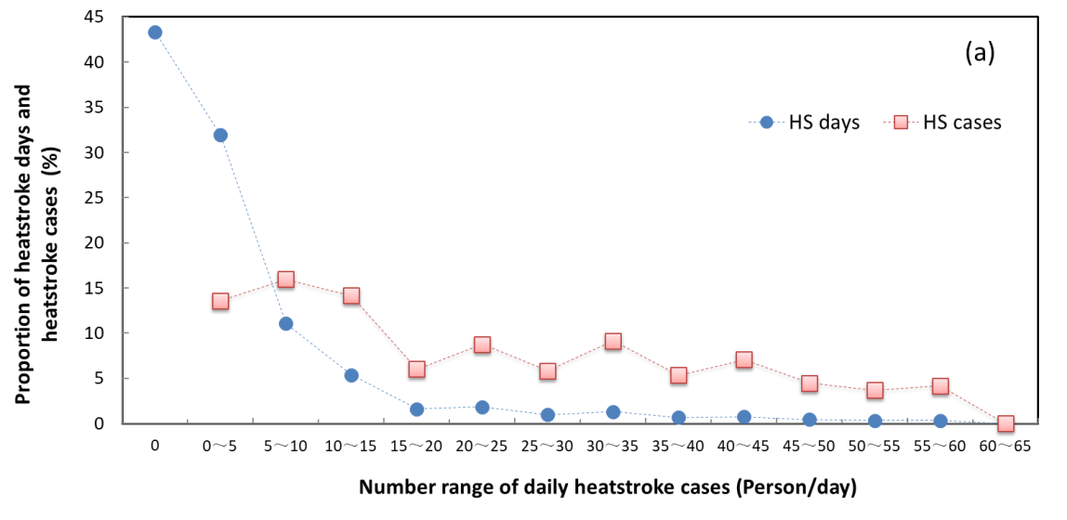
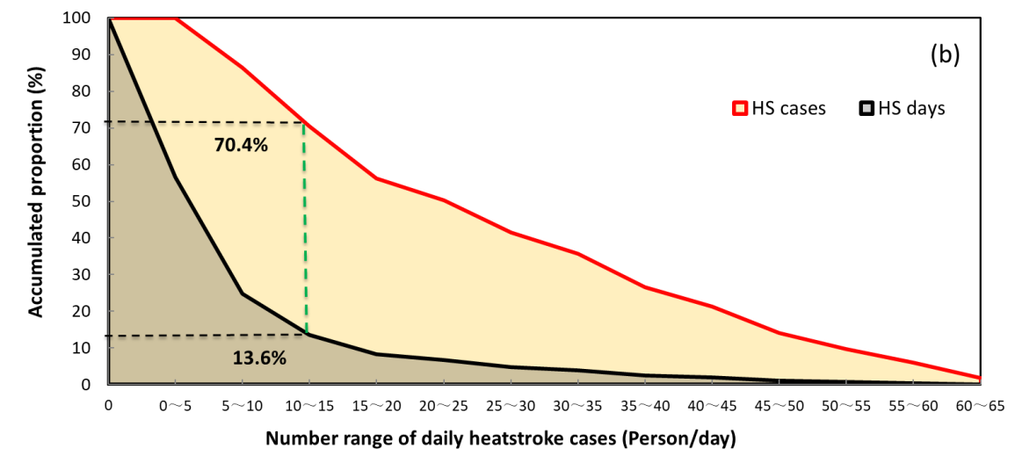
Fig. S1 Probability density distributions (a) and accumulated proportion (b) of heatstroke happen days and heatstroke cases in each number range of daily heatstroke cases in July and August during 2008-2022 in Hefei.

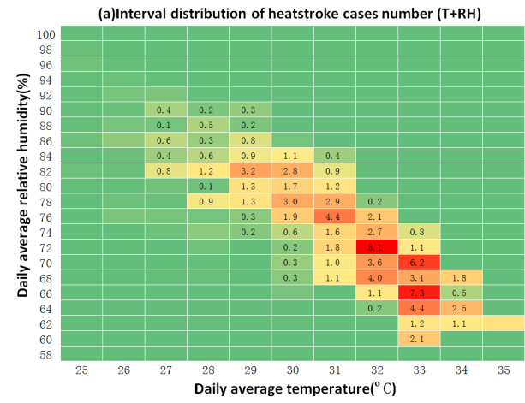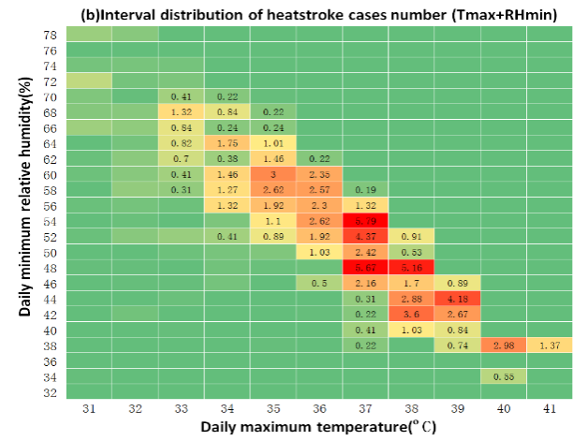

Fig. S2 Interval distribution of heatstroke cases number for each grid in daily average temperature and relative humidity (a), daily maximum temperature and minimum relative humidity (b) in July and August during 2008-2022 in Hefei.

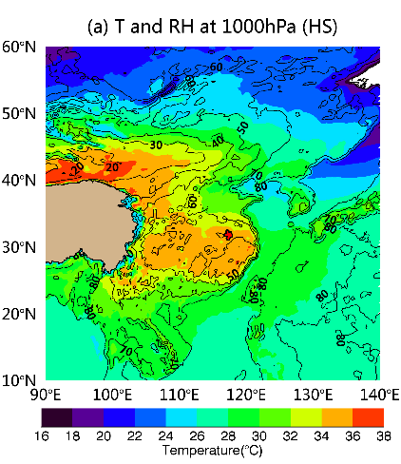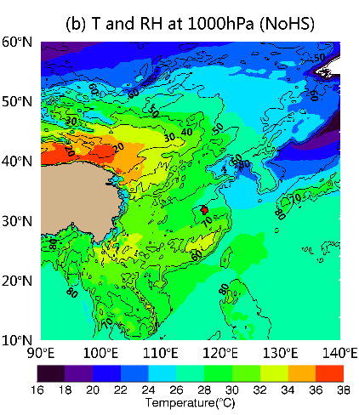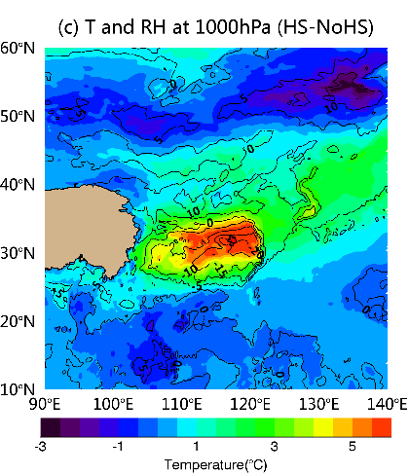
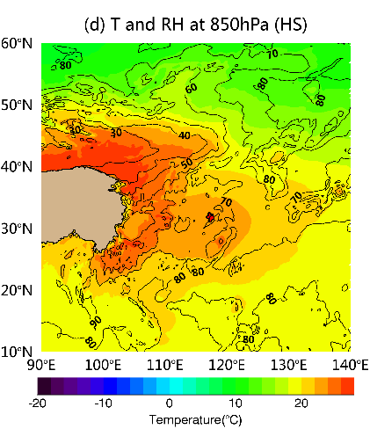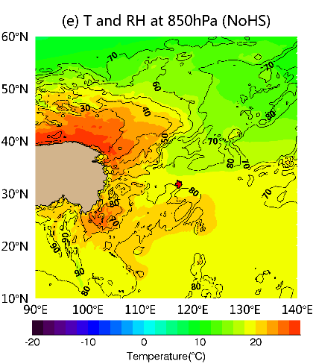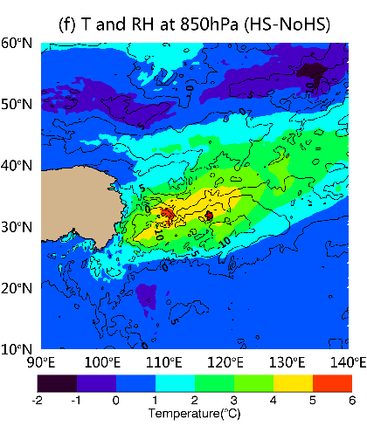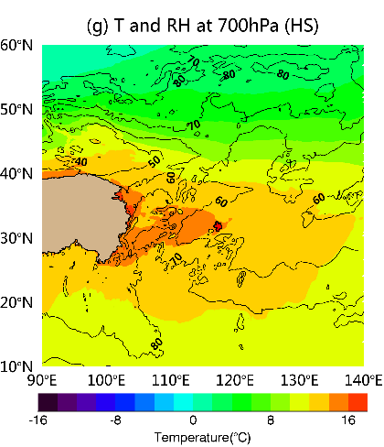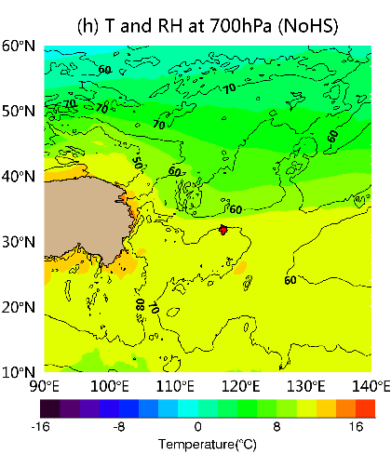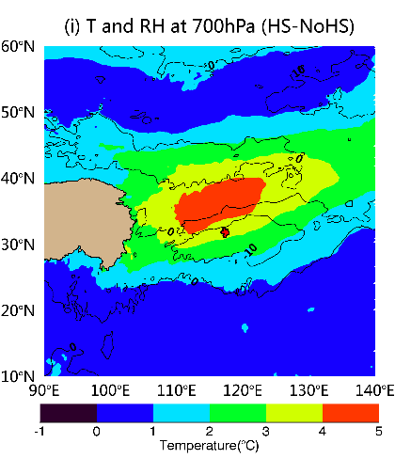
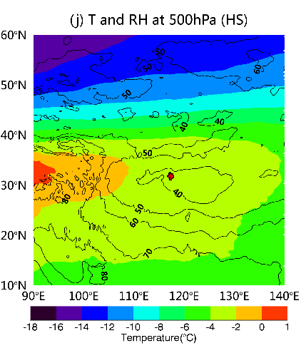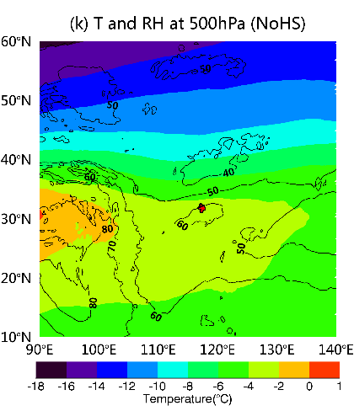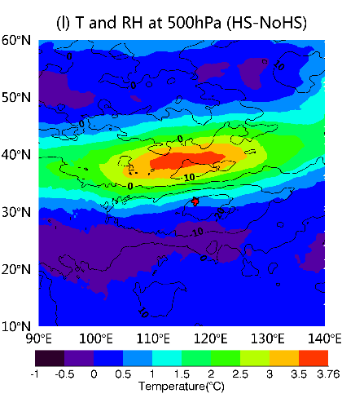
Fig. S3 Spatial distribution of the relative humidity (black contour), superimposed by temperature (shaded) at 1000 hPa (a,b,c), 850 hPa ( d,e,f ), 700 hPa ( g,h,i) and 500 hPa (j,k,l) pressure level under heatstroke happen days (left column), no heatstroke happen days (middle column) and the difference between them (right column), respectively, in July and August during 2008-2022. The areas highlighted with red lines represent the region of interest (Hefei).

