Supplementary material
- Supplemental Brief introduction of the Cohort 3
- Supplemental Table 1 The Bayesian Information Criterion for models with varying group number groups (two to five clusters) 5
- Supplemental Table 2 Cox proportional hazards analysis of the association between TyG index and cardiovascular disease risk in men living with HIV 6
- Supplementary Table 3 Cox proportional hazards analysis of the association between TyG index and cardiovascular disease risk in women living with HIV 7
- Supplementary Table 4 Sensitivity analysis of the association between TyG index and cardiovascular disease risk in PLWH including missing TyG values 8
- Supplementary Table 5 Logistic regression analysis of the association between the TyG index and cardiovascular disease risk in PLWH diagnosed with prevalent CVD prior to, at, or within three months of follow-up 9
- Supplementary Table 6 Cox proportional hazards analysis of the association between ART regimens and cardiovascular disease risk in PLWH 11
- Supplementary Table 7 Reclassification and discrimination of different models for TyG index and cardiovascular disease risk in PLWH 12
- Supplementary Table 8 Sensitivity analysis of the threshold effect of the TyG index on cardiovascular disease risk in PLWH excluding individuals with less than one year of follow-up 13
- Supplemental Fig. 1 Trajectory groups of TyG index over time in PLWH (two to five groups), identified using Group-Based Trajectory Modeling 14
- Supplemental Fig. 2 Comparative receiver operating characteristic (ROC) curves for the TyG index, TG/HDL ratio, fasting glucose, and LDL in predicting cardiovascular disease risk 15
- Supplemental Fig. 3 Multivariable adjusted spline curves for associations of the TyG index with cardiovascular disease in PLWH including the missing TyG values 16
- Supplemental Fig. 4 Multivariable adjusted spline curves for associations of the TyG index with cardiovascular disease in PLWH excluding people with less than one year of follow-up 17
- Survey questionnaire on the association between TyG index and cardiovascular disease in people living with HIV 18

Supplemental Brief introduction of the Cohort
This study is based on a cohort study at the Third People’s Hospital of Shenzhen, the only designated hospital for HIV care in Shenzhen, China. The hospital managed approximately 17,000 people living with HIV (PLWH) from 2010 to 2021. Antiretroviral therapy (ART) is provided free-of-charge according to national HIV treatment guidelines. PLWH visit the hospital every three months for continuous ART prescriptions and health monitoring. Before starting ART, comprehensive baseline assessments are conducted, including HIV viral load, T-cell subsets, common opportunistic infections, complete blood count, liver and kidney function, thyroid function, electrocardiogram, bone density, and co-infections (e.g., CMV, HBV, HCV, syphilis, HPV). Detailed patient histories and lifestyle information are also collected. After initiating ART, patients are regularly followed up every three months with routine HIV viral load and T-cell subset testing, and additional tests as needed. The high reimbursement rate of Shenzhen’s health insurance policies contributes to a low loss-to-follow-up rate, providing a stable cohort and valuable clinical data for research

The following are some studies we have conducted based on this cohort：
1. Li T, Sun L, He Y, et al. Increasing trends of overweight and obesity in treatment-naive people living with HIV in Shenzhen from 2014 to 2020: an emerging health concern. Front Public Health 2023; 11:1186838.
2. Sun L, He Y, Xu L, et al. Higher Risk of Dyslipidemia With Coformulated Elvitegravir, Cobicistat, Emtricitabine, and Tenofovir Alafenamide than Efavirenz, Lamivudine, and Tenofovir Disoproxil Fumarate Among Antiretroviral-Naive People Living With HIV in China. J Acquir Immune Defic Syndr 2022; 91: S8-S15.
3. Liu J, Hou Y, Sun L, et al. High population-attributable fractions of traditional risk factors for non-AIDS-defining diseases among people living with HIV in China: a cohort study. Emerging Microbes & Infections 2021; 10:416-423.
4. Liu J, Sun L, Hou Y, et al. Barriers to early diagnosis and treatment of persistently high burden of severely immunosuppressed patients with HIV-1: a quantitative and qualitative study. HIV Medicine 2020; 21:708-717.
5. Sun LQ, Liu JY, He Y, et al. Evolution of blood lipids and risk factors of dyslipidemia among people living with human immunodeficiency virus who had received first-line antiretroviral regimens for 3 years in Shenzhen. Chin Med J 2020; 133:2808-2815.
Supplementary Table 1 The Bayesian Information Criterion for models with varying group number groups (two to five clusters).
Number of trajectory group | Order of the trajectory polynomials | BIC | AIC | No. of patients classified into group | patients classified into group (%) | AvePP
2 | (3, 3) | -208076.5 | -208038.2 | 10095 | 63.6 | 0.979
 |  |  |  | 5784 | 36.4 | 0.970
3 | (3, 3, 3) | -182361.6 | -182304.0 | 6447 | 40.6 | 0.960
 |  |  |  | 6860 | 43.2 | 0.943
 |  |  |  | 2572 | 16.2 | 0.965
4 | (3, 3, 3, 3) | -170256.5 | -170179.8 | 4144 | 26.1 | 0.938
 |  |  |  | 6098 | 38.4 | 0.914
 |  |  |  | 4129 | 26.2 | 0.936
 |  |  |  | 1508 | 9.3 | 0.963
5 | (3, 3, 3, 3, 3) | -164011.0 | -163915.1 | 3382 | 21.3 | 0.926
 |  |  |  | 5446 | 34.3 | 0.895
 |  |  |  | 4240 | 26.7 | 0.904
 |  |  |  | 2255 | 14.2 | 0.933
 |  |  |  | 556 | 3.5 | 0.956
According to the likelihood ratio test, the final model is a four-group model. Order: 0= zero-order (intercept), 1=linear; 2= quadratic; 3=cubic. BIC= Bayesian Information Criterion; AIC= Akaike’s Information Criterion; AvePP= Average Posterior Probability

Supplementary Table 2 Cox proportional hazards analysis of the association between TyG index and cardiovascular disease risk in men living with HIV
 | Quartiles of TyG index |  |  |  | P value |  | Per 1 SD increase in  Log TyG values, P value
 | Quartile 1 | Quartile 2 | Quartile 3 | Quartile 4 |  |  | Per 1 SD increase in  Log TyG values, P value
Median | 7.93 | 8.32 | 8.65 | 9.14
No. of cases/Person-years | 14/ 21349 | 40/ 21164 | 47/ 20520 | 90/ 21060
Model 1, HR (95% CI) | 1.00 | 2.86 (1.55, 5.25) | 3.48 (1.91, 6.31) | 6.21 (3.53, 10.92) |  | <0.001 | 1.55 (1.38-1.73) <0.001
Model 2, HR (95% CI) | 1.00 | 2.23 (1.21, 4.11) | 2.42 (1.33, 4.41) | 3.51 (1.99, 6.19) |  | <0.001 | 1.35 (1.19-1.53) <0.001
Model 3, HR (95% CI) | 1.00 | 2.07 (1.11, 3.84) | 2.47 (1.34, 4.54) | 3.80 (2.11, 6.85) |  | <0.001 | 1.40 (1.22-1.61) <0.001
 | Trajectories of TyG index |  |  |  |  | P value | Per 1 SD increase in  Log TyG values, P value
 | Low-stable | Low-Moderate-stable | High-Moderate-stable | High-increasing |  |  | Per 1 SD increase in  Log TyG values, P value
Median | 8.06 | 8.43 | 8.78 | 9.25
No. of cases/Person-years | 19/20506 | 53/31680 | 70/22365 | 47/8329
Model 1, HR (95% CI) | 1.00 | 1.80 (1.06, 3.03) | 3.28 (1.97, 5.45) | 5.50 (3.21, 9.41) |  | <0.001 | 1.55 (1.38-1.74) <0.001
Model 2, HR (95% CI) | 1.00 | 1.33 (0.79, 2.26) | 2.09 (1.25, 3.47) | 2.93 (1.70, 5.03) |  | <0.001 | 1.36 (1.19-1.54) <0.001
Model 3, HR (95% CI) | 1.00 | 1.27 (0.75, 2.17) | 2.06 (1.21, 3.49) | 2.98 (1.67, 5.30) |  | <0.001 | 1.40 (1.22-1.60) <0.001
TyG, triglyceride-glucose; HR, hazard ratio; CI, confidence interval; ART, antiretroviral therapy
Model 1: an unadjusted model
Model 2: adjusted for age, body mass index, marital status
Model 3: adjusted for age, body mass index, marital status, smoking, drinking, high-density lipoprotein cholesterol, low-density lipoprotein cholesterol, total cholesterol, hypertension, CD4 count, HIV transmission route, Hepatitis B virus; Hepatitis C virus; ART treatment regimen
Supplementary Table 3 Cox proportional hazards analysis of the association between TyG index and cardiovascular disease risk in women living with HIV
 | Quartiles of TyG index |  |  |  | P value |  | Per 1 SD increase in  Log TyG values, P value
 | Quartile 1 | Quartile 2 | Quartile 3 | Quartile 4 |  |  | Per 1 SD increase in  Log TyG values, P value
Median | 7.90 | 8.33 | 8.65 | 9.14
No. of cases/Person-years | 1/ 2595 | 3/ 2608 | 8/ 2657 | 11/ 2930
Model 1, HR (95% CI) | 1.00 | 2.88 (0.30, 27.70) | 7.96 (1.00, 63.66) | 9.01 (1.16, 70.11) |  | 0.014 | 1.59 (1.11-2.27) 0.011
Model 2, HR (95% CI) | 1.00 | 2.10 (0.21, 20.55) | 3.00 (0.35, 25.39) | 2.68 (0.33, 21.73) |  | 0.780 | 1.08 (0.70-1.68) 0.716
Model 3, HR (95% CI) | 1.00 | 2.35 (0.68, 8.09) | 4.37 (1.79, 10.68) | 2.73 (1.18, 6.33) |  | 0.776 | 1.09 (0.69-1.73) 0.704
 | Trajectories of TyG index |  |  |  |  | P value | Per 1 SD increase in  Log TyG values, P value
 | Low-stable | Low-Moderate-stable | High-Moderate-stable | High-increasing |  |  | Per 1 SD increase in  Log TyG values, P value
Median | 8.13 | 8.51 | 8.80 | 9.21
No. of cases/Person-years | 2/3336 | 4/4053 | 12/2324 | 5/718
Model 1, HR (95% CI) | 1.00 | 1.65 (0.30, 9.03) | 8.41 (1.88, 37.60) | 11.2 (2.17, 57.82) |  | 0.020 | 1.56 (1.09-2.23) 0.015
Model 2, HR (95% CI) | 1.00 | 1.01 (0.18, 5.66) | 3.40 (0.73, 15.88) | 2.90 (0.52, 16.14) |  | 0.794 | 1.08 (0.70-1.67) 0.728
Model 3, HR (95% CI) | 1.00 | 1.01 (0.34, 2.99) | 3.13 (1.34, 7.29) | 2.87 (1.01, 8.16) |  | 0.765 | 1.10 (0.69-1.73) 0.693
TyG, triglyceride-glucose; PLWH, people living with HIV; HR, hazard ratio; CI, confidence interval; ART, antiretroviral therapy
Model 1: an unadjusted model
Model 2: adjusted for age, body mass index, marital status
Model 3: adjusted for age, body mass index, marital status, smoking, drinking, high-density lipoprotein cholesterol, low-density lipoprotein cholesterol, total cholesterol, hypertension, CD4 count, HIV transmission route, Hepatitis B virus; Hepatitis C virus; ART treatment regimen
Supplementary Table 4 Sensitivity analysis of the association between TyG index and cardiovascular disease risk in PLWH including missing TyG values
 | Quartiles of TyG index |  |  |  | P value |  | Per 1 SD increase in  Log TyG values, P value
 | Quartile 1 | Quartile 2 | Quartile 3 | Quartile 4 |  |  | Per 1 SD increase in  Log TyG values, P value
Median | 7.92 | 8.31 | 8.64 | 9.14
No. of cases/Person-years | 15/ 23741 | 41/ 23893 | 56/ 23431 | 104/ 24574
Model 1, HR (95% CI) | 1.00 | 2.69 (1.49, 4.87) | 3.76 (2.13, 6.64) | 6.37 (3.71, 10.96) |  | <0.001 | 1.57 (1.41-1.74) <0.001
Model 2, HR (95% CI) | 1.00 | 2.07 (1.14, 3.74) | 2.51 (1.42, 4.44) | 3.51 (2.04, 6.06) |  | <0.001 | 1.35 (1.20-1.52) <0.001
Model 3, HR (95% CI) | 1.00 | 1.89 (1.04, 3.44) | 2.40 (1.34, 4.28) | 3.32 (1.88, 5.87) |  | <0.001 | 1.36 (1.19-1.56) <0.001
 | Trajectories of TyG index |  |  |  |  | P value | Per 1 SD increase in  Log TyG values, P value
 | Low-stable | Low-Moderate-stable | High-Moderate-stable | High-increasing |  |  | Per 1 SD increase in  Log TyG values, P value
Median | 8.07 | 8.43 | 8.78 | 9.24
No. of cases/Person-years | 21/24044 | 59/36061 | 82/24827 | 52/9135
Model 1, HR (95% CI) | 1.00 | 1.87 (1.14, 3.08) | 3.70 (2.29, 5.97) | 6.04 (3.63, 10.04) |  | <0.001 | 1.57 (1.40-1.74) <0.001
Model 2, HR (95% CI) | 1.00 | 1.37 (0.83, 2.26) | 2.33 (1.44, 3.76) | 3.11 (1.87, 5.19) |  | <0.001 | 1.36 (1.20-1.53) <0.001
Model 3, HR (95% CI) | 1.00 | 1.29 (0.78, 2.13) | 2.21 (1.34, 3.64) | 2.90 (1.68, 5.00) |  | <0.001 | 1.38 (1.20-1.57) <0.001
TyG, triglyceride-glucose; PLWH, people living with HIV; HR, hazard ratio; CI, confidence interval; ART, antiretroviral therapy
Model 1: an unadjusted model
Model 2: adjusted for sex, age
Model 3: adjusted for sex, age, body mass index, marital status, smoking, drinking, high-density lipoprotein cholesterol, low-density lipoprotein cholesterol, total cholesterol, hypertension, CD4 count, HIV transmission route, Hepatitis B virus, Hepatitis C virus, ART treatment regimen
Supplementary Table 5 Logistic regression analysis of the TyG index and cardiovascular disease risk in PLWH diagnosed with prevalent CVD prior to at or within three months
Variables | OR (95% CI) | P value
TyG | 1.39 (0.74, 2.61) | 0.300
Age | 1.06 (1.03, 1.09) | <0.001
Sex | 0.59 (0.19, 1.63) | 0.335
BMI | 0.94 (0.84, 1.05) | 0.276
Marital status | 1.44 (0.77, 2.63) | 0.241
Smoking | 1.16 (0.46, 2.80) | 0.743
Drinking | 0.46 (0.15, 1.24) | 0.142
High-density lipoprotein cholesterol, mgdL | 0.93 (0.86, 1.00) | 0.046
Low-density lipoprotein cholesterol, mgdL | 0.99 (0.96, 1.02) | 0.565
Hypertension | 18.60 (6.44, 55.40) | <0.001
CD4 count, cells/μL | 1.00 (0.99, 1.00) | 0.963
HIV transmission route | 2.10 (1.46, 3.03) | <0.001
HBV | 0.51 (0.19, 1.48) | 0.192
HCV | 0.27 (0.03, 1.55) | 0.183
2NRTIs + ANV | 5.03 (0.05, 10.32) | 0.990
2NRTIs +NVP | 0.10 (0.01, 1.08) | 0.567
2NRTIs +LPV/r | 1.77 (1.53, 2.08) | <0.001
2NRTIs +EFV | 1.06 (0.87, 1.27) | 0.509
2NRTIs +DOR | 0.03 (0.01, 3.44) | 0.994
BIC/FTC/TAF | 2.07 (1.24, 3.12) | <0.001
EVG /c/FTC/TAF | 3.52 (1.89, 6.81) | <0.001
DTG-containing | 3.93 (2.79, 5.73) | <0.001
Others | 3.54 (1.93, 6.56) | <0.001
TyG, triglyceride-glucose; PLWH, people living with HIV; OR, odds ratio; CI, confidence interval; BMI, body-mass index; HIV, human immunodeficiency virus; HBV, hepatitis B virus; HCV, hepatitis C virus; NRTIs, nucleotide reverse transcriptase inhibitors; ANV, atazanavir; NVP, nevirapine; LPVr, lopinavir/ritonavir; EFV, efavirenz; DOR, doravirine; BIC, bictegravir; FTC, emtricitabine; TAF, tenofovir alafenamide; EVG, elvitegravir; DTG, dolutegravir

Supplementary Table 6 Cox proportional hazards analysis of the association between ART regimens and cardiovascular disease risk in PLWH
ART treatment regimen | HR (95% CI) | P value
2NRTIs + ANV | 1.76 (1.11, 2.80) | 0.016
2NRTIs +NVP | 0.88 (0.82, 0.94) | <0.001
2NRTIs +LPV/r | 0.89 (0.84, 0.94) | <0.001
2NRTIs +EFV | 0.86 (0.81, 0.90) | <0.001
2NRTIs +DOR | 1.02 (0.41, 2.53) | 0.965
BIC/FTC/TAF | 1.10 (0.95, 1.28) | 0.208
EVG /c/FTC/TAF | 0.98 (0.86, 1.12) | 0.785
DTG-containing | 1.11 (1.03, 1.20) | 0.005
Others | 0.96 (0.84, 1.10) | 0.540
Adjusted for sex, age, body mass index, marital status, smoking, drinking, high-density lipoprotein cholesterol, low-density lipoprotein cholesterol, total cholesterol, hypertension, CD4 count, Hepatitis B virus; Hepatitis C virus, HIV transmission route
TyG, triglyceride-glucose; ART, antiretroviral therapy; 3TC, lamivudine; AZT, zidovudine; ABC, Abacavir; FTC, Emtricitabine; TDF, tenofovir disoproxil fumarate; TAF, Tenofovir Alafenamide; ANV, Atazanavir; DDI, Didanosine; D4T, stavudine; NVP, nevirapine; LPVr, lopinavir/ritonavir; EFV, efavirenz; DOR, Doravirine; BIC, Bictegravir; EVG, Elvitegravir; DTG, Dolutegravir

Supplemental Table 7 Reclassification and discrimination of different models for TyG index and cardiovascular disease risk in PLWH
 | C statistic |  |  | NRI (continuous) |  |  | NRI (categorical) |  |  | IDI
 | Estimate (95% Cl) | P Value |  | Estimate  (95% Cl), % | P Value |  | Estimate  (95% Cl), % | P Value |  | Estimate (95%Cl), % | P Value
Conventional model | 0.835 (0.809, 0.867) |  |  | Reference |  |  | Reference |  |  | Reference
Conventional model + TyG | 0.849 (0.828, 0.875) | <0.001 |  | 37.78 (23.65, 48.12) | <0.001 |  | 1.65 (1.41, 1.87) | <0.001 |  | 0.17 (-0.28, 0.47) | 0.473
TyG, triglyceride-glucose; Cl, confidence interval; PLWH, people living with HIV; NRI, net reclassification improvement; IDI, integrated discrimination index
Conventional model included sex, age, body mass index, marital status, smoking, drinking, high-density lipoprotein cholesterol, low-density lipoprotein cholesterol, total cholesterol, hypertension, CD4 count, HIV transmission route, Hepatitis B virus; Hepatitis C virus, ART treatment regime
Supplemental Table 8 Sensitivity analysis of the threshold effect of TyG index on cardiovascular disease risk in PLWH excluding people with less than one year of follow-up
 | Adjusted HR (95% CI) | P value
TyG index on cardiovascular disease
Fitting by the standard Cox proportional risk model | 1.48 (1.18, 1.87) | <0.001
Fitting by the two-piecewise Cox proportional risk model
Infection point | 8.479
TyG index < 8.479 | 3.43 (1.12, 10.37) | 0.035
TyG index ≥ 8.479 | 1.31 (1.01, 1.78) | 0.041
P for Log-likelihood ratio | <0.001
TyG, triglyceride-glucose; HR, hazard ratio; CI, confidence interval; PLWH, people living with HIV
Cox proportional hazard models were used to estimate HR and 95% CI
Adjusted for sex, age, body mass index, marital status, smoking, drinking, high-density lipoprotein cholesterol, low-density lipoprotein cholesterol, total cholesterol, hypertension, CD4 count, HIV transmission route, Hepatitis B virus; Hepatitis C virus, ART treatment regimen

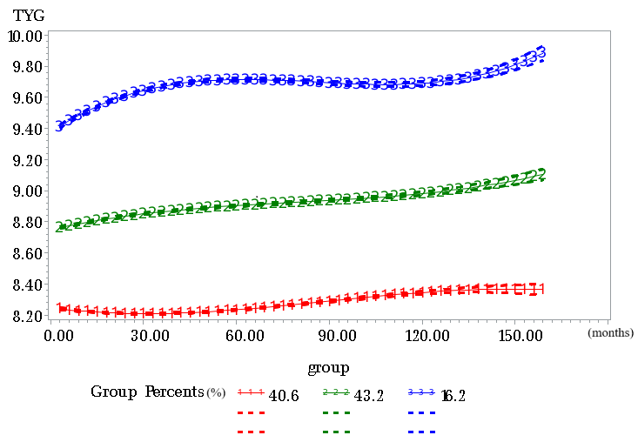
Supplemental Fig. 1 Trajectory groups of TyG index over time in PLWH (two to five groups), identified using Group-Based Trajectory Modeling
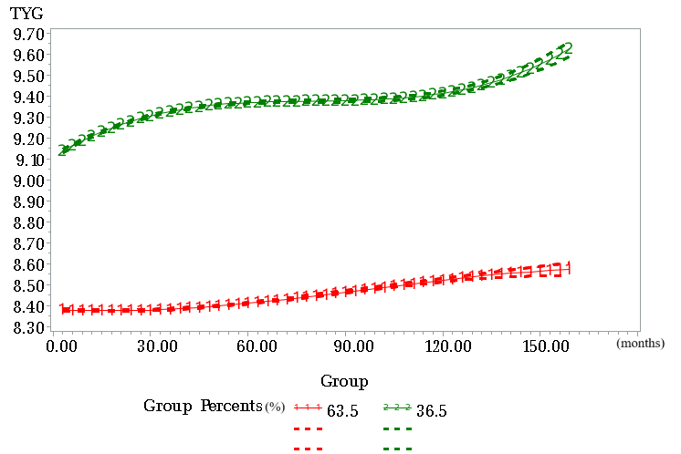

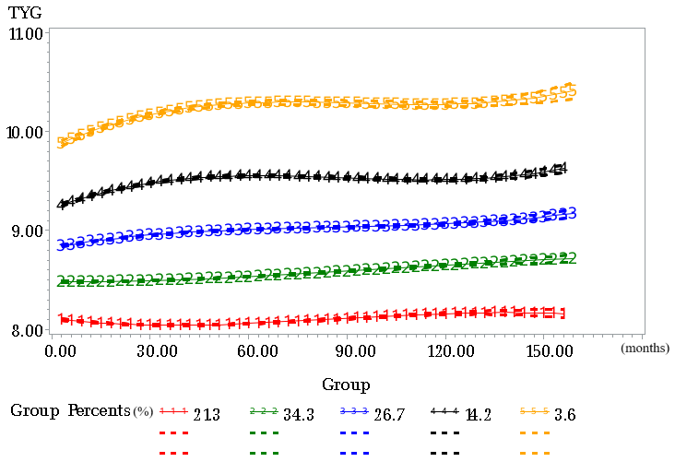
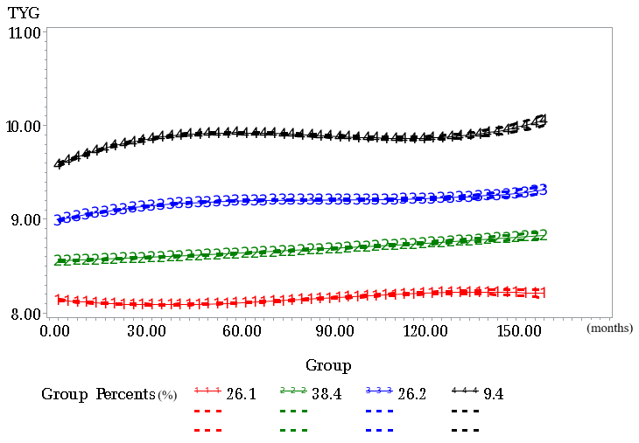

Supplemental Fig. 2 Comparative receiver operating characteristic (ROC) curves for the TyG index, TG/HDL ratio, fasting glucose, and LDL in predicting cardiovascular disease risk
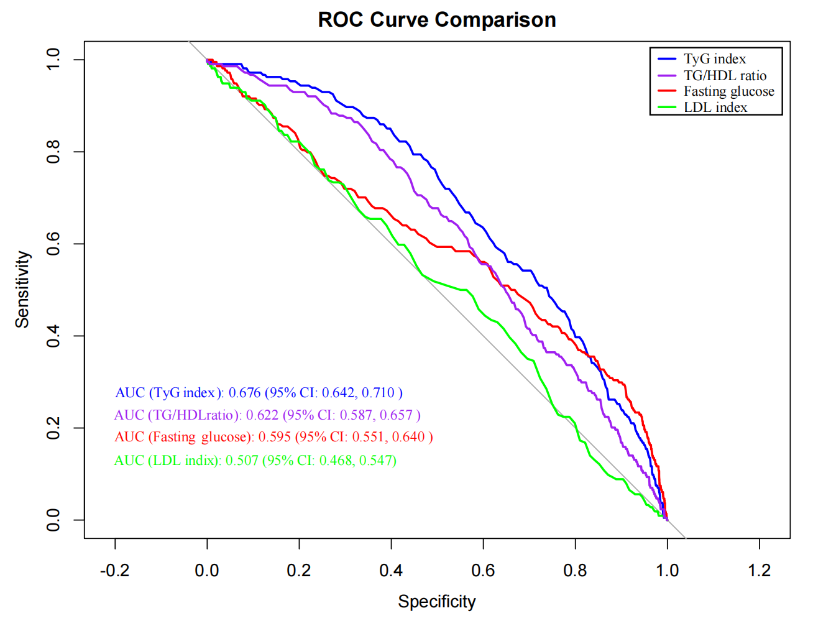

TyG, triglyceride-glucose; TG, triglycerides; HDL, high-density lipoprotein cholesterol; LDL, low-density lipoprotein cholesterol

Supplemental Fig. 3 Multivariable adjusted spline curves for associations of the TyG index with cardiovascular disease in PLWH including the missing TyG values

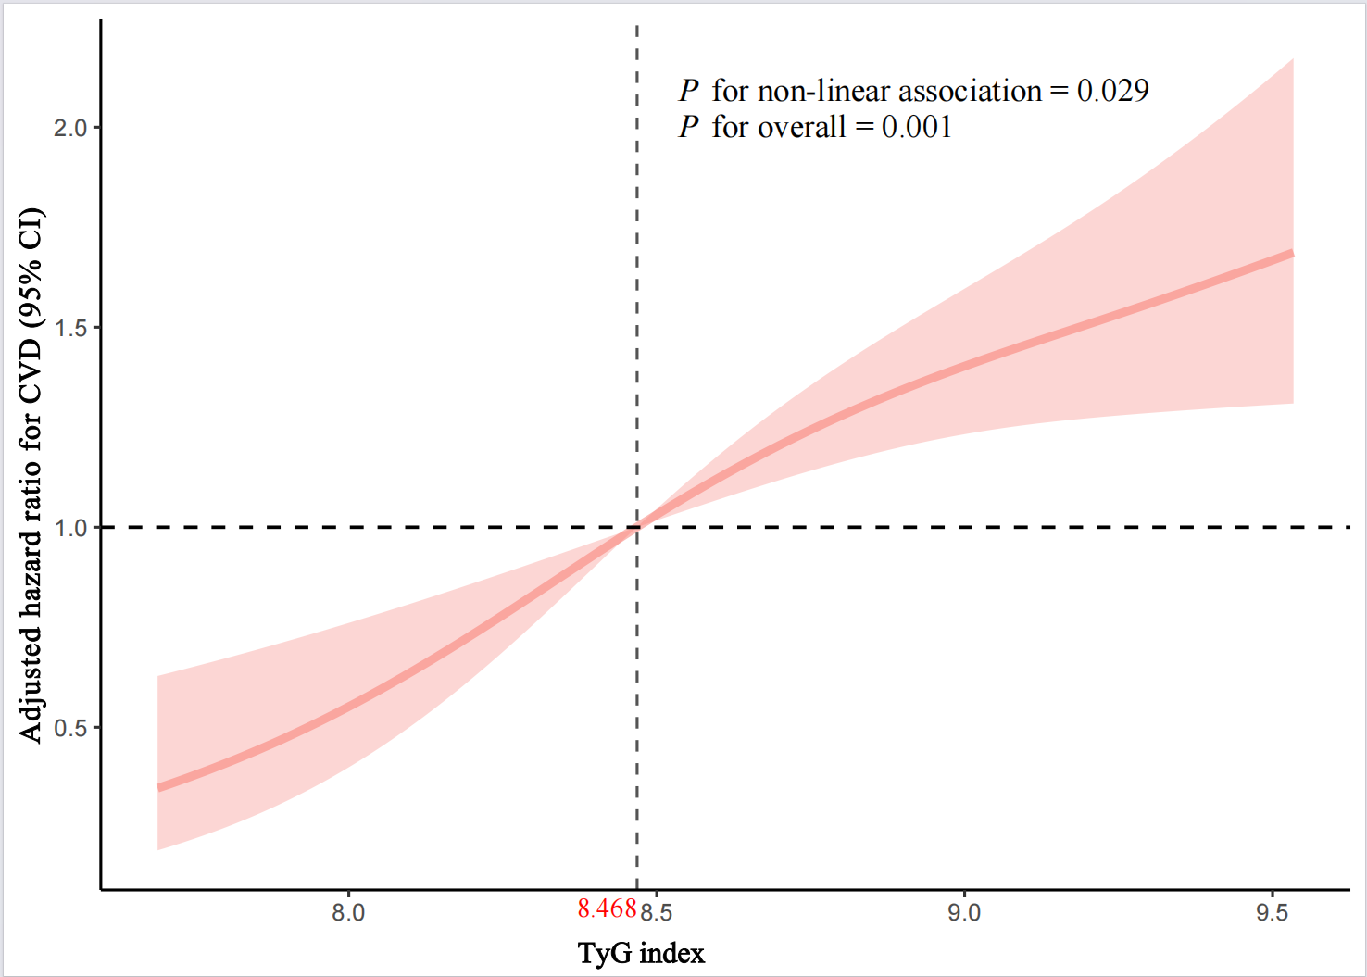

Hazard ratios adjusted for sex, age, BMI, marital status, smoking, drinking, HDL-C, LDL-C, TC, hypertension, CD4 count, HIV transmission route, HBV, HCV, ART treatment regimen.
The solid line and red area represent the estimated values and their corresponding 95% CI. TyG, triglyceride–glucose; CVD, cardiovascular diseases; PLWH, people living with HIV; HR, hazard ratio; CI, confidence interval; BMI, body mass index; HDL-C, high-density lipoprotein cholesterol; LDL-C, low-density lipoprotein cholesterol; TC, total cholesterol; HBV, hepatitis B virus; HCV, hepatitis C virus; ART, antiretroviral therapy

Supplemental Fig. 4 Multivariable adjusted spline curves for associations of the TyG index with cardiovascular disease in PLWH excluding people with less than one year of follow-up

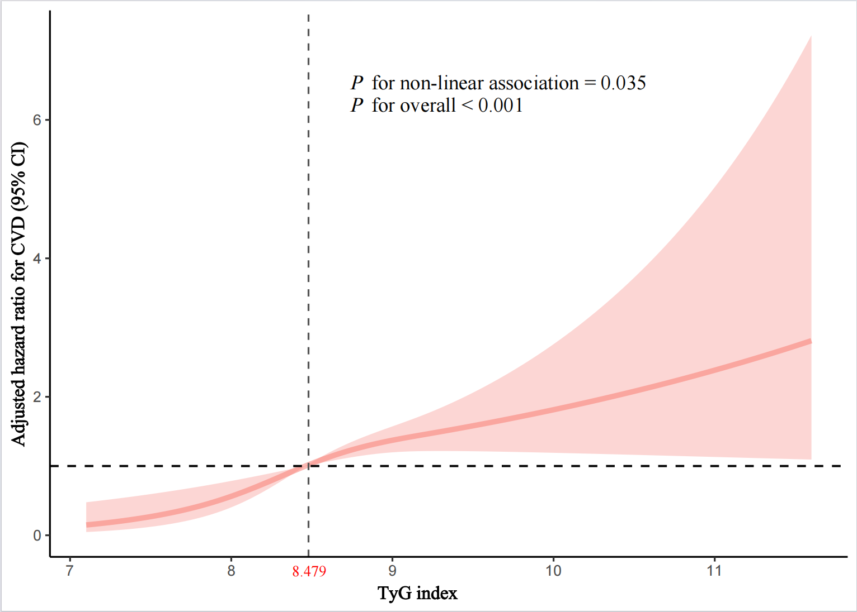

Hazard ratios adjusted for sex, age, BMI, marital status, smoking, drinking, HDL-C, LDL-C, TC, hypertension, CD4 count, HIV transmission route, HBV, HCV, ART treatment regimen.
The solid line and red area represent the estimated values and their corresponding 95% CI. TyG, triglyceride–glucose; CVD, cardiovascular diseases; PLWH, people living with HIV; HR, hazard ratio; CI, confidence interval; BMI, body mass index; HDL-C, high-density lipoprotein cholesterol; LDL-C, low-density lipoprotein cholesterol; TC, total cholesterol; HBV, hepatitis B virus; HCV, hepatitis C virus; ART, antiretroviral therapy

Survey questionnaire on the association between TyG index and cardiovascular disease in people living with HIV
Ⅰ. Demographic information
1. ID number：
2. Name： ; Age:
3. Gender：①Male ②Female
4. Contact number：
5. Sexual orientation：①Heterosexual ②Homosexual ③Bisexual ④Other
6. Ethnicity：①Han ②Hui ③Miao ④Uyghur ⑤Manchu ⑥Zhuang ⑦Other
7. Education level: ①Illiterate or minimal literacy ②Primary school ③Junior high school ④High school / Vocational high school / Technical school ⑤College / Bachelor’s degree ⑥Master’s degree or higher
8. Occupation：①Civil servant ②Teacher ③Medical professional ④Other public sector employee ⑤Student ⑥Farmer ⑦Worker ⑧Other corporate employee ⑨Other
9. Marital status: ①Married or cohabiting ②Divorced or separated ③Widowed ④Never married
10. Personal medical insurance (multiple choices allowed): ①Resident medical insurance ②Employee medical insurance ③Commercial medical insurance ④No medical insurance
11. Permanent residence: ①Urban ②Rural
Ⅱ. Laboratory parameters and comorbidities
1.Height (m): ______; Weight (kg): ______
2. Glucose level: ______ mmol/L
3. HDL-C (High-density lipoprotein cholesterol): ______ mmol/L
4. LDL-C (Low-density lipoprotein cholesterol): ______ mmol/L
5. Triglycerides (TG): ______ mmol/L
6. Total cholesterol (TC): ______ mmol/L
7. Creatinine: ______ µmol/L
8 AST (aspartate aminotransferase): ______ U/L
9. ALT (alanine aminotransferase): ______ U/L
10. White blood cells (WBC): ______ ×10⁹/L
11. Platelet count: ______ ×10⁹/L
12. Hypertension
① Yes, diagnosed
② Yes, on antihypertensive medication
③ No
13. Diabetes:
① Yes, diagnosed
② Yes, on diabetes medication
③ Yes, fasting glucose ≥ 7 mmol/L
④ No
14. Hypercholesterolemia:
① Yes, TC ≥ 5.2 mmol/L
② Yes, using lipid-modifying agents
③ No
15. Hepatitis B Virus (HBV) Infection:
① Positive HBV surface-antigen test
② Positive envelope-antigen test
③ Detectable HBV DNA
④ No
16. Hepatitis C Virus (HCV) Infection:
① Positive anti-HCV antibody test
② Detectable HCV RNA
③ No

Ⅲ. HIV-Related Information
- Route of HIV transmission:
① Male-to-male sexual contact
② Heterosexual contact
③ Injection drug use
④ Other
- Immune system assessment:
① Current CD4 count (CCD4) (most recent CD4 count): ______ cells/µL
② CD4 count at diagnosis (DCD4): ______ cells/µL
③ Nadir CD4 count (NCD4): ______ cells/µL
- Time interval between HIV diagnosis and ART initiation:
① <1 month
② 1-3 months
③ >3 months
- Virological assessment:
① Current serum viral RNA copy number (CBENA): ______
② Serum viral RNA copy number at diagnosis (DBRNA, leave blank if no results):______
- Antiretroviral therapy (ART) information:
(1) Current drug combination (CART): ______
(2) Switch in therapy (SART): ① Yes ② No
If therapy was switched, reason for switch (RART):
① Drug interaction
② Side effects
③ First-line treatment failure
④ Pregnancy-related reasons
⑤ Other
(3) Previous drug combination before switch (PRART):
(4) Years on antiretroviral therapy (convert months to years if less than one year) (YART): ______
8. HIV transmission route (HTRANS):
① Sexual transmission via anal intercourse
② Sexual transmission via vaginal intercourse
③ Injection drug use
④ Blood transfusion (medical transfusion or blood selling)
⑤ Mother-to-child transmission
⑥ Don’t remember

