Supplementary materials

Supplementary Table 1: Coding approach for the 30-variables electronic frailty index
No. | Deficits | Data source | Coding
1 | Coronary atherosclerosis and other heart disease | Medical history | 1 = Any of the ICD-10 codes: I20, I24, I25, Z95.1
2 | Stroke or transient ischemic attack | Medical history | 1 = Any of the ICD-10 codes: G45.0–G45.3, G45.8–G45.9, H34.1, I60, I61, I63, I64
3 | Hypertension | Medical history | 1 = Any of the ICD-10 codes: I10–I13, I15
 |  | Physical examination | 1 = Systolic≥140 mm Hg or diastolic≥90 mm Hg
4 | Cardiac arrhythmia | Medical history | 1 = Any of the ICD-10 codes in the past year: I49.9, I49.80, I25.104
5 | Chronic pulmonary disease | Medical history | 1 = Any of the ICD-10 codes: I27.8, I27.9, J40.x–J47.x, J60.x–J67.x, J68.4, J70.1, J70.3
6 | Asthma | Medical history | 1 = Any of the ICD-10 codes: J45
7 | Abnormal breath sounds in the lungs | Physical examination | 1 = Record of abnormal breath sounds in the lungs
8 | Abnormal respiratory rate | Physical examination | 1 = Respiratory rate < 12 times/min or Respiratory rate > 24 times/min
9 | Peptic ulcer | Medical history | 1 = Any of the ICD-10 codes: K25–K28
10 | Gallstone | Medical history | 1 = Any of the ICD-10 codes: K80
11 | Constipation | Medical history | 1 = Any of the ICD-10 codes: K59.000, BNP000
 |  | Physical examination | 1= Symptom record of Constipation
12 | Diabetes | Medical history | 1 = Any of the ICD-10 codes: E10–E14
 |  | Physical examination | 1 = Fasting blood glucose ≥7.0 mmol/L
13 | Thyroid dysfunction | Medical history | 1 = Any of the ICD-10 codes: E00–E07, E89.0, R94.6
14 | Rheumatoid arthritis or osteoarthritis | Medical history | 1 = Any of the ICD-10 codes: M05, M06, M15–M19, M31.5, M32-M34, M35.1, M35.3, M36.0
15 | Fracture | Medical history | 1 = Any of the ICD-10 codes: M48.5, M80.0, M80.8, M84.3–M84.7, S02, S12, S22, S32, S42, S52, S62, S72, S82, S92
16 | Osteoporosis | Medical history | 1 = Any of the ICD-10 codes: M80, M81
17 | Chronic kidney disease | Medical history | 1 = Any of the ICD-10 codes: N03, N04, N05, N11.9, N18, N19, E11.2, E13.2, I12, I13.1
18 | Estimated glomerular filtration rate(eGFR) | Physical examination | 1 = <60 ml/min/1.73 m2
19 | Cancer | Medical history | 1 = Any of the ICD-10 codes: C00–C97
20 | Neurasthenia | Medical history | 1 = Any of the ICD-10 codes: F00-F03, F48.000, R45.000, F99
21 | Sleep disorders | Medical history | 1 = Any of the ICD-10 codes: F51, G47, R40.000
22 | Depression or anxiety | Medical history | 1 = Any of the ICD-10 codes: F20.4, F31.3–F31.5, F32, F33, F34.1, F41.2, F43.2
23 | Anemia | Medical history | 1 = Any of the ICD-10 codes: D50.0, D50.8, D50.9, D51–D53
24 | Weight loss | Physical examination | 1 = weight loss ≥ 2.5kg in the past year
25 | Obesity or underweight | Physical examination | 0 = BMI≥18.5 kg/m² and <24.0 kg/m²; 0.5 = BMI ≥24.0 kg/m² and <28.0 kg/m²; 1 = BMI <18.5 kg/m² or ≥28.0 kg/m²
26 | Hemoglobin (HGB) | Physical examination | 0 = 135–180 g/L for men and 120–160 g/L for women; 1 = <135 or >180 g/L for men, and <120 or >160 g/L for women
27 | Hearing impairment | Physical examination | 1 = hearing problem record
28 | Physical activity | Physical examination | 1 = never exercise
29 | Chronic pain | Medical history | 1 = Any of the ICD-10 codes in the last year: F45.4, M08.1, M25.5, M43.2–M43.6, M45, M46.1, M46.3, M46.4, M46.9, M47, M48.0, M48.1, M48.8, M48.9, M50.8, M50.9, M51, M53.1–M53.3, M53.8, M53.9, M54, M60.8, M60.9, M63.3, M79.0–M79.2, M79.6, M79.7, M96.1
 |  | Physical examination | 1 = symptom record of headache and chest pain
30 | Dentures | Physical examination | 1 = Dentures problem record

Supplementary Table 2: Sensitivity analyses for association of eFI with hospitalization and all-cause mortality by removing participants with 5 major diseases at baseline in the development cohort
 | Removing participants with corresponding diseases at baseline
Outcome | Diabetes | Heart disease | Stroke or transient ischemic attack | Emphysema or chronic bronchitis | Cancer
Hospitalization
Prefrail | 1.55(1.43-1.69) | 1.53(1.40-1.67) | 1.57(1.45-1.69) | 1.62(1.50-1.75) | 1.62(1.51-1.75)
Frailty | 2.26(1.89-2.71) | 1.90(1.52-2.37) | 2.08(1.79-2.41) | 2.48(2.14-2.88) | 2.34(2.06-2.65)
Mortality
Prefrail | 1.72(1.18-2.52) | 1.42(0.95-2.12) | 1.46(1.02-2.10) | 1.64(1.15-2.34) | 1.55(1.10-2.19)
Frailty | 2.54(1.42-4.53) | 2.34(1.14-4.79) | 1.95(1.09-3.47) | 2.35(1.37-4.03) | 2.15(1.34-3.47)

Supplementary Table 3: Sensitivity analyses for the impact of missing data definition on the clinical utility of the eFI in the development cohort
Outcome | Frailty status
 | Prefrail |  | Frail
Hospitalization | HR (95% CI) | p | HR (95% CI) | p
Univariate | 2.12(1.56-2.87) | <0.001 | 2.65(1.54-4.54) | <0.001
Multivariable | 1.98(1.44-2.72) | <0.001 | 2.32(1.32-4.09) | 0.003
Mortality
Univariate | 1.71(0.35-8.25) | 0.507 | 6.42(1.20-34.23) | 0.029
Multivariable | 1.50(0.31-7.31) | 0.613 | 5.93(1.11-31.51) | 0.037
For all outcomes the comparator is fit older people. Multivariable adjusted for age, sex, education status and marital status.
HR, hazard ratio; CI, confidence interval.

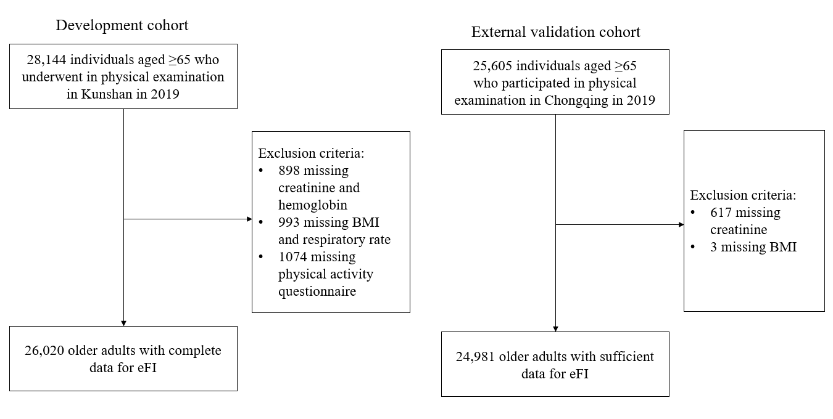

Supplementary Fig. 1: Flowchart of sample selection in development and external validation cohorts

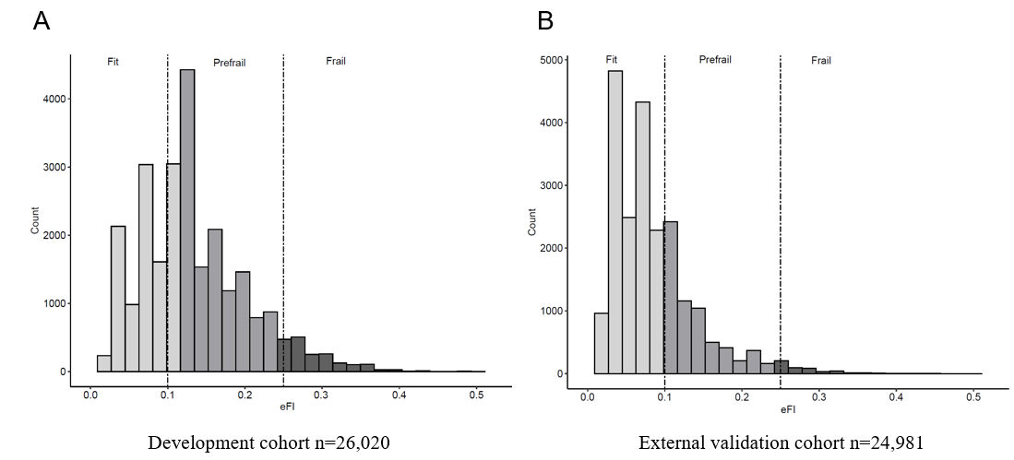

Supplementary Fig. 2: Distribution of the electronic frailty index in the development and external validation cohort

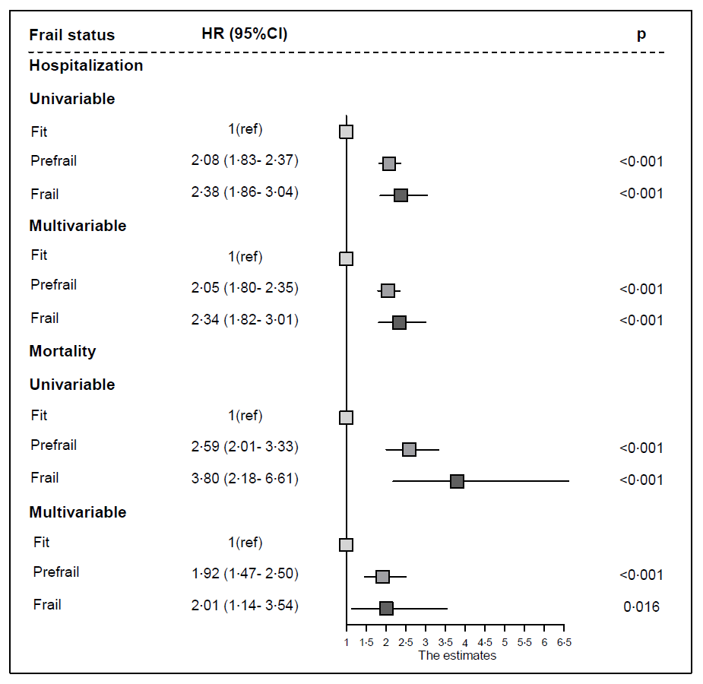

Supplementary Fig. 3: Forest plot between frailty status and adverse outcomes in the external validation cohort

