Supplementary information for A Randomized Controlled Trial of Empathetic Refutational Learning with Health Care Professionals

Table S1
Demographic differences between the control and ERI groups (Fisher’s Exact Test)
Variable | n | p | p (adj)
Age | 347 | .778 | 1.000
Gender | 347 | .221 | 1.000
Profession | 347 | .458 | 1.000
Vaccination work | 347 | .643 | 1.000
Children | 347 | .662 | 1.000
Note. Adjusted p-values are calculated with a Bonferroni correction of alpha = .05/5.

Table S2
Baseline differences between the control and ERI groups (Student’s t-test)
Variable | Control | ERI | t | df | p | p (adj)
Refutation
Pretest | 180 | 167 | 0.28 | 342.46 | 0.777 | 1.000
I-Pro-VC-Be
Self-efficacy | 180 | 167 | -0.81 | 342.85 | 0.418 | 1.000
Reluctant trust | 180 | 167 | -0.89 | 344.98 | 0.373 | 1.000
Openness to patients | 180 | 167 | -1.21 | 330.93 | 0.229 | 1.000
Commitment to vaccination | 180 | 167 | -0.97 | 341.68 | 0.334 | 1.000
Note. Refutation = Perceived difficulty of refuting anti-vaccination arguments. Adjusted p-values are calculated with a Bonferroni correction of alpha = .05/5.

Figure S1
Experimental procedure
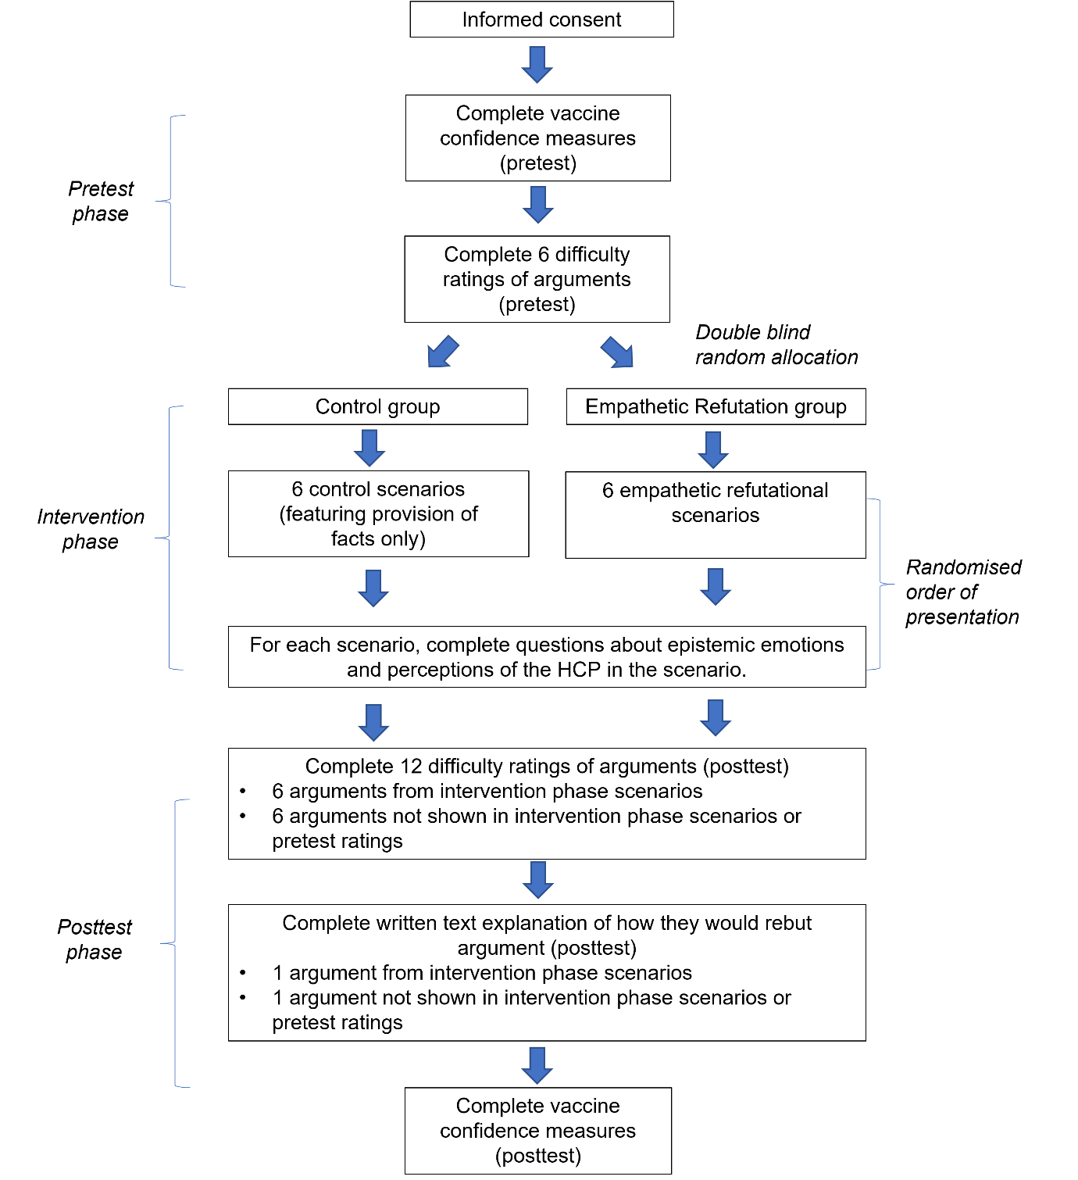

Table S3
Anti-vaccination arguments used in the experiment
Argument | Attitude root | Perceived difficulty of rebuttal  (z-score) |  | Endorsement of argument  (z-score)
Argument | Attitude root | UK | Finland | Endorsement of argument  (z-score)
The authorities are lying and covering up important information about vaccines. | Conspiracy | 0 | 0.38 | 0.25
“Big Pharma” is colluding with the medical authorities to profit from people getting vaccinated. | Conspiracy | 0.30 | 0.54 | 0.58
Research on vaccine safety is based on biased or incomplete data. | Distrust | 0.23 | 0.43 | 0.25
Medical authorities are overreacting, with vaccines being recommended for every minor illness now. | Distrust | -0.07 | -0.17 | 0.25
Powerful groups oppress disadvantaged groups and genders by imposing vaccination. | Distrust | 0.30 | 0.46 | 0.02
Instead of vaccines, people should improve environmental factors like good hygiene, healthy lifestyles, and protective measures against the disease. | Unwarranted beliefs | 0.14 | 0.27 | 0.41
Scientists are still debating the benefits of vaccination, and the science is not settled. | Unwarranted beliefs | 0.17 | 0 | 0.38
Politicians use vaccinations as strategies to boost their own political agendas at the expense of the common good. | Worldview & politics | - | - | 0.54
Not allowing religious exemptions to vaccines is discriminatory. | Religious concerns | - | - | 0.29
People should not accept vaccines that are produced using tissues from aborted foetuses. | Moral concerns | - | - | 0.30
I worry about experiencing side effects from the vaccine. | Fears & phobias | 0.15 | 0.02 | 0.68
Vaccines should not be administered to vulnerable people, such as pregnant women, young children or patients with allergies. | Fears & phobias | -0.20 | -0.11 | 0.40
Vaccines overwhelm the immune system, especially when taken in many doses. | Fears & phobias | -0.17 | -0.33 | 0.16
People should look after their own health rather than put themselves or their child at risk to protect others. | Perceived self-interest | - | - | 0.37
The vaccination movement does not respect alternative perspectives on health that are more comprehensive and holistic. | Epistemic relativism | - | - | 0.35
People are experts on their own bodies so they may legitimately conclude based on their own reading that vaccination is not for them. | Epistemic relativism | - | - | 0.40
Vaccination campaigns bully and harass people into getting a vaccine. | Reactance | - | - | 0.59
People should be able to decide what goes into their bodies, so it should be a matter of free personal choice whether someone gets a vaccine | Reactance | - | - | 1.17
Note. - indicates that data was not available for this argument (as it was not used in that study).

Figure S2
Structure and example of control and empathetic refutational interview text scenarios featuring the HCP and patient interaction
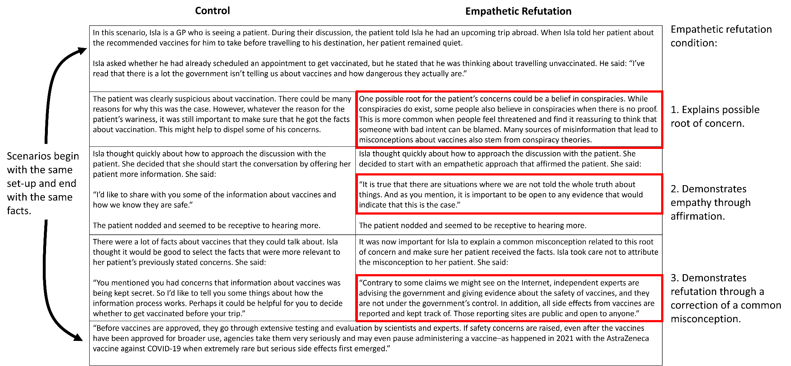

Table S4
Differences in emotional response to the control and ERI scenarios
Emotion | Group1 | Group2 | t | df | p | p (adj)
Surprised | Control | ER | -2.05 | 335.99 | .041 | .368
Curious | Control | ER | -1.81 | 343.12 | .071 | .636
Excited | Control | ER | -0.53 | 332.70 | .599 | 1.000
Confused | Control | ER | -1.91 | 328.58 | .057 | .515
Anxious | Control | ER | -0.89 | 335.16 | .376 | 1.000
Frustrated | Control | ER | -2.53 | 327.19 | .012 | .105
Bored | Control | ER | -1.75 | 325.37 | .080 | .724
Angry | Control | ER | -2.33 | 321.00 | .020 | .184
Irritated | Control | ER | -2.44 | 321.21 | .015 | .136
Note. Adjusted p-values are calculated with a Bonferroni correction of alpha = .05/9.

Table S5
Pre-registered coding framework for participants’ use of ERI techniques
Category | Description | Indicative example
Root concern | Participant mentions that the patients’ concerns may stem from a root or underlying concern, characteristic, or belief. | “This patient is probably worried about X.”
Empathy or affirmation | Participant describes needing to, or intending to show empathy to the patient when they respond, or describes “affirming” the patient. | “I would show empathy by giving the patient affirmation.”
Correcting misconceptions | Participant mentions the need to correct misconceptions the patient might hold, or demonstrates a correction. | “I would explain that X is wrong.”
Providing facts | a) Participant mentions the need to provide factual information about the vaccines. Coder should also note as subcategories:  b) If participant describes the actual facts about vaccines that they would give the patient.  c) Whether the facts described are relevant to the target argument. | “I would give them the facts.”  “I’d tell them vaccines are safe and effective.”  Example of relevance:  [for argument = “the authorities are covering up information”]  “Independent regulators make sure vaccines are safe and effective.”
Uncertainty | Response includes phrases showing uncertainty about what to do. | “I don’t know how I would approach this.”

Table S6
Inter-rater reliability among coders for participants’ use of ERI techniques
Code | UK |  | Finland
Code | Proportion agreement | Krippendorf’s α | Proportion agreement | Krippendorf’s α
Root concern | 90.8% | 0.54 | 91.8% | 0.55
Empathy or affirmation | 87.8% | 0.71 | 89.0% | 0.61
Correcting misconceptions | 78.9% | 0.54 | 72.3% | 0.44
Providing facts | 88.8% | 0.66 | 78.7% | 0.57
Facts described | 82.8% | 0.65 | 78.7% | 0.57
Facts relevant | 80.4% | 0.61 | 78.7% | 0.56
Uncertainty | 97.8% | 0.75 | 96.8% | 0.38

Table S7
Reliability (Cronbach’s α) of vaccine-communication confidence measures by sample
Measure | Combined |  | UK |  | Finland
Measure | Pretest | Posttest | Pretest | Posttest | Pretest | Posttest
Proactive efficacy | 0.88 | 0.89 | 0.91 | 0.92 | 0.79 | 0.83
Reluctant trust | 0.82 | 0.89 | 0.84 | 0.90 | 0.78 | 0.86
Openness to patients | 0.51 | 0.50 | 0.60 | 0.51 | 0.38 | 0.45
Commitment to vaccination | 0.85 | 0.86 | 0.89 | 0.91 | 0.77 | 0.78

Table S8
Vaccine-communication confidence means and standard deviations
Variable | Control |  |  |  |  |  | ERI
Variable | Combined |  | UK |  | Finland |  | Combined |  | UK |  | Finland
Variable | M | SD | M | SD | M | SD | M | SD | M | SD | M | SD
Pretest
Commit_Vax | 4.19 | 1.06 | 4.34 | 1.00 | 3.99 | 1.11 | 4.30 | 0.93 | 4.53 | 0.71 | 3.97 | 1.10
Commit_Knowledge | 4.49 | 0.83 | 4.57 | 0.86 | 4.39 | 0.78 | 4.51 | 0.78 | 4.67 | 0.64 | 4.28 | 0.91
Commit_Communic | 4.47 | 0.83 | 4.57 | 0.87 | 4.34 | 0.75 | 4.58 | 0.75 | 4.68 | 0.64 | 4.43 | 0.87
Effic_Advice | 4.24 | 0.94 | 4.37 | 0.98 | 4.08 | 0.87 | 4.25 | 0.93 | 4.44 | 0.76 | 3.97 | 1.08
Effic_Discuss | 3.84 | 1.15 | 4.22 | 0.97 | 3.33 | 1.18 | 3.98 | 1.07 | 4.22 | 0.92 | 3.62 | 1.16
Effic_Trainbring | 3.72 | 1.10 | 4.08 | 1.03 | 3.25 | 1.03 | 3.80 | 1.20 | 4.17 | 1.05 | 3.28 | 1.21
Effic_Traindisc | 3.79 | 1.12 | 4.08 | 1.10 | 3.40 | 1.04 | 3.89 | 1.09 | 4.28 | 0.93 | 3.35 | 1.07
Open_Legit | 4.29 | 0.87 | 4.27 | 0.80 | 4.31 | 0.96 | 4.26 | 0.90 | 4.15 | 0.89 | 4.41 | 0.91
Open_Influence | 4.11 | 1.09 | 4.48 | 0.87 | 3.61 | 1.16 | 4.15 | 1.11 | 4.55 | 0.83 | 3.58 | 1.21
Open_Delay | 2.48 | 1.16 | 2.93 | 1.06 | 1.87 | 0.99 | 2.77 | 1.29 | 3.15 | 1.23 | 2.23 | 1.19
Reluct_Inform | 2.61 | 1.41 | 2.06 | 1.23 | 3.35 | 1.31 | 2.71 | 1.31 | 2.31 | 1.22 | 3.28 | 1.22
Reluct_Policy | 2.62 | 1.32 | 2.29 | 1.23 | 3.06 | 1.33 | 2.67 | 1.25 | 2.42 | 1.15 | 3.03 | 1.32
Reluct_Safety | 2.26 | 1.24 | 2.09 | 1.21 | 2.48 | 1.25 | 2.43 | 1.23 | 2.27 | 1.22 | 2.67 | 1.22
Commitment | 4.38 | 0.81 | 4.50 | 0.84 | 4.24 | 0.77 | 4.46 | 0.68 | 4.63 | 0.58 | 4.23 | 0.75
Self-Efficacy | 3.90 | 0.92 | 4.19 | 0.92 | 3.51 | 0.78 | 3.98 | 0.92 | 4.28 | 0.81 | 3.55 | 0.91
Openness | 3.63 | 0.72 | 3.90 | 0.68 | 3.26 | 0.62 | 3.73 | 0.82 | 3.95 | 0.74 | 3.41 | 0.83
Reluctant Trust | 2.50 | 1.15 | 2.15 | 1.07 | 2.96 | 1.09 | 2.60 | 1.07 | 2.33 | 1.03 | 2.99 | 1.03
Posttest
Commit_Vax | 4.29 | 0.90 | 4.39 | 0.90 | 4.17 | 0.89 | 4.39 | 0.80 | 4.61 | 0.60 | 4.07 | 0.94
Commit_Knowledge | 4.49 | 0.80 | 4.56 | 0.86 | 4.39 | 0.71 | 4.62 | 0.63 | 4.78 | 0.47 | 4.41 | 0.75
Commit_Communic | 4.51 | 0.85 | 4.63 | 0.85 | 4.34 | 0.82 | 4.63 | 0.63 | 4.76 | 0.45 | 4.43 | 0.78
Effic_Advice | 4.19 | 0.83 | 4.37 | 0.83 | 3.96 | 0.77 | 4.25 | 0.85 | 4.42 | 0.76 | 4.00 | 0.91
Effic_Discuss | 3.86 | 1.02 | 4.14 | 0.92 | 3.49 | 1.03 | 3.89 | 0.96 | 4.10 | 0.90 | 3.59 | 0.96
Effic_Trainbring | 3.74 | 1.05 | 4.15 | 0.89 | 3.19 | 1.00 | 3.89 | 1.02 | 4.22 | 0.88 | 3.42 | 1.03
Effic_Traindisc | 3.70 | 1.05 | 3.98 | 1.04 | 3.33 | 0.95 | 3.92 | 1.00 | 4.20 | 0.87 | 3.52 | 1.04
Open_Legit | 4.23 | 0.87 | 4.30 | 0.79 | 4.14 | 0.97 | 4.15 | 0.95 | 4.05 | 0.94 | 4.29 | 0.96
Open_Influence | 4.02 | 1.10 | 4.37 | 0.94 | 3.56 | 1.14 | 4.05 | 1.09 | 4.43 | 0.84 | 3.52 | 1.20
Open_Delay | 2.34 | 1.16 | 2.75 | 1.17 | 1.79 | 0.91 | 2.64 | 1.23 | 2.99 | 1.12 | 2.14 | 1.23
Reluct_Inform | 2.77 | 1.36 | 2.23 | 1.24 | 3.49 | 1.18 | 2.89 | 1.33 | 2.51 | 1.23 | 3.42 | 1.29
Reluct_Policy | 2.72 | 1.31 | 2.37 | 1.25 | 3.19 | 1.25 | 2.76 | 1.24 | 2.51 | 1.20 | 3.12 | 1.23
Reluct_Safety | 2.51 | 1.24 | 2.24 | 1.18 | 2.87 | 1.23 | 2.60 | 1.22 | 2.38 | 1.17 | 2.93 | 1.22
Commitment | 4.43 | 0.77 | 4.53 | 0.82 | 4.30 | 0.69 | 4.55 | 0.58 | 4.72 | 0.42 | 4.30 | 0.67
Self-Efficacy | 3.87 | 0.87 | 4.16 | 0.83 | 3.49 | 0.77 | 3.99 | 0.83 | 4.24 | 0.76 | 3.63 | 0.80
Openness | 3.53 | 0.74 | 3.81 | 0.70 | 3.16 | 0.63 | 3.62 | 0.80 | 3.82 | 0.68 | 3.32 | 0.85
Reluctant Trust | 2.67 | 1.18 | 2.28 | 1.12 | 3.19 | 1.04 | 2.75 | 1.15 | 2.47 | 1.08 | 3.15 | 1.14

Table S9
Perceived HCP performance means and standard deviations
Variable | Control |  |  |  |  |  | ERI
Variable | Combined |  | UK |  | Finland |  | Combined |  | UK |  | Finland
Variable | M | SD | M | SD | M | SD | M | SD | M | SD | M | SD
HCP_1 | 4.01 | 0.82 | 3.98 | 0.84 | 4.05 | 0.81 | 4.10 | 0.97 | 4.02 | 0.96 | 4.20 | 0.98
HCP_2 | 3.78 | 0.92 | 3.81 | 0.84 | 3.75 | 1.01 | 4.10 | 0.85 | 4.03 | 0.82 | 4.19 | 0.90
HCP_3 | 3.77 | 0.93 | 3.68 | 0.87 | 3.88 | 1.01 | 3.98 | 0.88 | 3.99 | 0.74 | 3.96 | 1.06
HCP_4 | 3.75 | 1.05 | 3.67 | 1.06 | 3.86 | 1.02 | 3.90 | 1.01 | 3.88 | 0.92 | 3.94 | 1.14
HCP_5 | 3.65 | 1.04 | 3.55 | 1.03 | 3.78 | 1.05 | 3.99 | 0.87 | 3.96 | 0.85 | 4.04 | 0.90
HCP_6 | 3.79 | 1.01 | 3.67 | 1.00 | 3.96 | 0.99 | 3.97 | 0.98 | 3.83 | 0.98 | 4.17 | 0.94
HCP | 3.79 | 0.68 | 3.73 | 0.67 | 3.88 | 0.69 | 4.01 | 0.65 | 3.95 | 0.61 | 4.08 | 0.72

Table S10
Perceived difficulty of refuting anti-vaccination arguments means and standard deviations
 | Control |  |  |  |  |  | ERI
Variable | Combined |  | UK |  | Finland |  | Combined |  | UK |  | Finland
 | M | SD | M | SD | M | SD | M | SD | M | SD | M | SD
Pretest
Consp01 | 2.36 | 1.24 | 2.35 | 1.12 | 2.37 | 1.40 | 2.47 | 1.15 | 2.38 | 1.13 | 2.62 | 1.20
Consp02 | 2.59 | 1.05 | 2.62 | 0.92 | 2.56 | 1.22 | 2.39 | 0.92 | 2.40 | 0.93 | 2.35 | 0.93
Distr01 | 2.24 | 0.95 | 2.28 | 0.81 | 2.20 | 1.09 | 2.29 | 0.94 | 2.18 | 0.90 | 2.43 | 0.98
Distr02 | 2.00 | 0.86 | 2.00 | 0.87 | 2.00 | 0.86 | 1.96 | 0.90 | 2.06 | 0.98 | 1.84 | 0.78
Distr03 | 2.17 | 1.09 | 2.32 | 0.98 | 2.00 | 1.21 | 2.50 | 1.16 | 2.70 | 1.18 | 2.06 | 1.03
Unwar01 | 2.08 | 1.07 | 2.15 | 0.97 | 2.00 | 1.17 | 1.94 | 0.98 | 2.06 | 1.03 | 1.76 | 0.89
Unwar02 | 2.35 | 1.02 | 2.39 | 0.99 | 2.30 | 1.08 | 2.00 | 1.00 | 2.03 | 0.97 | 1.97 | 1.05
World01 | 2.46 | 1.15 | 2.34 | 1.03 | 2.60 | 1.28 | 2.38 | 1.11 | 2.22 | 0.98 | 2.62 | 1.28
Relig01 | 2.80 | 1.14 | 2.94 | 1.17 | 2.55 | 1.05 | 2.67 | 1.29 | 2.71 | 1.20 | 2.64 | 1.38
Moral01 | 2.70 | 1.19 | 2.88 | 1.20 | 2.44 | 1.16 | 2.86 | 1.15 | 2.92 | 1.16 | 2.77 | 1.15
Fears01 | 2.02 | 0.88 | 1.84 | 0.97 | 2.20 | 0.76 | 2.12 | 0.98 | 2.00 | 0.86 | 2.33 | 1.16
Fears02 | 1.96 | 0.95 | 1.97 | 1.03 | 1.95 | 0.83 | 2.07 | 0.95 | 2.03 | 0.83 | 2.13 | 1.09
Fears03 | 1.91 | 0.91 | 2.00 | 0.98 | 1.81 | 0.83 | 2.17 | 0.91 | 2.25 | 0.94 | 2.00 | 0.87
Selfi01 | 1.96 | 0.85 | 1.91 | 0.87 | 2.05 | 0.83 | 2.08 | 1.01 | 2.18 | 0.95 | 1.97 | 1.08
Epist01 | 2.44 | 1.11 | 2.44 | 0.97 | 2.43 | 1.28 | 2.42 | 1.01 | 2.44 | 0.95 | 2.38 | 1.12
Epist02 | 2.39 | 1.00 | 2.55 | 1.06 | 2.15 | 0.86 | 2.56 | 1.18 | 2.73 | 1.22 | 2.29 | 1.10
React01 | 2.21 | 0.93 | 2.27 | 0.84 | 2.10 | 1.07 | 2.36 | 1.15 | 2.46 | 1.15 | 2.26 | 1.15
React02 | 2.88 | 1.19 | 2.71 | 1.09 | 3.11 | 1.28 | 2.50 | 1.00 | 2.36 | 0.96 | 2.77 | 1.03
Rebut | 2.32 | 0.75 | 2.35 | 0.73 | 2.28 | 0.79 | 2.30 | 0.76 | 2.32 | 0.77 | 2.26 | 0.76
Posttest
Consp01 | 2.36 | 1.09 | 2.24 | 1.04 | 2.53 | 1.14 | 2.25 | 1.07 | 2.15 | 1.04 | 2.40 | 1.11
Consp02 | 2.50 | 1.15 | 2.55 | 1.09 | 2.42 | 1.23 | 2.44 | 1.08 | 2.46 | 0.99 | 2.42 | 1.18
Distr01 | 2.19 | 1.02 | 2.18 | 0.98 | 2.21 | 1.08 | 2.20 | 0.99 | 2.19 | 1.03 | 2.23 | 0.95
Distr02 | 2.01 | 0.77 | 2.03 | 0.74 | 1.98 | 0.81 | 2.02 | 0.90 | 2.03 | 0.89 | 2.00 | 0.93
Distr03 | 2.35 | 1.06 | 2.49 | 0.99 | 2.16 | 1.13 | 2.32 | 1.03 | 2.49 | 1.03 | 2.12 | 1.00
Unwar01 | 1.98 | 0.78 | 2.06 | 0.80 | 1.87 | 0.74 | 2.04 | 1.00 | 2.10 | 0.99 | 1.94 | 1.02
Unwar02 | 2.04 | 0.84 | 2.08 | 0.92 | 1.98 | 0.74 | 2.23 | 0.92 | 2.25 | 0.96 | 2.21 | 0.88
World01 | 2.43 | 1.09 | 2.34 | 1.11 | 2.55 | 1.06 | 2.45 | 1.05 | 2.39 | 1.01 | 2.52 | 1.11
Relig01 | 2.73 | 1.23 | 2.61 | 1.18 | 2.86 | 1.29 | 2.57 | 1.03 | 2.57 | 1.01 | 2.58 | 1.08
Moral01 | 2.64 | 1.18 | 2.65 | 1.15 | 2.62 | 1.23 | 2.68 | 1.15 | 2.68 | 1.20 | 2.69 | 1.09
Fears01 | 2.05 | 0.94 | 2.00 | 0.92 | 2.13 | 0.97 | 2.08 | 0.92 | 1.93 | 0.81 | 2.25 | 1.02
Fears02 | 1.89 | 0.74 | 1.90 | 0.75 | 1.88 | 0.73 | 2.07 | 1.07 | 1.97 | 1.02 | 2.24 | 1.15
Fears03 | 1.94 | 0.83 | 1.96 | 0.72 | 1.92 | 0.99 | 1.88 | 0.90 | 1.85 | 0.67 | 1.90 | 1.12
Selfi01 | 2.08 | 0.84 | 2.19 | 0.86 | 1.95 | 0.79 | 2.11 | 1.03 | 2.02 | 0.98 | 2.26 | 1.11
Epist01 | 2.54 | 1.01 | 2.51 | 0.98 | 2.60 | 1.06 | 2.45 | 1.02 | 2.42 | 0.96 | 2.48 | 1.11
Epist02 | 2.42 | 1.11 | 2.54 | 1.00 | 2.26 | 1.23 | 2.26 | 1.07 | 2.40 | 1.06 | 2.06 | 1.06
React01 | 2.22 | 0.99 | 2.14 | 0.95 | 2.32 | 1.04 | 2.11 | 0.86 | 2.11 | 0.92 | 2.10 | 0.76
React02 | 2.76 | 1.21 | 2.68 | 1.24 | 2.86 | 1.16 | 2.52 | 1.20 | 2.49 | 1.12 | 2.56 | 1.30
Rebut Global | 2.28 | 0.68 | 2.28 | 0.64 | 2.28 | 0.74 | 2.27 | 0.69 | 2.26 | 0.70 | 2.28 | 0.69
Rebut Test | 2.26 | 0.70 | 2.26 | 0.68 | 2.25 | 0.74 | 2.23 | 0.74 | 2.24 | 0.76 | 2.21 | 0.74
Rebut Transfer | 2.30 | 0.73 | 2.30 | 0.66 | 2.30 | 0.81 | 2.31 | 0.72 | 2.28 | 0.72 | 2.35 | 0.72

Table S11
Emotional response to scenarios means and standard deviations
 | Control |  |  |  |  |  | ERI
Variable | Combined |  | UK |  | Finland |  | Combined |  | UK |  | Finland
 | M | SD | M | SD | M | SD | M | SD | M | SD | M | SD
Angry | 1.32 | 0.55 | 1.40 | 0.58 | 1.23 | 0.49 | 1.48 | 0.67 | 1.49 | 0.67 | 1.46 | 0.68
Anxious | 1.44 | 0.58 | 1.48 | 0.60 | 1.39 | 0.55 | 1.50 | 0.64 | 1.49 | 0.67 | 1.51 | 0.60
Bored | 1.43 | 0.60 | 1.31 | 0.57 | 1.58 | 0.62 | 1.55 | 0.72 | 1.41 | 0.64 | 1.75 | 0.77
Confused | 1.54 | 0.60 | 1.49 | 0.60 | 1.59 | 0.59 | 1.67 | 0.70 | 1.55 | 0.69 | 1.84 | 0.68
Curious | 2.29 | 0.86 | 2.26 | 0.84 | 2.33 | 0.90 | 2.46 | 0.86 | 2.36 | 0.90 | 2.60 | 0.79
Excited | 1.80 | 0.81 | 1.65 | 0.75 | 2.00 | 0.84 | 1.85 | 0.91 | 1.65 | 0.83 | 2.14 | 0.94
Frustrated | 1.73 | 0.69 | 1.75 | 0.72 | 1.69 | 0.64 | 1.93 | 0.80 | 1.80 | 0.77 | 2.12 | 0.82
Irritated | 1.55 | 0.60 | 1.59 | 0.64 | 1.49 | 0.56 | 1.72 | 0.74 | 1.63 | 0.69 | 1.86 | 0.79
Surprised | 1.78 | 0.64 | 1.80 | 0.69 | 1.74 | 0.59 | 1.93 | 0.70 | 1.87 | 0.74 | 2.00 | 0.64

Table S12
Perceived difficulty of refuting anti-vaccination arguments at pre- and posttest
Predictor | Combined |  |  | UK |  |  | Finland
Predictor | b | β | p | b | β | p | b | β | p
Condition | < 0.01 | < 0.01 | .932 | < 0.01 | < 0.01 | .964 | 0.02 | 0.01 | .826
Pretest | 0.66 | 0.72 | < .001 | 0.59 | 0.66 | < .001 | 0.74 | 0.80 | < .001
Note. Pretest scores were centered for the analysis.

Table S13
Frequency of the use of ERI techniques by sample and condition
Variable | Combined |  | UK |  | Finland
Variable | Control | ERI | Control | ERI | Control | ERI
Identify Root | 10% | 13% | 11% | 13% | 9% | 12%
Affirmation | 14% | 36% | 15% | 45% | 13% | 23%
Correct Misconception | 37% | 44% | 33% | 41% | 42% | 48%
Facts Presented | 72% | 64% | 83% | 71% | 58% | 54%
Facts Described | 55% | 51% | 58% | 54% | 50% | 46%
Facts Relevant | 47% | 43% | 49% | 46% | 45% | 38%
Uncertain | 2% | 4% | 2% | 6% | 3% | 1%

Table S14
Results of chi-square tests for differences in use of ERI techniques between conditions
Variable | Combined |  | UK |  | Finland
Variable | χ² | p | χ² | p | χ² | p
Identify Root | 0.75 | .385 | 0.21 | .648 | 0.36 | .547
Affirmation | 43.02 | .000 | 41.00 | .000 | 4.44 | .035
Correct Misconception | 3.36 | .067 | 2.11 | .146 | 1.18 | .278
Facts Presented | 4.53 | .033 | 7.68 | .006 | 0.17 | .678
Facts Described | 1.00 | .318 | 0.92 | .337 | 0.14 | .709
Facts Relevant | 0.88 | .349 | 0.17 | .677 | 0.81 | .368
Uncertain | 1.16 | .280 | 2.75 | .097 | 0.06 | .811

Table S15
Regression coefficients on Pro-VC-Be measures of vaccine confidence measured at posttest
Outcome/Predictor | Combined |  |  | UK |  |  | Finland
Outcome/Predictor | b | β | p | b | β | p | b | β | p
Reluctant Trust
Condition | < 0.01 | < 0.01 | .988 | 0.06 | 0.03 | .635 | -0.05 | -0.02 | .643
Baseline | 0.78 | 0.75 | < .001 | 0.70 | 0.66 | < .001 | 0.81 | 0.79 | < .001
Openness to Patients
Condition | 0.02 | 0.02 | .720 | 0.00 | < 0.01 | .977 | 0.05 | 0.03 | .574
Baseline | 0.59 | 0.60 | < .001 | 0.36 | 0.37 | < .001 | 0.75 | 0.73 | < .001
Self-efficacy
Condition | 0.07 | 0.04 | .341 | 0.04 | 0.02 | .712 | 0.12 | 0.07 | .239
Baseline | 0.59 | 0.64 | < .001 | 0.48 | 0.53 | < .001 | 0.62 | 0.66 | < .001
Commitment to Vaccination
Condition | 0.08 | 0.06 | .202 | 0.15 | 0.11 | .094 | 0.01 | 0.01 | .883
Baseline | 0.48 | 0.53 | < .001 | 0.33 | 0.36 | < .001 | 0.60 | 0.67 | < .001

