Fig. S1 Representation of variables
Two-dimensional MCA plot. Correlations between the variables.

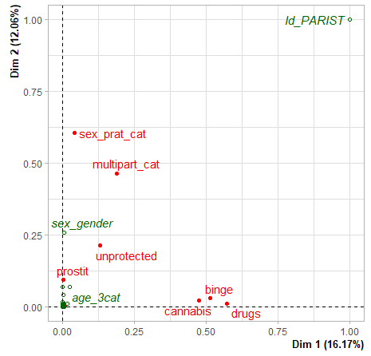
Abbreviations: Dim1, dimension 1; Dim2, dimension 2 MCA, Multiple correspondence analysis

