Supplementary materials
Subgroup analysis
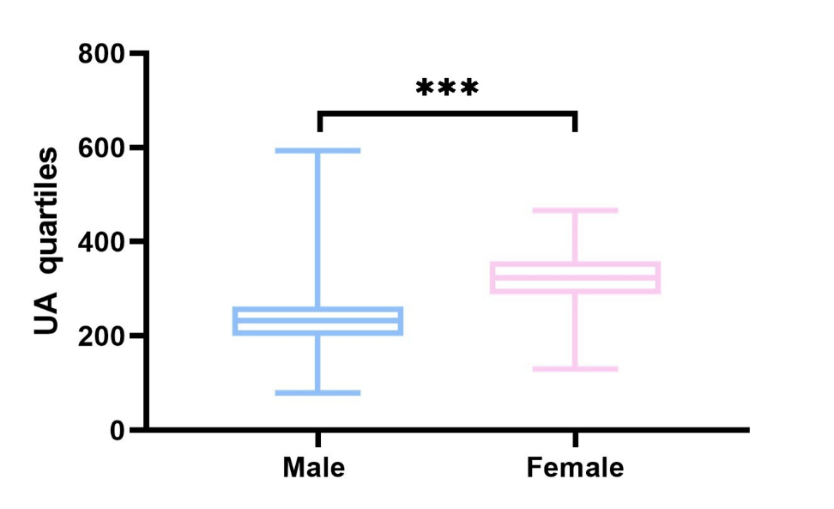
Figure S1 UA quartiles in males and females. ***P < 0.001.
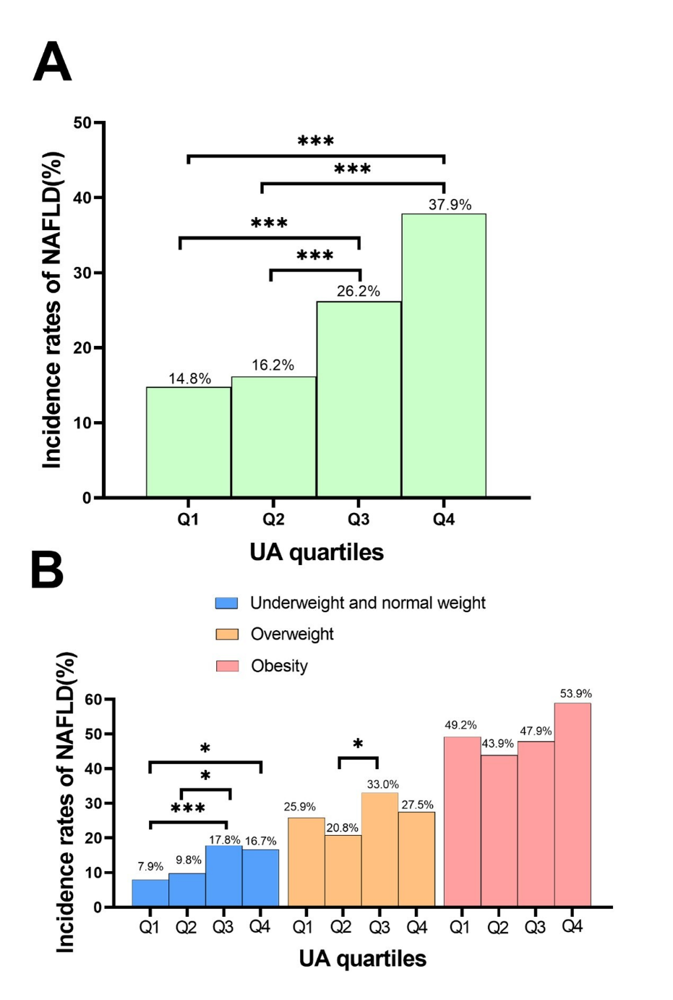

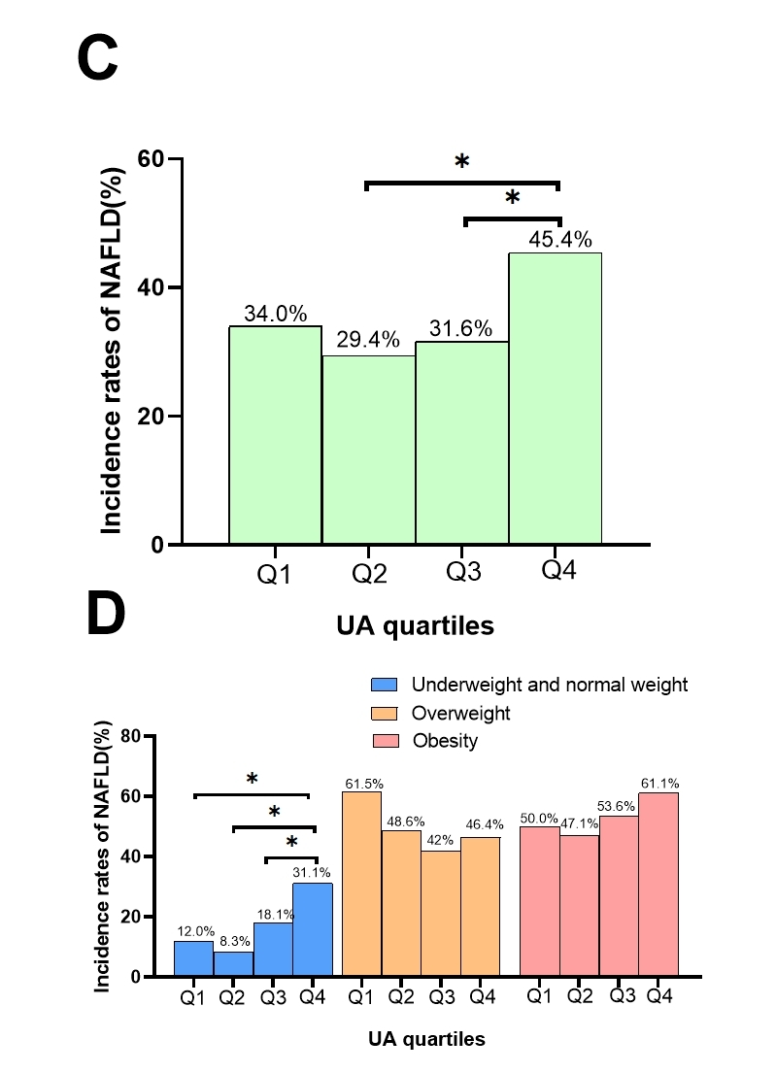
Figure S2 Incidence rates of NAFLD in males and females by different UA group. (A) All participants; (B) underweight and normal weight participants, overweight participants, obese participants; (C) All participants; (D) underweight and normal weight participants, overweight participants, obese participants. NAFLD, non-alcoholic fatty liver disease; UA, uric acid. Q1, 69–210 μmol/L; Q2, 211–255 μmol/L; Q3, 256–310 μmol/L; Q4, 311–593 μmol/L. *P < 0.05; ***P < 0.001.

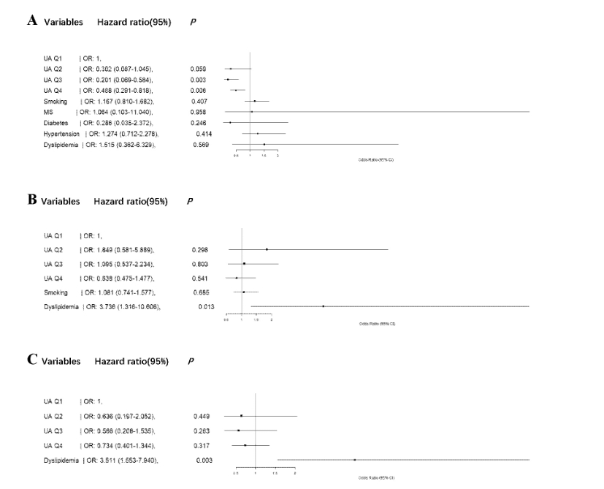
Figure S3 Univariate analysis of NAFLD patients by males. (A) Underweight and normal weight participants; (B) overweight participants; (C) obese participants. MS, metabolic syndrome; NAFLD, non-alcoholic fatty liver disease; Ref, reference; UA, uric acid. Q1, 69-210μmol/L; Q2, 211-255μmol/L; Q3, 256-310μmol/L; Q4, 311-593μmol/L.

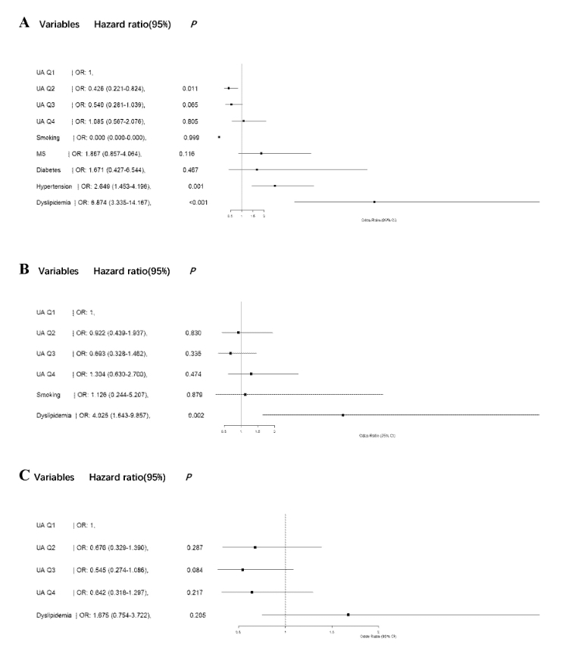
Figure S4 Univariate analysis of NAFLD patients by females. (A) Underweight and normal weight participants; (B) overweight participants; (C) obese participants. MS, metabolic syndrome; NAFLD, non-alcoholic fatty liver disease; Ref, reference; UA, uric acid. Q1, 69-210μmol/L; Q2, 211-255μmol/L; Q3, 256-310μmol/L; Q4, 311-593μmol/L.

