ELEMENT LIST
eAppendix. Funding, Staff and Methodology
eTable 1. Population stratified by occupation
eTable 2. Population characteristics of the study overall and stratified by groups of daily sitting time among occupations
eTable 3. Population characteristics of the study overall and stratified by groups of daily sitting and activity time among occupations
eTable 4. Sensitivity Analysis for Further Adjusting for Potential Mediators or Confounders
eTable 5. Sensitivity Analysis for Addressing the Possibility of Reverse Causation
eTable 6. Sensitivity Analysis for Using the Injury as a Negative Control Outcome to Explore the Extent to Which the Association Between Sitting Time and Major Cardiovascular Outcome is Explained by Confounding
eFigure 1. Sensitivity Analysis for Competing Risks Model to Assess the Impact of Non-CVD Death on the Association Between Sitting Time and Major Cardiovascular Outcomes
eTable 7. Subgroup Analyses of the Associations of Daily Sitting Time and the Composite Outcome
eFigure 2. Survival Curves for Major Cardiovascular Outcomes by Occupations

eAppendix. Funding, Staff and Methodology
Funding/Support
Dr S Yusuf is supported by the Marion W Burke endowed chair of the Heart and Stroke Foundation of Ontario. The PURE study is an investigator-initiated study that is funded by the Population Health Research Institute, Hamilton Health Sciences Research Institute (HHSRI), the Canadian Institutes of Health Research, Heart and Stroke Foundation of Ontario, Support from Canadian Institutes of Health Research’s Strategy for Patient Oriented Research, through the Ontario SPOR Support Unit, as well as the Ontario Ministry of Health and Long-Term Care and through unrestricted grants from several pharmaceutical companies [with major contributions from AstraZeneca (Canada), Sanofi-Aventis (France and Canada), Boehringer Ingelheim (Germany and Canada), Servier, and GlaxoSmithKline], and additional contributions from Novartis and King Pharma and from various national or local organisations in participating countries.
Role of Sponsor: The external funders and sponsors had no role in the design and conduct of the study; in the collection, analysis, and interpretation of the data; in the preparation, review, or approval of the manuscript; or in the decision to submit the manuscript for publication.

PURE Project Office Staff, National Coordinators, Investigators, and Key Staff
Project office (Population Health Research Institute, Hamilton Health Sciences and McMaster University, Hamilton, Canada): S Yusuf* (Principal Investigator).
S Rangarajan (Program Manager); K K Teo, S S Anand, C K Chow, M O’Donnell, A Mente, D Leong, A Smyth, P Joseph, M Duong, R D’Souza, M Walli-Attaei, S Islam (Statistician), W Hu (Statistician), C Ramasundarahettige (Statistician), P Sheridan (Statistician), S Bangdiwala, L Dyal, B Liu (Biometric Programmer), C Tang (Biometric Programmer), X Yang (Biometric Programmer), R Zhao (Biometric Programmer), L Farago (ICT), M Zarate (ICT), J Godreault (ICT), M Haskins (ICT), M Jethva (ICT), G Rigitano (ICT), A Vaghela (ICT), M Dehghan (Nutrition Epidemiologist), A Aliberti, A Reyes, A Zaki, B Connolly, B Zhang, D Agapay, D Krol, E McNeice, E Ramezani, F Shifaly, G McAlpine, I Kay, J Rimac, J Swallow, M Di Marino, M Jakymyshyn, M(a) Mushtaha, M(o) Mushtaha, M Trottier, N Aoucheva, N Kandy, P Mackie, R Buthool, R Patel, R Solano, S Gopal, S Ramacham, S Trottier Core Laboratories: G Pare, M McQueen, S Lamers, J Keys (Hamilton), X Wang (Beijing, China), A Devanath (Bangalore, India).

Supplementary Methods
PURE Study Participant Selection Methodology
Excerpted from Teo et al. Am Heart J. 2009 Jul;158(1):1-7
Selection of Countries
The choice and number of countries selected in PURE reflects a balance between involving a large number of communities in countries at different economic levels, with substantial heterogeneity in social and economic circumstances and policies, and the feasibility of centers to successfully achieve long-term follow-up. Thus, PURE included sites in which investigators are committed to collecting good-quality data for a low-budget study over the planned 10-year follow-up period and did not aim for a strict proportionate sampling of the entire world.
Selection of Communities
Within each country, urban and rural communities were selected based on broad guidelines (see Guidelines for Selection of Countries, Communities, Households, and Individuals Recruited to PURE). A common definition for “community” that is applicable globally is difficult to establish. In PURE, a community was defined as a group of people who have common characteristics and reside in a defined geographic area. A city or large town was not usually considered a single community, rather communities from low-, middle-, and high-income areas were selected from sections of the city and the community area defined according to a geographical measure (e.g., a set of contiguous postal code areas or a group of streets or a village). The primary sampling unit for rural areas in many countries was the village. The reason for inclusion of both urban and rural communities is that for many countries, urban and rural environments exhibit distinct characteristics in social and physical environment, and hence, by sampling both, we ensured considerable variation in societal factors across PURE communities.
The number of communities selected in each country varied, with the aim to recruit communities with substantial heterogeneity in social and economic circumstances balanced against the capacity of local investigators to maintain follow-up. In some countries (e.g., India, China, Canada, and Colombia), communities from several states/provinces were included to capture regional diversity, in policy, socioeconomic status, culture, and physical environment. In other countries (e.g. Iran, Poland, Sweden, and Zimbabwe), fewer communities were selected.
Selections of Households and Individuals
Within each community, sampling was designed to achieve a broadly representative sample of that community of adults aged between 35 and 70 years[1]. The choice of sampling frame within each centre was based on both “representativeness” and feasibility of long-term follow-up, following broad study guidelines. Once a community was identified, where possible, common and standardized approaches were applied to the enumeration of households, identification of individuals, recruitment procedures, and data collection.
The method of approaching households differed between regions. For example, in rural areas of India and China, a community announcement was made to the village through contact of a community leader, followed by in-person door-to-door visits of all households. In contrast, in Canada, initial contact was by mail followed by telephone inviting members of the households to a central clinic. Households were eligible if at least 1 member of the household was between the ages of 35 and 70 years and the household members intended to continue living in their current home for a further 4 years.
For each approach, at least 3 attempts at contact were made. All individuals within these households between 35 and 70 years providing written informed consent were enrolled. When an eligible household or eligible individual in a household refused to participate, demographics and self-reported data about CVD risk factors, education, and history of CVD, cancers and deaths in the households within the 2 previous years were recorded.
To ensure standardization and high data quality, we used a comprehensive operations manual, training workshops, DVDs, regular communication with study personnel and standardized report forms. We entered all data in a customized database programmed with range and consistency checks, which was transmitted, electronically to the Population Health Research Institute in Hamilton (Ontario, Canada) where further quality checks were implemented.

Prospective Follow-up for Cardiovascular Events and Mortality
History of disease was collected at baseline from every participant with standardized questionnaires regarding history of a) hypertension, b) diabetes c) stroke d) angina/myocardial infarction/coronary artery disease e) heart failure f) other heart disease.
Information on specific events (death, myocardial infarction, stroke, heart failure, cancer, hospitalizations, new diabetes, injury, tuberculosis, human immunodeficiency viral infections, malaria, pneumonia, asthma, chronic obstructive pulmonary disease) were obtained from participants or their family members (events were reported by the participants if alive or by a relative if the individual had died). This information was adjudicated centrally in each country by trained physicians using standardized definitions. Because the PURE study involves urban and rural areas from middle- and low-income countries, supporting documents to confirm cause of death and/or event varied in degrees of completion and availability. In most of middle- and low-income countries there was no central system of death or event registration. Therefore, information was obtained about prior medical illness and medically certified cause of death where available, and, second, best available information was captured from reliable sources in those instances where medical information was not available in order to be able to arrive at a probable diagnosis or cause of death. Event documentation was based on information from household interviews and medical records, death certificates and other sources. Verbal autopsies were also used to ascertain cause of death in addition to medical records which were reviewed by a health professional. This approach has been used in several studies conducted in middle- and low-income countries.
To ensure a standard approach and accuracy for classification of events across all countries and over time, the first 100 CVD events (deaths, MI, strokes, heart failure or cancers) for China and India, and 50 cases for other countries were adjudicated both locally and also by the adjudication chair, and if necessary further training was provided.

PURE baseline data collections
As previously described[2], baseline information was recorded with standardized procedures of data collection, including socio-demographic factors, medical history, lifestyle risk factors, and physical and laboratory measurements.

Variable | Definition
Urban and rural | In urban areas, communities from China were selected based on known information of the geographical area such as a set of contiguous postal codes or groups of streets to obtain some representative population of each area. Rural communities were villages at least 50 km from the cities. Many of these communities were remote with few health facilities.
Household wealth | Information on indicators of housing characteristics (e.g., type of windows and flooring, water and sanitation facilities) and assets (e.g., ownership of home, car, computer, and mobile phone) were weighted and combined with weights derived from a principal component analysis procedure. The resulting variable was standardized to a mean of 0 and standard deviation of 1 and using this index the household population was divided into thirds from poorest to richest.
INTERHEART risk score | A validated score for quantifying risk factor burden that includes data on age, sex, status with respect to smoking, diabetes, high blood pressure, and family history of heart disease, waist-to-hip ratio, psychosocial factors, diet, and physical activity. Scores range from 0 to 48, with higher scores indicating greater risk factor burden.
Hypertension | Defined as blood pressure of ≥140/90 mmHg, self-reported hypertension, or use of antihypertensive medications.
Diabetes | Defined as fasting blood glucose ≥7 mmol/L, self-reported diabetes, or taking hypoglycaemic agents regularly.
Physical impairments | Having difficulty grasping, walking, bending, reading, seeing people, speaking/hearing, or using walking aids.
Symptoms of depression | Defined as a score of at least four on a seven-symptom depression score using an adapted version of the Short-Form Composite International Diagnostic Interview (CIDI-SF) for major depressive disorders.
PURE diet score | Diet was measured using country specific, food frequency dietary questionnaires (FFQ). Using these, a comprehensive diet score was created based on eight food types associated with a lower risk of CVD in PURE: fruits, vegetables, legumes, nuts, fish, dairy, unprocessed red meat and poultry; with each classified into high-consumption (1 point) or low-consumption (0 points) based on the median amount consumed in PURE (in grams/day), then added to a final score (with lower scores representing a lower quality diet)

eTable 1. Population Stratified by Occupation
Occupation | Number | Percentage (%) | Daily sitting time  mean (SD), h/d | Daily activity time  mean (SD), h/d
1= legislators, senior officials and managers | 1099 | 2.54 | 4.15(2.06) | 6.97(7.28)
2=Professionals | 2399 | 5.55 | 3.93(2.03) | 7.41(7.08)
3=Technicians and associate professionals | 1935 | 4.47 | 3.91(1.98) | 7.66(6.76)
4=Clerks | 2529 | 5.85 | 4.12(2.0) | 7.72(7.32)
5=Service, shop and market sales workers | 997 | 2.30 | 3.73(2.04) | 8.94(8.39)
6=Skilled agricultural and fishery workers | 1284 | 2.97 | 2.59(1.94) | 9.26(12.57)
7=Craft and related trade workers | 967 | 2.24 | 3.27(2.07) | 11.17(13.85)
8=Plant and machine operators and assemblers | 9445 | 21.83 | 3.79(1.89) | 8.91(9.27)
9=Elementary occupations | 15162 | 35.05 | 2.68(1.80) | 13.13(15.58)
10=Armed forces | 81 | 0.19 | 3.77(2.15) | 7.59(10.61)
11=Homemaker | 7358 | 17.01 | 2.97(2.09) | 6.49(8.10)
Total | 43256 | 100 | 3.26(2.01) | 9.75(11.88)

eTable 2. Population Characteristics of the Study Overall and Stratified by Groups of Daily Sitting Time Among Occupations
 | Manual labour occupations |  |  |  | Non-manual labour occupations
Variables | <4h  (n=24,012) | 4-6h  (n=7,429) | 6-8h  (n=3,087) | ≥8h  (n=757) | <4h  (n=3,611) | 4-6h  (n=2,877) | 6-8h  (n=1,170) | ≥8h  (n=304)
Daily sitting time, median (IQR), h/d | 2.0(1.1-3.0) | 4.6(4.0-5.0) | 6.3(6.0-7.0) | 8.0(8.0-9.0) | 2.3(1.4-3.0) | 4.9(4.1-5.1) | 6.4(6.0-7.0) | 8.3(8.0-9.1)
Daily sitting time, mean (SD), h/d | 2.0±1.0 | 4.6±0.6 | 6.5±0.5 | 8.7±1.4 | 2.2±1.0 | 4.7±0.6 | 6.5±0.5 | 8.7±1.1
Age, mean (SD), y | 50.4±9.4 | 51.0±9.5 | 50.4±9.8 | 49.4±9.9 | 52.3±10.1 | 50.5±9.8 | 49.6±9.4 | 47.8±9.0
Male | 9876 (41.1) | 2965 (39.9) | 1212 (39.3) | 325 (42.9) | 1666 (46.1) | 1256 (43.7) | 548 (46.8) | 156 (51.3)
Female | 14145 (58.9) | 4462 (60.1) | 1875 (60.7) | 432 (57.1) | 1945 (53.9) | 1621 (56.3) | 622 (53.2) | 148 (48.7)
Residence
Urban | 7787 (32.4) | 4150 (55.9) | 1722 (55.8) | 407 (53.8) | 3021 (83.7) | 2571 (89.4) | 1066 (91.1) | 263 (86.5)
Rural | 16234 (67.6) | 3279 (44.1) | 1365 (44.2) | 350 (46.2) | 590 (16.3) | 306 (10.6) | 104 (8.9) | 41 (13.5)
Tobacco use
Former | 954 (4.0) | 304 (4.1) | 126 (4.1) | 44 (5.8) | 242 (6.7) | 156 (5.4) | 74 (6.3) | 27 (8.9)
Current | 5607 (23.3) | 1662 (22.4) | 677 (21.9) | 184 (24.3) | 764 (21.2) | 613 (21.3) | 260 (22.2) | 80 (26.3)
Never | 17151 (71.4) | 5376 (72.4) | 2253 (73.0) | 524 (69.2) | 2571 (71.2) | 2091 (72.7) | 824 (70.4) | 195 (64.1)
Alcohol use
Former | 614 (2.6) | 186 (2.5) | 84 (2.7) | 29 (3.8) | 176 (4.9) | 108 (3.8) | 56 (4.8) | 17 (5.6)
Current | 5016 (20.9) | 1471 (19.8) | 604 (19.6) | 165 (21.8) | 885 (24.5) | 798 (27.7) | 347 (29.7) | 103 (33.9)
Never | 18228 (75.9) | 5715 (76.9) | 2381 (77.1) | 561 (74.1) | 2540 (70.3) | 1963 (68.2) | 764 (65.3) | 184 (60.5)
Education
Primary school or less | 10382 (43.2) | 2322 (31.3) | 1045 (33.9) | 262 (34.6) | 237 (6.6) | 110 (3.8) | 36 (3.1) | 11 (3.6)
Secondary school | 12725 (53.0) | 4539 (61.1) | 1779 (57.6) | 420 (55.5) | 1439 (39.9) | 1041 (36.2) | 393 (33.6) | 120 (39.5)
Post-secondary school | 851 (3.5) | 544 (7.3) | 256 (8.3) | 73 (9.6) | 1924 (53.3) | 1719 (59.7) | 737 (63.0) | 172 (56.6)
wealth index
Low | 9637 (40.1) | 2001 (26.9) | 936 (30.3) | 221 (29.2) | 284 (7.9) | 120 (4.2) | 54 (4.6) | 19 (6.3)
Moderate | 12576 (52.4) | 4499 (60.6) | 1783 (57.8) | 425 (56.1) | 2386 (66.1) | 1872 (65.1) | 749 (64.0) | 184 (60.5)
High | 1433 (6.0) | 850 (11.4) | 323 (10.5) | 101 (13.3) | 871 (24.1) | 849 (29.5) | 349 (29.8) | 94 (30.9)
Physical activity
Low | 3760 (15.7) | 1087 (14.6) | 482 (15.6) | 180 (23.8) | 496 (13.7) | 360 (12.5) | 206 (17.6) | 64 (21.1)
Moderate | 9604 (40.0) | 3083 (41.5) | 1342 (43.5) | 296 (39.1) | 1507 (41.7) | 1370 (47.6) | 586 (50.1) | 151 (49.7)
High | 10220 (42.5) | 3190 (42.9) | 1243 (40.3) | 273 (36.1) | 1582 (43.8) | 1137 (39.5) | 377 (32.2) | 87 (28.6)
BMI, mean (SD) | 24.3±3.7 | 24.6±3.6 | 24.7±3.7 | 24.7±3.8 | 24.8±3.6 | 24.6±3.4 | 24.9±3.7 | 25.0±3.5
INTERHEART score | 8.8±5.1 | 9.2±5.1 | 9.1±5.1 | 10.0±5.6 | 9.6±5.3 | 9.5±5.4 | 9.8±5.4 | 10.3±5.3
PURE diet score | 2.6±1.7 | 3.2±1.7 | 3.2±1.7 | 3.2±1.6 | 3.8±1.6 | 4.1±1.5 | 4.1±1.5 | 3.9±1.5
Hypertension | 9494 (39.5) | 3016 (40.6) | 1225 (39.7) | 305 (40.3) | 1407 (39.0) | 1063 (36.9) | 418 (35.7) | 109 (35.9)
Diabetes | 1552 (6.5) | 578 (7.8) | 259 (8.4) | 68 (9.0) | 324 (9.0) | 250 (8.7) | 88 (7.5) | 23 (7.6)
Dyslipidemia | 11227 (46.7) | 3665 (49.3) | 1464 (47.4) | 374 (49.4) | 1619 (44.8) | 1351 (47.0) | 546 (46.7) | 151 (49.7)
Depression | 515 (2.1) | 165 (2.2) | 85 (2.8) | 26 (3.4) | 124 (3.4) | 81 (2.8) | 44 (3.8) | 14 (4.6)
Having ≥2 physical impairments | 2619 (10.9) | 652 (8.8) | 247 (8.0) | 107 (14.1) | 408 (11.3) | 239 (8.3) | 165 (14.1) | 53 (17.4)

eTable 3. Population Characteristics of The Study Overall and Stratified by Groups of Daily Sitting and Activity Time Among Occupations
Variables (mean, h/d) | Total  (n=43,256) | Manual labour group  (n=35,295) | Non-manual labour group  (n=7,961)
Daily sitting time | 3.3±2.0 | 3.1±2.0 | 4.0±2.0
Daily sitting time on weekdays | 3.1±2.3 | 2.9±2.3 | 4.1±2.4
Daily sitting time on weekends | 3.6±2.1 | 3.5±2.1 | 3.9±2.1
Daily physical activity time | 9.8±11.9 | 10.3±12.7 | 7.5±7.1
Occupational daily physical activity time | 4.0±10.3 | 4.7±11.1 | 1.3±4.1
Recreational daily physical activity time | 1.4±2.5 | 1.2±2.4 | 2.0±3.0
Transport-related daily physical activity time | 1.8±2.9 | 1.7±2.9 | 2.1±3.0
Housework-related daily physical activity time | 2.6±4.4 | 2.8±4.7 | 2.1±2.8
walk as part of your work | 0.3±1.0 | 0.3±1.0 | 0.3±0.8
moderate physical activity at work | 0.5±1.4 | 0.6±1.5 | 0.1±0.6
heavy physical activity at work | 0.1±0.8 | 0.2±0.9 | 0.01±0.2
walk during leisure time | 0.3±0.6 | 0.3±0.6 | 0.5±0.7
moderate physical activity in leisure time | 0.03±0.2 | 0.03±0.2 | 0.04±0.2
heavy physical activity in leisure time | 0.02±0.2 | 0.01±0.1 | 0.04±0.2

eTable 4. Sensitivity Analysis for Further Adjusting for Potential Mediators or Confounders
Outcome | Manual labour group (n=35,295) |  |  |  | Non-manual labour group (n=7961)
Outcome | <4h  HR(95%CI) | 4-6h  HR(95%CI) | 6-8h  HR(95%CI) | ≥8h  HR(95%CI) | <4h  HR(95%CI) | 4-6h  HR(95%CI) | 6-8h  HR(95%CI) | ≥8h  HR(95%CI)
Further adjusting for hypertension(n=43256)
Major CVD | 1[Ref] | 0.99 (0.89, 1.09) | 1.18(1.03, 1.35) | 1.40(1.10, 1.78) | 1[Ref] | 0.89 (0.71, 1.11) | 1.17 (0.88, 1.57) | 1.88(1.19, 2.98)
CVD mortality | 1[Ref] | 1.05 (0.84, 1.31) | 1.49 (1.14, 1.95) | 2.17 (1.43, 3.30) | 1[Ref] | 0.46 (0.25, 0.85) | 0.66 (0.31, 1.42) | 2.73(1.24, 5.99)
CVD incidence | 1[Ref] | 0.99 (0.89, 1.09) | 1.18(1.03, 1.35) | 1.37(1.07, 1.75) | 1[Ref] | 0.91 (0.73, 1.15) | 1.19 (0.89, 1.59) | 1.94(1.22, 3.08)
Further adjusting for hypertension, diabetes(n=43256)
Major CVD | 1[Ref] | 0.99 (0.89, 1.09) | 1.18(1.03, 1.35) | 1.40(1.09, 1.78) | 1[Ref] | 0.88(0.70, 1.11) | 1.17(0.88, 1.57) | 1.88(1.19, 2.99)
CVD mortality | 1[Ref] | 1.05 (0.84, 1.31) | 1.49 (1.13, 1.95) | 2.17(1.43, 3.29) | 1[Ref] | 0.45 (0.24, 0.83) | 0.66 (0.31, 1.43) | 2.75(1.25, 6.05)
CVD incidence | 1[Ref] | 0.99 (0.89, 1.09) | 1.18 (1.03, 1.35) | 1.37 (1.07, 1.75) | 1[Ref] | 0.91 (0.72, 1.14) | 1.18(0.88, 1.59) | 1.95 (1.23, 3.09)
Further adjusting for hypertension, diabetes, and BMI (n=43256)
Major CVD | 1[Ref] | 0.98 (0.89, 1.09) | 1.18(1.03, 1.35) | 1.40(1.09, 1.78) | 1[Ref] | 0.89 (0.71, 1.11) | 1.17 (0.87, 1.56) | 1.88 (1.19, 2.98)
CVD mortality | 1[Ref] | 1.06 (0.85, 1.32) | 1.49 (1.14, 1.96) | 2.17 (1.43, 3.29) | 1[Ref] | 0.45 (0.24, 0.84) | 0.67 (0.31, 1.46) | 2.79 (1.27, 6.13)
CVD incidence | 1[Ref] | 0.98 (0.89, 1.09) | 1.17(1.03, 1.35) | 1.37(1.07, 1.75) | 1[Ref] | 0.91 (0.73, 1.15) | 1.18 (0.88, 1.59) | 1.94 (1.22, 3.08)
Values are hazard ratios (95% confidence intervals).
Base models adjusted for age, sex, urban and rural location, education, household wealth index, tobacco use, alcohol use, physical activity, depression, dyslipidemia and physical impairments, and a random intercept for clustering of communities. CVD=cardiovascular disease.

eTable 5. Sensitivity Analysis for Addressing the Possibility of Reverse Causation
Outcome | Manual labour group (35,295) |  |  |  | Non-manual labour group (7961)
Outcome | <4h  HR(95%CI) | 4-6h  HR(95%CI) | 6-8h  HR(95%CI) | ≥8h  HR(95%CI) | <4h  HR(95%CI) | 4-6h  HR(95%CI) | 6-8h  HR(95%CI) | ≥8h  HR(95%CI)
Excluding outcome events within the first 2 years(n=42319)
Major CVD | 1[Ref] | 0.96 (0.86, 1.06) | 1.23 (1.07, 1.41) | 1.43 (1.11, 1.83) | 1[Ref] | 0.91 (0.72, 1.15) | 1.26 (0.94, 1.70) | 2.01 (1.25, 3.23)
CVD mortality | 1[Ref] | 0.94 (0.74, 1.21) | 1.58 (1.19, 2.09) | 2.27 (1.47, 3.51) | 1[Ref] | 0.42 (0.21, 0.83) | 0.74 (0.34, 1.61) | 2.73 (1.19, 6.30)
CVD incidence | 1[Ref] | 0.96 (0.86, 1.07) | 1.23 (1.07, 1.41) | 1.40 (1.08, 1.80) | 1[Ref] | 0.93 (0.74, 1.18) | 1.27 (0.94, 1.72) | 2.07 (1.29, 3.33)
Values are hazard ratios (95% confidence intervals).
Models adjusted for age, sex, urban and rural location, education, household wealth index, tobacco use, alcohol use, physical activity, depression, dyslipidemia and physical impairments, and a random intercept for clustering of communities. CVD=cardiovascular disease.

eTable 6. Sensitivity Analysis for Using the Injury as a Negative Control Outcome to Explore the Extent to Which the Association Between Sitting Time and Major Cardiovascular Outcome is Explained by Confounding
Outcome | Manual labour group (35,295) |  |  |  | Non-manual labour group (7961)
Outcome | <4h  HR(95%CI) | 4-6h  HR(95%CI) | 6-8h  HR(95%CI) | ≥8h  HR(95%CI) | <4h  HR(95%CI) | 4-6h  HR(95%CI) | 6-8h  HR(95%CI) | ≥8h  HR(95%CI)
Major CVD | 1[Ref] | 0.99(0.89, 1.09) | 1.20(1.05, 1.37) | 1.43(1.12, 1.82) | 1[Ref] | 0.89 (0.71, 1.12) | 1.17(0.87, 1.56) | 1.86(1.18, 2.95)
Injury | 1[Ref] | 1.01 (0.91, 1.13) | 0.97(0.81, 1.16) | 1.10(0.82, 1.50) | 1[Ref] | 1.10(0.85, 1.42) | 1.17(0.81, 1.70) | 1.14(0.60, 2.18)
Values are hazard ratios (95% confidence intervals).
Models adjusted for age, sex, urban and rural location, education, household wealth index, tobacco use, alcohol use, physical activity, depression, dyslipidemia and physical impairments, and a random intercept for clustering of communities. CVD=cardiovascular disease.

eFigure 1. Sensitivity Analysis for Competing Risks Model to Assess the Impact of Non-CVD Death on the Association Between Sitting Time and Major Cardiovascular Outcomes

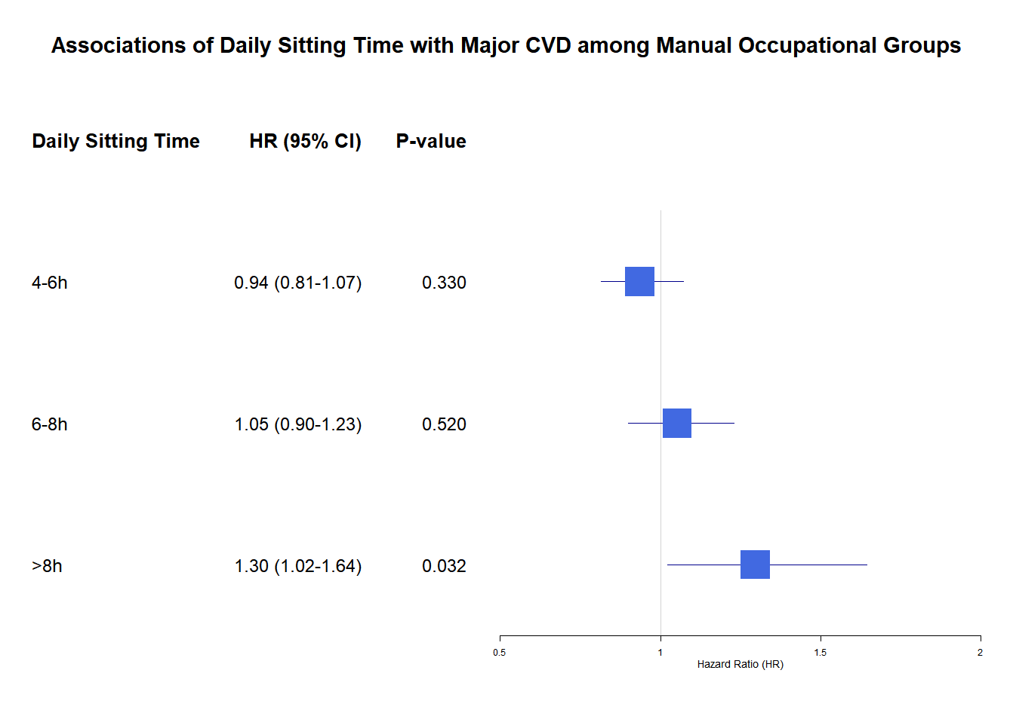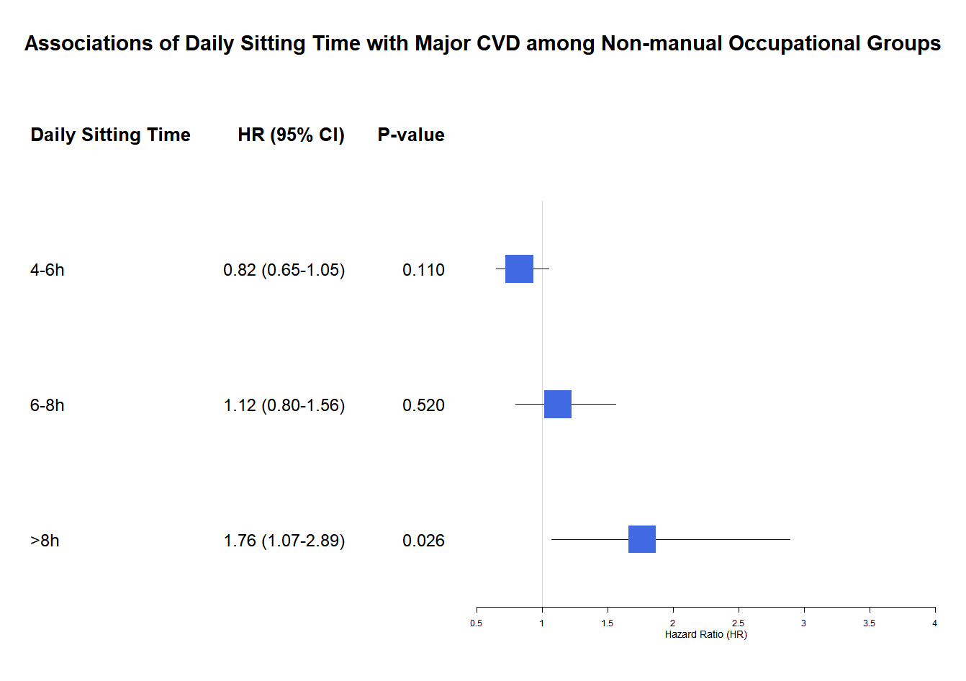

eTable 7. Subgroup Analyses of the Associations of Daily Sitting Time and Major Cardiovascular Events
Events (Rate) n (%) | Manual labour group (35,295) |  |  |  | Non-manual labour group (7961)
Events (Rate) n (%) | <4h  HR(95%CI) | 4-6h  HR(95%CI) | 6-8h  HR(95%CI) | ≥8h  HR(95%CI) | <4h  HR(95%CI) | 4-6h  HR(95%CI) | 6-8h  HR(95%CI) | ≥8h  HR(95%CI)
Age
＜50 | 1[Ref] | 0.98 (0.80, 1.19) | 0.98 (0.74, 1.29) | 0.88 (0.50, 1.55) | 1[Ref] | 0.76 (0.46, 1.25) | 1.06 (0.58, 1.92) | 1.93 (0.92, 4.05)
≥50 | 1[Ref] | 1.01 (0.89, 1.13) | 1.29 (1.10, 1.50) | 1.66 (1.27, 2.17) | 1[Ref] | 0.91 (0.71, 1.17) | 1.09 (0.78, 1.52) | 1.59 (0.87, 2.88)
Sex
Male | 1[Ref] | 1.07 (0.93, 1.24) | 1.22 (1.00, 1.49) | 1.83 (1.31, 2.54) | 1[Ref] | 0.95 (0.71, 1.27) | 0.99 (0.67, 1.47) | 2.02 (1.18, 3.44)
Female | 1[Ref] | 0.91 (0.79, 1.04) | 1.13 (0.95, 1.36) | 1.11 (0.78, 1.58) | 1[Ref] | 0.85 (0.60, 1.22) | 1.50 (0.96, 2.33) | 1.70 (0.67, 4.32)
Residence
Urban | 1[Ref] | 0.97 (0.83, 1.13) | 1.15 (0.95, 1.41) | 1.34 (0.94, 1.92) | 1[Ref] | 0.94 (0.73, 1.19) | 1.24 (0.91, 1.69) | 1.88 (1.14, 3.10)
Rural | 1[Ref] | 1.00 (0.87, 1.14) | 1.23 (1.02, 1.47) | 1.48 (1.07, 2.06) | 1[Ref] | 0.68 (0.36, 1.28) | 0.81 (0.34, 1.94) | 1.72 (0.51, 5.85)
Values are hazard ratios (95% confidence intervals).
Models adjusted for age, sex, urban and rural location, education, household wealth index, tobacco use, alcohol use, physical activity, depression, dyslipidemia and physical impairments, and a random intercept for clustering of communities. CVD=cardiovascular disease.

eFigure 2. Survival Curves for Major Cardiovascular Outcomes by Occupations
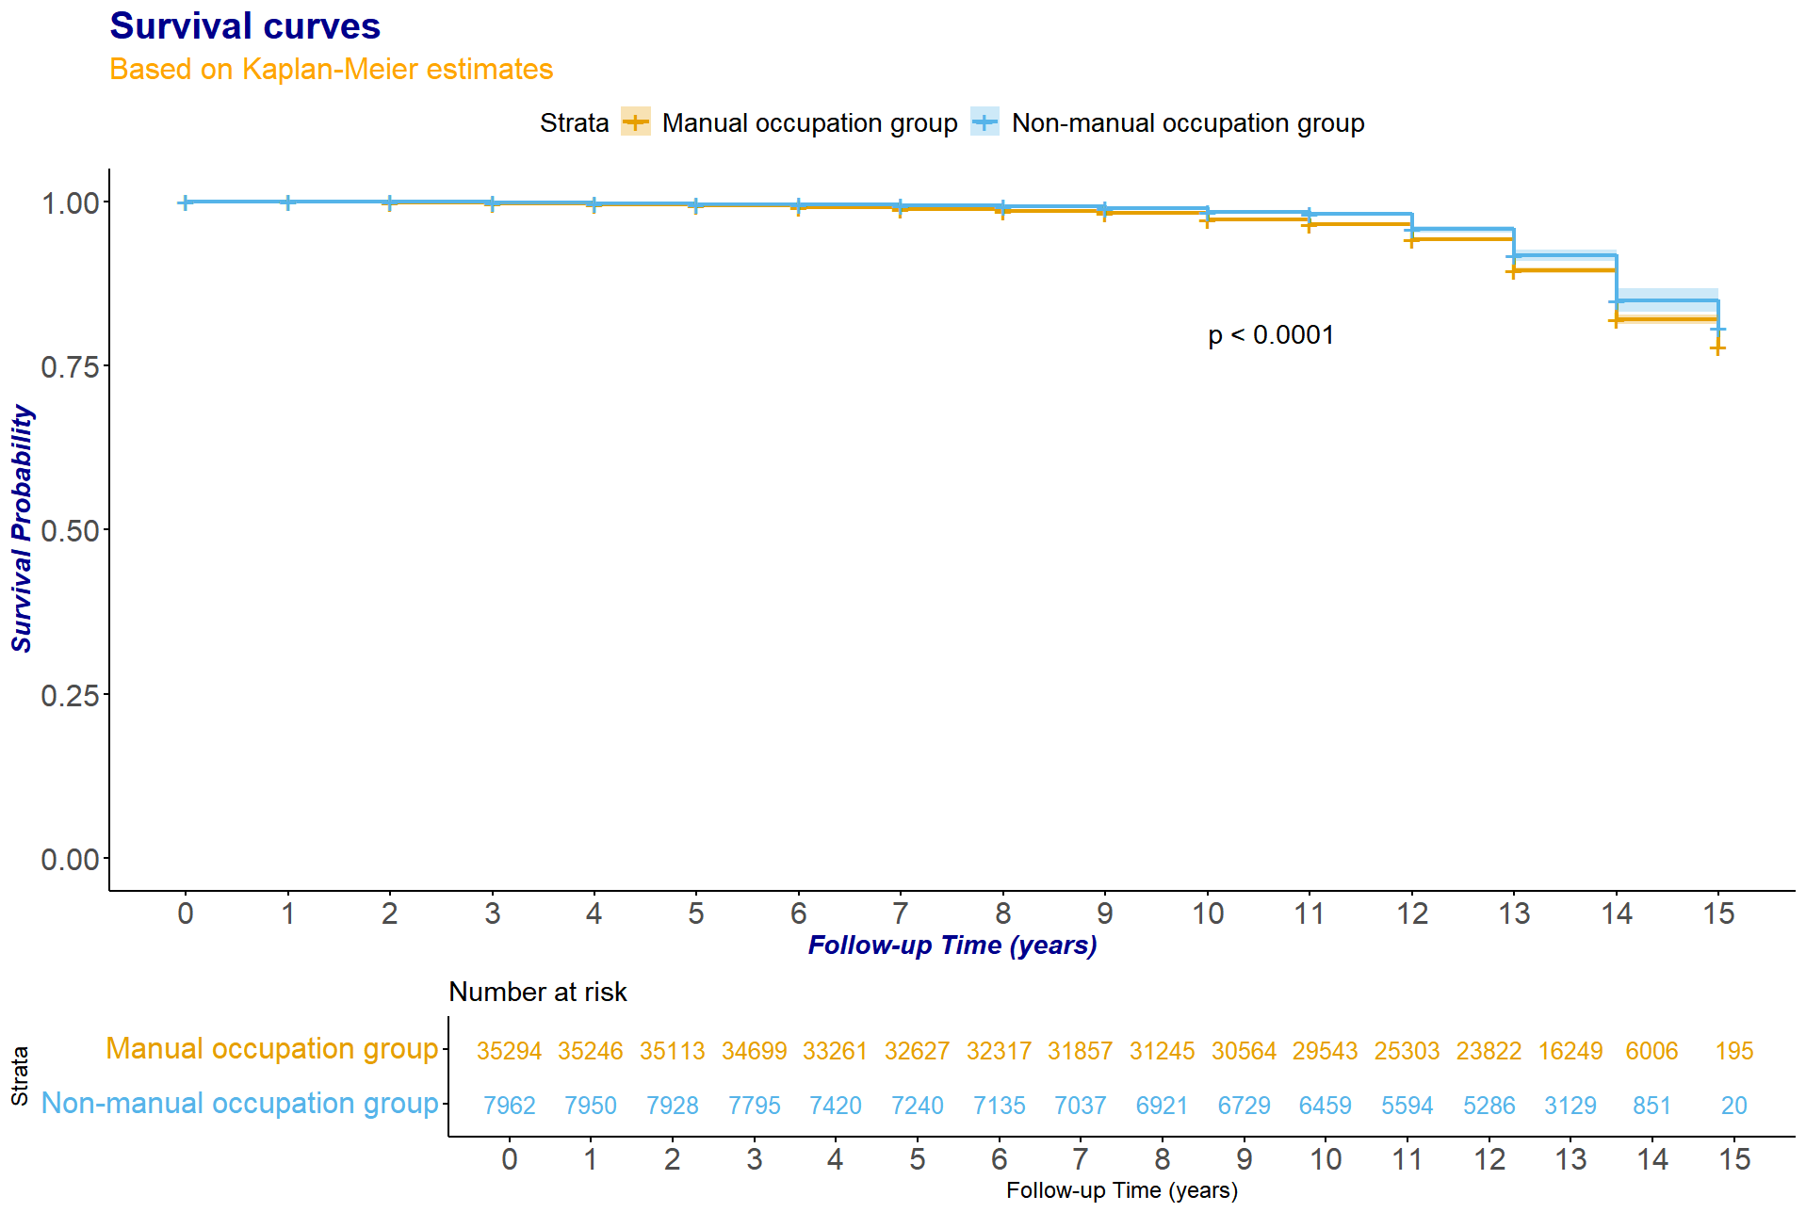
eReferences
1. Corsi DJ, Subramanian SV, Chow CK, et al. Prospective Urban Rural Epidemiology (PURE) study: Baseline characteristics of the household sample and comparative analyses with national data in 17 countries. American heart journal. Oct 2013;166(4):636-646.e4. http://doi.org/10.1016/j.ahj.2013.04.019
2. Teo K, Chow CK, Vaz M, Rangarajan S, Yusuf S. The Prospective Urban Rural Epidemiology (PURE) study: examining the impact of societal influences on chronic noncommunicable diseases in low-, middle-, and high-income countries. American heart journal. Jul 2009;158(1):1-7.e1. http://doi.org/10.1016/j.ahj.2009.04.019

