Survey Questionnaire and responses from both people with obesity (PwO) and healthcare professionals (HCPs)
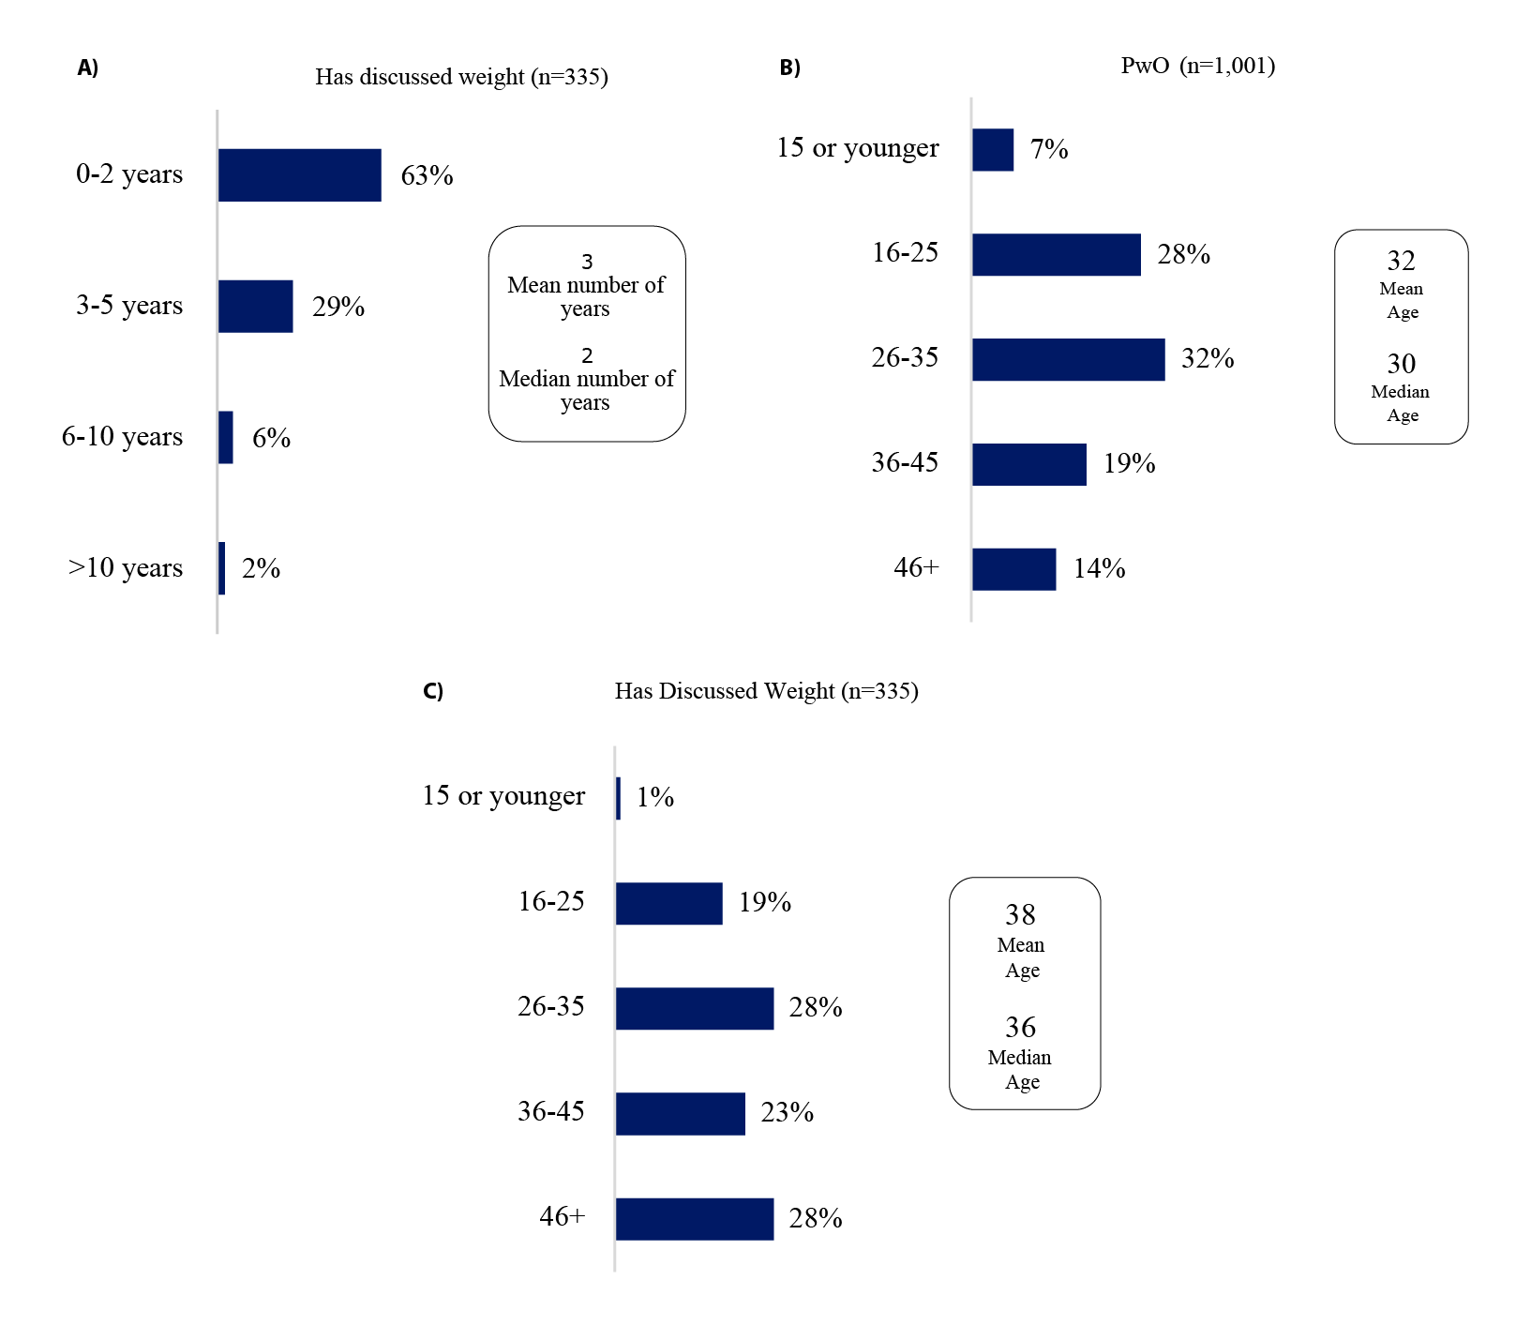
Supplementary Figure 1: A) Average delay in seeking treatment (number of years)
B) Age when started struggling with weight
C) Age When First Discussed Weight with HCP
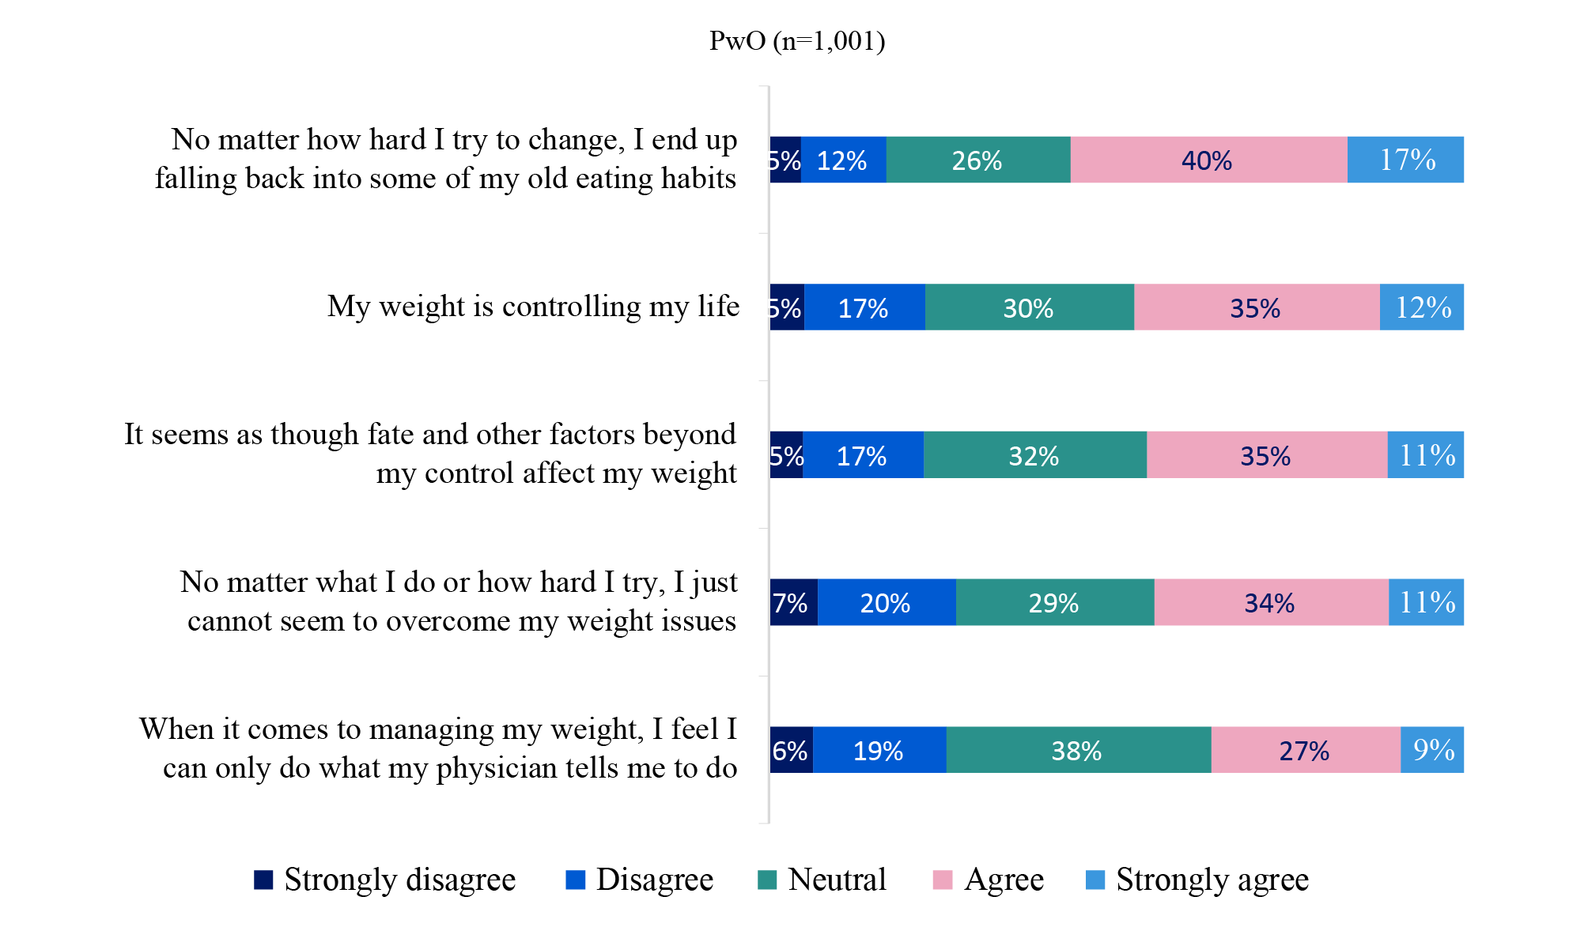
Supplementary Figure 2: Perceived barriers to weight management among PwO
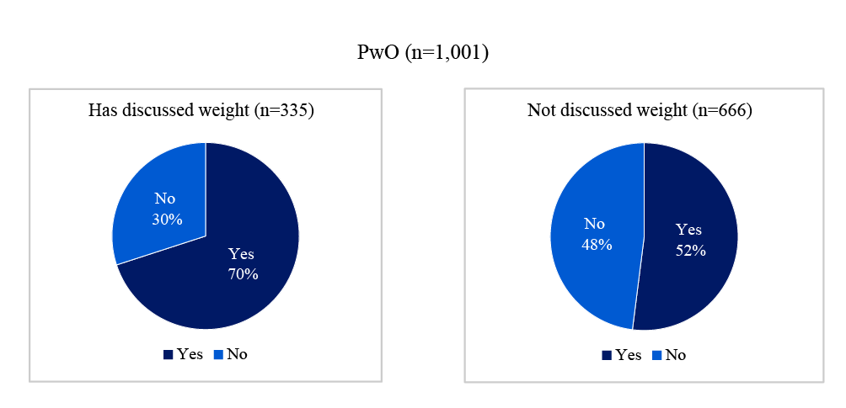

Supplementary Figure 3: Follow-up appointment schedules among PwO: who discussed vs. have not discussed weight

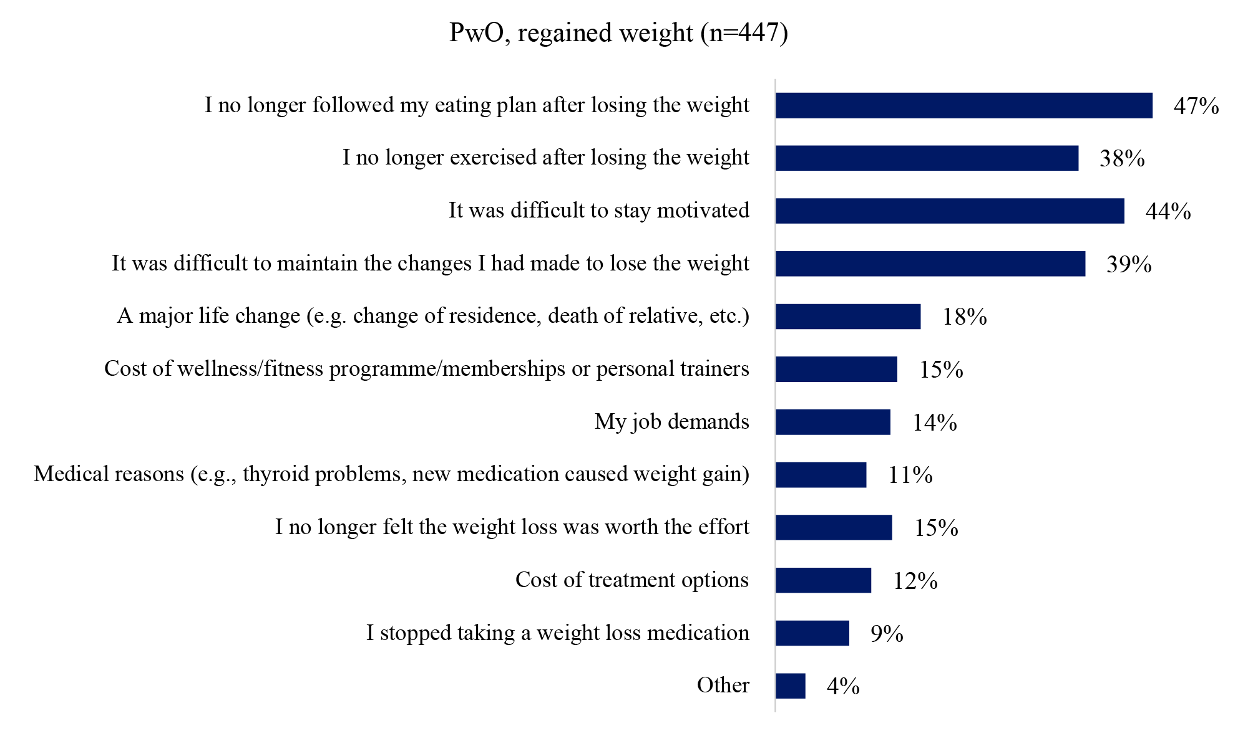
Supplementary Figure 4: Reasons for weight regain among PwO

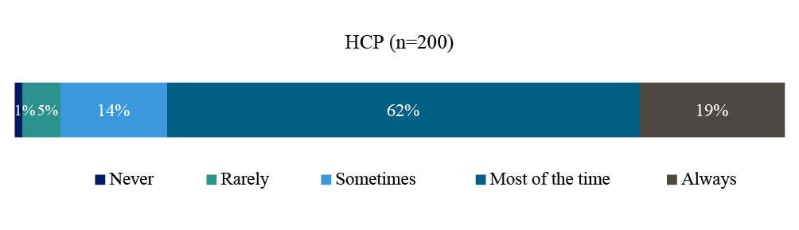
Supplementary Figure 5: Frequency of obesity diagnosis documentation in medical records by HCPs
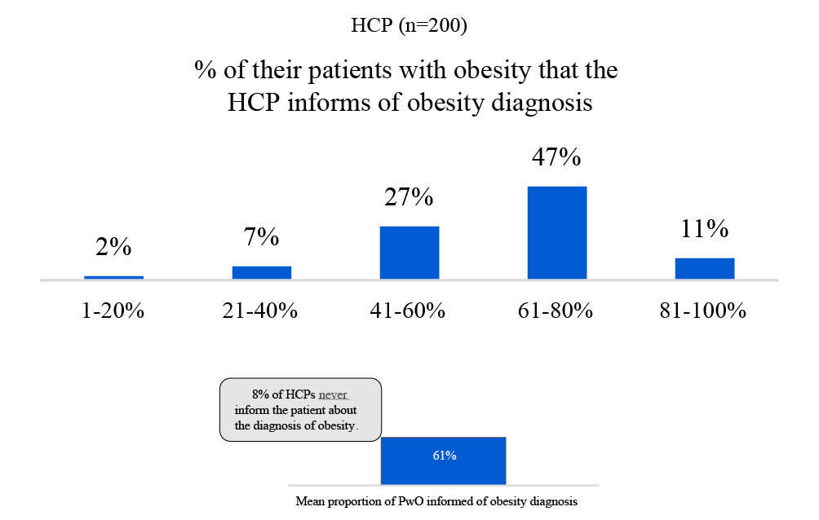
Supplementary Figure 6: Proportion of PwO informed of their diagnosis by HCPs

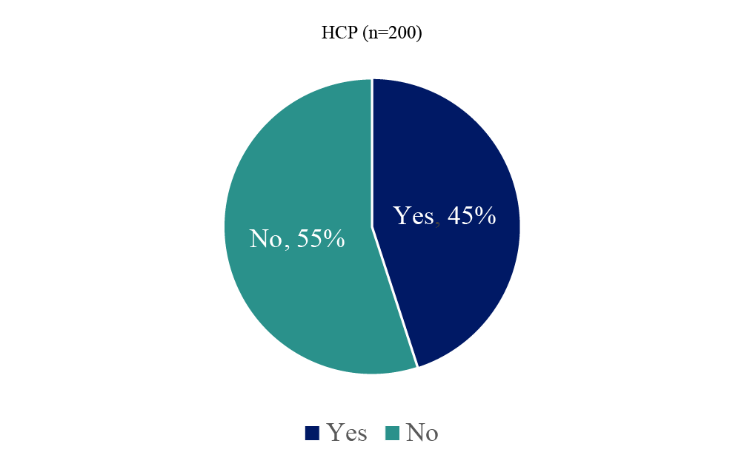
Supplementary Figure 7: Proportion of PwO receiving follow-up appointments for weight discussions by HCPs

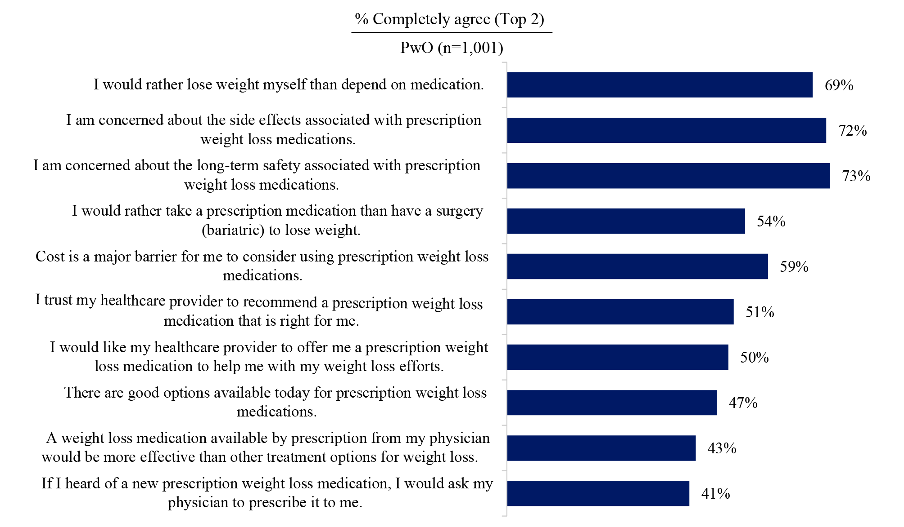
Supplementary Figure 8: Attitudes toward prescription weight loss medications among PwO

