Figure S1 Age-standardized prevalence (ASPR) and incidence rate (ASIR) for substance use disorders in adolescents for 21 GBD regions and 204 countries/territories from 1990 to 2021
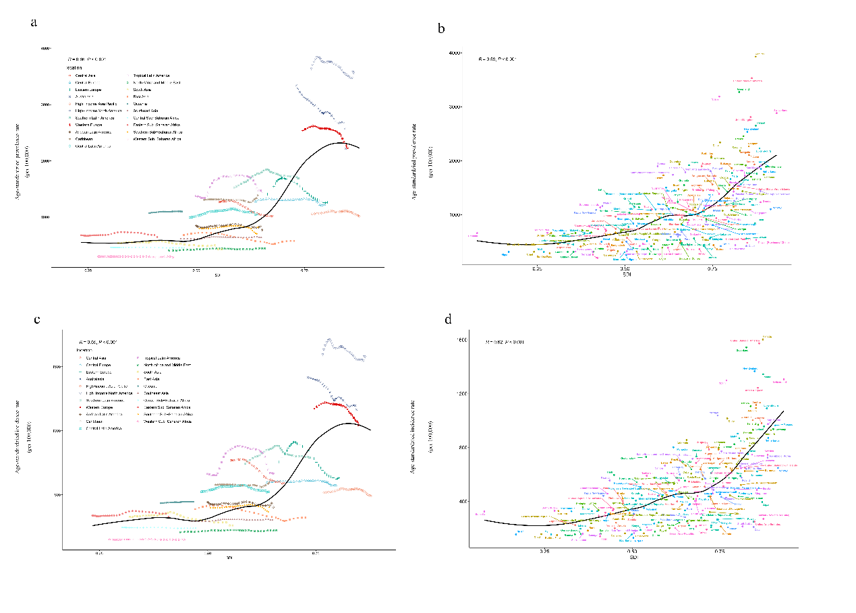
(a), ASPR by regions (b), ASPR by countries (c), ASIR by regions (d), ASIR by countries. Black lines indicate excepted values based on SDI in all locations

Figure S2. Prediction of age-standardized prevalence and incidence rate and number of adolescent substance use disorders in the United States, Mongolia, Iran (Islamic Republic of), India, and China from 1990 to 2030.
