Household predictors of malaria episode in northern Uganda: Its implication for future malaria control

Richard Echodu1,2*, William Sam Oyet1, Tereza Iwiru2, Felister Apili3, Julius Julian Lutwama 4, Elizabeth Auma Opiyo1, Ochan Otim5,6

- Department of Biology, Faculty of Science, Gulu University, P. O. Box 166, Gulu City, Uganda.
- Gulu University Multifunctional Research Laboratories, P. O. Box 166, Gulu City, Uganda.
- Department of Midwifery, Faculty of Nursing and Midwifery, Lira University, P. O. Box 1035, Lira City Uganda.
- Department of Arbovirology, Emerging and Re-emerging Infectious Diseases, Uganda Virus Research Institute, P. O. Box 49, Entebbe, Uganda.
- Department of Health Sciences and Sciences, University of California, City of Los Angeles, CA, USA.
- Department of Chemistry, Faculty of Science, Gulu University, P.O. Box 166, Gulu City, Uganda.

Appendix (additional files)
Table. S1A. Description by the categories of each of the four (4) Intervention clusters identified by HCPC.
$`1`
INTERVENTION | Cla/Mod |  | Mod/Cla |  | Global |  | p-value |  | v.test
In.Res.Spr_No | 92.00 |  | 100.00 |  | 40.98 |  | 7.99E-15 |  | 7.77
IRS_No | 84.60 |  | 95.65 |  | 42.62 |  | 1.41E-11 |  | 6.76
A | 62.96 |  | 73.90 |  | 44.26 |  | 3.77E-04 |  | 3.56
Treat.BedNet_yes | 45.10 |  | 100.00 |  | 83.61 |  | 5.24E-03 |  | 2.79
Test.BedNet_yes | 46.67 |  | 91.30 |  | 73.77 |  | 1.58E-02 |  | 2.41
G | 0.00 |  | 0.00 |  | 9.84 |  | 4.97E-02 |  | -1.96
D | 0.00 |  | 0.00 |  | 9.84 |  | 4.97E-02 |  | -1.96
Test.BedNet_No | 12.50 |  | 8.70 |  | 26.23 |  | 1.58E-02 |  | -2.41
Treat.BedNet_No | 0.00 |  | 0.00 |  | 16.39 |  | 5.24E-03 |  | -2.79
IRS_yes | 2.86 |  | 4.35 |  | 57.38 |  | 1.41E-11 |  | -6.76
In.Res.Spr_yes | 0.00 |  | 0.00 |  | 59.02 |  | 7.99E-15 |  | -7.77
$`2`
INTERVENTION | Cla/Mod |  | Mod/Cla |  | Global |  | p-value |  | v.test
G | 100.00 |  | 40.00 |  | 9.84 |  | 9.01E-05 |  | 3.92
IRS_yes | 40.00 |  | 93.33 |  | 57.38 |  | 9.47E-04 |  | 3.31
In.Res.Spr_yes | 36.11 |  | 86.67 |  | 59.02 |  | 1.27E-02 |  | 2.49
D | 66.67 |  | 26.67 |  | 9.84 |  | 3.06E-02 |  | 2.16
Treat.BedNet_yes | 29.41 |  | 100.00 |  | 83.61 |  | 4.52E-02 |  | 2.00
Test.BedNet_yes | 31.11 |  | 93.33 |  | 73.77 |  | 4.76E-02 |  | 1.98
Test.BedNet_No | 6.25 |  | 6.67 |  | 26.23 |  | 4.76E-02 |  | -1.98
Treat.BedNet_No | 0.00 |  | 0.00 |  | 16.39 |  | 4.52E-02 |  | -2.00
In.Res.Spr_No | 8.00 |  | 13.33 |  | 40.98 |  | 1.27E-02 |  | -2.49
IRS_No | 3.85 |  | 6.67 |  | 42.62 |  | 9.47E-04 |  | -3.31
A | 0.00 |  | 0.00 |  | 44.26 |  | 2.63E-05 |  | -4.20
$`3`
INTERVENTION | Cla/Mod |  | Mod/Cla |  | Global |  | p-value |  | v.test
Test.BedNet_No | 81.25 |  | 100.00 |  | 26.23 |  | 8.53E-11 |  | 6.49
In.Res.Spr_yes | 36.11 |  | 100.00 |  | 59.02 |  | 3.52E-04 |  | 3.57
IRS_yes | 34.29 |  | 92.31 |  | 57.38 |  | 3.75E-03 |  | 2.90
IRS_No | 3.85 |  | 7.69 |  | 42.62 |  | 3.75E-03 |  | -2.90
In.Res.Spr_No | 0.00 |  | 0.00 |  | 40.98 |  | 3.52E-04 |  | -3.57
Test.BedNet_yes | 0.00 |  | 0.00 |  | 73.77 |  | 8.53E-11 |  | -6.49
$`4`
INTERVENTION | Cla/Mod |  | Mod/Cla |  | Global |  | p-value |  | v.test
Treat.BedNet_No | 100.00 |  | 100.00 |  | 16.39 |  | 1.11E-11 |  | 6.79
In.Res.Spr_yes | 27.78 |  | 100.00 |  | 59.02 |  | 2.82E-03 |  | 2.99
Test.BedNet_yes | 22.22 |  | 100.00 |  | 73.77 |  | 3.54E-02 |  | 2.10
Test.BedNet_No | 0.00 |  | 0.00 |  | 26.23 |  | 3.54E-02 |  | -2.10
In.Res.Spr_No | 0.00 |  | 0.00 |  | 40.98 |  | 2.82E-03 |  | -2.99
Treat.BedNet_yes | 0.00 |  | 0.00 |  | 83.61 |  | 1.11E-11 |  | -6.79

Table S1B. Link between the cluster variable and the quantitative variables
 | Eta2 | p-value
Number.BedNet | 0.3061956 | 0.0001046178
Table S1C. Description of each cluster by quantitative variables
 | v-test | Mean in category | Overall mean | sd in category | Overall sd | p-value
$`1` | NULL | - | - | - | - | -
$`2` | NULL | - | - | - | - | -
$`3`
Number.BedNet | 2.709 | 2.308 | 1.443 | 1.976 | 1.287 | 0.0067
$`4`
Number.BedNet | -3.845 | 0 | 1.443 | 0 | 1.287 | 0.0001
Table S1D. Link between the cluster variable and the categorical variables (chi-square test)
 | p-value | df
TreatBedNet | 3.817439e-24 | 4
TestBedNet | 1.889126e-22 | 4
Malaria.control | 5.831636e-22 | 88
IRS | 1.727859e-16 | 4
InResSpr | 1.456689e-14 | 4

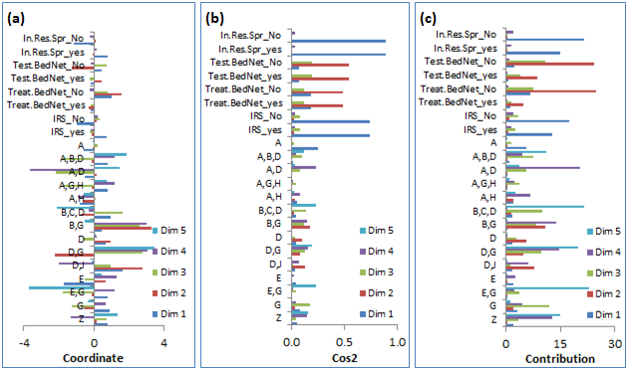
Supplementary Material Fig. S1. Qualities of predictors representation along the first five MCA dimensions. (a) Coordinates of each variable category showing how far they are from the origin. (b) The quality of representation, given as cosine square. (c) The contribution of each variable along the dimensions. The abbreviations representing predictors are defined in Fig. 2 caption. The ‘_No or ‘_Yes’ in some abbreviations are binary levels of a category.

