b
a
Event rate

Weight (%)

Event rate

Vaccine acceptance (%)
Vaccine acceptance (%)
Event rate

Weight (%)

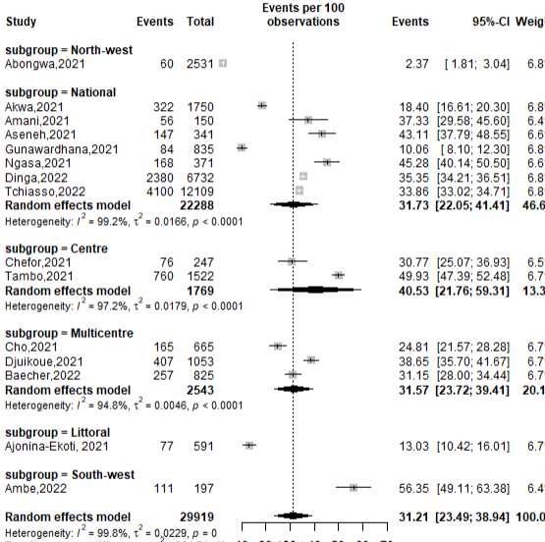
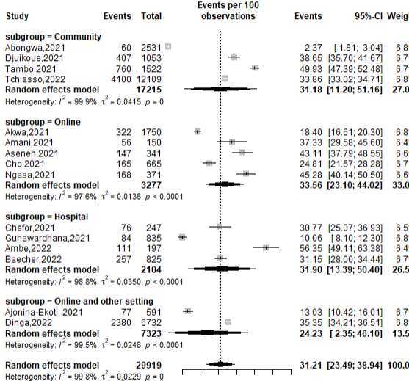

c
d
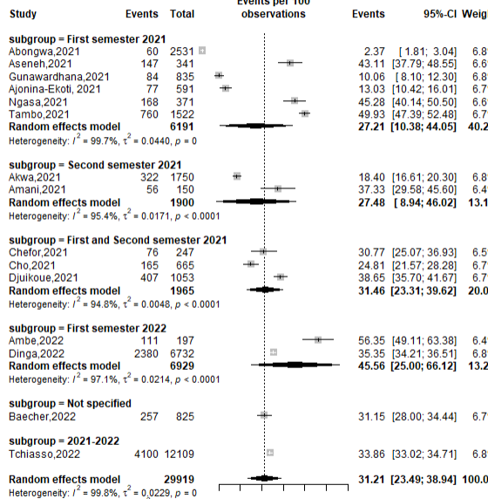
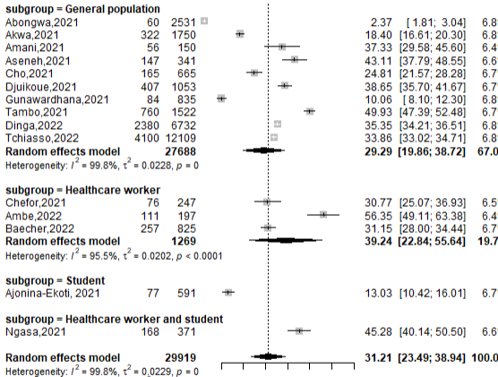

70
30
0
0
30
70

Supplementary fig. 1 Subgroup analysis reporting the COVID-19 vaccine acceptance rate in Cameroon, 2021-2023 (a: by Region; b: by setting; c: by study period and d: by type of participants)

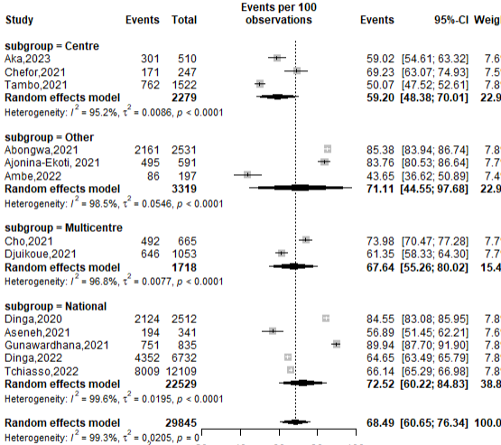  c  Vaccine hesitancy (%)  a  Event rate | 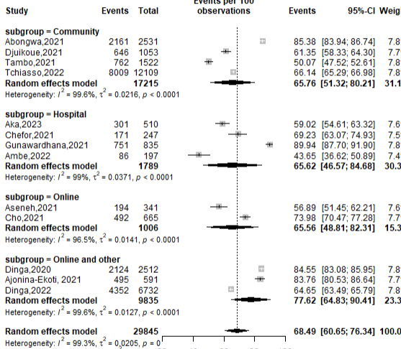  Vaccine hesitancy (%)  Weight (%)  b  d  Weight (%)  Event rate
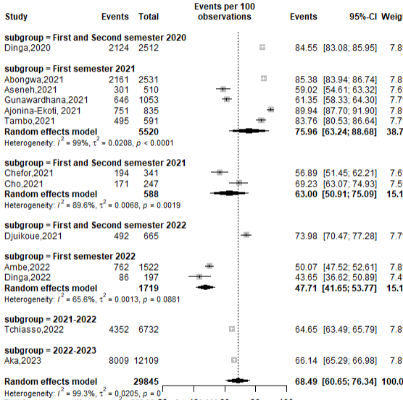  60  100  20 | 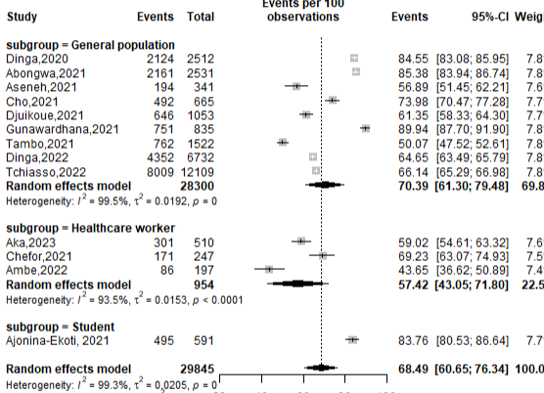  60  100  20

Supplementary fig. 2 Forest plot showing the subgroup analysis of the COVID-19 vaccine hesitancy rate in Cameroon, 2020-2023 (a: by Region; b: by setting; c: by study period and d: by type of participants)

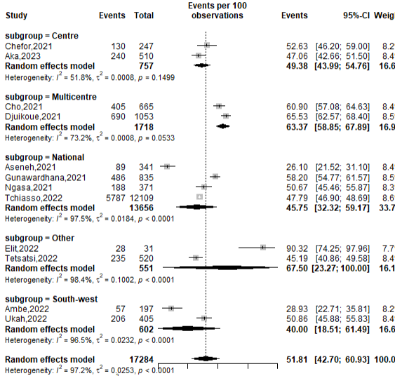  Vaccine perception (%)  a  Event rate | 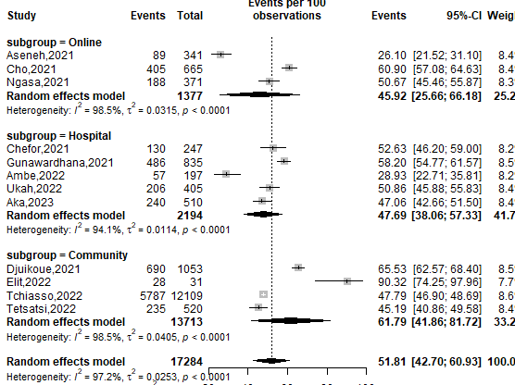  Weight (%)  Vaccine perception (%)  b  Weight (%)  Event rate
c  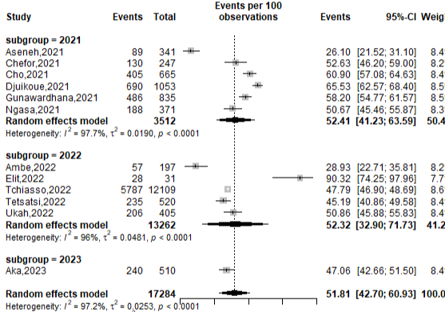  100  60  20 | d  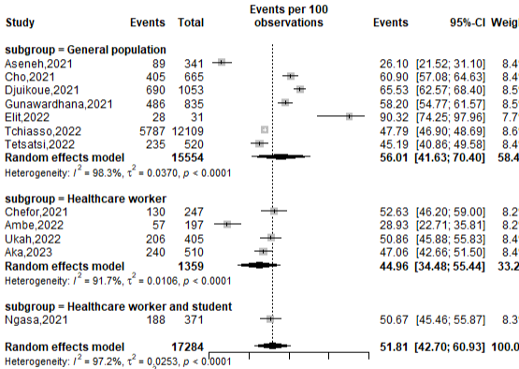  100  60  20

Supplementary fig. 3 Negative perception subgroup estimates of the COVID-19 vaccine in Cameroon, 2021-2023 (a: by Region; b: by setting; c: by study period and d: by type of participants)

Supplementary table 1 Sensitivity analysis of the proportion of vaccine acceptance in Cameroon
Removed Study | Pooled vaccine acceptance rate | Confidence Interval
 |  | Lower | Upper
Akwa,2021 | 0.3327863 | 0.2623020 | 0.4032705
Amani,2021 | 0.3214558 | 0.2406606 | 0.4022509
Aseneh,2021 | 0.3080581 | 0.2258091 | 0.3923072
Chefor,2021 | 0.3037891 | 0.2228070 | 0.3847712
Cho,2021 | 0.3125557 | 0.2296672 | 0.3954443
Djuikoue,2021 | 0.3168277 | 0.2343444 | 0.3993110
Gunawardhana,2021 | 0.3068601 | 0.2246163 | 0.3893838
Ajonina-Ekoti,2021 | 0.3273389 | 0.2506798 | 0.4039980
Ngasa,2021 | 0.3251996 | 0.2467886 | 0.4036106
Tambo,2021 | 0.3022056 | 0.2220019 | 0.3824694
Ambe,2022 | 0.2985074 | 0.2205711 | 0.3766407
Baecher,2022 | 0.2946952 | 0.2203298 | 0.3683020
Dinga,2022 | 0.3122916 | 0.2292612 | 0.3953620
Tchiasso,2022 | 0.3092318 | 0.2264028 | 0.3933222
Overall | 0.3103215 | 0.2273408 | 0.3933022

Supplementary table 2 Sensitivity analysis of the proportion of vaccine hesitancy in Cameroon
Removed Study | Pooled vaccine hesitancy rate | Confidence Interval
 |  | Lower | Upper
Abongwa,2021 | 0.6713889 | 0.5910263 | 0.7517515
Aseneh,2021 | 0.6707048 | 0.5908965 | 0.7505131
Chefor,2021 | 0.6927085 | 0.6091774 | 0.7762396
Cho,2021 | 0.6943801 | 0.6117217 | 0.7770386
Djuikoue,2021 | 0.6842138 | 0.5990975 | 0.7693302
Gunawardhana,2021 | 0.6802402 | 0.5954829 | 0.7649974
Ajonina-Ekoti, 2021 | 0.6908289 | 0.6065077 | 0.7751501
Tambo,2021 | 0.6670308 | 0.5908343 | 0.7432272
Ambe,2022 | 0.6721686 | 0.5912740 | 0.7530631
Dinga,2022 | 0.7005610 | 0.6220555 | 0.7790664
Tchiasso,2022 | 0.7048177 | 0.6310359 | 0.7785996
Aka,2023 | 0.6880715 | 0.6029913 | 0.7731516
Overall | 0.6868031 | 0.6015337 | 0.7720725

Supplementary table 3 Sensitivity analysis of the proportion of negative perception of the COVID-19 vaccine in Cameroon
Removed Study | Pooled proportion of poor vaccine perception | Confidence Interval
 |  | Lower | Upper
Chefor,2021 | 0.5411564 | 0.4555731 | 0.6267397
Cho,2021 | 0.5175637 | 0.4175106 | 0.6176168
Djuikoue,2021 | 0.5098601 | 0.4113738 | 0.6083464
Gunawardhana,2021 | 0.5054185 | 0.4092549 | 0.6015821
Ngasa,2021 | 0.5123682 | 0.4129607 | 0.6117757
Ambe,2022 | 0.5193381 | 0.4191769 | 0.6194992
Elit,2022 | 0.5382864 | 0.4490094 | 0.6275635
Tchiasso,2022 | 0.4864359 | 0.4152509 | 0.5576209
Tetsatsi,2022 | 0.5220483 | 0.4219680 | 0.6221285
Ukah,2022 | 0.5243416 | 0.4249592 | 0.6237241
Aka,2023 | 0.5191674 | 0.4189808 | 0.6193539
Overall | 0.5226441 | 0.4228377 | 0.6224504

