Supplementary File
Supplementary methods
Multimorbidity patterns and SES were assessed using latent class analysis (LCA). LCA is a statistical procedure used to identify quantitatively different subgroups (also known as latent classes) within populations that share similar characteristics¹. It was used to identify multimorbidity patterns based on 11 chronic conditions and to generate SES groups based on the family poverty-to-income ratio, educational level, and health insurance status.

We selected the optimal number of latent classes based on interpretability of the study findings and the following fit indices: Bayesian Information Criterion (BIC), sample-size adjusted BIC (SABIC), Akaike Information Criterion (AIC), entropy, adjusted Lo-Mendell-Rubin likelihood ratio test (LMR-LRT), and adjusted Vuong-Lo-Mendell-Rubin likelihood ratio test (VLMR-LRT). The lowest values of BIC, AIC, and SABIC were used to determine the best-fitting model, and BIC and SABIC were recommended to determine the number of classes rather than AIC². Entropy, ranging from 0 to 1, was used to indicate the classification accuracy but not model selection, with higher entropy indicating more accurate models. The LMR-LRT and VLMR-LRT were applied to compare the current model (k) against the model of one fewer latent profile (k-1). If the P value ≥ 0.05, the k-1 profile model was chosen, or otherwise the k profile model was chosen³. To identify multimorbidity patterns, sequentially fitting models from two to eight latent classes were used. Although the BIC and SABIC continuously decreased along with increased latent classes, the values decreased slowly after six latent classes, and LMR-LRT and VLMR-LRT suggested six was the optimum number. We identified six multimorbidity patterns according to the characteristics of the combination of chronic conditions by comparing the prevalence across classes. The “relatively healthy” class (57.06% of the sample) was characterized by low probabilities of reporting all chronic conditions. The “hypercholesterolemia” class (15.34% for the sample) had a high prevalence of hypercholesterolemia (78.80%). The “metabolic” class (12.57% for the sample) had a high prevalence of diabetes (37.20%), obesity (83.70%), and hypertension (67.70%). The “arthritis-respiratory” class (5.87% for the sample) had a high prevalence of arthritis (56.70%), asthma (56.70%), and COPD (57.50%). The “CKD-vascular-cancer” class (5.12% for the sample) had a high prevalence of cancer (28.40%), CVD (51.70%), stroke (20.50%), hypertension (74.60%), and CKD (57.20%). The “severely impaired” class (4.04% for the sample) had the highest probability of reporting almost all chronic conditions, including arthritis (75.10%), CVD (51.70%), stroke (20.50%), cancer (28.40%), asthma (29.60%), COPD (32.90%), diabetes (58.50%), hypercholesterolemia (82.90%), hypertension (90.20%), obesity (74.20%), and CKD (48.20%; Supplementary Table 1-2, and Supplementary Figure 2).

To create SES groups, sequentially fitted models from two to five latent classes were used. BIC and SABIC were lowest when three latent classes were selected, which was also confirmed by LMR-LRT and VLMR-LRT. Thus, we finally identified low, medium, and high SES classes (Supplementary Table 3 and Supplementary Figure 3).

Reference
1. Porcu M, Giambona F. Introduction to latent class analysis with applications. The Journal of Early Adolescence 2017; 37(1): 129-58.
2. Myrseth H, Notelaers G. A latent class approach for classifying the problem and disordered gamers in a group of adolescence. Frontiers in Psychology 2018; 9: 2273.
3. Ling Y, Huebner ES, Yuan H, Li Z, Liu W. Subtyping of strengths and difficulties in a Chinese adolescent sample: A latent class analysis. Child Indicators Research 2016; 9(4): 933-48.

Supplementary Table 1. Model fit indices for two- to eight-latent classes to identify multimorbidity patterns.
Class | AIC | BIC | SSABIC | Entropy | VLMR adj LRT p | LMR adj LRT p
2 | 329187 | 329383 | 329310 | 0.66 | < 0.001 | < 0.001
3 | 327604 | 327904 | 327792 | 0.69 | < 0.001 | < 0.001
4 | 326424 | 326825 | 326676 | 0.63 | < 0.001 | < 0.001
5 | 325722 | 326226 | 326038 | 0.67 | < 0.001 | < 0.001
6 | 325338 | 325945 | 325719 | 0.62 | 0.04 | 0.04
7 | 325176 | 325885 | 325622 | 0.62 | 0.52 | 0.52
8 | 325042 | 325854 | 325552 | 0.64 | 0.24 | 0.24
Abbreviations: AIC, Akaike information criterion; BIC, Bayesian information criterion; LMR adj LRT, LMR adjusted Lo-Mendell-Rubin likelihood ratio test; SABIC, sample size adjusted BIC; VLMR adj LRT, VLMR adjusted Vuong-Lo-Mendell-Rubin likelihood ratio test.

Supplementary Table 2. Definitions of multimorbidity patterns in the six-latent-class solution.
Diseases | Class 1ª | Class 2ª | Class 3ª | Class 4ª | Class 5ª | Class 6ª
Diseases | Relatively healthy | Hypercholesterolemia | Metabolic | Arthritis-respiratory | CKD-vascular-cancer | Severely impaired
Arthritis | 5.50 | 41.00 | 35.50 | 56.70 | 43.20 | 75.10
CVD | 0.30 | 5.80 | 5.70 | 12.30 | 23.90 | 51.70
Stroke | 0.10 | 1.80 | 1.70 | 4.50 | 10.80 | 20.50
Cancer | 2.50 | 16.90 | 6.50 | 18.90 | 27.00 | 28.40
Asthma | 12.30 | 4.80 | 10.30 | 56.70 | 3.70 | 29.60
COPD | 2.30 | 0.90 | 2.30 | 57.50 | 5.90 | 32.90
Diabetes | 1.50 | 3.80 | 37.20 | 8.40 | 21.80 | 58.50
Hypercholesterolemia | 37.70 | 78.80 | 64.50 | 61.40 | 72.50 | 82.90
Hypertension | 5.90 | 46.30 | 67.70 | 35.60 | 74.60 | 90.20
Obesity | 24.30 | 32.70 | 83.70 | 45.90 | 2.50 | 74.20
CKD | 3.90 | 0.00 | 25.50 | 8.90 | 57.20 | 48.20
Abbreviations: CKD, chronic kidney disease; COPD, chronic obstructive pulmonary disease; CVD, cardiovascular disease.
ªThe classes were labeled according to the characteristics of the chronic conditions. The numbers represent the prevalence of each condition among each latent class.

Supplementary Table 3. Model fit indices for two- to five-latent classes to identify SES classes.
Class | AIC | BIC | SSABIC | Entropy | VLMR LRT p | LMR adj LRT p
2 | 198649 | 198760 | 198718 | 0.64 | < 0.001 | < 0.001
3 | 197717 | 197888 | 197825 | 0.54 | 0.01 | 0.01
4 | 197710 | 197940 | 197855 | 0.63 | 0.48 | 0.48
5 | 197713 | 198003 | 197896 | 0.53 | 0.50 | 0.50
Abbreviation: AIC, Akaike information criterion; BIC, Bayesian information criterion; LMR adj LRT, LMR adjusted Lo-Mendell-Rubin likelihood ratio test; SABIC, sample size adjusted BIC; VLMR adj LRT, VLMR adjusted Vuong-Lo-Mendell-Rubin likelihood ratio test.

Supplementary Table 4. Association between SES and the number of chronic conditions.
Characteristics | Model 1ª | Model 2^{b}
Characteristics | IRR (95% CI) | IRR (95% CI)
SES
High SES | 1.00 (Ref.) | 1.00 (Ref.)
Median SES | 1.09 (1.06, 1.12) | 1.07 (1.04, 1.09)
Low SES | 1.21 (1.18, 1.24) | 1.16 (1.13, 1.19)
SES components
PIR
≥ 4 | 1.00 (Ref.) | 1.00 (Ref.)
1 - 4 | 1.07 (1.05, 1.10) | 1.06 (1.04, 1.09)
≤ 1 | 1.18 (1.14, 1.22) | 1.16 (1.12, 1.20)
Education level
College or higher | 1.00 (Ref.) | 1.00 (Ref.)
High school | 1.06 (1.03, 1.08) | 1.04 (1.01, 1.06)
Less than high school | 1.06 (1.04, 1.09) | 1.03 (1.01, 1.06)
Insurance status
Private insurance | 1.00 (Ref.) | 1.00 (Ref.)
Public insurance only | 1.12 (1.10, 1.15) | 1.11 (1.09, 1.13)
No insurance | 0.92 (0.89, 0.95) | 0.91 (0.88, 0.94)
Abbreviations: CI, confidence interval; IRR, incident rate ratio; NHANES, National Health and Nutrition Examination Survey; PIR, Family poverty-to-income ratio; SES, socioeconomic status.
ªModel 1: adjusted for NHANES cycles, age (continuous, years), sex (male and female), race/ethnicity (Hispanic, non-Hispanic white, non-Hispanic black, and others).
^{b}Model 2: adjusted for healthy lifestyles (0-1, 2, and 3-4) plus variables in Model 2.

Supplementary Table 5. Association between multimorbidity patterns and healthcare utilizations.
Multimorbidity patterns | Cases/participants | Model 1^{b} | Model 2^{c}
Multimorbidity patterns | Cases/participants | OR (95% CI) | OR (95% CI)
Outpatient service utilizationª
Relatively healthy | 15,284/19,995 | 1.00 (Ref.) | 1.00 (Ref.)
Hypercholesterolemia | 5,048/5,524 | 2.54 (2.19, 2.94) | 2.49 (2.15, 2.88)
Metabolic | 5,028/5,610 | 2.25 (1.98, 2.55) | 2.26 (1.99, 2.56)
Arthritis-respiratory | 1,945/2,094 | 3.06 (2.43, 3.85) | 3.00 (2.37, 3.80)
CKD-vascular-cancer | 2,631/2,801 | 4.20 (3.46, 5.11) | 4.23 (3.49, 5.13)
Severely impaired | 1,961/1,987 | 17.66 (10.56, 29.53) | 17.43 (10.41, 29.19)
Inpatient service utilizationª
Relatively healthy | 1,479/19,995 | 1.00 (Ref.) | 1.00 (Ref.)
Hypercholesterolemia | 581/5,524 | 1.62 (1.40, 1.88) | 1.60 (1.37, 1.85)
Metabolic | 644/5,610 | 1.63 (1.44, 1.85) | 1.57 (1.39, 1.79)
Arthritis-respiratory | 403/2,094 | 2.72 (2.33, 3.18) | 2.63 (2.24, 3.08)
CKD-vascular-cancer | 582/2,801 | 3.27 (2.78, 3.86) | 3.18 (2.70, 3.76)
Severely impaired | 678/1,987 | 6.78 (5.75, 8.00) | 6.48 (5.49, 7.65)
Abbreviations: CKD, chronic kidney disease; CI, confidence interval; NHANES, National Health and Nutrition Examination Survey; OR, odds ratio; SES, socioeconomic status.
ªThe outpatient service utilization was defined according to whether the participants ever had at least one visit to a doctor or other health professional in the past year, while the inpatient service utilization was defined according to whether participants had at least one overnight hospital stay in the past year.
^{b}Model 1: adjusted for NHANES cycles, age (continuous, years), sex (male and female), race/ethnicity (Hispanic, non-Hispanic white, non-Hispanic black, and others), alternative SES measurement (low, medium, and high).
^{c}Model 2: adjusted for healthy lifestyles (0-1, 2, and 3-4) plus variables in Model 2.

Supplementary Table 6. Association between multimorbidity patterns and healthcare utilizations by SES.
Multimorbidity patterns | Cases/participants | Outpatient visitª | Case/participants | Inpatient  overnight stay^{b}
Multimorbidity patterns | Cases/participants | OR (95% CI)^{c} | Case/participants | OR (95% CI)^{c}
High SES
Relatively healthy | 5,164/5,983 | 1.00 (Ref.) | 321/5,983 | 1.00 (Ref.)
Hypercholesterolemia | 1,741/1,838 | 2.44 (1.79, 3.32) | 169/1,838 | 1.84 (1.43, 2.37)
Metabolic | 1,334/1,416 | 2.50 (1.77, 3.54) | 136/1,416 | 1.93 (1.50, 2.49)
Arthritis-respiratory | 463/478 | 4.75 (2.45, 9.20) | 66/478 | 2.69 (1.92, 3.78)
CKD-vascular-cancer | 530/548 | 4.82 (2.59, 8.96) | 95/548 | 3.67 (2.65, 5.10)
Severely impaired | 324/326 | 22.14 (3.8, 129.08) | 94/326 | 7.75 (5.65, 10.61)
Medium SES
Relatively healthy | 6,836/8,991 | 0.53 (0.47, 0.60) | 681/8,991 | 1.26 (1.08, 1.48)
Hypercholesterolemia | 2,333/2,543 | 1.38 (1.11, 1.71) | 275/2,543 | 2.07 (1.65, 2.60)
Metabolic | 2,397/2,645 | 1.26 (1.02, 1.55) | 291/2,645 | 2.01 (1.62, 2.50)
Arthritis-respiratory | 906/967 | 1.34 (0.93, 1.92) | 181/967 | 3.48 (2.71, 4.46)
CKD-vascular-cancer | 1,359/1,425 | 2.36 (1.78, 3.14) | 293/1,425 | 4.38 (3.47, 5.53)
Severely impaired | 949/960 | 7.58 (3.58, 16.05) | 329/960 | 9.19 (7.25, 11.66)
Low SES
Relatively healthy | 3,284/5,021 | 0.34 (0.29, 0.38) | 477/5,021 | 1.96 (1.59, 2.42)
Hypercholesterolemia | 974/1,143 | 0.74 (0.59, 0.92) | 137/1,143 | 2.32 (1.77, 3.03)
Metabolic | 1,297/1,549 | 0.61 (0.49, 0.76) | 217/1,549 | 2.38 (1.90, 2.96)
Arthritis-respiratory | 576/649 | 0.96 (0.7, 1.32) | 156/649 | 5.09 (3.86, 6.72)
CKD-vascular-cancer | 742/828 | 1.15 (0.83, 1.60) | 194/828 | 4.61 (3.52, 6.03)
Severely impaired | 688/701 | 6.41 (3.44, 11.94) | 255/701 | 9.52 (7.41, 12.23)
P for interaction |  | 0.48 |  | 0.16
Abbreviations: CKD, chronic kidney disease; CI, confidence interval; NHANES, National Health and Nutrition Examination Survey; OR, odds ratio; SES, socioeconomic status.
ªThe outpatient utilization was defined according to whether the participants ever had at least one visit to a doctor or other health professional in the past year.
^{b}The inpatient utilization was defined according to whether participants had at least one overnight hospital stay in the past year.
^{c}All models were adjusted for NHANES cycles, age (continuous, years), sex (male and female), race/ethnicity (Hispanic, non-Hispanic white, non-Hispanic black, and others), and healthy lifestyle (0-1, 2, 3-4).

Supplementary Table 7. Associations of multimorbidity with survival years after adjusting for SES components and healthy lifestyle indicators.
Multimorbidity patterns | Cases/person years | Model 1ª | Model 2^{b}
Multimorbidity patterns | Cases/person years | TR (95% CI) | TR (95% CI)
All-cause mortality
Relatively healthy | 945/2,562,678 | 1.00 (Ref.) | 1.00 (Ref.)
Hypercholesterolemia | 1,016/653,253 | 0.88 (0.81, 0.95) | 0.90 (0.83, 0.97)
Metabolic | 909/621,041 | 0.75 (0.69, 0.82) | 0.77 (0.71, 0.83)
Arthritis-respiratory | 428/236,664 | 0.67 (0.61, 0.74) | 0.72 (0.65, 0.79)
CKD-vascular-cancer | 1,325/258,863 | 0.60 (0.55, 0.65) | 0.62 (0.57, 0.68)
Severely impaired | 802/170,437 | 0.51 (0.47, 0.56) | 0.55 (0.50, 0.60)
CVD mortality
Relatively healthy | 205/2,562,678 | 1.00 (Ref.) | 1.00 (Ref.)
Hypercholesterolemia | 285/653,253 | 0.83 (0.71, 0.98) | 0.83 (0.71, 0.98)
Metabolic | 314/621,041 | 0.59 (0.50, 0.70) | 0.60 (0.51, 0.71)
Arthritis-respiratory | 113/236,664 | 0.64 (0.53, 0.76) | 0.65 (0.54, 0.78)
CKD-vascular-cancer | 470/258,863 | 0.52 (0.43, 0.61) | 0.53 (0.44, 0.63)
Severely impaired | 301/170,437 | 0.41 (0.34, 0.49) | 0.42 (0.35, 0.51)
Abbreviations: CI, confidence interval; CKD, chronic kidney disease; CVD, cardiovascular disease; NHANES, National Health and Nutrition Examination Survey; SES, socioeconomic status; TR, time ratio.
ªModel 1: adjusted for NHANES cycles, age (continuous, years), sex (male and female), race/ethnicity (Hispanic, non-Hispanic white, non-Hispanic black, and others), education (less than high school, high school, and college or higher), family poverty-to-income ratio (≤ 1, 1-4, and ≥ 4), and insurance status (no insurance, public insurance only, and private insurance).
^{b}Model 2: adjusted for diet (healthy and unhealthy), physical activity (healthy and unhealthy), smoking (healthy and unhealthy), alcohol drinking (healthy and unhealthy) plus variables in Model 2.

Supplementary Table 8. Associations of multimorbidity with survival years using an alternative SES measure.
Multimorbidity patterns | Cases/person years | Model 1ª | Model 2^{b}
Multimorbidity patterns | Cases/person years | TR (95% CI) | TR (95% CI)
All-cause mortality
Relatively healthy | 945/2,562,678 | 1.00 (Ref.) | 1.00 (Ref.)
Hypercholesterolemia | 1024/660,292 | 0.88 (0.81, 0.95) | 0.89 (0.82, 0.97)
Metabolic | 909/621,133 | 0.73 (0.68, 0.79) | 0.76 (0.70, 0.83)
Arthritis-respiratory | 420/229,533 | 0.64 (0.58, 0.71) | 0.70 (0.63, 0.77)
CKD-vascular-cancer | 1,328/259,823 | 0.57 (0.52, 0.62) | 0.61 (0.56, 0.66)
Severely impaired | 799/169,477 | 0.47 (0.43, 0.52) | 0.53 (0.48, 0.58)
CVD mortality
Relatively healthy | 205/256,2678 | 1.00 (Ref.) | 1.00 (Ref.)
Hypercholesterolemia | 289/660,292 | 0.83 (0.71, 0.98) | 0.84 (0.71, 0.99)
Metabolic | 314/621,133 | 0.59 (0.49, 0.69) | 0.59 (0.50, 0.70)
Arthritis-respiratory | 109/229,533 | 0.64 (0.53, 0.77) | 0.65 (0.54, 0.79)
CKD-vascular-cancer | 471/259,823 | 0.51 (0.43, 0.61) | 0.52 (0.44, 0.62)
Severely impaired | 300/169,477 | 0.41 (0.34, 0.49) | 0.42 (0.35, 0.50)
Abbreviations: CI, confidence interval; CKD, chronic kidney disease; CVD, cardiovascular disease; NHANES, National Health and Nutrition Examination Survey; SES, socioeconomic status; TR, time ratio.
ªModel 1: adjusted for NHANES cycles, age (continuous, years), sex (male and female), race/ethnicity (Hispanic, non-Hispanic white, non-Hispanic black, and others), alternative SES measure (low, medium, and high).
^{b}Model 2: adjusted for healthy lifestyles (0-1, 2, and 3-4) plus variables in Model 2.

Supplementary Table 9. Associations of multimorbidity with survival years across age, sex and years of enrollment.
Multimorbidity patterns | Age; TR (95% CI)ª |  |  | P for  interaction |  | Sex; TR (95% CI)ª |  | P for  interaction |  | Years of enrollment;  TR (95% CI)ª |  | P for  interaction
Multimorbidity patterns | 20-39 | 40-59 | 60~ | P for  interaction |  | Male | Female | P for  interaction |  | 1999-2008 | 2009-2018 | P for  interaction
All-cause mortality |  |  |  | < 0.001 |  |  |  | 0.04 |  |  |  | 0.04
Relatively healthy | 1.00 (Ref.) | 1.00 (Ref.) | 1.00 (Ref.) |  |  | 1.00 (Ref.) | 1.00 (Ref.) |  |  | 1.00 (Ref.) | 1.00 (Ref.)
Hypercholesterolemia | 0.79 (0.48, 1.31) | 0.80 (0.69, 0.94) | 0.98 (0.91, 1.06) |  |  | 0.88 (0.81, 0.96) | 1.03 (0.85, 1.24) |  |  | 0.87 (0.79, 0.95) | 1.01 (0.84, 1.22)
Metabolic | 0.47 (0.32, 0.67) | 0.65 (0.55, 0.77) | 0.87 (0.79, 0.95) |  |  | 0.75 (0.68, 0.82) | 0.87 (0.73, 1.04) |  |  | 0.74 (0.68, 0.81) | 0.86 (0.73, 1.03)
Arthritis-Respiratory | 0.39 (0.26, 0.59) | 0.81 (0.65, 0.99) | 0.74 (0.67, 0.82) |  |  | 0.72 (0.65, 0.80) | 0.79 (0.62, 1.00) |  |  | 0.69 (0.62, 0.77) | 0.76 (0.61, 0.96)
CKD-vascular-cancer | 0.29 (0.15, 0.55) | 0.49 (0.39, 0.62) | 0.71 (0.65, 0.77) |  |  | 0.62 (0.57, 0.69) | 0.57 (0.46, 0.71) |  |  | 0.63 (0.57, 0.69) | 0.57 (0.46, 0.71)
Severely impaired | 0.19 (0.09, 0.41) | 0.39 (0.31, 0.49) | 0.61 (0.55, 0.67) |  |  | 0.56 (0.50, 0.62) | 0.51 (0.41, 0.62) |  |  | 0.55 (0.49, 0.61) | 0.50 (0.41, 0.61)
CVD mortality |  |  |  | < 0.001 |  |  |  | < 0.001 |  |  |  | < 0.001
Relatively healthy | 1.00 (Ref.) | 1.00 (Ref.) | 1.00 (Ref.) |  |  | 1.00 (Ref.) | 1.00 (Ref.) |  |  | 1.00 (Ref.) | 1.00 (Ref.)
Hypercholesterolemia | 0.46 (0.16, 1.33) | 0.63 (0.40, 1.00) | 0.98 (0.86, 1.13) |  |  | 0.85 (0.72, 1.01) | 0.90 (0.59, 1.37) |  |  | 0.84 (0.71, 0.99) | 0.86 (0.57, 1.30)
Metabolic | 0.38 (0.16, 0.90) | 0.37 (0.23, 0.58) | 0.72 (0.62, 0.84) |  |  | 0.58 (0.47, 0.70) | 0.73 (0.51, 1.04) |  |  | 0.57 (0.47, 0.69) | 0.71 (0.50, 1.01)
Arthritis-Respiratory | 0.42 (0.17, 1.04) | 0.57 (0.34, 0.96) | 0.75 (0.63, 0.88) |  |  | 0.67 (0.56, 0.82) | 0.77 (0.48, 1.22) |  |  | 0.64 (0.53, 0.78) | 0.72 (0.46, 1.13)
CKD-vascular-cancer | 0.18 (0.05, 0.65) | 0.24 (0.13, 0.43) | 0.66 (0.57, 0.76) |  |  | 0.52 (0.43, 0.63) | 0.52 (0.35, 0.77) |  |  | 0.53 (0.44, 0.63) | 0.52 (0.36, 0.77)
Severely impaired | 0.13 (0.02, 1.09) | 0.21 (0.11, 0.40) | 0.51 (0.43, 0.60) |  |  | 0.44 (0.36, 0.54) | 0.41 (0.27, 0.61) |  |  | 0.43 (0.35, 0.52) | 0.40 (0.27, 0.60)
Abbreviations: CI, confidence interval; CKD, chronic kidney disease; CVD, cardiovascular disease; NHANES, National Health and Nutrition Examination Survey; TR, time ratio..
ªAll models were adjusted for NHANES cycles, age (continuous, years), sex (male and female), race/ethnicity (Hispanic, non-Hispanic white, non-Hispanic black, and others), SES (low, medium, and high), and healthy lifestyle score (0-1, 2, and 3-4).

Supplementary Table 10. Associations of SES with survival years.
Mortality | Model 1ª | Model 2^{b}
Mortality | TR (95% CI) | TR (95% CI)
All-cause mortality
High SES | 1.00 (Ref.) | 1.00 (Ref.)
Median SES | 0.70 (0.66, 0.74) | 0.75 (0.71, 0.79)
Low SES | 0.54 (0.49, 0.58) | 0.63 (0.58, 0.68)
CVD mortality
High SES | 1.00 (Ref.) | 1.00 (Ref.)
Median SES | 0.69 (0.62, 0.77) | 0.73 (0.66, 0.81)
Low SES | 0.54 (0.47, 0.62) | 0.62 (0.54, 0.71)
Abbreviations: CI, confidence interval; CVD, cardiovascular disease; NHANES, National Health and Nutrition Examination Survey; SES, socioeconomic status; TR, time ratio.
ªModel 1: adjusted for NHANES cycles, age (continuous, years), sex (male and female), race/ethnicity (Hispanic, non-Hispanic white, non-Hispanic black, and others).
^{b}Model 2: adjusted for multimorbidity patterns (relatively healthy, hypercholesterolemia, metabolic, Arthritis-respiratory, CKD-vascular-cancer, and severely impaired), and healthy lifestyle (0-1, 2, and 3-4) plus variables in Model 2.

Supplementary Table 11. Associations of healthy lifestyles with survival years.
Mortality | Model 1ª | Model 2^{b}
Mortality | TR (95% CI) | TR (95% CI)
All-cause mortality
HL 0-1 | 1.00 (Ref.) | 1.00 (Ref.)
HL 2 | 1.30 (1.24, 1.36) | 1.24 (1.18, 1.30)
HL 3-4 | 1.66 (1.58, 1.75) | 1.47 (1.40, 1.55)
CVD mortality
HL 0-1 | 1.00 (Ref.) | 1.00 (Ref.)
HL 2 | 1.22 (1.11, 1.35) | 1.17 (1.07, 1.29)
HL 3-4 | 1.42 (1.29, 1.57) | 1.25 (1.13, 1.38)
Abbreviations: CI, confidence interval; CVD, cardiovascular disease; HL, healthy lifestyle; NHANES, National Health and Nutrition Examination Survey; TR, time ratio.
ªModel 1: adjusted for NHANES cycles, age (< 40, 40-60, and ≥ 60), sex (male and female), race/ethnicity (Hispanic, non-Hispanic white, non-Hispanic black, and others).
^{b}Model 2: adjusted for multimorbidity patterns (relatively healthy, hypercholesterolemia, metabolic, Arthritis-respiratory, CKD-vascular-cancer, and severely impaired), and SES (low, medium, and high) plus variables in Model 2.

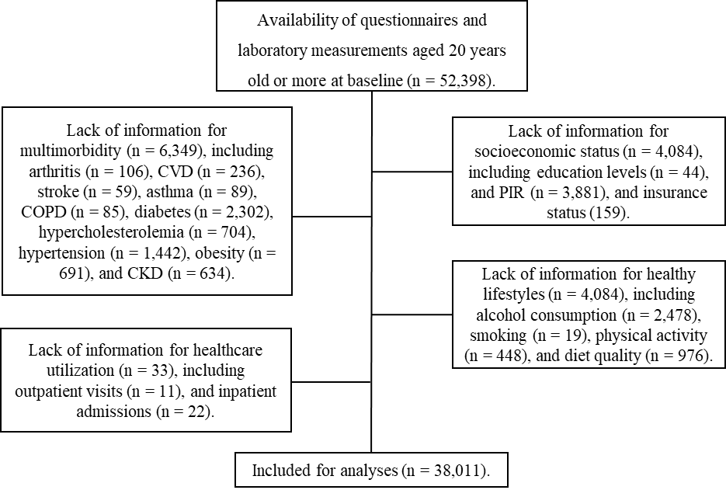
Supplementary Figure 1. Flowchart of inclusion and exclusion of study participants in the NHANES.
Abbreviations: CKD, chronic kidney disease; COPD, chronic obstructive pulmonary disease; CVD, cardiovascular disease; NHANES, National Health and Nutrition Examination Survey; PIR, Family poverty-to-income ratio.

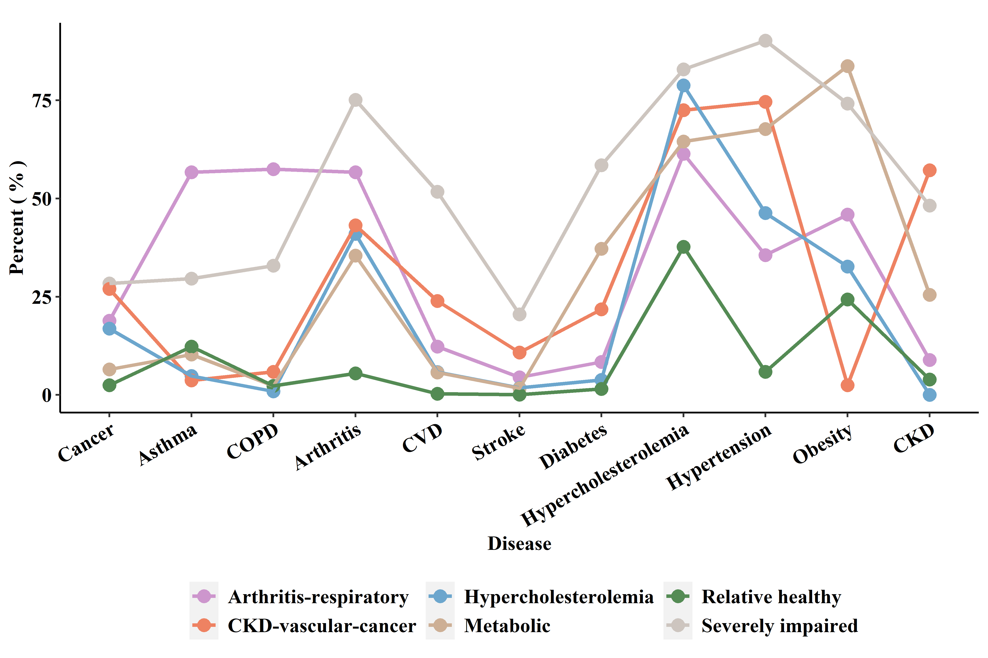
Supplementary Figure 2. Prevalence of individual chronic diseases for each of the six multimorbidity patterns.
Abbreviations: CKD, chronic kidney disease; COPD, chronic obstructive pulmonary disease; CVD, cardiovascular disease.

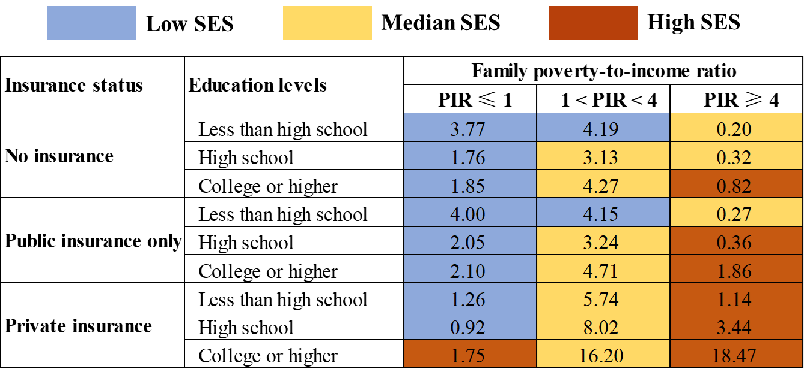
Supplementary Figure 3. Definitions of high, medium, and low SES in the three-latent-class solution. Abbreviations: PIR, Family poverty-to-income ratio; SES, socioeconomic status. The numbers in the cells represent the unweighted percentage of participants out of the total study population.

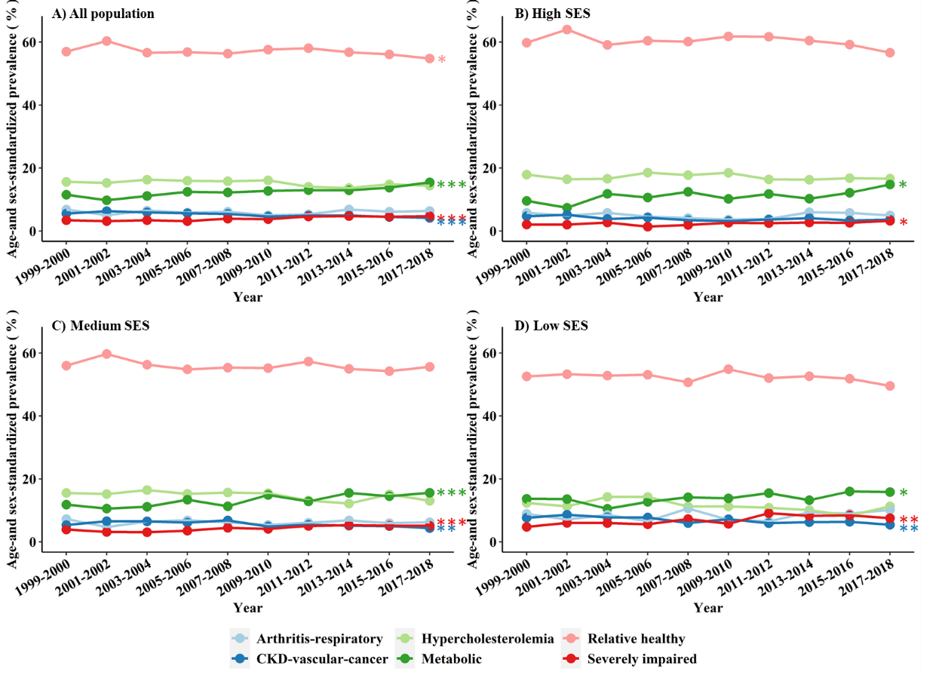
Supplementary Figure 4. Trends of age- and sex-adjusted standardized prevalence of multimorbidity patterns. Abbreviations: CKD, chronic kidney disease; SES, socioeconomic status. * indicating 0.05 < P ≤ 0.05；** indicating 0.001 < P ≤ 0.01；*** indicating P ≤ 0.001.

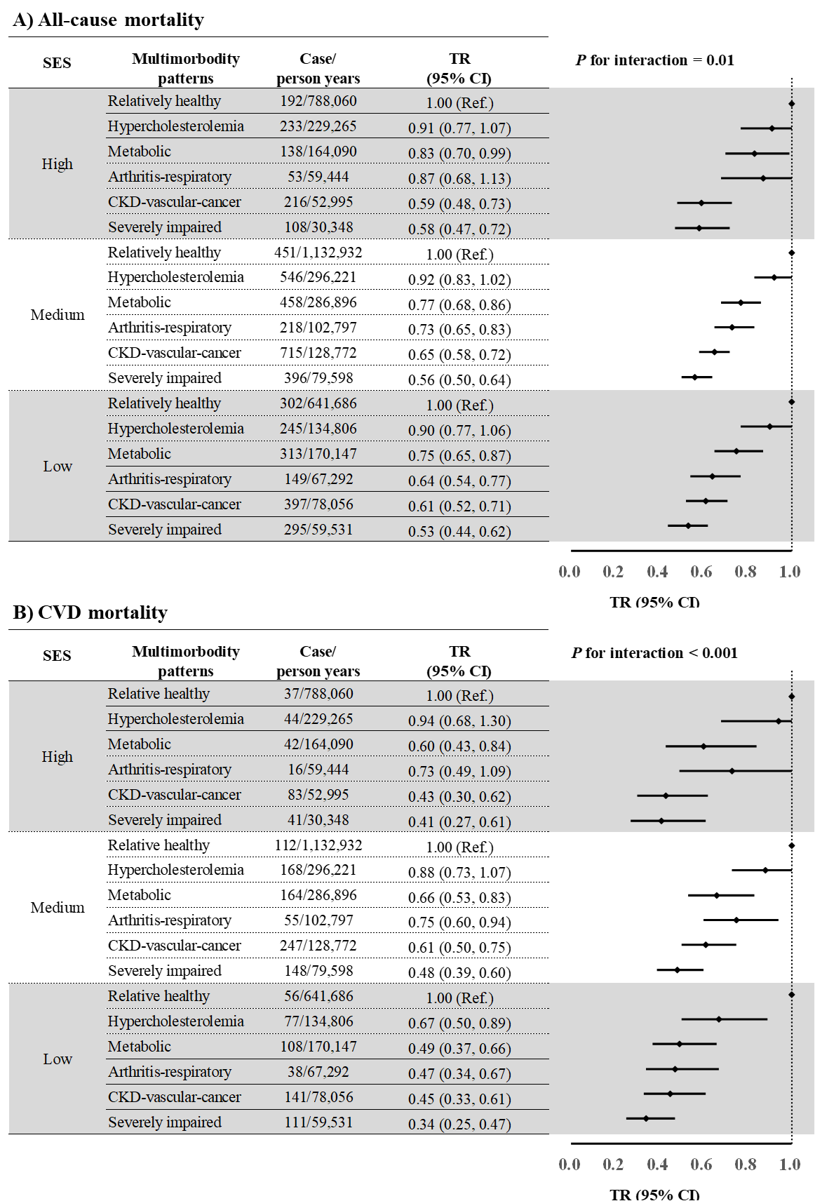
Supplementary Figure 5. Associations of multimorbidity patterns with survival years by SES after adjusting for SES components and individual healthy lifestyle factors instead of overall SES and healthy lifestyle scores. Abbreviations: CI, confidence interval; CKD, chronic kidney disease; CVD, cardiovascular disease; NHANES, National Health and Nutrition Examination Survey; SES, socioeconomic status; TR, time ratio. All models were adjusted for NHANES cycles, age (continuous, years), sex (male and female), race/ethnicity (Hispanic, non-Hispanic white, non-Hispanic black, and others), education (less than high school, high school, and college or higher), family poverty-to-income ratio (≤ 1, 1-4, and ≥ 4), and insurance status (no insurance, public insurance only, and private insurance), smoking (healthy and unhealthy), alcohol drinking (healthy and unhealthy), diet (healthy and unhealthy), and physical activity (healthy and unhealthy).

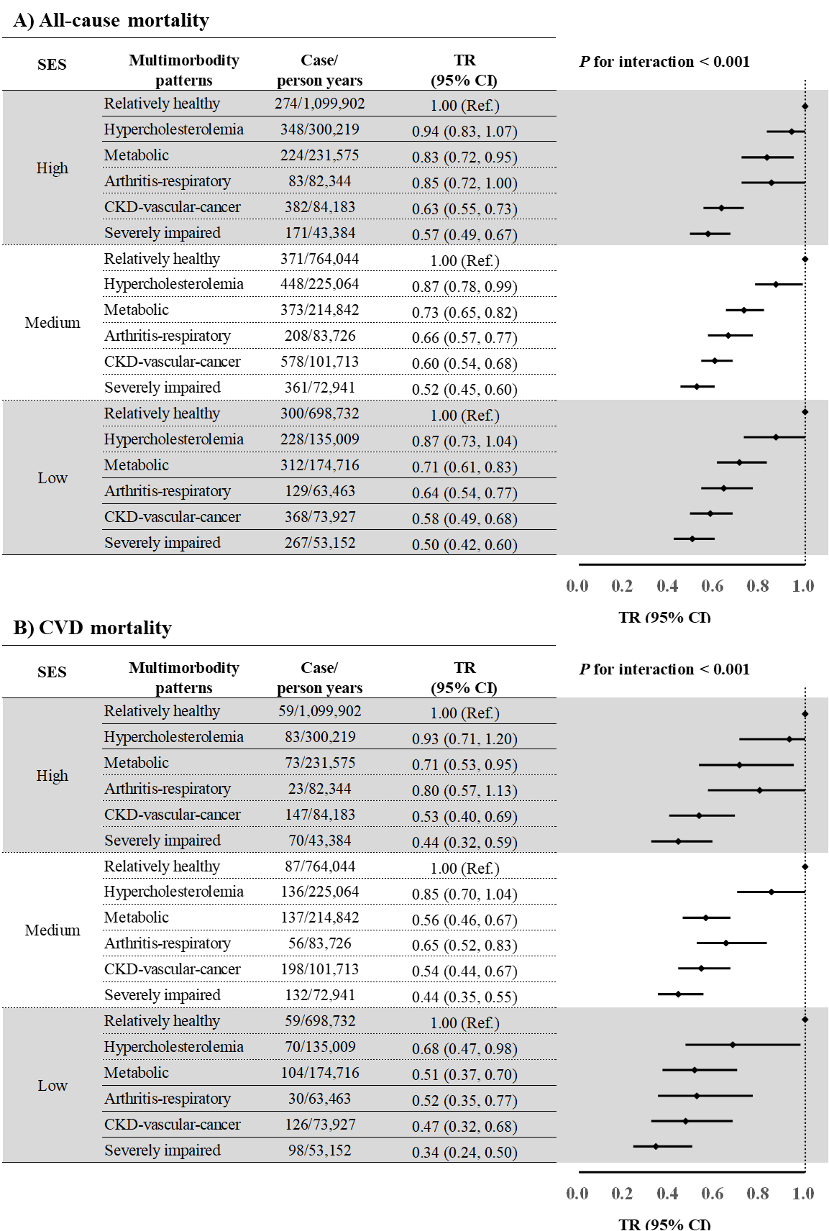
Supplementary Figure 6. Associations of multimorbidity patterns with survival years by SES using an alternative SES measure. Abbreviations: CI, confidence interval; CKD, chronic kidney disease; CVD, cardiovascular disease; NHANES, National Health and Nutrition Examination Survey; SES, socioeconomic status; TR, time ratio. All models were adjusted for NHANES cycles, age (continuous, years), sex (male and female), race/ethnicity (Hispanic, non-Hispanic white, non-Hispanic black, and others), healthy lifestyle (0-1, 2, and 3-4).

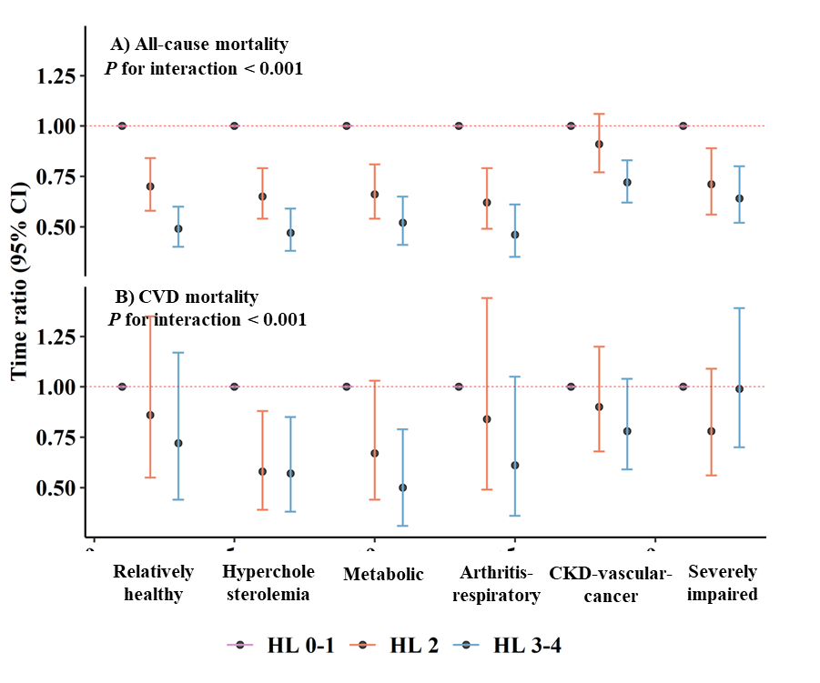
Supplementary Figure 7. Associations of healthy lifestyle with survival years by multimorbidity patterns after adjusting for SES components.
Abbreviations: CI, confidence interval; CKD, chronic kidney disease; CVD, cardiovascular disease; HL, healthy lifestyle; NHANES, National Health and Nutrition Examination Survey; SES, socioeconomic status; TR, time ratio. All models were adjusted for NHANES cycles, age (continuous, years), sex (male and female), race/ethnicity (Hispanic, non-Hispanic white, non-Hispanic black, and others), education (less than high school, high school, and college or higher), family poverty-to-income ratio (≤ 1, 1-4, and ≥ 4), and insurance status (no insurance, public insurance only, and private insurance).

