SUPPLEMENTAL MATERIALS
Breaking up Prolonged Sedentary Behavior to Improve Cardiometabolic Health (BREAK2): Protocol for A Dose-Finding Adaptive Randomization Trial
Keith M. Diaz¹, Margaret E. Murdock¹, Adriana Clark¹, Sitara Kumar¹, Victor Jerez¹, Maria A. Serafini¹, Chang Xu¹, Benjamin D. Boudreaux¹, Emily K. Romero¹, Jennifer Aguirre¹, Heather Seid², Renu Nandakumar³, Henry Ginsberg¹, Daichi Shimbo¹, Ying Kuen Cheung⁴
¹Department of Medicine, Columbia University Irving Medical Center, New York, NY 10032, United States of America
²Bionutrition Research Core, Irving Institute for Clinical and Translational Research, Columbia University Irving Medical Center, New York, NY 10032, United States of America
³Biomarkers Core Laboratory, Irving Institute for Clinical and Translational Research, Columbia University Irving Medical Center, New York, NY 10032, United States of America
⁴Department of Biostatistics, Mailman School of Public Health, Columbia University, New York, NY 10032, United States of America

Address for Correspondence:
Keith M. Diaz
Columbia University Medical Center
622 West 168th Street, PH9-301
New York, NY 10032
USA
212-305-1170
Email: kd2442@columbia.edu

Technical details of PIPE
- General approach: This dose-finding study uses the Product of Independent Probability Estimation (PIPE) method to estimate the minimum effective doses of sedentary break based on cardiometabolic response. The general PIPE approach is introduced in Cheung et al.¹ This appendix provides the specific design parameters employed in the study.
PIPE is a Bayesian projective method that estimates the minimum effective doses by maximizing the joint posterior gain projected over the constrained space of partial ordering, i.e.,

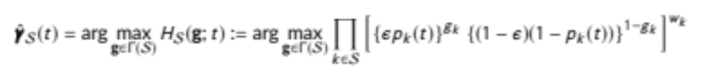 (1)

where p_{k}(t) = Prob( θ_{k} > 0.60 | data) is the unconstrained posterior probability that dose k has a response rate greater than 60%, and the posterior probability for each dose k is calculated based on beta-binomial conjugate prior, i.e., θ_{k} ~ beta (1.14, 0.86) a priori. This prior was chosen to be the least informative beta distribution that was unimodal, such that the prior median equals the null response rate 0.60. This setup corresponds to the aim to identify doses with at least 60% cardiometabolic response.

- Implementation at each interim analysis:
Posterior updates using PIPE: On the morning of the first visit of each participant, a member of our data management team performs real-time randomization via a Shiny app that implements PIPE. At the time of the randomization, PIPE per Equation (1) will be implemented with w_{k} = m_{k} + 1 where m_{k} is the sample size at dose k and ε will be calculated based on a linear tapering function:

$$ε= \frac{275-n}{276} ×0.5+ \frac{n+1}{276}×0.055$$

where n is the total sample size (with outcome evaluated) at the time of the randomization.

PIPE will identify doses that are effective based on the interim data and will give an estimate of the minimum effective contour (MEC). A dose belongs to the MEC if at least one of its neighboring doses is ineffective based on PIPE.

Adaptive randomization: The sedentary break condition for the next participant will be randomly selected from doses belonging to the MEC and adjacent doses that are ineffective. The allocation probabilities will be defined proportionately to p_{k}(t).

Simulation details of sample size estimation
We expect 324 participants will enroll in this study. Allowing for 10% attrition and 5% missing data, we expect that 275 participants will have complete data for both trial days. Simulation was used to determine operating characteristics of the PIPE algorithm where the truly ineffective doses had the null response rate $π_{0}=60\%$ and the truly effective doses had the alternative response rate 80%. We simulated 25,200 PIPE trials for all 252 possible dose-response configurations (i.e., 100 simulation replicates per configuration) using linear tapering per Equation.¹ For each simulated trial, the true positive rate was calculated as the ratio of the number of truly effective doses declared as effective to the number of truly effective doses, and the false discovery rate was calculated as the ratio of the number of ineffective doses among those selected as the minimally effective doses. The true positive probability (TPP) was then calculated by averaging the true positive rates across simulated trials. Conceptually, the TPP is the probability of classifying a true effective dose as effective, and it is analogous to statistical power in a single hypothesis test setting (while this trial deals with 25 hypothesis tests). The false discovery probability (FDP, probability of selecting an ineffective dose among the estimated minimally effective dose) was calculated by averaging the false discovery rates across all simulated trials. With N=275, the adaptive PIPE algorithm yielded a TPP of 0.82 and FDP of 0.049. In contrast, with the same sample size, a non-adaptive balanced randomization design (i.e., 11 participants per combination) using the same estimation procedure at a trial’s end would give a TPP of 0.57 and an FDP of 0.064.

REFERENCES
1. Cheung YK, Chandereng T, Diaz KM. A Novel Framework to Estimate Multidimensional Minimum Effective Doses Using Asymmetric Posterior Gain and ϵ-Tapering. Ann Appl Stat. 2022;16(3):1445-1458.

Study Consent Form
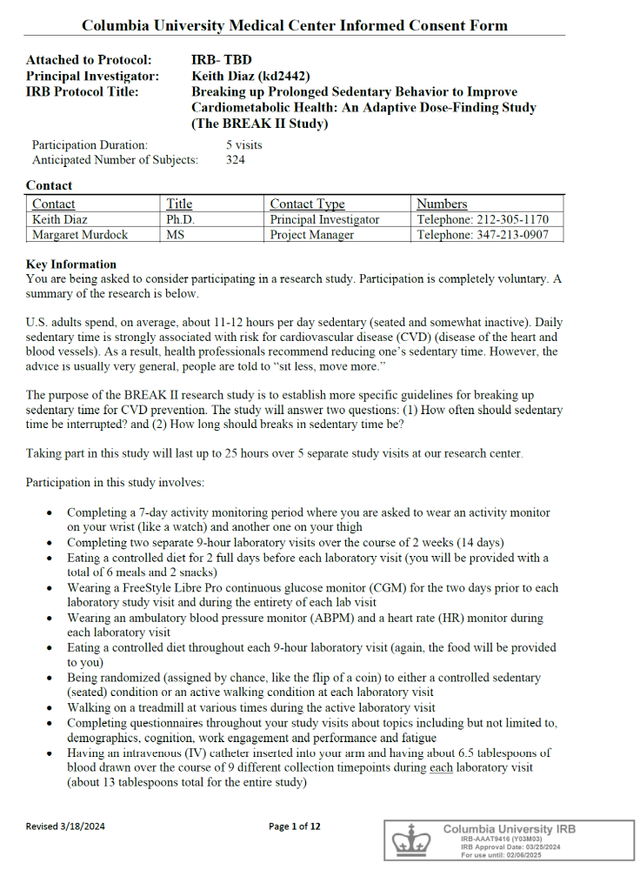





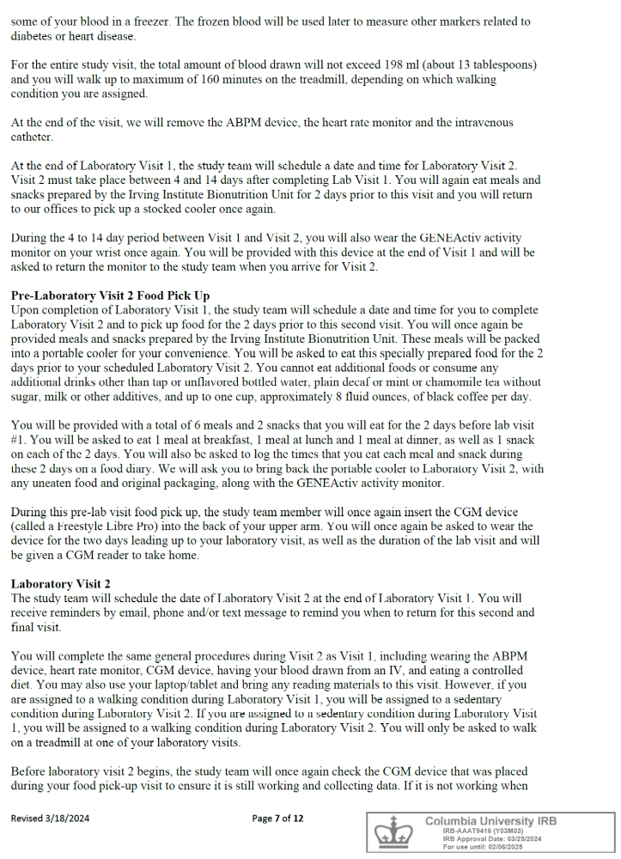
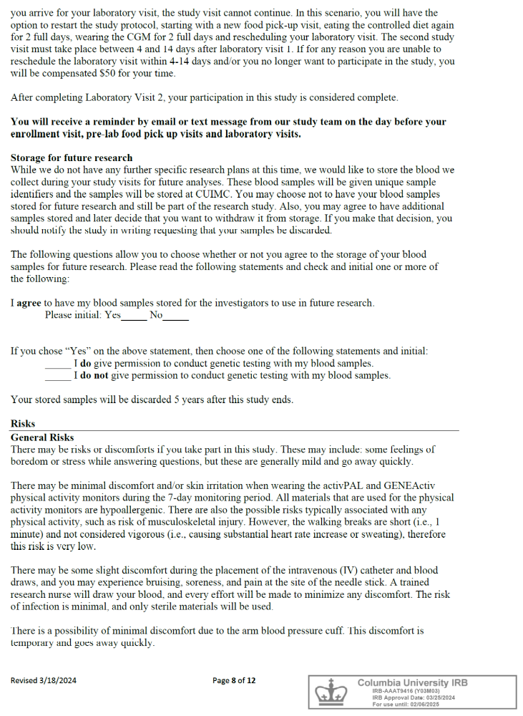
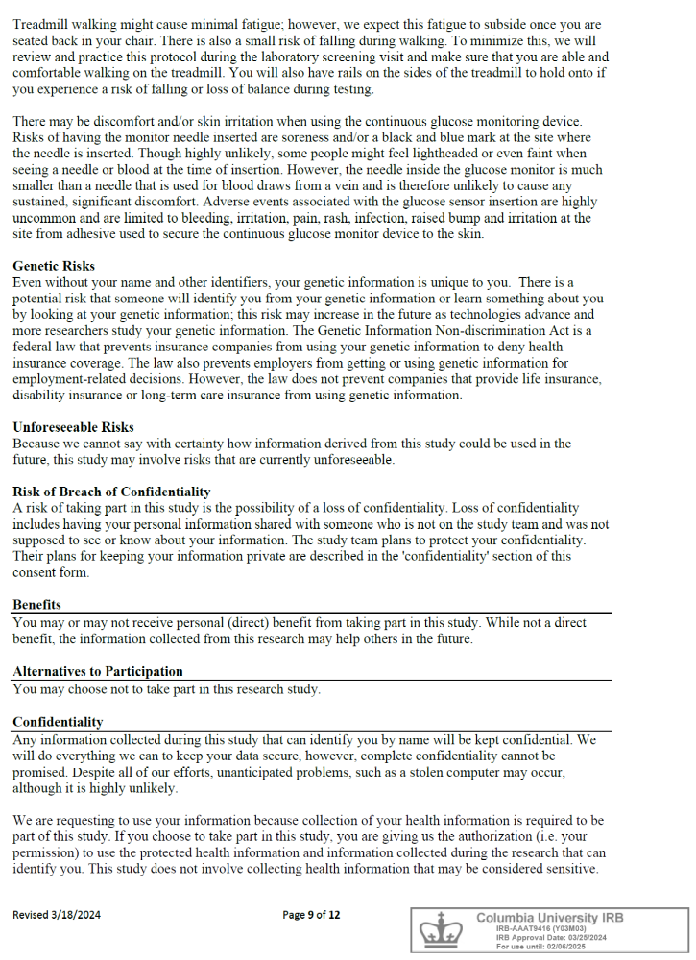


SPIRIT 2013 Checklist: Recommended items to address in a clinical trial protocol and related documents*
Section/item | ItemNo | Description | Addressed on Page Number
Administrative information
Title | 1 | Descriptive title identifying the study design, population, interventions, and, if applicable, trial acronym | 1
Trial registration | 2a | Trial identifier and registry name. If not yet registered, name of intended registry | 9
Trial registration | 2b | All items from the World Health Organization Trial Registration Data Set | N/A
Protocol version | 3 | Date and version identifier | N/A
Funding | 4 | Sources and types of financial, material, and other support | 30
Roles and responsibilities | 5a | Names, affiliations, and roles of protocol contributors | 1, 30-31
Roles and responsibilities | 5b | Name and contact information for the trial sponsor | 30
 | 5c | Role of study sponsor and funders, if any, in study design; collection, management, analysis, and interpretation of data; writing of the report; and the decision to submit the report for publication, including whether they will have ultimate authority over any of these activities | 30
 | 5d | Composition, roles, and responsibilities of the coordinating centre, steering committee, endpoint adjudication committee, data management team, and other individuals or groups overseeing the trial, if applicable (see Item 21a for data monitoring committee) | N/A
Introduction
Background and rationale | 6a | Description of research question and justification for undertaking the trial, including summary of relevant studies (published and unpublished) examining benefits and harms for each intervention | 1-7
 | 6b | Explanation for choice of comparators | N/A
Objectives | 7 | Specific objectives or hypotheses | 7
Trial design | 8 | Description of trial design including type of trial (eg, parallel group, crossover, factorial, single group), allocation ratio, and framework (eg, superiority, equivalence, noninferiority, exploratory) | 7-8
Methods: Participants, interventions, and outcomes
Study setting | 9 | Description of study settings (eg, community clinic, academic hospital) and list of countries where data will be collected. Reference to where list of study sites can be obtained | 8
Eligibility criteria | 10 | Inclusion and exclusion criteria for participants. If applicable, eligibility criteria for study centres and individuals who will perform the interventions (eg, surgeons, psychotherapists) | 9-10
Interventions | 11a | Interventions for each group with sufficient detail to allow replication, including how and when they will be administered | 14-15
Interventions | 11b | Criteria for discontinuing or modifying allocated interventions for a given trial participant (eg, drug dose change in response to harms, participant request, or improving/worsening disease) | N/A
Interventions | 11c | Strategies to improve adherence to intervention protocols, and any procedures for monitoring adherence (eg, drug tablet return, laboratory tests) | 13-15
Interventions | 11d | Relevant concomitant care and interventions that are permitted or prohibited during the trial | 13
Outcomes | 12 | Primary, secondary, and other outcomes, including the specific measurement variable (eg, systolic blood pressure), analysis metric (eg, change from baseline, final value, time to event), method of aggregation (eg, median, proportion), and time point for each outcome. Explanation of the clinical relevance of chosen efficacy and harm outcomes is strongly recommended | 15-22
Participant timeline | 13 | Time schedule of enrolment, interventions (including any run-ins and washouts), assessments, and visits for participants. A schematic diagram is highly recommended (see Figure) | 8
Sample size | 14 | Estimated number of participants needed to achieve study objectives and how it was determined, including clinical and statistical assumptions supporting any sample size calculations | 26-27
Recruitment | 15 | Strategies for achieving adequate participant enrolment to reach target sample size | 10
Methods: Assignment of interventions (for controlled trials)
Allocation:
Sequence generation | 16a | Method of generating the allocation sequence (eg, computer-generated random numbers), and list of any factors for stratification. To reduce predictability of a random sequence, details of any planned restriction (eg, blocking) should be provided in a separate document that is unavailable to those who enrol participants or assign interventions | 23-24
Allocation concealment mechanism | 16b | Mechanism of implementing the allocation sequence (eg, central telephone; sequentially numbered, opaque, sealed envelopes), describing any steps to conceal the sequence until interventions are assigned | 12
Implementation | 16c | Who will generate the allocation sequence, who will enrol participants, and who will assign participants to interventions | 12
Blinding (masking) | 17a | Who will be blinded after assignment to interventions (eg, trial participants, care providers, outcome assessors, data analysts), and how | 12
 | 17b | If blinded, circumstances under which unblinding is permissible, and procedure for revealing a participant’s allocated intervention during the trial | N/A
Methods: Data collection, management, and analysis
Data collection methods | 18a | Plans for assessment and collection of outcome, baseline, and other trial data, including any related processes to promote data quality (eg, duplicate measurements, training of assessors) and a description of study instruments (eg, questionnaires, laboratory tests) along with their reliability and validity, if known. Reference to where data collection forms can be found, if not in the protocol | 15-22
 | 18b | Plans to promote participant retention and complete follow-up, including list of any outcome data to be collected for participants who discontinue or deviate from intervention protocols | 10
Data management | 19 | Plans for data entry, coding, security, and storage, including any related processes to promote data quality (eg, double data entry; range checks for data values). Reference to where details of data management procedures can be found, if not in the protocol | 11-12, 22-23
Statistical methods | 20a | Statistical methods for analysing primary and secondary outcomes. Reference to where other details of the statistical analysis plan can be found, if not in the protocol | 25-26
 | 20b | Methods for any additional analyses (eg, subgroup and adjusted analyses) | 26
 | 20c | Definition of analysis population relating to protocol non-adherence (eg, as randomised analysis), and any statistical methods to handle missing data (eg, multiple imputation) | 25-26
Methods: Monitoring
Data monitoring | 21a | Composition of data monitoring committee (DMC); summary of its role and reporting structure; statement of whether it is independent from the sponsor and competing interests; and reference to where further details about its charter can be found, if not in the protocol. Alternatively, an explanation of why a DMC is not needed | N/A
 | 21b | Description of any interim analyses and stopping guidelines, including who will have access to these interim results and make the final decision to terminate the trial | N/A
Harms | 22 | Plans for collecting, assessing, reporting, and managing solicited and spontaneously reported adverse events and other unintended effects of trial interventions or trial conduct | N/A
Auditing | 23 | Frequency and procedures for auditing trial conduct, if any, and whether the process will be independent from investigators and the sponsor | N/A
Ethics and dissemination
Research ethics approval | 24 | Plans for seeking research ethics committee/institutional review board (REC/IRB) approval | 9
Protocol amendments | 25 | Plans for communicating important protocol modifications (eg, changes to eligibility criteria, outcomes, analyses) to relevant parties (eg, investigators, REC/IRBs, trial participants, trial registries, journals, regulators) | N/A
Consent or assent | 26a | Who will obtain informed consent or assent from potential trial participants or authorised surrogates, and how (see Item 32) | 10
 | 26b | Additional consent provisions for collection and use of participant data and biological specimens in ancillary studies, if applicable | N/A
Confidentiality | 27 | How personal information about potential and enrolled participants will be collected, shared, and maintained in order to protect confidentiality before, during, and after the trial | Supplement
Declaration of interests | 28 | Financial and other competing interests for principal investigators for the overall trial and each study site | 30
Access to data | 29 | Statement of who will have access to the final trial dataset, and disclosure of contractual agreements that limit such access for investigators | 27
Ancillary and post-trial care | 30 | Provisions, if any, for ancillary and post-trial care, and for compensation to those who suffer harm from trial participation | N/A
Dissemination policy | 31a | Plans for investigators and sponsor to communicate trial results to participants, healthcare professionals, the public, and other relevant groups (eg, via publication, reporting in results databases, or other data sharing arrangements), including any publication restrictions | 27
 | 31b | Authorship eligibility guidelines and any intended use of professional writers | N/A
 | 31c | Plans, if any, for granting public access to the full protocol, participant-level dataset, and statistical code | 27
Appendices
Informed consent materials | 32 | Model consent form and other related documentation given to participants and authorised surrogates | Supplement
Biological specimens | 33 | Plans for collection, laboratory evaluation, and storage of biological specimens for genetic or molecular analysis in the current trial and for future use in ancillary studies, if applicable | N/A
*It is strongly recommended that this checklist be read in conjunction with the SPIRIT 2013 Explanation & Elaboration for important clarification on the items. Amendments to the protocol should be tracked and dated. The SPIRIT checklist is copyrighted by the SPIRIT Group under the Creative Commons “Attribution-NonCommercial-NoDerivs 3.0 Unported” license.

