Supplementary Material
Table S1 Test of measurement invariance of psychology security across year
Table S2 Indicator coding for income.
Table S3 Simple slope of Inc-L.
Fig. S1 Interaction between income and PS on NA.
Table S4 Ihe mediating role of PS
Table S5 Ihe moderating role of PS.

Table S1 Test of measurement invariance of psychology security across year
Model | χ2 | df | CFI | RMSEA | SRMR | △CFI | △RMSEA
M0(configural) | 8158.91 | 1689 | 0.927 | 0.041 | 0.037
M1(metric) | 8234.91 | 1747 | 0.927 | 0.04 | 0.038 | 0 | 0.001
M2(scalar) | 8387.81 | 1805 | 0.926 | 0.04 | 0.038 | 0.001 | 0
M3(strict) | 8524.077 | 1877 | 0.925 | 0.039 | 0.04 | 0.001 | 0.001
Note. CFl = comparative fit index; RMSEA = root mean square error of approximation; SRMR = standardized root mean square residual.
Table S2 Indicator coding for income
 | High income | Middle income | Low income
Inc-M | 0 | 1 | 0
Inc-L | 0 | 0 | 1
Note：Inc-L low-income as a reference to high-income; Inc-M middle-income as a reference to high-income.

Table S3 Simple slope of Inc-L.
Psychological security |  | Effect | se | t | p | LLCI | ULCI
M-SD | 2.880 | -0.043 | 0.038 | -1.125 | 0.261 | -0.1182 | 0.0320
M | 3.479 | 0.009 | 0.027 | 0.318 | 0.751 | -0.0443 | 0.0615
M+SD | 4.079 | 0.060 | 0.037 | 1.631 | 0.103 | -0.0122 | 0.1327

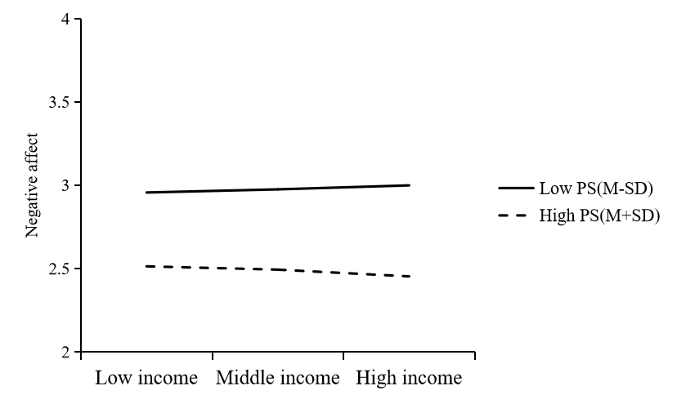
Fig. S1 Interaction between income and PS on NA.

Table S4 The mediating role of PS
 | LS |  | PA |  | NA
 | model1 | Model2 | Model3 | Model4 | Model5 | Model6
Income | 0.246*** | 0.161*** | 0.196*** | 0.107*** | -0.046*** | -0.015
 | (14.982) | (11.224) | (14.136) | (9.770) | (-4.120) | (-1.387)
Gender | 0.057 | 0.027 | 0.017 | -0.014 | -0.069** | -0.058**
 | (1.850) | (1.001) | (0.669) | (-0.686) | (-3.267) | (-2.845)
Age | 0.191*** | 0.172*** | 0.058* | 0.039 | -0.103*** | -0.096***
 | (6.109) | (6.375) | (2.220) | (1.890) | (-4.848) | (-4.701)
Education | 0.108*** | 0.071** | 0.089*** | 0.050** | 0.007 | 0.021
 | (4.236) | (3.203) | (4.151) | (2.986) | (0.429) | (1.256)
PS |  | 1.093*** |  | 1.130*** |  | -0.398***
 |  | (48.428) |  | (65.329) |  | (-23.179)
Constant | 2.780*** | -0.661*** | 3.381*** | -0.180** | 2.948*** | 4.201***
 | (42.918) | (-7.306) | (61.938) | (-2.590) | (66.662) | (61.034)
N | 6953 | 6953 | 6953 | 6953 | 6953 | 6953
adj. R² | 0.048 | 0.288 | 0.039 | 0.404 | 0.007 | 0.078
t statistics in parentheses, * p < 0.05, ** p < 0.01, *** p < 0.001
Gender coding: 0=male, 1=female; Age coding: 0=under 35, 1=over 35; Education coding: Junior college or below =1 Bachelor degree = 2 Graduate degree or above = 3
Abbreviations: LS life satisfaction; PA positive affect; NA negative affect; PS psychological security

Table S5 The moderating role of PS
 | Model1 | Model3 | Model3
 | LS | PA | NA
Income | -0.183* | 0.014 | 0.103
 | (-2.348) | (0.237) | (1.738)
Gender | 0.029 | -0.014 | -0.059**
 | (1.068) | (-0.663) | (-2.876)
Age | 0.171*** | 0.039 | -0.096***
 | (6.331) | (1.871) | (-4.679)
Education | 0.070** | 0.050** | 0.021
 | (3.166) | (2.972) | (1.274)
PS | 0.797*** | 1.050*** | -0.296***
 | (11.444) | (19.641) | (-5.583)
Income*PS | 0.099*** | 0.027 | -0.034*
 | (4.489) | (1.585) | (-2.028)
Constant | 0.360 | 0.097 | 3.849***
 | (1.472) | (0.517) | (20.644)
N | 6953 | 6953 | 6953
adj. R² | 0.290 | 0.404 | 0.079
t statistics in parentheses, * p < 0.05, ** p < 0.01, *** p < 0.001
Gender coding: 0=male, 1=female; Age coding: 0=under 35, 1=over 35; Education coding: Junior college or below =1 Bachelor degree = 2 Graduate degree or above = 3
Abbreviations: LS life satisfaction; PA positive affect; NA negative affect; PS psychological security

