Contents
SUPPLEMENTAL METHODS 2
SUPPLEMENTAL TABLES AND FIGURE 4
Table S1. Variable in analysis 4
Table S2. Sample characteristics by smartphone addiction status, unweighted 4
Table S3. Prevalence of smartphone addiction among males and females in China by provincial-level administrative division, weighted 5
Figure S1. Prevalence of smartphone addiction among males and females in China by provincial-level administrative division, weighted 6
Table S4: Mediation analyses stratified by gender, weighted 6
Table S5. Bootstrap analyses of the mediation model stratified by gender, weighted 7
Table S6. Mediation analyses stratified by age, weighted 7
Table S7. Bootstrap analyses of the mediation model stratified by age, weighted 8
Table S8. Moderated mediation analyses of self-control between parental monitoring and smartphone addiction, weighted 8
SUPPLEMENTAL REFERENCES 9

SUPPLEMENTAL METHODS
We collected data through a two-stage online survey. We stratified the sampling within each provincial-level administrative division (PLAD) by school type (junior high school, senior high school or college) to estimate the sample size by utilizing data from the Statistical Communiqué on the 2022 Economic and Statistical Bulletin on Education Development (Table S2), which includes data from China and the 31 PLADs. Based on statistical conventions, a sample size exceeding 30 is considered large and robust. Since the number of college students in Xizang is the smallest, its data were set as the benchmark. We set the sample size for college students in the Xizang stratum to 30. The sample sizes for the other strata were allocated based on the proportion of the number of college, high school, and middle school students in each PLAD to the number of college students in Xizang. The estimated sample sizes from each PLAD were aggregated, resulting in a total estimated sample size of 9,270.

In the first stage, we included all 31 PLADs in the Chinese mainland. The overall sample size goal was allocated to each PLAD based on the proportion of students in each PLAD relative to the national total. In the second stage, we applied stratified sampling within each type of school (junior high school, senior high school or college) in each PLAD. We allocated sample size goals to each stratum based on the proportion of students in each stratum relative to the total number in the corresponding PLAD.

The online survey was administered by KuRunData, a survey company recognized for its reliable data collection methods that have been extensively used in previous analyses.[1-3] Respondents were recruited through the registered member networks of KuRunData and its partner companies. To expand the surveys’ reach, registered members were encouraged to invite new members via WeChat, a highly prevalent social networking platform in China. Duplicate registrations were identified and excluded from surveys. Registered members also had to pass authenticity and seriousness tests to be eligible for survey participation, and these tests were repeated at regular intervals of at least every 180 days. Basic personal information, including gender, date of birth, education, and location, was collected from registered members. To ensure the accuracy of the information, IP addresses were used to verify the location, and phone numbers and email addresses had to be activated. Additionally, gender and date of birth could not be changed after submission, and changes to the location information required re-verification through the IP address.

Our survey was conducted between October and November 2023. The target group for the survey was identified based on the basic personal information provided by registered members. Randomly selected potential respondents from the target group received SMS messages and email invitations containing a unique survey link, which could only be used once. These invitation messages did not contain any information related to the survey to avoid participation bias. The e-questionnaire used in the survey was created in standard Chinese and hosted on the survey platform of KuRunData. It was refined based on feedback received during a pilot online survey involving a convenience sample of 104 high school students. Participation in the survey was voluntary and guaranteed anonymity. Before participation, respondents were requested to read an informed consent statement for at least 15 seconds and provide an electronic signature to confirm their understanding of the survey’s purpose, as well as the potential benefits and risks of participation. During the survey, each question had to be completed before proceeding to the next. The survey platform incorporated automatic logic checks and skipping patterns, such as skipping questions about current e-cigarette use for those who did not currently use them. Respondents who completed the e-questionnaire in less than a preset threshold of five minutes were instantly excluded, as rushed responses may not meet the required quality standards.

A total of 12,642 adolescents accessed the e-questionnaire, and 10,388 completed it. Among the 10,388 respondents, 495 responses were identified as unqualified, and 623 responses were stored as backup data. Ultimately, 9,270 respondents were included in our analysis. The overall response rate was 73.3% (9,270/12,642).

SUPPLEMENTAL TABLES AND FIGURES

Table S1. Variable in analysis
Variable | Inclusion from | Role in models
Smartphone addiction [4-6] | Continuous variable | Outcome variable
Parent‒child relationship | Continuous variable | Exposure variable
Parental monitoring [7, 8] | Continuous variable | Mediating variable
Self-control [9] | Continuous variable | Moderating variable
Gender | A binary variable with values of male or female | Control variable
Age | Continuous variable | Control variable
Residence | A binary variable with values of urban or rural | Control variable
Educational attainment | Three categorical variables  1) Junior high school  2) Senior high school vs. Junior high school  3) College vs. Junior high school | Control variable
Family economic situation | Four categorical variables  1) Lower-middle  2) Middle  3) Upper-middle  4) Well-off  5) Difficult | Control variable

Table S2: Number of students across school types in each PLAD
PLAD | Data Sources
Shanghai | https://edu.sh.gov.cn/xxgk2_zdgz_jygzydynb_02/20230327/4cd452a549f44a468f0b04fbcf20ee1c.html
Beijing | https://jw.beijing.gov.cn/xxgk/shujufab/tongjigaikuang/202303/t20230317_2938666.html
Liaoning | https://jyt.ln.gov.cn/jyt/gk/sjfb/tjgb/sytjgb/2024082817194666954/2024082817194612582.pdf
Hainan | -ª
Tianjin | https://jy.tj.gov.cn/ZWGK_52172/zfxxgk1_1/fdzdgknr1/tjxx/202303/t20230329_6153842.html
Jiangsu | http://www.zgjssw.gov.cn/yaowen/202303/t20230303_7849886.shtml
Hebei | http://www.hebei.gov.cn/columns/3bbf017c-0e27-4cac-88c0-c5cac90ecd73/202308/14/5d0aeadb-7d84-4e06-8e52-47d9a19dfb74.html
Fujian | http://tjj.fujian.gov.cn/xxgk/tjgb/202303/t20230313_6130081.htm
Xinjiang | https://www.xinjiang.gov.cn/xinjiang/tjgb/202303/a527e6eb22524c40bc7fca952a05710e.shtml
Zhejiang | http://tjj.zj.gov.cn/art/2023/3/16/art_1229129205_5080307.html
Qinghai | https://mp.weixin.qq.com/s?__biz=MjM5NDMzNzEwNg==&mid=2650280373&idx=1&sn=9349787ca4054f5fecce8c709649253b&chksm=be85e98889f2609ede0eb200965e67317fbc5e2b63e254444dbe3fd4c8eed92b20af07baed2d&scene=27
Sichuan | https://www.sc.gov.cn/10462/c108715/2023/3/22/5d2ee2bb1c0c45088d011638934d0cfa.shtml
Xizang | https://www.xizang.gov.cn/zwgk/zfsj/ndtjgb/202304/t20230427_352840.html
Jiangxi | http://tjj.jiangxi.gov.cn/default/files/986d3cf5-e3e9-4503-b3af-2993a2b3f033.pdf
Shandong | http://tjj.shandong.gov.cn/art/2023/3/2/art_104039_10303465.html
Henan | https://www.henan.gov.cn/2023/03-23/2711902.html
Hubei | http://www.hubei.gov.cn/zwgk/hbyw/hbywqb/202303/t20230318_4589713.shtml
Ningxia | https://nxccpit.nx.gov.cn/xwzx/zzqxx/202304/t20230426_4047068.html
Shanxi | http://www.shanxi.gov.cn/ywdt/sxyw/202303/t20230324_8210360.shtml
Anhui | https://www.ah.gov.cn/zfsj/tjgblmdz/sjtjgb/564232991.html
Gansu | http://www.jcs.gov.cn/zfxxgk/fdzdgknr/zdmsxx/jyxx/jygk/art/2023/art_ff4e81aa1b7541ce83ec13de4255e912.html
Yunnan | https://www.yn.gov.cn/sjfb/tjgb/202303/t20230328_256987.html
Heilongjiang | https://www.hlj.gov.cn/hlj/c108419/202303/c00_31558765.shtml
Guizhou | https://www.guizhou.gov.cn/zwgk/zfsj/tjgb/202305/t20230517_79768889.html
Hunan | http://tjj.hunan.gov.cn/tjfx/tjgb/jjfzgb/202303/t20230323_29289710.html
Jilin | http://tjj.jl.gov.cn/tjsj/tjgb/ndgb/202304/t20230401_8687326.html
Guangdong | http://stats.gd.gov.cn/attachment/0/517/517175/4146083.pdf
Inner Mongolia | https://www.nmg.gov.cn/zwgk/zfgb/2023n/202311/202307/t20230710_2344824.html
Guangxi | http://tjj.gxzf.gov.cn/syyw/t16224266.shtml
Shaanxi | https://www.shaanxi.gov.cn/zfxxgk/fdzdgknr/tjxx/tjgb_240/stjgb/202304/t20230419_2283054.html
Chongqing | http://wap.cq.gov.cn/zwgk/zfxxgkml/sjfb_120853/tjgb/202303/t20230320_11785098.html
Total | https://www.stats.gov.cn/sj/zxfb/202302/t20230228_1919011.html
ªThe data for Hainan Province was not available. The data for Xizang was used as a reference. The reference data was multiplied by 1 to compute the data for Hainan. PLAD, provincial-level administrative division.

Table S3. Sample characteristics by smartphone addiction status, unweighted
Variable | Full sample  (n = 9,270) | Smartphone addiction  (n = 6,671) | Non smartphone addiction  (n = 2,559)
Male, n (%) | 4,635 (50.0) | 3,356 (50.3) | 1,279 (49.2)
Age (years), median (IQR)
Age group (years), n (%) | 16 (14, 19) | 16 (14, 19) | 16 (14, 20)
11~15 | 3,742 (41.6) | 1,954 (29.3) | 1,042 (40.1)
16~18 | 2,597 (26.0) | 2,751 (41.2) | 787 (30.3)
19~22 | 2,036(22.0) | 1,459 (21.9) | 577 (22.2)
23~25 | 700(7.6) | 507 (7.6) | 139 (7.4)
Urban residence, n (%) | 6,938 (74.8) | 4,946 (74.1) | 1,992 (76.6)
Educational attainment, n (%)
Junior high school | 3,060 (33.0) | 2,190 (32.8) | 870 (33.5)
Senior high school | 3120 (33.7) | 2,259 (33.9) | 861 (33.1)
College | 3,090 (33.3) | 2,222 (33.3) | 868 (33.4)
Family economic situation, n (%)
Lower-middle | 1267 (13.7) | 1007 (15.1) | 260 (10.0)
Middle | 5,049 (54.5) | 3,684 (55.2) | 1,365 (52.5)
Upper-middle | 2954 (31.9) | 1980 (29.7) | 974 (37.5)
The presented results were derived from a weighted sample, n (%), frequency with percentage, IQR, interquartile range. The percentage in parenthetical represents the distribution of various variables in the full sample and different levels of smartphone addiction.

Table S4. Prevalence of smartphone addiction among males and females in China by provincial-level administrative division, weighted
PLAD | Full sample, n (%) | Male, n (%) | Female, n (%)
Shanghai | 322 (4.5) | 173 (4.7) | 149 (4.3)
Beijing | 71 (1.0) | 36 (1.0) | 35 (1.0)
Liaoning | 419 (5.8) | 210 (5.7) | 209 (6.0)
Hainan | 172 (2.4) | 90 (2.4) | 82 (2.4)
Tianjin | 85 (1.2) | 46 (1.2) | 39 (1.1)
Jiangsu | 181 (2.5) | 91 (2.5) | 90 (2.6)
Hebei | 128 (1.8) | 61 (1.6) | 68 (2.0)
Fujian | 132 (1.8) | 74 (2.0) | 58 (1.7)
Xinjiang | 85 (1.2) | 42 (1.1) | 42 (1.2)
Zhejiang | 368 (5.1) | 175 (4.7) | 193 (5.6)
Qinghai | 222 (3.1) | 118 (3.2) | 104 (3.0)
Sichuan | 313 (4.4) | 179 (4.8) | 134 (3.9)
Xizang | 202 (2.8) | 104 (2.8) | 98 (2.8)
Jiangxi | 290 (4.0) | 155 (4.2) | 136 (3.9)
Shandong | 499 (7.0) | 247 (6.7) | 252 (7.3)
Henan | 583 (8.1) | 317(8.5) | 267 (7.7)
Hubei | 277 (3.9) | 150 (4.0) | 127 (3.7)
Ningxia | 370 (5.2) | 196 (5.3) | 174 (5.0)
Shanxi | 557 (7.8) | 287 (7.7) | 270 (7.8)
Anhui | 299 (4.2) | 152 (4.1) | 147 (4.2)
Gansu | 48 (0.7) | 24 (0.7) | 24 (0.7)
Yunnan | 169 (2.4) | 83 (2.2) | 86 (2.5)
Heilongjiang | 399 (5.6) | 204 (5.5) | 195 (5.6)
Guizhou | 217 (3.0) | 114 (3.1) | 102 (3.0)
Hunan | 237 (3.3) | 119 (3.2) | 119 (3.4)
Jilin | 15 (0.2) | 9 (0.2) | 7 (0.2)
Guangdong | 196 (2.7) | 101 (2.7) | 96 (2.8)
Inner Mongolia | 124 (1.7) | 63 (1.7) | 61 (1.8)
Guangxi | 27 (0.4) | 14 (0.4) | 14 (0.4)
Shaanxi | 38 (0.5) | 17 (0.5) | 21 (0.6)
Chongqing | 129 (1.8) | 61 (1.7) | 68 (2.0)
Total | 7,175 (100.0) | 3,710 (100.0) | 3,465 (100.0)
PLAD, provincial-level administrative division; n (%), frequency with percentage.

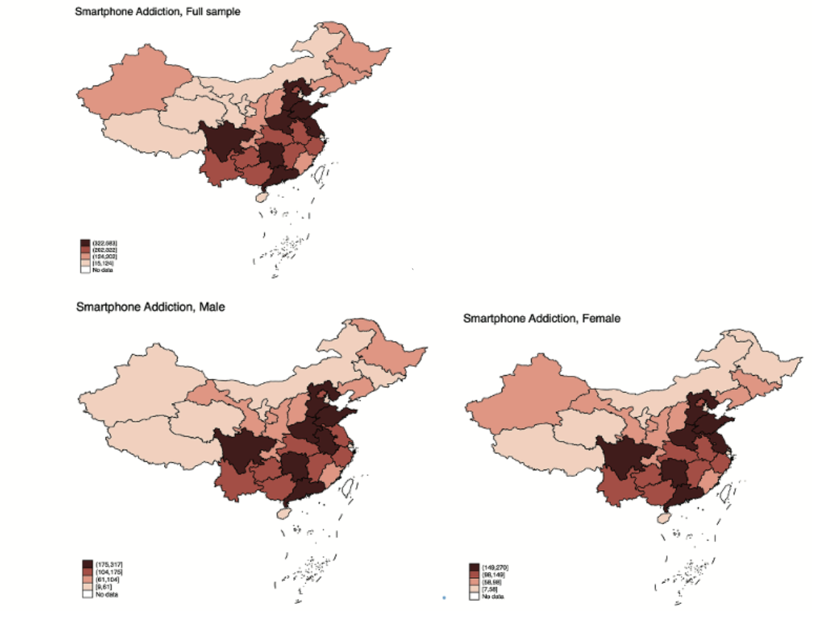

Figure S1. Prevalence of smartphone addiction among males and females in China by provincial-level administrative division, weighted
The blank areas represent the provincial-level administrative divisions not included in the survey. The presented results were derived from a weighted sample.

Table S5: Mediation analyses stratified by gender, weighted
 | Full sample, Coefficient | Male, Coefficient | Female, Coefficient
 | (95% CI) | (95% CI) | (95% CI)
Parental
monitoring
Parent‒child relationship | 0.32(0.30, 0.34) | 0.32 (0.29, 0.34) | 0.33 (0.30, 0.36)
Smartphone
addiction
Parental monitoring | -0.29 (-0.31, -0.26) | -0.26 (-0.30, -0.23) | -0.31 (-0.34, -0.28)
Parent‒child relationship | -0.10(-0.12, -0.08) | -0.11 (-0.14, -0.08) | -0.08(-0.11, -0.05)
The presented results were the standardized coefficients with 95% confidence intervals. Maximum likelihood estimation was used to estimate the model standardized coefficients and 95% confidence intervals. Gender, age, residence, school type and family economic situation were the control variables in the model.

Table S6. Bootstrap analyses of the mediation model stratified by gender, weighted
 | Full sample, % | Male, % | Female, %
 | (95% CI) | (95% CI) | (95% CI)
Total effect | -0.42  (-0.47, -0.37) | -0. 45  (-0.53, -0.37) | -0. 40  (-0.46, -0.33)
Mediation effect | -0.20  (-0.23, -0.17) | -0. 19  (-0.23, -0.15) | -0. 22  (-0.25, -0.18)
Direct effect | -0.22  (-0.27, -0.16) | -0. 26  (-0.34, -0.18) | -0. 18  (-0.25, -0.11)
The presented results were the standardized coefficients with 95% confidence intervals. Bootstrap analyses were used to estimate the total effect, mediation effect, direct effect and 95% confidence intervals. Age, residence, school type and family economic situation were the control variables in the model.

Table S7. Mediation analyses stratified by age (years), weighted
 | Full sample, Coefficient | Age 11~15, Coefficient | Age 16~18, Coefficient | Age 19~22, Coefficient | Age 23~25, Coefficient
 | (95% CI) | (95% CI) | (95% CI) | (95% CI) | (95% CI)
Parental
monitoring
Parent‒child  relationship | 0.32  (0.30, 0.34) | 0.33  (0.30, 0.36) | 0.34  (0.30, 0.38) | 0.28  (0.24, 0.33) | 0.32  (0.26, 0.39)
Smartphone
addiction
Parental  monitoring | -0.29  (-0.31, -0.26) | -0.29  (-0.32, -0.25) | -0.32  (-0.37, -0.28) | -0.26  (-0.31, -0.22) | -0.21  (-0.30, -0.13)
Parent‒child relationship | -0.10  (-0.12, -0.08) | -0.09  (-0.12, -0.06) | -0.12  (-0.16, -0.08) | -0.10  (-0.15, -0.07) | -0.05  (-0.12, -0.03)
The presented results were the standardized coefficients with 95% confidence intervals. Maximum likelihood estimation was used to estimate the model standardized coefficients and 95% confidence intervals. Gender, residence, school type and family economic situation were the control variables in the model.

Table S8. Bootstrap analyses of the mediation model stratified by age (years), weighted
 | Full sample, % | Age 11~15, % | Age 16~18, % | Age 19~22, % | Age 23~25, %
 | (95% CI) | (95% CI) | (95% CI) | (95% CI) | (95% CI)
Total effect | -0.42  (-0.47, -0.37) | -0.41  (-0.48, -0.33) | -0.49  (-0.59, -0.40) | -0.43  (-0.53, -0.32) | 0.26  (-0.46, -0.06)
Mediation effect | -0.20  (-0.23, -0.17) | -0.21  (-0.25, -0.17) | -0.24  (-0.29, -0.18) | -0.17  (-0.23, -0.11) | -0.16  (-0.25, -0.06)
Direct effect | -0.22  (-0.27, -0.16) | -0.19  (-0.27, -0.12) | -0.26  (-0.36, -0.16) | -0.25  (-0.36, -0.14) | -0.11  (-0.32, 0.11)
The presented results were the standardized coefficients with 95% confidence intervals. Bootstrap analyses were used to estimate the total effect, mediation effect, direct effect and 95% confidence intervals. Gender, residence, school type and family economic situation were the control variables in the model.

Table S9. Moderated mediation analyses of self-control between parental monitoring and smartphone addiction, weighted
 | Coefficient (95% CI) | P value
Parental monitoring
Parent‒child relationship | 0.22 (0.20, 0.24) | <0.001
Smartphone addiction
Parental monitoring | -0.45 (-0.55, -0.36) | <0.001
Parent‒child relationship | -0.05 (-0.10, -0.01) | 0.020
Self-control | -0.58 (-0.65, -0.51) | <0.001
Self-control×Parental monitoring | -0.48(-0.57, -0.38) | <0.001
The presented results were the standardized coefficients with 95% confidence intervals. Maximum likelihood estimation was used to estimate the model standardized coefficients and 95% confidence intervals. Gender, age, residence, school type and family economic situation were the control variables in the model.

SUPPLEMENTAL REFERENCES
1. Homepage for KuRunData [https://www.kurundata.com/en/index.html]
2. Yu H, Du R, Wang M, Yu F, Yang J, Jiao L, Wang Z, Liu H, Wu P, Bärnighausen T et al: Attitudes Toward the Global Allocation of Chinese COVID-19 Vaccines: Cross-sectional Online Survey of Adults Living in China. JMIR Public Health Surveill 2022, 8(6):e33484.
3. Yu F, Geldsetzer P, Meierkord A, Yang J, Chen Q, Jiao L, Abou-Arraj NE, Pan A, Wang C, Bärnighausen T et al: Knowledge About COVID-19 Among Adults in China: Cross-sectional Online Survey. J Med Internet Res 2021, 23(4):e26940.
4. Esmaeilpour F, Letafatkar A, Baker JS, Dutheil F, Khazaei O, Rabiei P, Anarinejad A: Reliability and construct validity of the smartphone addiction scale short version (SAS-SV) in Iranian students. Journal of public health 2023(3):31.
5. Min, Kwon, Dai-Jin, Kim, Hyun, Cho, Soo, Yang: The Smartphone Addiction Scale: Development and Validation of a Short Version for Adolescents. PLoS ONE 2013, 8(12).
6. Luk TT, Wang MP, Shen C, Wan A, Chau PH, Oliffe J, Viswanath K, Chan SS, Lam TH: Short version of the Smartphone Addiction Scale in Chinese adults: Psychometric properties, sociodemographic, and health behavioral correlates. J Behav Addict 2018, 7(4):1157-1165.
7. Brown BB, Mounts N, Lamborn SD, Steinberg L: Parenting Practices and Peer Group Affiliation in Adolescence. Blackwell Publishing Ltd 1993(2).
8. Luk TT, Wang MP, Leung LT, Chen J, Wu Y, Lam TH, Ho SY: Perceived family relationship quality and use of poly-tobacco products during early and late adolescence. Addict Behav 2018, 85:38-42.
9. Terry PC, Lane AM, Lane HJ, Keohane L: Development and validation of a mood measure for adolescents. J Sports Sci 1999, 17(11):861-872.

