Supplementary materials

The association between visceral adiposity index and long-term all-cause mortality shows age-related disparities: a nationwide cohort study

Running title: VAI and mortality in US adults
Additional file 1:
Supplementary Fig. S1 Directed acyclic graph (DAG) of variables in the study.
Supplementary Fig. S2 Receiver operating characteristic (ROC) curves and the area under the curve (AUC) comparisons among VAI, BMI and WC for all-cause mortality at 9.3 years (median follow-up in this study).
Supplementary Fig. S3 Hazard ratios (95% CIs) of log₂-transformed VAI with all-cause mortality excluding smokers (former or current) or not.
Supplementary Fig. S4 Hazard ratios (95% CIs) of log₂-transformed VAI with all-cause mortality excluding alcohol drinkers or not.
Supplementary Fig. S5 Hazard ratios (95% CIs) of log₂-transformed VAI with all-cause mortality excluding history of CVD or not.
Supplementary Table S1. Variables used in this study.
Supplementary Table S2. Risk of all-cause mortality below and above the inflection point of log₂-transformed VAI (continuous variable).
Supplementary Table S3. Association of VAI with all-cause mortality in NHANES 1999-2018 without covariates multiple imputation.
Supplementary Table S4. Association of VAI with all-cause mortality in NHANES 1999-2018 with covariates determined using the DAG method.
Supplementary Table S5. Association of VAI with all-cause mortality in NHANES 1999-2018 after excluding participants who died within the first 2 years of follow-up (N=421).
Supplementary Table S6. Association of VAI with all-cause mortality in NHANES 1999-2018 by adding BMI or WC as a covariable in the model.
Supplementary Table S7. Association of VAI with all-cause mortality after excluding participants with more than 10 years of follow-up (N=9872).
Supplementary Table S8. Association of VAI with all-cause mortality by removing extreme values.
Supplementary Fig. S1 Directed acyclic graph (DAG) of variables in the study. DAG represents associations between covariates and primary exposure (VAI in the study) and outcome (all-cause mortality). Pink circles represent ancestors of the exposure and outcome (i.e., confounders), and blue circles represent ancestors of the outcome (i.e., causal determinants of the outcome). Green lines represent causal paths, and dark red lines represent biasing paths. The minimally sufficient adjustment set represents covariates such that the adjustment for these variables will minimize confounding bias when estimating the association between the exposure and the outcome. The DAG and minimally sufficient adjustment set was performed using the DAGitty software. The final minimally sufficient adjustment set comprised age, gender, race, diabetes, smoking status and drinking status.
Supplementary Fig. S2 Receiver operating characteristic (ROC) curves and the area under the curve (AUC) comparisons among VAI, BMI and WC for all-cause mortality at 9.3 years (median follow-up in this study). A, based on crude model; B, based on the fully-adjusted model (model 3), including age (continuous), gender (male or female), race (Mexican American, other Hispanic, non-Hispanic White, non-Hispanic Black, or other race), education level (<9th grade, 9-11th grade, high school, college, or graduate or above), family income to poverty ratio (continuous), hypertension (yes or no), diabetes (yes or no), smoking status (never, former, or current smoker), drinking status (yes or no), eGFR (continuous) and CVD (yes or no).
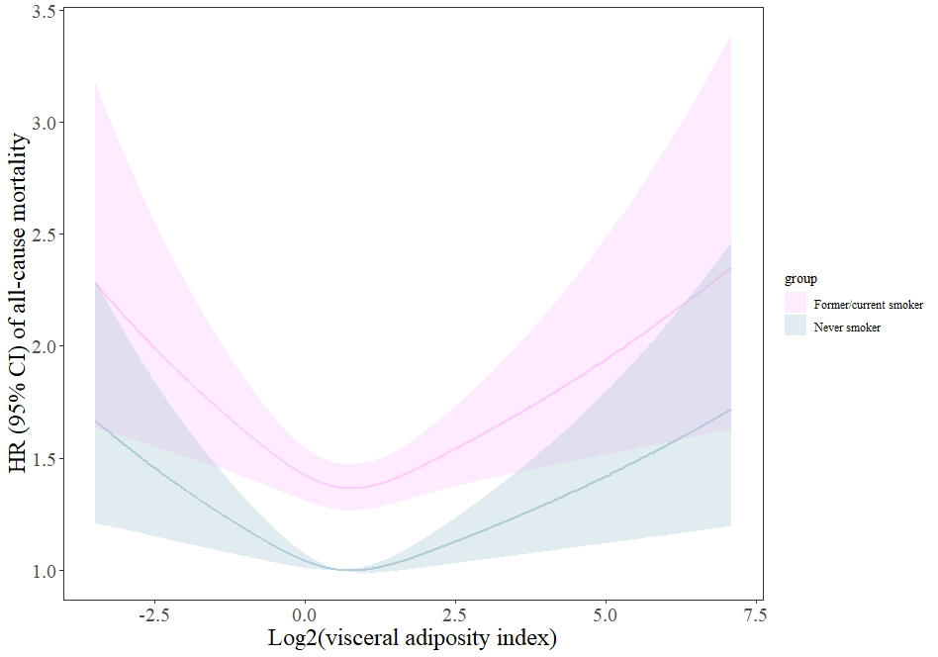
Supplementary Fig. S3 Hazard ratios (95% CIs) of log₂-transformed VAI with all-cause mortality excluding smokers (former or current) or not. Analysis was adjusted for age, gender, race, education level, family income to poverty ratio, hypertension, diabetes, drinking status, eGFR and CVD.
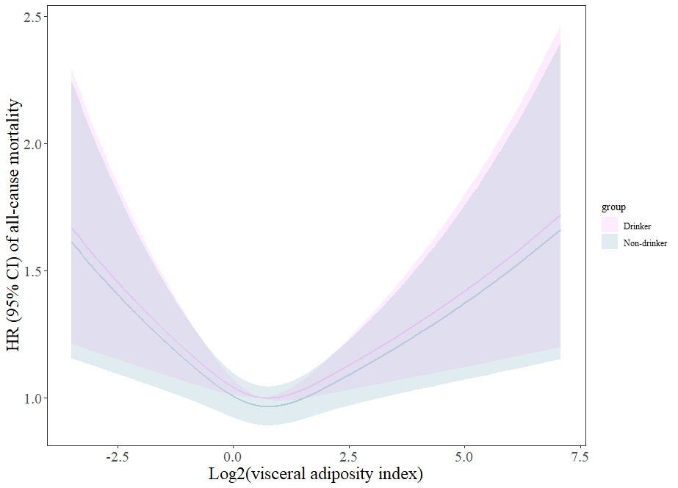
Supplementary Fig. S4 Hazard ratios (95% CIs) of log₂-transformed VAI with all-cause mortality excluding alcohol drinkers or not. Analysis was adjusted for age, gender, race, education level, family income to poverty ratio, hypertension, diabetes, smoking status, eGFR and CVD.
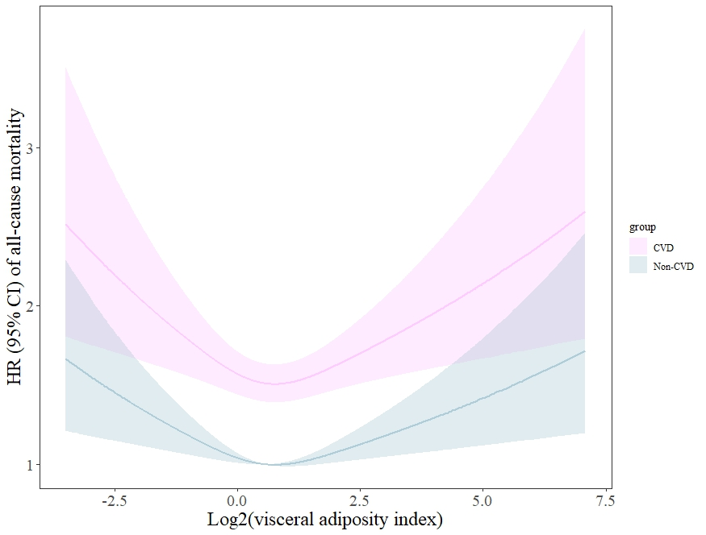
Supplementary Fig. S5 Hazard ratios (95% CIs) of log₂-transformed VAI with all-cause mortality excluding history of CVD or not. Analysis was adjusted for age, gender, race, education level, family income to poverty ratio, hypertension, diabetes, smoking status, drinking status and eGFR.
Supplementary Table S1. Variables used in this study.
Characteristics | Missing valuesª | Before imputation^{b} | After imputation^{b} | P value
Age, yrs | 0 (0.0) | 46.9 (0.2) | 46.9 (0.2) | --
Gender, % | 0 (0.0) |  |  | --
Male |  | 49.1 (0.3) | 49.1 (0.3)
Female |  | 50.9 (0.3) | 50.9 (0.3)
Race, % | 0 (0.0) |  |  | --
Mexican American |  | 8.2 (0.5) | 8.2 (0.5)
Other Hispanic |  | 5.5 (0.5) | 5.5 (0.5)
Non-Hispanic White |  | 68.6 (1.0) | 68.6 (1.0)
Non-Hispanic Black |  | 10.9 (0.6) | 10.9 (0.6)
Other Race |  | 6.8 (0.3) | 6.8 (0.3)
Education level, % | 27 (0.1) |  |  | 0.999
Less than 9th grade |  | 6.0 (0.3) | 6.0 (0.3)
9-11th grade |  | 11.3 (0.4) | 11.3 (0.4)
High school |  | 24.1 (0.5) | 24.1 (0.5)
College |  | 30.8 (0.5) | 30.8 (0.5)
Graduate or above |  | 27.8 (0.8) | 27.8 (0.8)
Hypertension, % | 4 (0.0) | 36.7 (0.5) | 36.7 (0.5) | 0.987
Diabetes, % | 0 (0.0) | 14.0 (0.4) | 14.0 (0.4) | --
Smoker, % | 20 (0.1) |  |  | 0.999
Never |  | 53.3 (0.6) | 53.3 (0.6)
Former |  | 25.4 (0.5) | 25.4 (0.5)
Current |  | 21.3 (0.5) | 21.3 (0.5)
Alcohol user, % | 1403 (6.4) | 77.8 (0.6) | 77.4 (0.6) | 0.258
CVD, % | 0 (0.0) | 8.2 (0.3) | 8.2 (0.3) | --
Income to poverty ratio | 1889 (8.6) | 3.00 (0.03) | 2.98 (0.03) | 0.114
eGFR, mL/min/1.73m² | 66 (0.3) | 95.94 (0.31) | 95.94 (0.31) | 0.988
BMI, kg/m² | 0 (0.0) | 28.71 (0.08) | 28.71 (0.08) | --
WC, cm | 0 (0.0) | 98.38 (0.21) | 98.38 (0.21) | --
TG, mmol/L | 0 (0.0) | 1.19 (0.82, 1.75) | 1.19 (0.82, 1.75) | --
HDL-C, mmol/L | 0 (0.0) | 1.39 (0.01) | 1.39 (0.01) | --
ª Frequencies (%) of the missing values in this study.
^{b} Data were presented as weighted mean (SE) or weighted median (25th percentile, 75th percentile) for continuous variables and weighted percentages (SE) for categorical variables.
Supplementary Table S2. Risk of all-cause mortality below and above the inflection point of log₂-transformed VAI (continuous variable).
Outcome | Inflection point | Groups | Adjusted HR |  | 95% CI | P value
All-cause mortality | 0.824 | ≤ 0.824 |  | 0.86 | (0.77, 0.96) | 0.007
All-cause mortality | 0.824 | > 0.824 |  | 1.10 | (1.01, 1.19) | 0.029
Abbreviations: HR, hazard ratio; CI, confidence interval.
Analysis was adjusted for age (continuous), gender (male or female), race (Mexican American, other Hispanic, non-Hispanic White, non-Hispanic Black, or other race), education level (<9th grade, 9-11th grade, high school, college, or graduate or above), family income to poverty ratio (continuous), hypertension (yes or no), diabetes (yes or no), smoking status (never smoker, former smoker, or current smoker), drinking status (yes or no), eGFR (continuous) and CVD (yes or no) (Model 3).

Supplementary Table S3. Association of VAI with all-cause mortality in NHANES 1999-2018 without covariates multiple imputation.
Outcome | Quintiles of VAI, adjusted HR (95% CI)
Outcome | Q1 | Q2 | Q3 | Q4 | Q5
Outcome | ≤0.803 | 0.803-1.232 | 1.232-1.827 | 1.827-2.862 | >2.862
Total No.ª | 4388 | 4389 | 4389 | 4389 | 4388
Deaths No.ª | 428 | 601 | 671 | 756 | 870
Model 1 | 0.73 (0.62, 0.85) *** | 0.94 (0.80, 1.10) | 1 [Reference] | 1.20 (1.03, 1.40) * | 1.39 (1.22, 1.59) ***
Model 2 | 0.95 (0.81, 1.12) | 1.04 (0.91, 1.20) | 1 [Reference] | 1.12 (0.97, 1.29) | 1.36 (1.20, 1.54) ***
Model 3 | 1.14 (0.97, 1.35) | 1.12 (0.95, 1.31) * | 1 [Reference] | 1.02 (0.87, 1.19) | 1.16 (1.01, 1.33) *
Abbreviations: VAI, visceral adiposity index; HR, hazard ratio; CI, confidence interval.
ª Unweighted No..
Model 1: unadjusted model. Model 2: adjusted for age (continuous), gender (male or female) and race (Mexican American, other Hispanic, non-Hispanic White, non-Hispanic Black, or other race). Model 3: adjusted for Model 2 plus education level (<9th grade, 9-11th grade, high school, college, or graduate or above), family income to poverty ratio (continuous), hypertension (yes or no), diabetes (yes or no), smoking status (never smoker, former smoker, or current smoker), drinking status (yes or no), eGFR (continuous) and CVD (yes or no).
* P < 0.05, *** P < 0.001.
Supplementary Table S4. Association of VAI with all-cause mortality in NHANES 1999-2018 with covariates determined using the DAG method.
Outcome | Quintiles of VAI
Outcome | Q1 | Q2 | Q3 | Q4 | Q5
Outcome | ≤0.803 | 0.803-1.232 | 1.232-1.827 | 1.827-2.862 | >2.862
Total No.ª | 4388 | 4389 | 4389 | 4389 | 4388
Deaths No.ª | 428 | 601 | 671 | 756 | 870
HR (95% CI) | 1.03 (0.87, 1.23) | 1.11 (0.96, 1.28) | 1 [Reference] | 1.09 (0.94, 1.26) | 1.22 (1.07, 1.39) **
Abbreviations: VAI, visceral adiposity index; HR, hazard ratio; CI, confidence interval.
ª Unweighted No..
Analysis was adjusted for age (continuous), gender (male or female), race (Mexican American, other Hispanic, non-Hispanic White, non-Hispanic Black, or other race), diabetes (yes or no), smoking status (never smoker, former smoker, or current smoker) and drinking status (yes or no) which were determined using the DAG method. ** P < 0.01.
Supplementary Table S5. Association of VAI with all-cause mortality in NHANES 1999-2018 after excluding participants who died within the first 2 years of follow-up (N=421).
Outcome | Quintiles of VAI, adjusted HR (95% CI)
Outcome | Q1 | Q2 | Q3 | Q4 | Q5
Total No.ª | 4304 | 4305 | 4304 | 4305 | 4304
Deaths No.ª | 358 | 528 | 582 | 664 | 773
Model 1 | 0.75 (0.64, 0.88) ** | 0.96 (0.81, 1.13) | 1 [Reference] | 1.21 (1.04, 1.41) * | 1.43 (1.25, 1.65) ***
Model 2 | 1.01 (0.86, 1.20) | 1.08 (0.94, 1.24) | 1 [Reference] | 1.12 (0.97, 1.28) | 1.39 (1.22, 1.58) ***
Model 3 | 1.22 (1.03, 1.44) * | 1.20 (1.04, 1.39) * | 1 [Reference] | 1.05 (0.91, 1.21) | 1.17 (1.03, 1.34) *
Abbreviations: VAI, visceral adiposity index; HR, hazard ratio; CI, confidence interval.
ª Unweighted No..
Model 1: unadjusted model. Model 2: adjusted for age (continuous), gender (male or female) and race (Mexican American, other Hispanic, non-Hispanic White, non-Hispanic Black, or other race). Model 3: adjusted for Model 2 plus education level (<9th grade, 9-11th grade, high school, college, or graduate or above), family income to poverty ratio (continuous), hypertension (yes or no), diabetes (yes or no), smoking status (never smoker, former smoker, or current smoker), drinking status (yes or no), eGFR (continuous) and CVD (yes or no).
* P < 0.05, ** P < 0.01, *** P < 0.001.
Supplementary Table S6. Association of VAI with all-cause mortality in NHANES 1999-2018 by adding BMI or WC as a covariable in the model.
Outcome | Quintiles of VAI
Outcome | Q1 | Q2 | Q3 | Q4 | Q5
Outcome | ≤0.803 | 0.803-1.232 | 1.232-1.827 | 1.827-2.862 | >2.862
Total No.ª | 4388 | 4389 | 4389 | 4389 | 4388
Deaths No.ª | 428 | 601 | 671 | 756 | 870
HR (95% CI)^{b} | 1.12 (0.95, 1.32) | 1.15 (1.00, 1.33) | 1 [Reference] | 1.05 (0.90, 1.22) | 1.16 (1.02, 1.32) *
HR (95% CI)^{c} | 1.14 (0.96, 1.34) | 1.16 (1.01, 1.34) * | 1 [Reference] | 1.04 (0.90, 1.21) | 1.15 (1.01, 1.31) *
Abbreviations: VAI, visceral adiposity index; WC, waist circumference; HR, hazard ratio; CI, confidence interval.
ª Unweighted No..
^{b} Adjusted for age (continuous), gender (male or female), race (Mexican American, other Hispanic, non-Hispanic White, non-Hispanic Black, or other race), education level (<9th grade, 9-11th grade, high school, college, or graduate or above), family income to poverty ratio (continuous), hypertension (yes or no), diabetes (yes or no), smoking status (never smoker, former smoker, or current smoker), drinking status (yes or no), eGFR (continuous), CVD (yes or no) (Model 3) plus BMI.
^{c} Adjusted for Model 3 plus WC. * P < 0.05.

Supplementary Table S7. Association of VAI with all-cause mortality after excluding participants with more than 10 years of follow-up (N=9872).
Outcome | Quintiles of VAI, adjusted HR (95% CI)
Outcome | Q1 | Q2 | Q3 | Q4 | Q5
Total No.ª | 2414 | 2414 | 2415 | 2414 | 2414
Deaths No.ª | 283 | 413 | 439 | 516 | 638
Model 1 | 0.76 (0.65, 0.88) *** | 0.94 (0.82, 1.08) | 1 [Reference] | 1.14 (1.01, 1.30) * | 1.44 (1.27, 1.62) ***
Model 2 | 0.87 (0.74, 1.01) | 1.02 (0.89, 1.16) | 1 [Reference] | 1.13 (0.99, 1.28) | 1.44 (1.27, 1.63) ***
Model 3 | 1.00 (0.86, 1.16) | 1.08 (0.95, 1.24) | 1 [Reference] | 1.08 (0.95, 1.22) | 1.21 (1.06, 1.36) **
Abbreviations: VAI, visceral adiposity index; HR, hazard ratio; CI, confidence interval.
ª Unweighted No..
Model 1: unadjusted model. Model 2: adjusted for age (continuous), gender (male or female) and race (Mexican American, other Hispanic, non-Hispanic White, non-Hispanic Black, or other race). Model 3: adjusted for Model 2 plus education level (<9th grade, 9-11th grade, high school, college, or graduate or above), family income to poverty ratio (continuous), hypertension (yes or no), diabetes (yes or no), smoking status (never smoker, former smoker, or current smoker), drinking status (yes or no), eGFR (continuous) and CVD (yes or no).
* P < 0.05, ** P < 0.01, *** P < 0.001.
Supplementary Table S8. Association of VAI with all-cause mortality by removing extreme values.
Outcome | Quintiles of VAI, adjusted HR (95% CI)
Outcome | Q1 | Q2 | Q3 | Q4 | Q5
Total No.ª | 3950 | 3950 | 3950 | 3950 | 3949
Deaths No.ª | 420 | 561 | 591 | 667 | 754
Model 1 | 0.76 (0.64, 0.89) ** | 1.01 (0.85, 1.20) | 1 [Reference] | 1.21 (1.03, 1.43) * | 1.40 (1.21, 1.61) ***
Model 2 | 0.97 (0.81, 1.15) | 1.10 (0.95, 1.28) | 1 [Reference] | 1.14 (0.97, 1.33) | 1.29 (1.13, 1.48) ***
Model 3 | 1.15 (0.97, 1.38) | 1.22 (1.05, 1.42) * | 1 [Reference] | 1.08 (0.93, 1.27) | 1.15 (1.01, 1.32) *
Abbreviations: VAI, visceral adiposity index; HR, hazard ratio; CI, confidence interval.
ª Unweighted No..
Model 1: unadjusted model. Model 2: adjusted for age (continuous), gender (male or female) and race (Mexican American, other Hispanic, non-Hispanic White, non-Hispanic Black, or other race). Model 3: adjusted for Model 2 plus education level (<9th grade, 9-11th grade, high school, college, or graduate or above), family income to poverty ratio (continuous), hypertension (yes or no), diabetes (yes or no), smoking status (never smoker, former smoker, or current smoker), drinking status (yes or no), eGFR (continuous) and CVD (yes or no).
* P < 0.05, ** P < 0.01, *** P < 0.001.

