Supplementary file

Table S1. Search Strategies Per Database 1
Table S2.ROBINS-I Risk of Bias Assessment Table 9
Table S3.Reported Time,Estimated Median,and Exposed Category for Physical activity,Sedentary Time and Sleep Time Across the Included Studies 11
Table S5. Subgroup analysis on the association between near work and myopia 28
Table S6. Subgroup analysis on the association between screen time and myopia 31
Table S7. Subgroup analysis on the association between sleep time and myopia 33
Figure S1.The Forest Plot of the Association Between Physical Activity in the Highest Category and the Prevalence Incidence of Myopia 36
Figure S2.The Funnel Plot of the Association Between Physical Activity in the Highest Category and the Prevalence Incidence of Myopia 36
Figure S3.The Forest Plot of the Association Between Physical Activity in the Intermediate Category and the Prevalence Incidence of Myopia 37
Figure S4.The Funnel Plot of the Association Between Physical Activity in the Intermediate Category and the Prevalence Incidence of Myopia 37
Figure S5.Association Between WHO-Recommended Physical Activity Levels (≥60 vs. <60 minutes/day) and Myopia Incidence/Prevalence in Children and Adolescents: Forest Plot from Sensitivity Analysis 38
Figure S6. Physical Activity Sensitivity and Robustness Analysis 39
Figure S7. The Forest Plot of the Association Between Near Work in the Highest Category and the Prevalence Incidence of Myopia 45
Figure S8. The Funnel Plot of the Association Between Near Work in the Highest Category and the Prevalence Incidence of Myopia 45
Figure S9.The Forest Plot of the Association Between Near Work in the Intermediate Category and the Prevalence Incidence of Myopia 46
Figure S10.The Funnel Plot of the Association Between Near Work in the Intermediate Category and the Prevalence Incidence of Myopia 46
Figure S11.Funnel Plot with Trim-and-Fill Adjustment for Publication Bias: Near Work 47
Figure S12. Near Work Sensitivity and Robustness Analysis 48
Figure S13. The Forest Plot of the Association Between Screen Time in the Highest Category and the Prevalence Incidence of Myopia 51
Figure S14. The Funnel Plot of the Association Between Screen Time in the Highest Category and the Prevalence Incidence of Myopia 51
Figure S15. The Forest Plot of the Association Between Screen Time in the Intermediate Category and the Prevalence Incidence of Myopia 52
Figure S16. The Forest Plot of the Association Between Screen Time in the Intermediate Category and the Prevalence Incidence of Myopia 52
Figure S17.Funnel Plot with Trim-and-Fill Adjustment for Publication Bias: Screen Time 53
Figure S19. Screen Time Sensitivity and Robustness Analysis 55
Figure S20. The Forest Plot of the Association Between Sleep Time in the Highest Category and the Prevalence Incidence of Myopia 59
Figure S21. The Funnel Plot of the Association Between Screen Time in the Highest Category and the Prevalence Incidence of Myopia 59
Figure S22. The Forest Plot of the Association Between Sleep Time in the Intermediate Category and the Prevalence Incidence of Myopia 60
Figure S23. The Funnel Plot of the Association Between Screen Time in the Intermediate Category and the Prevalence Incidence of Myopia 60
Figure S24.Funnel Plot with Trim-and-Fill Adjustment for Publication Bias: Screen Time 61
Figure S25. Sleep Duration Sensitivity and Robustness Analysis 62
Figure S26.Association Between Age-Specific Sleep Duration (NSF Guidelines) and Myopia Incidence/Prevalence in Children and Adolescents: Forest Plot from Sensitivity Analysis 64

Table S1. Search Strategies Per Database
Database: PubMed < 19 Nov 2024>
#1 | "Myopia"[Mesh]
#2 | "Exercise"[Mesh]
#3 | "Sedentary Behavior"[Mesh]
#4 | "Sleep"[Mesh]
#5 | "Child"[Mesh]
#6 | myopia[Title/Abstract] OR myopic[Title/Abstract] OR myope[Title/Abstract] OR near-sightedness[Title/Abstract] OR nearsightedness[Title/Abstract] OR short-sightedness[Title/Abstract] OR shortsightedness[Title/Abstract] OR refractive error[Title/Abstract] OR refraction error[Title/Abstract] OR prevalence myopia[Title/Abstract] OR incidence myopia[Title/Abstract] OR myopia prevalence[Title/Abstract]
#7 | exercise[Title/Abstract] OR physical activity[Title/Abstract] OR sport[Title/Abstract] AND fitness[Title/Abstract] OR MVPA[Title/Abstract] OR moderate-to-vigorous physical activity[Title/Abstract] OR VPA[Title/Abstract] OR vigorous intensity physical activity[Title/Abstract]
#8 | sedentary behavior[Title/Abstract] OR sedentary lifestyle[Title/Abstract] OR sedentary time[Title/Abstract] OR screen time[Title/Abstract] OR watching television[Title/Abstract] OR computer[Title/Abstract] OR smartphone[Title/Abstract] OR reading[Title/Abstract] OR writing[Title/Abstract] OR reading distance[Title/Abstract] OR working distance[Title/Abstract] OR doing homework[Title/Abstract] OR near work[Title/Abstract] OR close work[Title/Abstract] OR near activity[Title/Abstract]
#9 | sleep[Title/Abstract] OR sleeping[Title/Abstract] OR sleep duration[Title/Abstract] OR sleep habit[Title/Abstract] OR sleep time[Title/Abstract]
#10 | adolescent[Title/Abstract] OR adolescents[Title/Abstract] OR adolescence school-age[Title/Abstract] OR child[Title/Abstract] OR children[Title/Abstract] OR young[Title/Abstract] OR youth[Title/Abstract] OR school-children[Title/Abstract] OR teenager preschool children[Title/Abstract]
#11 | ("Myopia"[Mesh]) OR (myopia[Title/Abstract] OR myopic[Title/Abstract] OR myope[Title/Abstract] OR near-sightedness[Title/Abstract] OR nearsightedness[Title/Abstract] OR short-sightedness[Title/Abstract] OR shortsightedness[Title/Abstract] OR refractive error[Title/Abstract] OR refraction error[Title/Abstract] OR prevalence myopia[Title/Abstract] OR incidence myopia[Title/Abstract] OR myopia prevalence[Title/Abstract])
#12 | ("Exercise"[Mesh]) OR (exercise[Title/Abstract] OR physical activity[Title/Abstract] OR sport[Title/Abstract] AND fitness[Title/Abstract] OR MVPA[Title/Abstract] OR moderate-to-vigorous physical activity[Title/Abstract] OR VPA[Title/Abstract] OR vigorous intensity physical activity[Title/Abstract])
#13 | ("Sedentary Behavior"[Mesh]) OR (sedentary behavior[Title/Abstract] OR sedentary lifestyle[Title/Abstract] OR sedentary time[Title/Abstract] OR screen time[Title/Abstract] OR watching television[Title/Abstract] OR computer[Title/Abstract] OR smartphone[Title/Abstract] OR reading[Title/Abstract] OR writing[Title/Abstract] OR reading distance[Title/Abstract] OR working distance[Title/Abstract] OR doing homework[Title/Abstract] OR near work[Title/Abstract] OR close work[Title/Abstract] OR near activity[Title/Abstract])
#14 | ("Sleep"[Mesh]) OR (sleep[Title/Abstract] OR sleeping[Title/Abstract] OR sleep duration[Title/Abstract] OR sleep habit[Title/Abstract] OR sleep time[Title/Abstract])
#15 | ("Child"[Mesh]) OR (adolescent[Title/Abstract] OR adolescents[Title/Abstract] OR adolescence school-age[Title/Abstract] OR child[Title/Abstract] OR children[Title/Abstract] OR young[Title/Abstract] OR youth[Title/Abstract] OR school-children[Title/Abstract] OR teenager preschool children[Title/Abstract])
#16 | ((("Exercise"[Mesh]) OR (exercise[Title/Abstract] OR physical activity[Title/Abstract] OR sport[Title/Abstract] AND fitness[Title/Abstract] OR MVPA[Title/Abstract] OR moderate-to-vigorous physical activity[Title/Abstract] OR VPA[Title/Abstract] OR vigorous intensity physical activity[Title/Abstract])) OR (("Sedentary Behavior"[Mesh]) OR (sedentary behavior[Title/Abstract] OR sedentary lifestyle[Title/Abstract] OR sedentary time[Title/Abstract] OR screen time[Title/Abstract] OR watching television[Title/Abstract] OR computer[Title/Abstract] OR smartphone[Title/Abstract] OR reading[Title/Abstract] OR writing[Title/Abstract] OR reading distance[Title/Abstract] OR working distance[Title/Abstract] OR doing homework[Title/Abstract] OR near work[Title/Abstract] OR close work[Title/Abstract] OR near activity[Title/Abstract]))) OR (("Sleep"[Mesh]) OR (sleep[Title/Abstract] OR sleeping[Title/Abstract] OR sleep duration[Title/Abstract] OR sleep habit[Title/Abstract] OR sleep time[Title/Abstract]))
#17 | ((("Myopia"[Mesh]) OR (myopia[Title/Abstract] OR myopic[Title/Abstract] OR myope[Title/Abstract] OR near-sightedness[Title/Abstract] OR nearsightedness[Title/Abstract] OR short-sightedness[Title/Abstract] OR shortsightedness[Title/Abstract] OR refractive error[Title/Abstract] OR refraction error[Title/Abstract] OR prevalence myopia[Title/Abstract] OR incidence myopia[Title/Abstract] OR myopia prevalence[Title/Abstract])) AND (("Child"[Mesh]) OR (adolescent[Title/Abstract] OR adolescents[Title/Abstract] OR adolescence school-age[Title/Abstract] OR child[Title/Abstract] OR children[Title/Abstract] OR young[Title/Abstract] OR youth[Title/Abstract] OR school-children[Title/Abstract] OR teenager preschool children[Title/Abstract]))) AND (((("Exercise"[Mesh]) OR (exercise[Title/Abstract] OR physical activity[Title/Abstract] OR sport[Title/Abstract] AND fitness[Title/Abstract] OR MVPA[Title/Abstract] OR moderate-to-vigorous physical activity[Title/Abstract] OR VPA[Title/Abstract] OR vigorous intensity physical activity[Title/Abstract])) OR (("Sedentary Behavior"[Mesh]) OR (sedentary behavior[Title/Abstract] OR sedentary lifestyle[Title/Abstract] OR sedentary time[Title/Abstract] OR screen time[Title/Abstract] OR watching television[Title/Abstract] OR computer[Title/Abstract] OR smartphone[Title/Abstract] OR reading[Title/Abstract] OR writing[Title/Abstract] OR reading distance[Title/Abstract] OR working distance[Title/Abstract] OR doing homework[Title/Abstract] OR near work[Title/Abstract] OR close work[Title/Abstract] OR near activity[Title/Abstract]))) OR (("Sleep"[Mesh]) OR (sleep[Title/Abstract] OR sleeping[Title/Abstract] OR sleep duration[Title/Abstract] OR sleep habit[Title/Abstract] OR sleep time[Title/Abstract]))) (Results: 943)

Database: Web of Science < 19 Nov 2024>
#1 | TS=(myopia OR myopic OR myope OR near-sightedness OR nearsightedness OR short-sightedness OR shortsightedness OR refractive error OR refraction error OR prevalence myopia OR incidence myopia OR myopia prevalence)
#2 | TS=(exercise OR physical activity OR sport and fitness OR MVPA OR moderate-to-vigorous physical activity OR VPA OR vigorous intensity physical activity)
#3 | TS=(sedentary behavior OR sedentary lifestyle OR sedentary time OR screen time OR watch television OR computer OR smartphone OR read OR write OR read distance OR work distance OR do homework OR nearwork OR closework OR nearactivity)
#4 | TS=(sleep OR sleeping OR sleep duration OR sleep habit OR sleep time)
#5 | TS=(adolescent OR adolescents OR adolescence school-age OR child OR children OR young OR youth OR school-children OR teenager preschool children)
#6 | #2 OR #3 OR #4
#7 | #1 AND #6 AND #5 (Results: 1374)

Database: The Cochrane Library < 19 Nov 2024>
#1 | MeSH descriptor: [Myopia] explode all trees
#2 | MeSH descriptor: [Exercise] explode all trees
#3 | MeSH descriptor: [Sedentary Behavior] explode all trees
#4 | MeSH descriptor: [Sleep] explode all trees
#5 | MeSH descriptor: [Child] explode all trees
#6 | myopia OR myopic OR myope OR 'near-sightedness' OR nearsightedness OR 'short-sightedness' OR shortsightedness OR 'refractive error' OR 'refraction error' OR 'prevalence myopia' OR 'incidence myopia' OR 'myopia prevalence'):ti,ab,kw (Word variations have been searched
#7 | exercise OR 'physical activity' OR 'sport and fitness' OR MVPA OR 'moderate-to-vigorous physical activity' OR VPA OR 'vigorous intensity physical activity'):ti,ab,kw (Word variations have been searched
#8 | 'sedentary behavior' OR 'sedentary lifestyle' OR 'sedentary time' OR 'screen time' OR 'watching television' OR computer OR smartphone OR read OR write OR 'read distance' OR 'work distance' OR 'do homework' OR nearwork OR closework OR nearactivity):ti,ab,kw (Word variations have been searched
#9 | sleep OR sleeping OR 'sleep duration' OR 'sleep habit' OR 'sleep time'
#10 | adolescent OR adolescents OR 'adolescence school-age' OR child OR children OR young OR youth OR 'school-children' OR 'teenager preschool children'):ti,ab,kw (Word variations have been searched
#11 | #1 OR #6
#12 | #2 OR #7
#13 | #3 OR #8
#14 | #4 OR #9
#15 | #5 OR #10
#16 | #12 OR #13 OR #14
#17 | #11 AND #15 AND #16 (Results: 386)

Database: Embase< 19 Nov 2024 >
#1 | 'myopia'/exp
#2 | 'exercise'/exp
#3 | 'sedentary behavior'/exp
#4 | 'sleep'/exp
#5 | 'child'/exp
#6 | myopia:ti,ab,kw OR myopic:ti,ab,kw OR myope:ti,ab,kw OR 'near-sightedness':ti,ab,kw OR nearsightedness:ti,ab,kw OR 'short-sightedness':ti,ab,kw OR  shortsightedness:ti,ab,kw OR 'refractive error':ti,ab,kw OR 'refraction error':ti,ab,kw OR 'prevalence myopia':ti,ab,kw OR 'incidence myopia':ti,ab,kw OR 'myopia prevalence':ti,ab,kw
#7 | exercise:ti,ab,kw OR 'physical activity':ti,ab,kw OR sport:ti,ab,kw) AND fitness:ti,ab,kw OR mvpa:ti,ab,kw OR 'moderate-to-vigorous physical activity':ti,ab,kw OR vpa:ti,ab,kw OR 'vigorous intensity physical activity':ti,ab,kw
#8 | 'sedentary behavior':ti,ab,kw OR 'sedentary lifestyle':ti,ab,kw OR 'sedentary time':ti,ab,kw OR 'screen time':ti,ab,kw OR 'watching television':ti,ab,kw OR computer:ti,ab,kw OR smartphone:ti,ab,kw OR read:ti,ab,kw OR write:ti,ab,kw OR 'read distance':ti,ab,kw OR 'work distance':ti,ab,kw OR 'do homework':ti,ab,kw OR 'near work':ti,ab,kw OR 'close work':ti,ab,kw OR 'near activity':ti,ab,kw
#9 | sleep:ti,ab,kw OR sleeping:ti,ab,kw OR 'sleep duration':ti,ab,kw OR 'sleep habit':ti,ab,kw OR 'sleep time':ti,ab,kw
#10 | adolescent:ti,ab,kw OR adolescents:ti,ab,kw OR 'adolescence school-age':ti,ab,kw OR child:ti,ab,kw OR children:ti,ab,kw OR young:ti,ab,kw OR youth:ti,ab,kw OR 'school-children':ti,ab,kw
#11 | #1 OR #6
#12 | #2 OR #7
#13 | #3 OR #8
#14 | #4 OR #9
#15 | #5 OR #10
#16 | #12 OR #13 OR #14
#16 | #11 AND #15 AND #16 (Results: 903)

Table S2.ROBINS-I Risk of Bias Assessment Table

Table S3.Reported Time,Estimated Median,and Exposed Category for Physical activity,Sedentary Time and Sleep Time Across the Included Studies
Publication | Reported Time and  Estimated Median | Reference Level,h/d | Level 2,h/d | Level 3,h/d | Level4,h/d | Level5,h/d | Level6,h/d
PHYSICAL ACTIVITY
Highest category[median duration: 0.5 h/day, interquartile range: 0.25-0.75 h/day]
Intermediate category[median duration: 2h/day, interquartile range: 1.5-2.5h/day]
Lowest category[median duration: 4h/day, interquartile range: 3.5-4.5h/day]
M.Ali | Reported Time  Estimated Median | <1  0.5  [reference, lowest] | ≥1  1.5  [intermediate] | NA | NA | NA | NA
L. Ye | Reported Time  Estimated Median | ≤1  0.5  [reference, lowest] | 1-2  1.5 | 2-3  2.5  [intermediate] | 3-4  3.5 | >4  4.5  [highest] | NA
H. J. Wardati | Reported Time  Estimated Median | <2  1  [reference, lowest] | ≥2  3  [intermediate] | NA | NA | NA | NA
J. Y. Wang | Reported Time  Estimated Median | <1  0.5  [reference, lowest] | 1-2  1.5  [intermediate] | ≥2  2.5  [highest] | NA | NA | NA
T. Palumaa | Reported Time  Estimated Median | <1  0.5  [reference, lowest] | 1-2  1.5  [intermediate] | ≥2  2.5  [highest] | NA | NA | NA
F. Ma | Reported Time  Estimated Median
R. L. Li | Reported Time  Estimated Median | <1  0.5  [reference, lowest] | 1-2  1.5 | 2-3  2.5  [intermediate] | ≥3  3.5  [highest] | NA | NA
 | Reported Time  Estimated Median | <1  0.5  [reference, lowest] | 1-2  1.5 | 2-3  2.5  [intermediate] | ≥3  3.5  [highest] | NA | NA
X. H. Fang | Reported Time  Estimated Median | <2  1  [reference, lowest] | ≥2  3  [intermediate] | NA | NA | NA | NA
D. Zhang | Reported Time  Estimated Median | <1  0.5  [reference, lowest] | 1-2  1.5  [intermediate] | ≥2  2.5  [highest] | NA | NA | NA
P. Cheng | Reported Time  Estimated Median | <2  1  [reference, lowest] | ≥2  3  [intermediate] | NA | NA | NA | NA
W. F. Zhu | Reported Time  Estimated Median
C. Y. Wang | Reported Time  Estimated Median | <2  1  [reference, lowest] | ≥2  3  [intermediate] | NA | NA | NA | NA
D. Philipp | Reported Time  Estimated Median | <1  0.5  [reference, lowest] | 1-2  1.5 | 2-3  2.5  [intermediate] | >4  4.5  [highest] | NA | NA
A.Mukazhanova | Reported Time  Estimated Median | <1  0.5  [reference, lowest] | 1-2  1.5  [intermediate] | ＞2  2.5  [highest] | NA | NA | NA
A. N. French | Reported Time  Estimated Median | ≤2  1  [reference, lowest] | 2-3  2.5  [intermediate] | >3  3.5  [highest] | NA | NA | NA
 | Reported Time  Estimated Median | ≤2  1  [reference, lowest] | 2-3  2.5  [intermediate] | >3  3.5  [highest] | NA | NA | NA
Z. H. Xie | Reported Time  Estimated Median | <1  0.5  [reference, lowest] | 1-2  1.5 | 2-3  2.5  [intermediate] | ≥3  3.5  [highest] | NA | NA
H. D. Hung | Reported Time  Estimated Median | <2  1  [reference, lowest] | ≥2  3  [intermediate] | NA | NA | NA | NA
M. H. Hansen | Reported Time  Estimated Median
P. W. Ku | Reported Time  Estimated Median | <1  0.5  [reference, lowest] | 1-2  1.5  [intermediate] | 3-5  4  [highest] | ≥6  7 | NA | NA
 | Reported Time  Estimated Median | <1  0.5  [reference, lowest] | 1-2  1.5  [intermediate] | 3-5  4  [highest] | ≥6  7 | NA | NA
L. S. Qi | Reported Time  Estimated Median | <1  0.5  [reference, lowest] | 1-2  1.5  [intermediate] | ＞2  2.5  [highest] | NA | NA | NA
S. X. Liu | Reported Time  Estimated Median | <1  0.5  [reference, lowest] | 1-2  1.5 | 2-3  2.5  [intermediate] | 3-4  3.5 | 4-5  4.5  [highest] | ≥5  6
N. Ashiq | Reported Time  Estimated Median | <1  0.5  [reference, lowest] | ≥1  1.5  [intermediate] | NA | NA | NA | NA
R. Saxena | Reported Time  Estimated Median | <2  1  [reference, lowest] | >2  3  [intermediate] | NA | NA | NA | NA
Y. Y. Lyu | Reported Time  Estimated Median | <1  0.5  [reference, lowest] | 1-2  1.5  [intermediate] | ＞2  2.5  [highest] | NA | NA | NA
NEAR WORK
Highest category[median duration: 1.5 h/day, interquartile range: 1.25-1.75 h/day]
Intermediate category[median duration: 4.5h/day, interquartile range: 4-5h/day]
Lowest category[median duration: 7.5h/day, interquartile range: 7-8h/day]
M.Ali | Reported Time(read)  Estimated Median | ≤1  0.5  [reference, lowest] | 2-8  5  [intermediate] | >8  11  [highest] | NA
L.J.Zhao | Reported Time(homework)  Estimated Median | <2  1  [reference, lowest] | ≥2  3  [intermediate] | NA | NA
 | Reported Time(short distance)  Estimated Median | <1  0.5  [reference, lowest] | ≥1  1.5  [intermediate] | NA | NA
L. Ye | Reported Time(continuous study)  Estimated Median | ≤1  0.5  [reference, lowest] | 1-2  1.5  [intermediate] | 2-3  2.5 | >3  3.5  [highest]
 | Reported Time(study)  Estimated Median | ≤6  3  [reference, lowest] | 6-8  7  [intermediate] | 8-10  9  [highest] | >10  11
Y. Wang | Reported Time(study)  Estimated Median | <4  2  [reference, lowest] | 4-8  7  [intermediate] | >8  10  [highest] | NA
J. Y. Wang | Reported Time(homework)  Estimated Median | <2  1  [reference, lowest] | ≥2  3  [intermediate] | NA | NA
T. Palumaa | Reported Time(homework)  Estimated Median | 2-5  3.5  [reference, lowest] | 5-9  7  [intermediate] | 9-13  11  [highest] | NA
R. L. Li | Reported Time (homework-elementary)  Estimated Median | <1  0.5  [reference, lowest] | 1-2  1.5 | 2-3  2.5  [intermediate] | ≥3  3.5  [highest]
 | Reported Time(homework-junior)  Estimated Median | <1  0.5  [reference, lowest] | 1-2  1.5 | 2-3  2.5  [intermediate] | ≥3  3.5  [highest]
J. M. Kim | Reported Time(near work)  Estimated Median | ≤2  1  [reference, lowest] | 2-3  2.5  [intermediate] | ≥4  4.5  [highest] | NA
Z. H. Huang | Reported Time(homework)  Estimated Median | <1  0.5  [reference, lowest] | 1-3  2  [intermediate] | >3  4  [highest] | NA
X. H. Fang | Reported Time(near work)  Estimated Median | ＜2  1  [reference, lowest] | ≥2  3  [intermediate] | NA | NA
D. Zhang | Reported Time(homework)  Estimated Median | <1  0.5  [reference, lowest] | 1-2  1.5  [intermediate] | ≥2  2.5  [highest] | NA
W. Peng | Reported Time(homework)  Estimated Median | <1  0.5  [reference, lowest] | 1-2  1.5 | 2-3  2.5  [intermediate] | >3  3.5  [highest]
 | Reported Time(near work)  Estimated Median | ≤6.43  3.215  [reference, lowest] | 6.44-9.00  7.72  [intermediate] | >9  10.28  [highest] | NA
D. Philipp | Reported Time(near work)  Estimated Median | <1  0.5  [reference, lowest] | 1-2  1.5 | 2-3  2.5  [intermediate] | >3  3.5  [highest]
A.Mukazhanova | Reported Time(near work)  Estimated Median | <1  0.5  [reference, lowest] | 1-2  1.5  [intermediate] | ＞2  2.5 | NA
E. A. Gebru | Reported Time(near work)  Estimated Median | <3  1.5  [reference, lowest] | 3-8  5.5  [intermediate] | 9-11  10  [highest] | >11  12
D. Czepita | Reported Time(read)  Estimated Median | <2  1  [reference, lowest] | 2-3.5  2.75  [intermediate] | >3.5  4.25  [highest] | NA
A. N. French | Reported Time(Near work 8years)  Estimated Median | ≤2  1  [reference, lowest] | 2-3  2.5  [intermediate] | >3  3.5  [highest] | NA
 | Reported Time(Near work 12years)  Estimated Median | ≤2  1  [reference, lowest] | 2-3  2.5  [intermediate] | >3  3.5  [highest] | NA
Z. H. Xie | Reported Time(homework)  Estimated Median | <1  0.5  [reference, lowest] | 1-2  1.5 | 2-3  2.5  [intermediate] | ≥3  3.5  [highest]
H. Kim | Reported Time(near work)  Estimated Median | ≤1  0.5  [reference, lowest] | 1-2  1.5 | 2-3  2.5  [intermediate] | ≤4  30.5.5  [highest]
H. D. Hung | Reported Time(read)  Estimated Median | <3  1.5  [reference, lowest] | ≥3  4.5  [intermediate] | NA | NA
R. Alomair | Reported Time(homework)  Estimated Median | ≤1  0.5  [reference, lowest] | 2-3  2.5  [intermediate] | 4-5  4.5 | ≥6  6.5  [highest]
P. W. Ku | Reported Time (read Cross-sectional)  Estimated Median | <1  0.5  [reference, lowest] | ≥1  1.5  [intermediate] | NA | NA
 | Reported Time(read prospective cohort)  Estimated Median | <1  0.5  [reference, lowest] | ≥1  1.5  [intermediate] | NA | NA
L. S. Qi | Reported Time(read)  Estimated Median | <1  0.5  [reference, lowest] | ≥1  1.5  [intermediate] | NA | NA
 | Reported Time(near work)  Estimated Median | <4  2  [reference, lowest] | ≥4  6  [intermediate] | NA | NA
R. Saxena | Reported Time(read)  Estimated Median | 4-5  4.5  [reference, lowest] | 5-6  5.5  [intermediate] | >6  6.5  [highest] | NA
L. O'Donoghue | Reported Time(homework)  Estimated Median | <1  0.5  [reference, lowest] | 1-2  1.5 | 2-3  2.5  [intermediate] | >3  3.5  [highest]
Y. Y. Lyu | Reported Time(learn)  Estimated Median | <1  0.5  [reference, lowest] | 1-2  1.5 | 2-3  2.5  [intermediate] | >3  3.5  [highest]
 | Reported Time(Continuous learn)  Estimated Median | <1  0.5  [reference, lowest] | ≥1  1.5  [intermediate] | NA | NA
T. P. L. Quek | Reported Time(read)  Estimated Median | ≤1  0.5  [reference, lowest] | >1  1.5  [intermediate] | NA | NA
SCREEN TIME
Highest category[median duration: 1h/day, interquartile range: 0.75-1.25 h/day]
Intermediate category[median duration: 3h/day, interquartile range: 2.5-3.5h/day]
Lowest category[median duration: 5h/day, interquartile range: 4.5-5.5h/day]
M.Ali | Reported Time(TV)  Estimated Median | ≤1  0.5  [reference, lowest] | 2-4  3  [intermediate] | >4  5  [highest] | NA
L.J.Zhao | Reported Time(TV)  Estimated Median | <2  1  [reference, lowest] | ≥2  3  [intermediate] | NA | NA
 | Reported Time(computer)  Estimated Median | <2  1  [reference, lowest] | ≥2  3  [intermediate] | NA | NA
L. Ye | Reported Time(screen time)  Estimated Median | ≤1  0.5  [reference, lowest] | 1-2  1.5  [intermediate] | >2  2.5  [highest] | NA
H. J. Wardati | Reported Time(screen time)  Estimated Median | <2  1  [reference, lowest] | ≥2  3  [intermediate] | NA | NA
Y. Wang | Reported Time(screen time)  Estimated Median | <1  0.5  [reference, lowest] | 1-3  2  [intermediate] | >3  4  [highest] | NA
J. Y. Wang | Reported Time(computer)  Estimated Median | <1  0.5  [reference, lowest] | 1-2  1.5  [intermediate] | ≥2  2.5  [highest] | NA
T. Palumaa | Reported Time(screen time)  Estimated Median | <2  1  [reference, lowest] | 2-3  2.5  [intermediate] | 3-9  6  [highest] | NA
R. L. Li | Reported Time (screen time)  Estimated Median | <1  0.5  [reference, lowest] | 1-2  1.5 | 2-3  2.5  [intermediate] | ≥3  3.5  [highest]
 | Reported Time(screen time)  Estimated Median | <1  0.5  [reference, lowest] | 1-2  1.5 | 2-3  2.5  [intermediate] | ≥3  3.5  [highest]
Z. H. Huang | Reported Time(phone)  Estimated Median | <1  0.5  [reference, lowest] | 1-3  2  [intermediate] | >3  4  [highest] | NA
 | Reported Time(TV)  Estimated Median | <1  0.5  [reference, lowest] | 1-3  2  [intermediate] | >3  4  [highest] | NA
D. Zhang | Reported Time(computer)  Estimated Median | <1  0.5  [reference, lowest] | ≥1  1.5  [intermediate] | NA | NA
P. Cheng | Reported Time(screen time)  Estimated Median | <1  0.5  [reference, lowest] | ≥1  1.5  [intermediate] | NA | NA
C. Y. Wang | Reported Time(screen time)  Estimated Median | <1  0.5  [reference, lowest] | ≥1  1.5  [intermediate] | NA | NA
A.Mukazhanova | Reported Time( phone)  Estimated Median | <1  0.5  [reference, lowest] | 1-2  1.5  [intermediate] | ＞2  2.5  [highest] | NA
D. Czepita | Reported Time(computer)  Estimated Median | <1  0.5  [reference, lowest] | >1  1.5  [intermediate] | NA | NA
 | Reported Time(TV)  Estimated Median | <2  1  [reference, lowest] | 2-2.5  2.25  [intermediate] | >2.5  2.75  [highest] | NA
A. S. Assem | Reported Time(PHONE)  Estimated Median | <2  1  [reference, lowest] | 2-4  3  [intermediate] | >4  5  [highest] | NA
Z. H. Xie | Reported Time(TV)  Estimated Median | <1  0.5  [reference, lowest] | 1-2  1.5 | 2-3  2.5  [intermediate] | ≥3  3.5  [highest]
 | Reported Time(screen time)  Estimated Median | <1  0.5  [reference, lowest] | >1  1.5  [intermediate] | NA | NA
H. D. Hung | Reported Time(computer)  Estimated Median | <1  0.5  [reference, lowest] | ≥1  1.5  [intermediate] | NA | NA
 | Reported Time(TV)  Estimated Median | <1  0.5  [reference, lowest] | ≥1  1.5  [intermediate] | NA | NA
M. H. Hansen | Reported Time(screen time)  Estimated Median | <2  1  [reference, lowest] | 2-4  3  [intermediate] | 4-6  5  [highest] | >6  7
S. Y. Chiang | Reported Time(TV)  Estimated Median | ≤1  0.5  [reference, lowest] | 1-3  2  [intermediate] | ≥3  4  [highest] | NA
 | Reported Time(computer)  Estimated Median | <1  0.5  [reference, lowest] | 1-2  1.5 | 2-3  2.5  [intermediate] | ≥3  3.5  [highest]
P. W. Ku | Reported Time(computer)  Estimated Median | <1  0.5  [reference, lowest] | ≥1  1.5  [intermediate] | NA | NA
 | Reported Time(TV)  Estimated Median | <2  1  [reference, lowest] | 2-3  2.5  [intermediate] | ≥3  4  [highest] | NA
R. Saxena | Reported Time(TV)  Estimated Median | <2  1  [reference, lowest] | 2-3  2.5  [intermediate] | >3  4  [highest] | NA
Y. Y. Lyu | Reported Time(computer)  Estimated Median | <1  0.5  [reference, lowest] | >1  1.5  [intermediate] | NA | NA
T. P. L. Quek | Reported Time(computer)  Estimated Median | ≤1  0.5  [reference, lowest] | >1  1.5  [intermediate] | NA | NA
Sleep time
Highest category[median duration: 4h/day, interquartile range: 3.25-4.75 h/day]
Intermediate category[median duration: 8h/day, interquartile range: 7.5-8.5h/day]
Lowest category[median duration: 10h/day, interquartile range: 9.25-10.75h/day]
L.J.Zhao | Reported Time  Estimated Median | <8  4  [reference, lowest] | ≥8  12  [intermediate] | NA | NA
J. Y. Wang | Reported Time  Estimated Median | <8  4  [reference, lowest] | ≥8  12  [intermediate] | NA | NA
R. L. Li | Reported Time  Estimated Median | <7  3.5  [reference, lowest] | 7-9  8  [intermediate] | ≥9  10  [highest] | NA
Z. H. Huang | Reported Time  Estimated Median | <8  4  [reference, lowest] | >8  12  [intermediate] | NA | NA
Y. Huang | Reported Time  Estimated Median | <8  4  [reference, lowest] | 8-9  8.5  [intermediate] | ≥9  9.5  [highest] | NA
Z. R. Gao | Reported Time  Estimated Median | <8  4  [reference, lowest] | 8-9  8.5  [intermediate] | 9-10  9.5 | >10  10.5  [highest]
D. Zhang | Reported Time  Estimated Median | <8  4  [reference, lowest] | ≥8  12  [intermediate] | NA | NA
S. J. Lin | Reported Time  Estimated Median | <8  4  [reference, lowest] | 8-9  8.5  [intermediate] | 9-10  9.5 | ≥10  10.5  [highest]
P. Cheng | Reported Time  Estimated Median | <9  4.5  [reference, lowest] | ≥9  13.5  [highest] | NA | NA
X. X. Zhao | Reported Time  Estimated Median | <8  4  [reference, lowest] | ≥8  12  [intermediate] | NA | NA
L. Huang | Reported Time  Estimated Median | <8  4  [reference, lowest] | 8-9  8.5  [intermediate] | >9  9.5  [highest] | NA
X. N. Liu | Reported Time  Estimated Median | <9.5  4.75  [reference, lowest] | 9.5-10  9.75  [intermediate] | ≥10  10.5  [highest] | NA
 | Reported Time  Estimated Median | <9.5  4.75  [reference, lowest] | 9.5-10  9.75  [intermediate] | ≥10  10.5  [highest] | NA
L. S. Qi | Reported Time  Estimated Median | ≤7  3.5  [reference, lowest] | >7  10.5  [intermediate] | NA | NA
S. X. Liu | Reported Time  Estimated Median | <7  3.5  [reference, lowest] | 7-8  7.5  [intermediate] | 8-9  8.5 | ≥9  9.5  [highest]
N. Ashiq | Reported Time  Estimated Median | <8  4  [reference, lowest] | ≥8  12 | NA | NA
Y. Y. Lyu | Reported Time  Estimated Median | <8  4  [reference, lowest] | 8-9  8.5  [intermediate] | 9-10  9.5 | >10  10.5  [highest]

Table S4. Subgroup analysis on the association between physical activity and myopia
Subgroups | N. of studies | OR(95% CI) | I² (%) | P for heterogeneity | P for interaction
The intermediate compared with the lowest categories of total physical activity time
Age
5-11years | 14 | 0.63[0.44; 0.91] | 92.3 | <0.0001 | 0.1737
12-18years | 8 | 0.88[0.64; 1.22] | 67.9 | 0.0027
Income level of a country
Lower-middle-income countries | 2 | 0.39[0.19; 0.78] | 94 | <0.0001 | 0.0380
Middle-income countries | 18 | 0.74[0.61; 0.90] | 86.1 | <0.0001
High-income countries | 6 | 1.05[0.73; 1.51] | 57.4 | <0.0001
sample size
Small sample size (<1,000) | 6 | 0.41[0.25; 0.68] | 83.5 | <0.0001 | 0.0088
Large sample size (≥1,000) | 20 | 0.84[0.70; 1.01] | 88.6 | <0.0001
Type of research
Cross-sectional study | 20 | 0.68[0.54; 0.87] | 89.4 | <0.0001 | 0.0162
cohort study | 6 | 1.05[0.81; 1.35] | 69.7 | <0.0001
Myopia definition
≤-0.5 | 23 | 0.71[0.57; 0.88] | 88.3 | <0.0001 | 0.0031
Other situations | 3 | 1.13[0.91; 1.40] | 58.4 | 0.0653
Use of cycloplegia
Yes | 12 | 0.83[0.62; 1.10] | 90.8 | <0.0001 | 0.4326
NO | 14 | 0.70[0.53; 0.93] | 84.3 | <0.0001
ROBINS-I risk of bias
Moderate risk | 23 | 0.75 [0.61; 0.93] | 89.8 | <0.0001 | 0.7542
Serious risk | 3 | 0.83 [0.76; 0.91] | 0 | 0.3705
The highest compared with the lowest categories of physical activity time
Age
5-11years | 11 | 0.77[0.60; 1.00] | 81.1 | <0.0001 | 0.9232
12-18years | 6 | 0.75[0.44; 1.28] | 83.6 | <0.0001
Income level of a country
Lower-middle-income countries | - | - | - | - | -
Middle-income countries | 13 | 0.69[0.56; 0.85] | 72.6 | <0.0001 | 0.0111
High-income countries | 4 | 1.27[0.83; 1.95] | 85.8 | <0.0001
sample size
Small sample size (<1,000) | 4 | 0.60[0.35; 1.04] | 56.1 | 0.0775 | 0.3329
Large sample size (≥1,000) | 13 | 0.81[0.64; 1.01] | 80.9 | <0.0001
Type of research
Cross-sectional study | 11 | 0.66[0.52; 0.85] | 77.9 | <0.0001 | 0.0410
cohort study | 6 | 1.01[0.73; 1.39] | 81.2 | <0.0001
Myopia definition
≤-0.5 | 15 | 0.75[0.59; 0.95] | 82.1 | <0.0001 | 0.5096
Other situations | 2 | 0.86[0.76; 0.98] | 0 | 0.6984
Use of cycloplegia
Yes | 8 | 0.93[0.69; 1.26] | 82.4 | <0.0001 | 0.0887
NO | 9 | 0.65[0.49; 0.87] | 76.7 | <0.0001
ROBINS-I risk of bias
Moderate risk | 14 | 0.76 [0.60; 0.97] | 81.9 | <0.0001 | 0.8020
Serious risk | 3 | 0.80 [0.71; 0.90] | 13.7 | 0.3138

Table S5. Subgroup analysis on the association between near work and myopia
Subgroups | N. of studies | OR(95% CI) | I² (%) | P for heterogeneity | P for interaction
The intermediate compared with the lowest categories of near work
Age
5-11years | 14 | 1.33[1.12; 1.59] | 87.8 | <0.0001 | 0.6708
12-18years | 7 | 1.42[1.13; 1.78] | 92.7 | <0.0001
Income level of a country
Lower-middle-income countries | 3 | 1.49[0.98; 2.27] | 92.9 | <0.0001 | 0.8173
Middle-income countries | 16 | 1.31[1.14; 1.51] | 93.2 | <0.0001
High-income countries | 8 | 1.26[1.18; 1.35] | 18 | 0.2826
Sample size
Small sample size (<1,000) | 9 | 1.14[1.01; 1.29] | 45.4 | 0.0574 | 0.3271
Large sample size (≥1,000) | 18 | 1.38[1.21; 1.57] | 93.2 | <0.0001
Type of research
Cross-sectional study | 23 | 1.33[1.18; 1.51] | 91.7 | <0.0001 | 0.8448
cohort study | 4 | 1.39[0.95; 2.04] | 64.1 | 0.0251
Myopia definition
≤-0.5 | 22 | 1.37[1.21; 1.55] | 91.3 | <0.0001 | 0.4053
Other situations | 5 | 1.20[0.90; 1.60] | 83.5 | <0.0001
Use of cycloplegia
Yes | 14 | 1.26[1.07; 1.49] | 75.9 | <0.0001 | 0.3412
NO | 13 | 1.41[1.20; 1.65] | 94.6 | <0.0001
ROBINS-I risk of bias
Moderate risk | 4 | 1.32 [1.17; 1.50] | 90.9 | <0.0001 | 0.6296
Serious risk | 23 | 1.43 [1.07; 1.90] | 86.9 | <0.0001
The highest compared with the lowest categories of near work
Age
5-11years | 6 | 2.16[1.15; 4.08] | 88.9 | <0.0001 | 0.3748
12-18years | 13 | 1.55[1.07; 2.26] | 97.9 | <0.0001
Income level of a country
Lower-middle-income countries | 3 | 2.53[1.07; 5.98] | 97.4 | <0.0001 | 0.4302
Middle-income countries | 12 | 1.78[1.23; 2.56] | 97.6 | <0.0001
High-income countries | 7 | 1.31[0.74; 2.31] | 84.3 | <0.0001
Sample size
Small sample size (<1,000) | 7 | 1.70[1.20; 2.39] | 98.1 | <0.0001 | 0.9351
Large sample size (≥1,000) | 15 | 1.74[1.00; 3.05] | 77.4 | <0.0001
Type of research
Cross-sectional study | 19 | 1.73[1.25; 2.40] | 97.7 | <0.0001 | 0.4831
cohort study | 3 | 1.44[0.96; 2.14] | 57.6 | 0.0695
Myopia definition
≤-0.5 | 17 | 1.98[1.49; 2.63] | 96.9 | <0.0001 | 0.0148
Other situations | 5 | 0.87[0.48; 1.58] | 93.3 | <0.0001
Use of cycloplegia
Yes | 12 | 1.76[1.18; 2.62] | 94.9 | <0.0001 | 0.8422
NO | 10 | 1.66[1.08; 2.54] | 98.2 | <0.0001
ROBINS-I risk of bias
Moderate risk | 18 | 1.73 [1.25; 2.40] | 95.8% | <0.0001 | 0.8512
Serious risk | 4 | 1.61 [0.82; 3.17] | 98.9 | <0.0001

Table S6. Subgroup analysis on the association between screen time and myopia
Subgroups | N. of studies | OR(95% CI) | I² (%) | P for heterogeneity | P for interaction
The intermediate compared with the lowest categories of screen time
Age
5-11years | 12 | 1.40[1.13; 1.75] | 94 | <0.0001 | 0.5401
12-18years | 8 | 1.26[0.96; 1.65] | 61.8 | 0.0035
Income level of a country
Lower-middle-income countries | 3 | 2.30[1.45; 3.64] | 98.4 | <0.0001 | 0.0285
Middle-income countries | 16 | 1.20[1.02; 1.40] | 88.3 | <0.0001
High-income countries | 4 | 1.27[1.11; 1.46] | 0 | 0.5907
sample size
Small sample size (<1,000) | 5 | 1.71[1.16; 2.52] | 78.6 | 0.0003 | 0.1235
Large sample size (≥1,000) | 18 | 1.24[1.06; 1.44] | 91.8 | <0.0001
Type of research
Cross-sectional study | 21 | 1.31[1.12; 1.54] | 92.1 | <0.0001 | 0.6155
cohort study | 2 | 1.08[0.99; 1.16] | 44.2 | 0.1461
Myopia definition
≤-0.5 | 19 | 1.33[1.13; 1.57] | 92.7 | <0.0001 | 0.5078
Other situations | 4 | 1.18[0.88; 1.59] | 69.9 | 0.0028
Use of cycloplegia
Yes | 11 | 1.29[1.04; 1.59] | 91 | <0.0001 | 0.9475
NO | 12 | 1.30[1.06; 1.59] | 91.1 | <0.0001
The highest compared with the lowest categories of screen time
Age
5-11years | 7 | 2.32[1.29; 4.18] | 97.3 | <0.0001 | 0.2118
12-18years | 6 | 1.40[0.83; 2.38] | 78.4 | <0.0001
Income level of a country
Lower-middle-income countries | 3 | 6.67[3.42; 12.99] | 90.7 | <0.0001 | <0.0001
Middle-income countries | 10 | 1.25[0.93; 1.68] | 95.2 | <0.0001
High-income countries | 3 | 1.33[0.82; 2.17] | 34.5 | 0.1916
sample size
Small sample size (<1,000) | 3 | 2.93[1.14; 7.58] | 83.9 | 0.0020 | 0.1781
Large sample size (≥1,000) | 13 | 1.47[1.04; 2.07] | 95.6 | <0.0001
Type of research
Cross-sectional study | 14 | 1.63[1.13; 2.36] | 95.9 | <0.0001 | 0.7478
cohort study | 2 | 1.40[0.58; 3.34] | 79 | 0.0085
Myopia definition
≤-0.5 | 12 | 1.54[1.04; 2.28] | 96.1 | <0.0001 | 0.7250
Other situations | 4 | 1.77[0.89; 3.53] | 88.1 | <0.0001
Use of cycloplegia
Yes | 7 | 2.27[1.29; 4.01] | 96.3 | <0.0001 | 0.1322
NO | 9 | 1.34[0.90; 1.98] | 94.8 | <0.0001

Table S7. Subgroup analysis on the association between sleep time and myopia
Subgroups | N. of studies | OR(95% CI) | I² (%) | P for heterogeneity | P for interaction
The intermediate compared with the lowest categories of sleep time
Age
5-11years | 6 | 0.89[0.83; 0.95] | 24.4 | 0.2507 | 0.8314
12-18years | 8 | 0.83[0.69; 0.99] | 84.7 | <0.0001
sample size
Small sample size (<1,000) | 5 | 0.82[0.68; 1.00] | 0 | 0.6035 | 0.9548
Large sample size (≥1,000) | 10 | 0.82[0.71; 0.94] | 85.4 | <0.0001
Type of research
Cross-sectional study | 13 | 0.81[0.71; 0.91] | 80.5 | <0.0001 | 0.3488
cohort study | 2 | 0.95[0.83; 1.09] | 0 | 0.9414
Use of cycloplegia
Yes | 8 | 0.84[0.71; 0.99] | 84.7 | <0.0001 | 0.7192
NO | 7 | 0.80[0.68; 0.95] | 50.9 | 0.0570
The highest compared with the lowest categories of sleep time
Age
5-11years | 6 | 0.69[0.45; 1.06] | 84.7 | <0.0001 | 0.7901
12-18years | 4 | 0.63[0.36; 1.09] | 76.1 | 0.0057
sample size
Small sample size (<1,000) | 3 | 0.73[0.53; 1.00] | 0 | 0.8840 | 0.8180
Large sample size (≥1,000) | 6 | 0.65[0.43; 0.98] | 88.7 | <0.0001
Use of cycloplegia
Yes | 6 | 0.67[0.44; 1.03] | 85.8 | <0.0001 | 0.9419
NO | 3 | 0.66[0.37; 1.15] | 67.5 | 0.0264

Table S8. Multivariable Meta-Regression Analysis: Associations of Physical Activity, Near Work, and Screen Time with Myopia
 | PA-Intermediate | PA-Highest
Income level of a country
Lower middle | 1.5546 (0.4036, 5.9879) | 2.7316 (0.563, 13.2521)
Middle | 1.1608 (0.4592, 2.9344) | 1.1918 (0.4677, 3.0371)
High | 1.4151 (0.4905, 4.0827) | 1.4194 (0.4405, 4.5739)
Type of research
Cross-sectional study | 0.5207 (0.1072, 2.5287) | 0.5120 (0.0958, 2.736)
cohort study | 0.5531 (0.0801, 3.8214) | 0.5398 (0.0782, 3.7282)
Sample size
Small sample size (<1,000) | 0.4923 (0.0918, 2.641) | 0.5602 (0.0837, 3.7505)
Large sample size (≥1,000) | 0.6612 (0.1559, 2.8047) | 0.6416 (0.14, 2.9406)
Myopia definition
≤-0.5 | 0.5117 (0.1049, 2.4966) | 0.5136 (0.0987, 2.6731)
Other situations | 0.5976 (0.1025, 3.4855) | 0.5173 (0.0762, 3.5105)
 | Near work-Intermediate | Near work-Highest
Myopia definition
≤-0.5 | 1.2463 (0.3957, 3.9252) | 1.3892 (0.4236, 4.5557)
Other situations | 1.0768 (0.3158, 3.6719) | 0.8719 (0.2425, 3.1351)
 | Screen time-Intermediate | Screen time-Highest
Income level of a country
Lower middle | 1.5546 (0.4036, 5.9879) | 2.7316 (0.563, 13.2521)
Middle | 1.1608 (0.4592, 2.9344) | 1.1918 (0.4677, 3.0371)
High | 1.4151 (0.4905, 4.0827) | 1.4194 (0.4405, 4.5739)
The analyses were adjusted for age, use of cycloplegia, and ROBINS-I risk of bias

Figure S1.The Forest Plot of the Association Between Physical Activity in the Highest Category and the Prevalence Incidence of Myopia
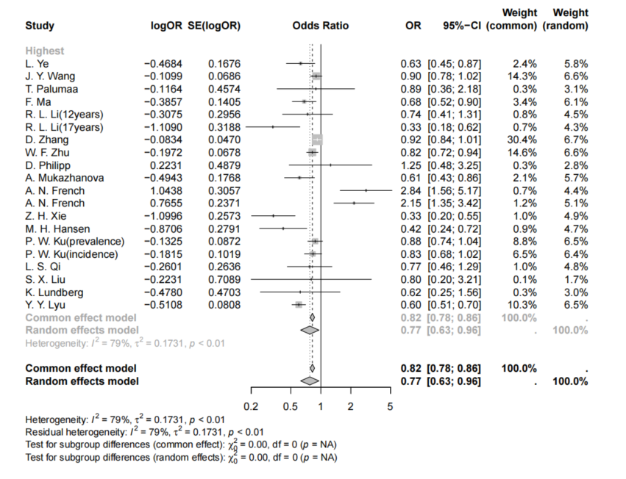

Figure S2.The Funnel Plot of the Association Between Physical Activity in the Highest Category and the Prevalence Incidence of Myopia
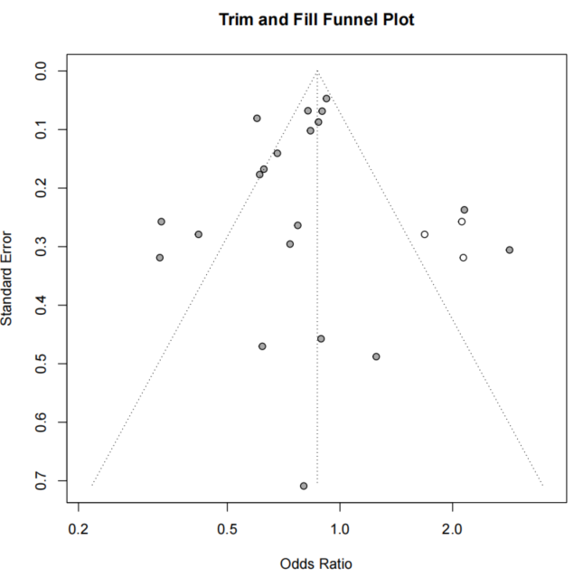

Figure S3.The Forest Plot of the Association Between Physical Activity in the Intermediate Category and the Prevalence Incidence of Myopia
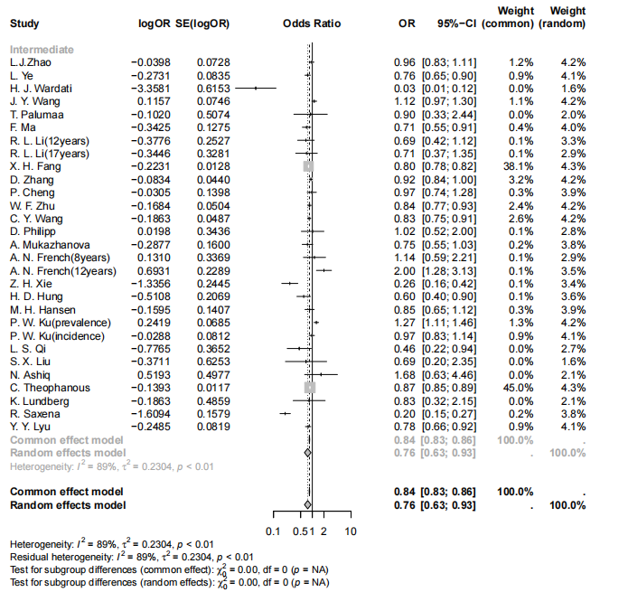

Figure S4.The Funnel Plot of the Association Between Physical Activity in the Intermediate Category and the Prevalence Incidence of Myopia
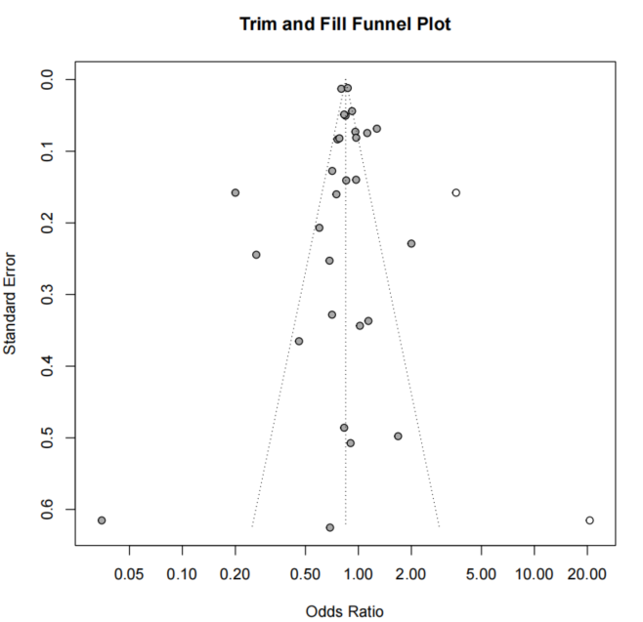

Figure S5.Association Between WHO-Recommended Physical Activity Levels (≥60 vs. <60 minutes/day) and Myopia Incidence/Prevalence in Children and Adolescents: Forest Plot from Sensitivity Analysis
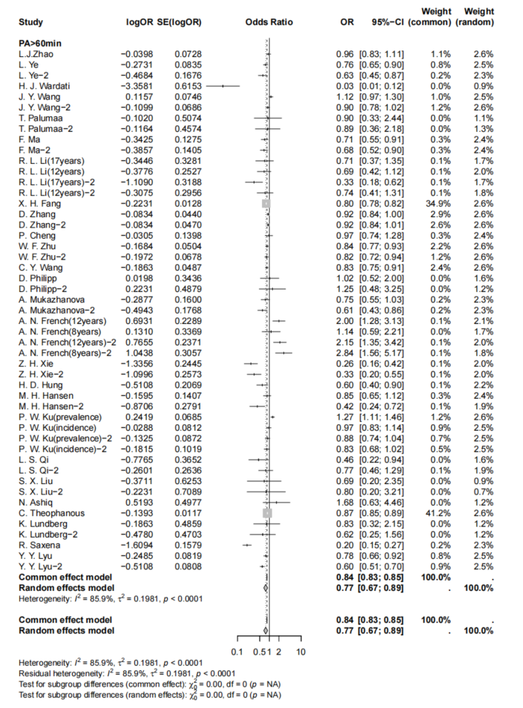

Figure S6. Physical Activity Sensitivity and Robustness Analysis
PA Intermediate Category-(Lower income countries)
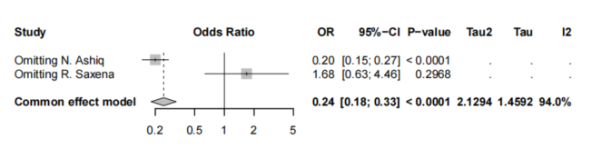
PA Intermediate Category-(Middle income countries)
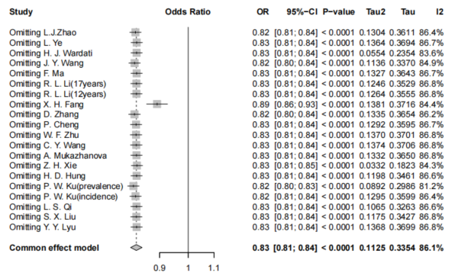
PA Intermediate Category-(High income countries)
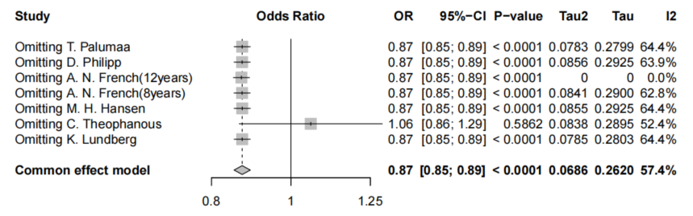

PA Highest Category-(Middle income countries)
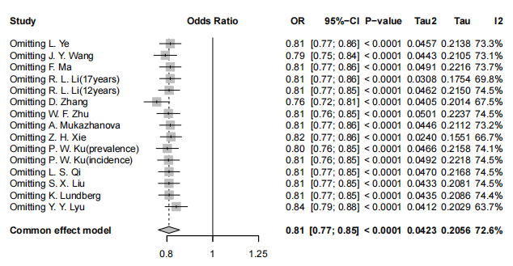
PA Highest Category-(High income countries)
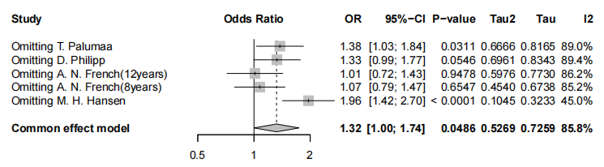
PA Intermediate Category-(Cross sectional study)
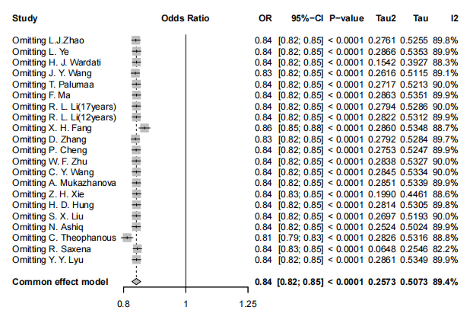
PA Intermediate Category-(Cohort study)
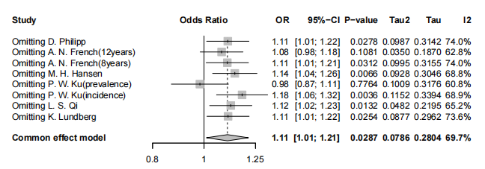
PA Highest Category-(Cross sectional study)
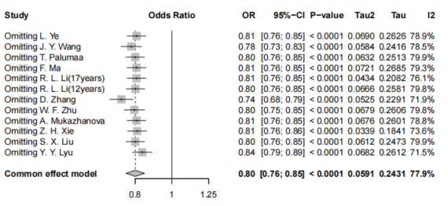
PA Highest Category-(Cohort study)
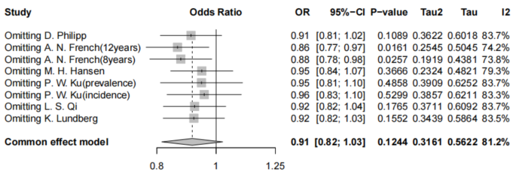
PA Intermediate Category-(sample size<1000)
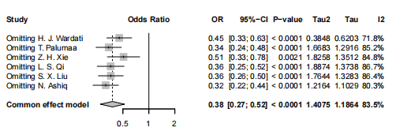
PA Intermediate Category-(sample size≥1000)
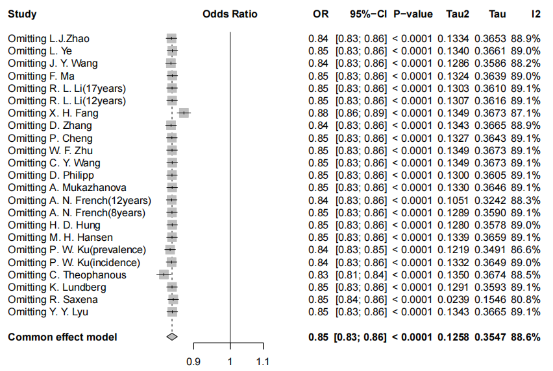
PA Intermediate Category-(Myopia definition≤-0.5)
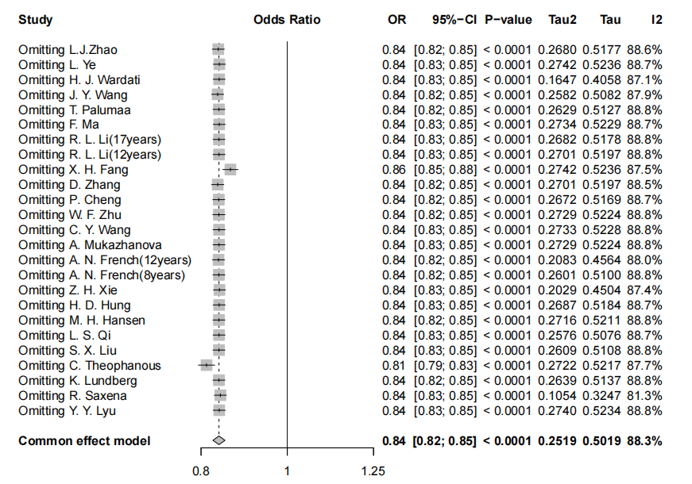
PA Intermediate Category-(Myopia definition Other situations)
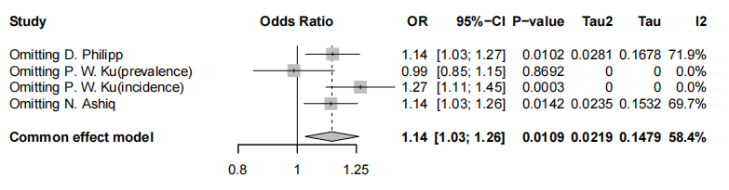
PA Intermediate Category-(Prevalence＜70%)
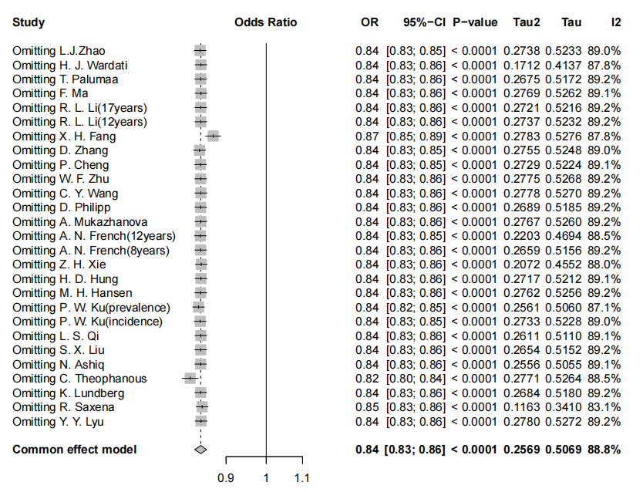
PA Intermediate Category-(Prevalence≥70%)
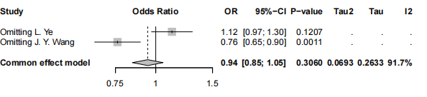
PA Highest Category-(Prevalence＜70%)
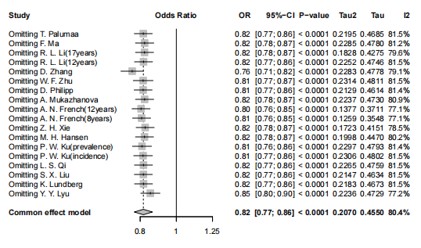
PA Highest Category-(Prevalence≥70%)
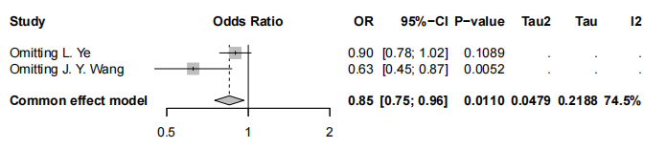

Figure S7. The Forest Plot of the Association Between Near Work in the Highest Category and the Prevalence Incidence of Myopia
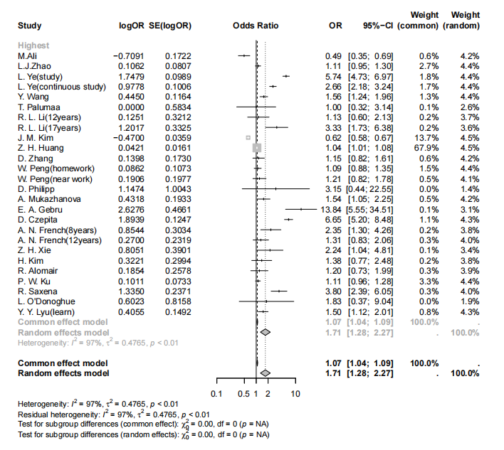

Figure S8. The Funnel Plot of the Association Between Near Work in the Highest Category and the Prevalence Incidence of Myopia
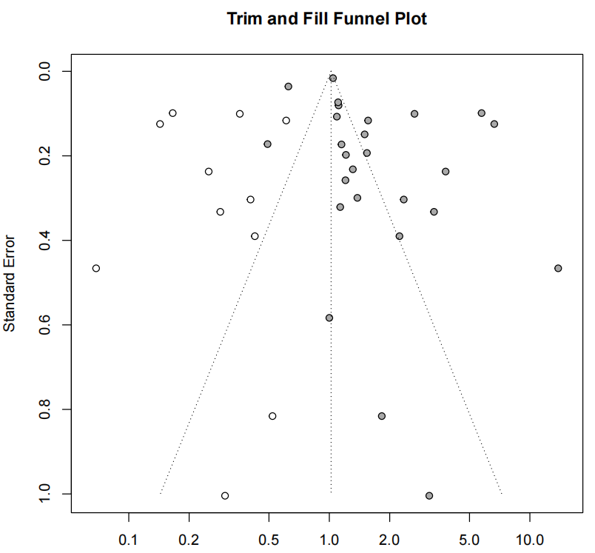

Figure S9.The Forest Plot of the Association Between Near Work in the Intermediate Category and the Prevalence Incidence of Myopia
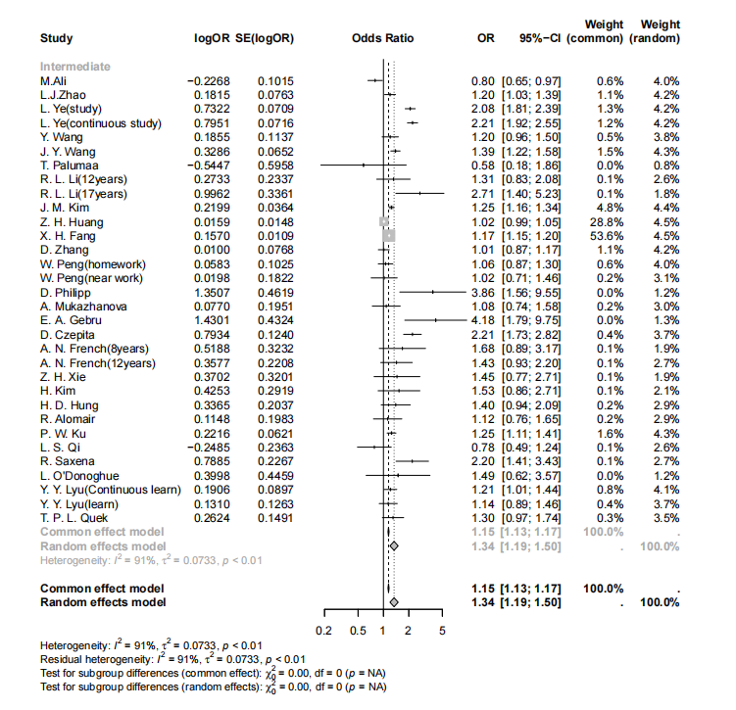

Figure S10.The Funnel Plot of the Association Between Near Work in the Intermediate Category and the Prevalence Incidence of Myopia
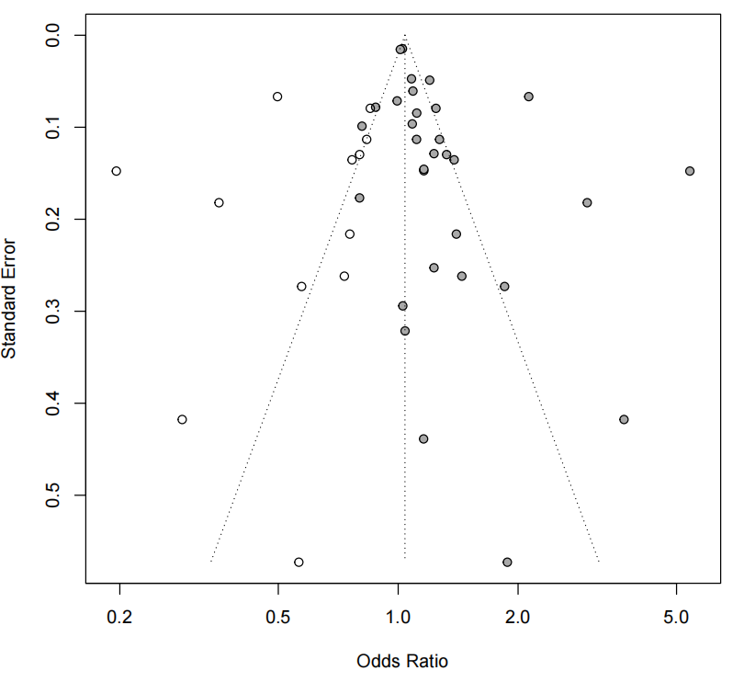

Figure S11.Funnel Plot with Trim-and-Fill Adjustment for Publication Bias: Near Work
Intermediate Category
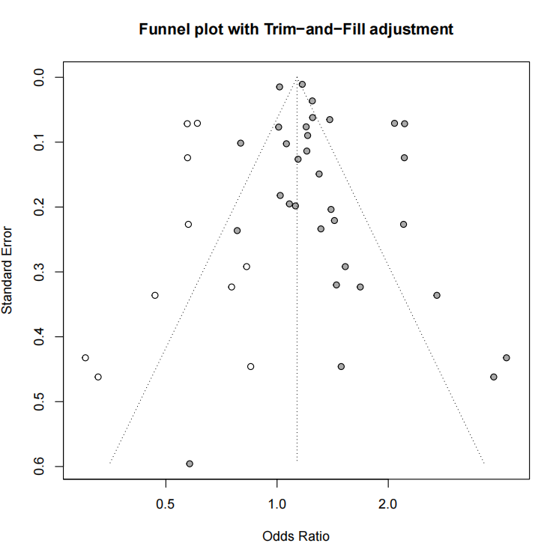
Intermediate Category
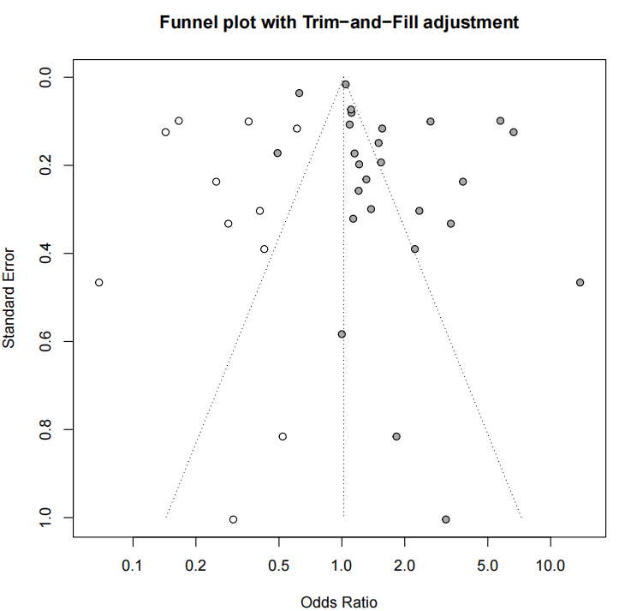

Figure S12. Near Work Sensitivity and Robustness Analysis
NW Highest Category-(Myopia definition≤-0.5)
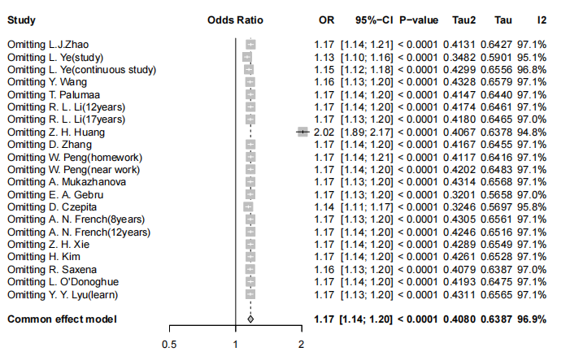
NW Highest Category-(Myopia definition Other situations)
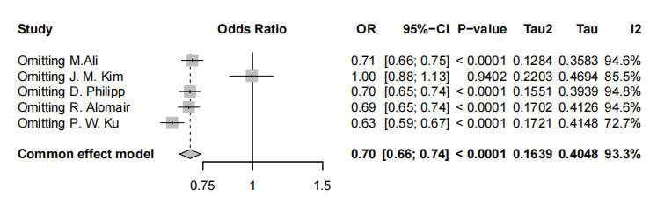
NW Intermediate Category-(Prevalence＜70%)
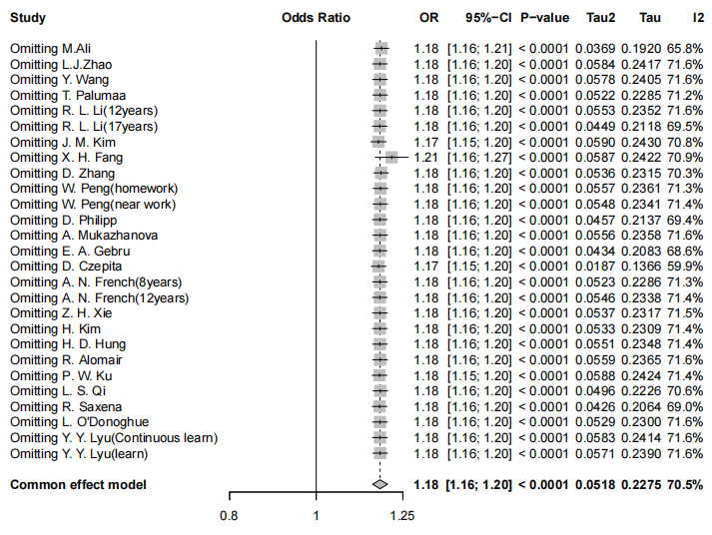
NW Intermediate Category-(Prevalence≥70%)
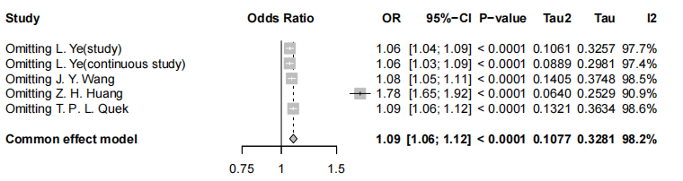
NW Highest Category-(Prevalence＜70%)
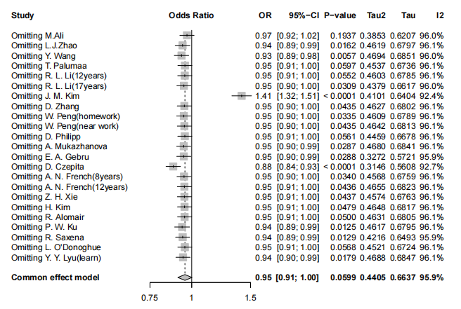
NW Highest Category-(Prevalence≥70%)
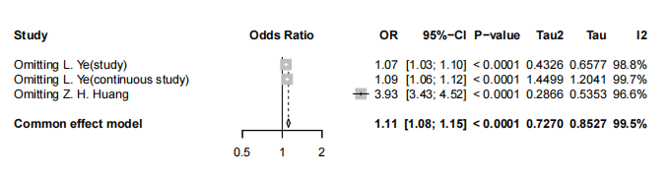
NW Intermediate Category-(sample size≤10000)
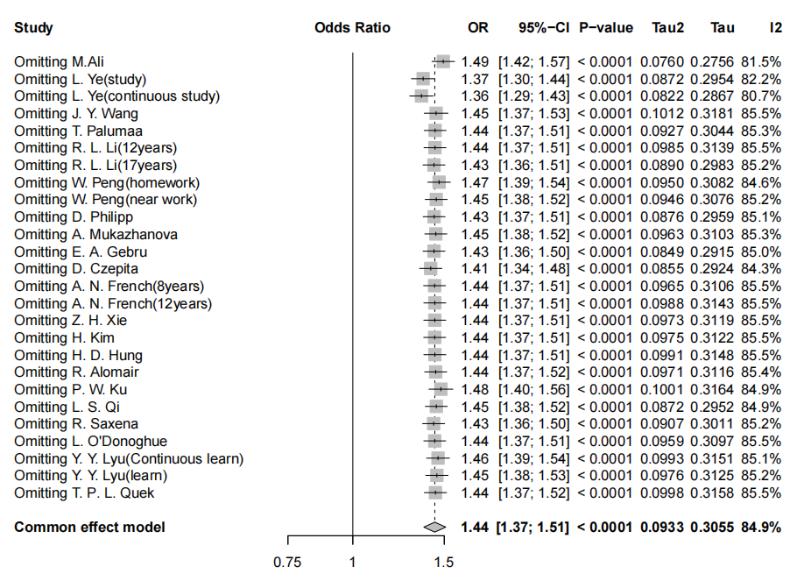
NW Intermediate Category-(sample size＞10000)
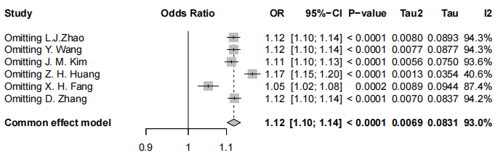
NW Highest Category-(sample size≤10000)
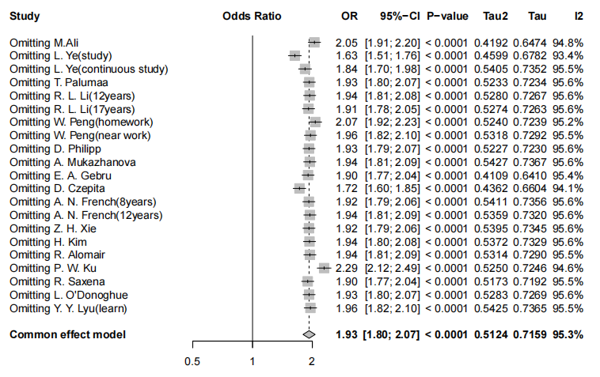
NW Highest Category-(sample size＞10000)
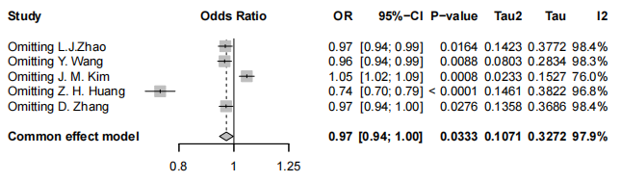

Figure S13. The Forest Plot of the Association Between Screen Time in the Highest Category and the Prevalence Incidence of Myopia
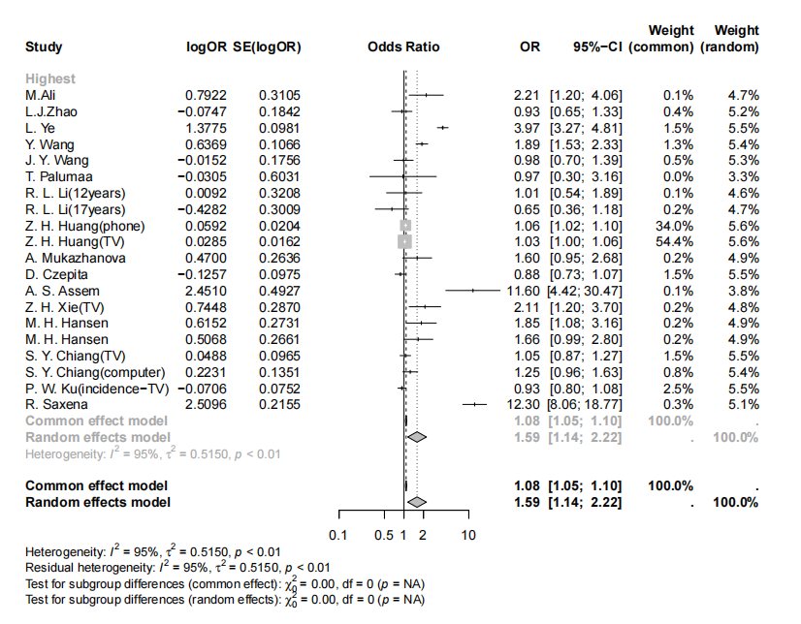

Figure S14. The Funnel Plot of the Association Between Screen Time in the Highest Category and the Prevalence Incidence of Myopia
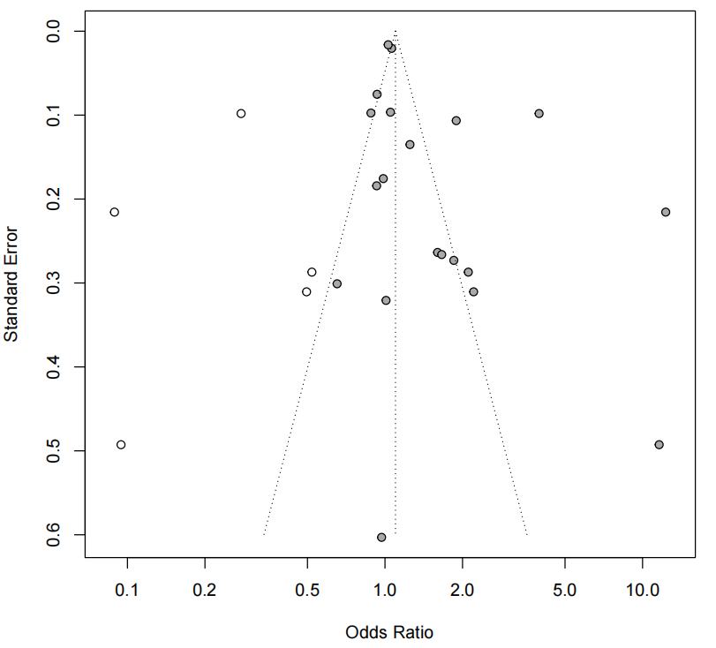

Figure S15. The Forest Plot of the Association Between Screen Time in the Intermediate Category and the Prevalence Incidence of Myopia
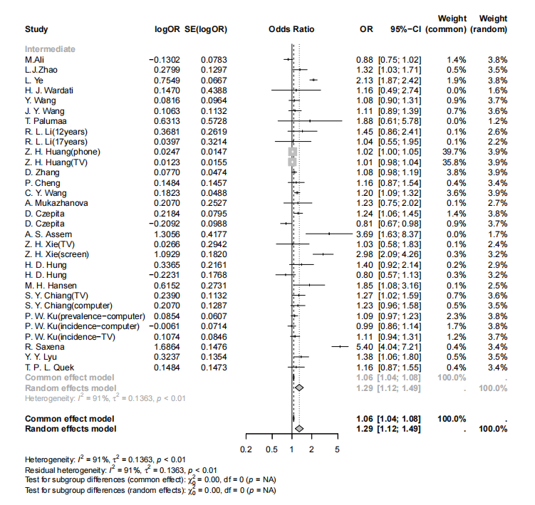

Figure S16. The Forest Plot of the Association Between Screen Time in the Intermediate Category and the Prevalence Incidence of Myopia
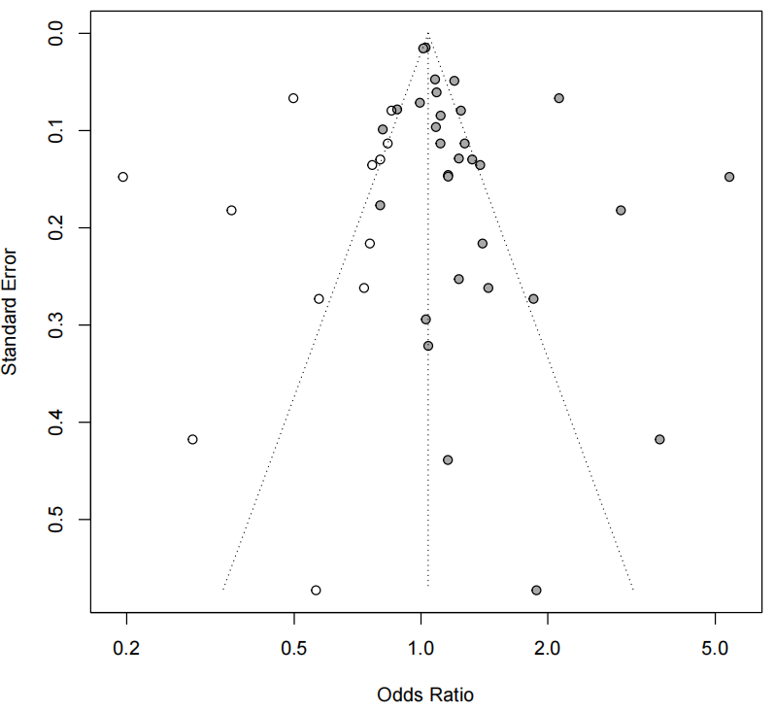

Figure S17.Funnel Plot with Trim-and-Fill Adjustment for Publication Bias: Screen Time
Intermediate Category
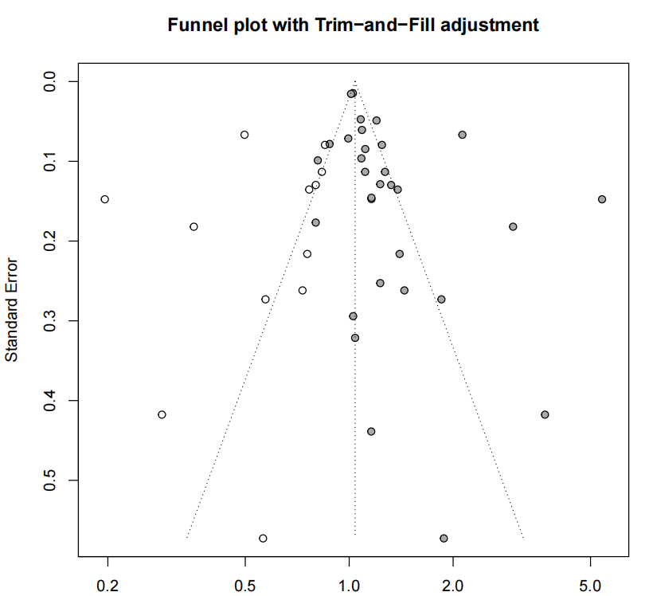
Highest Category
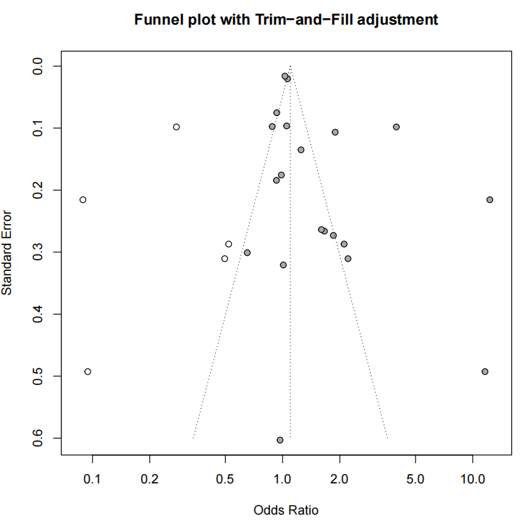

Figure S18.Association Between Recreational Screen Time (≥2 vs. <2 hours/day) and Myopia Incidence/Prevalence in Children and Adolescents: Forest Plot from Sensitivity Analysis (24-Hour Guidelines)
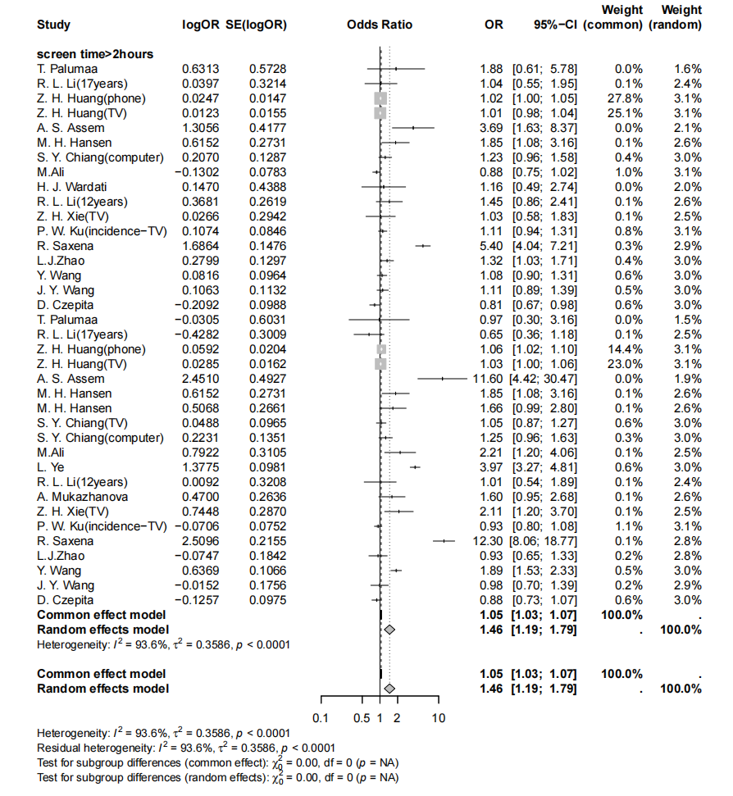

Figure S19. Screen Time Sensitivity and Robustness Analysis
ST Intermediate Category-(Lower income countries)
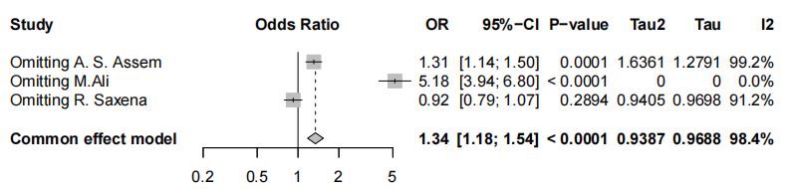
ST Intermediate Category-(Middle income countries)
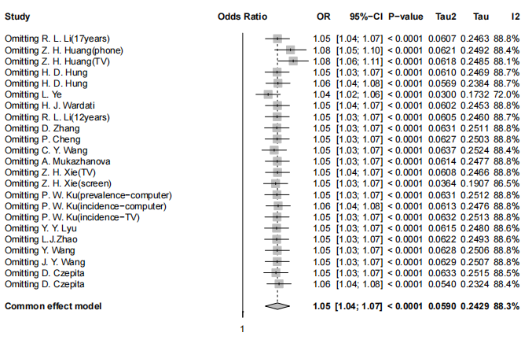
ST Intermediate Category-(High income countries)
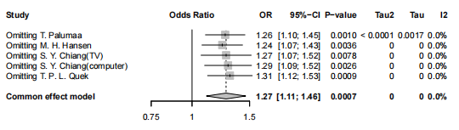
ST Highest Category-(Lower income countries)
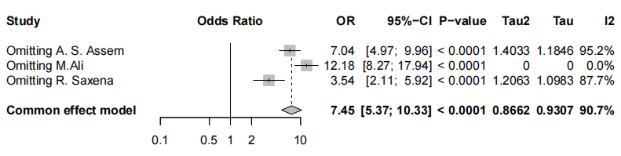
ST Highest Category-(Middle income countries)
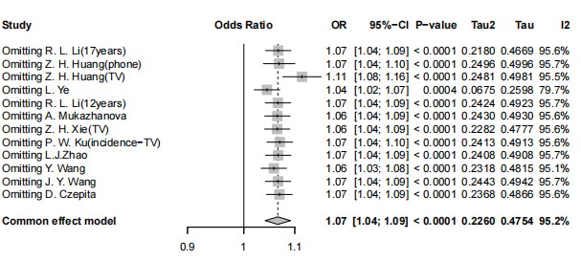
ST Highest Category-(High income countries)
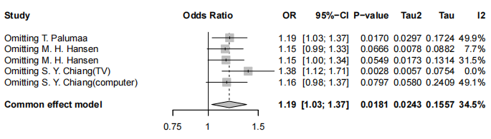
ST Intermediate Category-(sample size≤10000)
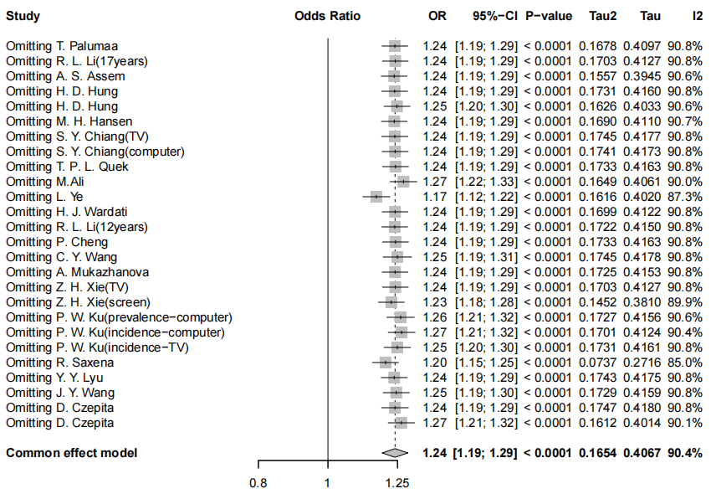
ST Intermediate Category-(sample size＞10000)
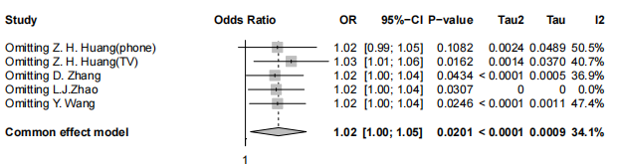
ST Highest Category-(sample size≤10000)
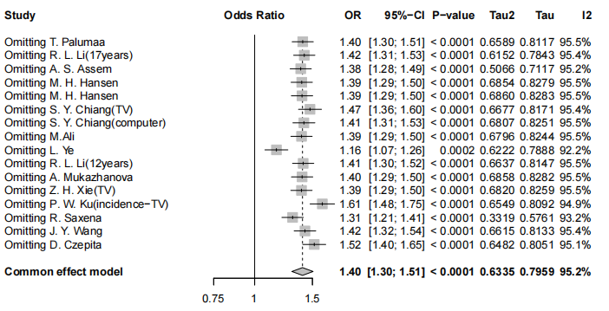
ST Highest Category-(sample size＞10000)
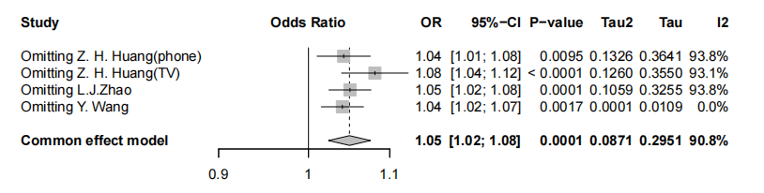
ST Intermediate Category-(Prevalence＜70%)
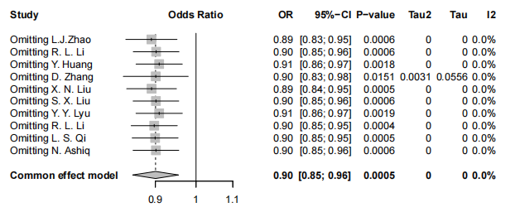
ST Intermediate Category-(Prevalence≥70%)
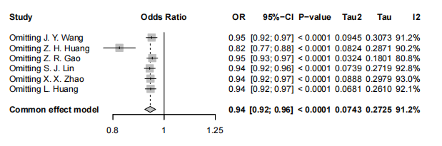

ST Highest Category-(Prevalence＜70%)
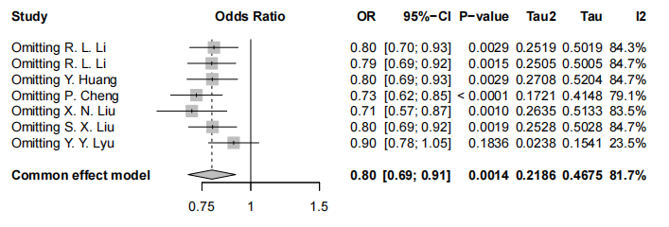
ST Highest Category-(Prevalence≥70%)
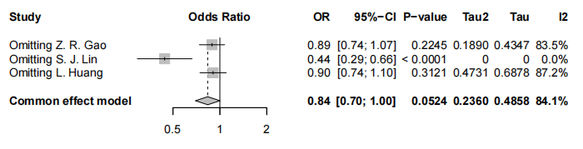

Figure S20. The Forest Plot of the Association Between Sleep Time in the Highest Category and the Prevalence Incidence of Myopia
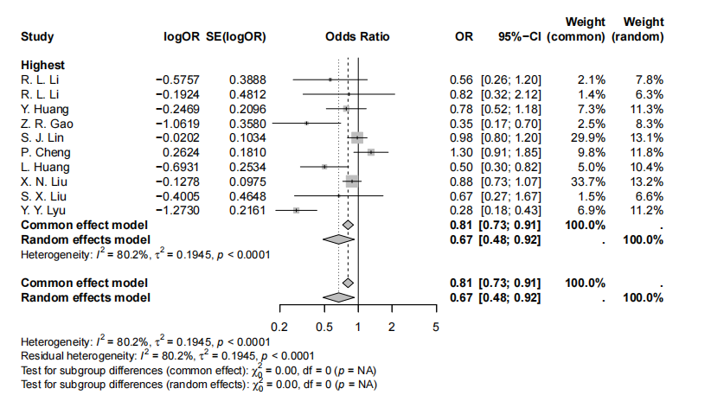

Figure S21. The Funnel Plot of the Association Between Screen Time in the Highest Category and the Prevalence Incidence of Myopia
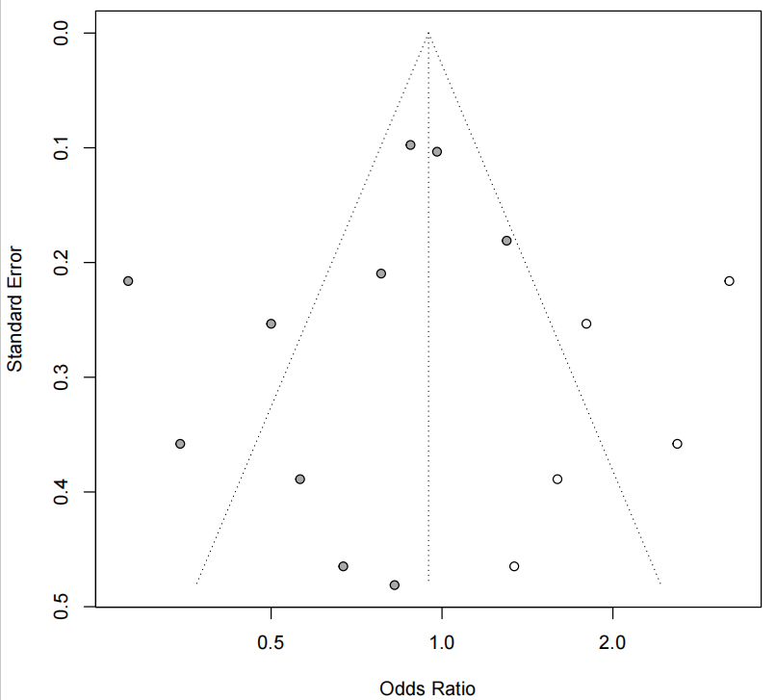

Figure S22. The Forest Plot of the Association Between Sleep Time in the Intermediate Category and the Prevalence Incidence of Myopia
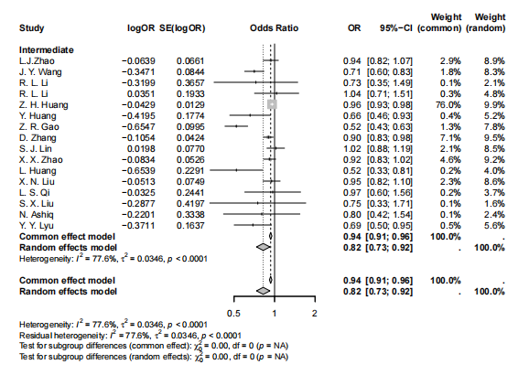

Figure S23. The Funnel Plot of the Association Between Screen Time in the Intermediate Category and the Prevalence Incidence of Myopia
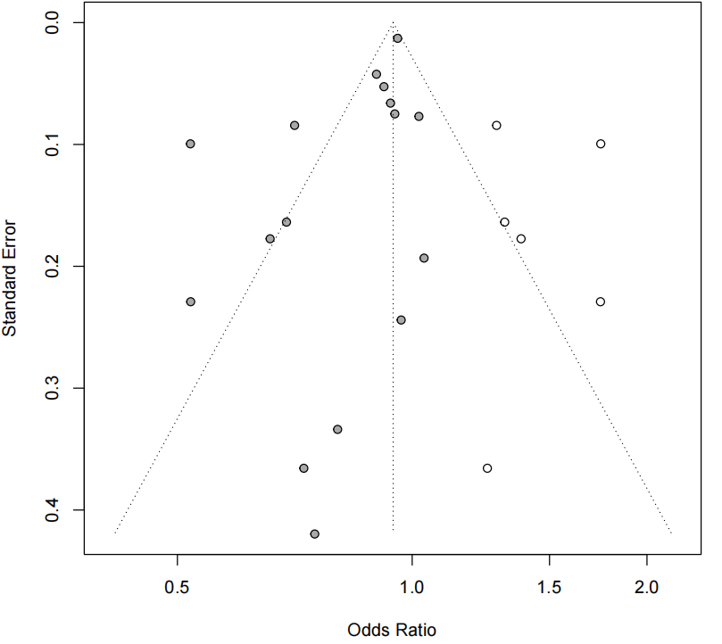

Figure S24.Funnel Plot with Trim-and-Fill Adjustment for Publication Bias: Screen Time
Highest Category
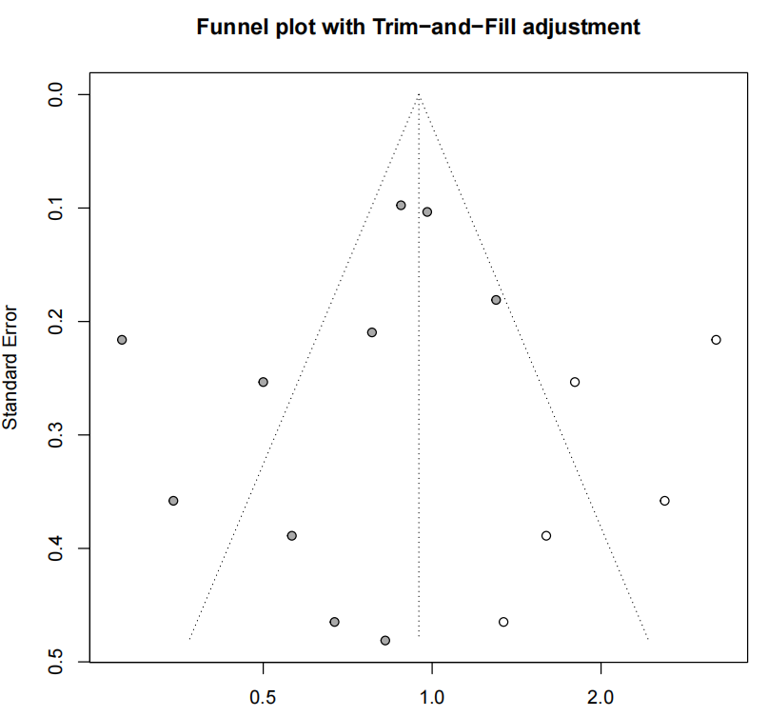

Figure S25. Sleep Duration Sensitivity and Robustness Analysis
SD Intermediate Category-(Prevalence＜70%)
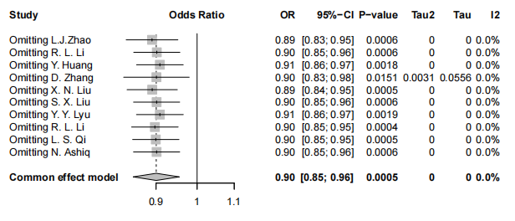SD Intermediate Category-(Prevalence≥70%)
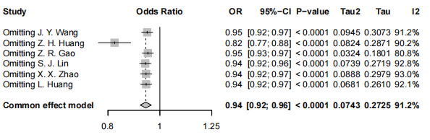SD Highest Category-(Prevalence＜70%)
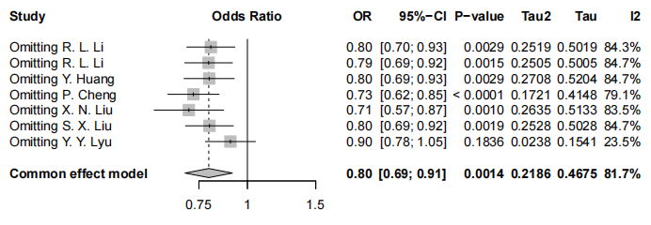SD Highest Category-(Prevalence≥70%)
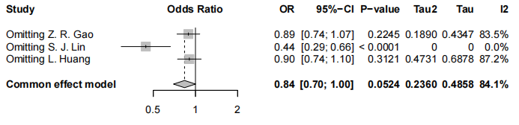SD Intermediate Category-(sample size≤10000)
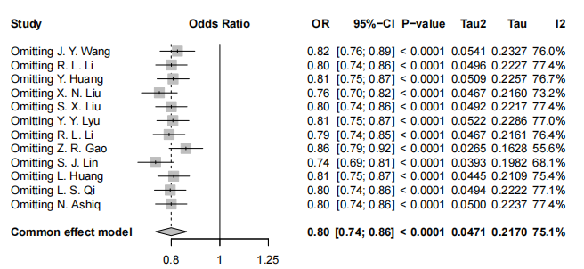SD Intermediate Category-(sample size>10000)
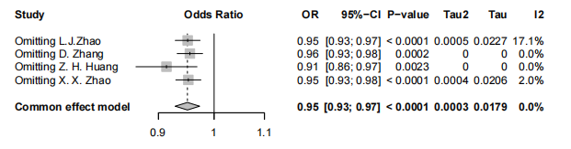

Figure S26.Association Between Age-Specific Sleep Duration (NSF Guidelines) and Myopia Incidence/Prevalence in Children and Adolescents: Forest Plot from Sensitivity Analysis
