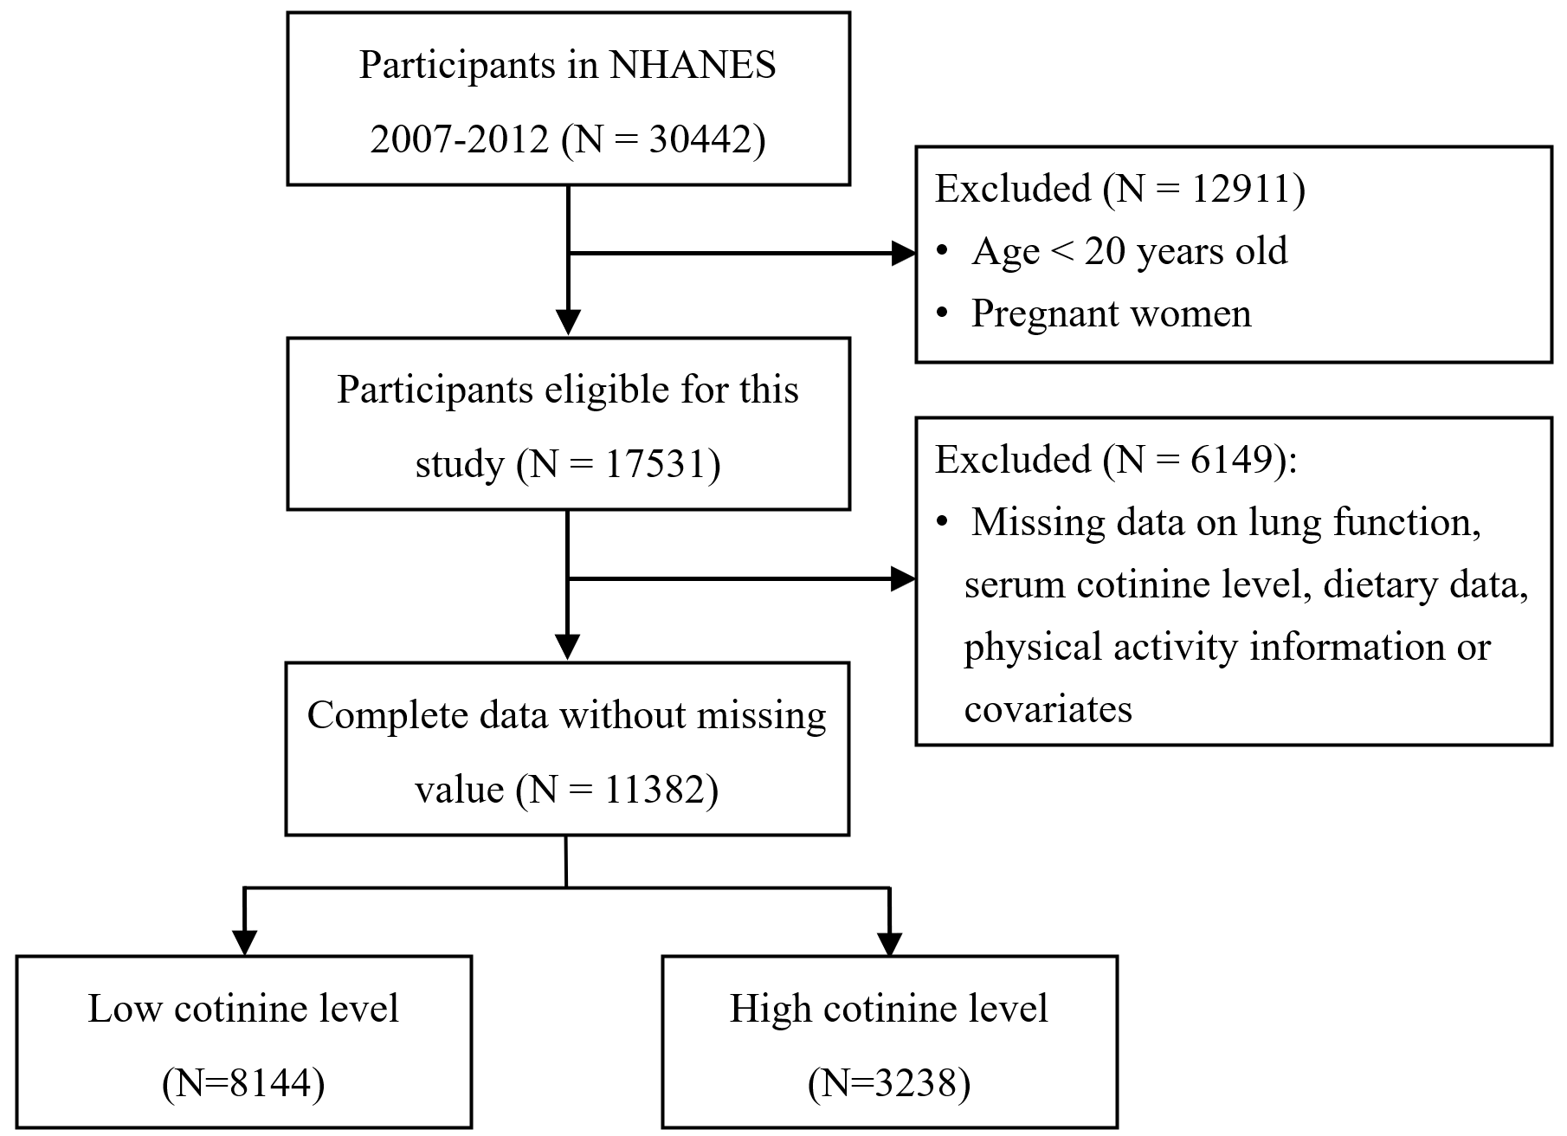
Supplementary Figure 1. Flowchart of the study.

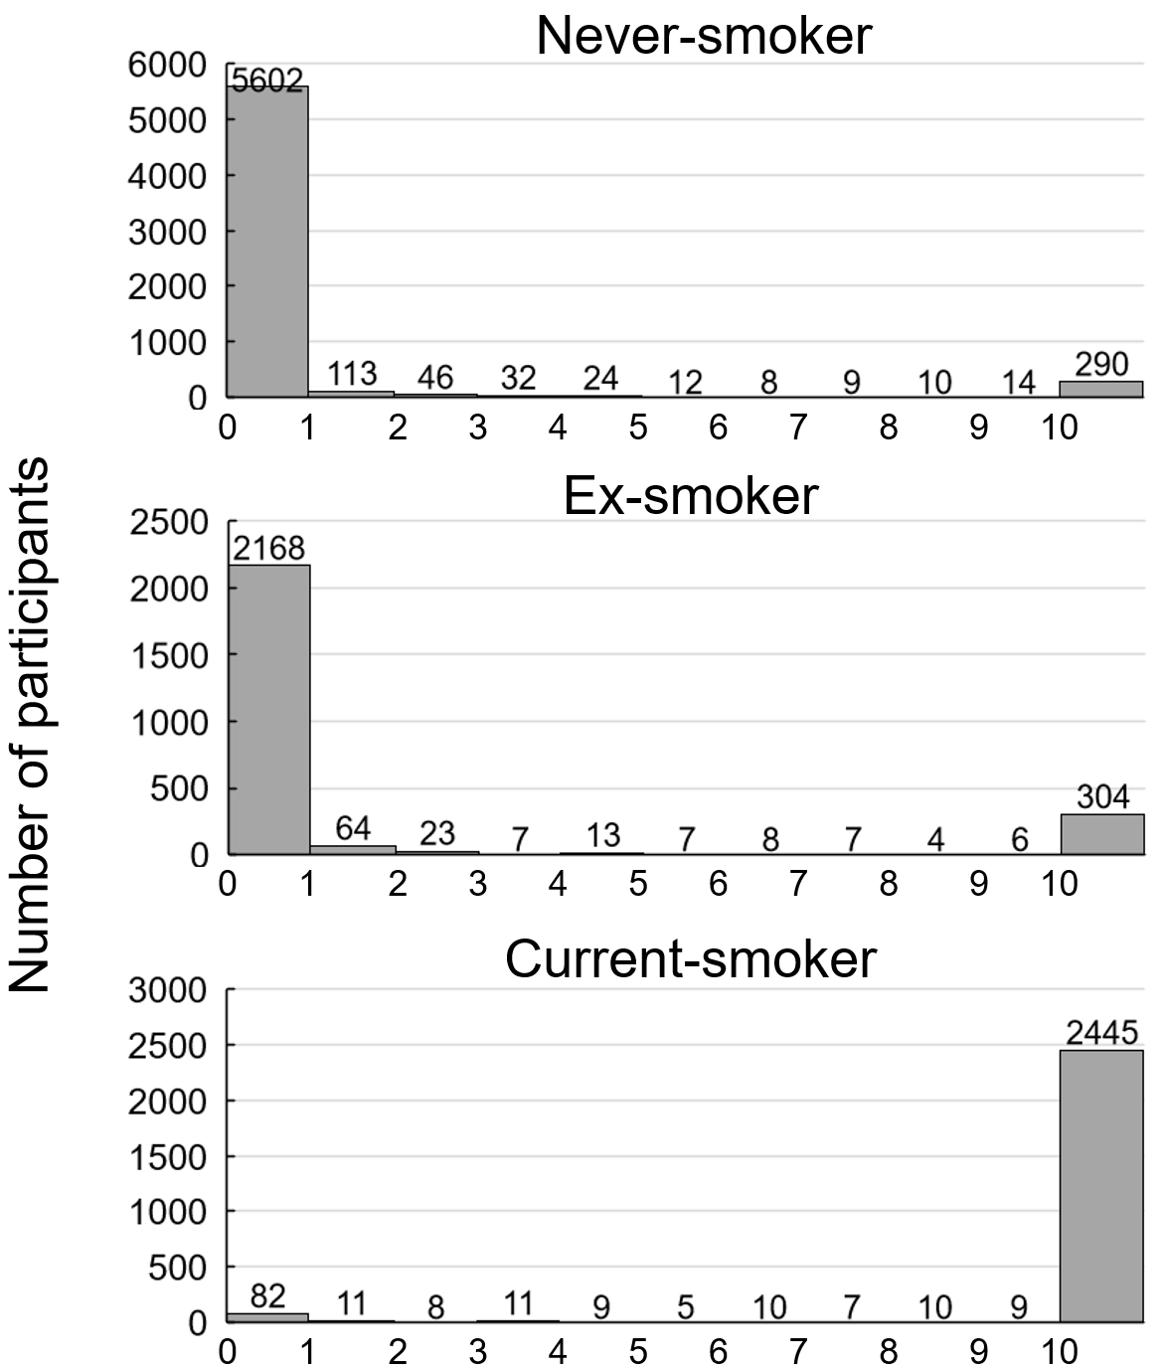
Supplementary Figure 2. The distribution of serum cotinine level in population with different smoking status.

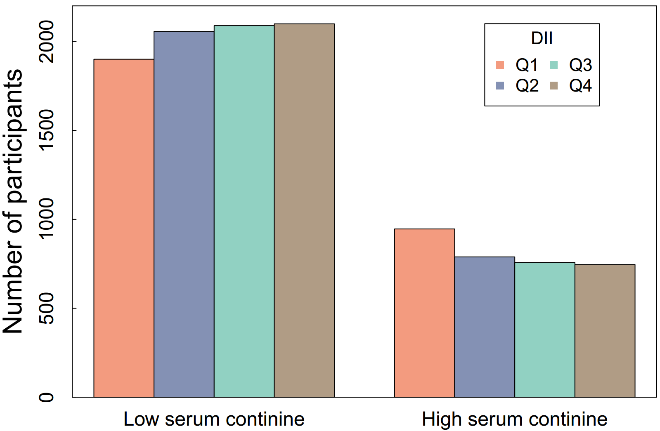
Supplementary Figure 3. The distribution of DII according to serum cotinine level.

Supplementary Table 1. The interactions between serum cotinine level and components of DII on lung function.
 | FEV₁% predicted |  |  | FVC% predicted |  |  | FEV₁/FVC
 | P | FDR |  | P | FDR |  | P | FDR
Cotinine level * Alcohol | 0.0129 | 0.0095 |  | 0.0404 | 0.0438 |  | 0.2188 | 0.2885
Cotinine level * VB12 | 0.0031 | 0.0029 |  | 0.0024 | 0.0029 |  | 0.3948 | 1.0000
Cotinine level * VB6 | 0.0022 | 0.0023 |  | 0.0554 | 0.0977 |  | 0.0020 | 0.0023
Cotinine level * β-Carotene | 0.7365 | 1.0000 |  | 0.0888 | 0.0977 |  | 0.0108 | 0.0095
Cotinine level * Caffeine | <.0001 | <.0001 |  | 0.0002 | 0.0021 |  | <.0001 | <.0001
Cotinine level * Carbohydrate | 0.0529 | 0.0438 |  | 0.2805 | 0.2885 |  | 0.0369 | 0.0409
Cotinine level * Cholesterol | 0.0073 | 0.0095 |  | 0.1370 | 0.0977 |  | 0.0019 | 0.0021
Cotinine level * Energy | 0.0007 | 0.0021 |  | 0.0120 | 0.0095 |  | 0.0121 | 0.0095
Cotinine level * Total fat | 0.0020 | 0.0023 |  | 0.0150 | 0.0095 |  | 0.0311 | 0.0314
Cotinine level * Fiber | 0.4416 | 1.0000 |  | 0.6132 | 1.0000 |  | 0.0040 | 0.0049
Cotinine level * Folic acid | 0.0328 | 0.0314 |  | 0.3540 | 0.2885 |  | 0.0019 | 0.0021
Cotinine level * Fe | 0.0154 | 0.0314 |  | 0.1602 | 0.0977 |  | 0.0029 | 0.0029
Cotinine level * Mg | 0.0300 | 0.0314 |  | 0.1723 | 0.0977 |  | 0.0104 | 0.0095
Cotinine level * Monounsaturated fatty acids | 0.0045 | 0.0049 |  | 0.0302 | 0.0314 |  | 0.0482 | 0.0438
Cotinine level * VB3 | 0.0016 | 0.0021 |  | 0.0212 | 0.0314 |  | 0.0136 | 0.0095
Cotinine level * n-3 fatty acids | 0.0071 | 0.0070 |  | 0.1456 | 0.0977 |  | 0.0037 | 0.0035
Cotinine level * n-6 fatty acids | 0.0034 | 0.0035 |  | 0.0481 | 0.0438 |  | 0.0142 | 0.0095
Cotinine level * Protein | <.0001 | <.0001 |  | 0.0059 | 0.0049 |  | 0.0002 | 0.0021
Cotinine level * Polyunsaturated fatty acids | 0.0015 | 0.0021 |  | 0.0276 | 0.0314 |  | 0.0102 | 0.0095
Cotinine level * VB2 | 0.5747 | 1.0000 |  | 0.6853 | 1.0000 |  | 0.3206 | 0.2885
Cotinine level * Saturated fat | 0.0009 | 0.0021 |  | 0.0016 | 0.0021 |  | 0.1972 | 0.2705
Cotinine level * Se | <.0001 | <.0001 |  | 0.0050 | 0.0049 |  | 0.0005 | 0.0021
Cotinine level * VB1 | 0.0671 | 0.0977 |  | 0.1190 | 0.0977 |  | 0.1215 | 0.0977
Cotinine level * VA | 0.6929 | 1.0000 |  | 0.9656 | 1.0000 |  | 0.1725 | 0.2705
Cotinine level * VC | 0.0349 | 0.0314 |  | 0.3669 | 0.3515 |  | 0.0053 | 0.0049
Cotinine level * VD | 0.1095 | 0.0977 |  | 0.1345 | 0.0977 |  | 0.2956 | 0.2885
Cotinine level * VE | 0.1619 | 0.0977 |  | 0.3468 | 0.2885 |  | 0.1008 | 0.0977
Cotinine level * Zn | 0.0034 | 0.0035 |  | 0.0061 | 0.0070 |  | 0.1421 | 0.0977

