Title: Body mass index trajectories in older adulthood and all-cause mortality: a cohort study in China

Outline(supplementary files)

eTable 1 Age-adjusted baseline characteristics of included and excluded participants
eTable 2 Fit indices of latent class growth modelling on body mass index trajectories
eTable 3 Hazard ratios for all-cause mortality (95% CIs) in stratified analyses
eTable 4 Association between body mass index trajectories and the risk of all-cause mortality, stratification analyses for health status
eTable 5 Association between BMI and the risk of all-cause mortality
eTable 6 Mediation analysis between BMI trajectories (low-normal stable VS normal slight increase) and all-cause mortality
eFigure 1 Flow diagram of study participants, a prospective cohort (2008-2018)
eFigure 2 Distribution of body mass index in three waves of follow-up survey
eFigure 3 Distribution of study population in 2008-2014 wave (N = 3676)
eFigure 4 Kaplan-Meier survival curves for participants with different trajectories of body mass index
eFigure 5 The all-cause mortality in different BMl trajectories by gender and smoke status
eFigure 6 Joint effects of BMI trajectories and smoking status (A) or depression (B) on all-cause mortality
eMethods1: Assessment of covariates
eMethods2: Statistical methods
eResults1: Stratified and sensitivity analyses

eTable 1 Age-adjusted baseline characteristics of included and excluded participants due to missing death information or lost to follow-up
Characteristics | Included (n=3,676) | Excluded (n=1,104) | P-value
Age, years, median (IQR) | 77.00 (70.00-85.00) | 79.00 (71.00-87.00) | <0.001
Female, n (%) | 1,921 (53.14) | 592 (54.5) | 0.426
Ethnic, Hans, n (%) | 3,425 (93.04) | 1,059 (95.89) | <0.001
Residence, n (%) |  |  | <0.001
Rural | 2,470 (67.19) | 602 (54.45)
Town | 783 (21.40) | 215 (19.43)
City | 423 (11.42) | 287 (26.12)
Education level, n (%) |  |  | <0.001
Illiteracy | 1,927 (54.41) | 551 (51.81)
Primary school and below | 1,315 (34.57) | 358 (31.43)
Junior high school and above | 431 (10.94) | 195 (16.77)
Farmers, n (%) | 2,707 (73.96) | 653 (59.28) | <0.001
Living expenses, enough, n (%) | 2,855 (77.61) | 853 (77.33) | 0.843
Marital status, n (%) |  |  | 0.780
Married and living with spouse | 1,863 (47.95) | 554 (47.47)
Others | 1,813 (52.05) | 550 (52.53)
Sleep quality, n (%) |  |  | 0.506
Good | 2,432 (66.22) | 731 (66.25)
Fair | 849 (23.14) | 268 (24.19)
Poor | 395 (10.64) | 105 (9.56)
Sleep duration, hours, n (%) |  |  | 0.046
<7 | 1,039 (28.13) | 282 (25.15)
7-8 | 1,551 (41.55) | 507 (45.49)
>8 | 1,086 (30.32) | 315 (29.36)
Drinking status, n (%) |  |  | 0.681
Never | 2,402 (65.81) | 727 (66.43)
Former | 463 (12.62) | 148 (13.15)
Current | 811 (21.57) | 229 (20.42)
Smoking status, n (%) |  |  | 0.938
Never | 2,316 (63.76) | 696 (64.12)
Former | 512 (13.85) | 157 (14)
Current | 848 (22.39) | 251 (21.88)
Exercise status, n (%) |  |  | <0.001
Never | 2,136 (58.33) | 521 (47.69)
Former | 316 (8.68) | 118 (11.01)
Current | 1,224 (32.99) | 465 (41.3)
Dietary diversity, good, n (%) | 2,696 (72.84) | 852 (76.34) | 0.020
Cognitive impairment, n (%) | 349 (10.68) | 94 (9.63) | 0.242
Depression, n (%) | 955 (26.34) | 320 (29.25) | 0.134
Chronic disease, n (%) | 753 (20.09) | 293 (26.27) | <0.001
Physical limitation, n (%) | 140 (4.33) | 73 (7.34) | <0.001
The Chi-square test was used for unordered categorical data, the Wilcoxon rank sum test was used for ordinal data and skewed continuous data.
eTable 2 Fit indices of latent class growth modelling on body mass index trajectories
Model | Log likelihood | AIC | BIC | aBIC | Entropy | Class (%)
1 | -29826.34 | 59658.68 | 59677.31 | 59667.78 | 1 | 100
2 | -28508.65 | 57029.29 | 57066.55 | 57047.49 | 0.77 | 26.09/73.91
3 | -28049.85 | 56117.70 | 56173.59 | 56144.99 | 0.74 | 47.33/44.45/8.22
4 | -27938.01 | 55900.03 | 55974.54 | 55936.41 | 0.73 | 36.83/2.50/47.14/13.52
5 | -27900.80 | 55831.59 | 55924.73 | 55877.07 | 0.68 | 0.73/26.74/43.61/6.50/22.42
6 | -27856.05 | 55748.10 | 55859.88 | 55802.68 | 0.71 | 23.34/25.16/6.34/0.92/43.50/0.73
7 | -27839.83 | 55721.66 | 55852.06 | 55785.33 | 0.70 | 2.23/19.97/27.67/7.64/0.30/41.38/0.82
Abbreviation: AIC, Akaike Information Criterion; BIC, Bayesian Information Criterion; aBIC, adjusted Bayesian Information Criterion.

eTable 3 Hazard ratios for all-cause mortality (95% CIs) in stratified analyses
Subgroups | n | Cases/person-years | BMI trajectories, HRs (95%CI) ª |  |  | P _{for interaction}
Subgroups | n | Cases/person-years | Low-normal stable  (n=1,740) | Normal slight increase (n=1,634) | Overweight to obesity (n=302) | P _{for interaction}
Age, years |  |  |  |  |  | 0.736
60- | 2,091 | 398/7,966 | 1.31 (1.02, 1.67) * | 1.00 [Reference] | 1.14 (0.74, 1.77)
80- | 1,585 | 933/4,550 | 1.46 (1.24, 1.73) *** | 1.00 [Reference] | 0.98 (0.58, 1.67)
Sex |  |  |  |  |  | 0.162
Female | 1,921 | 683/6,593 | 1.52 (1.24, 1.86) *** | 1.00 [Reference] | 1.55 (0.98, 2.46)
Male | 1,755 | 648/5,923 | 1.31 (1.09, 1.58) ** | 1.00 [Reference] | 0.85 (0.51, 1.39)
BMI, kg/m² |  |  |  |  |  | 0.407
<24 | 2,996 | 1,167/10,019 | 1.32 (1.16, 1.51) *** | 1.00 [Reference] | 1.45 (0.85, 2.49)
≥24 | 680 | 164/2,497 | 1.54 (0.81, 2.94) | 1.00 [Reference] | 1.19 (0.81, 1.74)
Dietary diversity |  |  |  |  |  | 0.474
Good | 2,696 | 921/9,328 | 1.44 (1.22, 1.69) *** | 1.00 [Reference] | 1.23 (0.85, 1.78)
Suboptimal | 980 | 410/3,188 | 1.27 (0.99, 1.64) | 1.00 [Reference] | 0.94 (0.44, 1.99)
Smoking status |  |  |  |  |  | 0.018
Never | 2,316 | 810/7,966 | 1.61 (1.34, 1.94) *** | 1.00 [Reference] | 1.27 (0.82, 1.97)
Former or current | 1,360 | 521/4,550 | 1.19 (0.97, 1.47) | 1.00 [Reference] | 1.02 (0.60, 1.71)
Drinking status |  |  |  |  |  | 0.541
Never | 2,402 | 871/8,174 | 1.50 (1.26, 1.79) *** | 1.00 [Reference] | 1.21 (0.79, 1.85)
Former or current | 1,274 | 460/4,341 | 1.29 (1.03, 1.61) * | 1.00 [Reference] | 1.08 (0.63, 1.86)
Exercise status |  |  |  |  |  | 0.722
Never | 2,136 | 801/7,170 | 1.42 (1.19, 1.70) *** | 1.00 [Reference] | 0.99 (0.60, 1.62)
Former or current | 1,540 | 530/5,346 | 1.37 (1.11, 1.70) ** | 1.00 [Reference] | 1.43 (0.90, 2.26)
Sleep Quality |  |  |  |  |  | 0.427
Good | 2,432 | 913/8,197 | 1.37 (1.16, 1.61) *** | 1.00 [Reference] | 1.03 (0.70, 1.54)
Suboptimal | 1,244 | 418/3,319 | 1.45 (1.13, 1.85) ** | 1.00 [Reference] | 1.32 (0.70, 2.47)
Sleep duration, hours |  |  |  |  |  | 0.630
<7 | 1,039 | 337/3,616 | 1.12 (0.85, 1.47) | 1.00 [Reference] | 1.23 (0.62, 2.47)
7-8 | 1,551 | 523/5,406 | 1.65 (1.33, 2.05) *** | 1.00 [Reference] | 0.88 (0.52, 1.49)
>8 | 1,086 | 471/3,494 | 1.32 (1.04, 1.67) * | 1.00 [Reference] | 1.56 (0.89, 2.74)
Abbreviation: HR, hazard ratio; CI, confidence interval.
P-value: *P<0.05; **P<0.01; ***P<0.001.
ª Adjusted for age (continuous), sex (male, female), ethnic (Hans, others), residence (city, town, rural), education (illiteracy, primary school and below, junior high school and above), occupation (farmers, others), living expenses (enough, not enough), marital status (married and living with spouse, others); drinking status (never, former, current), smoking status (never, former, current), exercise status (never, former, current), sleep quality (good, fair, poor), sleep duration (<7, 7-8, >8 hours), dietary diversity (good, bad); chronic disease (no, yes), physical function (normal, disabled), depression (yes, no), cognitive function (normal, impairment), and BMI (underweight, normal, overweight, obesity).
The bold values indicated statistical significance P<0.05.
eTable 4 Association between body mass index trajectories and the risk of all-cause mortality, stratification analyses for health status
Subgroups | n | Cases/person-years | Body mass index trajectories, HRs (95%CI) ª |  |  | P _{for interaction}
Subgroups | n | Cases/person-years | Low-normal stable (n=1,740) | Normal slight increase (n=1,634) | Overweight to obesity (n=302) | P _{for interaction}
Physical function |  |  |  |  |  | 0.372
Normal | 3,536 | 1,236/12,159 | 1.39 (1.21, 1.60) *** | 1.00 [Reference] | 1.16 (0.83, 1.63)
Disabled | 140 | 95/357 | 1.07 (0.57, 2.00) | 1.00 [Reference] | 0.48 (0.10, 2.38)
Cognitive function |  |  |  |  |  | 0.992
Normal | 3,322 | 1,106/11,571 | 1.40 (1.21, 1.61) *** | 1.00 [Reference] | 1.18 (0.83, 1.66)
Impairment | 349 | 223/926 | 1.52 (0.98, 2.36) | 1.00 [Reference] | 0.97 (0.25, 3.83)
Depression |  |  |  |  |  | 0.031
No | 2,564 | 842/8,996 | 1.45 (1.22, 1.71) *** | 1.00 [Reference] | 1.39 (0.96, 2.03)
Yes | 955 | 391/3,109 | 1.29 (1.02, 1.62) * | 1.00 [Reference] | 0.60 (0.29, 1.26)
Chronic disease |  |  |  |  |  | 0.259
No | 2,830 | 1,010/9,687 | 1.39 (1.19, 1.62) *** | 1.00 [Reference] | 1.46 (0.99, 2.17)
Yes | 753 | 282/2,508 | 1.38 (1.02, 1.86) * | 1.00 [Reference] | 0.75 (0.41, 1.40)
Abbreviation: HR, hazard ratio; CI, confidence interval.
P-value: *P<0.05; **P<0.01; ***P<0.001.
ª Adjusted for age (continuous), sex (male, female), ethnic (Hans, others), residence (city, town, rural), education (illiteracy, primary school and below, junior high school and above), occupation (farmers, others), living expenses (enough, not enough), marital status (married and living with spouse, others); drinking status (never, former, current), smoking status (never, former, current), exercise status (never, former, current), sleep quality (good, fair, poor), sleep duration (<7, 7-8, >8 hours), dietary diversity (good, bad); chronic disease (no, yes), physical function (normal, disabled), depression (yes, no), cognitive function (normal, impairment), and BMI (underweight, normal, overweight, obesity).
The bold values indicated statistical significance P<0.05.
eTable 5 Association between BMI and the risk of all-cause mortality
Outcome | Cases/person-years | Adjusted HRs (95%CIs)
Outcome | Cases/person-years | Mode1-Adjusted | Model 2-Adjusted | Model 3-Adjusted | Model 4-Adjusted
BMI, kg/m²
<18.5 | 375/2101 | 1.31 (1.15, 1.49) | 1.29 (1.13, 1.46) | 1.25 (1.10, 1.42) | 1.27 (1.10, 1.48)
18.5- | 718/6968 | 1.00 [Reference] | 1.00 [Reference] | 1.00 [Reference] | 1.00 [Reference]
24- | 184/2647 | 0.79 (0.67, 0.93) | 0.82 (0.69, 0.96) | 0.82 (0.69, 0.96) | 0.79 (0.65, 0.94)
28- | 54/800 | 0.95 (0.72, 1.26) | 0.97 (0.73, 1.28) | 0.94 (0.71, 1.24) | 0.86 (0.63, 1.17)
P _{for trend} | 1331/12516 | <0.001 | <0.001 | <0.001 | <0.001
Continuous, per 1 kg/m² | 1331/12516 | 0.96 (0.94, 0.97) | 0.96 (0.94, 0.98) | 0.96 (0.95, 0.98) | 0.96 (0.94, 0.98)
Abbreviation: HR, hazard ratio; CI, confidence interval.
All adjusted variables were obtained from 2014 wave.
Model 1 was adjusted for age (continuous), sex (male, female).
Model 2 model was further adjusted for ethnic (Hans, others), residence (city, town, rural), education (illiteracy, primary school and below, junior high school and above), occupation (farmers, others), living expenses (adequate, inadequate), marital status (married and living with spouse, others).
Model 3 model was further adjusted for drinking status (never, former, current), smoking status (never, former, current), exercise status (never, former, current), sleep quality (good, fair, poor), sleep duration (<7, 7-8, >8 hours), dietary diversity (good, bad).
Model 4 model was further adjusted for chronic disease (no, yes), depression (no, yes), physical function (normal, disabled), cognitive function (normal, impairment).
The bold values indicated statistical significance P<0.05.

eTable 6 Mediation analysis between BMI trajectories (low-normal stable VS normal slight increase) and all-cause mortality
Effect | Unadjusted model | P | PM | Adjusted model ª | P | PM
Mediated by lack of leisure activities (n=3131)
NDE | 1.67 (1.42, 1.92) | <0.001 | 41.31 | 1.41 (1.13, 1.69) | 0.004 | 20.41
NIE | 1.28 (1.19, 1.38) | <0.001 |  | 1.07 (1.02, 1.13) | 0.009
TE | 2.15 (1.80, 2.50) | <0.001 |  | 1.51 (1.20, 1.82) | 0.001
Mediated by poor self-reported health status (n=3131)
NDE | 1.87 (1.60, 2.13) | <0.001 | 2.37 | 1.45 (1.16, 1.73) | 0.002 | 7.23
NIE | 1.01 (1.00, 1.02) | 0.034 |  | 1.02 (1.00, 1.04) | 0.015
TE | 1.89 (1.62, 2.15) | <0.001 |  | 1.48 (1.19, 1.77) | 0.001
Mediated by cognitive impairment (n=2890) ^{b}
NDE | 1.68 (1.40, 1.95) | <0.001 | 41.06 | 1.41 (1.11, 1.70) | 0.007 | 19.58
NIE | 1.28 (1.16, 1.40) | <0.001 |  | 1.07 (1.00, 1.14) | 0.042
TE | 2.15 (1.75, 2.54) | <0.001 |  | 1.50 (1.18, 1.83) | 0.002

TE: Total Effect, NDE: Natural Direct Effect, NIE: Natural Indirect Effect, PM: Percentage Mediated.
ª Adjusted for age (continuous), sex (male, female), ethnic (Hans, others), residence (city, town, rural), education (illiteracy, primary school and below, junior high school and above), occupation (farmers, others), living expenses (enough, not enough), marital status (married and living with spouse, others); drinking status (never, former, current), smoking status (never, former, current), exercise status (never, former, current), sleep quality (good, fair, poor), sleep duration (<7, 7-8, >8 hours), dietary diversity (good, bad); chronic disease (no, yes), physical function (normal, disabled), depression (yes, no), cognitive function (normal, impairment), and BMI (underweight, normal, overweight, obesity).
^{b} Excluded participants with cognitive impairment at baseline.
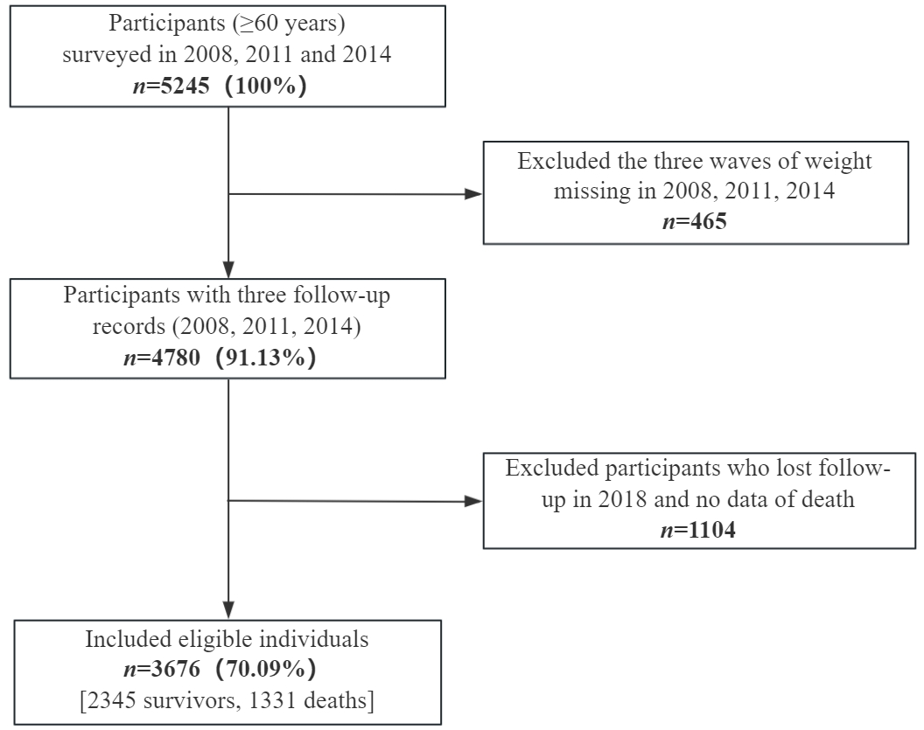

eFigure 1 Flow diagram of study participants, a prospective cohort (2008-2018).
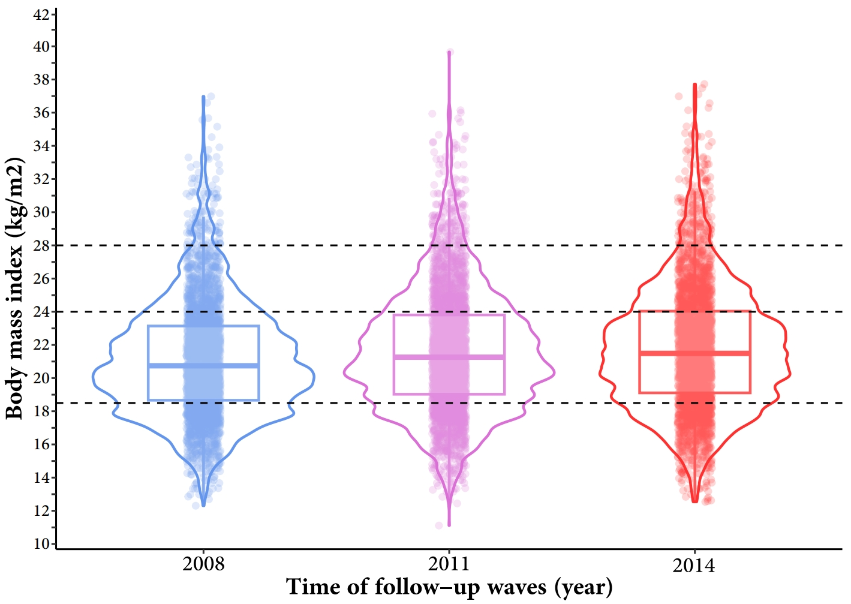

eFigure 2 Distribution of body mass index in three waves of follow-up survey
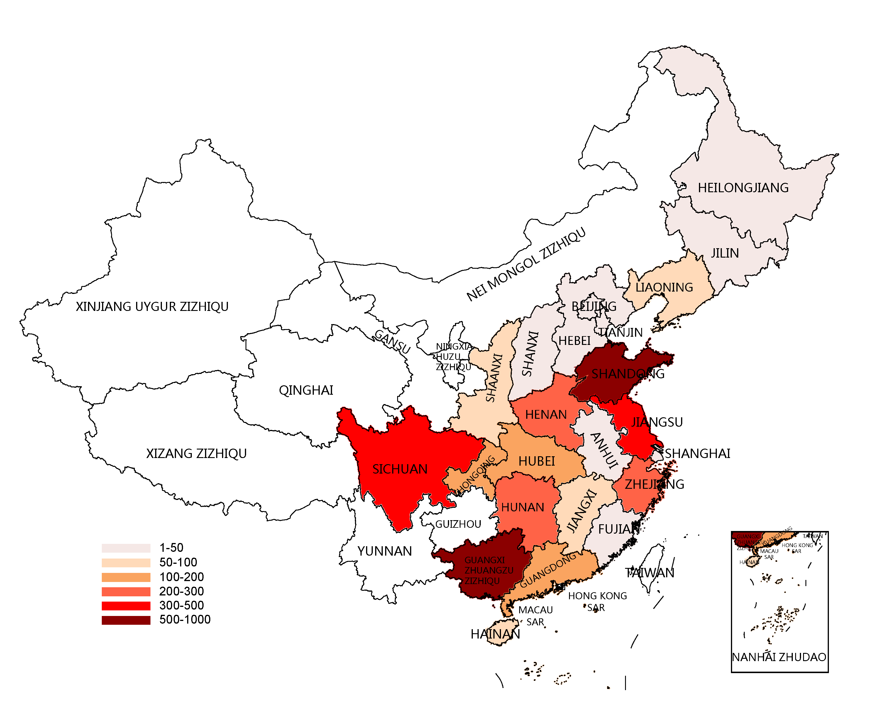

eFigure 3 Distribution of study population in 2008-2014 wave (N = 3676)
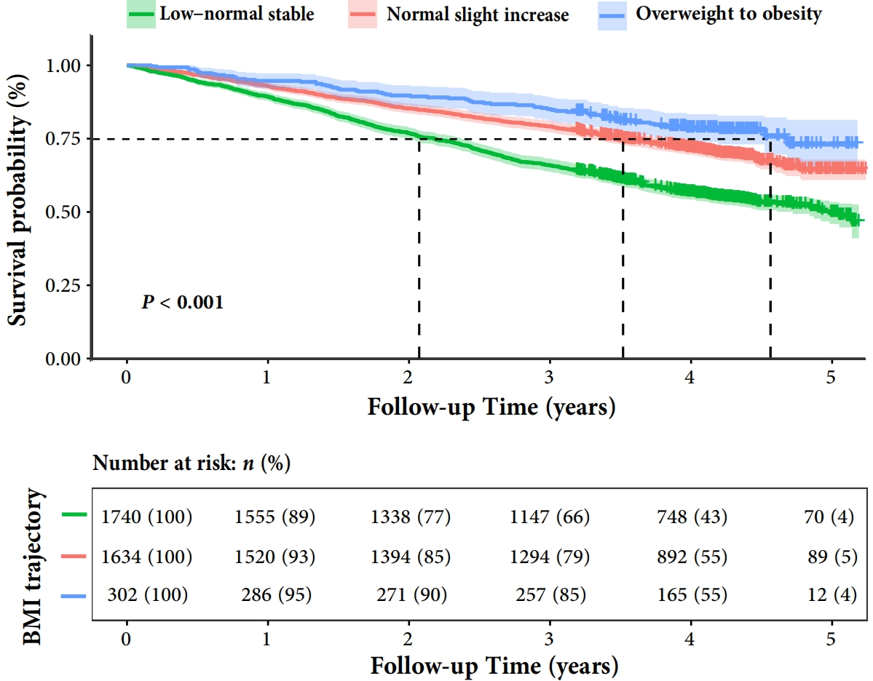

eFigure 4 Kaplan-Meier survival curves for participants with different trajectories of body mass index

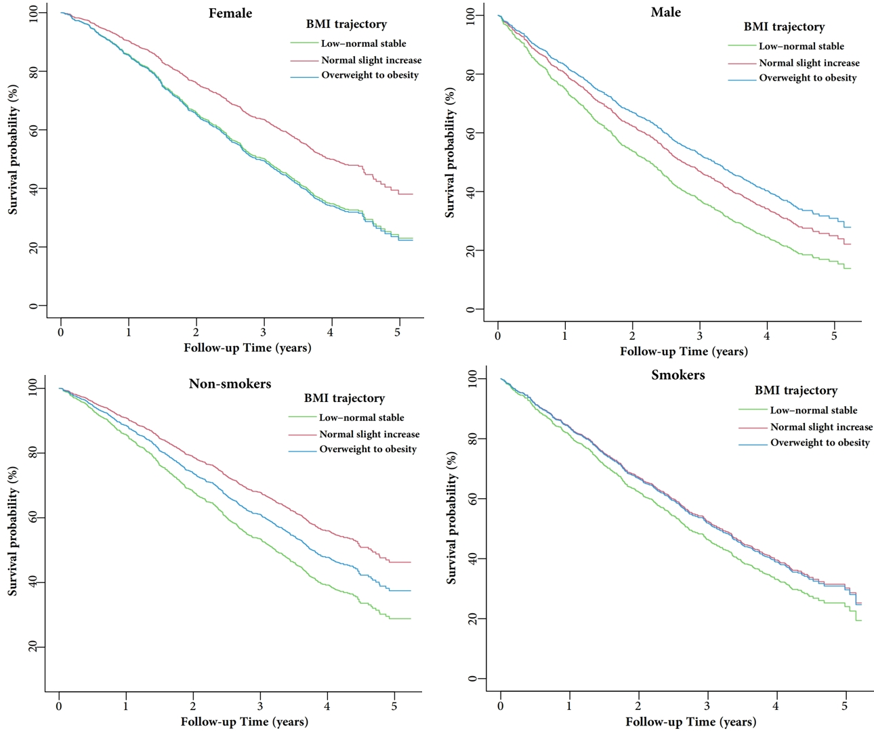
eFigure 5 The all-cause mortality in different BMl trajectories by gender and smoke status
Adjusted for age (continuous), sex (male, female), ethnic (Hans, others), residence (city, town, rural), education (illiteracy, primary school and below, junior high school and above), occupation (farmers, others), living expenses (enough, not enough), marital status (married and living with spouse, others); drinking status (never, former, current), smoking status (never, former, current), exercise status (never, former, current), sleep quality (good, fair, poor), sleep duration (<7, 7-8, >8 hours), dietary diversity (good, bad); chronic disease (no, yes), physical function (normal, disabled), depression (yes, no), cognitive function (normal, impairment), and BMI (underweight, normal, overweight, obesity).

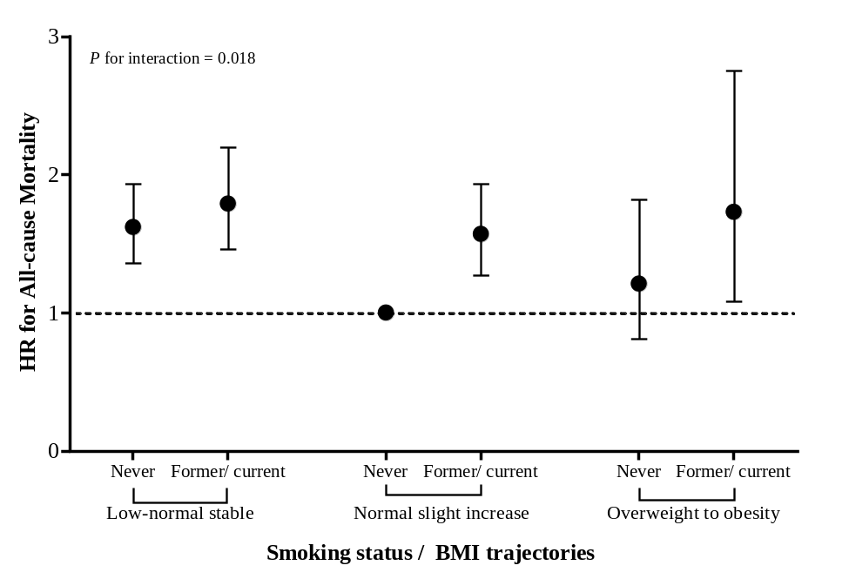
(A)
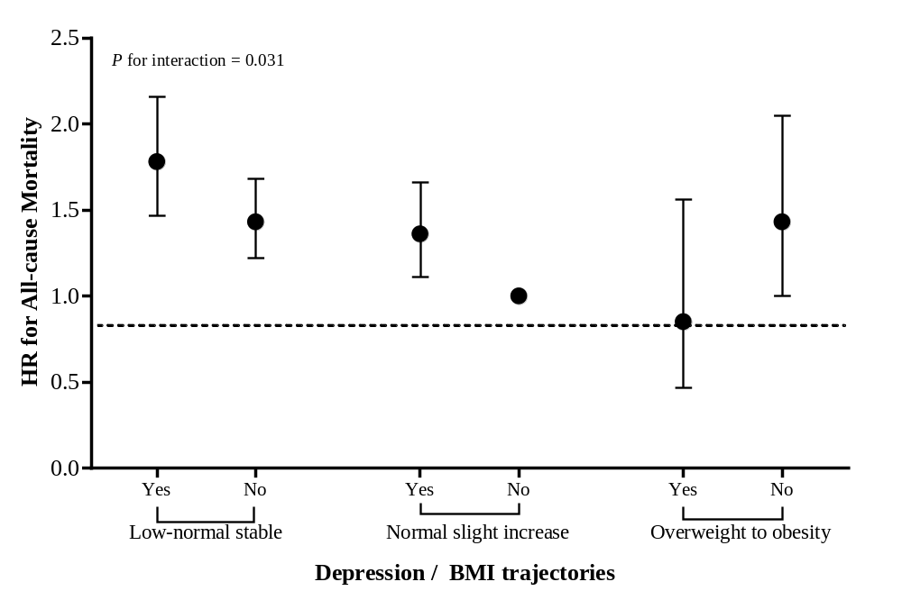
(B)

eFigure 6 Joint effects of BMI trajectories and smoking status (A) or depression (B) on all-cause mortality
Adjusted for age (continuous), sex (male, female), ethnic (Hans, others), residence (city, town, rural), education (illiteracy, primary school and below, junior high school and above), occupation (farmers, others), living expenses (enough, not enough), marital status (married and living with spouse, others); drinking status (never, former, current), smoking status (never, former, current), exercise status (never, former, current), sleep quality (good, fair, poor), sleep duration (<7, 7-8, >8 hours), dietary diversity (good, bad); chronic disease (no, yes), physical function (normal, disabled), depression (yes, no), cognitive function (normal, impairment), and BMI (underweight, normal, overweight, obesity).

eMethods1: Assessment of covariates
Demographic characteristics included age, gender (male, female), ethnicity (Han nationality, others) ¹, residence district (city, town, rural), education (illiteracy, primary school and below, junior high school and above), marital status ² (married and living with spouse, others); living expenses³ (adequate, inadequate), occupation (farmer, others). Lifestyle information included sleep quality (good, fair, poor), sleep duration ⁴ (<7, 7-8, >8 hours/day), dietary diversity⁵ (Dietary Diversity Score, DDS: good, poor), smoking status (never, former, current), drinking status (never, former, current) and exercise status (never, former, current). Health information included chronic disease (yes, no), physical function (normal, disabled), depression (yes, no), cognitive function (normal, impairment).

Chronic diseases included cancer, chronic lung disease, diabetes, heart disease and stroke, which are the five major diseases that cause the burden of diseases in the older Chinese population⁶. Participants who self-reported one or more of these diseases were classified as having chronic diseases. The Katz Index of Independence in Activities of Daily Living (ADL) was used to assess physical function (including dressing, bathing, eating, toileting, transferring and continence), and needing assistance with one or more tasks was defined as disability⁷. Three questions were used to screen depressive symptoms, including whether the respondents felt useless, fearful, or lonely in daily life. Absence of these depressive symptoms indicated no depression⁸. The Mini-Mental State Examination (MMSE) was used to assess cognitive function, which included 24 items, with a total score of 30 points. According to their education level, the participants were divided into two groups: cognitively normal and impairment⁹. A dietary diversity score (DDS) was constructed based on nine food items (fresh vegetables, fresh fruits, meat, fish and other aquatic products, eggs, soybeans, garlic, tea, and pickles/salted vegetables) of a food frequency questionnaire. If the intake frequency of the above foods was ≤3, the dietary diversity was defined as poor; otherwise, it was good³. When participants were unable to answer questions (except for those that required self-completion), these questions could be answered by adult family members who was acquainted with the life situation of the participant.

The proportion of missing values in the covariates was fewer than 7% (occupation missing in 3 cases, education in 3, cognitive impairment in 5, chronic diseases in 93, and depression in 157).

eMethods2: Statistical methods
Considering the importance of age, sex, lifestyle, and health status in relation to mortality, we performed stratified analyses by age, sex, smoking status, drinking status, exercise status, baseline BMI, sleep duration, sleep quality, ADL, cognitive function, depression, and chronic diseases. The likelihood ratio test was used to assess statistical interactions between these factors and BMI trajectory with mortality risk. To compare with previous studies, we also used the single-measured BMI in 2014 wave and assessed its association with all-cause mortality risk by restricted cubic splines and threshold effect analysis, and the adjusted covariates were all obtained from 2014.

In addition, the following sensitivity analyses were conducted to verify the robustness of the results: (1) we conducted a two-year lagged analysis to eliminate potential reverse causation by pre-existing diseases through excluding the elderly who died within the first 2 years¹⁰; (2) we restricted participants to Han Chinese, illiterate, farmers and with adequate living expenses, and reassessed the association of BMI trajectories with all-cause mortality; (3) to reduce the influence of unbalanced confounding factors on the association, the inverse probability weighting (IPW) method was used as a different approach for the analysis¹¹; (4) previous studies have found that self-rated health status, hypertension, co-residence status and leisure activities are predictors of mortality; thus, we further adjusted for these variables, respectively^{7,12,13}; (5) to evaluate the effect of missing value, we used multiple imputations (10 imputations) and repeated main analysis ¹⁴.

We used the mediation model (SAS PROC CAUSALMED) to assess the potential mediating role of factors such as cognitive function, leisure activity, and self-rated health in the association between the BMI trajectory and the risk of all-cause mortality^{15,16}. Leisure activities were assessed through seven items: gardening or pet care, non-exercise outdoor activities, reading or newspaper, raising poultry or livestock, playing cards or mahjong, watching TV or listening to radio, and participating in organized social activities. Participation in any of these activities at least once a day or weekly is defined as having leisure activities, otherwise it is classified as lacking of physical activity ^{3,17}. Self-rated health status was assessed by the question "How do you rate your current health condition?" Categories "Very good" and "Good" are classified as good health status, while "Average," "Poor," and "Very poor" are classified as poor health status ^{18,19}. The factors adjusted in the mediation analysis were the same as those in the main analysis.

Data management and all statistical analyses were performed using Empower (R) (https://www.empowerstats.net/cn/, X & Y solutions, inc. Boston MA), SAS software version 9.4 (SAS Institute, Inc., Cary, NC, USA), Mplus 8.0 and R (https://www.r-project.org/). All P values were 2-sided and P <0.05 was considered statistically significant.

eResults1: Stratified and sensitivity analyses
In the stratified analysis, the association between BMI trajectories and all-cause mortality risk remained consistent across subgroups of age, sex, body size, dietary diversity, drinking status, exercise status, sleep duration, and sleep quality, with non-significant interactions (P > 0.05) except for smoking status (eTable 3 and eFigure 5).

After stratification by smoking status, a notably stronger association was observed in never smokers compared to former or current smokers (P _{for} _{interaction}=0.018) (eTable 3). Additionally, we examined the combined impact of smoking status and BMI trajectories on the all-cause mortality. Compared to non-smokers with a "normal slight increase" BMI trajectory, individuals who were former or current smokers with a "low-normal stable" trajectory exhibited the highest risk of all-cause mortality, with a fully adjusted HR (95%CI) of 1.79 (1.46, 2.20) (eFigure 6A).

To ensure the robustness of the results, we conducted further analyses by stratifying health-related factors and found that the association was more significant in participants with good health. Notably, the association was more pronounced in individuals without depression compared to those with depression. Specifically, among individuals without depressive symptoms, those with a BMI categorized as "low-normal stable" exhibited a 45% higher risk of all-cause mortality (95%CI: 1.22, 1.71), with a significant interaction observed (P=0.031) (eTable 4). Furthermore, the joint analysis revealed that older adults with depressive symptoms and a BMI trajectory of "low-normal stable" had a 78% increased risk of all-cause mortality compared to those with good mental health and a BMI trajectory showing "normal slight increase" (eFigure 6B).

We conducted multiple sensitivity analyses to validate the robustness of our findings. Firstly, excluding older adults who died within the first two years of follow-up did not alter the association between BMI trajectory and the risk of all-cause mortality. Secondly, by restricting the analysis to specific subgroups such as Han Chinese, farmers, illiterate individuals, and adequate-living conditions, the associations remained consistent. Thirdly, after further adjusting for self-reported health status, leisure activities, co-residence status, and hypertension, the results remained stable. Lastly, we utilized inverse probability weighting (IPW) and multiple imputation data to assess the association between BMI trajectory and all-cause mortality risk, and the results were consistent (Table 3).

Supplementary Reference
1. Qiu, L, Sautter, J, Liu, Y, and Gu, D. Age and gender differences in linkages of sleep with subsequent mortality and health among very old Chinese. Sleep Med. 2011;12(10):1008-1017.
2. Zhang, Y, Xiong, Y, Yu, Q, Shen, S, Chen, L, and Lei, X. The activity of daily living (ADL) subgroups and health impairment among Chinese elderly: a latent profile analysis. BMC Geriatr. 2021;21(1):30.
3. Zhou, J H, Liu, S X, Zhang, Z, et al. Distribution characteristics of body mass index among Chinese oldest-old aged 80 years and above. Zhonghua Liu Xing Bing Xue Za Zhi. 2023;44(6):855-861.
4. Zhang, M, Lv, X, Chen, Y, et al. Excessive sleep increased the risk of incidence of cognitive impairment among older Chinese adults: a cohort study based on the Chinese Longitudinal Healthy Longevity Survey (CLHLS). Int Psychogeriatr. 2022;34(8):725-734.
5. Lv, Y B, Kraus, V B, Gao, X, et al. Higher dietary diversity scores and protein-rich food consumption were associated with lower risk of all-cause mortality in the oldest old. Clinical Nutrition. 2020;39(7):2246-2254.
6. Nakagawa, T, Cho, J, Yeung, D Y, and Ailshire, J. Successful Aging in East Asia: Comparison Among China, Korea, and Japan. The Journals of Gerontology: Series B. 2021;76(Supplement_1):S17-S26.
7. Lv, Y B, Yuan, J Q, Mao, C, et al. Association of Body Mass Index With Disability in Activities of Daily Living Among Chinese Adults 80 Years of Age or Older. JAMA Netw Open. 2018;1(5):e181915.
8. Feng, Q, Son, J, and Zeng, Y. Prevalence and correlates of successful ageing: a comparative study between China and South Korea. Eur J Ageing. 2015;12(2):83-94.
9. Cui, G H, Yao, Y H, Xu, R F, et al. Cognitive impairment using education-based cutoff points for CMMSE scores in elderly Chinese people of agricultural and rural Shanghai China. Acta Neurologica Scandinavica. 2011;124(6):361-367.
10. Ding, R, Ding, P, Tian, L, Kuang, X, Huang, L, and Shi, H. Sleep duration trajectories and all-cause mortality among Chinese elderly: A community-based cohort study. BMC Public Health. 2023;23(1):1095.
11. Wu, S, Lv, X, Shen, J, et al. Association between body mass index, its change and cognitive impairment among Chinese older adults: a community-based, 9-year prospective cohort study. Eur J Epidemiol. 2021;36(10):1043-1054.
12. Ruan, R, Feng, L, Li, J, Ng, T P, and Zeng, Y. Tea consumption and mortality in the oldest-old Chinese. J Am Geriatr Soc. 2013;61(11):1937-1942.
13. Zhao, X, Yu, J, and Liu, N. Relationship between specific leisure activities and successful aging among older adults. J Exerc Sci Fit. 2023;21(1):111-118.
14. Liu, R, Dang, S, Zhao, Y, Yan, H, Han, Y, and Mi, B. Long-term waist circumference trajectories and body mass index with all-cause mortality in older Chinese adults: a prospective nationwide cohort study. Arch Public Health. 2022;80(1):94.
15. Lee, G B, Kim, H C, Jeon, Y J, and Jung, S J. Association between socioeconomic status and longitudinal sleep quality patterns mediated by depressive symptoms. Sleep. 2021;44(8).
16. Ou, Y, Qiu, Z, Geng, T, et al. Associations of serum vitamin C concentrations with risk of all-cause and cause-specific mortality among individuals with and without type 2 diabetes. European Journal of Nutrition. 2023;62(6):2555-2565.
17. Zhu, A, Wu, C, Yan, L L, et al. Association between residential greenness and cognitive function: analysis of the Chinese Longitudinal Healthy Longevity Survey. BMJ Nutr Prev Health. 2019;2(2):72-79.
18. Maria, M S, Büla, C, Santos-Eggimann, B, Krief, H, Heinzer, R, and Seematter-Bagnoud, L. Sleep characteristics and self-rated health in older persons. Eur Geriatr Med. 2020;11(1):131-138.
19. Zhang, J, Li, D, and Gao, J M. Health Disparities between the Rural and Urban Elderly in China: A Cross-Sectional Study. Int J Env Res Pub He. 2021;18(15).

