Supplementary Table 1:
Missing values
Variable | Rural, n (%) | Urban, n (%)
Sex | 0 | 0
Income | 847 (17.2) | 0
Tobacco use | 10 (0.2) | 17 (1.6)
Alcohol use | 22 (0.4) | 432 (39.7)
Dyslipidemia diagnosis | 0 | 19 (1.7)
Hypertension | 0 | 11 (1)
Cardiac Illness | 0 | 18 (1.7)
Stroke | 0 | 18 (1.7)
Obesity | 82 (1.7) | 125 (11.5)
Physically active | 948 (19.3) | 379 (34.8)
Cholesterol | 519 (10.6) | 113 (10.4)
TG | 526 (10.7) | 115 (10.6)
LDL | 555 (11.3) | 114 (10.5)
HDL | 520 (10.6) | 113 (10.4)
Dyslipidemia | 518 (10.4) | 113 (10.4)
C/HDL | 528 (10.7) | 114 (10.5)
TG/HDL | 539 (11) | 116 (10)

Supplementary Table 2: Sensitivity (Sens), specificity (Spec), Min Distance, and YoudensJ for LDLc/HDLc ratio in the study population

Due to the lack of a well-established cutoff for the LDLc/HDLc ratio, a population-specific cutoff was estimated. To evaluate the discriminative ability of the LDLC/HDLC ratio for predicting diabetes, dyslipidemia, hypertension, and cardiovascular disease combinations (presence of ≥2 conditions among diabetes, hypertension, and dyslipidemia), we performed a Receiver Operating Characteristic (ROC) analysis across a range of cutoff values. Sensitivity and specificity were calculated at each cutoff point to assess the test's performance. The optimal cutoff values were determined using two criteria: the minimum Euclidean distance to the point (0,1) on the ROC curve and the maximum Youden's J index. The Euclidean distance was calculated as $\sqrt{{(1-Sensitivity)}^{2}+{(1-Specificity)}^{2}}$, representing the shortest distance to the ideal test with 100% sensitivity and specificity. Youden's J index was computed as (Sensitivity + Specificity −1), indicating the maximum potential effectiveness of the biomarker. Based on both methods, the optimal cutoff values ranged between 2.5 and 4 for all the diseases evaluated. To capture the best balance of sensitivity and specificity across all conditions, we selected a cutoff value of 3 as the optimum for the population. This methodological approach aligns with established practices in ROC analysis for medical research, facilitating the identification of cutoff points that best distinguish between individuals with and without the diseases of interest.

LDLc/HDLc levels | Hypertension |  |  |  | Diabetes |  |  |  | Dyslipidemia |  |  |  | Cardiovascular disease risk
Cutoff | Sens (%) | Spec (%) | Distance | YoudensJ | Sens (%) | Spec (%) | Distance | YoudensJ | Sens (%) | Spec (%) | Distance | YoudensJ | Sens (%) | Spec (%) | Distance | YoudensJ
0.5 | 0.997539 | 0.001992 | 0.998011 | -0.00047 | 0.995763 | 0.001588 | 0.998421 | -0.00265 | 0.998897 | 0.007874 | 0.992127 | 0.006771 | 0.997765 | 0.002122 | 0.997881 | -0.00011
1 | 0.981952 | 0.00996 | 0.990204 | -0.00809 | 0.977401 | 0.010322 | 0.989936 | -0.01228 | 0.993012 | 0.045276 | 0.95475 | 0.038288 | 0.986587 | 0.012732 | 0.987359 | -0.00068
1.5 | 0.923708 | 0.056275 | 0.946804 | -0.02002 | 0.905367 | 0.055181 | 0.949547 | -0.03945 | 0.967635 | 0.232283 | 0.768398 | 0.199919 | 0.942623 | 0.068435 | 0.93333 | 0.011058
2 | 0.792453 | 0.179781 | 0.846071 | -0.02777 | 0.79661 | 0.186582 | 0.838461 | -0.01681 | 0.883781 | 0.586614 | 0.429412 | 0.470395 | 0.851714 | 0.220159 | 0.793814 | 0.071873
2.5 | 0.630845 | 0.369024 | 0.731031 | -0.00013 | 0.65113 | 0.374752 | 0.715993 | 0.025882 | 0.722324 | 0.858268 | 0.311756 | 0.580592 | 0.707899 | 0.423873 | 0.645946 | 0.131771
3 | 0.421657 | 0.597112 | 0.70484 | 0.018769 | 0.456215 | 0.603017 | 0.673274 | 0.059232 | 0.483266 | 0.982283 | 0.517038 | 0.465549 | 0.491803 | 0.648276 | 0.61804 | 0.140079
3.5 | 0.251025 | 0.77739 | 0.781357 | 0.028416 | 0.278249 | 0.779277 | 0.754747 | 0.057526 | 0.27694 | 1 | 0.72306 | 0.27694 | 0.290611 | 0.807427 | 0.735063 | 0.098038
4 | 0.140279 | 0.904382 | 0.865022 | 0.044661 | 0.135593 | 0.894006 | 0.870881 | 0.029599 | 0.133505 | 1 | 0.866495 | 0.133505 | 0.152012 | 0.91565 | 0.852173 | 0.067662
4.5 | 0.059065 | 0.956673 | 0.941932 | 0.015738 | 0.062147 | 0.954347 | 0.938964 | 0.016494 | 0.058477 | 1 | 0.941523 | 0.058477 | 0.067064 | 0.963395 | 0.933654 | 0.030459
5 | 0.019688 | 0.981076 | 0.980494 | 0.000764 | 0.022599 | 0.981739 | 0.977572 | 0.004338 | 0.022803 | 1 | 0.977198 | 0.022803 | 0.02459 | 0.984615 | 0.975531 | 0.009206
5.5 | 0.009024 | 0.993028 | 0.991001 | 0.002052 | 0.007062 | 0.99206 | 0.99297 | -0.00088 | 0.009195 | 1 | 0.990805 | 0.009195 | 0.009687 | 0.993634 | 0.990333 | 0.003321
6 | 0.003281 | 0.997012 | 0.996723 | 0.000293 | 0.00565 | 0.997618 | 0.994353 | 0.003268 | 0.003678 | 1 | 0.996322 | 0.003678 | 0.004471 | 0.997878 | 0.995531 | 0.002349
6.5 | 0.002461 | 0.998008 | 0.997541 | 0.000469 | 0.001412 | 0.997618 | 0.99859 | -0.00097 | 0.002574 | 1 | 0.997426 | 0.002574 | 0.002235 | 0.997878 | 0.997767 | 0.000113
7 | 0.001641 | 0.998506 | 0.99836 | 0.000147 | 0.001412 | 0.998412 | 0.998589 | -0.00018 | 0.001839 | 1 | 0.998161 | 0.001839 | 0.00149 | 0.998408 | 0.998511 | -0.0001
7.5 | 0 | 0.999502 | 1 | -0.0005 | 0 | 0.999603 | 1 | -0.0004 | 0.000368 | 1 | 0.999632 | 0.000368 | 0 | 0.999469 | 1 | -0.00053

Supplementary Figure 1:
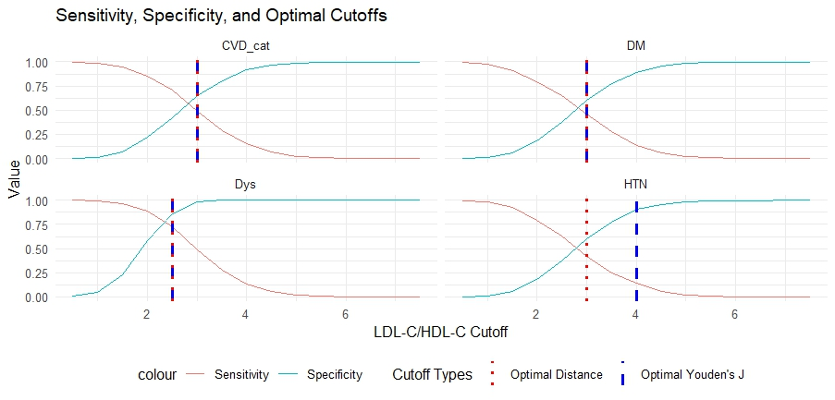
The X-axis represents the different levels of LDLc/HDLc ratio and the Y-axis represents the sensitivity and specificity values. CVD_cat- Cardiovascular disease combinations (presence of ≥2 conditions among diabetes, hypertension, and dyslipidemia), DM- Diabetes, Dys- Dyslipidemia, HTN- Hypertension. Optimal Distance corresponds to the Euclidean distance.

Supplementary Table 3: Association between age and abnormal TC with place of residence as an interaction term

Variable | Age |  | Sex |  | Diabetes |  | Hypertension |  | BMI |  | Physical Inactivity |  | Tobacco Use |  | Alcohol Use
Variable | OR | 95% CI | OR | 95% CI | OR | 95% CI | OR | 95% CI | OR | 95% CI | OR | 95% CI | OR | 95% CI | OR | 95% CI
Age | 1.01 | (1.0, 1.02) | 1.01 | (1.0, 1.02) | 1.01 | (1.0, 1.02) | 1.01 | (1.0, 1.02) | 1.01 | (1.0, 1.02) | 1.01 | (1.0, 1.02) | 1.01 | (1.0, 1.02) | 1.01 | (1.0, 1.02)
Place of Residence (Urban) | 12.9 | (1.84, 94.07) | 1.01 | (0.7, 1.45) | 1.81 | (1.32, 2.49) | 1.93 | (1.25, 2.97) | 10.75 | (2.92, 40.42) | 1 | (0.73, 1.37) | 1.01 | (0.75, 1.36) | 1.13 | (0.83, 1.53)
Sex (Female) | 2.2 | (1.86, 2.62) | 2.16 | (1.8, 2.59) | 2.2 | (1.85, 2.62) | 2.2 | (1.85, 2.62) | 2.22 | (1.87, 2.64) | 2.19 | (1.85, 2.61) | 2.2 | (1.85, 2.62) | 2.19 | (1.85, 2.61)
Diabetes | 1.09 | (0.9, 1.32) | 1.09 | (0.9, 1.33) | 1.49 | (1.2, 1.84) | 1.1 | (0.9, 1.33) | 1.08 | (0.89, 1.31) | 1.1 | (0.9, 1.33) | 1.09 | (0.9, 1.32) | 1.09 | (0.9, 1.32)
Hypertension | 1.12 | (0.94, 1.34) | 1.12 | (0.94, 1.34) | 1.12 | (0.94, 1.33) | 1.26 | (1.05, 1.52) | 1.11 | (0.93, 1.32) | 1.13 | (0.94, 1.34) | 1.13 | (0.94, 1.34) | 1.12 | (0.94, 1.34)
BMI | 1.04 | (1.02, 1.06) | 1.04 | (1.02, 1.06) | 1.04 | (1.02, 1.06) | 1.04 | (1.02, 1.06) | 1.06 | (1.03, 1.08) | 1.04 | (1.02, 1.06) | 1.04 | (1.02, 1.06) | 1.04 | (1.02, 1.06)
Physical Inactivity | 1.21 | (0.9, 1.63) | 1.19 | (0.88, 1.59) | 1.18 | (0.87, 1.59) | 1.15 | (0.85, 1.55) | 1.18 | (0.88, 1.59) | 1.03 | (0.65, 1.58) | 1.19 | (0.88, 1.6) | 1.17 | (0.86, 1.57)
Tobacco Smoking | 1.05 | (0.89, 1.25) | 1.08 | (0.91, 1.28) | 1.11 | (0.94, 1.32) | 1.08 | (0.91, 1.28) | 1.1 | (0.92, 1.3) | 1.08 | (0.91, 1.27) | 1.05 | (0.88, 1.25) | 1.08 | (0.91, 1.28)
Alcohol Use | 1.26 | (0.96, 1.64) | 1.23 | (0.94, 1.61) | 1.18 | (0.91, 1.54) | 1.21 | (0.93, 1.58) | 1.22 | (0.94, 1.59) | 1.24 | (0.95, 1.61) | 1.2 | (0.91, 1.57) | 1.3 | (0.96, 1.75)
(Risk factors) *Place of residence | 0.96 | (0.93, 0.99) | 1.11 | (0.72, 1.73) | 0.21 | (0.12, 0.34) | 0.43 | (0.27, 0.7) | 0.92 | (0.87, 0.96) | 1.3 | (0.72, 2.39) | 1.31 | (0.74, 2.28) | 0.81 | (0.48, 1.37)
OR: Odds Ratio, 95% CI: 95% Confidence Interval. For the categorical variables, the references are Rural (Place of residence), Male (Sex), Non-diabetic (Diabetes), Normotensive (Hypertension), Physically active, non-tobacco users, and non-alcohol users. Each column represents each risk factor. Each model for each specific risk factor was adjusted for all the other risk factors while including that risk factor as an interaction term.

Supplementary Figure 2: Forest plot depicting the interaction terms between the various risk factors and place of residence in association with abnormal TC
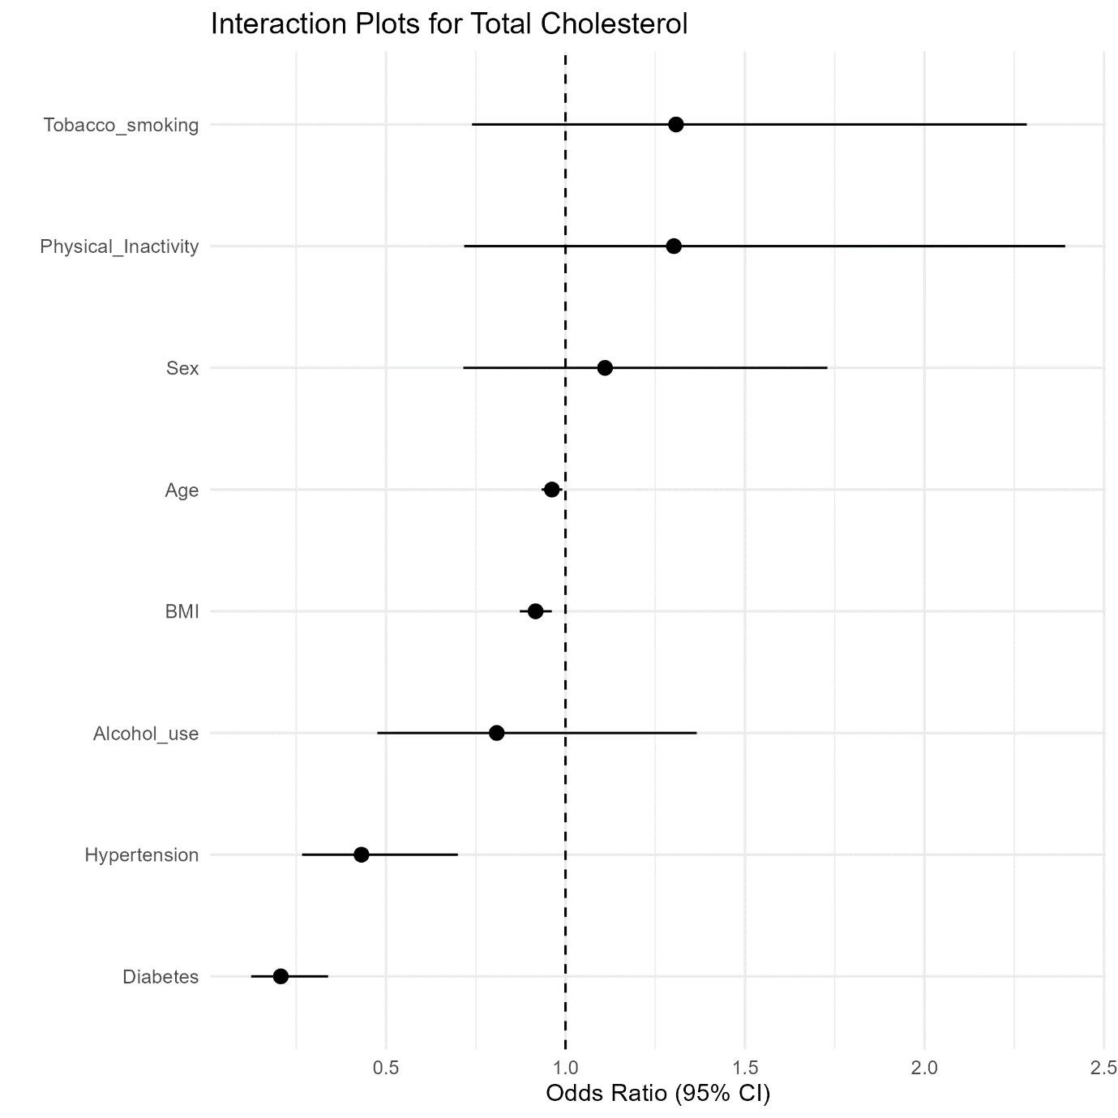
Supplementary Table 4: Association between age and abnormal TG with place of residence as an interaction term

Variable | Age |  | Sex |  | Diabetes |  | Hypertension |  | BMI |  | Physical Inactivity |  | Tobacco Use |  | Alcohol Use
Variable | OR | 95% CI | OR | 95% CI | OR | 95% CI | OR | 95% CI | OR | 95% CI | OR | 95% CI | OR | 95% CI | OR | 95% CI
Age | 1.01 | (1.0, 1.02) | 1 | (1.0, 1.01) | 1 | (1.0, 1.01) | 1 | (1.0, 1.01) | 1.01 | (1.0, 1.01) | 1 | (1.0, 1.01) | 1 | (1.0, 1.01) | 1.01 | (1.0, 1.01)
Place of Residence (Urban) | 1.95 | (0.26, 15.1) | 0.27 | (0.18, 0.38) | 0.43 | (0.31, 0.59) | 0.44 | (0.28, 0.69) | 3.52 | (0.9, 13.29) | 0.36 | (0.27, 0.5) | 0.37 | (0.27, 0.5) | 0.39 | (0.29, 0.54)
Sex (Female) | 1.1 | (0.94, 1.3) | 1.05 | (0.89, 1.24) | 1.1 | (0.94, 1.29) | 1.1 | (0.94, 1.29) | 1.11 | (0.95, 1.31) | 1.1 | (0.93, 1.29) | 1.09 | (0.93, 1.28) | 1.1 | (0.94, 1.29)
Diabetes | 2.35 | (1.96, 2.84) | 2.37 | (1.97, 2.86) | 2.69 | (2.18, 3.32) | 2.36 | (1.96, 2.85) | 2.32 | (1.93, 2.8) | 2.35 | (1.95, 2.83) | 2.37 | (1.96, 2.85) | 2.34 | (1.95, 2.83)
Hypertension | 0.95 | (0.8, 1.13) | 0.95 | (0.8, 1.13) | 0.95 | (0.81, 1.13) | 1 | (0.84, 1.19) | 0.95 | (0.8, 1.12) | 0.95 | (0.81, 1.13) | 0.95 | (0.81, 1.13) | 0.95 | (0.8, 1.12)
BMI | 1.14 | (1.12, 1.16) | 1.14 | (1.12, 1.16) | 1.14 | (1.11, 1.16) | 1.14 | (1.12, 1.16) | 1.16 | (1.13, 1.18) | 1.14 | (1.12, 1.16) | 1.14 | (1.12, 1.16) | 1.14 | (1.12, 1.16)
Physical Inactivity | 1.36 | (1.01, 1.83) | 1.35 | (1.0, 1.82) | 1.33 | (0.99, 1.79) | 1.32 | (0.98, 1.78) | 1.33 | (0.99, 1.78) | 1.65 | (1.08, 2.54) | 1.31 | (0.98, 1.77) | 1.29 | (0.95, 1.74)
Tobacco Smoking | 1.13 | (0.96, 1.33) | 1.16 | (0.99, 1.36) | 1.16 | (0.99, 1.37) | 1.15 | (0.98, 1.35) | 1.17 | (0.99, 1.37) | 1.15 | (0.97, 1.35) | 1.19 | (1.01, 1.4) | 1.15 | (0.98, 1.35)
Alcohol Use | 1.26 | (0.98, 1.61) | 1.27 | (0.99, 1.63) | 1.22 | (0.95, 1.56) | 1.23 | (0.96, 1.58) | 1.23 | (0.96, 1.58) | 1.22 | (0.96, 1.57) | 1.28 | (1.0, 1.64) | 1.44 | (1.09, 1.9)
(Risk factors) *Place of residence | 0.97 | (0.94, 1.0) | 1.58 | (1.01, 2.47) | 0.51 | (0.32, 0.81) | 0.67 | (0.41, 1.11) | 0.92 | (0.87, 0.96) | 0.66 | (0.36, 1.2) | 0.61 | (0.34, 1.08) | 0.53 | (0.31, 0.89)
OR: Odds Ratio, 95% CI: 95% Confidence Interval. For the categorical variables, the references are Rural (Place of residence), Male (Sex), Non-diabetic (Diabetes), Normotensive (Hypertension), Physically active, non-tobacco users, and non-alcohol users. Each column represents each risk factor. Each model for each specific risk factor was adjusted for all the other risk factors while including that risk factor as an interaction term.

Supplementary Figure 3: Forest plot depicting the interaction terms between the various risk factors and place of residence in association to abnormal TG
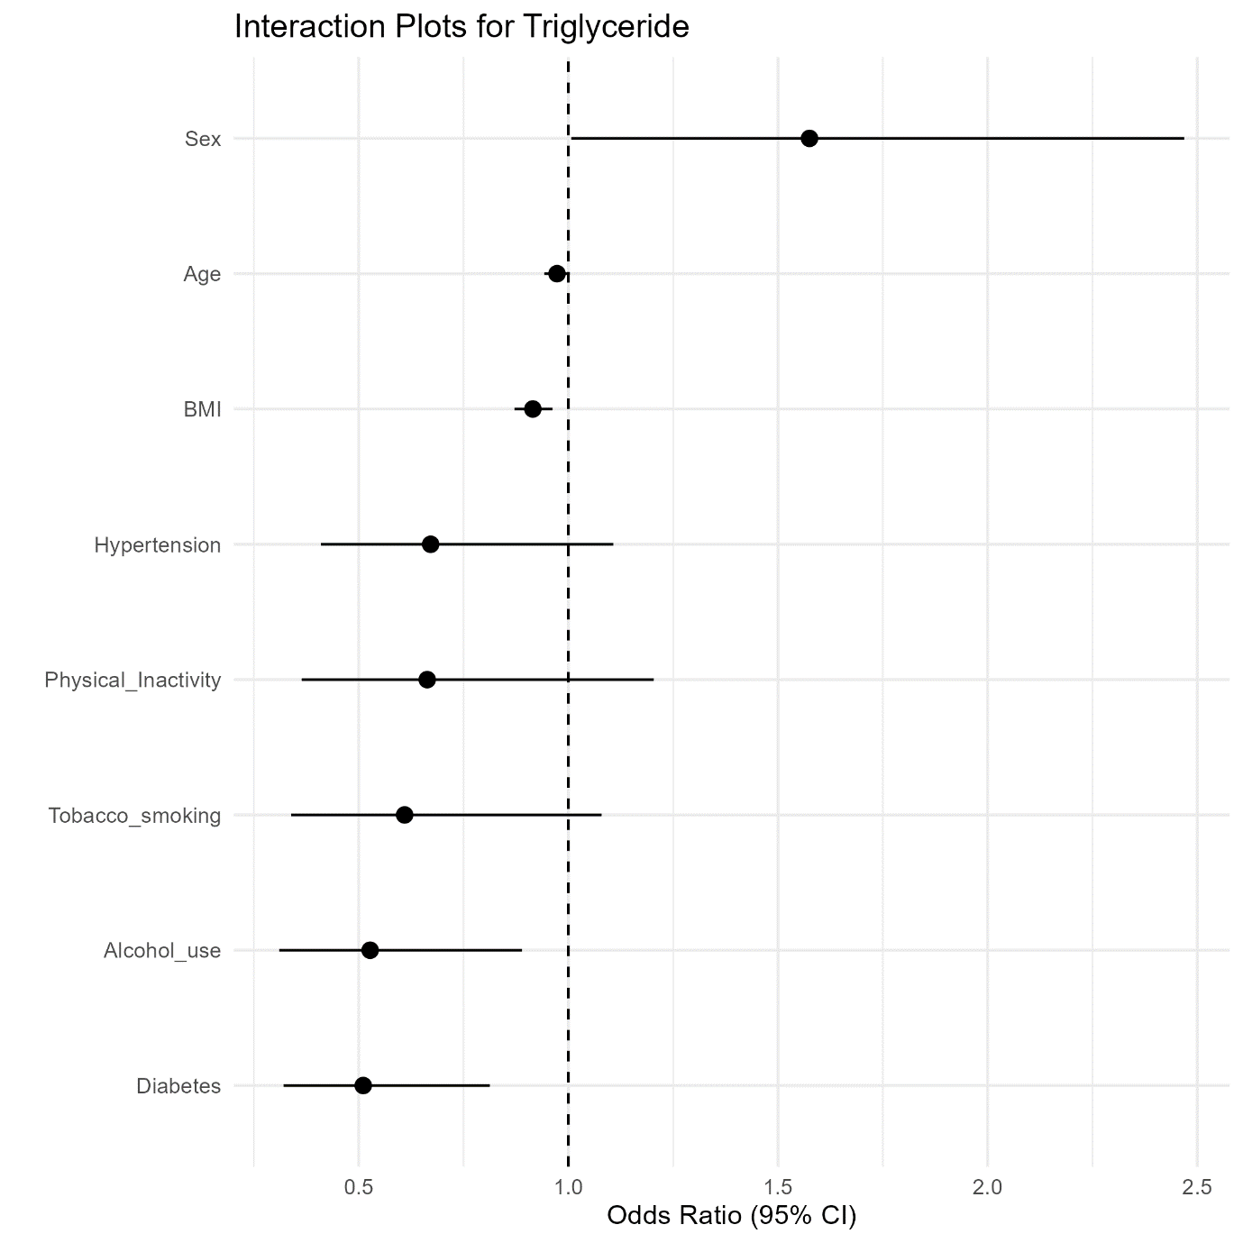
Supplementary Table 5: Association between age and abnormal LDL-c with place of residence as an interaction term

Variable | Age |  | Sex |  | Diabetes |  | Hypertension |  | BMI |  | Physical Inactivity |  | Tobacco Use |  | Alcohol Use
Variable | OR | 95% CI | OR | 95% CI | OR | 95% CI | OR | 95% CI | OR | 95% CI | OR | 95% CI | OR | 95% CI | OR | 95% CI
Age | 1.02 | (1.01, 1.03) | 1.01 | (1.0, 1.02) | 1.01 | (1.0, 1.02) | 1.01 | (1.0, 1.02) | 1.01 | (1.0, 1.02) | 1.01 | (1.0, 1.02) | 1.01 | (1.0, 1.02) | 1.01 | (1.0, 1.02)
Place of Residence (Urban) | 23.6 | (3.18, 183.83) | 1.11 | (0.77, 1.61) | 1.46 | (1.06, 2.02) | 1.71 | (1.1, 2.65) | 8.57 | (2.27, 32.99) | 0.96 | (0.69, 1.31) | 0.89 | (0.65, 1.21) | 0.97 | (0.71, 1.33)
Sex (Female) | 2.19 | (1.84, 2.62) | 2.23 | (1.85, 2.68) | 2.17 | (1.82, 2.59) | 2.18 | (1.83, 2.61) | 2.2 | (1.85, 2.63) | 2.18 | (1.83, 2.6) | 2.2 | (1.85, 2.63) | 2.17 | (1.82, 2.59)
Diabetes | 0.88 | (0.72, 1.08) | 0.88 | (0.72, 1.08) | 1.11 | (0.89, 1.38) | 0.89 | (0.72, 1.08) | 0.87 | (0.71, 1.07) | 0.89 | (0.72, 1.08) | 0.88 | (0.72, 1.07) | 0.88 | (0.72, 1.08)
Hypertension | 1.05 | (0.88, 1.26) | 1.06 | (0.88, 1.27) | 1.05 | (0.88, 1.26) | 1.17 | (0.97, 1.42) | 1.04 | (0.87, 1.25) | 1.06 | (0.88, 1.26) | 1.06 | (0.88, 1.27) | 1.06 | (0.88, 1.27)
BMI | 1.04 | (1.02, 1.06) | 1.04 | (1.02, 1.07) | 1.04 | (1.02, 1.06) | 1.04 | (1.02, 1.06) | 1.06 | (1.04, 1.08) | 1.04 | (1.02, 1.07) | 1.04 | (1.02, 1.07) | 1.04 | (1.02, 1.07)
Physical Inactivity | 1.18 | (0.87, 1.6) | 1.14 | (0.84, 1.54) | 1.14 | (0.84, 1.55) | 1.12 | (0.82, 1.52) | 1.15 | (0.84, 1.55) | 1.01 | (0.63, 1.57) | 1.17 | (0.86, 1.58) | 1.16 | (0.85, 1.56)
Tobacco Smoking | 1.01 | (0.85, 1.2) | 1.03 | (0.87, 1.22) | 1.06 | (0.89, 1.26) | 1.04 | (0.88, 1.24) | 1.05 | (0.88, 1.25) | 1.03 | (0.87, 1.23) | 0.98 | (0.82, 1.18) | 1.03 | (0.87, 1.23)
Alcohol Use | 1.17 | (0.89, 1.54) | 1.11 | (0.84, 1.47) | 1.1 | (0.83, 1.45) | 1.12 | (0.85, 1.47) | 1.13 | (0.85, 1.48) | 1.14 | (0.86, 1.5) | 1.07 | (0.8, 1.41) | 1.08 | (0.78, 1.48)
(Risk factors) *Place of residence | 0.95 | (0.92, 0.98) | 0.83 | (0.53, 1.3) | 0.32 | (0.19, 0.52) | 0.47 | (0.29, 0.77) | 0.92 | (0.88, 0.97) | 1.26 | (0.68, 2.35) | 1.88 | (1.06, 3.31) | 1.16 | (0.68, 2.0)
OR: Odds Ratio, 95% CI: 95% Confidence Interval. For the categorical variables, the references are Rural (Place of residence), Male (Sex), Non-diabetic (Diabetes), Normotensive (Hypertension), Physically active, non-tobacco users, and non-alcohol users. Each column represents each risk factor. Each model for each specific risk factor was adjusted for all the other risk factors while including that risk factor as an interaction term.

Supplementary Figure 4: Forest plot depicting the interaction terms between the various risk factors and place of residence in association to abnormal LDL-c
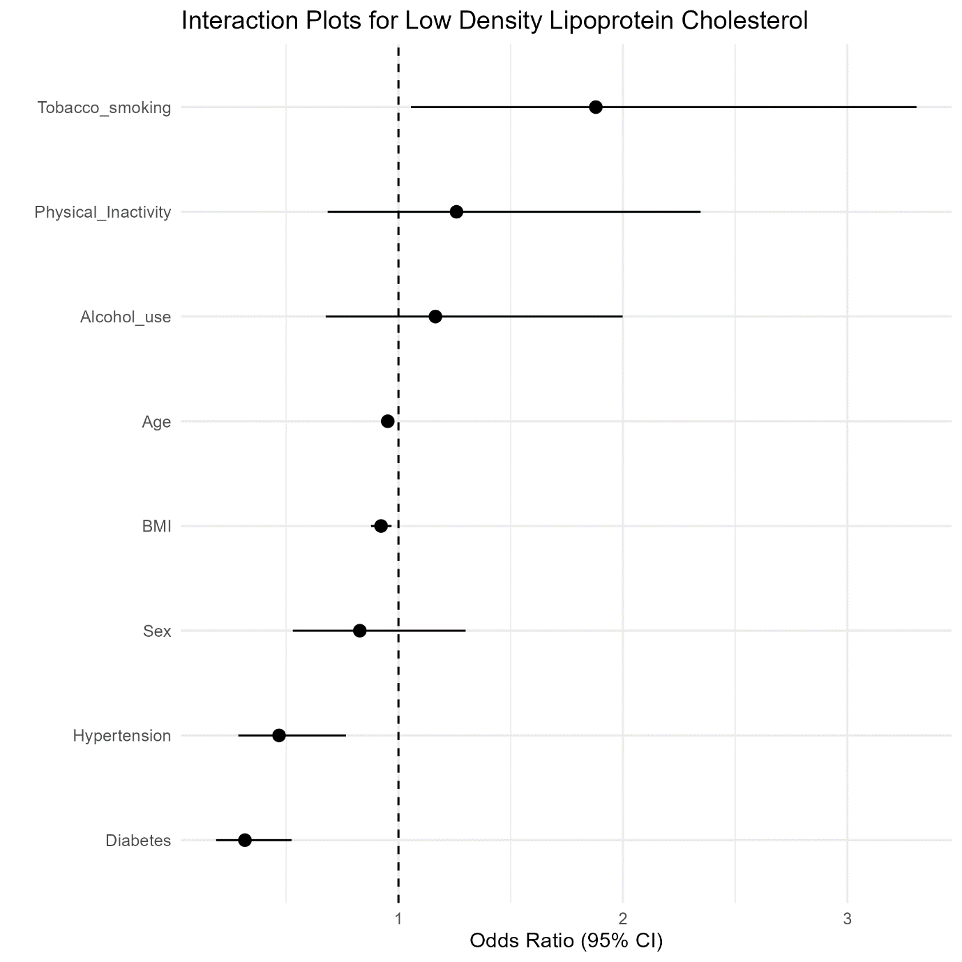
Supplementary Table 6: Association between age and abnormal HDLc with place of residence as an interaction term
Variable | Age |  | Sex |  | Diabetes |  | Hypertension |  | BMI |  | Physical Inactivity |  | Tobacco Use |  | Alcohol Use
Variable | OR | 95% CI | OR | 95% CI | OR | 95% CI | OR | 95% CI | OR | 95% CI | OR | 95% CI | OR | 95% CI | OR | 95% CI
Age | 1 | (0.99, 1.01) | 1 | (0.99, 1.01) | 1 | (0.99, 1.01) | 1 | (0.99, 1.01) | 1 | (0.99, 1.01) | 1 | (0.99, 1.01) | 1 | (0.99, 1.01) | 1 | (0.99, 1.01)
Place of Residence (Urban) | 0.17 | (0.03, 1.18) | 0.24 | (0.17, 0.34) | 0.2 | (0.14, 0.27) | 0.12 | (0.07, 0.19) | 0.53 | (0.13, 2.03) | 0.22 | (0.16, 0.3) | 0.22 | (0.16, 0.29) | 0.18 | (0.13, 0.25)
Sex (Female) | 1.52 | (1.28, 1.81) | 1.6 | (1.33, 1.92) | 1.52 | (1.28, 1.81) | 1.52 | (1.28, 1.81) | 1.53 | (1.29, 1.82) | 1.52 | (1.28, 1.8) | 1.51 | (1.28, 1.8) | 1.53 | (1.28, 1.81)
Diabetes | 1.47 | (1.2, 1.82) | 1.47 | (1.19, 1.8) | 1.43 | (1.13, 1.82) | 1.46 | (1.19, 1.8) | 1.46 | (1.19, 1.8) | 1.47 | (1.2, 1.81) | 1.48 | (1.2, 1.82) | 1.48 | (1.21, 1.82)
Hypertension | 0.81 | (0.67, 0.97) | 0.81 | (0.67, 0.97) | 0.81 | (0.67, 0.97) | 0.72 | (0.6, 0.88) | 0.8 | (0.67, 0.96) | 0.81 | (0.67, 0.96) | 0.81 | (0.67, 0.96) | 0.81 | (0.68, 0.97)
BMI | 1.11 | (1.09, 1.13) | 1.11 | (1.09, 1.14) | 1.11 | (1.09, 1.13) | 1.11 | (1.09, 1.14) | 1.12 | (1.09, 1.15) | 1.11 | (1.09, 1.13) | 1.11 | (1.09, 1.13) | 1.11 | (1.09, 1.13)
Physical Inactivity | 1.38 | (1.01, 1.89) | 1.36 | (1.0, 1.87) | 1.38 | (1.01, 1.89) | 1.42 | (1.04, 1.95) | 1.37 | (1.01, 1.88) | 1.68 | (1.02, 2.88) | 1.37 | (1.0, 1.87) | 1.42 | (1.04, 1.94)
Tobacco Smoking | 1.36 | (1.14, 1.62) | 1.34 | (1.13, 1.6) | 1.35 | (1.13, 1.61) | 1.35 | (1.13, 1.6) | 1.37 | (1.15, 1.63) | 1.35 | (1.14, 1.61) | 1.38 | (1.15, 1.66) | 1.35 | (1.14, 1.61)
Alcohol Use | 0.66 | (0.51, 0.85) | 0.65 | (0.51, 0.84) | 0.66 | (0.52, 0.85) | 0.67 | (0.52, 0.86) | 0.66 | (0.52, 0.85) | 0.66 | (0.51, 0.84) | 0.67 | (0.52, 0.87) | 0.6 | (0.45, 0.79)
(Risk factors) *Place of residence | 1 | (0.97, 1.03) | 0.71 | (0.46, 1.09) | 1.13 | (0.71, 1.81) | 2.17 | (1.32, 3.62) | 0.96 | (0.92, 1.02) | 0.73 | (0.37, 1.38) | 0.79 | (0.44, 1.39) | 1.48 | (0.89, 2.46)
OR: Odds Ratio, 95% CI: 95% Confidence Interval. For the categorical variables, the references are Rural (Place of residence), Male (Sex), Non-diabetic (Diabetes), Normotensive (Hypertension), Physically active, non-tobacco users, and non-alcohol users. Each column represents each risk factor. Each model for each specific risk factor was adjusted for all the other risk factors while including that risk factor as an interaction term.

Supplementary Figure 5: Forest plot depicting the interaction terms between the various risk factors and place of residence in association to TC/HDLc Ratio
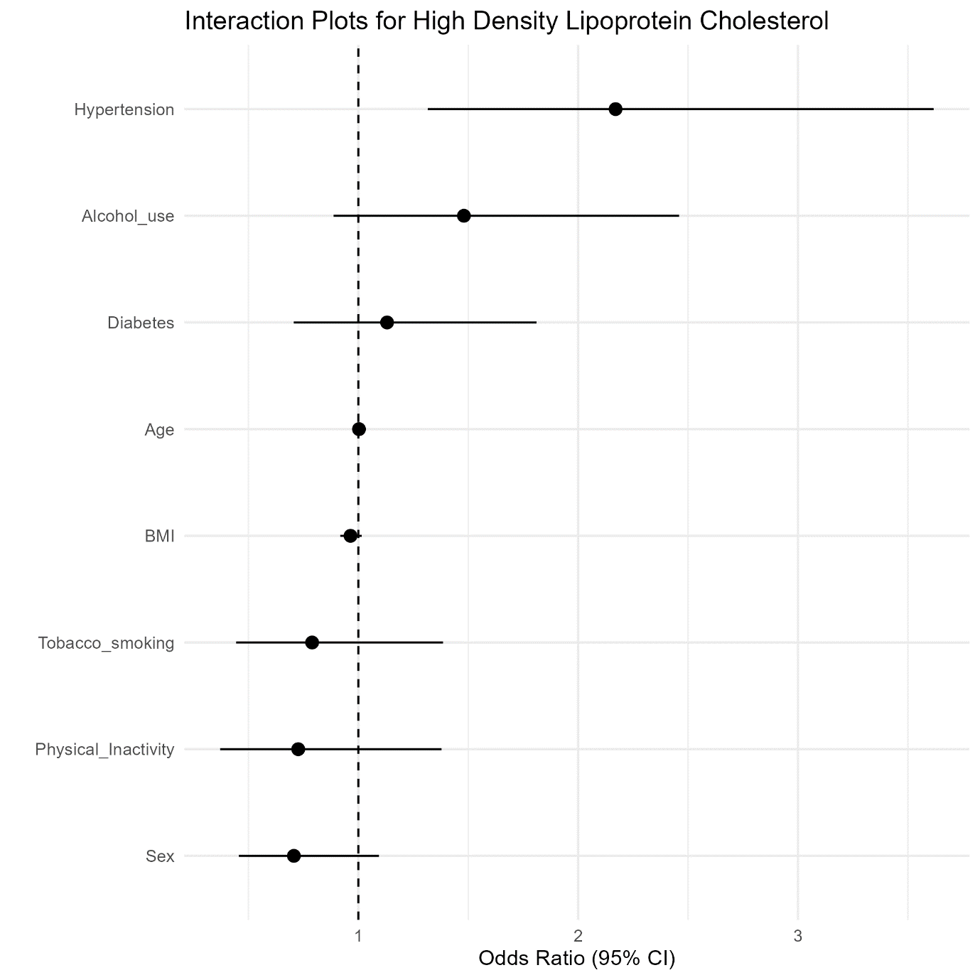
Supplementary Table 7: Association between age and Dyslipidemia with place of residence as an interaction term

Variable | Age |  | Sex |  | Diabetes |  | Hypertension |  | BMI |  | Physical Inactivity |  | Tobacco Use |  | Alcohol Use
Variable | OR | 95% CI | OR | 95% CI | OR | 95% CI | OR | 95% CI | OR | 95% CI | OR | 95% CI | OR | 95% CI | OR | 95% CI
Age | 1 | (0.99, 1.01) | 1 | (0.99, 1.01) | 1 | (0.99, 1.01) | 1 | (0.99, 1.01) | 1 | (0.99, 1.01) | 1 | (0.99, 1.01) | 1 | (0.99, 1.01) | 1 | (0.99, 1.01)
Place of Residence (Urban) | 1.2 | (0.14, 10.42) | 0.22 | (0.15, 0.32) | 0.29 | (0.2, 0.43) | 0.21 | (0.13, 0.35) | 3.62 | (0.73, 17.46) | 0.24 | (0.17, 0.35) | 0.26 | (0.18, 0.37) | 0.25 | (0.17, 0.36)
Sex (Female) | 1.85 | (1.49, 2.31) | 1.8 | (1.43, 2.29) | 1.84 | (1.48, 2.29) | 1.84 | (1.48, 2.3) | 1.88 | (1.51, 2.34) | 1.84 | (1.48, 2.29) | 1.82 | (1.46, 2.27) | 1.84 | (1.48, 2.29)
Diabetes | 1.52 | (1.17, 2.0) | 1.52 | (1.17, 2.0) | 1.98 | (1.42, 2.83) | 1.52 | (1.16, 1.99) | 1.48 | (1.14, 1.95) | 1.51 | (1.16, 1.99) | 1.54 | (1.18, 2.02) | 1.51 | (1.16, 1.99)
Hypertension | 0.79 | (0.63, 0.99) | 0.79 | (0.63, 0.99) | 0.79 | (0.63, 1.0) | 0.77 | (0.6, 0.99) | 0.79 | (0.63, 0.99) | 0.79 | (0.63, 0.99) | 0.79 | (0.63, 0.99) | 0.79 | (0.63, 0.99)
BMI | 1.14 | (1.11, 1.18) | 1.14 | (1.11, 1.18) | 1.14 | (1.11, 1.17) | 1.14 | (1.11, 1.18) | 1.18 | (1.14, 1.22) | 1.14 | (1.11, 1.18) | 1.15 | (1.11, 1.18) | 1.14 | (1.11, 1.18)
Physical Inactivity | 1.99 | (1.34, 3.01) | 1.95 | (1.32, 2.94) | 1.93 | (1.31, 2.89) | 1.95 | (1.32, 2.93) | 1.89 | (1.29, 2.82) | 3.14 | (1.39, 9.01) | 1.9 | (1.29, 2.86) | 1.9 | (1.28, 2.86)
Tobacco Smoking | 1.28 | (1.02, 1.59) | 1.3 | (1.05, 1.63) | 1.33 | (1.07, 1.66) | 1.3 | (1.04, 1.62) | 1.35 | (1.08, 1.68) | 1.3 | (1.04, 1.62) | 1.39 | (1.1, 1.75) | 1.3 | (1.05, 1.62)
Alcohol Use | 0.84 | (0.62, 1.14) | 0.83 | (0.62, 1.13) | 0.8 | (0.59, 1.09) | 0.83 | (0.61, 1.12) | 0.83 | (0.61, 1.12) | 0.82 | (0.61, 1.11) | 0.86 | (0.63, 1.17) | 0.9 | (0.63, 1.29)
(Risk factors) *Place of residence | 0.97 | (0.94, 1.01) | 1.14 | (0.68, 1.91) | 0.46 | (0.26, 0.81) | 1.15 | (0.65, 2.0) | 0.9 | (0.84, 0.95) | 0.53 | (0.17, 1.36) | 0.59 | (0.32, 1.08) | 0.77 | (0.43, 1.36)
OR: Odds Ratio, 95% CI: 95% Confidence Interval. For the categorical variables, the references are Rural (Place of residence), Male (Sex), Non-diabetic (Diabetes), Normotensive (Hypertension), Physically active, non-tobacco users, and non-alcohol users. Each column represents each risk factor. Each model for each specific risk factor was adjusted for all the other risk factors while including that risk factor as an interaction term.

Supplementary Figure 6: Forest plot depicting the interaction terms between the various risk factors and place of residence in association to Dyslipidemia

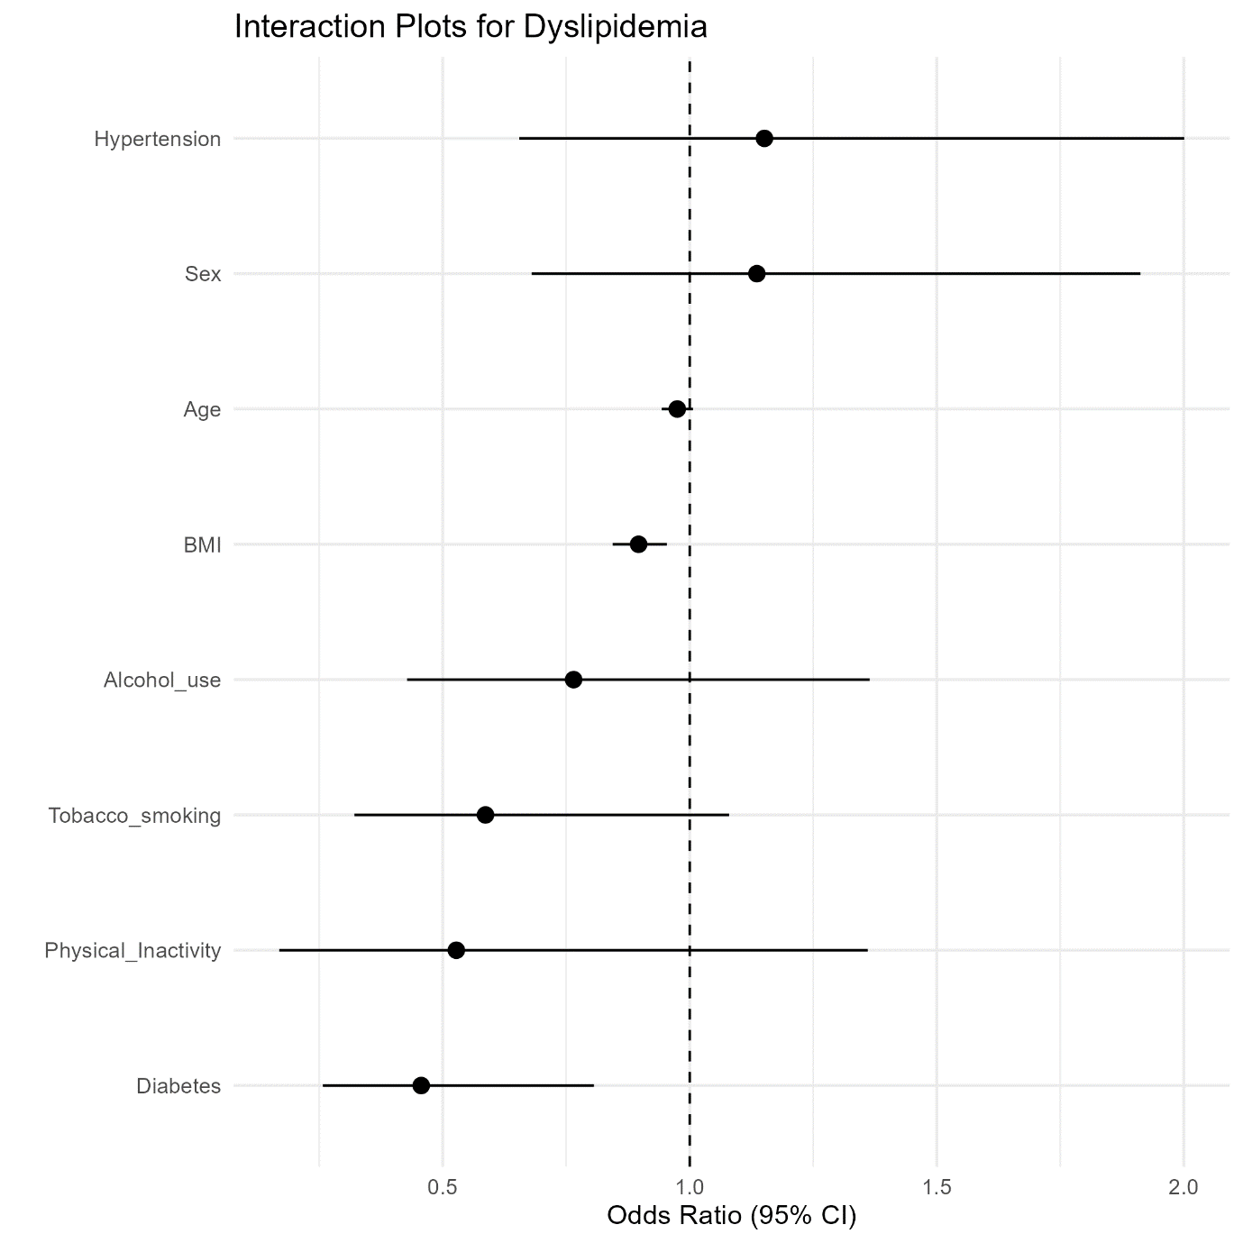

Supplementary Table 8: Association between age and abnormal TC/HDL Ratio with place of residence as an interaction term

Variable | Age |  | Sex |  | Diabetes |  | Hypertension |  | BMI |  | Physical Inactivity |  | Tobacco Use |  | Alcohol Use
Variable | OR | 95% CI | OR | 95% CI | OR | 95% CI | OR | 95% CI | OR | 95% CI | OR | 95% CI | OR | 95% CI | OR | 95% CI
Age | 1 | (0.99, 1.01) | 1 | (0.99, 1.01) | 1 | (0.99, 1.01) | 1 | (0.99, 1.01) | 1 | (0.99, 1.01) | 1 | (0.99, 1.01) | 1 | (0.99, 1.01) | 1 | (0.99, 1.01)
Place of Residence (Urban) | 1.25 | (0.18, 9.28) | 0.38 | (0.27, 0.54) | 0.46 | (0.33, 0.63) | 0.53 | (0.34, 0.81) | 19.39 | (5.29, 71.67) | 0.33 | (0.24, 0.45) | 0.3 | (0.22, 0.4) | 0.29 | (0.21, 0.4)
Sex (Female) | 0.76 | (0.65, 0.89) | 0.8 | (0.68, 0.94) | 0.76 | (0.65, 0.89) | 0.76 | (0.65, 0.89) | 0.77 | (0.66, 0.91) | 0.76 | (0.65, 0.89) | 0.76 | (0.65, 0.89) | 0.76 | (0.65, 0.89)
Diabetes | 1.51 | (1.26, 1.82) | 1.51 | (1.25, 1.82) | 1.85 | (1.5, 2.29) | 1.53 | (1.27, 1.84) | 1.48 | (1.23, 1.78) | 1.51 | (1.26, 1.82) | 1.51 | (1.26, 1.82) | 1.52 | (1.26, 1.83)
Hypertension | 0.91 | (0.77, 1.08) | 0.92 | (0.77, 1.08) | 0.91 | (0.77, 1.08) | 1 | (0.84, 1.19) | 0.9 | (0.76, 1.06) | 0.91 | (0.77, 1.08) | 0.91 | (0.77, 1.08) | 0.92 | (0.78, 1.08)
BMI | 1.13 | (1.11, 1.15) | 1.13 | (1.11, 1.15) | 1.13 | (1.11, 1.15) | 1.13 | (1.11, 1.15) | 1.16 | (1.14, 1.19) | 1.13 | (1.11, 1.15) | 1.13 | (1.11, 1.15) | 1.13 | (1.11, 1.15)
Physical Inactivity | 1.17 | (0.87, 1.57) | 1.15 | (0.85, 1.54) | 1.15 | (0.86, 1.55) | 1.13 | (0.84, 1.52) | 1.15 | (0.86, 1.54) | 1.3 | (0.86, 2.0) | 1.17 | (0.87, 1.57) | 1.18 | (0.88, 1.58)
Tobacco Smoking | 1.23 | (1.05, 1.44) | 1.23 | (1.05, 1.44) | 1.26 | (1.08, 1.48) | 1.25 | (1.06, 1.46) | 1.28 | (1.09, 1.5) | 1.24 | (1.06, 1.45) | 1.22 | (1.03, 1.43) | 1.24 | (1.05, 1.45)
Alcohol Use | 0.94 | (0.74, 1.2) | 0.9 | (0.71, 1.15) | 0.91 | (0.71, 1.16) | 0.92 | (0.72, 1.17) | 0.92 | (0.72, 1.17) | 0.92 | (0.72, 1.17) | 0.91 | (0.71, 1.17) | 0.87 | (0.66, 1.14)
(Risk factors) *Place of residence | 0.98 | (0.95, 1.01) | 0.65 | (0.41, 1.01) | 0.35 | (0.22, 0.57) | 0.48 | (0.29, 0.77) | 0.86 | (0.82, 0.9) | 0.79 | (0.44, 1.43) | 1.25 | (0.72, 2.17) | 1.32 | (0.8, 2.2)
OR: Odds Ratio, 95% CI: 95% Confidence Interval. For the categorical variables, the references are Rural (Place of residence), Male (Sex), Non-diabetic (Diabetes), Normotensive (Hypertension), Physically active, non-tobacco users, and non-alcohol users. Each column represents each risk factor. Each model for each specific risk factor was adjusted for all the other risk factors while including that risk factor as an interaction term.

Supplementary Figure 7: Forest plot depicting the interaction terms between the various risk factors and place of residence in association with abnormal TC/HDLc Ratio
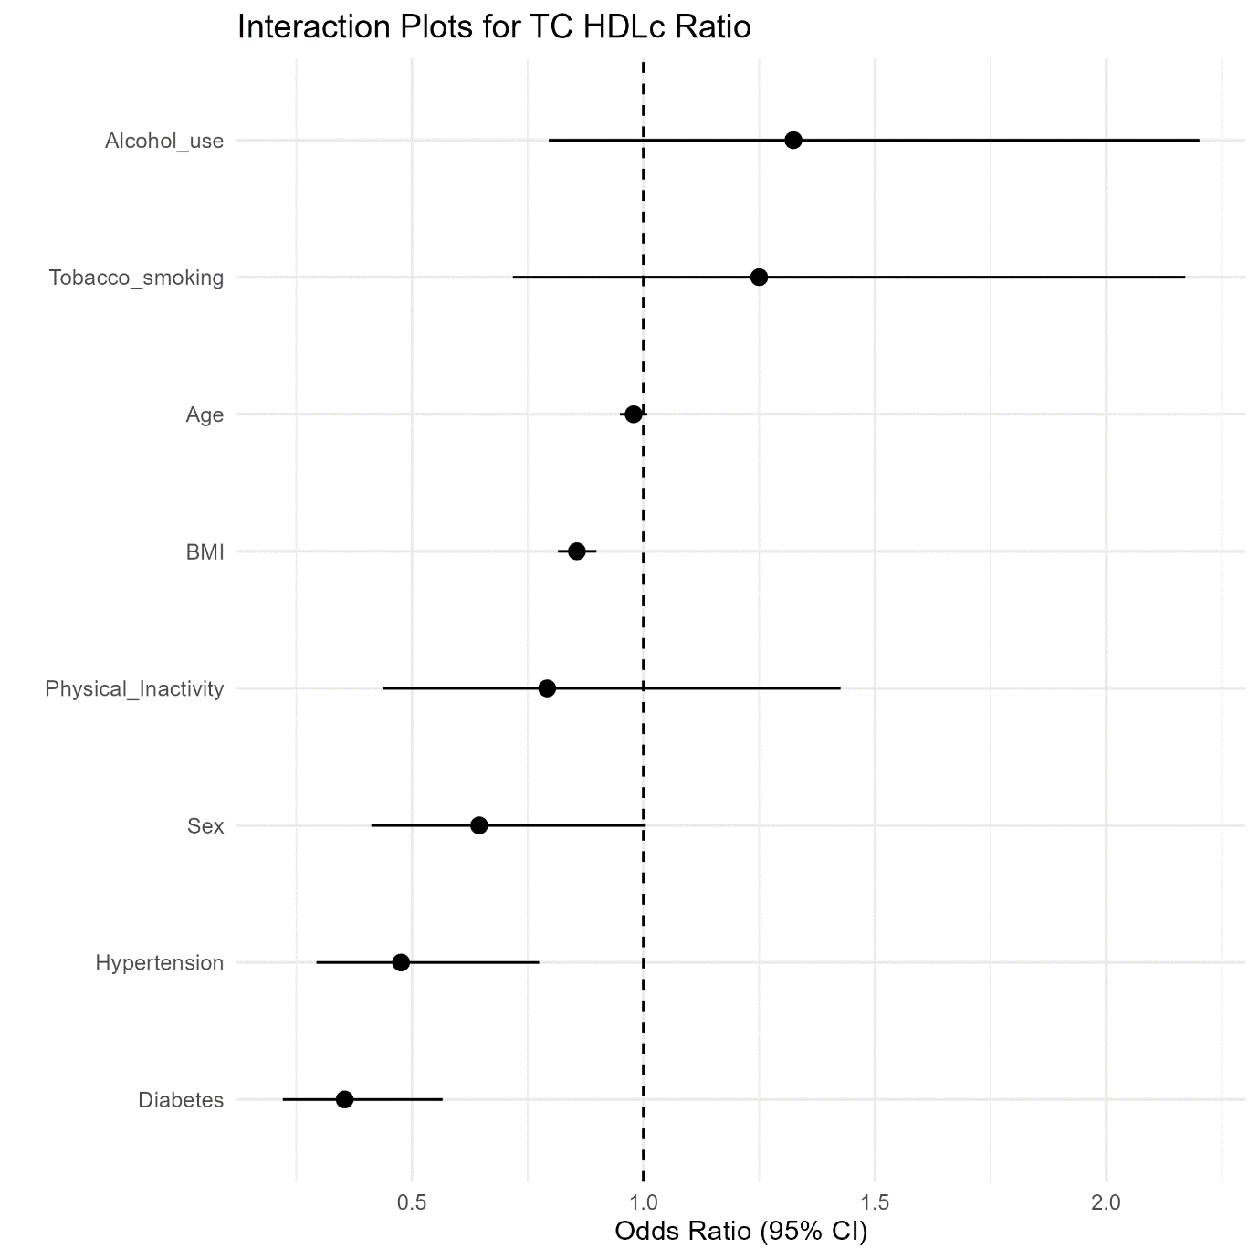
Supplementary Table 9: Association between age and abnormal TG/HDLc ratio with place of residence as an interaction term

Variable | Age |  | Sex |  | Diabetes |  | Hypertension |  | BMI |  | Physical Inactivity |  | Tobacco Use |  | Alcohol Use
Variable | OR | 95% CI | OR | 95% CI | OR | 95% CI | OR | 95% CI | OR | 95% CI | OR | 95% CI | OR | 95% CI | OR | 95% CI
Age | 1 | (0.99, 1.01) | 1 | (0.99, 1.01) | 1 | (0.99, 1.01) | 1 | (0.99, 1.01) | 1 | (0.99, 1.01) | 1 | (0.99, 1.01) | 1 | (0.99, 1.01) | 1 | (0.99, 1.01)
Place of Residence (Urban) | 1.66 | (0.17, 17.25) | 0.2 | (0.13, 0.29) | 0.26 | (0.18, 0.37) | 0.27 | (0.16, 0.43) | 4.18 | (0.99, 17.23) | 0.25 | (0.18, 0.35) | 0.21 | (0.15, 0.29) | 0.21 | (0.15, 0.29)
Sex (Female) | 1.3 | (1.11, 1.54) | 1.29 | (1.09, 1.53) | 1.3 | (1.1, 1.53) | 1.3 | (1.1, 1.53) | 1.32 | (1.12, 1.56) | 1.29 | (1.1, 1.52) | 1.3 | (1.1, 1.53) | 1.3 | (1.1, 1.53)
Diabetes | 2.39 | (1.98, 2.89) | 2.38 | (1.98, 2.88) | 2.64 | (2.14, 3.25) | 2.39 | (1.98, 2.89) | 2.35 | (1.95, 2.84) | 2.38 | (1.97, 2.87) | 2.38 | (1.98, 2.88) | 2.38 | (1.97, 2.88)
Hypertension | 0.95 | (0.8, 1.13) | 0.96 | (0.8, 1.14) | 0.95 | (0.8, 1.14) | 0.99 | (0.83, 1.19) | 0.94 | (0.79, 1.12) | 0.95 | (0.8, 1.13) | 0.96 | (0.8, 1.14) | 0.95 | (0.8, 1.13)
BMI | 1.15 | (1.13, 1.17) | 1.15 | (1.13, 1.17) | 1.15 | (1.13, 1.17) | 1.15 | (1.13, 1.17) | 1.17 | (1.15, 1.2) | 1.15 | (1.13, 1.18) | 1.15 | (1.13, 1.18) | 1.15 | (1.13, 1.18)
Physical Inactivity | 1.44 | (1.06, 1.98) | 1.42 | (1.04, 1.94) | 1.41 | (1.03, 1.93) | 1.4 | (1.03, 1.92) | 1.41 | (1.04, 1.92) | 2.12 | (1.38, 3.28) | 1.41 | (1.03, 1.93) | 1.41 | (1.03, 1.93)
Tobacco Smoking | 1.1 | (0.94, 1.3) | 1.12 | (0.95, 1.32) | 1.13 | (0.96, 1.33) | 1.12 | (0.95, 1.32) | 1.14 | (0.97, 1.35) | 1.11 | (0.94, 1.31) | 1.12 | (0.95, 1.33) | 1.12 | (0.95, 1.32)
Alcohol Use | 1.07 | (0.83, 1.38) | 1.06 | (0.82, 1.36) | 1.04 | (0.81, 1.35) | 1.05 | (0.81, 1.35) | 1.05 | (0.81, 1.36) | 1.03 | (0.8, 1.33) | 1.06 | (0.82, 1.37) | 1.08 | (0.81, 1.43)
(Risk factors) *Place of residence | 0.97 | (0.93, 1.0) | 1.05 | (0.65, 1.72) | 0.54 | (0.33, 0.9) | 0.68 | (0.39, 1.18) | 0.89 | (0.85, 0.94) | 0.41 | (0.22, 0.78) | 0.9 | (0.47, 1.68) | 0.89 | (0.5, 1.57)
OR: Odds Ratio, 95% CI: 95% Confidence Interval. For the categorical variables, the references are Rural (Place of residence), Male (Sex), Non-diabetic (Diabetes), Normotensive (Hypertension), Physically active, non-tobacco users, and non-alcohol users. Each column represents each risk factor. Each model for each specific risk factor was adjusted for all the other risk factors while including that risk factor as an interaction term.

Supplementary Figure 8: Forest plot depicting the interaction terms between the various risk factors and place of residence in association to abnormal TG/HDLc ratio
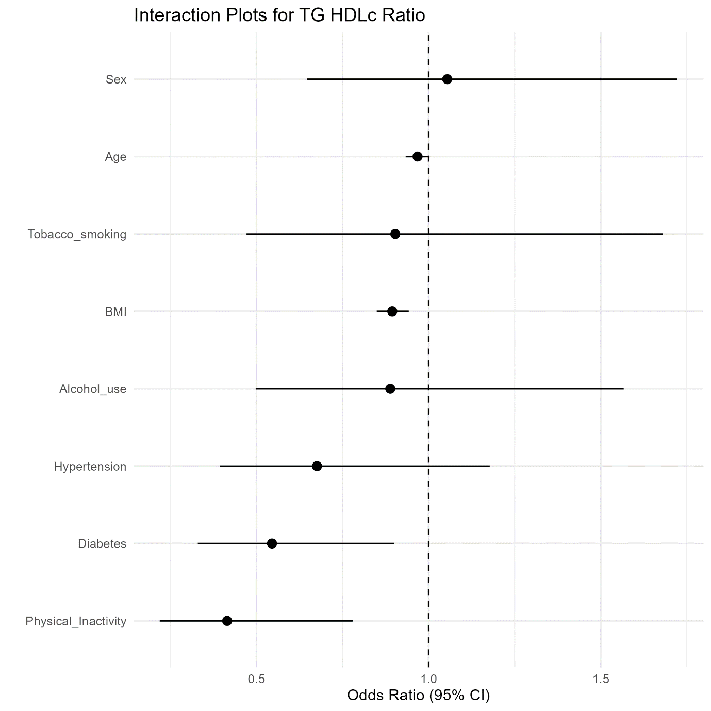

Supplementary Table 10: Association between age and abnormal LDL-c/HDL-c Ratio with place of residence as an interaction term

Variable | Age |  | Sex |  | Diabetes |  | Hypertension |  | BMI |  | Physical Inactivity |  | Tobacco Use |  | Alcohol Use
Variable | OR | 95% CI | OR | 95% CI | OR | 95% CI | OR | 95% CI | OR | 95% CI | OR | 95% CI | OR | 95% CI | OR | 95% CI
Age | 1.01 | (1.0, 1.02) | 1.01 | (1.0, 1.02) | 1.01 | (1.0, 1.02) | 1.01 | (1.0, 1.02) | 1.01 | (1.0, 1.02) | 1.01 | (1.0, 1.02) | 1.01 | (1.0, 1.02) | 1.01 | (1.0, 1.02)
Place of Residence (Urban) | 3.44 | (0.46, 26.69) | 0.57 | (0.41, 0.8) | 0.62 | (0.45, 0.85) | 0.63 | (0.4, 0.97) | 10.07 | (2.7, 37.97) | 0.44 | (0.32, 0.6) | 0.39 | (0.28, 0.52) | 0.34 | (0.24, 0.46)
Sex (Female) | 0.92 | (0.78, 1.07) | 0.98 | (0.83, 1.15) | 0.91 | (0.78, 1.06) | 0.91 | (0.78, 1.07) | 0.93 | (0.79, 1.08) | 0.91 | (0.78, 1.07) | 0.92 | (0.79, 1.08) | 0.91 | (0.78, 1.07)
Diabetes | 1.17 | (0.97, 1.4) | 1.16 | (0.97, 1.39) | 1.4 | (1.15, 1.71) | 1.17 | (0.98, 1.4) | 1.15 | (0.96, 1.38) | 1.17 | (0.97, 1.4) | 1.16 | (0.97, 1.39) | 1.18 | (0.98, 1.41)
Hypertension | 0.94 | (0.79, 1.1) | 0.94 | (0.8, 1.11) | 0.94 | (0.79, 1.11) | 1 | (0.84, 1.19) | 0.93 | (0.78, 1.09) | 0.94 | (0.8, 1.11) | 0.94 | (0.8, 1.11) | 0.95 | (0.8, 1.12)
BMI | 1.11 | (1.09, 1.13) | 1.11 | (1.09, 1.13) | 1.11 | (1.08, 1.13) | 1.11 | (1.09, 1.13) | 1.13 | (1.11, 1.15) | 1.11 | (1.09, 1.13) | 1.11 | (1.09, 1.13) | 1.11 | (1.09, 1.13)
Physical Inactivity | 1.08 | (0.8, 1.44) | 1.04 | (0.78, 1.4) | 1.05 | (0.78, 1.41) | 1.04 | (0.77, 1.39) | 1.05 | (0.79, 1.41) | 1.16 | (0.77, 1.74) | 1.07 | (0.8, 1.44) | 1.11 | (0.83, 1.49)
Tobacco Smoking | 1.21 | (1.03, 1.42) | 1.21 | (1.03, 1.42) | 1.25 | (1.07, 1.47) | 1.23 | (1.05, 1.44) | 1.26 | (1.07, 1.48) | 1.23 | (1.05, 1.44) | 1.19 | (1.02, 1.4) | 1.22 | (1.05, 1.43)
Alcohol Use | 1 | (0.79, 1.27) | 0.95 | (0.74, 1.2) | 0.96 | (0.75, 1.22) | 0.97 | (0.77, 1.24) | 0.97 | (0.77, 1.24) | 0.98 | (0.77, 1.24) | 0.95 | (0.75, 1.22) | 0.82 | (0.63, 1.07)
(Risk factors) *Place of residence | 0.97 | (0.94, 1.0) | 0.51 | (0.32, 0.8) | 0.34 | (0.21, 0.55) | 0.57 | (0.35, 0.94) | 0.89 | (0.85, 0.93) | 0.83 | (0.46, 1.49) | 1.5 | (0.86, 2.6) | 2.15 | (1.29, 3.58)
OR: Odds Ratio, 95% CI: 95% Confidence Interval. For the categorical variables, the references are Rural (Place of residence), Male (Sex), Non-diabetic (Diabetes), Normotensive (Hypertension), Physically active, non-tobacco users, and non-alcohol users. Each column represents each risk factor. Each model for each specific risk factor was adjusted for all the other risk factors while including that risk factor as an interaction term.

Supplementary Figure 9: Forest plot depicting the interaction terms between the various risk factors and place of residence in association with abnormal LDL-c/HDL-c Ratio
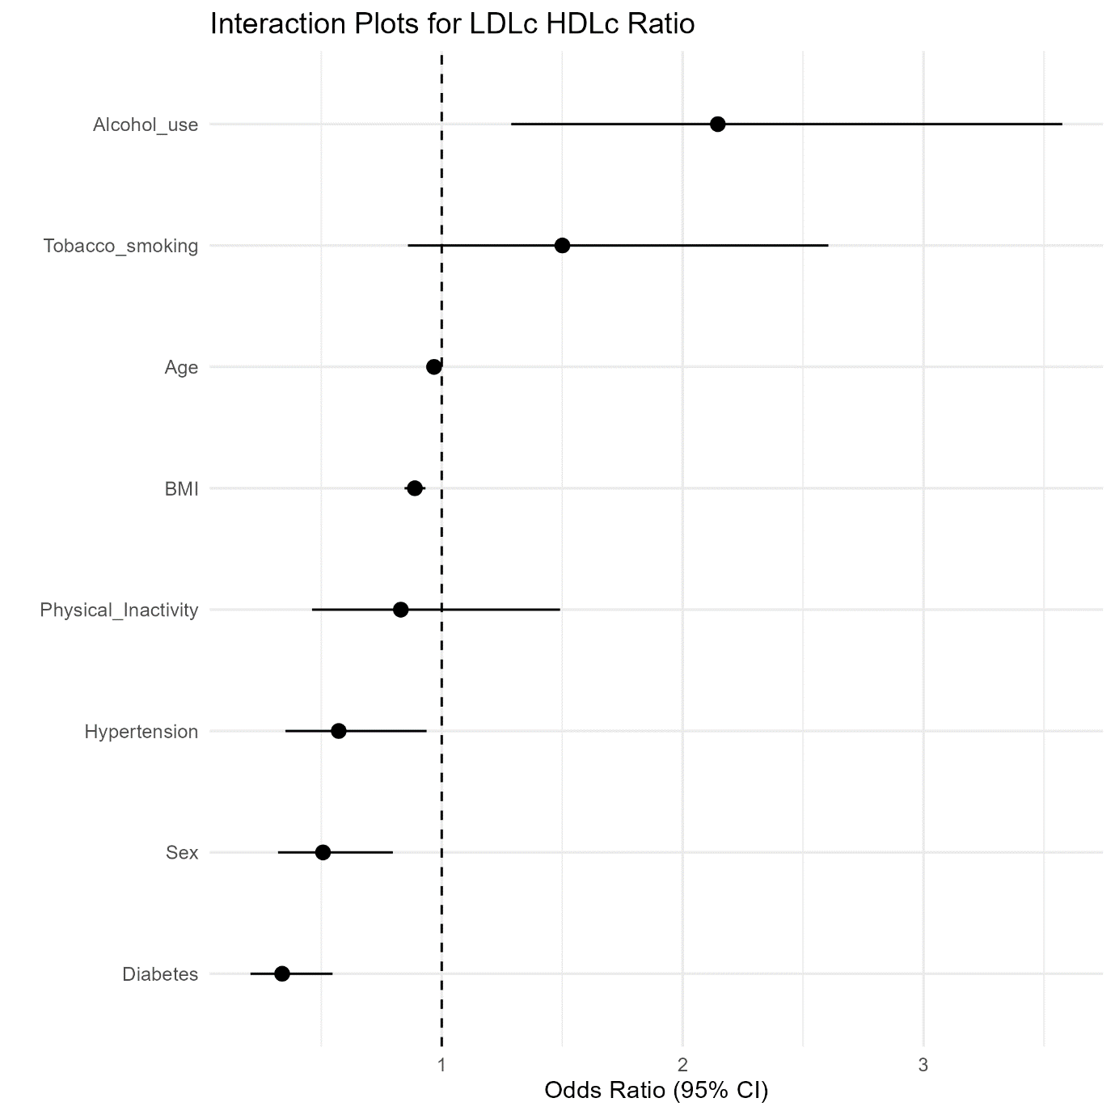
Supplementary Table 11: Association between age and abnormal non-HDLc with place of residence as an interaction term

Variable | Age |  | Sex |  | Diabetes |  | Hypertension |  | BMI |  | Physical Inactivity |  | Tobacco Use |  | Alcohol Use
Variable | OR | 95% CI | OR | 95% CI | OR | 95% CI | OR | 95% CI | OR | 95% CI | OR | 95% CI | OR | 95% CI | OR | 95% CI
Age | 1.02 | (1.01, 1.02) | 1.01 | (1.0, 1.02) | 1.01 | (1.0, 1.02) | 1.01 | (1.0, 1.02) | 1.01 | (1.0, 1.02) | 1.01 | (1.0, 1.02) | 1.01 | (1.0, 1.02) | 1.01 | (1.0, 1.02)
Place of Residence (Urban) | 8.89 | (1.37, 60.14) | 0.6 | (0.43, 0.84) | 1.12 | (0.81, 1.56) | 1.05 | (0.68, 1.66) | 8.24 | (2.3, 29.38) | 0.58 | (0.43, 0.79) | 0.56 | (0.42, 0.75) | 0.64 | (0.47, 0.87)
Sex (Female) | 1.78 | (1.52, 2.08) | 1.78 | (1.51, 2.1) | 1.77 | (1.51, 2.07) | 1.77 | (1.52, 2.08) | 1.79 | (1.53, 2.1) | 1.77 | (1.51, 2.07) | 1.77 | (1.52, 2.07) | 1.76 | (1.51, 2.06)
Diabetes | 1.11 | (0.92, 1.33) | 1.11 | (0.93, 1.34) | 1.58 | (1.28, 1.95) | 1.12 | (0.93, 1.35) | 1.1 | (0.91, 1.32) | 1.11 | (0.93, 1.34) | 1.11 | (0.92, 1.33) | 1.11 | (0.92, 1.33)
Hypertension | 1 | (0.85, 1.18) | 1.01 | (0.85, 1.19) | 1 | (0.85, 1.19) | 1.11 | (0.93, 1.33) | 0.99 | (0.84, 1.17) | 1.01 | (0.85, 1.19) | 1.01 | (0.85, 1.19) | 1 | (0.85, 1.18)
BMI | 1.08 | (1.06, 1.1) | 1.08 | (1.06, 1.1) | 1.08 | (1.06, 1.1) | 1.08 | (1.06, 1.1) | 1.1 | (1.08, 1.12) | 1.08 | (1.06, 1.1) | 1.08 | (1.06, 1.1) | 1.08 | (1.06, 1.1)
Physical Inactivity | 1.16 | (0.87, 1.56) | 1.13 | (0.85, 1.52) | 1.13 | (0.84, 1.53) | 1.11 | (0.83, 1.48) | 1.13 | (0.85, 1.51) | 1.11 | (0.74, 1.7) | 1.14 | (0.86, 1.53) | 1.11 | (0.83, 1.49)
Tobacco Smoking | 1 | (0.85, 1.17) | 1.02 | (0.87, 1.19) | 1.05 | (0.9, 1.24) | 1.02 | (0.88, 1.2) | 1.04 | (0.89, 1.22) | 1.02 | (0.87, 1.19) | 1 | (0.85, 1.18) | 1.02 | (0.87, 1.19)
Alcohol Use | 1.13 | (0.89, 1.43) | 1.1 | (0.87, 1.39) | 1.05 | (0.83, 1.34) | 1.09 | (0.86, 1.38) | 1.1 | (0.87, 1.39) | 1.1 | (0.87, 1.4) | 1.08 | (0.85, 1.38) | 1.18 | (0.91, 1.54)
(Risk factors) *Place of residence | 0.96 | (0.93, 0.99) | 0.95 | (0.62, 1.45) | 0.18 | (0.11, 0.28) | 0.44 | (0.27, 0.72) | 0.9 | (0.86, 0.95) | 1.04 | (0.58, 1.85) | 1.23 | (0.72, 2.12) | 0.75 | (0.46, 1.23)
OR: Odds Ratio, 95% CI: 95% Confidence Interval. For the categorical variables, the references are Rural (Place of residence), Male (Sex), Non-diabetic (Diabetes), Normotensive (Hypertension), Physically active, non-tobacco users, and non-alcohol users. Each column represents each risk factor. Each model for each specific risk factor was adjusted for all the other risk factors while including that risk factor as an interaction term.

Supplementary Figure 10: Forest plot depicting the interaction terms between the various risk factors and place of residence in association with abnormal non-HDLc
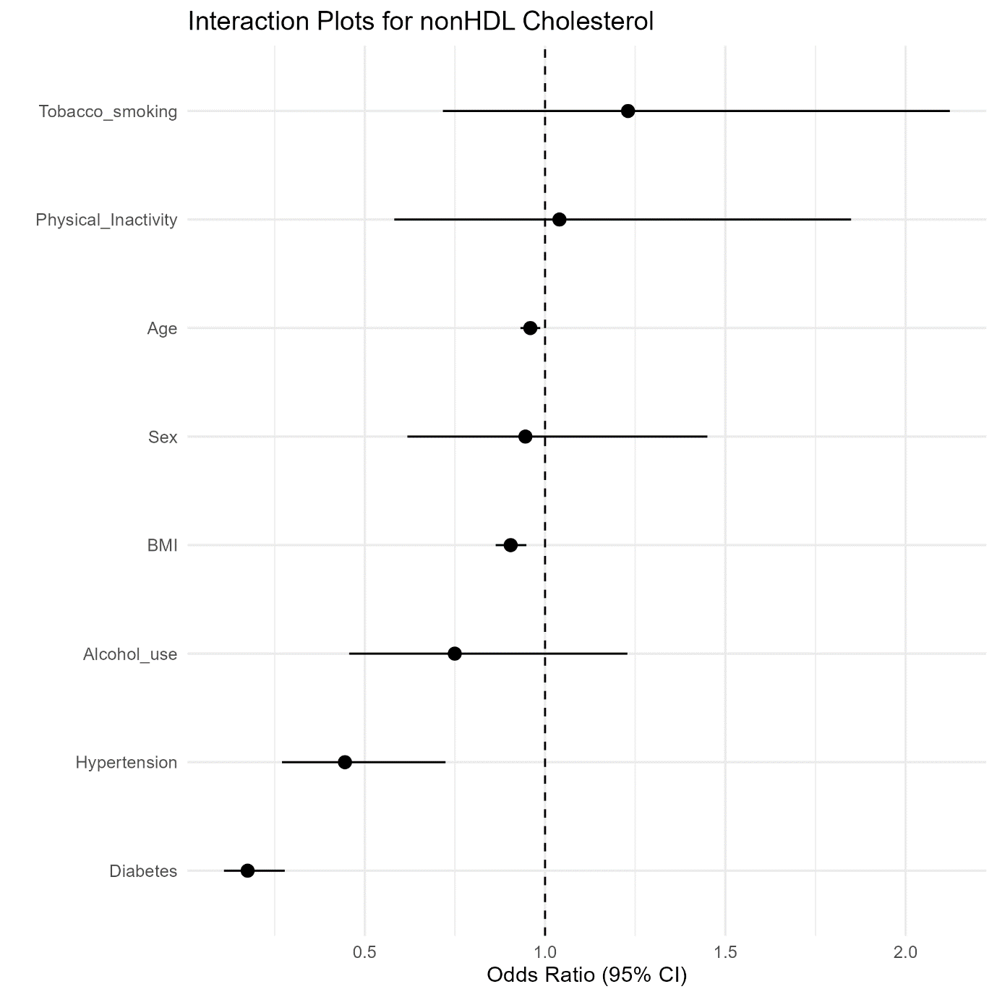
Supplementary figure 11: Association between various risk factors and TC/HDLc ratio

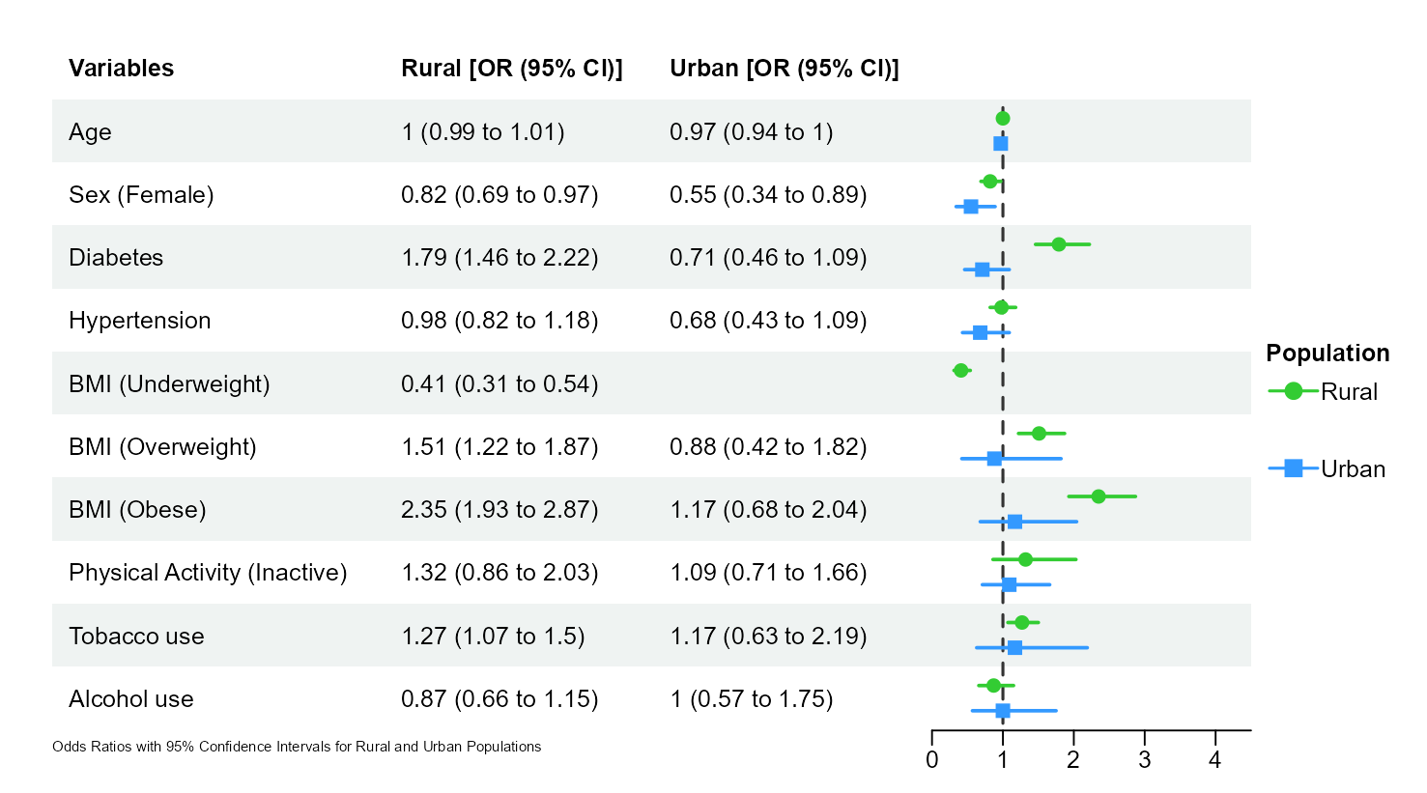

Supplementary figure 12: Association between various risk factors and TG/HDL-c ratio
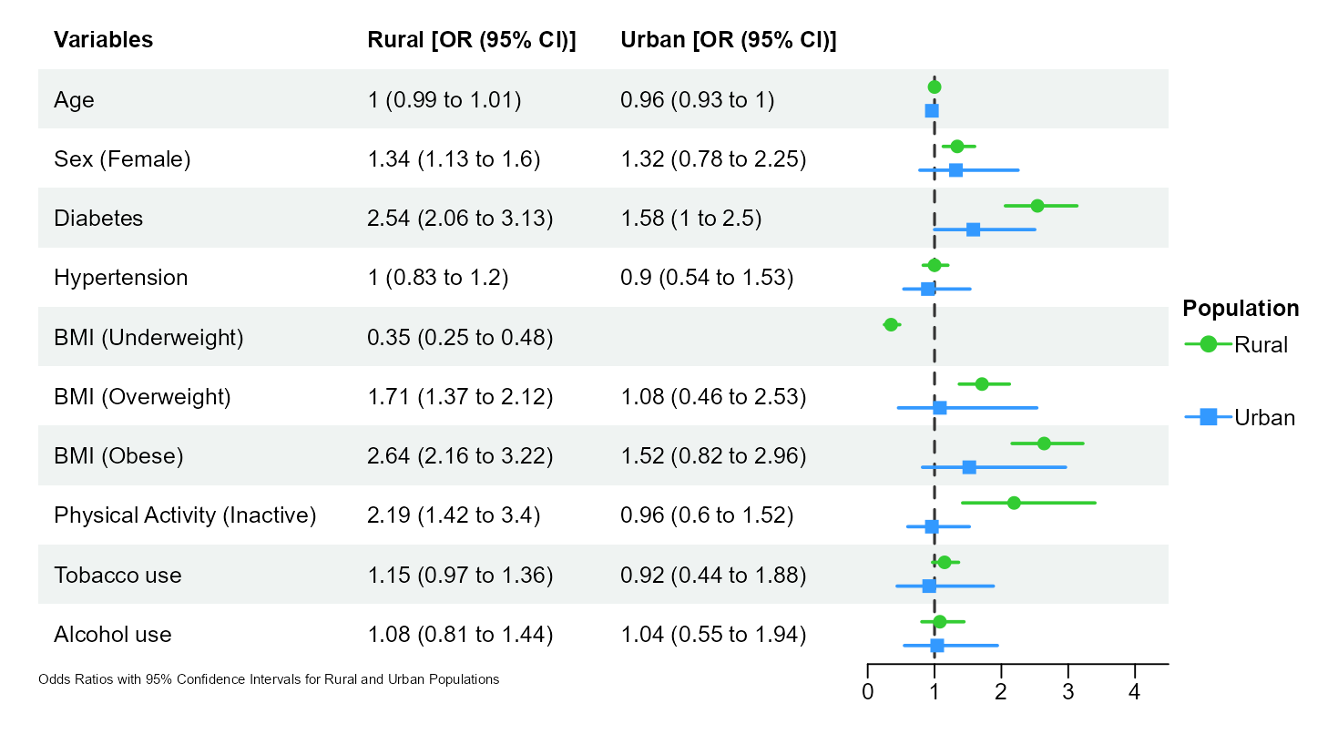

Supplementary figure 13: Association between various risk factors and LDLc/HDLc ratio
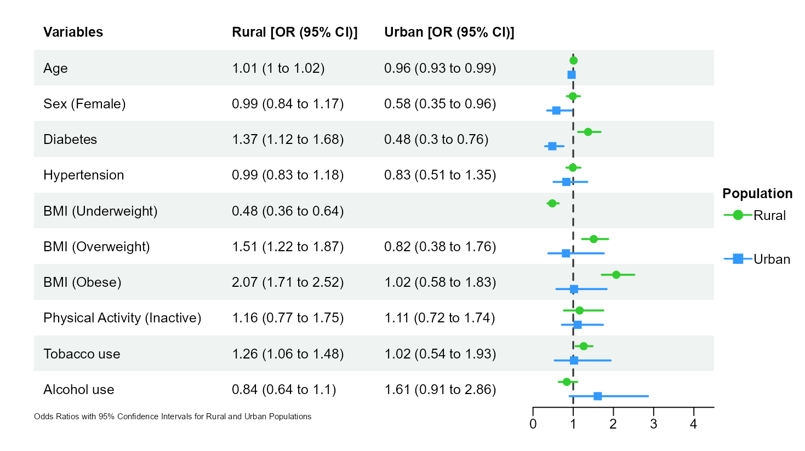

Supplementary figure 14: Association between various risk factors and non-HDLc

