Supplementary Information

Supplementary Tables

Supplementary Table 1. The comparison of descriptive statistics on health measurements and socio-demographics in 2018 between population with and without missing data
Characteristics | Study population  n=13,178 | Population with no missing data*  n=6,173 | Population with missing data**  n=7,005
Socio-demographics
Gender, male % | 6,239 (47.34) | 2,844 (46.07) | 3,395 (48.47)
Age, years | 65 (9) | 66 (9) | 65 (9)
Body mass index | 23.92 (3.48) | 23.96 (3.68) | 23.90 (3.31)
Socio-economics
Educational level, %
Elementary school below | 6,301 (47.81) | 2,921 (47.32) | 3,380 (48.25)
Elementary/secondary school | 6,426 (48.76) | 3,056 (49.51) | 3,370 (48.11)
College and above | 451 (3.42) | 196 (3.18) | 255 (3.64)
Unknown | - | - | -
Living region (rural/ urban areas)
Urban | 2,305 (17.49) | 949 (15.37) | 1,356 (19.36)
Urban-rural interface | 883 (6.70) | 384 (6.22) | 499 (7.12)
Rural | 9,927 (75.33) | 4,840 (78.41) | 5,087 (72.62)
Unknown | 63 (0.48) | - | 63 (0.90)
Lifestyle behavior
Drinking status, %
Non-drinkers | 8,962 (68.01) | 4,244 (68.75) | 4,718 (67.35)
Occasional drinkers | 913 (6.93) | 439 (7.11) | 474 (6.77)
Regular drinkers | 3,295 (25.0) | 1,490 (24.14) | 1,805 (25.77)
Unknown | 8 (0.06) | - | 8 (0.11)
Smoking status, %
Never smokers | 7,621 (57.83) | 3,599 (58.30) | 4,022 (57.42)
Former smokers | 2,086 (15.83) | 972 (15.75) | 1,114 (15.90)
Active smokers | 3,471 (26.34) | 1,602 (25.95) | 1,869 (26.68)
Unknown | - | - | -
Body pain, yes, %
Single site of pain by locations and organs
Headache | 3,443 (26.13) | 1,519 (24.61) | 1,924 (27.47)
Shoulders pain | 3,555 (26.98) | 1,591 (25.77) | 1,964 (28.04)
Arms pain | 2,788 (21.16) | 1,210 (19.60) | 1,578 (22.53)
Wrists pain | 1,859 (14.11) | 790 (12.80) | 1,069 (15.26)
Fingers pain | 2,031 (15.41) | 900 (14.58) | 1,131 (16.15)
Chest pain | 1,482 (11.25) | 623 (10.09) | 859 (12.26)
Stomachache | 2,246 (17.04) | 962 (15.58) | 1,284 (18.33)
Back pain | 2,648 (20.09) | 1,130 (18.31) | 1,518 (21.67)
Waists pain | 5,046 (38.29) | 2,298 (37.23) | 2,748 (39.23)
Buttocks pain | 1,354 (10.27) | 566 (9.17) | 788 (11.25)
Legs pain | 3,684 (27.96) | 1,628 (26.37) | 2,056 (29.35)
Knees pain | 4,089 (31.03) | 1,848 (29.94) | 2,241 (31.99)
Ankles pain | 1,910 (14.49) | 843 (13.66) | 1,067 (15.23)
Toes pain | 1,362 (10.34) | 579 (9.38) | 783 (11.18)
Neck pain | 2,418 (18.35) | 1,038 (16.82) | 1,380 (19.70)
Regional pain
Upper segment pain | 6,407 (48.62) | 2,957 (47.90) | 3,450 (49.25)
Lower segment pain | 5,667 (43.0) | 2,587 (41.91) | 3,080 (43.97)
Axial pain | 4,058 (30.79) | 1,760 (28.51) | 2,298 (32.81)
Upper or lower segment pain | 7,320 (55.55) | 3,375 (54.67) | 3,945 (56.32)
Multiple sites of pain
Widespread pain | 3,125 (23.71) | 1,342 (21.74) | 1,783 (25.45)
Note: Data were present as number (percentage), except for age and body mass index which were show in mean (Standard deviation).
* Population with no missing values on both HMs and covariates data. **Population with missing values on either HMs or covariates data.

Supplementary Table 2 The concentrations on eight heavy metals in soil (100mg/kg) for 125 prefectures

Heavy metals (100mg/kg) | Mean (Standard deviation) | Median (Interquartile range)
Arsenic | 0.166 (0.203) | 0.111 (0.078, 0.153)
Cadmium | 0.009 (0.019) | 0.003 (0.002, 0.008)
Chromium | 0.819 (0.787) | 0.701 (0.50, 0.857)
Copper | 0.481 (0.695) | 0.336 (0.263, 0.461)
Lead | 0.732 (0.975) | 0.382 (0.289, 0.629)
Mercury | 0.063 (0.327) | 0.002 (0.001, 0.004)
Nickel | 0.368 (0.335) | 0.301 (0.241, 0.388)
Zinc | 1.461 (1.555) | 0.995 (0.765, 1.568)

Supplementary Table 3. The results of sensitivity analysis-association between soil arsenic and body pain with adjustment for potential confounding factors
Variables in multivariate regression analysis  (n=6,173) | Shoulders pain | Wrists pain | Arms pain | Chest pain | Back pain | Ankles pain | Neck pain | Lower segment pain | Axial pain | Widespread pain
Variables in multivariate regression analysis  (n=6,173) | Adjusted OR (99.99% CI) | Adjusted OR (99.99% CI) | Adjusted OR (99.99% CI) | Adjusted OR (99.99% CI) | Adjusted OR (99.99% CI) | Adjusted OR (99.99% CI) | Adjusted OR (99.99% CI) | Adjusted OR (99.99% CI) | Adjusted OR (99.99% CI) | Adjusted OR (99.99% CI)
As (100mg/kg) | 2.26 (1.36, 3.76) | 2.96 (1.65, 5.30) | 1.99 (1.15, 3.43) | 2.25 (1.16, 4.36) | 2.27 (1.30, 3.95) | 2.27 (1.25, 4.13) | 1.84 (1.03, 3.30) | 1.98 (1.21, 3.25) | 2.13 (1.29, 3.53) | 2.42 (1.42, 4.12)
Pain at baseline, yes | 3.18 (2.31, 4.39) | 3.23 (2.01, 5.18) | 2.87 (1.99, 4.12) | 5.06 (3.11, 8.23) | 4.13 (2.84, 6.01) | 4.31 (2.70, 6.88) | 3.44 (2.23, 5.28) | 3.51 (2.70, 4.56) | 3.14 (2.33, 4.22) | 4.43 (3.12, 6.30)
Gender, male % | 2.09 (1.45, 3.0) | 1.88 (1.17, 3.03) | 1.85 (1.24, 2.75) | 1.29 (0.77, 2.14) | 2.35 (1.55, 3.56) | 1.66 (1.05, 2.62) | 2.35 (1.53, 3.63) | 1.77 (1.29, 2.44) | 2.14 (1.51, 3.05) | 2.31 (1.56, 3.42)
Age, years | 0.99 (0.98, 1.0) | 0.99 (0.97, 1.01) | 0.99 (0.97, 1.01) | 1.0 (0.98, 1.02) | 1.0 (0.98, 1.01) | 1.0 (0.98, 1.02) | 0.99 (0.97, 1.0) | 1.0 (0.99, 1.02) | 0.99 (0.98, 1.0) | 1.0 (0.98, 1.01)
BMI | 1.01 (0.98, 1.04) | 0.99 (0.95, 1.03) | 1.0 (0.97, 1.03) | 1.0 (0.96, 1.04) | 0.99 (0.96, 1.03) | 1.01 (0.98, 1.05) | 1.01 (0.97, 1.04) | 1.01 (0.98, 1.04) | 0.99 (0.96, 1.02) | 1.0 (0.96, 1.03)
Educational level, %
Elementary school below (referent) | 1.0 | 1.0 | 1.0 | 1.0 | 1.0 | 1.0 | 1.0 | 1.0 | 1.0 | 1.0
Elementary/secondary school | 0.98 (0.75, 1.29) | 0.87 (0.62, 1.23) | 0.85 (0.63, 1.13) | 0.76 (0.51, 1.11) | 0.87 (0.64, 1.18) | 0.80 (0.57, 1.12) | 0.90 (0.66, 1.22) | 0.93 (0.73, 1.19) | 0.85 (0.65, 1.11) | 0.86 (0.65, 1.15)
College and above | 0.73 (0.34, 1.56) | 0.56 (0.18, 1.72) | 0.63 (0.26, 1.49) | 0.67 (0.22, 2.04) | 0.70 (0.28, 1.70) | 0.61 (0.21, 1.73) | 0.97 (0.42, 2.21) | 0.79 (0.42, 1.48) | 0.88 (0.44, 1.77) | 0.78 (0.35, 1.74)
Living area
Urban (referent) | 1.0 | 1.0 | 1.0 | 1.0 | 1.0 | 1.0 | 1.0 | 1.0 | 1.0 | 1.0
Urban-rural interface | 1.02 (0.55, 1.87) | 0.97 (0.42, 2.25) | 1.21 (0.63, 2.32) | 1.45 (0.61, 3.46) | 0.89 (0.43, 1.84) | 1.08 (0.48, 2.42) | 1.08 (0.55, 2.14) | 1.09 (0.63, 1.87) | 1.05 (0.58, 1.89) | 1.09 (0.57, 2.10)
Rural | 1.08 (0.74, 1.57) | 1.15 (0.69, 1.90) | 1.03 (0.68, 1.56) | 1.23 (0.69, 2.20) | 1.0 (0.65, 1.54) | 1.16 (0.70, 1.91) | 0.96 (0.62, 1.47) | 1.06 (0.76, 1.47) | 1.02 (0.71, 1.48) | 1.03 (0.69, 1.55)
Drinking status, %
Non-drinkers (referent) | 1.0 | 1.0 | 1.0 | 1.0 | 1.0 | 1.0 | 1.0 | 1.0 | 1.0 | 1.0
Occasional drinkers | 0.99 (0.62, 1.58) | 0.97 (0.53, 1.78) | 0.98 (0.59, 1.64) | 0.98 (0.50, 1.89) | 0.83 (0.47, 1.46) | 1.08 (0.60, 1.92) | 0.90 (0.51, 1.57) | 1.17 (0.78, 1.75) | 0.91 (0.58, 1.44) | 0.92 (0.56, 1.54)
Regular drinkers | 1.02 (0.73, 1.42) | 0.98 (0.63, 1.53) | 0.99 (0.68, 1.44) | 0.79 (0.48, 1.29) | 1.05 (0.71, 1.54) | 0.84 (0.54, 1.30) | 0.91 (0.60, 1.37) | 0.90 (0.67, 1.21) | 0.95 (0.69, 1.32) | 0.89 (0.61, 1.29)
Smoking status, %
Never smokers (referent) | 1.0 | 1.0 | 1.0 | 1.0 | 1.0 | 1.0 | 1.0 | 1.0 | 1.0 | 1.0
Former smokers | 1.50 (0.91, 2.49) | 1.65 (0.87, 3.13) | 1.32 (0.75, 2.30) | 1.53 (0.78, 3.01) | 1.46 (0.81, 2.61) | 1.12 (0.57, 2.18) | 1.35 (0.73, 2.48) | 1.15 (0.73, 1.82) | 1.55 (0.95, 2.53) | 1.46 (0.84, 2.54)
Active smokers | 1.11 (0.77, 1.60) | 1.05 (0.65, 1.70) | 1.03 (0.69, 1.54) | 1.06 (0.63, 1.79) | 1.17 (0.77, 1.78) | 1.13 (0.71, 1.79) | 1.06 (0.68, 1.65) | 1.03 (0.75, 1.43) | 1.11 (0.78, 1.59) | 1.16 (0.78, 1.73)

Supplementary Table 4. The comparison of health measurements and socio-demographics in 2011 between study population and lost to follow-up
Characteristics | Population having health records in 2011(n=17228) | Study population  n=13178 | Population who lost to follow-up (n=4050) | p value*
Socio-demographics
Gender, male % | 8,387 (48.68) | 6,239 (47.34) | 2,148 (53.04) | <0.0001
Age, years | 59 (10) | 58 (9) | 63 (12) | <0.0001
Body mass index | 23.51 (3.68) | 23.66 (3.72) | 23.01 (3.49) | <0.0001
Socio-economics
Educational level, %
Elementary school below | 7,774 (45.12) | 5,911 (44.86) | 1,863 (46.0) | 0.157
Elementary/secondary school | 8,586 (49.84) | 6,718 (50.98) | 1,868 (46.12) | <0.0001
College and above | 839 (4.87) | 535 (4.06) | 304 (7.51) | <0.0001
Unknown | 29 (0.17) | 14 (0.11) | 15 (0.37) | -
Living region (rural/ urban areas)
Urban | 2,838 (16.47) | 2,060 (15.63) | 778 (19.21) | <0.0001
Urban-rural interface | 912 (5.29) | 772 (5.86) | 140 (3.46) | <0.0001
Rural | 12,896 (74.85) | 10,297 (78.14) | 2,599 (2,599) | <0.0001
Unknown | 582 (3.38) | 49 (0.37) | 533 (13.16) | -
Lifestyle behavior
Drinking status, %
Non-drinkers | 11,473 (66.60) | 8,720 (66.17) | 2,753 (67.98) | 0.033
Occasional drinkers | 1,361 (7.90) | 1,064 (8.07) | 297 (7.33) | 0.126
Regular drinkers | 4,350 (25.25) | 3,373 (25.60) | 977 (24.12) | 0.059
Unknown | 44 (0.26) | 21 (0.16) | 23 (0.57) | -
Smoking status, %
Never smokers | 10,268 (59.60) | 8,000 (60.71) | 2,268 (56.0) | <0.0001
Former smokers | 1,433 (8.32) | 985 (7.47) | 448 (11.06) | <0.0001
Active smokers | 4,841 (28.10) | 3,753 (28.48) | 1,088 (26.86) | 0.046
Unknown | 686 (3.98) | 440 (3.34) | 246 (6.07) | -
Body pain, yes, %
Single site of pain by locations and organs
Headache | 2,292 (13.30) | 1,801 (13.67) | 491 (12.12) | 0.011
Shoulders pain | 2,076 (12.05) | 1,642 (12.46) | 434 (10.72) | 0.003
Arms pain | 1,684 (9.77) | 1,314 (9.97) | 370 (9.14) | 0.117
Wrists pain | 1,080 (6.27) | 852 (6.47) | 228 (5.63) | 0.055
Fingers pain | 1,011 (5.87) | 787 (5.97) | 224 (5.53) | 0.296
Chest pain | 1,094 (6.35) | 798 (6.06) | 296 (7.31) | 0.004
Stomachache | 1,472 (8.54) | 1,177 (8.93) | 295 (7.28) | 0.001
Back pain | 1,565 (9.08) | 1,211 (9.19) | 354 (8.74) | 0.385
Waists pain | 3,301 (19.16) | 2,608 (19.79) | 693 (17.11) | <0.0001
Buttocks pain | 643 (3.73) | 499 (3.79) | 144 (3.56) | 0.497
Legs pain | 2,520 (14.63) | 1,973 (14.97) | 547 (13.51) | 0.021
Knees pain | 2,222 (12.90) | 1,763 (13.38) | 459 (11.33) | 0.001
Ankles pain | 981 (5.69) | 772 (5.86) | 209 (5.16) | 0.094
Toes pain | 573 (3.33) | 439 (3.33) | 134 (3.31) | 0.944
Neck pain | 1,158 (6.72) | 896 (6.80) | 262 (6.47) | 0.463
Regional pain
Upper segment pain | 4,270 (24.79) | 3,377 (25.63) | 893 (22.05) | <0.0001
Lower segment pain | 3,622 (21.02) | 2,865 (21.74) | 757 (18.69) | <0.0001
Axial pain | 2,525 (14.66) | 1,935 (14.68) | 590 (14.57) | 0.856
Upper or lower segment pain | 4,922 (28.57) | 3,878 (29.43) | 1,044 (25.78) | <0.0001
Multiple sites of pain
Widespread pain | 1,754 (10.18) | 1,370 (10.40) | 384 (9.48) | 0.092
Note: *p values are from Mann-Whitney U Test or Chi-squared tests.

Supplementary Figures

Supplementary Figure 1. The flowchart of population selecting and database mapping
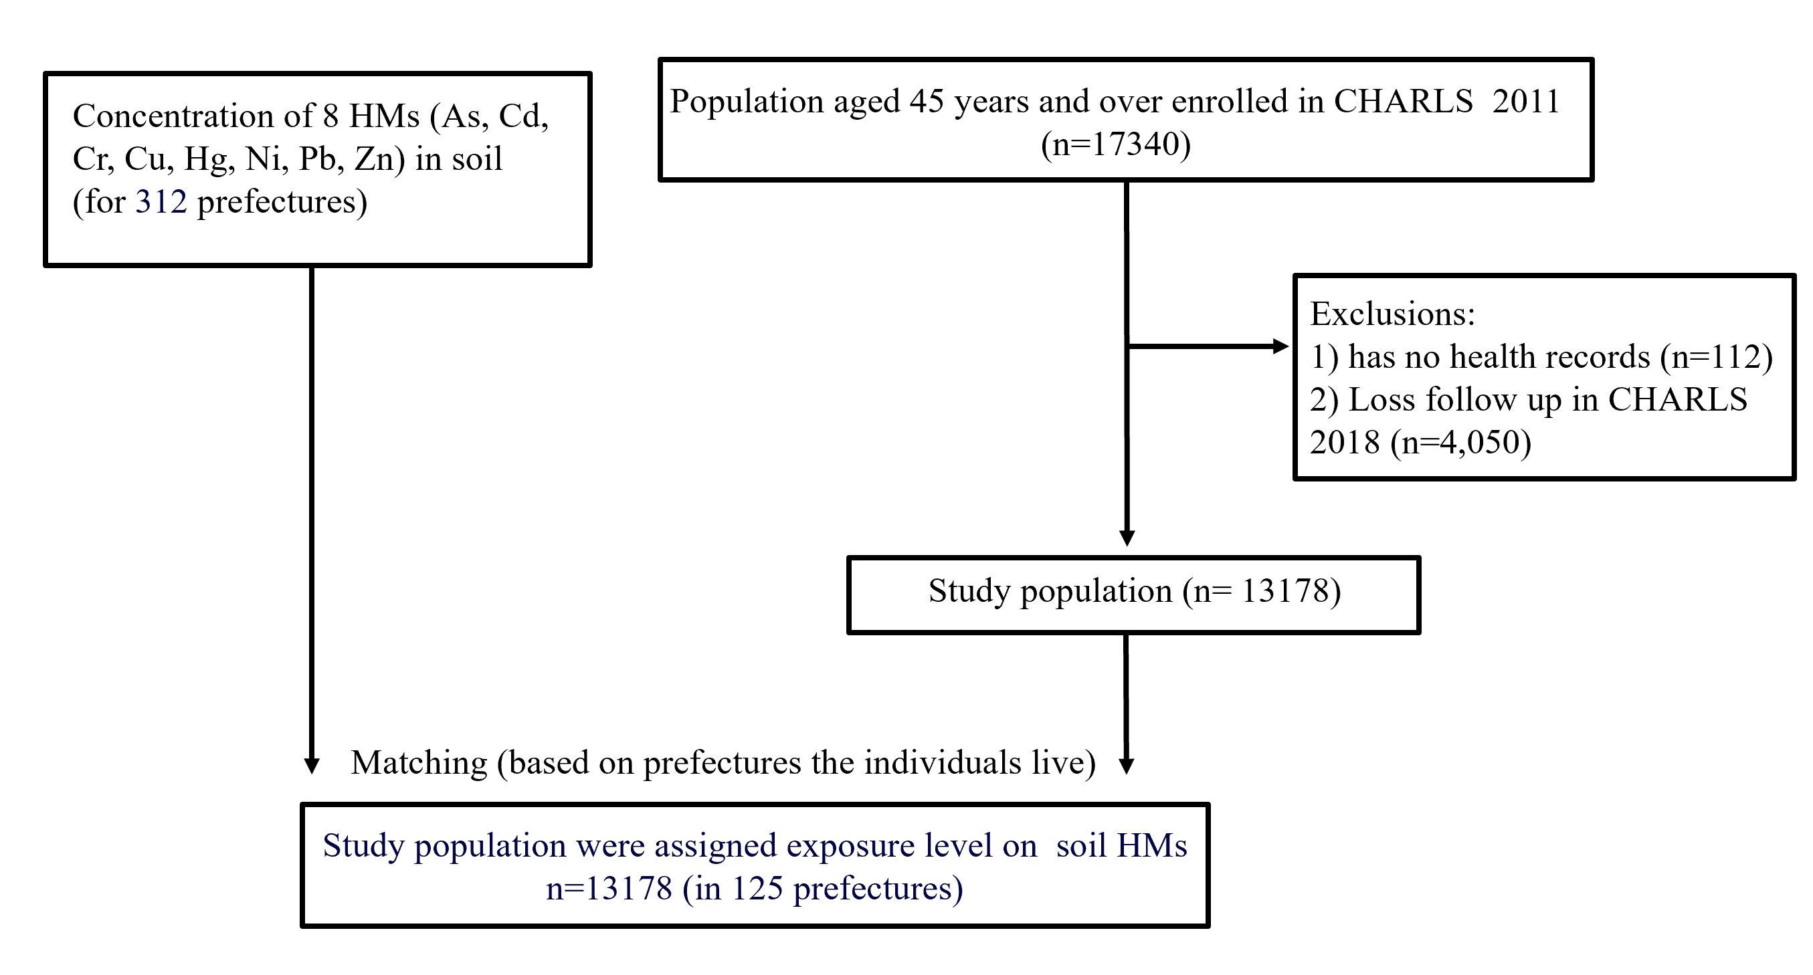

Supplementary Figure 2. Association between single heavy metal and each site-specific pain 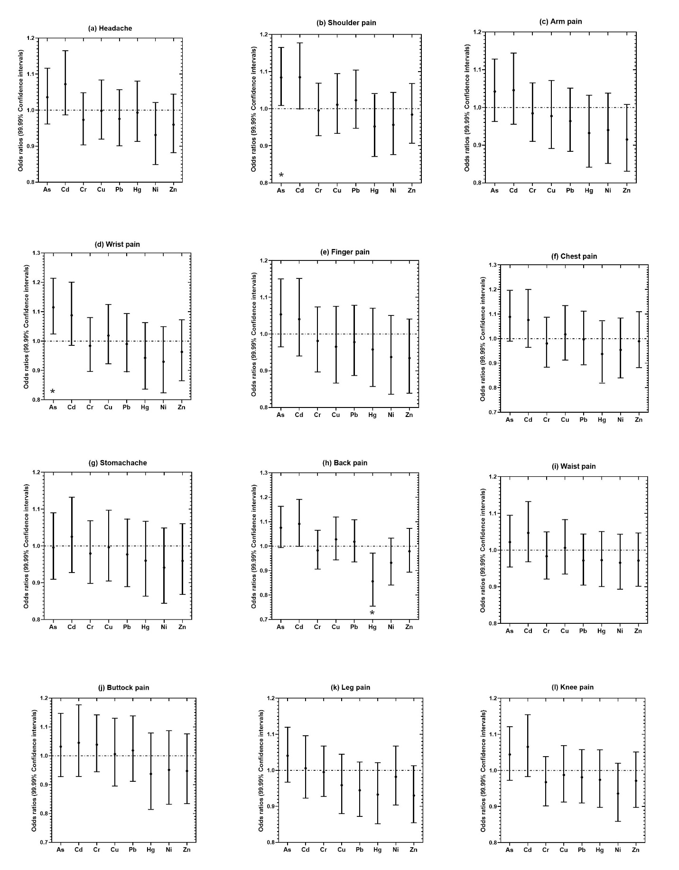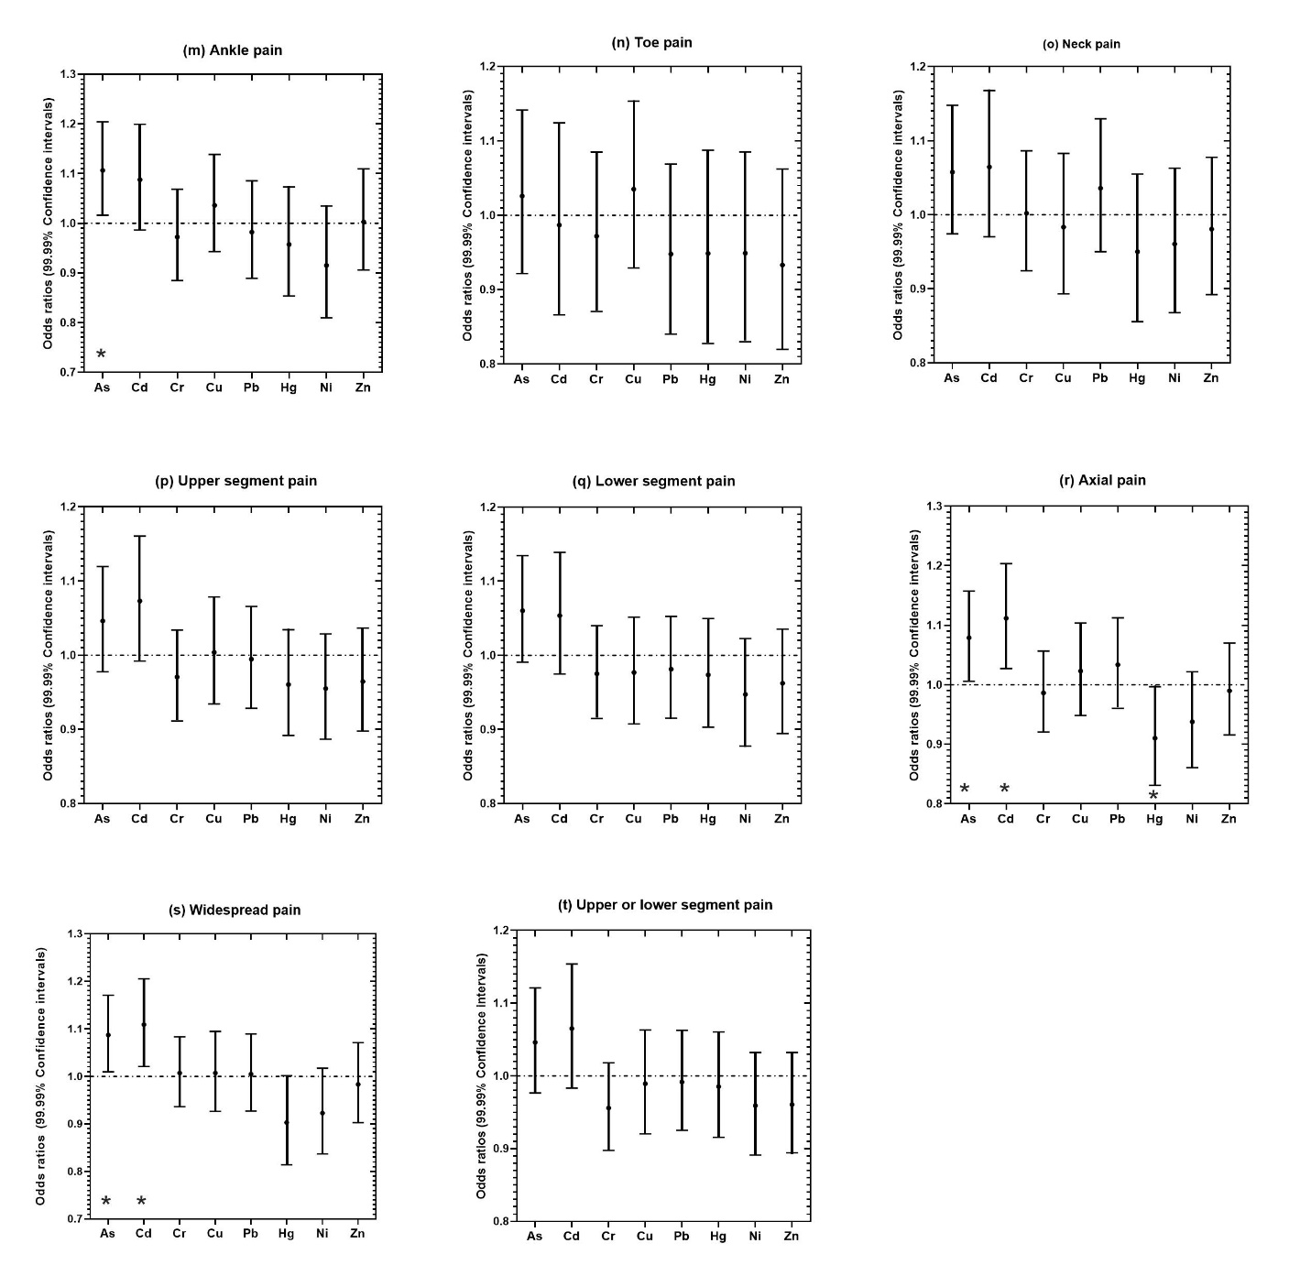
Notes: * p <0.0001. The ORs were based on z-score standardized value of concentrations on soil HMs.

