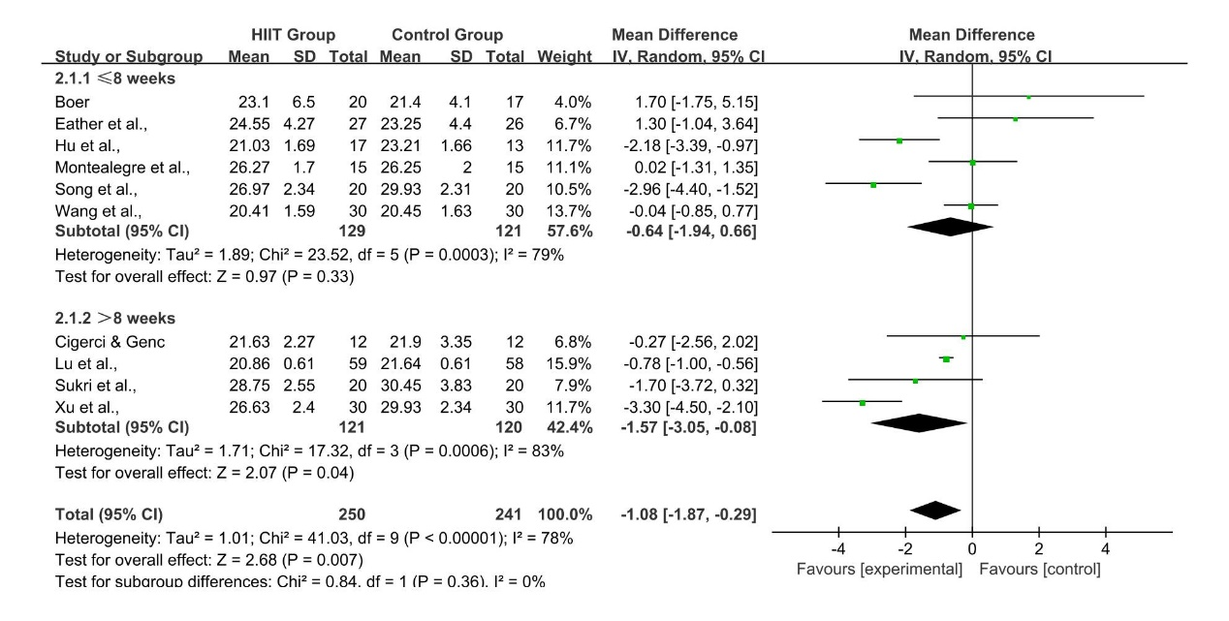
S1 Subgroup Analysis of HIIT Duration on BMI

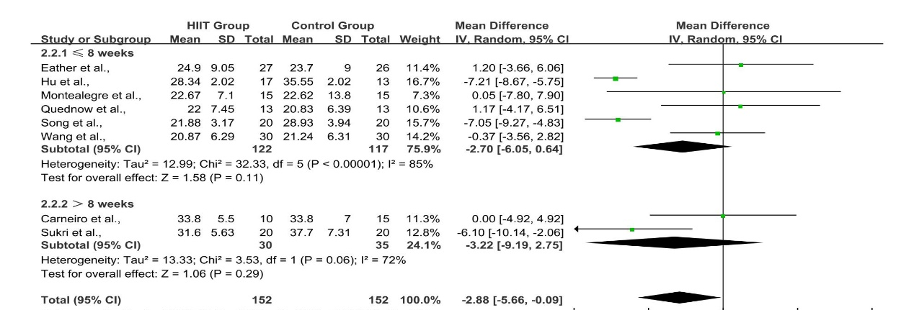
S2 Subgroup Analysis of HIIT Duration on BF%

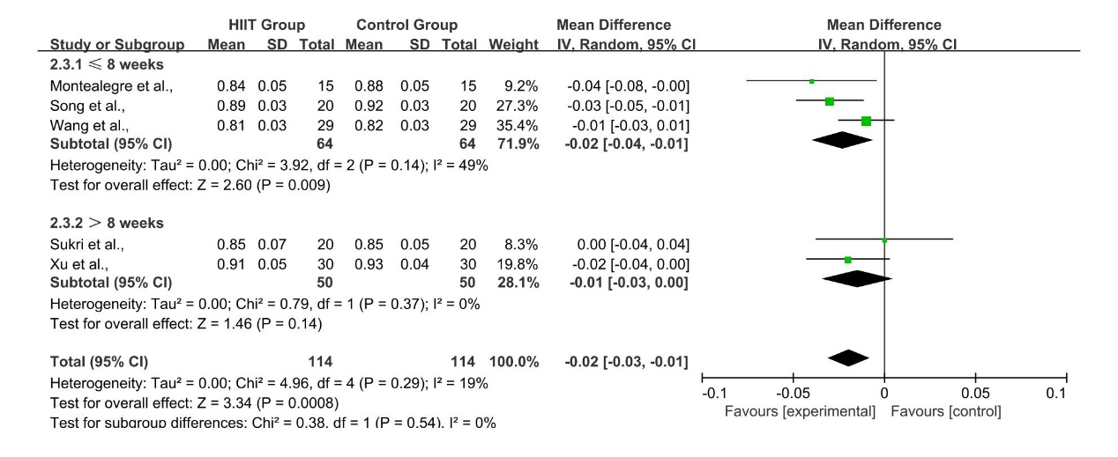
S3 Subgroup Analysis of HIIT Duration on WHR

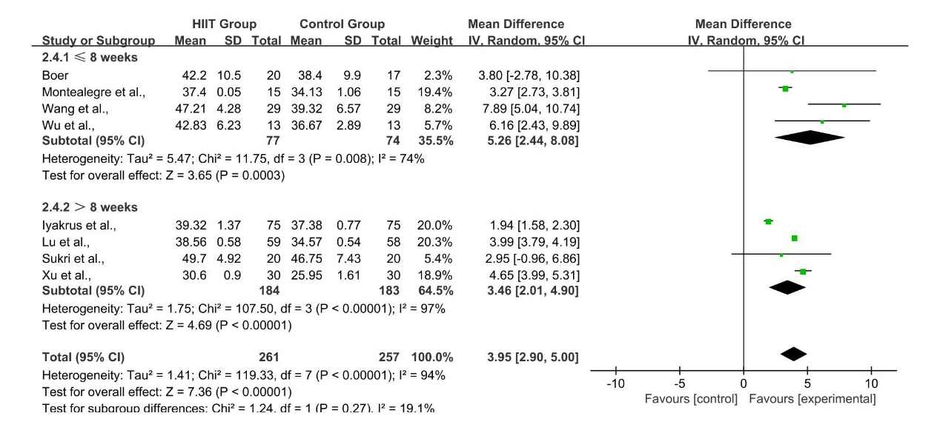
S4 Subgroup Analysis of HIIT Duration on VO₂max

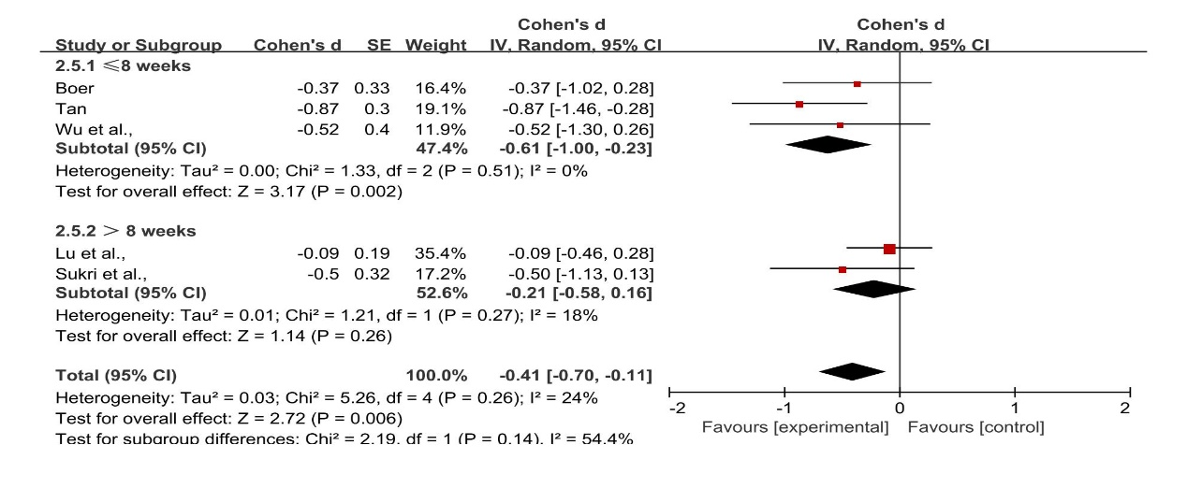
S5 Subgroup Analysis of HIIT Duration on HR

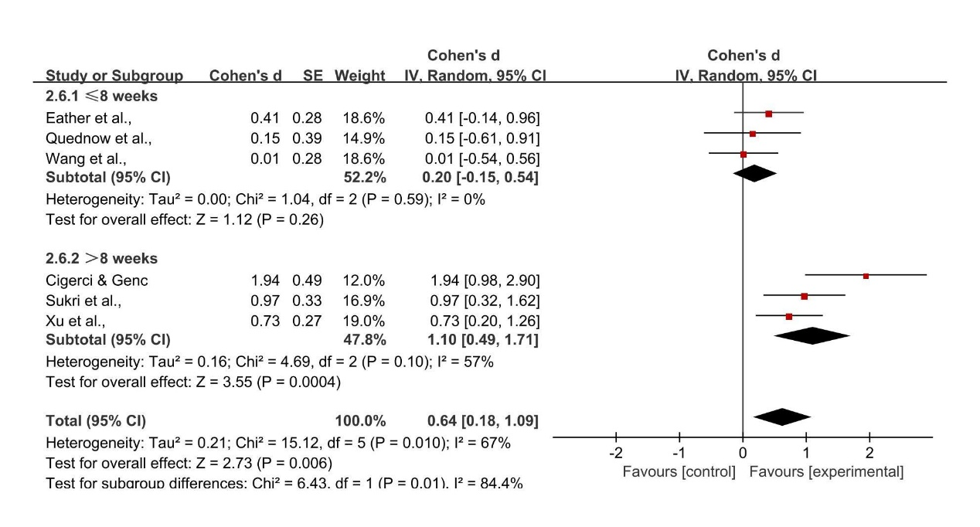
S6 Subgroup Analysis of HIIT Duration on muscle strength

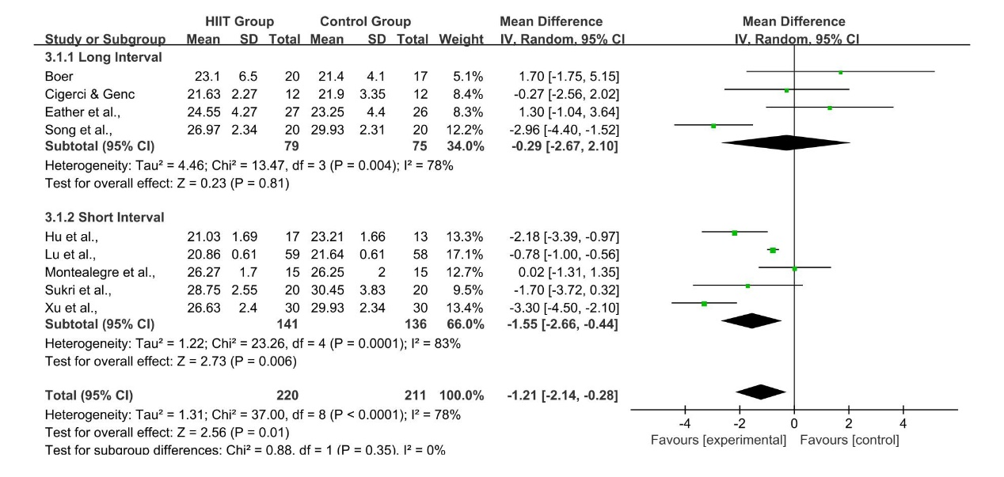
S7 Subgroup Analysis of HIIT Rest Interval on BMI

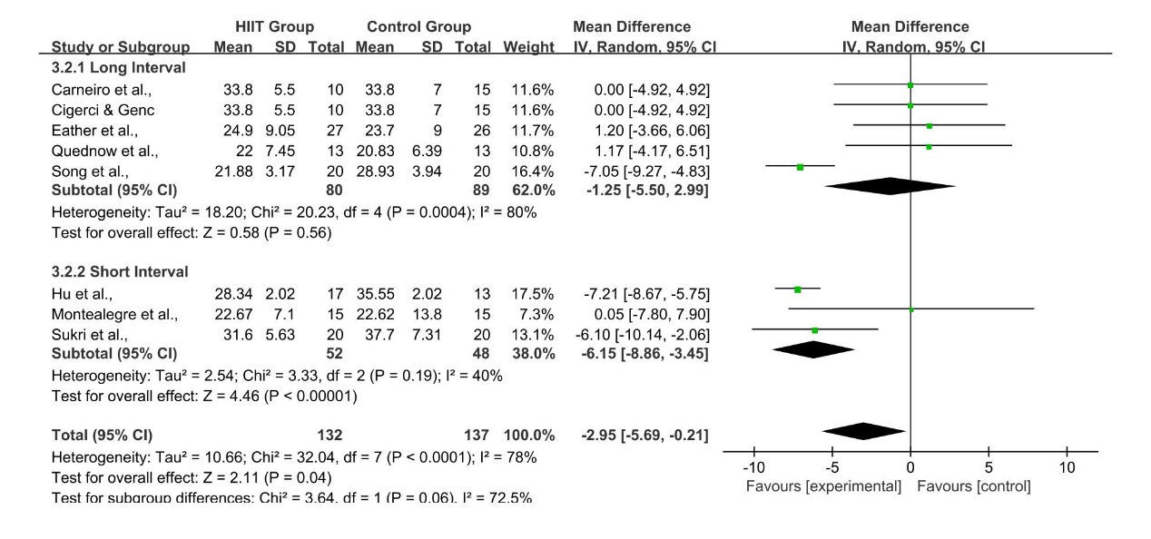
S8 Subgroup Analysis of HIIT Rest Interval on BF%

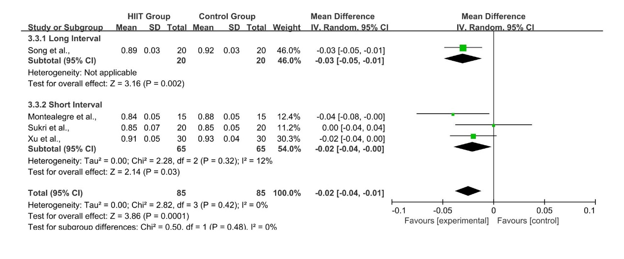
S9 Subgroup Analysis of HIIT Rest Interval on BF%

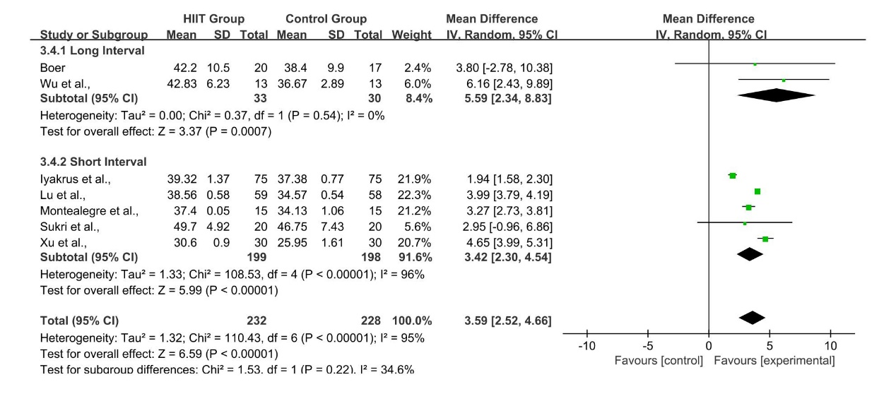
S10 Subgroup Analysis of HIIT Rest Interval on BF%

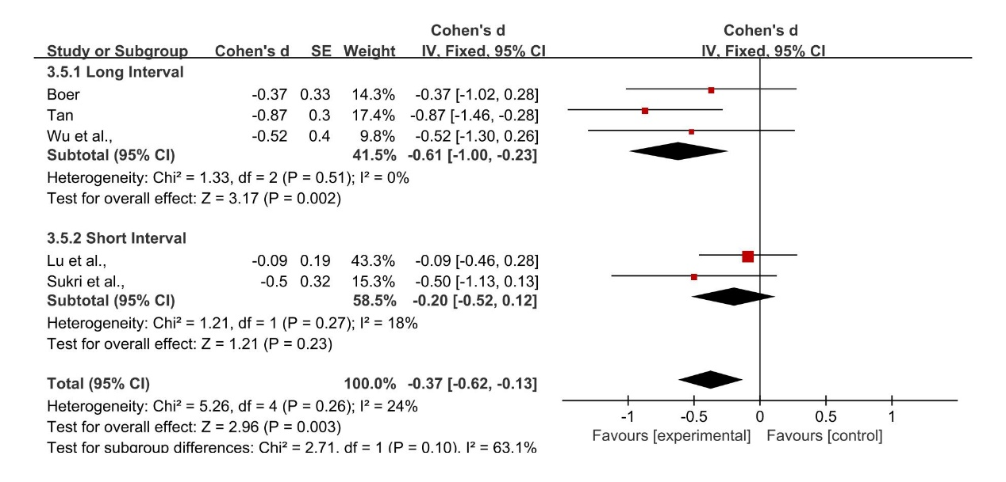
S11 Subgroup Analysis of HIIT Rest Interval on BF%

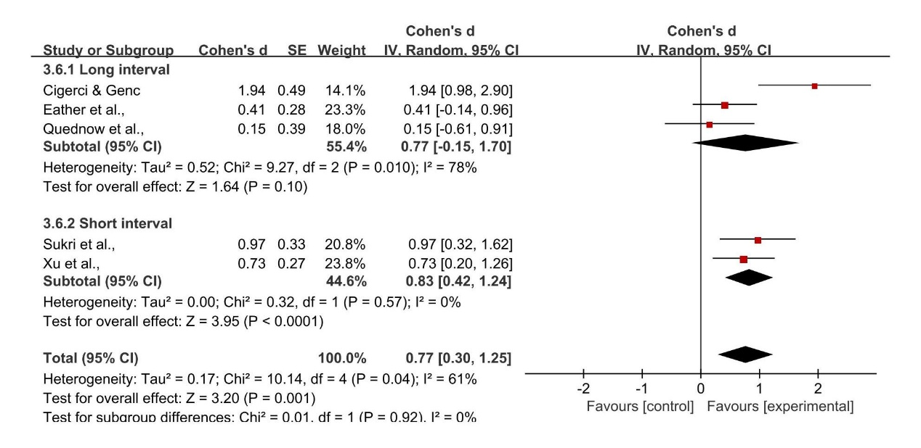
S12 Subgroup Analysis of HIIT Rest Interval on muscle strength

