The Global Burden of Polycystic Ovary Syndrome, Endometriosis, Uterine Fibroids, Cervical Cancer, Uterine Cancer, and Ovarian Cancer from 1990 to 2021
Wei-Zhen Tang ^{a, c}, Qin-Yu Cai ^{a, c}, Kang-Jin Huang ª，Wei-Ze Xu ^{a, c}, Jia-Zheng Li ^{a, c}, Yun-Ren Pan ^{a, c}, Hong-Yu Xu ^{a, c}, Yi-Fan Zhao ª, Ting-He Sheng ^{b}, Zhi-Mou Li ª, Tai-Hang Liu ^{a, c,}*,Ying-Bo Li ^{a, b,}*
Affiliations:
ª Department of Bioinformatics, School of Basic Medical Sciences, Chongqing Medical University, Chongqing, 400016, China.
^{b} Institute of Neuroscience, Department of Physiology, School of Basic Medical Science, Chongqing Medical University, Chongqing, 400016, China.
^{c} The Joint International Research Laboratory of Reproduction and Development, Chongqing Medical University, Chongqing, 400016, China.

*Correspondence:
*Tai-Hang Liu (liuth@cqmu.edu.cn); * Ying-Bo Li (liyingbo@cqmu.edu.cn)
Box 197, Chongqing Medical University, No.1 Yixueyuan Rd, Chongqing, 400016, PR China. Tel.: +86 023 68485868.
Wei-Zhen Tang, ORCID: 0009-0002-8130-7516
Tai-Hang Liu, ORCID: 0000-0001-9932-8281

Table S1. List of abbreviations

Abbreviation | Full Name
PCOS | Polycystic Ovary Syndrome
DALY | Disability-Adjusted Life Year
GBD | Global Burden of Disease
SDI | Socio-demographic Index
EAPC | The Estimated Annual Percentage Change
CI | Confidence Interval
ASIR | Age-Standardized Incidence Rate
ASPR | Age-Standardized Prevalence Rate
ASMR | Age-Standardized Mortality Rate
ASDR | Age-Standardized Disability Rate
BMI | Body Mass Index
HPV | Human Papillomavirus
COVID-19 | Corona Virus Disease 2019
DW | Disability Weights
YLD | Years Lived with Disability
YLL | Years of Life Lost
TMREL | Theoretical Minimum Risk Exposure Level
PAF | Population Attributable Fraction
ASR | Age-standardized Rate
UI | Uncertainty Interva
MAPK | Mitogen-activated Protein Kinase
ERK | Extracellular Signal-regulated Kinase
PI3K | Phosphoinositide 3-kinase (PI3K)
AKT | Protein Kinase B
VEGF | Vascular Endothelial Growth Factor
miRNA | MicroRNA
circRNA | Circular RNA
ceRNA | Competing endogenous RNA
FIGO | Federation of International of Gynecologists and Obstetricians

Table S2. EAPC of the ASIR, ASPR, ASMR, and ASDR for three non-malignant gynecological diseases globally and across 21 regions.

Location | EAPC of ASIR (95% CI) |  |  | EAPC of ASPR (95% CI) |  |  | EAPC of ASMR (95% CI) |  |  | EAPC of ASDR (95% CI)
 | PCOS | Endometriosis | Uterine fibroids | PCOS | Endometriosis | Uterine fibroids | PCOS | Endometriosis | Uterine fibroids | PCOS | Endometriosis | Uterine fibroids
Global | 0.01(-0.10,0.11) | -1.16(-1.21,-1.12) | 0.37(0.30,0.44) | 0.73(0.66,0.80) | -0.92(-0.96,-0.88) | 0.67(0.61,0.73) | 0 | 1.84(1.63,2.05) | 1.04(0.90,1.17) | 0.70(0.62,0.77) | -0.92(-0.96,-0.87) | 0.69(0.61,0.78)
High SDI | -0.80(-1.01,-0.59) | -1.44(-1.49,-1.39) | -0.34(-0.51,-0.18) | -0.34(-0.51,-0.18) | -1.18(-1.25,-1.10) | 0.04(-0.13,0.21) | 0 | 0.05(-0.17,0.26) | -0.68(-1.06,-0.30) | -0.37(-0.53,-0.20) | -1.18(-1.25,-1.11) | -0.42(-0.49,-0.36)
High-middle SDI | -0.24(-0.42,-0.07) | -1.17(-1.27,-1.07) | -0.27(-0.37,-0.17) | 0.93(0.75,1.11) | -0.72(-0.79,-0.64) | 0.23(0.13,0.33) | 0 | 0.60(0.32,0.88) | 0.80(0.57,1.04) | 0.90(0.71,1.09) | -0.72(-0.80,-0.65) | 0.09(-0.05,0.24)
Middle SDI | 0.27(0.12,0.42) | -1.25(-1.32,-1.19) | 0.82(0.70,0.95) | 1.66(1.51,1.81) | -0.82(-0.89,-0.76) | 1.46(1.37,1.55) | 0 | 3.67(3.24,4.10) | 2.67(2.33,3.02) | 1.62(1.47,1.77) | -0.83(-0.89,-0.76) | 1.70(1.52,1.87)
Low-middle SDI | 1.09(1.04,1.14) | -1.26(-1.29,-1.24) | 1.18(1.13,1.23) | 1.96(1.92,2.01) | -1.21(-1.24,-1.18) | 1.46(1.39,1.53) | 0 | 2.39(2.10,2.69) | 0.20(0.15,0.25) | 1.90(1.86,1.95) | -1.19(-1.22,-1.16) | 0.46(0.41,0.52)
Low SDI | 1.31(1.28,1.33) | -1.18(-1.23,-1.12) | 0.57(0.53,0.61) | 1.49(1.45,1.53) | -1.13(-1.20,-1.07) | 0.59(0.52,0.66) | 0 | 1.12(1.07,1.17) | -0.12(-0.27,0.04) | 1.46(1.43,1.49) | -1.10(-1.17,-1.04) | 0.01(-0.08,0.11)
Andean Latin America | -0.15(-0.33,0.03) | -1.09(-1.14,-1.04) | 0.58(0.55,0.60) | 1.28(1.18,1.38) | -0.70(-0.77,-0.63) | 1.07(1.04,1.09) | 0 | -2.63(-3.45,-1.80) | -1.48(-1.97,-1.00) | 1.25(1.15,1.35) | -0.70(-0.76,-0.63) | -0.80(-1.09,-0.51)
Australasia | -0.55(-0.68,-0.43) | -0.82(-0.92,-0.72) | -0.42(-0.48,-0.35) | -0.16(-0.26,-0.05) | -0.67(-0.75,-0.59) | 0.13(0.03,0.23) | 0 | -3.01(-6.44,0.56) | -5.20(-8.20,-2.11) | -0.16(-0.25,-0.06) | -0.67(-0.75,-0.58) | -1.36(-1.88,-0.84)
Caribbean | 0.04(-0.10,0.18) | -1.06(-1.13,-1.00) | 0.05(-0.08,0.17) | 0.68(0.58,0.78) | -0.82(-0.86,-0.77) | 0.74(0.64,0.84) | 0 | 0.24(-0.86,1.36) | -0.51(-0.70,-0.32) | 0.65(0.55,0.75) | -0.82(-0.86,-0.78) | -0.37(-0.53,-0.22)
Central Asia | 0.16(-0.09,0.41) | -0.22(-0.43,-0.01) | 0.69(0.56,0.82) | 1.47(1.35,1.59) | 0.04(-0.15,0.24) | 1.22(1.12,1.32) | 0 | 0.48(0.01,0.95) | 1.32(1.16,1.47) | 1.44(1.31,1.56) | 0.05(-0.15,0.25) | 1.14(1.03,1.24)
Central Europe | -1.21(-1.41,-1.01) | -0.84(-0.85,-0.83) | -0.17(-0.28,-0.06) | 0.22(0.08,0.36) | -0.42(-0.47,-0.37) | 0.17(0.01,0.34) | 0 | -2.87(-4.63,-1.07) | -4.84(-5.67,-4.00) | 0.20(0.06,0.34) | -0.42(-0.47,-0.37) | -1.61(-1.83,-1.39)
Central Latin America | -1.18(-1.30,-1.06) | -1.33(-1.38,-1.27) | 0.45(0.37,0.52) | 0.01(-0.14,0.16) | -0.93(-0.99,-0.87) | 1.16(1.13,1.20) | 0 | -2.42(-4.20,-0.60) | -0.27(-0.87,0.33) | -0.02(-0.16,0.13) | -0.94(-1.00,-0.88) | -0.02(-0.37,0.33)
Central Sub-Saharan Africa | 1.36(1.18,1.54) | -1.28(-1.40,-1.15) | 0.34(0.31,0.38) | 1.47(1.31,1.63) | -1.26(-1.39,-1.13) | 0.37(0.34,0.41) | 0 | 2.08(1.91,2.25) | 0.25(0.19,0.32) | 1.46(1.29,1.63) | -1.22(-1.35,-1.09) | 0.04(-0.01,0.09)
East Asia | -0.26(-0.73,0.21) | -2.02(-2.18,-1.86) | -0.06(-0.37,0.26) | 1.61(1.28,1.95) | -1.45(-1.62,-1.29) | 0.94(0.65,1.23) | 0 | 16.57(13.83,19.38) | 7.15(6.07,8.24) | 1.60(1.26,1.94) | -1.45(-1.62,-1.28) | 3.73(3.11,4.35)
Eastern Europe | -0.48(-0.75,-0.21) | -0.09(-0.26,0.07) | 0.01(-0.05,0.07) | 0.77(0.63,0.90) | 0.28(0.11,0.45) | 0.40(0.34,0.46) | 0 | -0.31(-0.83,0.22) | -1.35(-1.69,-1.00) | 0.74(0.60,0.88) | 0.28(0.11,0.45) | -0.55(-0.79,-0.32)
Eastern Sub-Saharan Africa | 0.92(0.88,0.95) | -1.33(-1.39,-1.28) | 0.51(0.46,0.56) | 1.16(1.10,1.22) | -1.18(-1.22,-1.15) | 0.51(0.43,0.60) | 0 | 1.43(1.34,1.52) | -0.66(-0.74,-0.59) | 1.14(1.09,1.19) | -1.15(-1.18,-1.11) | -0.24(-0.30,-0.19)
High-income Asia Pacific | -1.42(-1.57,-1.28) | -1.43(-1.56,-1.30) | -0.75(-1.00,-0.49) | -0.53(-0.59,-0.47) | -1.19(-1.32,-1.07) | -0.28(-0.40,-0.16) | 0 | 6.76(5.38,8.16) | 1.17(0.79,1.55) | -0.55(-0.61,-0.49) | -1.20(-1.32,-1.07) | -0.31(-0.41,-0.21)
High-income North America | -0.85(-1.37,-0.32) | -2.71(-2.91,-2.50) | 0.18(-0.13,0.50) | -1.04(-1.56,-0.52) | -2.46(-2.66,-2.26) | 0.39(0.10,0.68) | 0 | 0.14(-0.15,0.42) | 0.32(0.16,0.48) | -1.06(-1.57,-0.55) | -2.47(-2.67,-2.27) | 0.37(0.17,0.58)
North Africa and Middle East | -0.09(-0.25,0.06) | -1.06(-1.10,-1.03) | 0.81(0.73,0.89) | 1.45(1.29,1.61) | -0.70(-0.74,-0.65) | 1.14(1.09,1.19) | 0 | 2.83(2.71,2.95) | -0.24(-0.30,-0.18) | 1.37(1.20,1.54) | -0.70(-0.75,-0.65) | 0.19(0.14,0.24)
Oceania | 0.45(0.24,0.66) | -0.50(-0.54,-0.45) | 0.51(0.43,0.58) | 1.00(0.80,1.20) | -0.28(-0.33,-0.24) | 0.75(0.71,0.80) | 0 | 3.24(2.95,3.52) | 0.29(0.24,0.35) | 0.98(0.78,1.18) | -0.28(-0.32,-0.23) | 0.27(0.22,0.31)
South Asia | 1.50(1.40,1.59) | -1.27(-1.30,-1.25) | 1.43(1.33,1.53) | 2.52(2.40,2.64) | -1.26(-1.29,-1.22) | 1.73(1.60,1.86) | 0 | 1.34(1.19,1.50) | -0.28(-0.35,-0.20) | 2.45(2.34,2.56) | -1.24(-1.27,-1.20) | 0.30(0.23,0.36)
Southeast Asia | 1.25(1.13,1.38) | -0.86(-0.92,-0.79) | 0.42(0.31,0.54) | 2.38(2.22,2.54) | -0.50(-0.57,-0.43) | 1.08(0.98,1.17) | 0 | 4.67(4.27,5.07) | 0.29(0.22,0.36) | 2.32(2.17,2.48) | -0.49(-0.55,-0.42) | 0.54(0.48,0.60)
Southern Latin America | 0.69(0.37,1.00) | -0.39(-0.48,-0.31) | 0.38(0.27,0.49) | 1.57(1.33,1.82) | -0.15(-0.27,-0.03) | 0.62(0.50,0.75) | 0 | 4.92(3.65,6.21) | -3.34(-4.07,-2.61) | 1.56(1.32,1.80) | -0.15(-0.27,-0.03) | -1.30(-1.60,-1.00)
Southern Sub-Saharan Africa | -0.12(-0.32,0.08) | -0.70(-0.78,-0.62) | 0.58(0.54,0.62) | 1.01(0.87,1.15) | -0.34(-0.38,-0.31) | 0.89(0.84,0.94) | 0 | 5.81(3.80,7.85) | 1.98(1.61,2.34) | 0.96(0.82,1.10) | -0.37(-0.40,-0.33) | 1.36(1.11,1.61)
Tropical Latin America | -1.66(-1.85,-1.47) | -1.38(-1.52,-1.24) | 1.79(1.68,1.90) | -0.10(-0.25,0.06) | -0.83(-1.02,-0.64) | 2.06(1.97,2.15) | 0 | 3.76(3.35,4.17) | 3.20(3.01,3.39) | -0.14(-0.29,0.01) | -0.81(-1.01,-0.62) | 2.33(2.22,2.45)
Western Europe | -0.54(-0.63,-0.46) | -0.62(-0.72,-0.52) | -0.42(-0.56,-0.29) | -0.25(-0.35,-0.15) | -0.54(-0.60,-0.47) | 0.16(0.04,0.28) | 0 | -3.02(-3.58,-2.45) | -2.92(-3.40,-2.43) | -0.27(-0.37,-0.17) | -0.54(-0.61,-0.48) | -0.94(-1.04,-0.84)
Western Sub-Saharan Africa | 0.87(0.71,1.04) | -1.12(-1.22,-1.01) | 0.29(0.20,0.38) | 1.07(0.84,1.30) | -0.90(-1.00,-0.79) | 0.41(0.36,0.47) | 0 | 2.07(1.55,2.59) | 0.86(0.41,1.31) | 1.06(0.83,1.29) | -0.87(-0.98,-0.77) | 0.67(0.33,1.01)

Table S3. EAPC of the ASIR, ASPR, ASMR, and ASDR for three gynecological cancers globally and across 21 regions.

Location | EAPC of ASIR (95% CI) |  |  | EAPC of ASPR (95% CI) |  |  | EAPC of ASMR (95% CI) |  |  | EAPC of ASDR (95% CI)
 | Cervical cancer | Ovarian cancer | Uterine cancer | Cervical cancer | Ovarian cancer | Uterine cancer | Cervical cancer | Ovarian cancer | Uterine cancer | Cervical cancer | Ovarian cancer | Uterine cancer
Global | 0.33(0.24,0.42) | 0.66(0.62,0.70) | 1.74(1.65,1.83) | 0.80(0.74,0.87) | 0.80(0.74,0.86) | 1.93(1.84,2.01) | -0.20(-0.31,-0.10) | 0.60(0.56,0.64) | 0.50(0.38,0.62) | -0.36(-0.45,-0.27) | 0.48(0.44,0.52) | -0.78(-0.85,-0.71)
High SDI | -0.97(-1.11,-0.83) | -0.25(-0.37,-0.14) | 2.30(2.19,2.42) | -0.79(-0.92,-0.67) | -0.21(-0.38,-0.04) | 2.48(2.38,2.59) | -1.09(-1.21,-0.97) | -0.13(-0.20,-0.05) | 1.24(1.03,1.45) | -1.35(-1.45,-1.26) | -0.50(-0.58,-0.41) | 0.26(0.11,0.42)
High-middle SDI | 1.21(1.11,1.31) | 0.70(0.63,0.77) | 1.97(1.83,2.11) | 1.97(1.82,2.11) | 0.81(0.72,0.90) | 2.16(2.01,2.31) | 0.12(0.06,0.18) | 0.76(0.70,0.82) | 0.34(0.21,0.47) | -0.00(-0.06,0.06) | 0.43(0.37,0.49) | -1.27(-1.38,-1.15)
Middle SDI | 1.07(1.01,1.12) | 2.26(2.21,2.32) | 2.47(2.39,2.55) | 1.74(1.70,1.79) | 2.42(2.36,2.47) | 2.79(2.71,2.87) | 0.32(0.24,0.40) | 2.25(2.17,2.34) | 0.76(0.66,0.86) | 0.04(-0.03,0.11) | 1.97(1.90,2.05) | -1.29(-1.40,-1.18)
Low-middle SDI | 0.23(0.05,0.40) | 2.58(2.53,2.62) | 2.24(2.08,2.40) | 0.74(0.58,0.90) | 2.76(2.71,2.81) | 2.47(2.29,2.65) | -0.29(-0.48,-0.11) | 2.56(2.51,2.61) | 1.37(1.26,1.47) | -0.51(-0.68,-0.34) | 2.37(2.32,2.41) | 0.04(-0.03,0.11)
Low SDI | -0.95(-1.13,-0.77) | 1.40(1.23,1.58) | 0.62(0.41,0.83) | -0.33(-0.52,-0.13) | 1.80(1.63,1.98) | 0.93(0.69,1.16) | -1.41(-1.58,-1.25) | 1.17(1.00,1.35) | -0.02(-0.18,0.13) | -1.48(-1.64,-1.32) | 1.15(0.97,1.33) | -0.19(-0.27,-0.10)
Andean Latin America | 0.79(0.63,0.95) | 3.58(3.15,4.00) | 2.17(1.96,2.37) | 1.67(1.51,1.84) | 3.86(3.38,4.35) | 2.51(2.29,2.73) | 0.06(-0.08,0.20) | 3.55(3.19,3.92) | 0.79(0.58,0.99) | -0.31(-0.47,-0.16) | 3.29(2.90,3.67) | -1.13(-1.34,-0.93)
Australasia | -1.52(-1.75,-1.29) | -1.22(-1.62,-0.83) | 2.46(2.26,2.65) | -1.15(-1.39,-0.90) | -1.27(-1.72,-0.82) | 2.72(2.54,2.90) | -2.29(-2.50,-2.09) | -1.01(-1.38,-0.64) | 1.48(1.21,1.75) | -2.55(-2.78,-2.31) | -1.47(-1.83,-1.12) | 0.32(0.07,0.56)
Caribbean | 0.51(0.42,0.61) | 2.09(1.90,2.28) | 2.49(2.23,2.76) | 0.73(0.57,0.89) | 2.08(1.84,2.32) | 2.49(2.20,2.78) | 0.36(0.30,0.43) | 2.25(2.10,2.39) | 2.25(2.09,2.42) | 0.19(0.13,0.25) | 2.05(1.89,2.21) | 0.64(0.45,0.83)
Central Asia | 0.47(0.29,0.65) | 2.09(1.91,2.26) | 0.70(0.31,1.09) | 0.86(0.67,1.06) | 2.22(2.04,2.41) | 0.93(0.54,1.33) | -0.18(-0.33,-0.03) | 2.04(1.87,2.21) | -0.40(-0.74,-0.05) | -0.08(-0.24,0.09) | 2.01(1.84,2.17) | -1.14(-1.40,-0.88)
Central Europe | -0.29(-0.51,-0.08) | 1.22(1.04,1.40) | 2.63(2.53,2.73) | -0.08(-0.36,0.20) | 0.97(0.75,1.20) | 2.77(2.68,2.85) | -0.57(-0.71,-0.43) | 1.62(1.46,1.78) | 1.62(1.40,1.84) | -1.11(-1.30,-0.92) | 0.98(0.81,1.15) | -0.19(-0.36,-0.02)
Central Latin America | 0.11(-0.06,0.29) | 3.13(3.06,3.20) | 3.83(3.41,4.25) | 0.74(0.58,0.90) | 3.20(3.11,3.29) | 4.23(3.82,4.64) | -0.69(-0.84,-0.55) | 3.27(3.21,3.33) | 2.61(2.18,3.04) | -0.80(-0.95,-0.64) | 3.04(2.99,3.10) | 0.38(-0.01,0.78)
Central Sub-Saharan Africa | -0.06(-0.14,0.03) | 1.57(1.29,1.86) | 0.69(0.44,0.93) | 0.58(0.41,0.75) | 1.98(1.65,2.30) | 1.00(0.70,1.31) | -0.49(-0.53,-0.45) | 1.34(1.08,1.61) | 0.05(-0.09,0.18) | -0.48(-0.52,-0.43) | 1.40(1.12,1.69) | 0.17(0.10,0.24)
East Asia | 2.48(2.28,2.67) | 1.49(1.38,1.60) | 2.71(2.36,3.06) | 3.57(3.31,3.84) | 1.78(1.72,1.85) | 3.13(2.73,3.53) | 1.08(0.91,1.24) | 1.41(1.24,1.58) | -0.13(-0.44,0.17) | 0.72(0.56,0.88) | 1.07(0.93,1.21) | -2.39(-2.72,-2.06)
Eastern Europe | 0.46(0.35,0.57) | 0.52(0.33,0.71) | 1.69(1.22,2.17) | 1.44(1.30,1.59) | 0.47(0.29,0.66) | 1.81(1.31,2.31) | -0.79(-0.88,-0.70) | 0.64(0.46,0.82) | 0.49(0.07,0.91) | -0.43(-0.54,-0.32) | 0.30(0.11,0.49) | -0.48(-0.88,-0.07)
Eastern Sub-Saharan Africa | -1.02(-1.22,-0.82) | 1.41(1.21,1.61) | 0.52(0.28,0.77) | -0.35(-0.57,-0.12) | 1.86(1.65,2.06) | 0.90(0.63,1.16) | -1.50(-1.69,-1.32) | 1.16(0.95,1.37) | -0.12(-0.32,0.07) | -1.55(-1.74,-1.37) | 1.18(0.98,1.38) | -0.36(-0.44,-0.27)
High-income Asia Pacific | 0.64(0.56,0.73) | 1.32(1.14,1.50) | 3.48(3.31,3.65) | 1.06(0.92,1.20) | 1.43(1.16,1.70) | 3.71(3.49,3.93) | -0.04(-0.11,0.03) | 1.45(1.35,1.55) | 2.05(1.92,2.18) | -0.46(-0.52,-0.40) | 0.55(0.46,0.65) | 0.30(0.12,0.49)
High-income North America | -1.08(-1.29,-0.87) | -0.45(-0.60,-0.30) | 2.65(2.48,2.82) | -1.17(-1.38,-0.97) | -0.54(-0.73,-0.36) | 2.83(2.66,2.99) | -0.26(-0.38,-0.14) | -0.27(-0.41,-0.14) | 1.60(1.33,1.87) | -0.53(-0.64,-0.42) | -0.49(-0.62,-0.37) | 1.00(0.85,1.16)
North Africa and Middle East | 0.49(0.42,0.56) | 2.43(2.37,2.49) | 3.36(3.10,3.62) | 1.02(0.96,1.08) | 2.71(2.65,2.77) | 3.59(3.33,3.85) | -0.22(-0.31,-0.13) | 2.34(2.25,2.43) | 1.31(1.04,1.57) | -0.43(-0.50,-0.36) | 2.14(2.06,2.21) | 0.02(-0.17,0.22)
Oceania | -0.19(-0.28,-0.10) | 1.80(1.70,1.89) | 1.20(1.04,1.36) | -0.13(-0.24,-0.03) | 1.98(1.85,2.11) | 1.29(1.11,1.47) | -0.18(-0.28,-0.09) | 1.65(1.61,1.70) | 1.03(0.91,1.15) | -0.22(-0.30,-0.14) | 1.68(1.63,1.72) | 0.44(0.40,0.48)
South Asia | -0.37(-0.73,0.00) | 2.62(2.50,2.73) | 2.53(2.25,2.80) | 0.19(-0.16,0.54) | 2.81(2.70,2.92) | 2.81(2.52,3.11) | -0.89(-1.26,-0.53) | 2.59(2.47,2.70) | 1.50(1.31,1.69) | -1.17(-1.52,-0.83) | 2.33(2.20,2.45) | -0.11(-0.27,0.05)
Southeast Asia | 0.62(0.51,0.73) | 2.69(2.58,2.80) | 2.70(2.62,2.79) | 0.95(0.81,1.10) | 2.85(2.69,3.01) | 2.87(2.78,2.97) | 0.24(0.16,0.32) | 2.71(2.68,2.74) | 1.73(1.67,1.80) | -0.07(-0.17,0.02) | 2.49(2.44,2.55) | -0.05(-0.14,0.04)
Southern Latin America | 0.39(0.23,0.55) | 0.54(0.37,0.70) | 0.83(0.68,0.98) | 0.87(0.70,1.05) | 0.81(0.63,1.00) | 1.02(0.86,1.18) | -0.23(-0.37,-0.09) | 0.45(0.29,0.61) | -0.19(-0.31,-0.06) | -0.41(-0.55,-0.27) | 0.28(0.15,0.42) | -1.31(-1.46,-1.16)
Southern Sub-Saharan Africa | 2.92(2.36,3.48) | 2.60(2.46,2.74) | 3.59(3.36,3.82) | 2.85(2.25,3.44) | 2.39(2.25,2.53) | 3.67(3.48,3.87) | 2.83(2.33,3.33) | 2.78(2.67,2.89) | 3.05(2.75,3.35) | 2.76(2.17,3.34) | 2.65(2.52,2.79) | 1.90(1.55,2.24)
Tropical Latin America | 0.66(0.51,0.82) | 1.84(1.75,1.93) | 2.46(2.27,2.66) | 1.21(1.02,1.40) | 1.83(1.74,1.93) | 2.71(2.49,2.92) | 0.10(-0.01,0.21) | 2.04(1.96,2.13) | 1.57(1.40,1.73) | -0.09(-0.22,0.04) | 1.68(1.60,1.76) | -0.66(-0.81,-0.51)
Western Europe | -0.86(-1.05,-0.67) | -0.52(-0.60,-0.44) | 2.14(1.98,2.30) | -0.57(-0.72,-0.42) | -0.51(-0.66,-0.37) | 2.28(2.09,2.46) | -1.16(-1.39,-0.93) | -0.29(-0.34,-0.24) | 1.18(1.03,1.33) | -1.46(-1.66,-1.26) | -0.78(-0.83,-0.72) | 0.23(0.08,0.39)
Western Sub-Saharan Africa | -0.12(-0.17,-0.08) | 1.65(1.48,1.82) | 1.06(0.91,1.20) | 0.32(0.26,0.37) | 2.04(1.88,2.19) | 1.41(1.25,1.58) | -0.58(-0.62,-0.54) | 1.34(1.15,1.53) | 0.34(0.23,0.44) | -0.58(-0.62,-0.53) | 1.53(1.35,1.70) | 0.62(0.58,0.67)

Table S4. Regional prevalence and ASPR of six gynecological diseases in 2021.

Location | PCOS |  | Endometriosis |  | Uterine fibroids |  | Cervical cancer |  | Ovarian cancer |  | Uterine cancer
 | Prevalence (× 105, 95% UI) | ASPR (1/100,000, 95% UI) | Prevalence (× 105, 95% UI) | ASPR (1/100,000, 95% UI) | Prevalence (× 105, 95% UI) | ASPR (1/100,000, 95% UI) | Prevalence (× 105, 95% UI) | ASPR (1/100,000, 95% UI) | Prevalence (× 105, 95% UI) | ASPR (1/100,000, 95% UI) | Prevalence (× 105, 95% UI) | ASPR (1/100,000, 95% UI)
Global | 694.73(495.31,957.24) | 1757.83(1253.36,2421.26) | 222.75(155.17,304.14) | 556.98(388.85,764.05) | 1195.45(912.28,1549.44) | 2841.07(2164.43,3682.27) | 33.85(31.08,36.97) | 79.30(72.81,86.58) | 12.22(11.02,13.32) | 28.08(25.26,30.64) | 34.52(31.65,37.25) | 75.73(69.37,81.78)
High SDI | 175.74(129.81],238.77) | 3554.29(2624.21,4816.07) | 24.95(18.33,32.62) | 475.97(342.41,633.32) | 205.70(158.94,261.47) | 3184.07(2450.98,4074.76) | 4.68(4.51,4.83) | 68.67(66.45,70.84) | 3.16(2.96,3.30) | 37.89(35.88,39.41) | 14.48(13.46,15.06) | 152.48(143.48,158.54)
High-middle SDI | 111.81(78.75,155.91) | 1817.62(1277.35,2529.47) | 34.11(24.38,45.32) | 513.77(363.98,689.66) | 237.15(181.50,306.02) | 2913.18(2224.94,3741.19) | 6.78(5.81,7.80) | 79.72(68.44,91.34) | 2.76(2.42,3.09) | 30.37(26.64,34.23) | 10.98(9.98,12.07) | 106.73(96.90,117.72)
Middle SDI | 246.13(174.53,340.74) | 1971.07(1395.79,2724.23) | 65.49(46.02,89.77) | 506.23(354.30,696.05) | 363.01(277.08,467.26) | 2600.71(1987.89,3347.17) | 11.95(10.63,13.38) | 83.80(74.69,93.87) | 3.57(3.06,4.00) | 25.43(21.73,28.62) | 6.17(4.98,7.28) | 41.43(33.43,48.85)
Low-middle SDI | 121.18(84.34,170.27) | 1188.74(828.69,1668.94) | 60.92(42.18,84.92) | 603.63(417.71,842.37) | 275.47(206.90,360.78) | 2600.71(1987.89,3347.17) | 6.82(6.07,7.59) | 74.93(66.83,83.29) | 2.04(1.75,2.40) | 22.92(19.71,26.94) | 2.20(1.89,2.68) | 26.88(23.09,32.67)
Low SDI | 39.38(27.45,55.90) | 714.31(504.52,1007.40) | 37.10(25.12,51.80) | 714.86(485.20,987.94) | 113.14(85.40,148.58) | 2703.75(2040.97,3559.58) | 3.59(3.00,4.30) | 90.16(75.64,107.64) | 0.69(0.51,0.83) | 18.42(13.85,22.07) | 0.64(0.51,0.82) | 21.28(17.03,27.43)
Andean Latin America | 11.73(808337.39,1649165.85) | 3333.66(2301.61,4690.91) | 1.55(1.07,216870.53) | 435.83(299.30,606.35) | 20.89(15.94,27.11) | 6101.66(4649.90,7894.76) | 0.57(0.43,0.72) | 170.17(129.85,216.09) | 0.09(0.07,0.12) | 28.51(21.49,36.37) | 0.21(0.16,0.28) | 67.19(49.68,87.00)
Australasia | 7.02(5.00,9.75) | 4786.95(3430.23,6607.27) | 0.81(0.57,1.11) | 539.47(380.69,738.21) | 1.79(1.36,2.34) | 979.30(737.69,1282.38) | 0.12(0.11,0.13) | 60.80(54.12,67.62) | 0.07(0.07,0.08) | 32.16(29.64,34.60) | 0.26(0.23,0.30) | 107.23(94.76,119.20)
Caribbean | 3.61(2.45,5.20) | 1485.97(1008.31,2136.92) | 1.12(0.76,1。57) | 452.88(307.45,636.02) | 11.07(8.34,14.53) | 4278.48(3209.62,5612.04) | 0.37(0.31,0.43) | 141.59(118.09,165.87) | 0.07(0.06,0.09) | 26.86(22.83,32.64) | 0.31(0.27,0.36) | 110.55(95.94,127.31)
Central Asia | 2.38(1.63,3.33) | 483.56(330.71,678.72) | 2.79(1.95,3.87) | 553.49(386.57,768.61) | 25.41(19.09,32.58) | 4956.97(3739.86,6335.94) | 0.37(0.32,0.41) | 70.78(61.74,79.91) | 0.12(0.10,0.14) | 24.01(20.78,27.37) | 0.35(0.31,0.40) | 69.70(61.51,78.91)
Central Europe | 1.19(0.82,1.69) | 228.93(157.78,326.20) | 2.60(1.83,3.54) | 481.88(341.08,669.66) | 20.81(16.14,25.97) | 2874.02(2232.88,3584.04) | 0.71(0.63,0.78) | 90.48(80.59,100.41) | 0.40(0.37,0.43) | 43.47(39.98,47.08) | 1.64(1.47,1.79) | 152.72(137.41,167.81)
Central Latin America | 40.73(28.52,56.62) | 2967.64(2076.22,4124.04) | 5.76(3.98,8.04) | 413.67(285.58,577.79) | 70.43(53.56,90.04) | 4989.57(3806.85,6381.87) | 2.16(1.85,2.49) | 154.03(131.84,177.48) | 0.49(0.42,0.55) | 34.93(30.06,39.55) | 0.66(0.58,0.76) | 47.31(41.23,54.12)
Central Sub-Saharan Africa | 4.44(3.05,6.41) | 673.86(465.36,968.69) | 4.06(2.79,5.63) | 655.31(450.47,912.38) | 15.29(11.38,20.13) | 3040.03(2283.84,4001.45) | 0.63(0.41,0.86) | 133.67(90.05,182.02) | 0.06(0.04,0.09) | 14.60(8.47,20.94) | 0.09(0.06,0.13) | 24.62(15.95,35.55)
East Asia | 104.90(74.23,148.09) | 1548.43(1085.52,2170.68) | 31.16(22.68,41.21) | 409.56(292.82,543.04) | 134.37(103.27,173.01) | 1493.93(1141.77,1930.89) | 7.75(5.62,10.10) | 79.16(57.42,102.70) | 1.93(1.44,2.51) | 19.58(14.56,25.49) | 5.28(3.92,7.26) | 47.38(34.86,64.97)
Eastern Europe | 2.66(1.85,3.82) | 264.99(182.67,381.43) | 8.83(6.05,12.23) | 862.50(601.92,1189.75) | 95.92(73.28,125.03) | 6934.45(5230.48,8997.04) | 1.47(1.31,1.61) | 104.48(93.46,115.16) | 0.68(0.60,0.77) | 41.71(36.90,47.34) | 4.37(3.94,4.83) | 226.61(203.89,251.64)
Eastern Sub-Saharan Africa | 14.39(10.01,20.63) | 669.17(472.35,949.85) | 11.49(7.79,16.22) | 571.18(385.90,794.56) | 36.84(27.76,4826) | 2327.56(1749.64,3025.59) | 1.72(1.37,2.25) | 117.66(94.45,152.15) | 0.35(0.24,0.44) | 25.41(17.53,31.71) | 0.25(0.18,0.35) | 24.30(17.63,33.71)
High-income Asia Pacific | 41.05(29.23,57.75) | 5237.62(3779.21,7307.15) | 5.45(3.94,7.04) | 639.00(460.70,840.54) | 34.91(26.79,44.57) | 3502.52(2685.33,4493.03) | 0.98(0.90,1.06) | 79.24(73.58,85.98) | 0.50(0.44,0.53) | 33.22(30.01,35.16) | 1.01(0.92,1.10) | 65.55(60.19,71.27)
High-income North America | 63.62(47.43,83.24) | 3729.48(2777.89,4876.97) | 5.94(4.43,7.61) | 331.84(247.20,429.60) | 64.85(48.87,83.84) | 3033.16(2281.36,3957.99) | 1.91(1.83,1.98) | 86.28(82.71,89.75) | 1.07(1.01,1.12) | 38.38(36.76,39.93) | 8.09(7.57,8.47) | 252.73(239.06,263.63)
North Africa and Middle East | 66.73(46.72,94.35) | 2075.28(1453.41,2932.69) | 22.00(15.28,30.83) | 684.52(476.30,959.61) | 42.68(31.65,56.78) | 1368.71(1025.08,1810.34) | 0.59(0.50,0.69) | 19.29(16.43,22.81) | 0.54(0.43,0.63) | 19.50(15.67,22.61) | 1.31(0.96,1.56) | 51.70(37.60,61.50)
Oceania | 1.24(0.87,1.78) | 1772.65(1232.67,2531.47) | 0.68(0.46,0.94) | 996.78(673.44,1378.56) | 0.95(0.71,1.25) | 1550.37(1182.17,2044.04) | 0.06(0.05,0.09) | 109.68(85.14,162.49) | 0.01(0.00,0.01) | 15.47(8.78,21.50) | 0.02(0.01,0.04) | 53.87(31.01,81.42)
South Asia | 112.91(79.50,158.33) | 1135.87(799.70,1591.05) | 58.66(40.81,81.59) | 591.56(411.13,823.86) | 310.26(231.12,412.27) | 3384.79(2527.93,4468.71) | 5.72(4.94,6.58) | 63.62(54.88,73.03) | 1.93(1.61,2.31) | 22.03(18.49,26.24) | 1.56(1.31,2.08) | 19.13(16.08,25.37)
Southeast Asia | 105.20(73.79,148.10) | 2842.65(1993.15,3997.51) | 24.21(17.14,32.95) | 640.10(454.04,873.50) | 63.65(48.51,81.82) | 1641.67(1253.93,2108.75) | 2.94(2.48,3.44) | 75.11(63.34,87.74) | 1.67(1.23,2.17) | 43.52(32.08,56.58) | 1.85(1.25,2.25) | 47.19(32.15,57.57)
Southern Latin America | 6.68(4.69,9.57) | 1892.50(1326.86,2707.18) | 1.59(1.18,2.06) | 435.46(321.19,564.02) | 12.62(9.38,16.77) | 3251.72(2405.37,4329.64) | 0.51(0.47,0.56) | 132.90(121.50,145.38) | 0.13(0.12,0.14) | 31.73(29.30,33.94) | 0.23(0.21,0.26) | 51.14(46.17,56.95)
Southern Sub-Saharan Africa | 4.80(3.29,6.80) | 1094.76(749.33,1548.05) | 2.59(1.76,3.61) | 589.89(402.44,818.93) | 25.79(19.34,34.02) | 6223.91(4683.93,8138.92) | 0.70(0.60,0.81) | 172.03(147.39,197.69) | 0.10(0.08,0.12) | 26.13(20.12,30.57) | 0.14(0.11,0.17) | 39.03(29.71,46.20)
Tropical Latin America | 7.46(5.15,10.57) | 610.00(419.25,869.52) | 6.24(4.32,8.64) | 495.84(343.85,687.14) | 25.79(19.34,34.02) | 3120.36(2379.43,3983.68) | 1.48(1.41,1.56) | 109.51(104.02,115.29) | 0.36(0.34,0.37) | 26.41(24.97,27.71) | 0.69(0.64,0.73) | 48.48(45.21,51.39)
Western Europe | 74.56(52.32,104.61) | 3942.92(2761.02,5529.65) | 9.01(6.54,12.03) | 463.14(332.86,621.62) | 10.84(8.34,14.01) | 4088.41(3090.51,5352.23) | 1.65(1.56,1.73) | 59.03(56.44,61.83) | 1.46(1.36,1.53) | 40.81(38.95,42.49) | 5.94(5.43,6.28) | 143.09(133.28,150.66)
Western Sub-Saharan Africa | 17.42(12.10,24.93) | 722.68(508.32,1026.25) | 16.21(11.05,22.53) | 714.44(487.69,973.36) | 55.93(42.06,73.13) | 3099.78(2340.60,4077.08) | 1.45(1.09,1.80) | 83.68(63.82,102.81) | 0.18(0.12,0.24) | 11.78(7.92,15.22) | 0.24(0.19,0.31) | 20.39(15.67,25.96)

Table S5. Regional mortality and ASMR of the six gynecological diseases in 2021.
Location | PCOS |  | Endometriosis |  | Uterine fibroids |  | Cervical cancer |  | Ovarian cancer |  | Uterine cancer
 | Deaths (, 95% UI) | ASMR (1/100,000, 95% UI) | Deaths (95% UI) | ASMR (1/100,000, 95% UI)ASMR (95% UI) | Deaths (, 95% UI) | ASMR (1/100,000, 95% UI) | Deaths (× 105, 95% UI) | ASMR (1/100,000, 95% UI) | Deaths (× 105, 95% UI) | ASMR (1/100,000, 95% UI) | Deaths (× 105, 95% UI) | ASMR (1/100,000, 95% UI)
Global | 0 | 0 | 54.17(21.51,121.92) | 0.00(0.00,0.00) | 2077.75(1225.41,2574.28) | 0.05(0.03,0.06) | 2.97(2.72,3.22) | 6.62(6.07,7.18) | 1.86(1.68,2.01) | 4.06(3.67,4.40) | 0.98(0.87,1.08) | 2.11(1.87,2.34)
High SDI | 0 | 0 | 5.90(2.91,8.61) | 0.00(0.00,0.00) | 119.49(102.66,137.46) | 0.01(0.01,0.02) | 0.26(0.23,0.27) | 2.62(2.44,2.74) | 0.56(0.50,0.60) | 5.08(4.62,5.37) | 0.32(0.28,0.34) | 2.69(2.41,2.84)
High-middle SDI | 0 | 0 | 8.60(3.45,15.30) | 0.00(0.00,0.00) | 290.00(196.46,372.42) | 0.03(0.02,0.04) | 0.46(0.41,0.53) | 4.59(4.02,5.20) | 0.44(0.39,0.49) | 4.16(3.68,4.63) | 0.26(0.23,0.29) | 2.39(2.13,2.66)
Middle SDI | 0 | 0 | 24.12(8.94,49.48) | 0.00(0.00,0.00) | 711.47(376.14,951.24) | 0.05(0.03,0.07) | 0.96(0.87,1.064) | 6.72(6.05,7.43) | 0.46(0.40,0.51) | 3.18(2.78,3.57) | 0.23(0.19,0.27) | 1.61(1.35,1.87)
Low-middle SDI | 0 | 0 | 11.25(4.31,33.61) | 0.00(0.00,0.00) | 648.36(391.90,871.36) | 0.09(0.05,0.11) | 0.78(0.70,0.86) | 9.71(8.67,10.70) | 0.29(0.25,0.34) | 3.72(3.24,4.40) | 0.12(0.10,0.15) | 1.64(1.42,2.07)
Low SDI | 0 | 0 | 4.26(0.62,27.62) | 0.00(0.00,0.01) | 306.86(121.08,480.29) | 0.09(0.04,0.14) | 0.50(0.42,0.51) | 16.36(13.94,19.38) | 0.10(0.08,0.12) | 3.74(2.87,4.43) | 0.05(0.04,0.06) | 1.83(1.46,2.36)
Andean Latin America | 0 | 0 | 0.18(0.05,0.72) | 0.00(0.00,0.00) | 17.25(12.77,26.03) | 0.05(0.04,0.08) | 0.04(0.03,0.06) | 14.02(10.85,17.51) | 0.01(0.01,0.02) | 4.22(3.27,5.26) | 0.01(0.01,0.01) | 3.17(2.37,4.10)
Australasia | 0 | 0 | 0.10(0.01,0.25) | 0.00(0.00,0.00) | 0.48(0.38,0.61) | 0.00(0.00,0.00) | 0.00(0.00,0.01) | 1.85(1.66,2.02) | 0.01(0.01,0.01) | 4.68(4.12,5.08) | 0.01(0.01,0.01) | 2.12(1.78,2.39)
Caribbean | 0 | 0 | 0.31(0.12,0.89) | 0.00(0.00,0.00) | 34.90(25.32,49.56) | 0.13(0.10,0.19) | 0.03(0.03,0.04) | 12.31(10.33,14.68) | 0.01(0.01,0.01) | 4.17(3.59,4.95) | 0.02(0.01,0.02) | 5.38(4.63,6.24)
Central Asia | 0 | 0 | 0.23(0.07,0.67) | 0.00(0.00,0.00) | 33.28(27.26,40.71) | 0.07(0.05,0.08) | 0.03(0.003,0.03) | 6.33(5.62,7.13) | 0.02(0.02,0.02) | 4.08(3.57,4.63) | 0.01(0.01,0.01) | 2.68(2.40,3.01)
Central Europe | 0 | 0 | 0.39(0.12,0.72) | 0.00(0.00,0.00) | 7.17(5.85,10.00) | 0.01(0.01,0.01) | 0.07(0.06,0.07) | 6.02(5.53,6.53) | 0.09(0.08,0.10) | 7.40(6.79,7.96) | 0.06(0.05,0.06) | 4.17(3.77,4.57)
Central Latin America | 0 | 0 | 2.44(1.22,5.88) | 0.00(0.00,0.00) | 96.26(83.27,110.25) | 0.07(0.06,0.08) | 0.13(0.11,0.15) | 9.52(8.21,10.86) | 0.07(0.06,0.08) | 4.90(4.32,5.50) | 0.03(0.03,0.03) | 2.15(1.88,2.42)
Central Sub-Saharan Africa | 0 | 0 | 0.53(0.08,3.60) | 0.00(0.00,0.01) | 49.55(5.61,99.60) | 0.12(0.01,0.26) | 0.09(0.06,0.12) | 25.10(17.45,33.97) | 0.01(0.001,0.01) | 3.10(1.69,4.42) | 0.01(0.00,0.01) | 2.14(1.41,3.16)
East Asia | 0 | 0 | 4.63(0.58,11.01) | 0.00(0.00,0.00) | 485.20(179.71,679.89) | 0.04(0.02,0.06) | 0.52(0.39,0.67) | 4.68(3.55,5.98) | 0.26(0.20,0.34) | 2.33(1.72,3.01) | 0.14(0.11,0.19) | 1.25(0.93,1.69)
Eastern Europe | 0 | 0 | 4.35(2.01,7.22) | 0.00(0.00,0.01) | 78.41(67.47,93.01) | 0.05(0.04,0.06) | 0.10(0.09,0.11) | 5.50(4.96,6.07) | 0.12(0.11,0.14) | 6.00(5.37,6.73) | 0.10(0.09,0.11) | 4.65(4.18,5.20)
Eastern Sub-Saharan Africa | 0 | 0 | 3.24(0.54,17.71) | 0.00(0.00,0.01) | 36.03(5.47,100.59) | 0.03(0.00,0.07) | 0.23(0.19,0.29) | 21.68(17.79,26.85) | 0.05(0.04,0.06) | 5.21(3.74,6.35) | 0.02(0.01,0.03) | 2.17(1.59,2.95)
High-income Asia Pacific | 0 | 0 | 0.50(0.15,1.08) | 0.00(0.00,0.00) | 34.28(27.57,40.13) | 0.02(0.01,0.02) | 0.05(0.04,0.06) | 2.53(2.28,2.73) | 0.07(0.06,0.08) | 3.26(2.87,3.50) | 0.04(0.03,0.04) | 1.65(1.44,1.80)
High-income North America | 0 | 0 | 4.13(2.10,5.94) | 0.00(0.00,0.00) | 37.81(34.31,41.99) | 0.02(0.01,0.02) | 0.08(0.07,0.08) | 2.64(2.50,2.75) | 0.19(0.17,0.20) | 5.44(4.96,5.71) | 0.13(0.12,0.14) | 3.57(3.23,3.77)
North Africa and Middle East | 0 | 0 | 0.54(0.10,3.58) | 0.00(0.00,0.00) | 56.59(36.49,98.22) | 0.02(0.01,0.04) | 0.06(0.05,0.07) | 2.55(2.17,2.93) | 0.07(0.06,0.08) | 3.14(2.54,3.65) | 0.03(0.02,0.03) | 1.34(1.01,1.60)
Oceania | 0 | 0 | 0.05(0.01,0.41) | 0.00(0.00,0.01) | 1.96(0.69,4.05) | 0.04(0.01,0.07) | 0.01(0.01,0.01) | 15.27(12.10,22.32) | 0.00(0.00,0.00) | 1.97(1.23,2.64) | 0.00(0.00,0.00) | 3.55(2.06,5.32)
South Asia | 0 | 0 | 5.38(0.51,31.30) | 0.00(0.00,0.00) | 632.86(382.44,987.05) | 0.09(0.05,0.13) | 0.70(0.61,0.80) | 8.72(7.57,9.88) | 0.31(0.26,0.36) | 3.92(3.39,4.67) | 0.09(0.08,0.12) | 1.24(1.03,1.66)
Southeast Asia | 0 | 0 | 14.45(4.92,34.37) | 0.00(0.00,0.01) | 60.75(10.64,111.58) | 0.02(0.00,0.03) | 0.28(0.24,0.32) | 7.45(6.43,8.59) | 0.15(0.11,0.19) | 3.96(3.07,5.12) | 0.07(0.05,0.09) | 2.03(1.47,2.47)
Southern Latin America | 0 | 0 | 0.39(0.05,0.79) | 0.00(0.00,0.00) | 5.21(4.44,6.21) | 0.01(0.01,0.01) | 0.04(0.04,0.04) | 8.56(7.89,9.28) | 0.02(0.02,0.02) | 4.82(4.44,5.17) | 0.01(0.01,0.01) | 2.00(1.79,2.18)
Southern Sub-Saharan Africa | 0 | 0 | 0.75(0.31,1.96) | 0.00(0.00,0.00) | 71.37(43.40,91.77) | 0.19(0.11,0.25) | 0.09(0.07,0.10) | 23.90(21.02,26.67) | 0.02(0.01,0.02) | 5.38(4.05,6.16) | 0.01(0.01,0.01) | 2.94(2.15,3.41)
Tropical Latin America | 0 | 0 | 10.01(3.38,15.25) | 0.01(0.00,0.01) | 85.56(78.31,93.02) | 0.06(0.06,0.07) | 0.12(0.11,0.12) | 8.38(7.82,8.86) | 0.06(0.05,0.06) | 3.97(3.67,4.20) | 0.03(0.03,0.04) | 2.40(2.19,2.57)
Western Europe | 0 | 0 | 0.83(0.45,3.07) | 0.00(0.00,0.00) | 34.18(29.38,38.82) | 0.01(0.01,0.01) | 0.10(0.09,0.11) | 2.29(2.11,2.43) | 0.28(0.25,0.30) | 5.55(5.03,5.90) | 0.14(0.12,0.15) | 2.53(2.23,2.71)
Western Sub-Saharan Africa | 0 | 0 | 0.76(0.03,10.27) | 0.00(0.00,0.01) | 218.66(52.17,352.89) | 0.14(0.03,0.22) | 0.19(0.15,0.23) | 15.57(12.55,18.53) | 0.03(0.02,0.04) | 2.58(1.69,3.28) | 0.02(0.01,0.02) | 1.90(1.48,2.37)

Table S6. Regional DALYs and ASDR for six gynecological diseases in 2021.

Location | PCOS |  | Endometriosis |  | Uterine fibroids |  | Cervical cancer |  | Ovarian cancer |  | Uterine cancer
 | DALYs (× 105, 95% UI) | ASDR  (1/100,000, 95% UI) | DALYs (× 105, 95% UI) | ASDR  (1/100,000, 95% UI) | DALYs (× 105, 95% UI) | ASDR  (1/100,000, 95% UI) | DALYs (× 105, 95% UI) | ASDR  (1/100,000, 95% UI) | DALYs (× 105, 95% UI) | ASDR  (1/100,000, 95% UI) | DALYs (× 105, 95% UI) | ASDR  (1/100,000, 95% UI)
Global | 6.08(2.73,12.69) | 15.40(6.91,32.13) | 20.49(11.95,31.34) | 51.27(29.87,78.43) | 1.43(1.02,1.93) | 3.39(2.43,4.59) | 99.12(90.53,107.98) | 226.28(206.51,246.86) | 51.63(46.92,56.08) | 115.15(104.58,125.21) | 25.63(22.91,28.46) | 56.15(50.07,62.37)
High SDI | 1.54(0.71,3.15) | 31.37(14.37,64.00) | 2.30(1.37,3.54) | 43.84(26.40,66.59) | 0.11(0.08,0.18) | 1.69(1.11,2.69) | 7.08(6.65,7.42) | 86.41(82.45,90.30) | 12.76(11.73,13.43) | 133.80(125.32,140.06) | 7.35(6.68,7.83) | 71.79(66.24,76.26)
High-middle SDI | 0.97(0.43,2.05) | 15.91(7.10,33.31) | 3.15(1.87,4.94) | 47.57(28.31,72.59) | 0.20(0.14,0.28) | 2.36(1.66,3.37) | 14.32(12.53,16.35) | 152.90(133.88,174.32) | 11.94(10.55,13.36) | 119.79(105.13,134.14) | 6.88(6.19,7.67) | 65.74(58.93,73.57)
Middle SDI | 2.15(0.96,4.51) | 17.26(7.68,36.24) | 6.04(3.56,9.31) | 46.77(27.46,71.92) | 0.44(0.30,0.60) | 3.18(2.15,4.32) | 31.67(28.57,35.10) | 218.95(197.60,242.31) | 14.16(12.44,15.87) | 97.76(85.77,109.48) | 6.57(5.37,7.70) | 45.05(36.88,52.70)
Low-middle SDI | 1.07(0.47,2.24) | 10.43(4.56,21.89) | 5.59(3.23,8.69) | 55.32(32.22,85.34) | 0.45(0.32,0.60) | 4.92(3.55,6.51) | 27.51(24.55,30.57) | 321.36(287.11,356.77) | 9.26(8.02,10.91) | 111.40(96.54,131.20) | 3.47(2.95,4.30) | 43.77(37.41,54.37)
Low SDI | 0.34(0.15,0.73) | 6.20(2.67,13.05) | 3.40(1.94,5.29) | 65.33(37.51,100.53) | 0.22(0.13,0.31) | 5.36(3.09,7.56) | 18.43(15.52,22.00) | 535.11(454.02,638.34) | 3.45(2.60,4.13) | 108.72(82.67,129.40) | 1.32(1.05,1.70) | 46.80(37.40,60.25)
Andean Latin America | 0.10(0.044,0.21) | 28.78(12.57,60.15) | 0.14(0.08,0.22) | 40.13(23.00,62.35) | 0.02(0.01,0.02) | 4.73(3.33,6.85) | 1.40(1.08,1.77) | 431.74(331.78,543.15) | 0.40(0.31,0.51) | 125.60(95.71,158.01) | 0.26(0.19,0.34) | 82.94(61.69,107.41)
Australasia | 0.06(0.03,0.13) | 41.77(18.75,86.35) | 0.07(0.04,0.12) | 49.52(29.15,77.73) | 0.00(0.00,0.00) | 0.42(0.24,0.76) | 0.13(0.12,0.15) | 61.68(56.34,67.50) | 0.29(0.26,0.32) | 116.72(106.15,125.99) | 0.14(0.12,0.16) | 53.92(47.26,60.21)
Caribbean | 0.03(0.01,0.07) | 13.03(5.70,27.37) | 0.10(0.06,0.16) | 41.52(23.82,63.65) | 0.02(0.02,0.03) | 8.05(5.91,11.10) | 1.16(0.96,1.41) | 433.17(356.80,526.53) | 0.34(0.29,0.42) | 124.35(106.00,151.66) | 0.40(0.35,0.47) | 144.02(122.94,168.01)
Central Asia | 0.02(0.01,0.04) | 4.24(1.81,9.10) | 0.26(0.15,0.40) | 51.22(30.55,79.31) | 0.03(0.02,0.04) | 5.71(4.28,7.79) | 1.08(0.95,1.23) | 213.84(187.54,241.95) | 0.62(0.54,0.71) | 124.11(108.08,141.31) | 0.37(0.32,0.42) | 75.47(66.42,85.96)
Central Europe | 0.01(0.00,0.02) | 2.00(0.86,4.17) | 0.24(0.14,0.38) | 44.65(26.13,69.21) | 0.01(0.01,0.02) | 1.52(0.92,2.52) | 1.82(1.66,1.97) | 191.83(175.35,209.14) | 2.16(1.98,2.32) | 205.22(189.37,221.33) | 1.25(1.13,1.37) | 105.93(95.65,116.22)
Central Latin America | 0.35(0.16,0.74) | 25.74(11.36,53.72) | 0.53(0.31,0.82) | 38.12(21.92,58.85) | 0.06(0.05,0.08) | 4.50(3.51,6.00) | 4.42(3.81,5.09) | 315.97(272.32,363.77) | 2.10(1.83,2.38) | 150.76(131.25,170.19) | 0.81(0.70,0.93) | 58.74(50.83,66.90)
Central Sub-Saharan Africa | 0.04(0.02,0.08) | 5.82(2.51,12.02) | 0.37(0.21,0.58) | 59.69(34.10,91.76) | 0.03(0.01,0.05) | 6.62(2.41,11.34) | 3.31(2.28,4.48) | 813.59(562.84,1104.29) | 0.34(0.19,0.49) | 90.01(50.59,129.58) | 0.18(0.12,0.27) | 55.82(36.31,80.74)
East Asia | 0.90(0.39,1.86) | 13.38(5.91,27.61) | 2.90(1.70,4.60) | 38.24(22.80,60.19) | 0.19(0.10,0.26) | 1.94(1.04,2.67) | 16.16(11.95,20.80) | 151.15(111.80,195.41) | 7.87(5.81,10.25) | 72.07(53.13,94.15) | 4.25(3.20,5.71) | 38.29(28.87,51.57)
Eastern Europe | 0.02(0.01,0.05) | 2.35(0.97,4.92) | 0.81(0.47,1.27) | 79.58(46.32,123.71) | 0.08(0.05,0.11) | 5.41(3.88,7.90) | 3.20(2.89,3.54) | 200.77(180.38,221.47) | 3.32(2.964,3.72) | 180.89(160.79,203.55) | 2.70(2.43,3.03) | 133.05(118.82,149.61)
Eastern Sub-Saharan Africa | 0.12(0.05,0.26) | 5.77(2.49,12.17) | 1.06(0.60,1.63) | 52.32(29.68,80.83) | 0.04(0.02,0.07) | 2.49(1.24,4.64) | 8.77(7.02,11.06) | 709.49(572.26,890.60) | 1.70(1.18,2.12) | 150.96(106.18,185.66) | 0.53(0.38,0.75) | 54.81(39.90,75.48)
High-income Asia Pacific | 0.36(0.16,0.72) | 45.62(20.81,92.93) | 0.50(0.31,0.77) | 59.29(36.70,88.00) | 0.02(0.01,0.03) | 1.89(1.24,3.07) | 1.33(1.20,1.45) | 87.68(81.63,94.36) | 1.68(1.49,1.80) | 98.97(89.26,104.57) | 0.88(0.78,0.97) | 47.34(42.79,51.08)
High-income North America | 0.56(0.26,1.14) | 33.02(15.20,66.90) | 0.54(0.33,0.83) | 30.28(18.79,46.49) | 0.04(0.03,0.06) | 1.78(1.21,2.73) | 2.40(2.29,2.51) | 92.68(88.88,96.91) | 4.39(4.09,4.60) | 139.13(131.42,145.12) | 3.30(3.04,3.53) | 98.72(91.50,105.63)
North Africa and Middle East | 0.59(0.26,1.26) | 18.40(8.24,39.14) | 2.01(1.16,3.07) | 62.45(36.26,95.28) | 0.04(0.03,0.06) | 1.47(1.01,2.12) | 2.18(1.83,2.59) | 80.04(67.65,93.68) | 2.26(1.84,2.62) | 88.12(71.92,102.25) | 0.86(0.66,1.03) | 35.71(27.12,42.52)
Oceania | 0.01(0.00,0.02) | 15.41(6.71,32.47) | 0.06(0.04,0,10) | 91.69(52.17,145.64) | 0.00(0.00,0.00) | 2.62(1.43,4.20) | 0.25(0.19,0.38) | 499.47(390.49,739.25) | 0.03(0.02,0.04) | 59.04(35.09,80.86) | 0.04(0.02,0.07) | 100.13(56.81,152.20)
South Asia | 0.99(0.43,2.07) | 9.94(4.34,20.79) | 5.37(3.13,8.30) | 54.12(31.66,83.14) | 0.49(0.35,0.68) | 5.46(3.88,7.48) | 24.32(20.98,27.73) | 285.98(247.23,325.23) | 9.60(8.23,11.42) | 116.00(99.82,138.16) | 2.57(2.14,3.44) | 32.35(27.04,43.28)
Southeast Asia | 0.93(0.41,1.91) | 25.06(11.10,51.68) | 2.25(1.33,3.52) | 59.57(34.99,92.69) | 0.05(0.03,0.09) | 1.42(0.76,2.23) | 9.32(8.00,10.86) | 241.92(207.75,281.44) | 4.85(3.69,6.34) | 126.63(96.38,165.18) | 2.27(1.57,2.79) | 59.51(41.41,72.97)
Southern Latin America | 0.06(0.03,0.12) | 16.74(7.33,34.66) | 0.15(0.09,0.22) | 39.91(24.14,61.10) | 0.01(0.00,0.01) | 1.75(1.07,2.85) | 1.23(1.145,1.33) | 296.76(276.24,321.05) | 0.61(0.56,0.65) | 137.30(127.41,146.65) | 0.23(0.21,0.26) | 49.91(45.26,55.08)
Southern Sub-Saharan Africa | 0.04(0.02,0.09) | 9.47(4.10,19.92) | 0.23(0.13,0.37) | 53.45(30.70,82.78) | 0.04(0.03,0.06) | 10.58(7.30,13.62) | 3.01(2.61,3.39) | 788.82(685.47,885.31) | 0.54(0.42,0.63) | 150.23(114.98,174.11) | 0.25(0.190,0.29) | 72.06(54.21,84.72)
Tropical Latin America | 0.07(0.03,0.14) | 5.38(2.33,11.29) | 0.57(0.33,0.87) | 45.60(26.35,69.31) | 0.06(0.04,0.07) | 4.06(3.27,5.27) | 3.95(3.73,4.15) | 285.57(269.19,299.68) | 1.64(1.54,1.72) | 117.39(110.28,123.42) | 0.87(0.81,0.923) | 61.58(56.94,65.20)
Western Europe | 0.66(0.30,1.37) | 35.16(15.84,72.77) | 0.83(0.49,1.28) | 42.61(25.08,65.09) | 0.05(0.03,0.08) | 1.70(0.99,2.91) | 2.57(2.40,2.72) | 72.71(68.94,76.61) | 5.94(5.42,6.30) | 140.16(131.08,146.93) | 2.95(2.61,3.18) | 63.54(57.66,68.10)
Western Sub-Saharan Africa | 0.15(0.07,0.32) | 6.24(2.69,13.23) | 1.49(0.85,2.29) | 65.38(37.53,100.96) | 0.15(0.06,0.21) | 8.02(3.47,11.67) | 7.10(5.49,8.65) | 490.75(383.61,591.44) | 0.94(0.63,1.21) | 72.64(48.64,93.39) | 0.49(0.38,0.63) | 45.23(34.73,57.30)

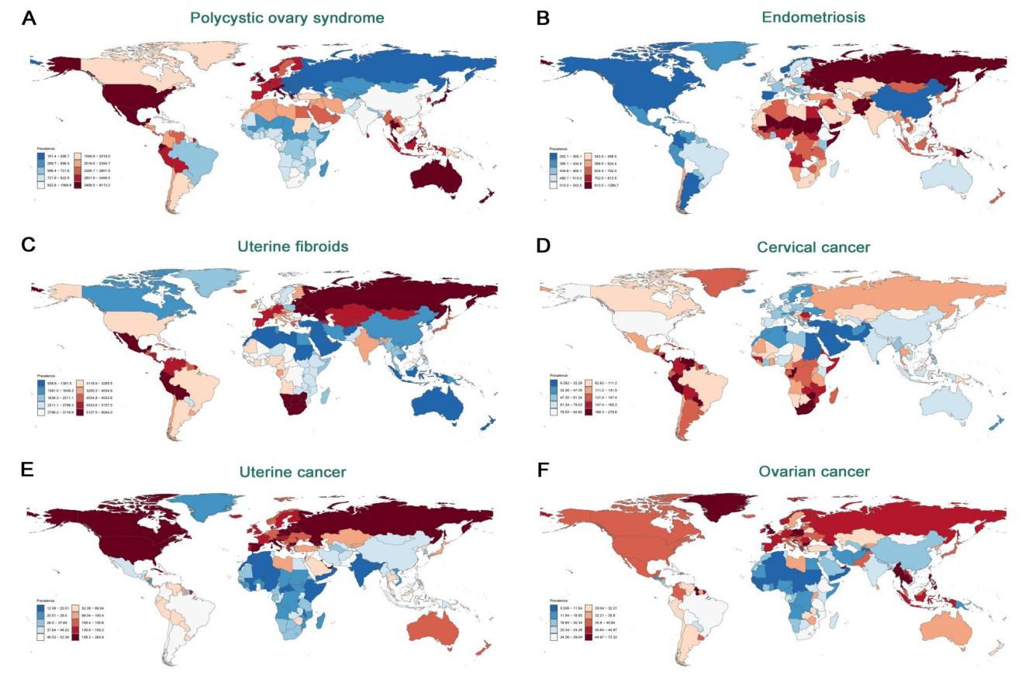
Figure S1. ASPR for six gynecological diseases in 2021: (A) PCOS, (B) Endometriosis, (C) Uterine Fibroids, (D) Cervical Cancer, (E) Ovarian Cancer, (F) Uterine Cancer.

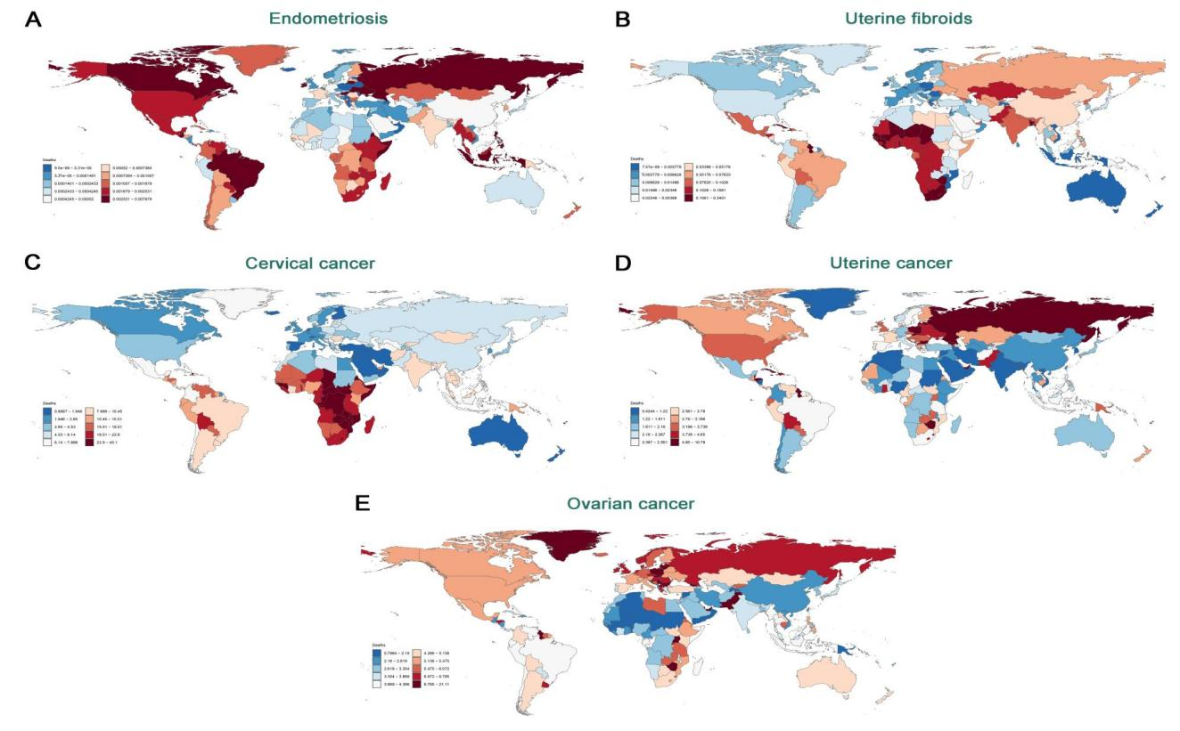
Figure S2. ASMR for six gynecological diseases in 2021: (A) PCOS, (B) Endometriosis, (C) Uterine Fibroids, (D) Cervical Cancer, (E) Ovarian Cancer, (F) Uterine Cancer.
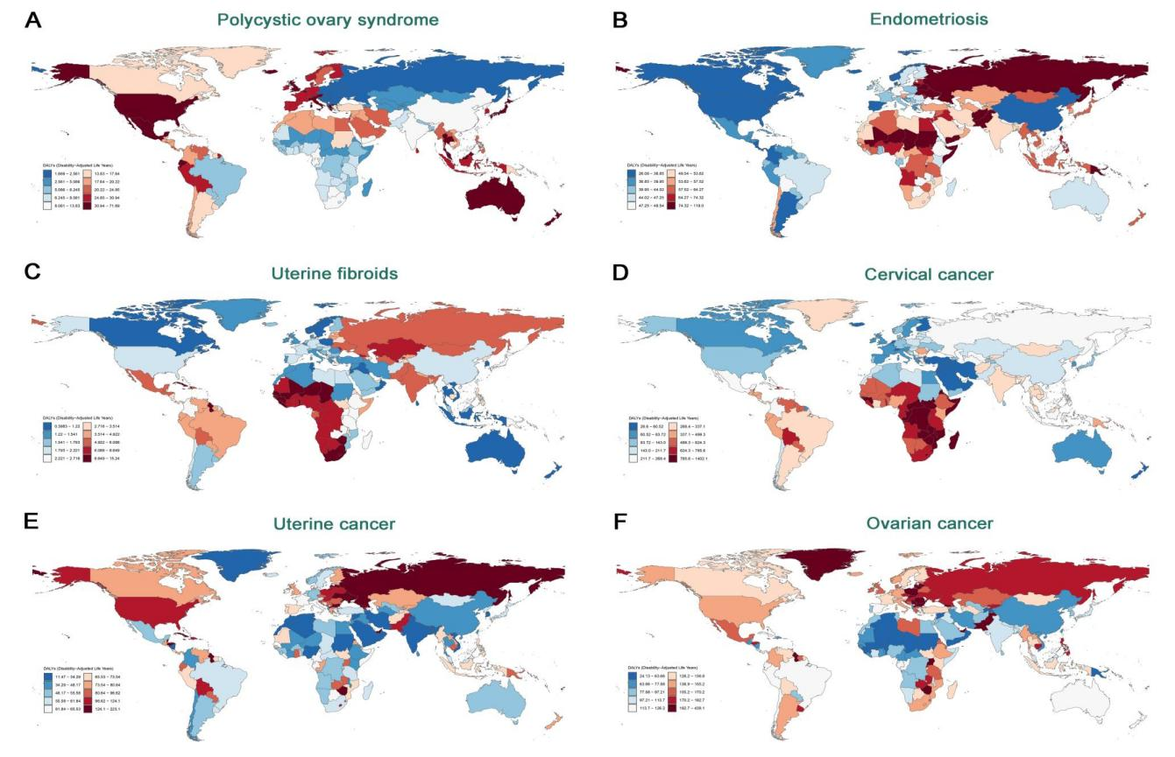
Figure S3. ASDR for six gynecological diseases in 2021: (A) PCOS, (B) Endometriosis, (C) Uterine Fibroids, (D) Cervical Cancer, (E) Ovarian Cancer, (F) Uterine Cancer.
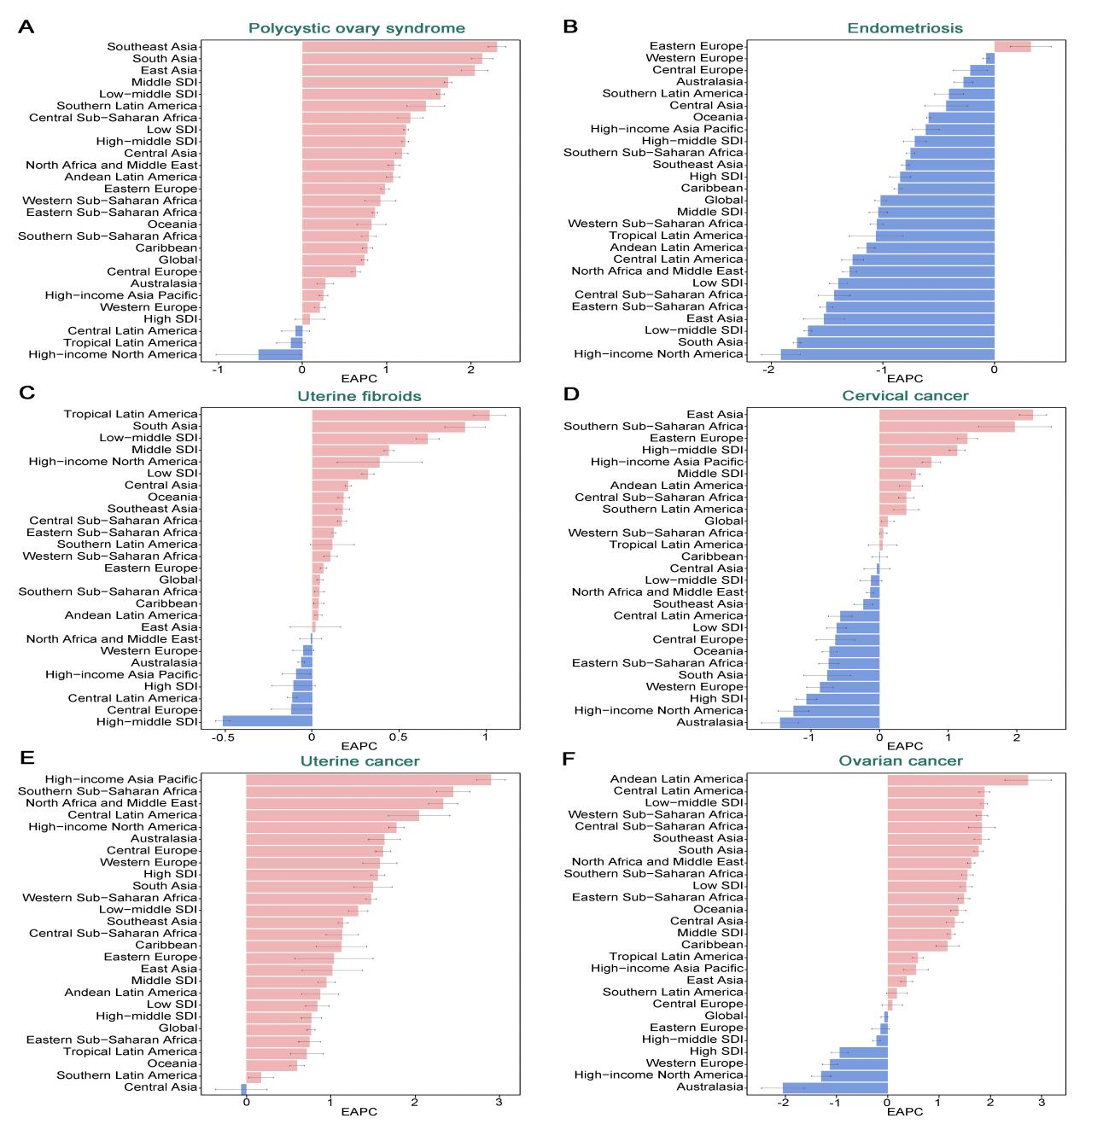
Figure S4. EAPC of ASPR for six gynecological diseases globally and across 21 regions.

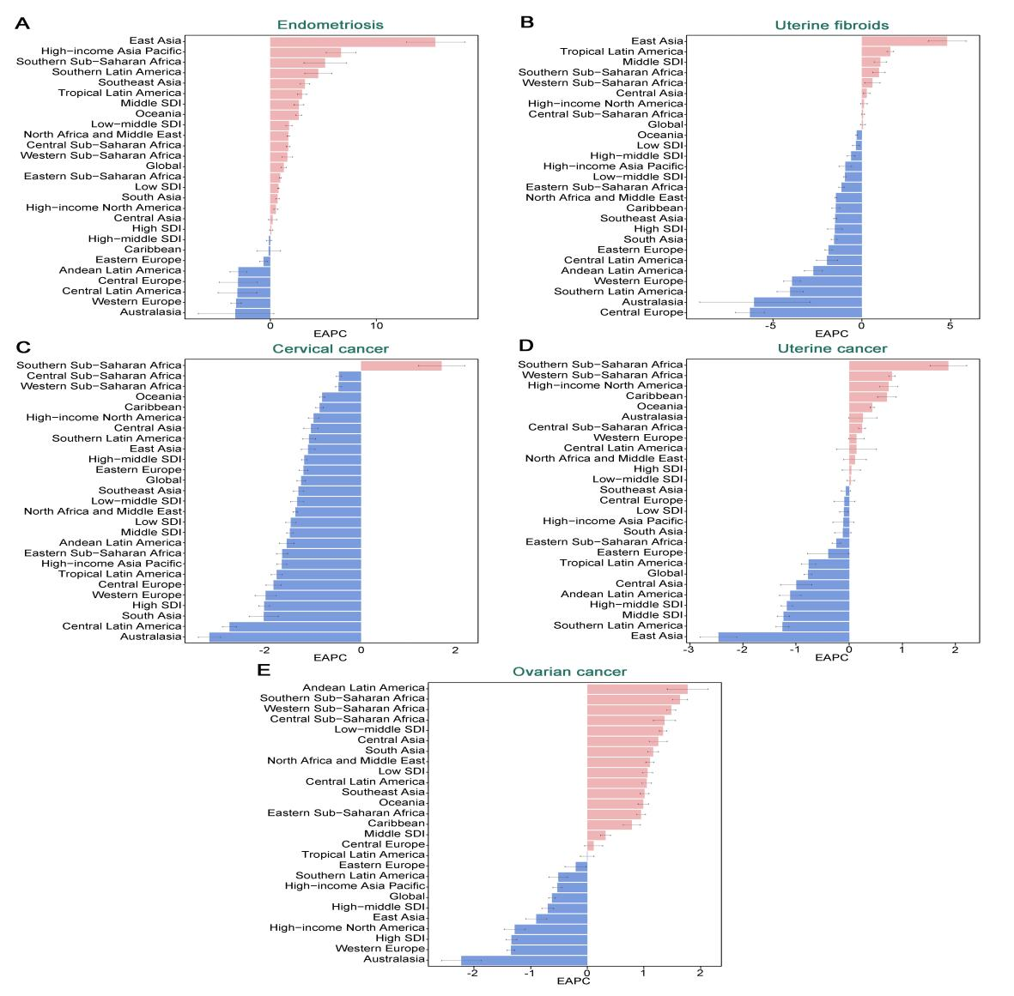
Figure S5. EAPC of ASMR for five gynecological diseases globally and across 21 regions.
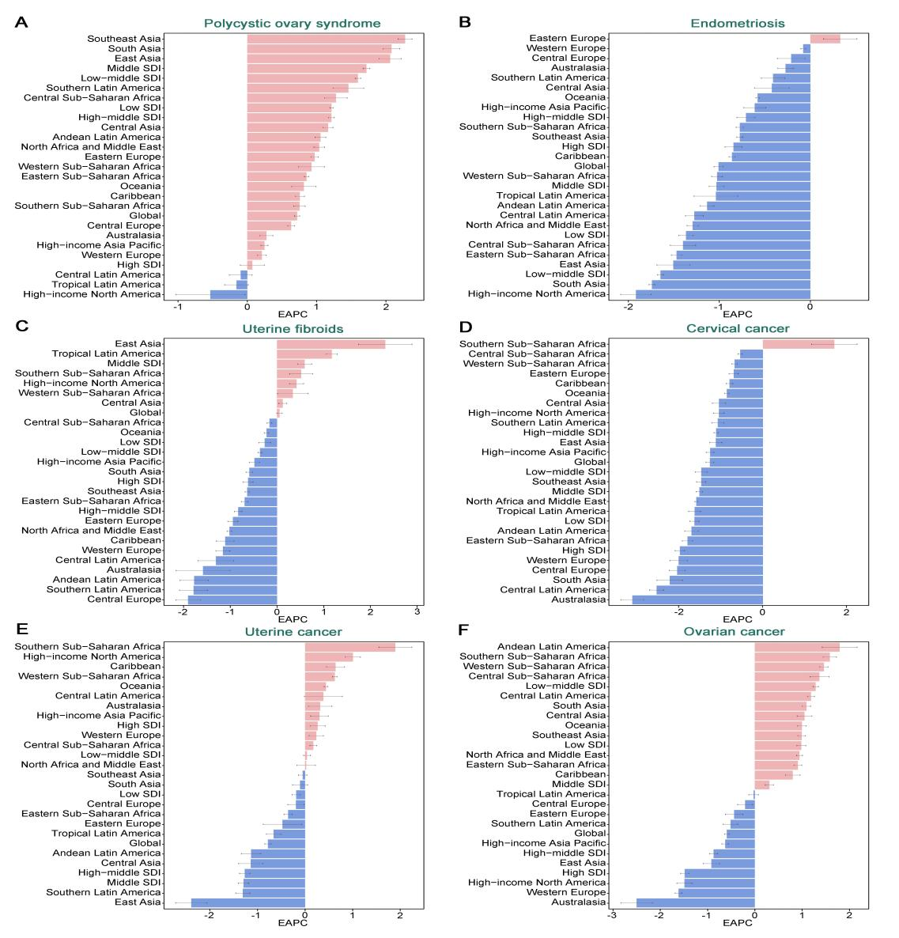
Figure S6. EAPC of ASDR for six gynecological diseases globally and across 21 regions.
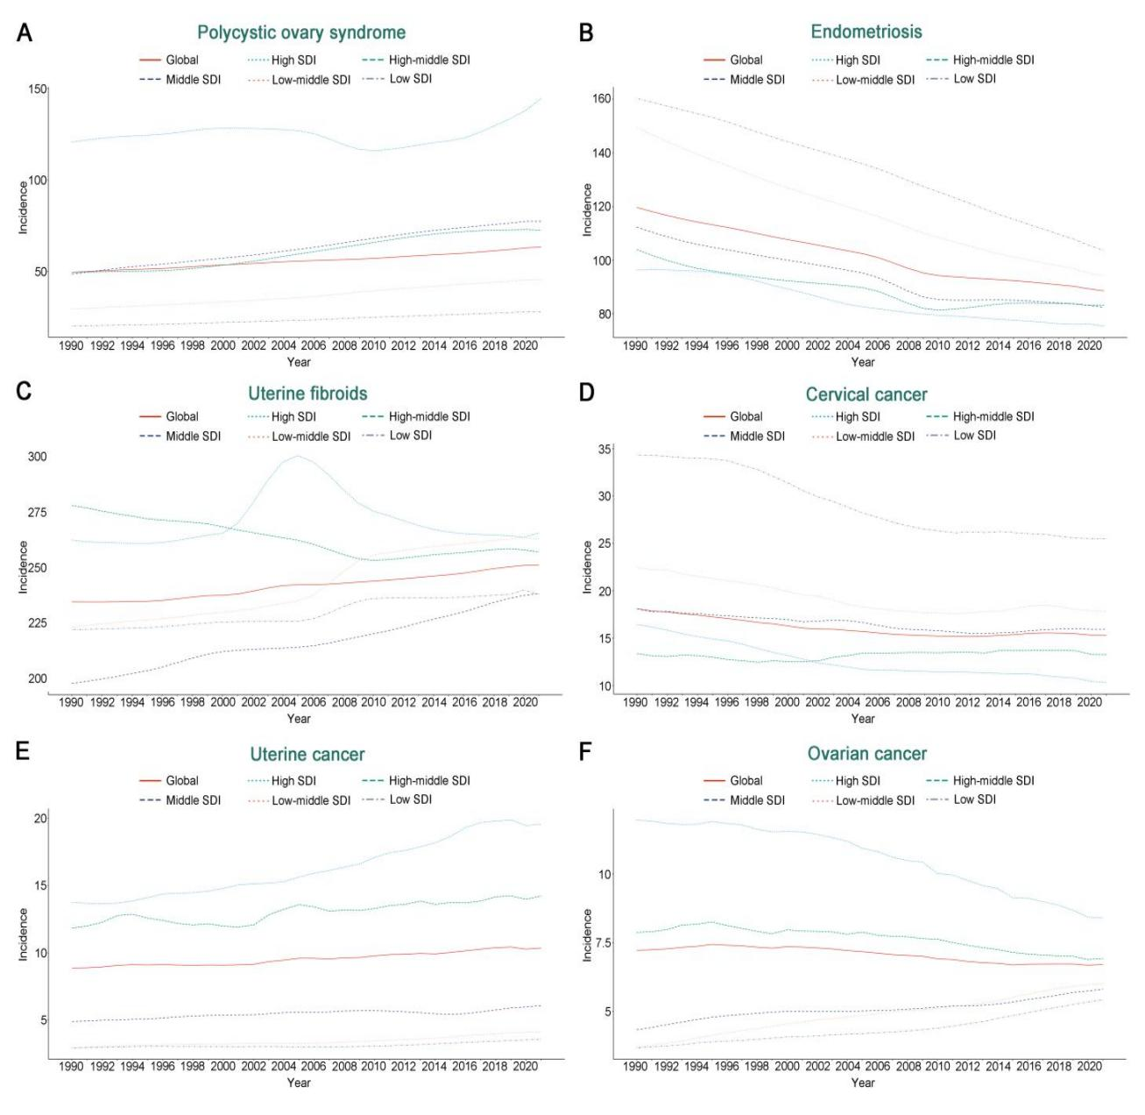
Figure S7. ASIR for six gynecological diseases in different SDI regions from 1990 to 2021.
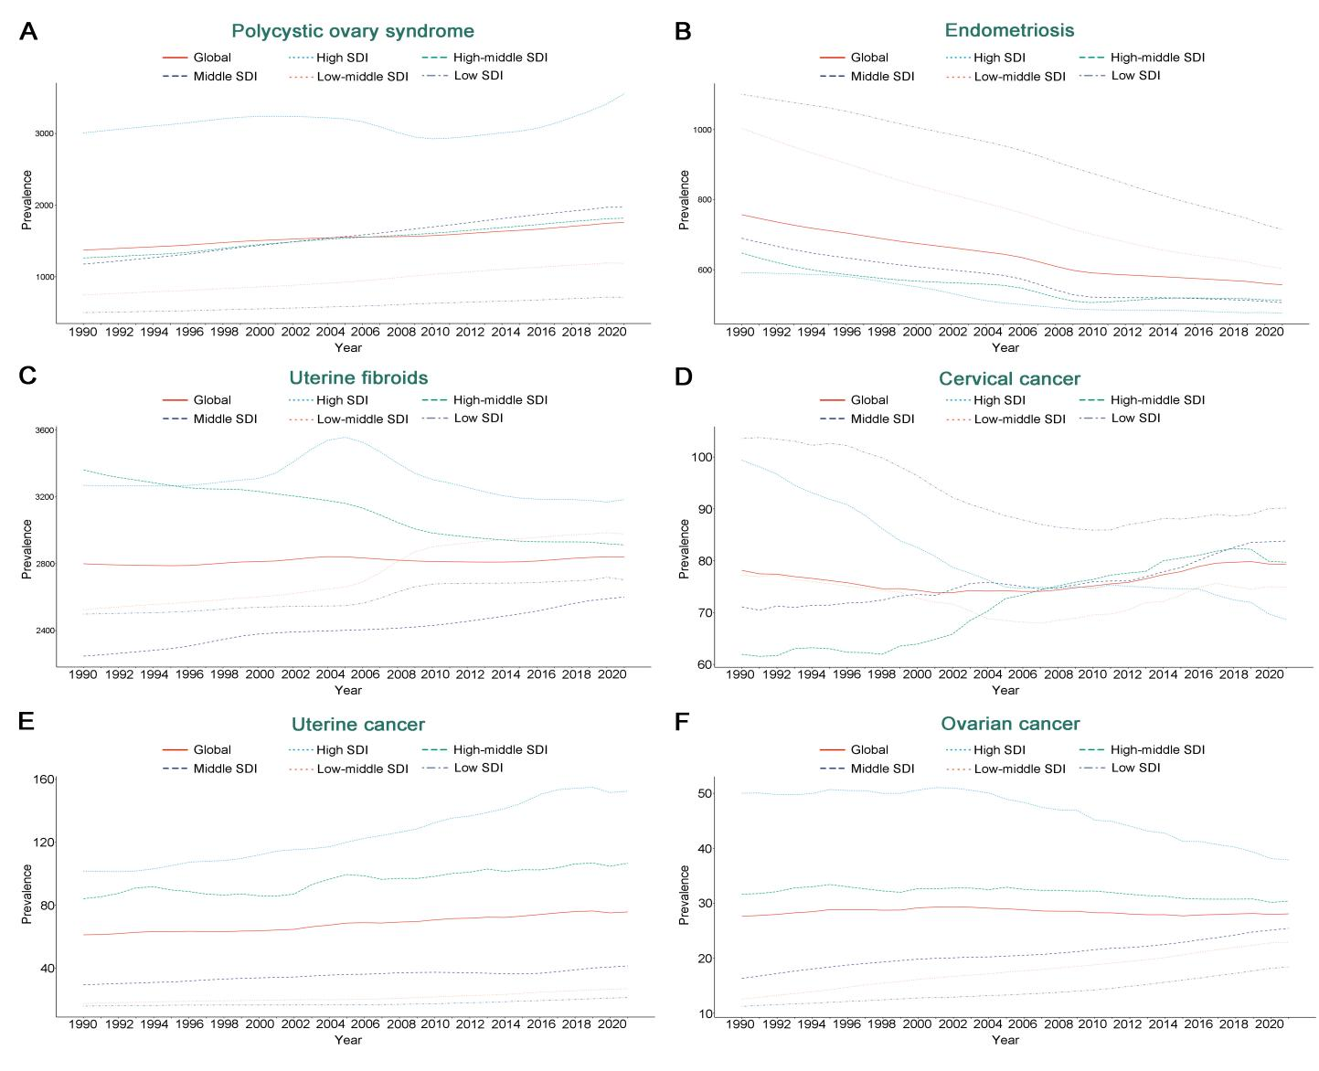
Figure S8. ASPR for six gynecological diseases in different SDI regions from 1990 to 2021.
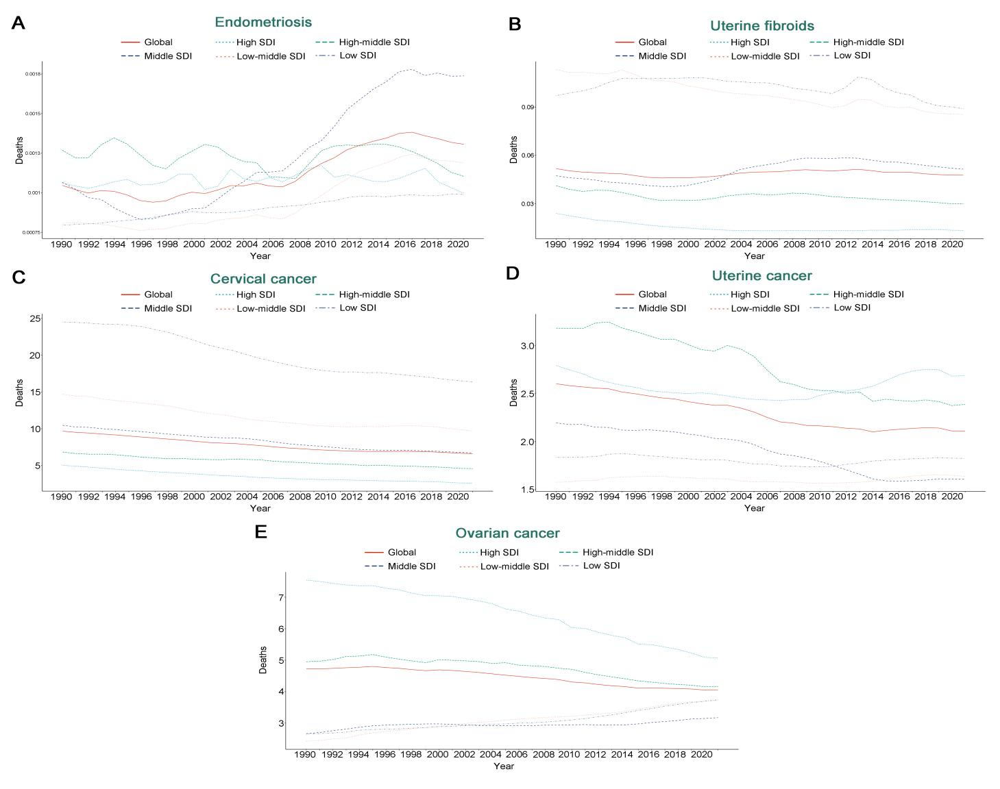
Figure S9. ASMR for five gynecological diseases in different SDI regions from 1990 to 2021.
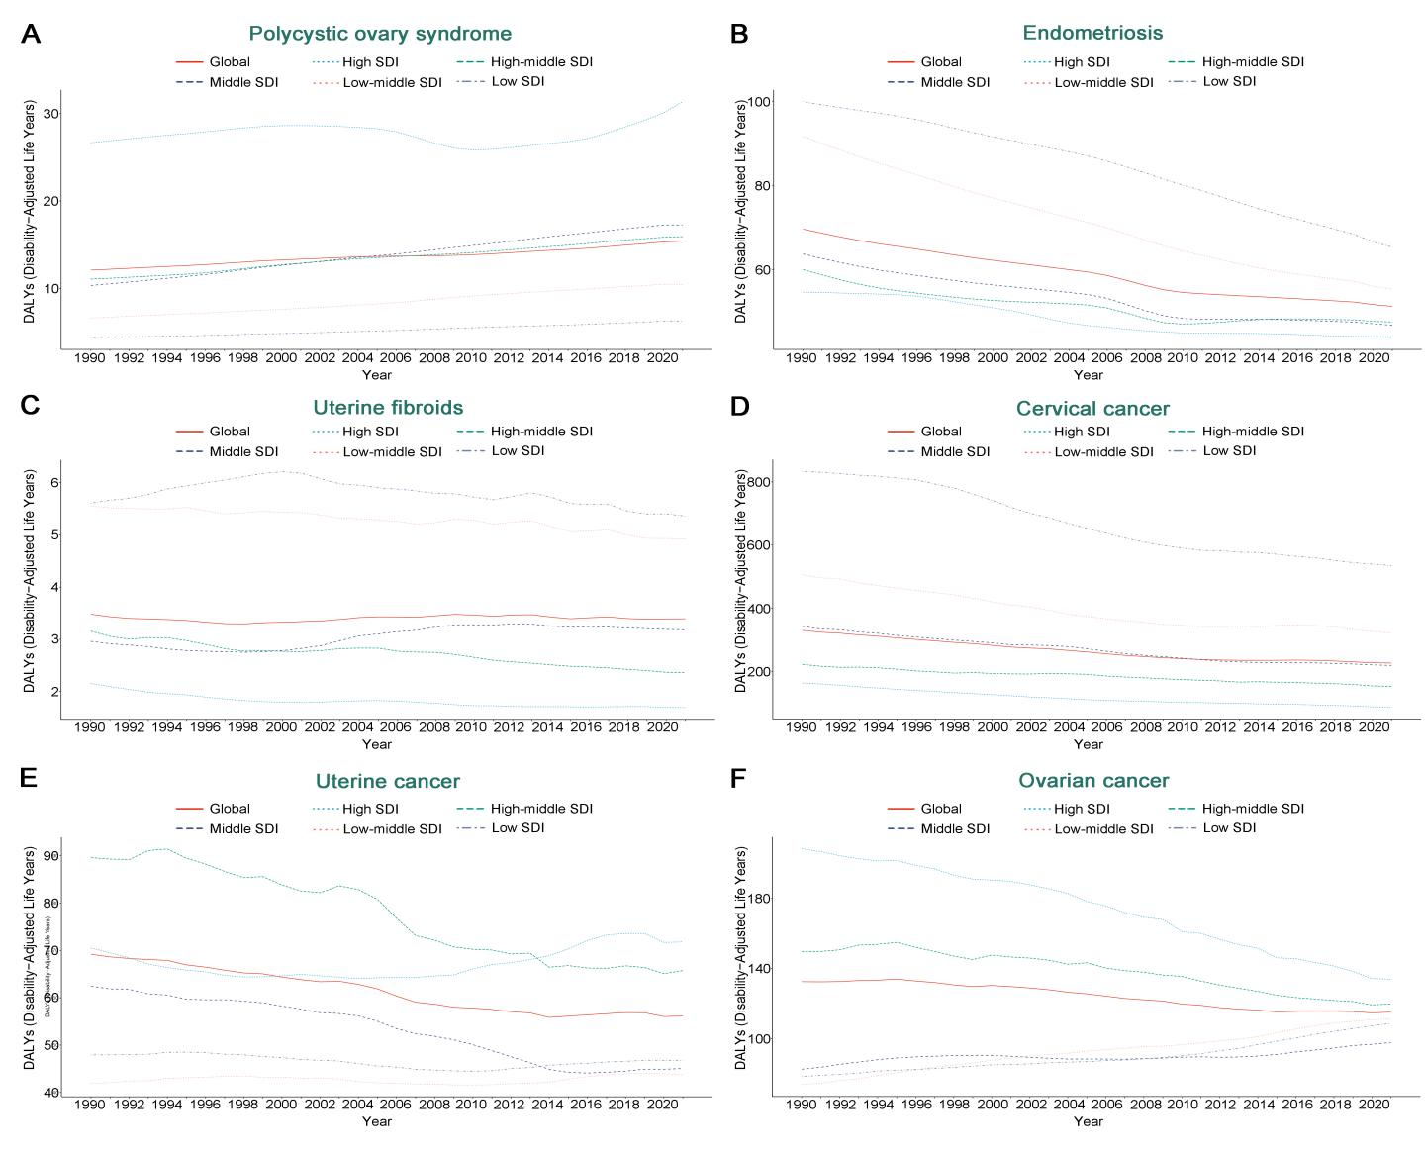
Figure S10. ASDR for six gynecological diseases in different SDI regions from 1990 to 2021.
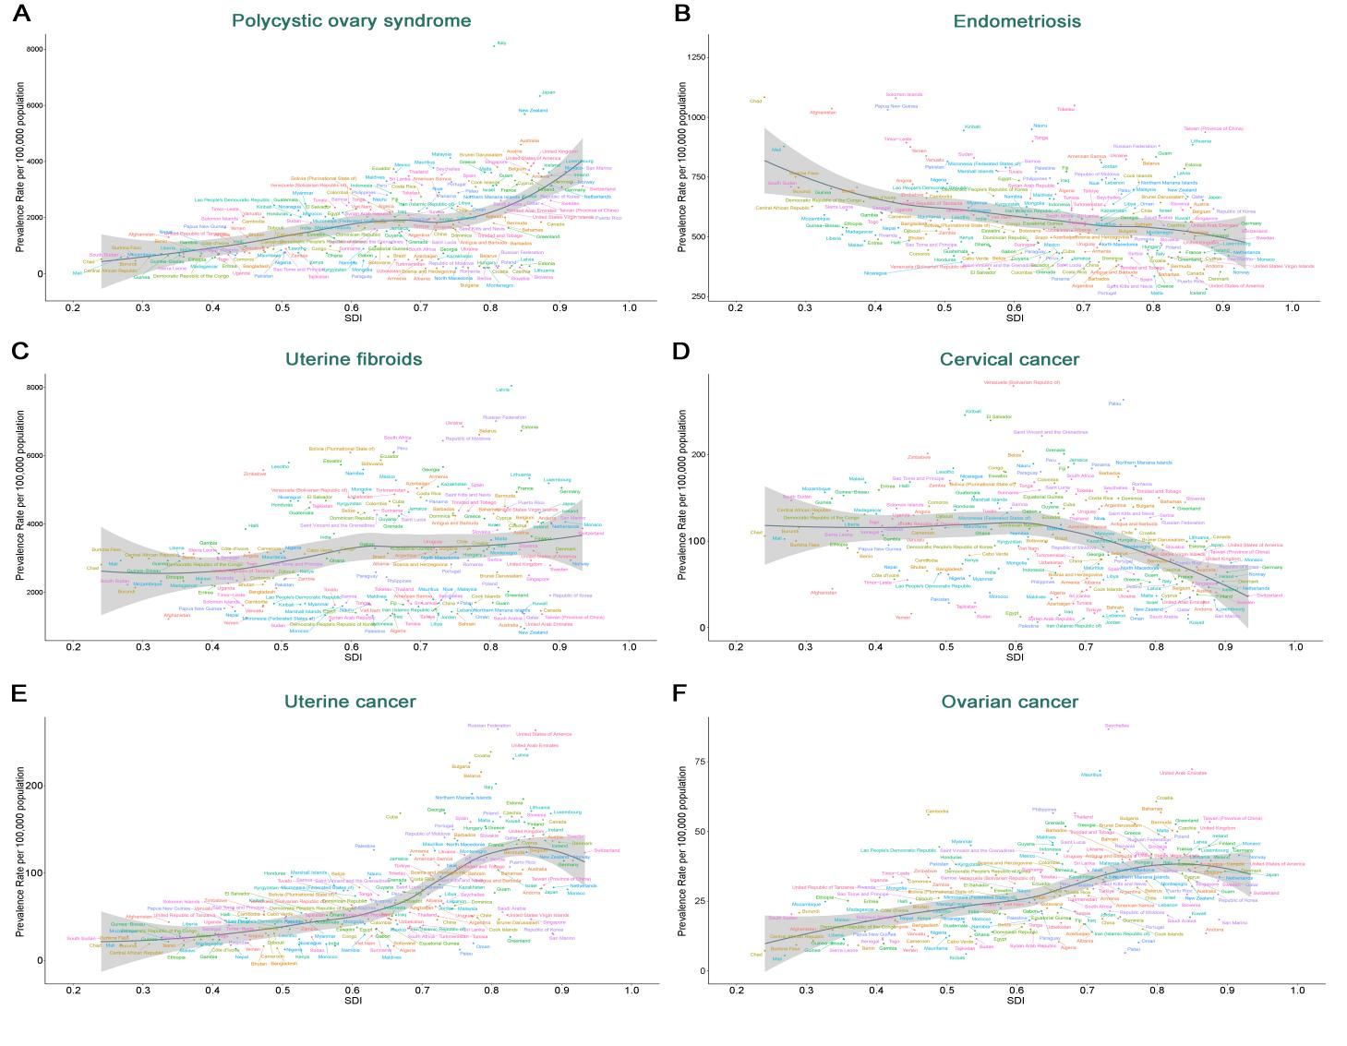
Figure S11. ASPR of six gynecological diseases for 204 countries and territories by SDI.

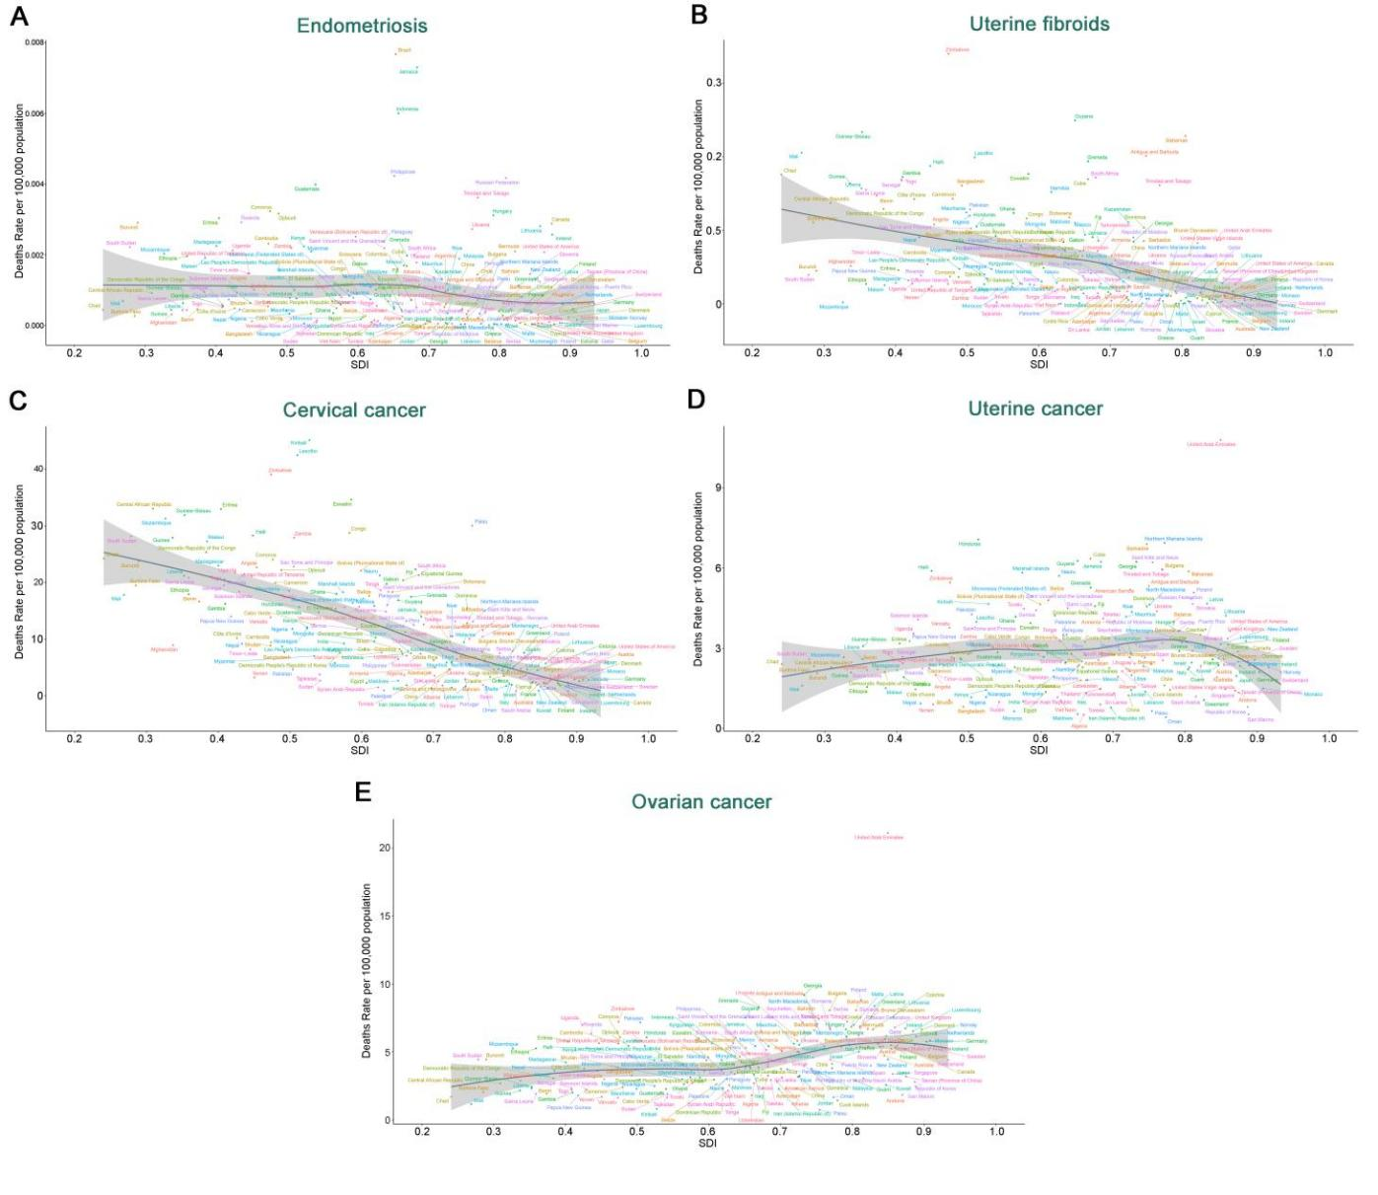
Figure S12. ASMR of five gynecological diseases for 204 countries and territories by SDI.
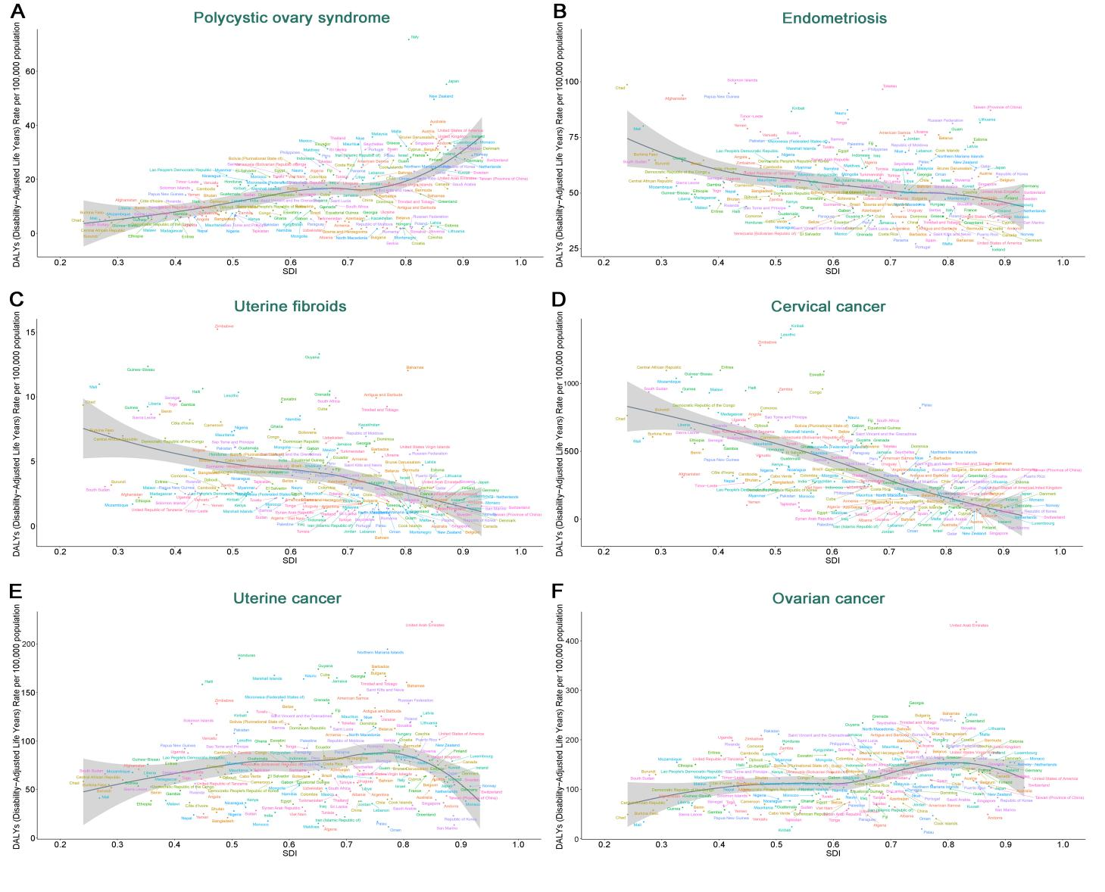
Figure S13. ASDR of six gynecological diseases for 204 countries and territories by SDI.
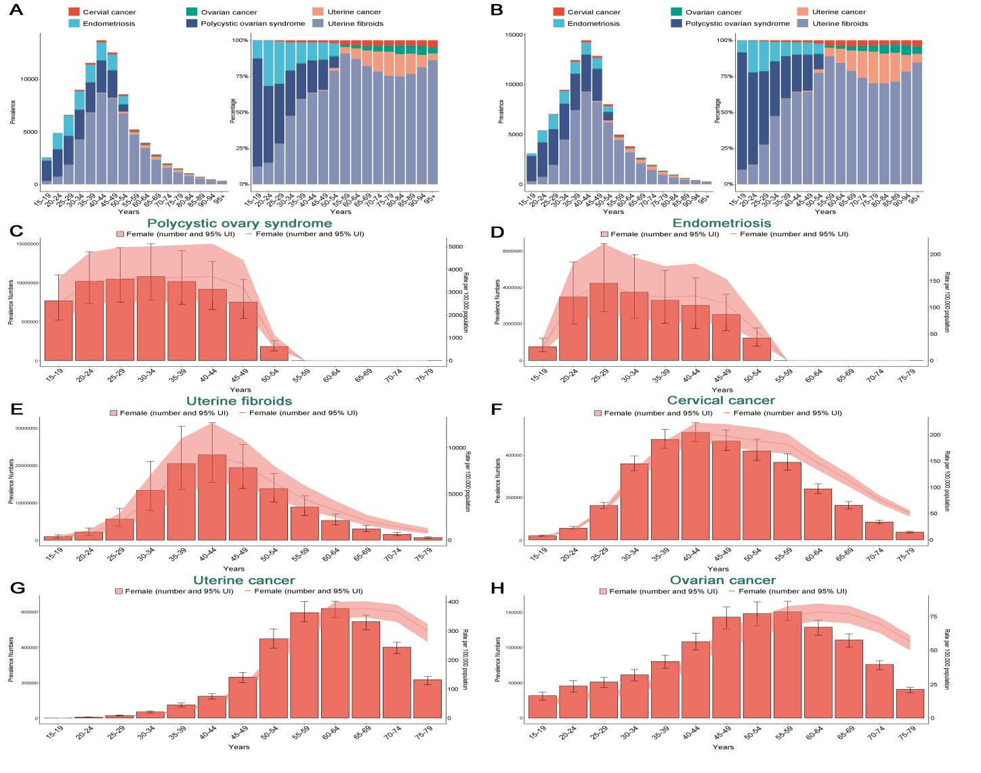
Figure S14. Age- and etiology-specific prevalence proportions of gynecological diseases in 1990 and 2021, and the global prevalence of six gynecological diseases by age in 2021.
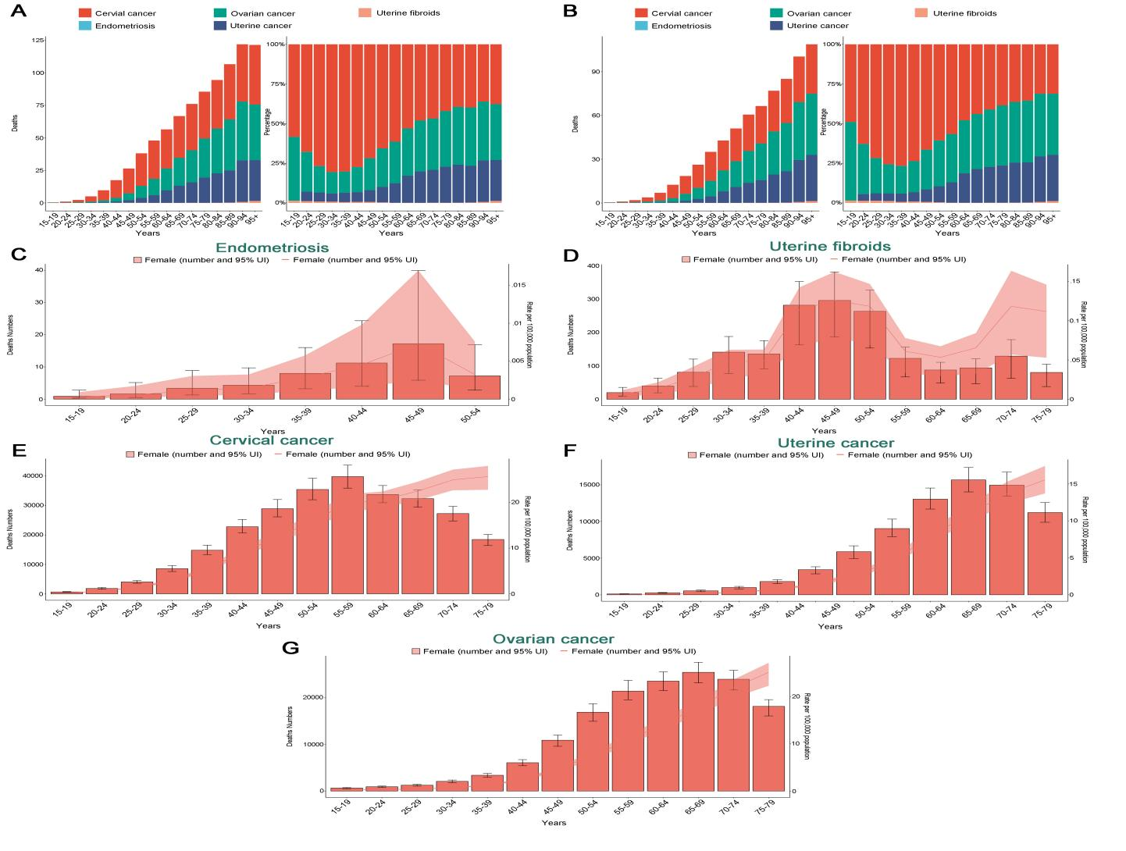
Figure S15. Age- and etiology-specific mortality proportions of gynecological diseases in 1990 and 2021, and the global mortality of five gynecological diseases by age in 2021.

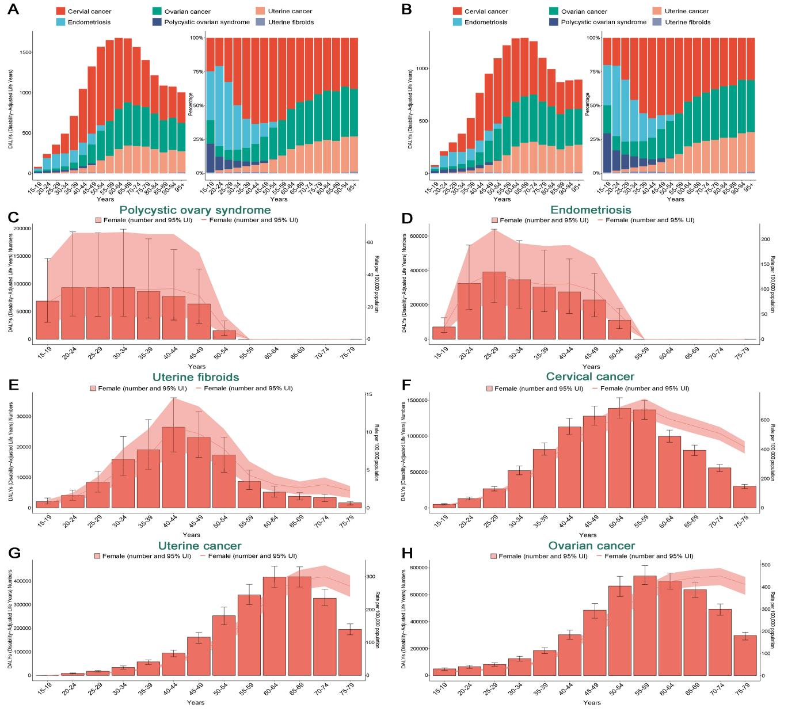
Figure S16. Age- and etiology-specific DALYs proportions of gynecological diseases in 1990 and 2021, and the global DALYs of six gynecological diseases by age in 2021.

