Appendix A. Supplementary data

Number of pregnant women delivering vaginally
N=5,458,483
22 weeks ≤ Gestational weeks ≤ 42 weeks
N=5,451,678
16 ≤ Mother’s age ≤ 50 and singleton live birth
N=5,403,875
Pregnant women who completed their pregnancy and gave birth between 2014 and 2018
N=5,2408,28
Study sample
N=5,240,828

N=5458483
Fig. S1. The original cohort was processed to form the PTB cohort in our study.

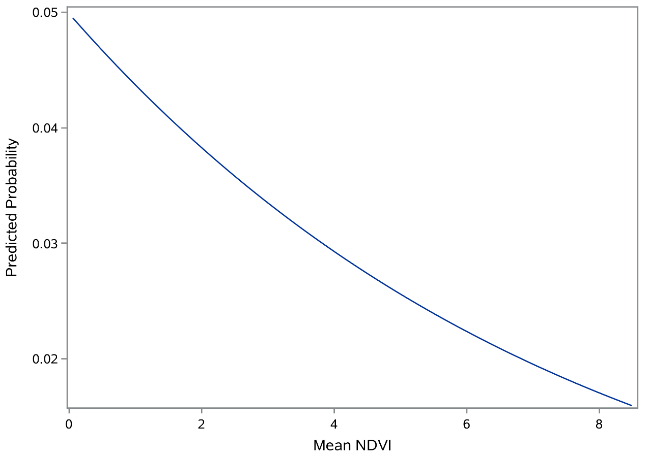
Fig. S2. Dose-response curve of NDVI and probability of preterm birth within 500m of pregnant woman’s residence.

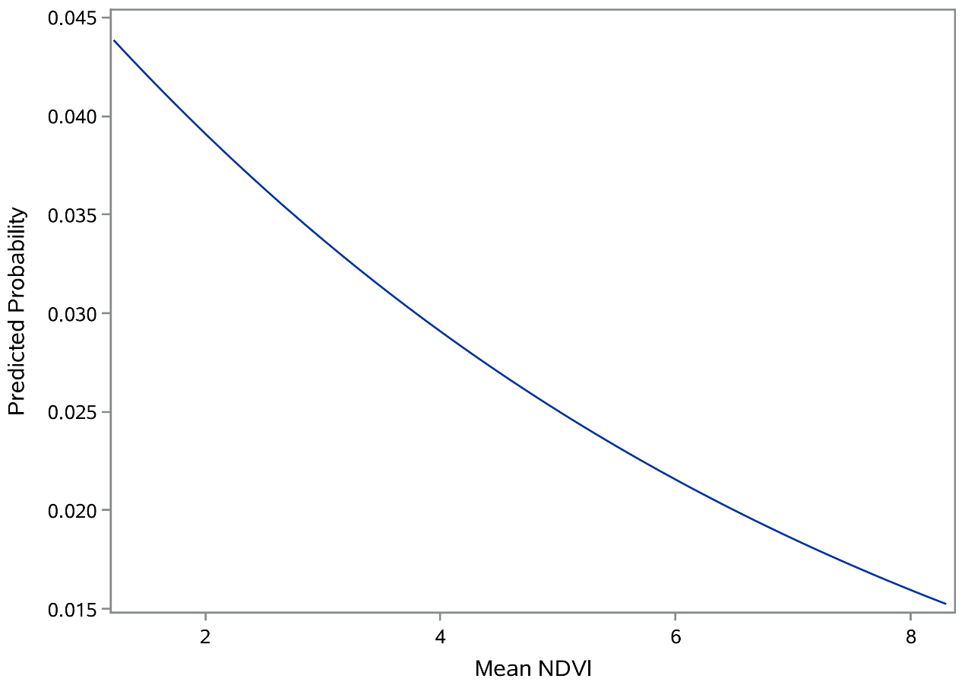
Fig. S3. Dose-response curve of NDVI and probability of preterm birth within 1,000m of pregnant woman’s residence.

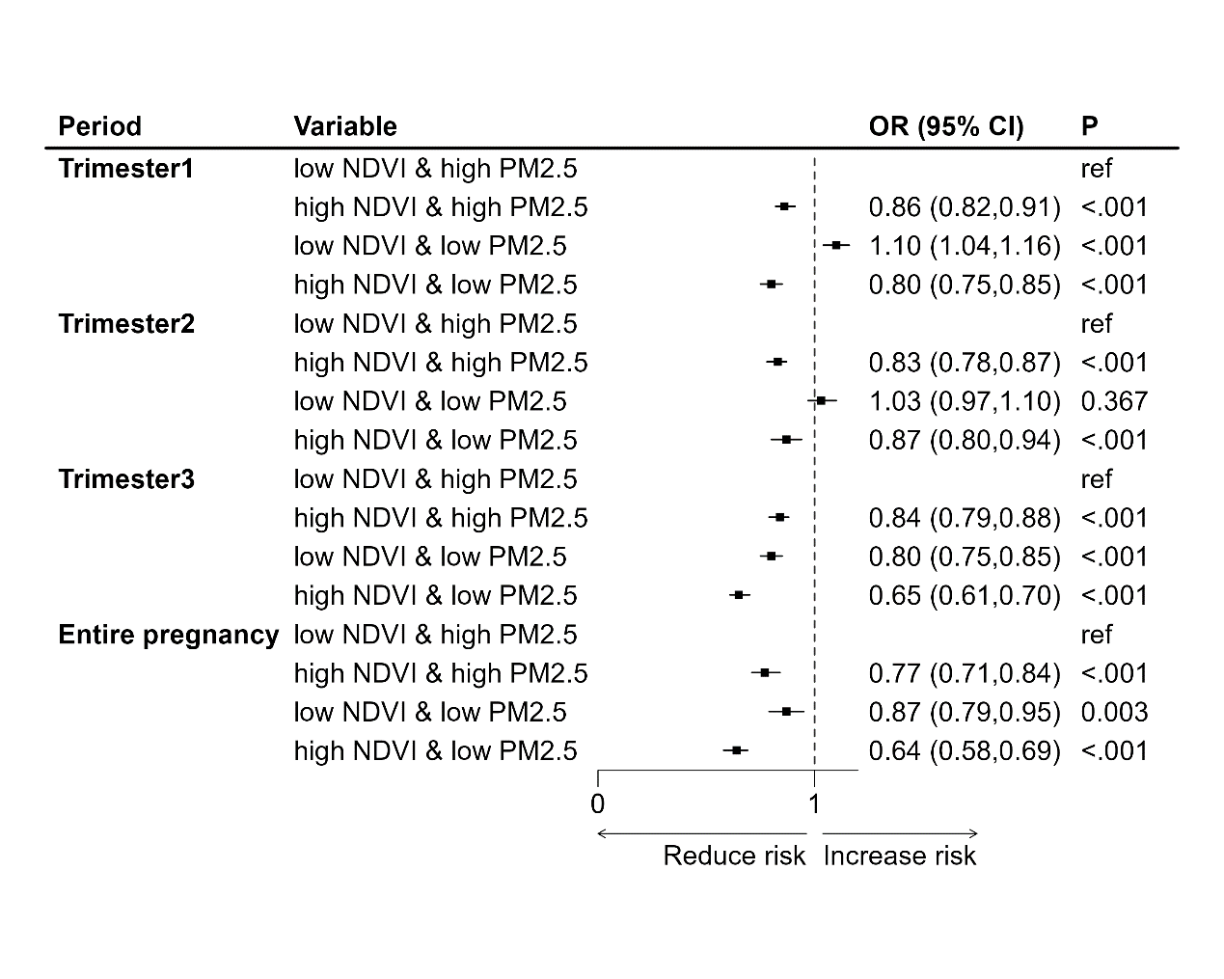
Fig. S4. The joint effects of the new variables on PTB within 500m. Models were constructed by NDVI and PM_{2.5}, and only adjusted the influences of temperature. high NDVI: NDVI ≥ $P_{{50}_{NDVI}}$, and low NDVI: NDVI < $P_{{50}_{NDVI}}$; high PM2.5: PM_{2.5} ≥ $P_{{50}_{{PM}_{2.5}}}$, and low PM2.5: PM_{2.5} < $P_{{50}_{{PM}_{2.5}}}$.
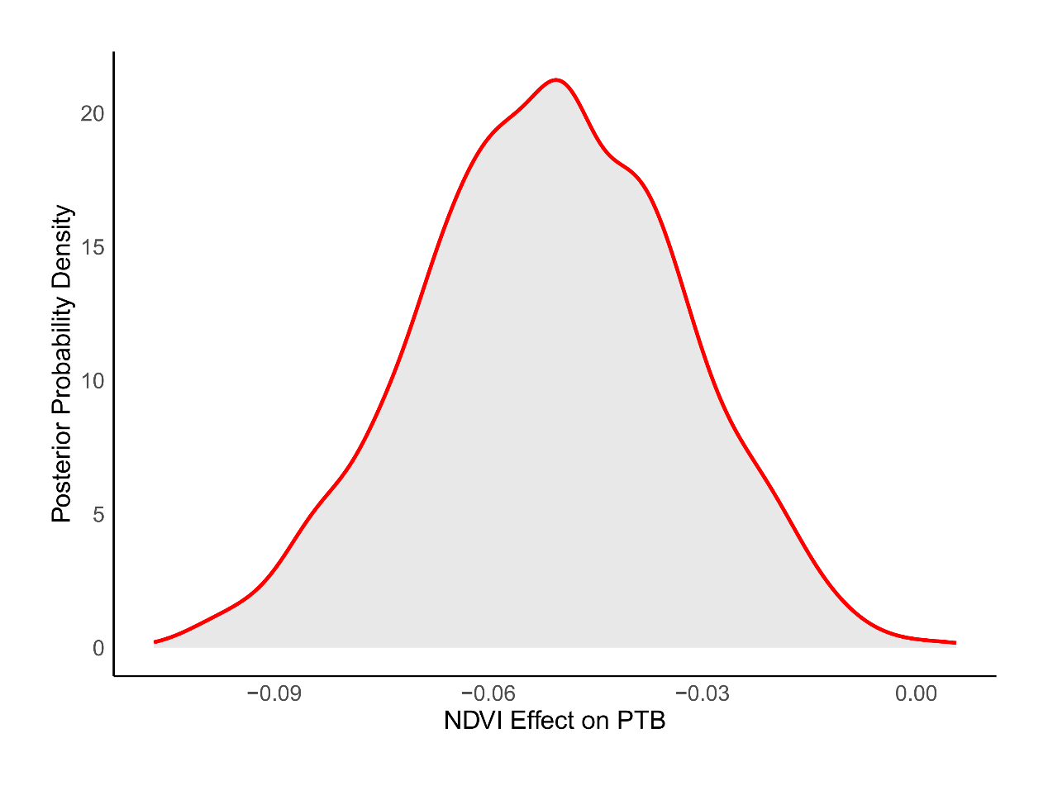
Fig. S5. Posterior probability density plot of the association between NDVI and PTB based on the Bayesian spatiotemporal model. The model adjusted the influences of PM_{2.5}, the region’s average summer temperature, average winter temperature, and GDP.

Table S1
Associations between NDVI and PTB only adjusted by PM_{2.5} and temperature.
Period | OR (95% CI) | P
Trimester 1 | 0.74 (0.71, 0.77) | <.001
Trimester 2 | 0.85 (0.83, 0.88) | <.001
Trimester 3 | 0.84 (0.81, 0.87) | <.001
Entire pregnancy | 0.75 (0.65, 0.86) | <.001

Table S2
Associations between NDVI and PTB when O₃ and NO₂ were added to model sequentially. ª
Factor | Period | OR  95% CI | P
O₃ | Trimester 1 | 0.75 (0.72, 0.79) | <.001
O₃ | Trimester 2 | 0.87 (0.84, 0.90) | <.001
O₃ | Trimester 3 | 0.87 (0.83, 0.90) | <.001
O₃ | Entire pregnancy | 0.80 (0.70, 0.92) | 0.002
NO₂ | Trimester 1 | 0.75 (0.72, 0.79) | <.001
NO₂ | Trimester 2 | 0.87 (0.85, 0.90) | <.001
NO₂ | Trimester 3 | 0.87 (0.84, 0.90) | <.001
NO₂ | Entire pregnancy | 0.81 (0.71, 0.93) | 0.002
ª The models were adjusted by maternal age, neonate’s sex, gravidity, parity, birthing season, PM_{2.5} and temperature.
Table S3
Associations between NDVI and PTB within 500m stratified by neonate’s sex, maternal age, gravidity and parity.
Period | Subgroup1 | OR (95% CI) | Subgroup2 | OR (95% CI)
Maternal age
Trimester 1 | < 35 years | 0.72 (0.69, 0.76) * | ≥ 35 years | 0.72 (0.67, 0.78) *
Trimester 2 | < 35 years | 0.86 (0.83, 0.89) * | ≥ 35 years | 0.85 (0.81, 0.89) *
Trimester 3 | < 35 years | 0.86 (0.83, 0.89) * | ≥ 35 years | 0.83 (0.78, 0.88) *
Entire pregnancy | < 35 years | 0.80 (0.70, 0.92) * | ≥ 35 years | 0.80 (0.67, 0.95) *
Neonate’s sex
Trimester 1 | female | 0.73 (0.70, 0.77) * | male | 0.71 (0.68, 0.75) *
Trimester 2 | female | 0.85 (0.82, 0.88) * | male | 0.88 (0.85, 0.91) *
Trimester 3 | female | 0.85 (0.82, 0.89) * | male | 0.86 (0.82, 0.89) *
Entire pregnancy | female | 0.78 (0.68, 0.90) * | male | 0.83 (0.72, 0.95) *
Gravidity
Trimester 1 | No | 0.71 (0.67, 0.75) * | Yes | 0.73 (0.70, 0.77) *
Trimester 2 | No | 0.86 (0.82, 0.90) * | Yes | 0.86 (0.83, 0.89) *
Trimester 3 | No | 0.86 (0.81, 0.90) * | Yes | 0.85 (0.82, 0.89) *
Entire pregnancy | No | 0.76 (0.65, 0.89) * | Yes | 0.83 (0.72, 0.95) *
Parity
Trimester 1 | No | 0.72 (0.68, 0.76) * | Yes | 0.73 (0.69, 0.76) *
Trimester 2 | No | 0.87 (0.84, 0.91) * | Yes | 0.86 (0.83, 0.89) *
Trimester 3 | No | 0.86 (0.82, 0.90) * | Yes | 0.86 (0.82, 0.89) *
Entire pregnancy | No | 0.79 (0.67, 0.93) * | Yes | 0.82 (0.72, 0.93) *
* indicates statistical significance (P < 0.05)

