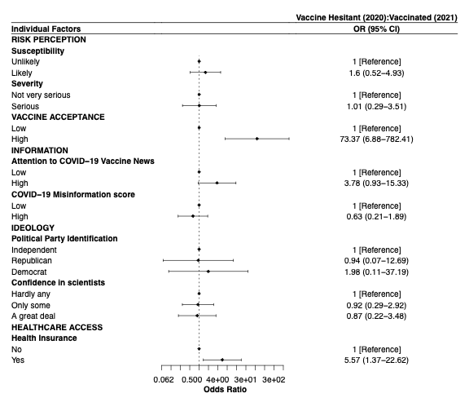
Figure S1: Odds ratios and 95% Confidence Interval plots for association between predictors of intention-behavior gap and being vaccinated (2021) among vaccine hesitant (2020) individuals, after adjusting for other predictors as well as demographic and social factors including gender, age, education, income, and race/ethnicity [OR = Odds Ratio, CI = Confidence Intervals].
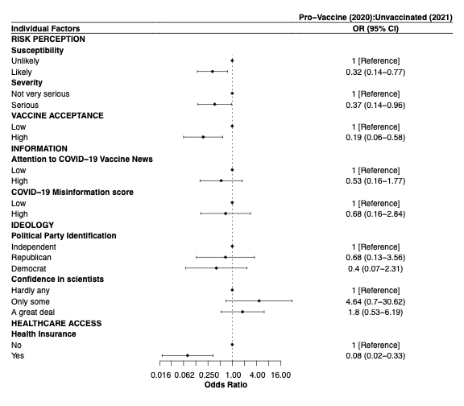
Figure S2: Odds ratios and 95% Confidence Interval plots for association between predictors of intention-behavior gap and being unvaccinated (2021) among pro-vaccine (2020) individuals, after adjusting for other predictors as well as demographic and social factors including gender, age, education, income, and race/ethnicity [OR = Odds Ratio, CI = Confidence Intervals].

