SUPPLEMENTAL ONLINE MATERIALS
Linking cardiometabolic multimorbidity to depressive symptoms in oldest-old people: results from a cross-sectional study in Germany
Verena Maschke¹, Valerie Lohner¹, Ute Mons¹
Affiliations:
¹Cardiovascular Epidemiology of Aging, Department of Cardiology, Faculty of Medicine and University Hospital Cologne, University of Cologne, Germany.

Table of contents
A1. Descriptive analyses 3
Table A1 The mean of depressive symptoms with standard deviation (SD) and the prevalence of depressive mood with 95% confidence interval (CI) according to individual cardiometabolic diseases (CMD) and categorical CMD index 3
Figure A1 The ten most common cardiometabolic disease (CMD) combinations. 4
A2. Sensitivity analyses 5
Figure A2 Associations of cardiometabolic disease (CMD) indices excluding each CMD individually with depressive symptoms: results from linear regression models (beta estimates with 95% confidence intervals). 5
Table A2 Associations of individual cardiometabolic diseases (CMDs) and CMD indices with depressive symptoms, excluding proxy interviews: results from linear regression models. 6
Table A3 Associations of individual cardiometabolic diseases (CMDs) and CMD indices with depressive mood: results from logistic regression models. 7

A1. Descriptive analyses
Table A1 The mean of depressive symptoms with standard deviation (SD) and the prevalence of depressive mood with 95% confidence interval (CI) according to individual cardiometabolic diseases (CMD) and categorical CMD index.
 |  | Depressive symptomsª |  | Depressive mood^{b}
 | N | Mean | SD | n (%) | 95% CI
Myocardial infarction
no | 1581 | 0.93 | 1.13 | 429 (27.1) | 25.0 – 29.4
yes | 128 | 1.05 | 1.09 | 36 (28.1) | 21.1 – 36.5
Heart failure
no | 1102 | 0.85 | 1.09 | 276 (25.0) | 22.6 – 27.7
yes | 607 | 1.10 | 1.18 | 189 (31.1) | 27.6 – 35.0
Hypertension
no | 710 | 0.89 | 1.14 | 184 (26.0) | 22.8 – 29.3
yes | 999 | 0.97 | 1.11 | 281 (28.1) | 25.4 – 31.0
Stroke
no | 1576 | 0.90 | 1.10 | 409 (25.6) | 23.8 – 28.2
yes | 133 | 1.35 | 1.36 | 56 (42.1) | 34.1 – 50.6
Diabetes
no | 1438 | 0.90 | 1.11 | 376 (26.1) | 23.9 – 28.5
yes | 271 | 1.11 | 1.24 | 89 (32.8) | 27.5 – 38.6
Kidney disease
no | 1582 | 0.92 | 1.13 | 426 (27.0) | 24.8 – 29.2
yes | 127 | 1.12 | 1.14 | 39 (30.7) | 23.4 – 39.2
Obesity
no | 1426 | 0.90 | 1.11 | 371 (26.0) | 23.8 – 28.4
yes | 210 | 1.09 | 1.14 | 66 (31.4) | 25.5 – 38.0
Categorical CMD index
0 | 339 | 0.77 | 1.06 | 80 (23.6) | 19.4 – 28.4
1 | 576 | 0.78 | 1.04 | 124 (21.5) | 18.4 – 25.1
2 | 441 | 1.07 | 1.16 | 139 (31.5) | 27.4 – 36.0
≥ 3 | 271 | 1.17 | 1.21 | 90 (33.2) | 27.9 – 39.0
ª4-item short form of depression in old age (DIA-S4, range: 0-4 points). ^{b}DIA-S4 ≥ 1.5.

Figure A1 The ten most common cardiometabolic disease (CMD) combinations.
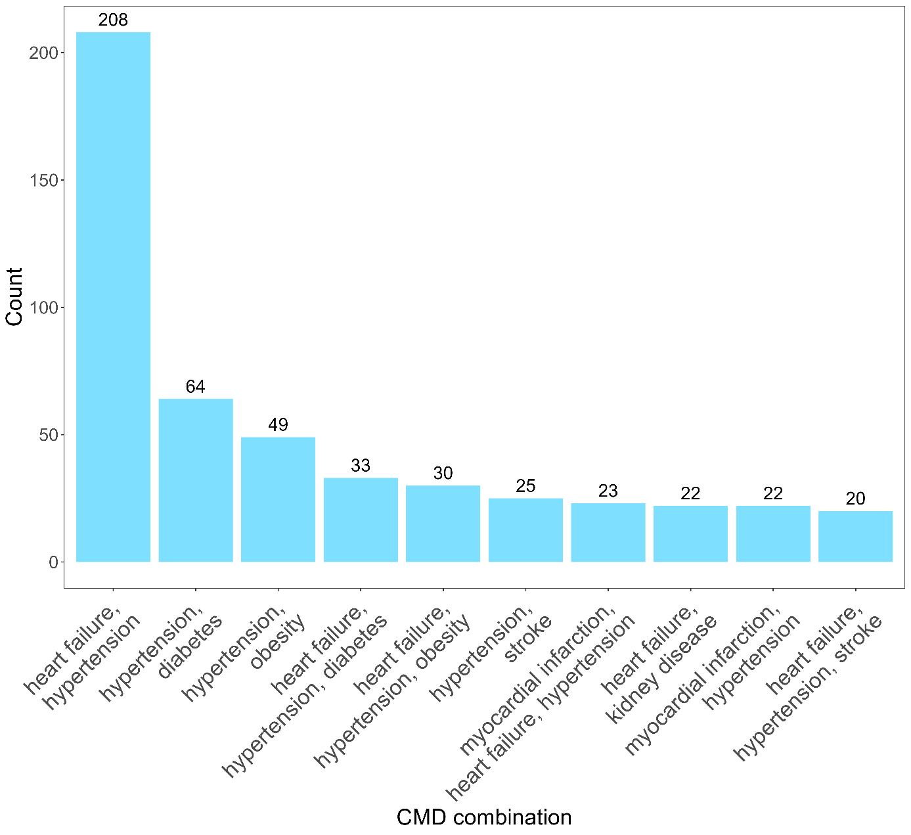

A2. Analysis of missing data

Table A2 Comparison of study participants with missing data for the final analyses (All missing values).
 | Missing values  (N = 280) | Included  (N = 1,583) | p value | Statistical test
Sex, n (%) |  |  | 0.001 | Chi-square test
Men | 112 (40.0) | 815 (51.5)
Women | 168 (60.0) | 768 (48.5)
Age group, n (%) |  |  | <0.001 | Chi-square test
80 – 84 years | 78 (27.9) | 650 (41.1)
85 – 89 years | 103 (36.8) | 522 (33.0
90 years and older | 99 (35.4) | 411 (26.0)

Table A3 Comparison of study participants with missing data for the final analyses (Missing values of DIA-S4).
 | Missing values  (N = 136) | Included  (N = 1,727) | p value | Statistical test
 | 136 | 1,727
Sex, n (%) |  |  | 0.883 | Chi-square test
Men | 69 (50.7) | 858 (49.7)
Women | 67 (49.3) | 869 (50.3)
Age group, n (%) |  |  | 0.360 | Chi-square test
80 – 84 years | 46 (33.8) | 682 (39.5)
85 – 89 years | 47 (34.6) | 578 (33.5)
90 years and older | 43 (31.6) | 467 (27.0)
Categorized CMD index, n (%) |  |  | 0.897 | Chi-square test
0 | 23 (18.9) | 339 (20.8)
1 | 42 (34.4) | 576 (35.4)
2 | 34 (27.9) | 441 (27.1)
≥ 3 | 23 (18.9) | 271 (16.7)
Respiratory and pulmonary disease, n (%) |  |  | 0.896 | Chi-square test
No | 116 (86.6) | 1,493 (87.4)
Yes | 18 (13.4) | 216 (12.6)
Cancer, n (%) |  |  | 0.440 | Chi-square test
No | 120 (89.6) | 1,570 (91.9)
Yes | 14 (10.4) | 139 (8.1)
Liver disease, n (%) |  |  | 0.325 | Chi-square test
No | 134 (100.0) | 1,685 (98.6)
yes | 0 (0.0) | 24 (1.4)
Socio-economic index, mean (SD) | 39.13 (19.24) | 42.93 (21.36) | 0.048 | t-test

Table A4 Comparison of study participants with missing data for the final analyses (Missing values of the CMD index).
 | Missing values  (N = 114) | Included  (N = 1,749) | p value | Statistical test
Sex, n (%) |  |  | <0.001 | Chi-square test
Men | 32 (28.1) | 895 (51.2)
Women | 82 (71.9) | 854 (48.8)
Age group, n (%) |  |  | <0.001 | Chi-square test
80 – 84 years | 26 (22.8) | 702 (40.1)
85 – 89 years | 43 (37.7) | 582 (33.3)
90 years and older | 45 (39.5) | 465 (26.6)
Depressive symptoms, mean (SD) | 1.23 (1.32) | 0.92 (1.12) | 0.008 | t-test
Respiratory and pulmonary disease, n (%) |  |  | 0.648 | Chi-square test
No | 84 (89.4) | 1,525 (87.2)
Yes | 10 (10.6) | 224 (12.8)
Cancer, n (%) |  |  | 0.907 | Chi-square test
No | 87 (92.6) | 1,603 (91.7)
Yes | 7 (7.4) | 146 (8.3)
Liver disease, n (%) |  |  | 1.000 | Chi-square test
No | 93 (98.9) | 1,726 (98.7)
yes | 1 (1.1) | 23 (1.3)
Socio-economic index, mean (SD) | 35.40 (19.20) | 43.09 (21.27) | <0.001 | t-test

A3. Sensitivity analyses

Figure A2 Associations of cardiometabolic disease (CMD) indices excluding each CMD individually with depressive symptoms: results from linear regression models (beta estimates with 95% confidence intervals).
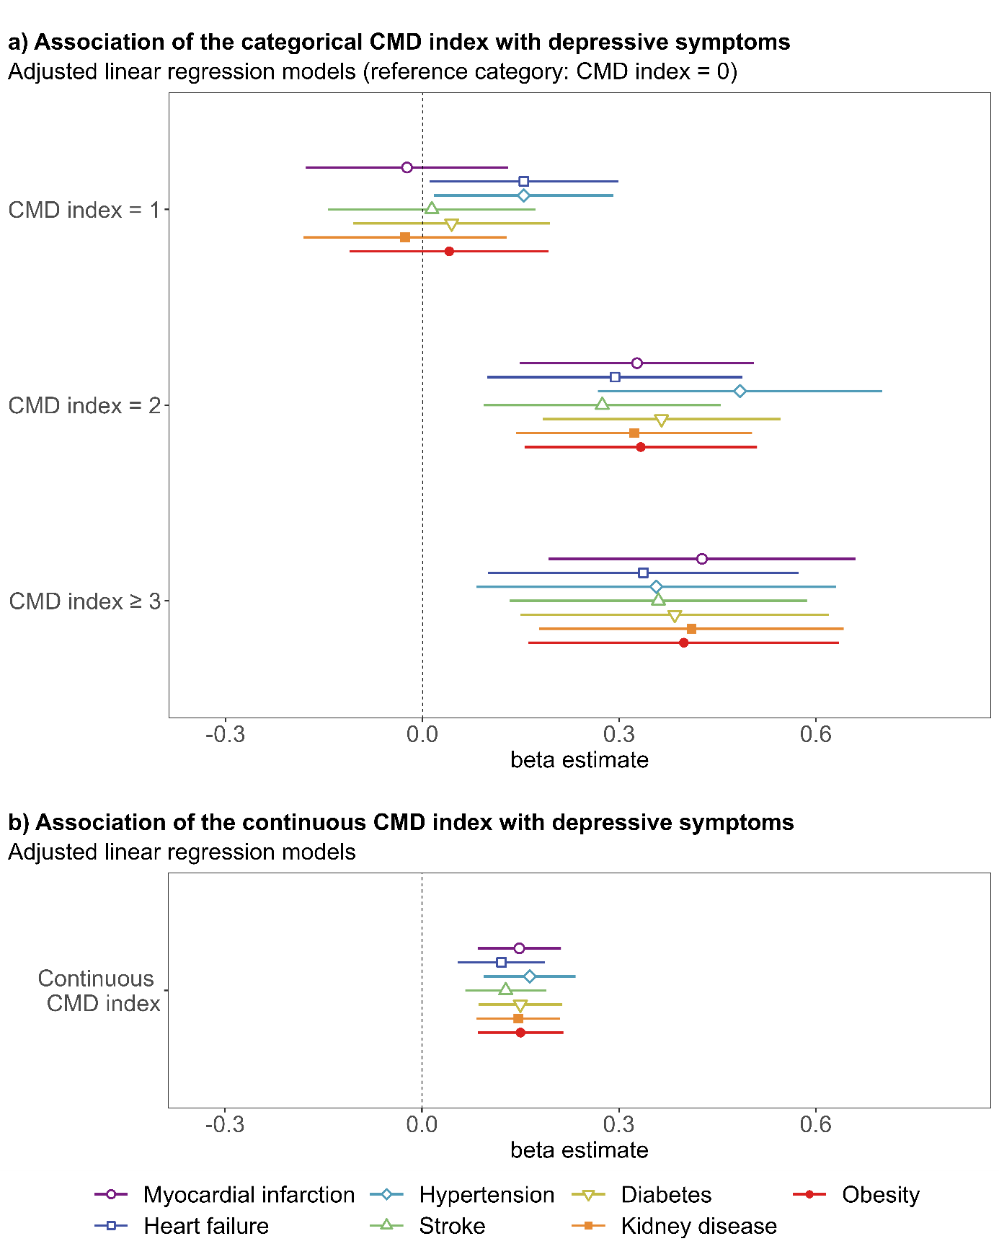

Table A5 Associations of individual cardiometabolic diseases (CMDs) and CMD indices with depressive symptoms, excluding proxy interviews: results from linear regression models.
Individual CMDs | Unadjusted estimates |  |  |  | Adjusted estimatesª
Individual CMDs | β | 95% CI | p-value |  | β | 95% CI | p-value
Myocardial infarction | 0.08 | -0.15 – 0.31 | 0.500 |  | 0.08 | -0.15 – 0.32 | 0.483
Heart failure | 0.32 | 0.18 – 0.46 | <.001 |  | 0.28 | 0.14 – 0.42 | <.001
Hypertension | 0.11 | -0.02 – 0.24 | 0.098 |  | 0.11 | -0.01 – 0.24 | 0.078
Stroke | 0.42 | 0.11 – 0.73 | 0.009 |  | 0.35 | 0.03 – 0.66 | 0.032
Diabetes | 0.21 | 0.03 – 0.40 | 0.026 |  | 0.17 | -0.01 – 0.36 | 0.067
Kidney disease | 0.25 | -0.00 – 0.49 | 0.053 |  | 0.18 | -0.08 – 0.43 | 0.174
Obesity | 0.26 | 0.07 – 0.45 | 0.009 |  | 0.22 | 0.03 – 0.41 | 0.025
CMD indices | Unadjusted estimates |  |  |  | Adjusted estimatesª
CMD indices | β | 95% CI | p-value |  | β | 95% CI | p-value
Overall
Categorical CMD index
0 (Ref.)
1 | 0.04 | -0.12 – 0.20 | 0.636 |  | 0.02 | -0.14 – 0.18 | 0.788
2 | 0.36 | 0.18 – 0.54 | <.001 |  | 0.32 | 0.14 – 0.50 | 0.001
≥ 3 | 0.48 | 0.26 – 0.70 | <.001 |  | 0.42 | 0.20 – 0.65 | <.001
Continuous CMD index | 0.18 | 0.12 – 0.25 | <.001 |  | 0.16 | 0.10 – 0.23 | <.001
N | 1,496 |  |  |  | 1,456
Women
Categorical CMD index
0 (Ref.)
1 | 0.12 | -0.10 – 0.35 | 0.271 |  | 0.09 | -0.13 – 0.32 | 0.416
2 | 0.48 | 0.22 – 0.74 | <.001 |  | 0.41 | 0.14 – 0.67 | 0.003
≥ 3 | 0.61 | 0.30 – 0.92 | <.001 |  | 0.52 | 0.19 – 0.84 | 0.002
Continuous CMD index | 0.23 | 0.13 – 0.32 | <.001 |  | 0.19 | 0.09 – 0.29 | <.001
N | 709 |  |  |  | 687
Men
Categorical CMD index
0 (Ref.)
1 | -0.10 | -0.31 – 0.11 | 0.356 |  | -0.09 | -0.31 – 0.12 | 0.398
2 | 0.17 | -0.05 – 0.40 | 0.133 |  | 0.17 | -0.06 – 0.40 | 0.149
≥ 3 | 0.25 | -0.03 – 0.54 | 0.078 |  | 0.26 | -0.03 – 0.54 | 0.077
Continuous CMD index | 0.11 | 0.03 – 0.20 | 0.010 |  | 0.11 | 0.03 – 0.19 | 0.011
N | 787 |  |  |  | 770
Footnote: Standard errors are heteroscedasticity robust. β - beta coefficient. CI - confidence interval. Ref. - reference category.
ªAdjusted for sex (except for the sex-stratified analyses), age, socio-economic status, respiratory and pulmonary disease, cancer, and liver disease.

Table A6 Associations of individual cardiometabolic diseases (CMDs) and CMD indices with depressive mood: results from logistic regression models.
Individual CMDs | Unadjusted estimates |  |  |  | Adjusted estimatesª
Individual CMDs | OR | 95% CI | p-value |  | OR | 95% CI | p-value
Myocardial infarction | 1.08 | 0.73 – 1.61 | 0.693 |  | 1.14 | 0.75– 1.73 | 0.537
Heart failure | 1.57 | 1.26 – 1.96 | <.001 |  | 1.46 | 1.16 – 1.84 | 0.001
Hypertension | 1.18 | 0.95 – 1.47 | 0.144 |  | 1.22 | 0.97 – 1.54 | 0.083
Stroke | 2.03 | 1.41 – 2.90 | <.001 |  | 1.85 | 1.27 – 2.70 | 0.001
Diabetes | 1.30 | 0.98 – 1.72 | 0.067 |  | 1.20 | 0.89 – 1.61 | 0.230
Kidney disease | 1.23 | 0.83 – 1.83 | 0.296 |  | 1.07 | 0.70 – 1.63 | 0.749
Obesity | 1.31 | 0.98 – 1.75 | 0.065 |  | 1.22 | 0.90 – 1.66 | 0.200
CMD indices | Unadjusted estimates |  |  |  | Adjusted estimatesª
CMD indices | OR | 95% CI | p-value |  | OR | 95% CI | p-value
Overall
Categorical CMD index
0 (Ref.) | 0.00 |  |  |  | 0.00
1 | 0.85 | 0.61 - 1.17 | 0.310 |  | 0.84 | 0.60 - 1.17 | 0.308
2 | 1.49 | 1.07 - 2.06 | 0.017 |  | 1.42 | 1.02 - 2.05 | 0.040
≥ 3 | 1.72 | 1.22 - 2.44 | 0.002 |  | 1.58 | 1.10 - 2.28 | 0.014
Continuous CMD index | 1.27 | 1.14 – 1.42 | <.001 |  | 1.23 | 1.10 – 1.39 | <.001
N | 1,627 |  |  |  | 1,583
Women
Categorical CMD index
0 (Ref.) | 0.00 |  |  |  | 0.00
1 | 1.01 | 0.64 – 1.59 | 0.973 |  | 0.99 | 0.65 – 1.50 | 0.960
2 | 1.68 | 1.06 – 2.67 | 0.028 |  | 1.55 | 1.01 – 2.37 | 0.043
≥ 3 | 2.11 | 1.29 – 3.45 | 0.003 |  | 1.84 | 1.16 – 2.91 | 0.009
Continuous CMD index | 1.34 | 1.15 – 1.56 | <.001 |  | 1.27 | 1.10 – 1.47 | 0.001
N | 795 |  |  |  | 768
Men
Categorical CMD index
0 (Ref.) | 0.00 |  |  |  | 0.00
1 | 0.60 | 0.38 – 0.97 | 0.036 |  | 0.62 | 0.35 – 1.10 | 0.101
2 | 1.20 | 0.76 – 1.90 | 0.432 |  | 1.22 | 0.70 – 2.13 | 0.477
≥ 3 | 1.15 | 0.68 – 1.91 | 0.607 |  | 1.18 | 0.63 – 2.20 | 0.606
Continuous CMD index | 1.15 | 0.97 – 1.35 | 0.102 |  | 1.16 | 0.95 – 1.41 | 0.154
N | 832 |  |  |  | 815
Footnote: CI - confidence interval. OR - Odds Ratio. Ref. - reference category.
ªAdjusted for sex (except for the sex-stratified analyses), age, socio-economic status, respiratory and pulmonary disease, cancer, liver disease.

