Does Global Budget promote the construction of integrated healthcare delivery system?
Evidence from Sanming, China: Supplemental Appendix
Content
Appendix Table A1: Variable definitions 2
Appendix Table A2: Robustness checks: exclude data from January 2020 to December 2022 3
Appendix Table A3: Robustness checks: false intervention dates (Jul.2017) 4
Appendix Table A4: Robustness checks: false intervention dates (Oct.2017) 5
Appendix Table A5: Robustness checks: false intervention dates (Apr.2018) 6
Appendix Table A6: Robustness checks: false intervention dates (Jul.2018) 7
Appendix Table A7: The ITSA results of cost per outpatient 8
Appendix Figure A1: Changes in inpatient costs variables in SHs and THs after GB reform using ITSA. 9
Appendix Figure A2: Changes in inpatient costs component variables in SHs and THs after GB reform using ITSA. 10
Appendix Figure A3: Changes in inpatient services delivery variables in SHs and THs after GB reform using ITSA 11
Appendix Figure A4: Changes in the cost per outpatient in LHs after GB using ITSA 12
Appendix Figure A5: Changes in the cost per outpatient in PHIs after GB using ITSA 13
Appendix Figure A6: Changes in the cost per outpatient in SHs and THs after GB using ITSA 14

Appendix Table A1: Variable definitions
Categories | Variables | Definition
Inpatient costs | Average inpatient costs (RMB) | Total inpatient costs divided by the number of inpatient admissions in the same period
Inpatient costs | Cost per bed day (RMB) | Total inpatient cost divided by the number of bed days occupied in the same period
Inpatient costs components | Proportion of drug costs (%) | The proportion of drug costs to total inpatient costs for an inpatient admission
Inpatient costs components | Proportion of consumable costs (%) | The proportion of consumable costs to total inpatient costs for an inpatient admission
Inpatient costs components | Proportion of testing and inspection costs (%) | The proportion of laboratory examination costs to total inpatient costs for an inpatient admission
Inpatient costs components | Proportion of medical service costs (%) | The proportion of diagnostic and surgical costs to total inpatient costs for an inpatient admission
Inpatient services delivery | Average length of stay (days) | Total inpatient days divided by the number of inpatient admissions in the same period
Inpatient services delivery | Bed occupancy rate (%) | Actual occupied beds to total available beds
Inpatient services delivery | Admissions per 100 outpatients (visits) | The number of inpatient admissions for every 100 outpatient visits

Appendix Table A2: Robustness checks: exclude data from January 2020 to December 2022
Variables | β₁, baseline trend  (95% CI) | β₂, level change  (95% CI) | β₃, trend change  (95% CI)
LHs
ln (Average inpatient costs) | 0.004*(-0.0001,0.008) | 0.013(-0.059,0.086) | -0.002(-0.007,0.003)
ln (Cost per bed day) | -0.001(-0.005,0.003) | 0.027(-0.037,0.091) | 0.006*(0.001,0.011)
Proportion of drug costs | -0.107**(-0.184, -0.029) | 1.052(-0.331,2.436) | 0.141**(0.051,0.231)
Proportion of consumable costs | -0.021(-0.065,0.023) | 0.280(-0.515,1.074) | 0.021(-0.028,0.071)
Proportion of testing and inspection costs | -0.044(-0.138, 0.051) | -0.895(-2.503,0.713) | 0.073(-0.041,0.186)
Proportion of medical service costs | 0.162*(0.008,0.315) | -0.148(-2.579,2.283) | -0.226*(-0.419, -0.034)
Average length of stay | 0.047**(0.011, 0.083) | -0.145(-0.789,0.499) | -0.068**(-0.110, -0.027)
Bed occupancy rate | 0.261(-0.122,0.644) | 0.974(-5.940,7.887) | -0.546*(-0.984, -0.109)
Admission per 100 outpatients | -0.023**(-0.037, -0.009) | -0.034(-0.292,0.224) | 0.019*(0.003, 0.036)
PHs
ln (Average inpatient costs) | 0.001(-0.004,0.005) | 0.034(-0.040,0.108) | 0.004(-0.001,0.010)
ln (Cost per bed day) | -0.002(-0.005,0.001) | 0.118***(0.060,0.176) | 0.004(0.0002,0.008)
Proportion of drug costs | -0.241**(-0.402, -0.081) | 0.057(-1.212,2.356) | 0.035(-0.188,0.258)
Proportion of testing and inspection costs | 0.191**(0.081,0.302) | 0.296(-1.565,2.158) | -0.241**(-0.375, -0.107)
Proportion of medical service costs | 0.039(-0.162,0.240) | -1.819(-4.803,1.166) | 0.212(-0.047,0.471)
Average length of stay | 0.012(-0.001,0.025) | -0.451***(-0.681, -0.221) | 0.001(-0.014,0.016)
Bed occupancy rate | 0.224(-0.261,0.709) | -0.579(-9.134, 7.976) | -0.551(-1.117, 0.016)
Admission per 100 outpatients | -0.073***(-0.105, -0.042) | 0.237(-0.292,0.766) | 0.037(-0.001,0.075)
Note: Significance levels *P<0.05; **P<0.01; ***P<0.001.

Appendix Table A3: Robustness checks: false intervention dates (Jul.2017)
Variables | β₁, baseline trend  (95% CI) | β₂, level change  (95% CI) | β₃, trend change  (95% CI)
LHs
ln (Average inpatient costs) | 0.005(-0.004,0.013) | 0.023(-0.076,0.122) | -0.003(-0.012,0.006)
ln (Cost per bed day) | -0.0003(-0.006,0.006) | -0.007(-0.070,0.056) | 0.003(-0.003,0.009)
Proportion of drug costs | -0.096(-0.228, 0.036) | 0.017(-1.532,1.566) | 0.113(-0.021,0.248)
Proportion of consumable costs | -0.031(-0.112,0.049) | 0.412(-0.552,1.375) | 0.036(-0.046,0.117)
Proportion of testing and inspection costs | -0.001(-0.152, 0.150) | -0.728(-2.423,0.967) | 0.007(-0.148,0.162)
Proportion of medical service costs | 0.141(-0.098,0.380) | 0.095(-2.464,2.654) | -0.166(-0.415,0.083)
Average length of stay | 0.033(-0.004, 0.070) | 0.296(-0.283,0.876) | -0.042*(-0.079, -0.005)
Bed occupancy rate | 0.263(-0.769,1.294) | 0.062(-11.886,12.010) | -0.479(-1.531, 0.573)
Admission per 100 outpatients | -0.041(-0.098,0.016) | 0.044(-0.587,0.675) | 0.032(-0.028, 0.091)
PHs
ln (Average inpatient costs) | 0.001(-0.005,0.007) | 0.021(-0.050,0.092) | 0.001(-0.005,0.007)
ln (Cost per bed day) | -0.00002(-0.007,0.007) | 0.058(-0.022,0.139) | 0.002(-0.005,0.009)
Proportion of drug costs | -0.004*(-0.595, -0.073) | -0.422(-2.588,1.744) | 0.227(-0.056,0.510)
Proportion of testing and inspection costs | 0.230(-0.043,0.504) | 0.926(-1.725,3.577) | -0.227(-0.517,0.062)
Proportion of medical service costs | 0.092(-0.138,0.321) | -1.324(-3.959,1.312) | 0.008(-0.227,0.242)
Average length of stay | 0.010(-0.013,0.034) | -0.260(-0.537,0.017) | -0.006(-0.030,0.018)
Bed occupancy rate | 0.417(-0.387,1.220) | -2.361(-11.644,6.922) | -0.610(-1.431,0.210)
Admission per 100 outpatients | -0.089***(-0.131, -0.048) | -0.031(-0.503,0.441) | 0.070**(0.027,0.112)
Note: Significance levels *P<0.05; **P<0.01; ***P<0.001. The outcome variables highlighted in bold exhibited significant changes during the month of the reform, with a change range surpassing the actual change range observed in January 2018.

Appendix Table A4: Robustness checks: false intervention dates (Oct.2017)
Variables | β₁, baseline trend  (95% CI) | β₂, level change  (95% CI) | β₃, trend change  (95% CI)
LHs
ln (Average inpatient costs) | 0.004(-0.003,0.010) | 0.024(-0.049,0.134) | -0.002(-0.009,0.005)
ln (Cost per bed day) | -0.0001(-0.005,0.005) | 0.013(-0.048,0.074) | 0.003(-0.002,0.008)
Proportion of drug costs | -0.097(-0.204, 0.009) | 0.415(-1.056,1.886) | 0.114*(0.005,0.223)
Proportion of consumable costs | -0.027(-0.090,0.037) | 0.490(-0.404,1.385) | 0.030(-0.035,0.094)
Proportion of testing and inspection costs | 0.004(-0.114, 0.122) | -1.091(-2.668,0.485) | 0.007(-0.115,0.129)
Proportion of medical service costs | 0.105(-0.091,0.301) | 0.567(-1.903,3.036) | -0.136(-0.342,0.070)
Average length of stay | 0.031(-0.011, 0.073) | 0.250(-0.342,0.840) | -0.041(-0.084, 0.001)
Bed occupancy rate | 0.351(-0.484,1.186) | -3.397(-14.803,8.008) | -0.556(-1.414, 0.303)
Admission per 100 outpatients | -0.044(-0.092,0.003) | 0.168(-0.445,0.782) | 0.035(-0.015, 0.085)
PHs
ln (Average inpatient costs) | 0.0003(-0.004,0.005) | 0.046(-0.019,0.111) | 0.002(-0.003,0.007)
ln (Cost per bed day) | -0.001(-0.006,0.004) | 0.092**(0.023,0.160) | 0.002(-0.003,0.007)
Proportion of drug costs | -0.342**(-0.564, -0.120) | 0.479(-1.664,2.621) | 0.234(-0.012,0.480)
Proportion of testing and inspection costs | 0.223(-0.005,0.451) | 0.451(-2.151,3.053) | -0.222(-0.468,0.024)
Proportion of medical service costs | 0.109(-0.070,0.287) | -1.900(-4.340,0.539) | -0.002(-0.187,0.182)
Average length of stay | 0.011(-0.006,0.028) | -0.328**(-0.565, -0.092) | -0.006(-0.023,0.012)
Bed occupancy rate | 0.675*(0.031,1.319) | -9.772*(-18.528, -1.015) | -0.836(-1.500, -0.172)
Admission per 100 outpatients | -0.070***(-0.103, -0.036) | -0.227(-0.676,0.223) | 0.052**(0.017,0.086)
Note: Significance levels *P<0.05; **P<0.01; ***P<0.001. The outcome variables highlighted in bold exhibited significant changes during the month of the reform, with a change range surpassing the actual change range observed in January 2018.

Appendix Table A5: Robustness checks: false intervention dates (Apr.2018)
Variables | β₁, baseline trend  (95% CI) | β₂, level change  (95% CI) | β₃, trend change  (95% CI)
LHs
ln (Average inpatient costs) | 0.003(-0.001,0.008) | 0.057(-0.025,0.140) | -0.002(-0.007,0.003)
ln (Cost per bed day) | 0.001(-0.003,0.004) | 0.019(-0.397,0.077) | 0.002(-0.002,0.006)
Proportion of drug costs | -0.079*(-0.153, 0.005) | 0.927(-0.434,2.286) | 0.092*(0.014,0.170)
Proportion of consumable costs | -0.058(-0.146,0.030) | 0.356(-0.179,1.892) | 0.066(-0.029,0.160)
Proportion of testing and inspection costs | -0.023(-0.065, 0.019) | 0.767(-0.022,1.556) | 0.022(-0.021,0.066)
Proportion of medical service costs | 0.142*(0.006,0.279) | -1.481(3.781,0.820) | -0.165*(-0.313,0.017)
Average length of stay | 0.025(-0.003, 0.054) | 0.192(-0.343,0.727) | -0.038*(-0.068, -0.008)
Bed occupancy rate | 0.198(-0.396,0.792) | -3.375(-14.470,6.965) | -0.399(-1.027, 0.229)
Admission per 100 outpatients | -0.027(-0.059,0.006) | -0.127(-0.693,0.439) | 0.020(-0.015, 0.055)
PHs
ln (Average inpatient costs) | 0.001(-0.002,0.004) | 0.066*(-0.011,0.122) | 0.001(-0.002,0.004)
ln (Cost per bed day) | -0.0003(-0.003,0.002) | 0.128***(0.079,0.177) | 0.001(-0.002,0.004)
Proportion of drug costs | -0.262**(-0.434, -0.089) | -0.127(-2.243,1.989) | 0.161(-0.042,0.364)
Proportion of testing and inspection costs | 0.196*(0.029,0.363) | 0.134(-2.375,2.644) | -0.203*(-0.391,0.015)
Proportion of medical service costs | 0.085(-0.033,0.202) | -2.110(-4.247,0.027) | 0.035(-0.089,0.158)
Average length of stay | 0.006(-0.004,0.017) | -0.374***(-0.567, -0.180) | 0.001(-0.010,0.012)
Bed occupancy rate | 0.267(-0.195,0.729) | -6.101(-14.403, 2.202) | -0.433(-0.922, 0.055)
Admission per 100 outpatients | -0.072***(-0.095, -0.048) | 0.131(-0.291,0.554) | 0.054***(0.028,0.079)
Note: Significance levels *P<0.05; **P<0.01; ***P<0.001. The outcome variables highlighted in bold exhibited significant changes during the month of the reform, with a change range surpassing the actual change range observed in January 2018.

Appendix Table A6: Robustness checks: false intervention dates (Jul.2018)
Variables | β₁, baseline trend  (95% CI) | β₂, level change  (95% CI) | β₃, trend change  (95% CI)
LHs
ln (Average inpatient costs) | 0.004(-0.00002,0.008） | 0.049(-0.030,0.129) | -0.003(-0.007,0.001)
ln (Cost per bed day) | 0.001(-0.002,0.004) | 0.028(-0.028,0.085) | 0.002(-0.002,0.005)
Proportion of drug costs | -0.067*(-0.130, -0.004) | 1.039(-0.268,2.345) | 0.078*(0.010,0.145)
Proportion of consumable costs | -0.014(-0.051,0.022) | 0.708(-0.060,1.475) | 0.010(-0.026,0.050)
Proportion of testing and inspection costs | -0.073*(-0.144, -0.001) | 1.167(-0.270,2.604) | 0.073(-0.005,0.152)
Proportion of medical service costs | 0.139*(0.028,0.249) | -2.360*(-4.510, 0.208) | -0.152*(-0.273, -0.030)
Average length of stay | 0.026**(0.007, 0.045) | 0.093(-0.344,0.530) | -0.039***(-0.058, -0.019)
Bed occupancy rate | 0.131(-0.375,0.637) | -3.780(-14.135,6.537) | -0.327(-0.872, 0.218)
Admission per 100 outpatients | -0.030*(-0.058, -0.001) | -0.005(-0.560,0.550) | 0.023(-0.008, 0.055)
PHs
ln (Average inpatient costs) | 0.002(-0.001,0.005) | 0.048(-0.001,0.104) | -0.000004 (-0.003,0.003)
ln (Cost per bed day) | 0.002(-0.001,0.005) | 0.073*(0.014,0.131) | -0.002(-0.005,0.131)
Proportion of drug costs | -0.253**(-0.406, -0.100) | 0.278(-1.826,2.382) | 0.150(-0.036,0.337)
Proportion of testing and inspection costs | 0.154*(0.007,0.301) | 0.888(-1.588,3.364) | -0.171(-0.342,0.001)
Proportion of medical service costs | 0.064(-0.040,0.167) | -1.734(-3.853,0.386) | 0.060(-0.051,0.171)
Average length of stay | -0.002(-0.012,0.008) | -0.191(-0.399, 0.018) | 0.009(-0.002,0.019)
Bed occupancy rate | 0.133(-0.257,0.523) | -4.462(-12.421, 3.497) | -0.302(-0.721, 0.118)
Admission per 100 outpatients | -0.066***(-0.087, -0.044) | 0.144(-0.280,0.567) | 0.048***(0.025,0.072)
Note: Significance levels *P<0.05; **P<0.01; ***P<0.001. The outcome variables highlighted in bold exhibited significant changes during the month of the reform, with a change range surpassing the actual change range observed in January 2018.

Appendix Table A7: The ITSA results of cost per outpatient
Variables | β₁, baseline trend  (95% CI) | β₂, level change  (95% CI) | β₃, trend change  (95% CI)
ln (Cost per outpatient)
LHs | 0.005*(0.001, 0.009) | 0.020(-0.037,0.077) | -0.004(-0.007,0.00002)
SHs | 0.005**(0.002,0.009) | -0.012(-0.074,0.049) | -0.004*(-0.008, 0.001)
THs | 0.003(-0.001,0.007) | 0.051(-0.015,0.117) | -0.002(-0.006,0.002)
PHIs | -0.007**(-0.012, -0.002) | 0.028(-0.050,0.107) | 0.013***(0.008,0.018)
Note: Significance levels *P<0.05; **P<0.01; ***P<0.001

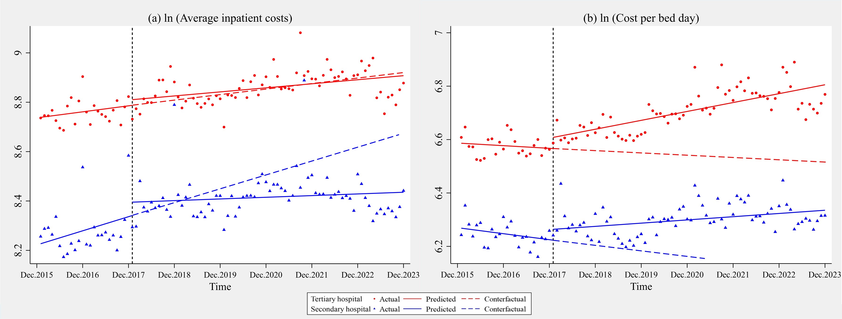
Appendix Figure A1: Changes in inpatient costs variables in SHs and THs after GB reform using ITSA. (a)ln (Average inpatient costs). (b)ln (Cost per bed day).

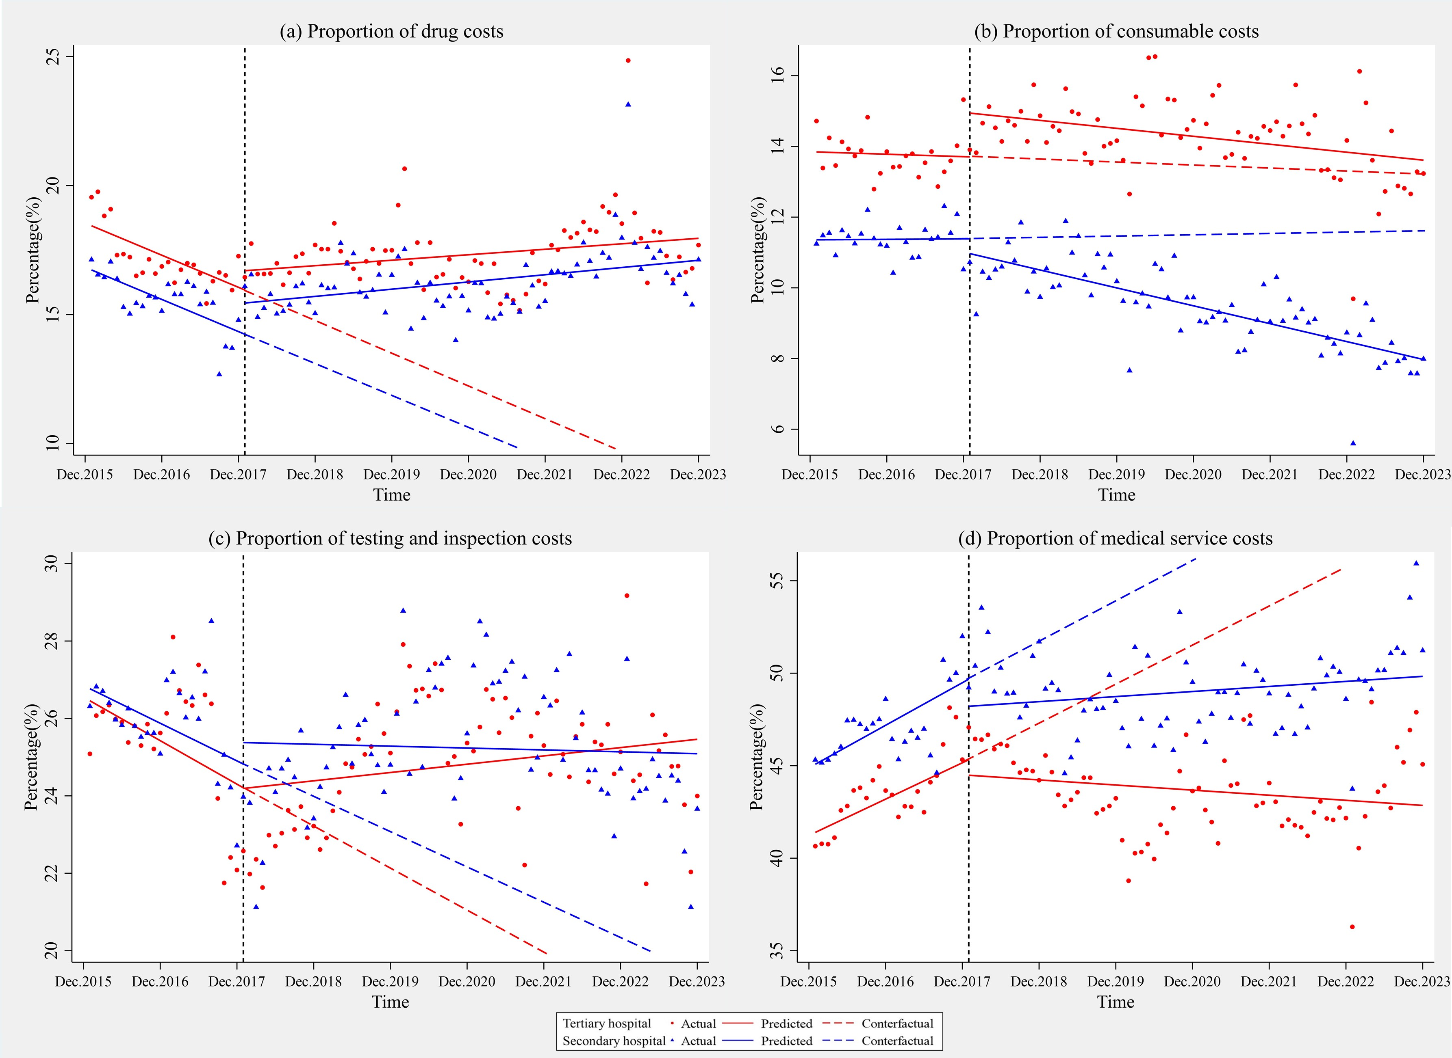
Appendix Figure A2: Changes in inpatient costs component variables in SHs and THs after GB reform using ITSA. (a)Proportion of drug costs. (b)Proportion of consumables costs. (c) Proportion of testing and inspection costs. (d) Proportion of medical service costs.
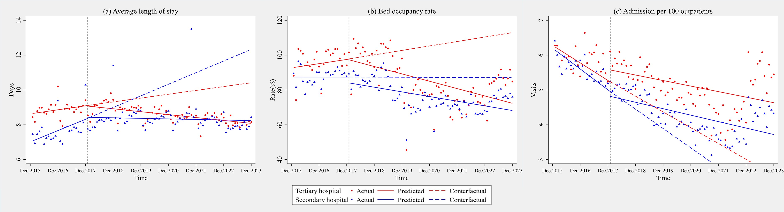

Appendix Figure A3: Changes in inpatient services delivery variables in SHs and THs after GB reform using ITSA. (a) Average length of stay. (b)Bed occupancy rate. (c) Admission per 100 outpatients.

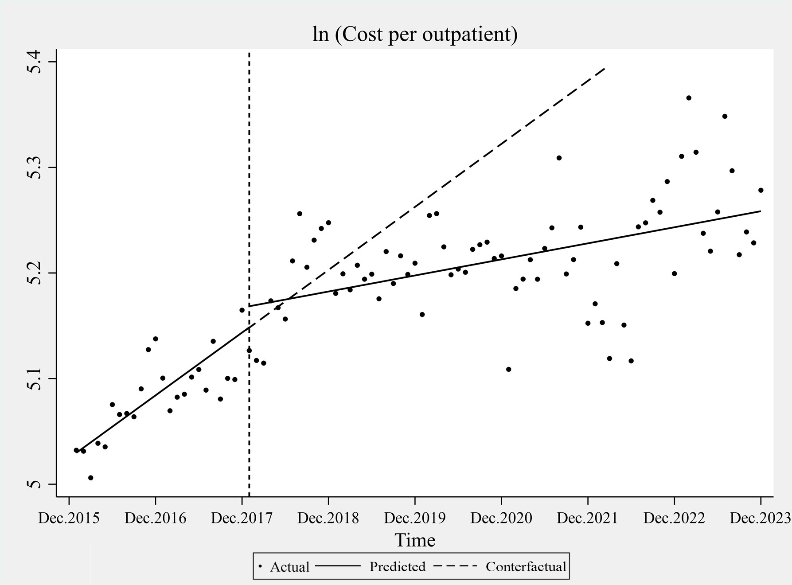
Appendix Figure A4: Changes in the cost per outpatient in LHs after GB using ITSA

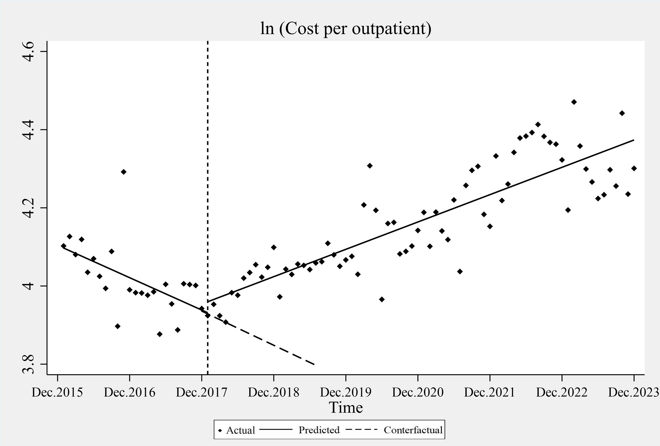
Appendix Figure A5: Changes in the cost per outpatient in PHIs after GB using ITSA

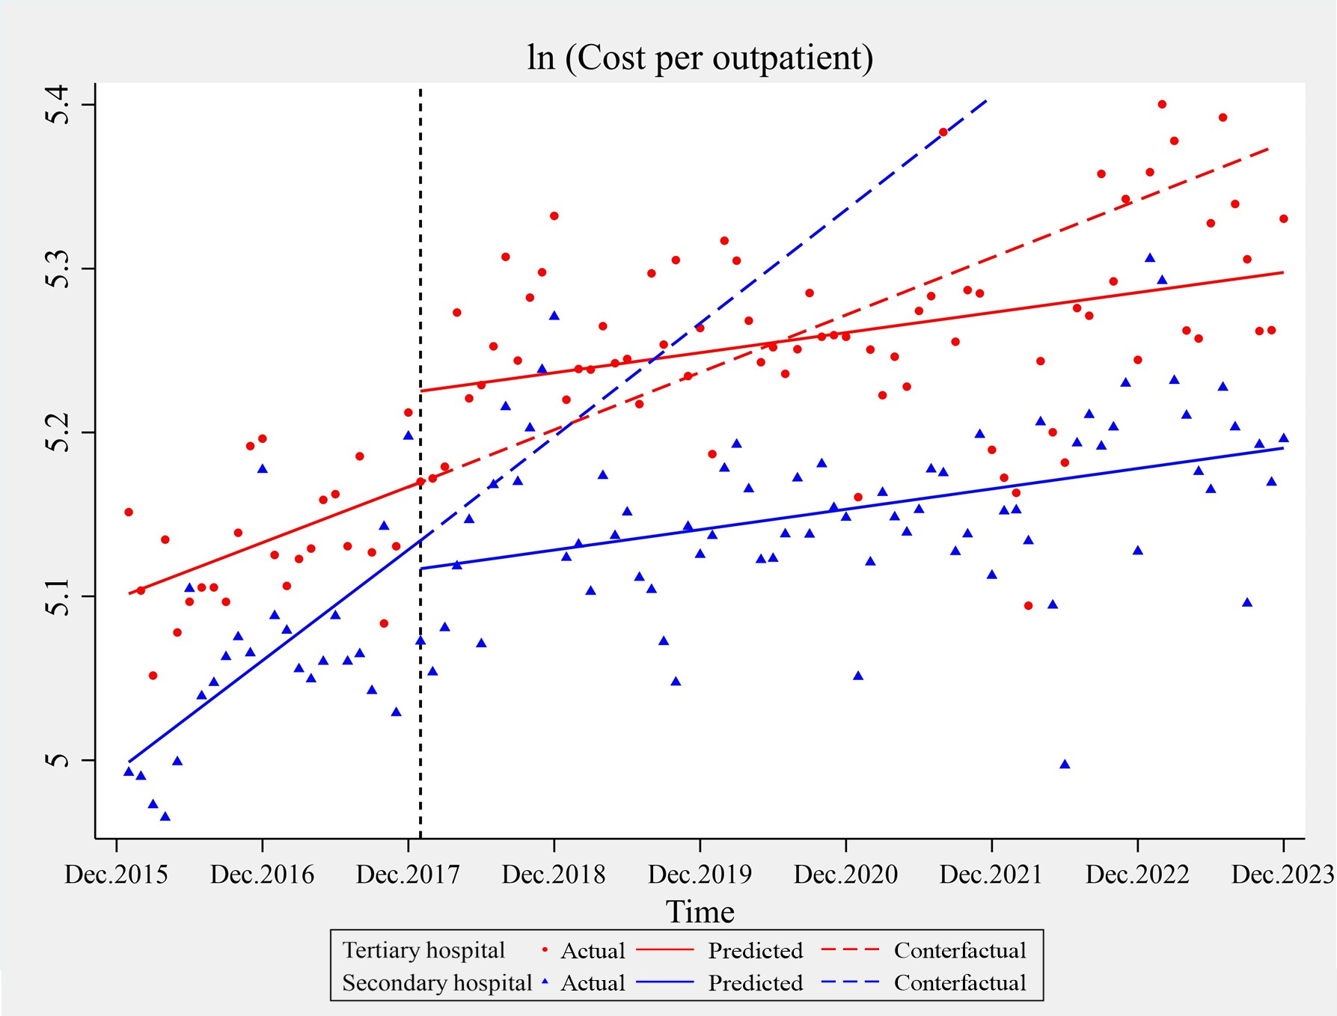
Appendix Figure A6: Changes in the cost per outpatient in SHs and THs after GB using ITSA

