Residential exposure to municipal solid waste incinerators and health effects: a systematic review with meta-analysis

Additional file 1. Details of search strategy, risk of bias assessment, exclude studies, included studies, meta-analysis results.

Table A1 Search Strategy for MEDLINE (via OVID)
Table A2 Criteria for the quality assessment of studies, according to the modified OHAT RoB rating tool.
Table A3 Quality assessment of studies and related motivation, according to the modified OHAT RoB rating tool
Table A4 Excluded studies and reasons for exclusion
Table A5 Characteristics of studies about the effects of MSWIs on health outcomes
Figure A1 Forest plot of meta-analysis results for preterm birth risk related to PM10 exposure from MSWIs
Figure A2 Forest plot of meta-analysis results for sex ratio related to PM10 exposure from MSWIs
Figure A3 Forest plot of meta-analysis results for cardiovascular diseases risk related to PM10 exposure from MSWIs
Figure A4 Forest plot of meta-analysis results for IHD risk related to PM10 exposure from MSWIs
Figure A5 Forest plot of meta-analysis results for respiratory diseases risk related to PM10 exposure from MSWIs
Figure A6 Forest plot of meta-analysis results for COPD risk related to PM10 exposure from MSWIs
Figure A7 Forest plot of meta-analysis results for asthma risk related to PM10 exposure from MSWIs
Figure A8 Funnel plot of preterm birth risk related to PM10 exposure from MSWIs
Figure A9 Funnel plot of sex ratio related to PM10 exposure from MSWIs
Figure A10 Funnel plot of cardiovascular diseases risk in men related to PM10 exposure from MSWIs
Figure A11 Funnel plot of cardiovascular diseases risk in women related to PM10 exposure from MSWIs
Figure A12 Funnel plot of cardiovascular diseases risk in overall population related to PM10 exposure from MSWIs
Figure A13 Funnel plot of ischemic heart diseases risk in men related to PM10 exposure from MSWIs
Figure A14 Funnel plot of ischemic heart diseases risk in women related to PM10 exposure from MSWIs
Figure A15 Funnel plot of ischemic heart diseases risk in overall population related to PM10 exposure from MSWIs
Figure A16 Funnel plot of respiratory diseases risk in men related to PM10 exposure from MSWIs
Figure A17 Funnel plot of respiratory diseases risk in women related to PM10 exposure from MSWIs
Figure A18 Funnel plot of respiratory diseases risk in overall population related to PM10 exposure from MSWIs
Figure A19 Funnel plot of COPD risk in men related to PM10 exposure from MSWIs
Figure A20 Funnel plot of COPD risk in women related to PM10 exposure from MSWIs
Figure A21 Funnel plot of COPD risk in overall population related to PM10 exposure from MSWIs
Figure A22 Funnel plot of asthma risk in overall population related to PM10 exposure from MSWIs

Table A1 Search Strategy for MEDLINE (via OVID)
1. (Incineration or Incinerat* or thermovalorization or thermal destruction or (energy adj2 plant)).ti,ab.
2. ("solid waste" or (waste adj2 management)).ti,ab.
3. 1 or 2
4. (residen* or residing or city or cities or community or communities or municipality or population* or neighbourhood* or neighborhood* or neighbouring or neighboring or urban or around or proximit* or surround* or vicinity or nearby or near or site*).ti,ab.
5. (Public health or Human health or health effect* or adverse effect* or consequence* or death* or mortality or morbidity or patholog* or disease* or outcome or syndrome* or cancer* or tumor* or leukaemia or lymphoma or neoplasm* or malignant or myeloma or sarcoma or carcinoma or malignant or digestive or liver or pancreatic or renal or renal or cardiovascular or respiratory or haematological or neurologic or cognitive or urinary or reproductive or infection* or thyroid or hormonal or immunological or transplant* or reproductive or miscarriage* or neonatal or congenital or fertility or pregnan* or birth).tw.
6. ((congenital adj2 malformation*) or (congenital adj2 anomal*) or (congenital adj2 defect*) or (birth adj2 defect*) or (malformative adj2 syndrome*)).ti,ab.
7. 5 or 6
8. incidence.ti,ab.
9. (hospital* or hospitalization).ti,ab
10. exp hospitalization/
11. exp incidence/
12. exp mortality/ or mortality.tw
13. 8 or 9 or 10 or 11 or 12
14. 3 AND 4 AND 7 AND 13
15. exp animal/ NOT human/
16. 14 NOT 15

Table A2 Criteria for the quality assessment of studies, modified according to the OHAT RoB rating tool.
Domain | Low Risk of Bias definition | Evaluation criteria
Participants’ recruitment | Absence of selection bias ensured by recruitment criteria | Not applicable
Blinding | Blinding is ensured or its absence does not affect exposure and outcome assessment | Not applicable
Exposure assessment | High confidence in the accuracy of exposure assessment methods | HIGH: Area or distance from emission sources  PROBABLY HIGH: There is insufficient information to permit a judgment of high risk of bias, but there is indirect evidence that suggests high risk of bias.  PROBABLY LOW: Dispersion model with resolution at area level or unknown residential history  LOW: Dispersion model with resolution at residential address level
Confounders | All potential confounders are accounted for.  Primary confounders:  - Age and/or sex  - Socioeconomic status  - Smoking habits  - Exposure or proximity to other relevant pollution sources (traffic, proximity to major roads, occupational exposure, level of pollution at baseline, other industrial plants…)  Secondary confounders  - Comorbidity  - Alcohol consumption  - Outcome-related confounders: (family history for breast cancer, maternal/paternal age and  season of birth/conception for birth outcomes ecc…) | HIGH: Two of four primary confounders are accounted for  PROBABLY HIGH: Two of four primary confounders and at least 1 secondary confounder are accounted for.  PROBABLY LOW: Three of four primary confounders are accounted for.  LOW: All four primary confounders are accounted for.
Incomplete outcome data | Incomplete outcome data does not introduce bias | LOW: No missing outcome data or reasons for missing outcome data not likely related to true outcome.  HIGH: missing outcome data are related to true outcome (e.g., substantial missing exposure data (≥10%), rationale for missing data not explained
Selective outcome reporting | All pre-specified outcomes have been reported in the pre-specified way | LOW: No pre-specified outcome omitted
Conflict of interests | Study did not receive support from entities having financial interest in the study outcome | LOW: Authors’ declaration of absent conflict of interest.  PROBABLY LOW: Absence of COI declaration but no entity having financial interest involved.

Table A3 Quality assessment of studies and related motivation, according to the modified OHAT RoB rating tool
Reference | Exposure assessment | Confounders | Incomplete outcome data | Outcome reporting | Conflict of interests
Praud et al., 2025 | Exposure defined by dispersion model with residential address resolution.  (Low) | 3 primary confounders (age, socioeconomic status, smoking status) and 2 secondary confounders accounted for (alcohol consumption, outcome related confounders)  (Probably low) | No evidence of incomplete outcome data  (Low) | No evidence of selective outcome reporting  (Low) | Authors declare no conflict of interests  (Low)
Gandini et al., 2025 | Exposure defined by dispersion model with residential address resolution.  (Low) | 3 primary confounders (age and sex, socioeconomic status, exposure to other sources of pollution)  (Probably low) | No evidence of incomplete outcome data  (Low) | No evidence of selective outcome reporting  (Low) | Authors declare no conflict of interests  (Low)
Zhang et al., 2024 | Exposure defined by proximity to emissions’ source  (High) | 4 primary confounders (age and sex, socioeconomic status, exposure to other sources of pollution, smoking habits) and 2 secondary confounders accounted for (outcome related  confounders, alcohol consumption)  (Low) | No evidence of incomplete outcome data  (Low) | No evidence of selective outcome reporting  (Low) | Authors declare no conflict of interests  (Low)
Fisher et al., 2024 | Exposure defined by an annual index based on distance from the plant  (Probably high) | 3 primary confounders (age, socioeconomic status, smoking status) and 2 secondary confounders accounted for (alcohol consumption, outcome related confounders)  (Probably low) | No evidence of incomplete outcome data  (Low) | No evidence of selective outcome reporting  (Low) | Authors declare no conflict of interests  (Low)
Ji et al., 2022 | Exposure defined by proximity to emissions’ source  (High) | 1 primary confounder accounted for (age)  (High) | No evidence of incomplete outcome data  (Low) | No evidence of selective outcome reporting  (Low) | Authors declare no conflict of interests  (Low)
Kim et al., 2022 | Exposure defined by proximity to emissions’ source  (High) | 2 primary confounders (age and sex, smoking status) and 2 secondary confounders accounted for (alcohol consumption, outcome related confounders)  (Probably high) | No evidence of incomplete outcome data  (Low) | No evidence of selective outcome reporting  (Low) | Authors declare no conflict of interests  (Low)
Piccinelli et al., 2022a | Exposure defined by dispersion model with residential address resolution.  Known residential history of each individual  (Low) | 3 primary confounders accounted for (age, deprivation index, exposure to other sources)  (Probably low) | No evidence of incomplete outcome data  (Low) | No evidence of selective outcome reporting  (Low) | Authors declare no conflict of interests  (Low)
Hao et al., 2021 | Exposure defined by proximity to emissions’ source  (High) | 2 primary confounders (age, socioeconomic status) and 1 secondary confounder accounted for (outcome related  confounders)  (Probably high) | No evidence of incomplete outcome data  (Low) | No evidence of selective outcome reporting  (Low) | Authors declare no conflict of interests  (Low)
VoPham et al., 2020 | Exposure defined by residential proximity, duration of residence and emissions  (High) | 3 primary confounders (age, socioeconomic status, smoking status) and 2 secondary confounders accounted for (alcohol consumption, outcome related confounders)  (Probably low) | No evidence of incomplete outcome data  (Low) | No evidence of selective outcome reporting  (Low) | Authors declare no conflict of interests  (Low)
Barjoan et al., 2020 | Exposure defined by dispersion model with resolution at area level  (Probably low) | 1 primary confounder accounted for (age)  (High) | No evidence of incomplete outcome data  (Low) | No evidence of selective outcome reporting  (Low) | Authors declare no conflict of interests  (Low)
Parkes et al., 2020 | Exposure defined by dispersion model with resolution at area level and proximity to nearest MSWI  (Probably low) | 3 primary confounders (age, socioeconomic status, exposure to other sources of pollution)  (Probably low) | No evidence of incomplete outcome data  (Low) | No evidence of selective outcome reporting  (Low) | Authors declare no conflict of interests  (Low)
Lung et al., 2020 | Exposure defined by proximity to emissions’ source  (High) | No primary nor secondary confounders accounted for  (High) | No evidence of incomplete outcome data  (Low) | No evidence of selective outcome reporting  (Low) | Authors declare no conflict of interests  (Low)
Bae et al., 2020 | Exposure defined by proximity to emissions’ source  (High) | 1 primary confounder accounted for (socioeconomic status)  (High) | No evidence of incomplete outcome data  (Low) | No evidence of selective outcome reporting  (Low) | Authors declare no conflict of interests  (Low)
Chellini et al., 2020 | Exposure defined by dispersion model with residential address resolution.  (Low) | 1 primary confounder accounted for (age and sex)  (High) | No evidence of incomplete outcome data  (Low) | No evidence of selective outcome reporting  (Low) | Authors declare no conflict of interests  (Low)
Ghosh et al., 2019 | Exposure defined by dispersion model with resolution at area level.  (Probably low) | 3 primary confounders (age and sex, socioeconomic status, exposure to other sources of pollution) and 1 secondary confounder accounted for (outcome related  confounders)  (Low) | No evidence of incomplete outcome data  (Low) | No evidence of selective outcome reporting  (Low) | Authors declare no conflict of interests  (Low)
Romanelli et al., 2019 | Exposure defined by dispersion model with residential address resolution.  Known residential history of each individual  (Low) | 3 primary confounders accounted for (age, deprivation index, exposure to other sources)  (Probably low) | No evidence of incomplete outcome data  (Low) | No evidence of selective outcome reporting  (Low) | Authors declare no conflict of interests  (Low)
Freni-Sterrantino et al., 2019 | Exposure defined by proximity to emissions’ source  (High) | 2 primary confounders accounted for (socioeconomic status, exposure to other sources) and 1 secondary confounder accounted for (outcome related  confounders)  (Probably high) | No evidence of incomplete outcome data  (Low) | No evidence of selective outcome reporting  (Low) | Authors declare no conflict of interests  (Low)
Vinceti et al., 2018 | Exposure defined by dispersion model with residential address resolution.  Known residential history of each individual  (Low) | 1 primary confounder accounted for (age)  (High) | No evidence of incomplete outcome data  (Low) | No evidence of selective outcome reporting  (Low) | Possible conflict of interest from funding  (Probably low)
Fonte et al., 2017 | Exposure defined by dispersion model with residential address resolution.  Known residential history of each individual  (Low) | 1 secondary confounder accounted for (outcome related confounder)  (High) | No evidence of incomplete outcome data  (Low) | No evidence of selective outcome reporting  (Low) | Authors declare no conflict of interests  (Low)
Minichilli et al., 2016 | Exposure defined by dispersion model with residential address resolution.  Known residential history of each individual  (Low) | 3 primary confounders accounted for (age, socioeconomic status, exposure to other sources)  (Probably low) | No evidence of incomplete outcome data  (Low) | No evidence of selective outcome reporting  (Low) | Authors declare no conflict of interests  (Low)
Santoro et al., 2016 | Exposure defined by dispersion model with residential address resolution.  Known residential history of each individual  (Low) | 3 primary confounders accounted for (age, socioeconomic status, exposure to other sources) and 1 secondary confounder accounted for (outcome related confounder)  (Probably low) | No evidence of incomplete outcome data  (Low) | No evidence of selective outcome reporting  (Low) | Authors declare no conflict of interests  (Low)
Candela et al., 2015 | Exposure defined by dispersion model with residential address resolution.  Known residential history of each individual  (Low) | 3 primary confounders accounted for (age, socioeconomic status, exposure to other sources) and 1 secondary confounder accounted for (outcome related confounder)  (Probably low) | No evidence of incomplete outcome data  (Low) | No evidence of selective outcome reporting  (Low) | Authors declare no conflict of interests  (Low)
Golini et al., 2014 | Exposure defined by dispersion model with residential address resolution.  Unknown residential history of each individual  (Probably low) | 3 primary confounders accounted for (age and sex, socioeconomic status, exposure to other sources)  (Probably low) | No evidence of incomplete outcome data  (Low) | No evidence of selective outcome reporting  (Low) | Authors declare no conflict of interests  (Low)
Lung et al., 2013 | Exposure defined by proximity to emissions’ source  (High) | No primary nor secondary confounders accounted for  (High) | No evidence of incomplete outcome data  (Low) | No evidence of selective outcome reporting  (Low) | Authors declare no conflict of interests  (Low)
Candela et al., 2013 | Exposure defined by dispersion model with residential address resolution.  Unknown residential history of each individual  (Probably low) | 3 primary confounders (age, socioeconomic status, exposure to other sources of pollution) and 1 secondary confounder accounted for (outcome related  confounders)  (Probably low) | No evidence of incomplete outcome data  (Low) | No evidence of selective outcome reporting  (Low) | Authors declare no conflict of interests  (Low)
Viel et al., 2011 | Exposure defined through biomonitoring of serum concentrations of organochlorine compounds  (Low) | 2 secondary confounders accounted for (outcome related confounders)  (High) | No evidence of incomplete outcome data  (Low) | No evidence of selective outcome reporting  (Low) | Authors declare no conflict of interests  (Low)
Ranzi et al., 2011 | Exposure defined by dispersion model with residential address resolution.  Known residential history of each individual  (Low) | 3 primary confounders accounted for (age and sex, socioeconomic status, exposure to other sources)  (Probably low) | No evidence of incomplete outcome data  (Low) | No evidence of selective outcome reporting  (Low) | Authors declare no conflict of interests  (Low)
Federico et al., 2010 | Exposure defined by proximity to emissions’ source  (High) | 2 primary confounders accounted for (age, deprivation index)  (High) | No evidence of incomplete outcome data  (Low) | No evidence of selective outcome reporting  (Low) | Authors declare no conflict of interests  (Low)
Gouveia & Ruscitto do Prado, 2010 | Exposure defined by proximity to emissions’ source  (High) | No primary nor secondary confounders accounted for  (High) | No evidence of incomplete outcome data  (Low) | No evidence of selective outcome reporting  (Low) | Authors declare no conflict of interests  (Low)
Cordier et al., 2010 | Exposure defined by dispersion model with residential address resolution.  Known residential history of each individual  (Low) | 4 primary confounders (age and sex, socioeconomic status, exposure to other sources of pollution, smoking habits) and 2 secondary confounders accounted for (outcome related  confounders, alcohol consumption)  (Low) | No evidence of incomplete outcome data  (Low) | No evidence of selective outcome reporting  (Low) | Authors declare no conflict of interests  (Low)
Goria et al., 2009 | Exposure defined by dispersion model with resolution at area level  (Probably low) | 2 primary confounders accounted for (socioeconomic status, exposure to other sources)  (High) | No evidence of incomplete outcome data  (Low) | Results of some pre-specified cancer types are not reported  (High) | Authors declare no conflict of interests  (Low)
Vinceti et al., 2009 | Exposure defined by dispersion model with residential address resolution.  Known residential history of each individual  (Low) | 2 primary confounders accounted for (age, socioeconomic status)  (High) | No evidence of incomplete outcome data  (Low) | No evidence of selective outcome reporting  (Low) | Absence of conflict of interests declaration  (Probably low)
Vinceti et al., 2008 | Exposure defined by dispersion model with residential address resolution.  Known residential history of each individual  (Low) | 1 primary confounder accounted for (age)  (High) | No evidence of incomplete outcome data  (Low) | No evidence of selective outcome reporting  (Low) | Absence of conflict of interests declaration  (Probably low)
Viel et al., 2008a | Exposure defined by dispersion model with resolution at area level  (Probably low) | 1 primary confounder accounted for (age)  (High) | No evidence of incomplete outcome data  (Low) | No evidence of selective outcome reporting  (Low) | Authors declare no conflict of interests  (Low)
Viel et al., 2008b | Exposure defined by dispersion model with resolution at area level  (Probably low) | 2 primary confounders accounted for (socioeconomic status, exposure to other sources) and 1 secondary confounder accounted for (outcome related  confounders)  (Probably high) | No evidence of incomplete outcome data  (Low) | No evidence of selective outcome reporting  (Low) | Authors declare no conflict of interests  (Low)
Zambon et al., 2007 | Exposure defined by dispersion model with residential address resolution.  Known residential history of each individual  (Low) | No primary nor secondary confounders accounted for  (High) | 14 cases and 153 controls excluded from the study  (High) | No evidence of selective outcome reporting  (Low) | Authors declare no conflict of interests  (Low)
Bianchi et al., 2007 | Exposure defined by proximity to emissions’ source  (High) | 1 primary confounder (deprivation index) and 1 secondary confounder accounted for (outcome related  confounders)  (High) | No evidence of incomplete outcome data  (Low) | No evidence of selective outcome reporting  (Low) | Authors declare no conflict of interests  (Low)
Biggeri & Cattelan, 2006 | Exposure defined by proximity to emissions’ source  (High) | No primary nor secondary confounders accounted for  (High) | No evidence of incomplete outcome data  (Low) | No evidence of selective outcome reporting  (Low) | Authors declare no conflict of interests  (Low)
Miyake et al., 2005 | Exposure defined by proximity to emissions’ source  (High) | 1 secondary confounder accounted for (outcome related  confounders)  (High) | No evidence of incomplete outcome data  (Low) | No evidence of selective outcome reporting  (Low) | Absence of conflict of interests declaration  (Probably low)
Cordier et al., 2004 | Exposure defined by dispersion model with resolution at area level  (Probably low) | 2 primary confounders accounted for (age, socioeconomic status) and 1 secondary confounder accounted for (outcome related  confounders)  (Probably high) | No evidence of incomplete outcome data  (Low) | Results derived from 1 of the 2 exposure assessment methods are not reported  (High) | Absence of conflict of interests declaration  (Probably low)
Tango et al., 2004 | Exposure defined by proximity to emissions’ source  (High) | 1 primary confounder accounted for (age) and 1 secondary confounder accounted for (outcome related  confounders)  (High) | No evidence of incomplete outcome data  (Low) | No evidence of selective outcome reporting  (Low) | Absence of conflict of interests declaration  (Probably low)
Floret et al., 2004 | Exposure defined by dispersion model with resolution at area level  (Probably low) | 1 primary confounder accounted for (socioeconomic level)  (High) | No evidence of incomplete outcome data  (Low) | No evidence of selective outcome reporting  (Low) | Absence of conflict of interests declaration  (Probably low)
Fukuda et al., 2003 | Exposure defined through dioxin-related municipal indices  (High) | 2 primary confounders accounted for (age, socioeconomic status)  (High) | No evidence of incomplete outcome data  (Low) | No evidence of selective outcome reporting  (Low) | Absence of conflict of interests declaration  (Probably low)
Dummer et al., 2003 | Exposure defined by proximity to emissions’ source  (High) | 1 primary confounder accounted for (socioeconomic status) and 1 secondary confounder accounted for (outcome related  confounders)  (High) | No evidence of incomplete outcome data  (Low) | No evidence of selective outcome reporting  (Low) | Authors declare no conflict of interests  (Low)
Floret et al., 2003 | Exposure defined by dispersion model with resolution at area level  (Probably low) | 1 primary confounder accounted for (socioeconomic status)  (High) | No evidence of incomplete outcome data  (Low) | No evidence of selective outcome reporting  (Low) | Absence of conflict of interests declaration  (Probably low)
Viel et al., 2000 | Exposure defined by proximity to emissions’ source  (High) | 1 primary confounder accounted for (age and sex)  (High) | No evidence of incomplete outcome data  (Low) | No evidence of selective outcome reporting  (Low) | Absence of conflict of interests declaration  (Probably low)
Mohan et al., 2000 | Exposure defined by proximity to emissions’ source  (High) | 3 primary confounders accounted for (age and sex,socioeconomic status, exposure to other sources) and 1 secondary confounder accounted for (outcome related  confounders)  (Probably low) | No evidence of incomplete outcome data  (Low) | No evidence of selective outcome reporting  (Low) | Absence of conflict of interests declaration  (Probably low)
Elliott et al., 1996 | Exposure defined by proximity to emissions’ source  (High) | 1 primary confounder accounted for (deprivation index)  (High) | No evidence of incomplete outcome data  (Low) | No evidence of selective outcome reporting  (Low) | Absence of conflict of interests declaration  (Probably low)
Biggeri et al., 1996 | Exposure defined by proximity to emissions’ source  (High) | 3 primary confounders (age, smoking habits, exposure to other sources of pollution) and 1 secondary confounder accounted for (outcome related  confounders)  (Probably low) | 182 cases excluded due to the impossibility of tracing the next of kin, 1 case excluded due to residence outside Trieste Province | No evidence of selective outcome reporting  (Low) | Absence of conflict of interests declaration  (Probably low)
Shy et al., 1995 | Exposure defined by proximity to emissions’ source and by assigning to all subjects in the same community the average 12-hr  ambient air pollution concentration measured at the neighbourhood monitoring station  (High) | 3 primary confounders (age and sex, smoking habits, exposure to other sources of pollution, socioeconomic status) and 1 secondary confounder accounted for (outcome related  confounders)  (Low) | No evidence of incomplete outcome data  (Low) | No evidence of selective outcome reporting  (Low) | Absence of conflict of interests declaration  (Probably low)
Williams et al., 1992 | Exposure defined by proximity to emissions’ source  (High) | No primary nor secondary confounders accounted for  (High) | No evidence of incomplete outcome data  (Low) | No evidence of selective outcome reporting  (Low) | Absence of conflict of interests declaration  (Probably low)

Table A4 Excluded studies and reasons for exclusion
Reference | Reason for exclusion
Ancona C, Mataloni F, Badaloni C, Bolignano A, Bucci S, Davoli M, Golini MN, Narduzzi S, Sozzi R, Forastiere F. Lo studio di coorte di popolazione in aree a forte pressione ambientale: il programma ERAS Lazio [Residential cohort approach in industrial contaminated sites: the ERAS Lazio project]. Epidemiol Prev. 2014 Mar-Apr;38(2 Suppl 1):158-61. Italian. | No estimation of risk
Bianchi, 2009. Incinerators, Waste Sites and Birth Defects | Conference Abstract
Bianchi et al. Risk of congenital malformations around incinerators of RSU of Emilia-Romagna. Epidemiologia & Prevenzione 2011;35(5-6):82-83 | Conference  Abstract
Bonvicini et al. Risk of miscarriage in a population exposed to emissions from incinerators for urban solid wastes. Epidemiologia & Prevenzione 2011;35(5-6):107-108 | Conference  Abstract
Candela et al. Mortality and incidence of tumours in resident subjects around incinerators for urban solid wastes in Emilia-Romagna. Epidemiologia e Prevenzione 2011; (5-6) Suppl. 1 | Conference Abstract
Capitao et al. Waste incineration and cancer mortality: a longitudinal controlled population-based study. Eur J Public Health 2023;33(2) | Conference Abstract
Chen LJ, Lin GZ, Ren ZF. [Municipal solid waste incinerator and cancer incidences among the residents in the vicinity]. Zhonghua Yu Fang Yi Xue Za Zhi. 2011 Apr;45(4):299-303. | Chinese language
D'oro et al. Preliminary assessment of cancer mortality for people who live in municipalities close to an incineration plant using data from the local registry of causes of death. EUROEPI 2010 | Conference Poster
Forastiere et al. Health impact assessment of waste management facilities in three European countries. Environ Health. 2011 Jun 2;10:53. doi: 10.1186/1476-069X-10-53. | Study design; health impact assessment
Faure et al. Evolution of sperm quality in men living in the vicinity of a municipal solid waste incinerator possibly correlated with decreasing dioxins emission levels. Andrologia. 2014 Sep;46(7):744-52. doi: 10.1111/and.12143. | No estimation of risk
Galise I, Serinelli M, Bisceglia L, Assennato G. Valutazione ex-ante dell'impatto sulla salute attribuibile all'inquinamento da inceneritore a Modugno (Bari) [Health impact assessment of pollution from incinerator in Modugno (Bari)]. Epidemiol Prev. 2012 Jan;36(1):27-33. Italian. | Study design; health impact assessment
Goria et al. Risk of Cancer and Past Residential Proximity to Municipal Solid Waste Incinerators in France. Epidemiology 2007;18(5):S82. | Conference  Abstract
Hu et al. Waste incineration and pulmonary function: an epidemiologic study of six communities. J Air Waste Manag Assoc 2001;51(8):1185-94. | Short term effects
Kim et al. Burden of disease attributable to air pollutants from municipal solid waste incinerators in Seoul, Korea: a source-specific approach for environmental burden of disease. Sci Total Environ. 2011 May 1;409(11):2019-28. doi: 10.1016/j.scitotenv.2011.02.032. | Objective of the study not relevant
Knox et al. Childhood cancers, birthplaces, incinerators and landfill sites. Int J Epidemiol. 2000 Jun;29(3):391-7. | No estimation of risk
Liao et al. Prevalence of asthma, rhinitis, and eczema from ISAAC survey of schoolchildren in Central Taiwan. J Asthma. 2005 Dec;42(10):833-7. | No estimation of risk
Lloyd et al. Twinning in human populations and in cattle exposed  to air pollution from incinerators. British Journal of Industrial Medicine 1988;45:556-560 | Study design; spatial analysis
Luberto et al. Incidence of sarcomas of soft tissues in resident subjects of incinerators for urban solid wastes in Emilia Romagna. 2011 | Conference Abstract
Marcilio et al. Residence Near a Municipal Solid Waste Incinerator and Cancer Risk: an Analysis Using a Geographic Information System (GIS). Epidemiology 2006;17(6):S479 | Conference Abstract
Ranzi et al.Impatto sulla salute delle politiche di gestione dei rifiuti solidi urbani: i risultati del Progetto SESPIR [Health impact assessment of policies for municipal solid waste management: findings of the SESPIR Project]. Epidemiol Prev. 2014 Sep-Oct;38(5):313-22. | Study design; health impact assessment
Rothenbacher et al. RESPIRATORY SYMPTOM PREVALENCE IN 3 NORTH-CAROLINA INCINERATOR COMMUNITIES. 1994 | Abstract
Samer et al. Cytochrome P450 1A2 activity and incidence of thyroid disease and cancer after chronic or acute exposure to dioxins. Basic Clin Pharmacol Toxicol. 2020 Mar;126(3):296-303. doi: 10.1111/bcpt.13339. Epub 2019 Nov 8. PMID: 31608602. | No estimation of risk
Staessen et al. Renal function, cytogenetic measurements, and sexual development in adolescents in relation to environmental pollutants: a feasibility study of biomarkers. Lancet. 2001 May 26;357(9269):1660-9. | No estimation of risk
Thabuis et al. Recensement rétrospectif des cas de cancers de 1994 à 2002 autour de l'usine d'incinération d'ordures ménagères de Gilly-sur-Isère [Retrospective census of cancers between 1994 and 2002 around the municipal solid waste incinerator of Gilly-sur-Isère]. Rev Epidemiol Sante Publique. 2007 Dec;55(6):426-32. | No estimation of risk
Vinceti et al. Prevalence at birth of congenital anomalies in a population living around a modern municipal solid waste incinerator. Epidemiology 2006;17(Suppl.):s272 | Conference abstract
Vinceti et al. Risk of Birth Defects in a Population Living Near a Municipal Solid Waste Incinerator During Different Operating Periods. Epidemiology 2008;19(6):S218-S218 | Conference  Abstract
Xu et al. A cross-sectional study on school-age children living near a municipal waste incinerator: Urinary metal levels and renal impairment assessment. Chemosphere. 2020 Feb;241:125081. doi: 10.1016/j.chemosphere.2019.125081. | No estimation of risk

Table A5 Characteristics of studies about the effects of MSWIs on health outcomes
First author, publication year, country; incinerators | Studied period | Study design | Exposure assessment | Pollutant | Studied population | Outcomes
Praud et al., 2025  France  (MSWI) | 1990-2011 | XENAIR case-control study nested in the E3N cohort | Industrial emission inventory, Dispersion modeling with residential address resolution | PCDD/Fs | Cases women with invasive breast cancer: N=5222, Matched controls: N=5222 | Breast cancer risk
Gandini et al., 2025  Italy  (1 WTE in Turin city) | 2014-2019 | Retrospective cohort | Dispersion modeling with residential address resolution | Heavy metals | Residents in exposed area 1 (max fallout>0.007μg/m2/year): N=120,479, Residents in exposed area 2 (max fallout>0.014μg/m2/year): N=6508, Residents in not exposed area: N=248,757 | Hospital admissions for cardiovascular and respiratory diseases, Birth outcomes
Zhang et al., 2024  China  (3 MSWI in Dongguan city) | 2021-22 | Cross-sectional | Distance (0-3, 3-8 km) | NR | Residents in 0-3 km area: N=454, Residents in 3-8 km area: N=427 | Prevalence respiratory symptoms
Fisher et al.,2024  United States  (MSWI in 6 states and 2 US cities) | 1995-2011 | Prospective cohort (NIH-AARP Diet and Health Study) | Distance (3, 5, 10 km),  Dispersion modeling with residential address resolution | PCDD/Fs | Exposed (areas 3,5,10 km): N=917, Not exposed (areas 3, 5, 10 km): N=18484 | NHL
Ji et al.,2022  China  (1 MSWI in Jiangsu  Province, eastern China) | 2009-2018 | Retrospective cohort/biomonitoring | Area | PCDD/F (biomonitoring) | Residents in two area: Upwind region: N= 11,186-11,480  Downwind region: N=10,380-11,386 | Mortality for all causes (SMR)
Kim et al.,2022  Korea  (1 MSWI in Gimhae city) | 2020 | Cross-sectional | Distance from incinerator.  Exposed areas: A (< 0,4), B (0,4-3,2 km), C (3,3 - 6,5 km).  Control area: D (>8,6 km) | NR | Exposed (areas A, B, C):1380;  Control (area D):390 | Prevalence allergic rhinitis, asthma, atopic dermatitis
Piccinelli et al., 2022a  Italy (Valmadera)  (Valmadrera incinerator) | 2003-2016 | Retrospective cohort | Dispersion model with residential address resolution | PM10 | 100576 individuals (52111 females) divided into high, medium + high and low (reference) exposure areas | Total and specific mortality, cancer incidence, perinatal outcomes
Hao et al.,2022  China  (5 MSWI sites in Shanghai) | 2014-2018 | Retrospective birth cohort | Residence within 10 km from the incinerator | NR | 59,606 births | Adverse birth outcomes
VoPham et al.,2020  United States  (Several MSWIs across USA) | 1989-2013 | Prospective cohort | Distance from the facility, duration of residence and estimated levels of emissions of such facility | PCDD/F | 11,2397 females registered nurses (Nurses' Health Study II) | Breast cancer incidence
Barjoan et al., 2020  France (Nice)  (Nice incinerator) | 2005-2014 (divided into 2005-2009 and 2010-2014) | Ecological | Dispersion model with resolution at area level | Dioxins | Exposed area: 6165 cancer cases  Non-exposed area: 74700 cancer cases | Incidence of cancer
Parkes et al.,2020  England and Scotland  (11 MSWIs across England and Scotland) | 2003-2010 | Retrospective cohort (birth registry study) | Dispersion model with resolution at area level and proximity to nearest MSWI | PM10 | 219,486 births, stillbirths and terminations of pregnancy for fetal anomaly | Congenital anomalies
Lung et al., 2020  Taiwan  (Several MSWIs across Taiwan) | October 2003 and follow-up until recruited babies are 8 years old | Birth cohort | Residence within 3 km from the incinerator | NR | 19591 children, of which 865 lived less than 3 km away from an incinerator | Children's development
Bae et al.,2020  Korea  (6 MSWI facilities in Seoul) | 2009-2011 | Spatial correlation study | Residence within 2 km and 2-5 km from the incinerator | NR | 424 sub-districts (dongs) of Seoul: 49 included in a buffer area of 2 km from MSWI, 138 included in a buffer area of 2-5 km from MSWI | Asthma-related hospital admission
Chellini et al., 2020  Italy (Pietrasanta-Camaiore)  (2 MSWIs in the same site in Pietrasanta) | 1987-2010 | Case-control | Dispersion model with residential address resolution | PM2.5 and PCDD/F | Residents of Pietrasanta and Camaiore municipalities and potentially exposed population residing in the exposed areas defined by the dispersion model | Mortality and hospitalization for oncological and non-oncological causes
Ghosh et al.,2019  United Kingdom  (22 MSWIs across Great Britain) | 2003-2010 | Retrospective cohort (birth registry study) and nested case-control | Dispersion model | PM10 | 1,025,064 births and 18,694 infant deaths | Birth outcomes
Romanelli et al., 2019  Italy (Pisa)  (Pisa incinerator) | 2001-2014 | Retrospective cohort | Dispersion model with residential address resolution.  Known residential history of each individual | NOx | 132293 residents | Cause-specific mortality and morbidity
Freni-Sterrantino et al.,2019  United Kingdom  (8 MSWIs in England and Wales) | 1996-2012 | Bayesan interrupted time-series | Middle layer Super Output Area whose centroids lie within 10 km of a MWI | NR | 526,642 single live births and 2462 infant | Infant mortality and sex-ratio
Vinceti 2018  Italy (Modena)  (Modena incinerator) | 2003-2013 | Retrospective cohort (birth registry study) | Dispersion model | Dioxins | 17432 women divided into high and intermediate exposure areas and the rest of Modena municipality | Adverse pregnancy outcomes
Fonte et al.,2017  Italy (Busto Arsizio)  (Busto Arsizio incinerator) | 2012-2014 | Cohort and case-control | Dispersion model | PM10, SO2, NOx | 218445 individuals | HR for the exposed population of being hospitalized and ORs for the cases to be exposed compared to controls
Minichilli et al.,2016  Italy (San Zeno)  (San Zeno incinerator) | 2001-2010 | Retrospective cohort | Dispersion model | PM10 | 51000 residents divided into high, medium and low (control) exposure areas | Mortality and hospitalization
Santoro et al., 2016  Italy (San Zeno)  (San Zeno incinerator) | 2001-2010 | Retrospective cohort (birth registry study) | Dispersion model | PM10 | 3069 newborns to 2401 mothers divided into high, medium and low (control) exposure areas | Adverse pregnancy outcomes
Candela et al.,2015  Italy (Emilia Romagna region)  (7 MSWIs in Emilia Romagna) | 2002-2006 | Retrospective cohort (birth registry study) | Dispersion model with residential address resolution. Known residential history of each individual | PM10 | 11,875 pregnancies within a 4 km radius around the 7 incinerators in the Emilia-Romagna Region | Miscarriages
Golini et al.,2014  Italy (Lazio)  (2 WTE plants in Collefferro and San Vittore) | 1996-2008 | Retrospective cohort | Dispersion model | PM10 | 47192 residents divided into high, medium and low (control) exposure areas | Hospitalization for specific causes
Lung et al.,2013  Taiwan  (Several MSWIs across Taiwan) | Started in 2003 and followed children until 36 months of age | Birth cohort | Residence near the incinerator | NR | 21248 newborns | Child development
Candela et al.,2013  Italy  (Emilia Romagna)  (7 MSWIs in Emilia Romagna) | 2003-2010 | Birth registry study (retrospective cohort) | Dispersion model | PM10 | 21517 birth to women residing within a 4-km radius of an incinerator at the time of delivery | Reproductive outcomes
Viel et al.,2011  France  (Besançon incinerator) | 2003-2005 | Case-control | Residence within 3 km from the incinerator | biomonitoring of or pesticide metabolites, PCDDs, PCDFs, | 34 cases and 34 controls | Risk of NHL
Ranzi 2011  Italy (Forlì)  (Forlì incinerator) | 1990-2003 | Retrospective cohort | Dispersion model with residential address resolution. Known residential history of each individual | Heavy metals | 31,347 individuals residing within 3.5 km radius around two incinerators located near Forlì (Italy) | Cancer incidence, mortality, hospitalization for specific causes
Federico  2010  Italy (Modena)  (Modena incinerator) | Italy (Modena), 1991-2005 | Ecological | Census unit within a 5 km radius from the incinerator | NR | 16433 cancer cases | Incidence cancer
Gouveia & Ruscitto do Prado, 2010  Brasil  (Vergueiro incinerator) | 1998-2002 | Ecological | Residence within 7 km from the incinerator | NR | 1,599,532 inhabitants | Cancer deaths
Cordier et al., 2010  France  (21 MSWIs in the Rhône-  Alpes region) | 2001-2003 | Case-control | Dispersion model with residential address resolution. Known residential history of each individual | Dioxins | 304 infants with urinary tract birth defects and 226 controls | Urinary tract birth defects
Goria et al., 2009  France  (16 MSWIs in 4 French departments) | 1972-1990 | Ecological | Dispersion model with resolution at area level | Dioxins | 2941 cancer cases in women and 3367 cancer cases in men | Risk of cancer
Vinceti et al., 2009  Italy (Reggio Emilia)  (Reggio Emilia incinerator) | 1998-2006 | Case-control | Dispersion model | PCDD/F | 228 cases of congenital anomalies and 228 controls in Reggio Emilia municipality | Prevalence for congenital anomalies
Vinceti et al.,2008  Italy (Modena) | 2003-2006 | Retrospective cohort (birth registry study) | Dispersion model | PCDD/F | 23 cases of spontaneous abortions | Spontaneous abortion
Viel et al.,2008a  France | 1996-2002 | Case-control | Dispersion model with resolution at area level | Dioxins | 434 invasive breast carcinomas and 2170 controls | Breast cancer
Viel et al.,2008b  France  (13 incinerators incl. Besançon, across 4 French departments) | 1990-1999 | Ecological | Dispersion model with resolution at area level | Dioxins | 3974 NHL incident cases | NHL
Zambon et al., 2007  Italy (Veneto)  (10 MSWIs in the Province of Venice) | 1990-1996 | Case-control | Dispersion model | Dioxins | 168 cases of sarcoma and 384 controls | Sarcoma
Bianchi et al.,2007  Italy  (25 MSWIs in 25 Italian municipalities) | 1981-2001 | Ecological | Residence in municipalities with MSWI | NR | Residents of the 25 italian municipalities with MSWI | NHL mortality
Biggeri & Cattelan, 2006  Italy (Tuscany)  (17 MSWIs in 17 Tuscany municipalities) | 1981-2001 | Ecological | Residence in Tuscany municipalities with an active MSWI during the period from early 70s to 1989 | NR | Residents in municipalities with an active MSWI during the period from 1970s to 1989 | NHL mortality
Miyake et al.,2005  Japan  (37 MSWIs in in Osaka Prefecture) |  | Cross-sectional | Distance of schools from MSWI | NR | 450,807 elementary school chil-dren aged 6–12 years | Respiratory symptoms
Cordier et al.,2004  France  (70 MSWIs in in the Rhône-Alpes region) | 1988-1997 | Ecological | Dispersion model with resolution at area level | Dioxins | Exposed: 94239 births  Unexposed: 470369 births | Congenital malformations
Tango et al.,2004  Japan  (63 MSWIs across Japan) | 1997-1998 | Ecological | Residence within 10 km from the incinerator | NR | 225,215 live births, 3,387 fetal deaths, and 835 infant deaths within a 10 km radius from the 63 MSWI | Adverse reproductive outcomes
Floret et al., 2004, France  (Besançon incinerator) | 1980-1995 | Case-control | Dispersion model | Dioxins | 37 cases of soft-tissue sarcoma and 370 controls | Incidence of soft-tissue sarcoma
Fukuda et al.,2003  Japan  (MSWIs in 590 municipalities in Japan) | 1996-1997 | Ecological | Dioxin-related municipal indices | Dioxins | 426 municipalities with and 164 municipalities without incineration plants | All causes and for specific causes mortality
Dummer et al.,2003  United Kingdom  (4 incinerators in Cumbria, north west England) | 1977-1993 | Birth registry study (retrospective cohort) | Distance of residence from MSWI | NR | 3234 stillbirths, 2663 neonatal deaths, and 1569 lethal congenital anomalies | Stillbirth, neonatal death, and lethal congenital anomaly
Floret et al.,2003  France  (Besançon incinerator) | 1980-1995 | Case-control | Dispersion model with resolution at area level | Dioxins | 222 incident cases of Non-Hodgkin lymphoma and 2220 controls | NHL
Viel et al.,2000  France  (Besançon incinerator) | 1980-1995 | Ecological | Proximity to MSWI | NR | 26 electoral ward of the department of Doubs | Soft tissue sarcoma, NHL and HL
Mohan et al.,2000  United States  (1 MSWI in North Carolina) | 1992-1993 | Cross-sectional | Proximity to MSWI | NR | 4205 respondents to the survey divided into 8 zones (4 exposed and 4 controls) | Respiratory symptoms
Elliot et al.,1996  United Kingdom  (72 MSWIs across Great Britain) | 1974-1987 | Ecological | Residence within 7,5 km from the incinerator | NR | First stage of the study: 85 113 cancer cases (43 383 males, 41 730 females) included for the 10 year lag and 140 010 cancer cases (71 203 males, 68 807 females) for the 5 year lag  Second stage of the study: 354831 cancer cases (181 118 males, 173713 females) included for the 10 year lag and 494 869 cancer cases (253 374 males, 241 495 females) for the 5 year lag. | Cancer incidence
Biggeri et al.,1996  Italy (Trieste)  (Trieste incinerator) | 1979-1981 & 1985-1986 | Case-control | Proximity to MSWI | NR | 755 cases of lung cancer and 755 controls | Lung cancer
Shy et al.,1995  United States  (1 MSWI in North Carolina) | 1992-1994 | Cross-sectional | Area and PM10, PM2.5 monitoring | NR | Residents of a community having a MSWI and control community | Respiratory symptoms
Williams et al.,1992  United Kingdom  (2 incinerators in Central Scotland) | 1975-1983 | Ecological | Proximity to MSWI | NR | 3577 births | Sex-ratios
Legend: NR=not reported; MSWI= Municipal solid waste incineration; PCDD/F= polychlorinated dibenzo-p-dioxins and dibenzofurans; NHL= Non-Hodgkin lymphoma; HL = Hodgkin lymphoma; SMR=standardized mortality rate; PM= particulate matter

Figure A1 Forest plot of meta-analysis results for preterm birth risk related to PM10 exposure from MSWIs. Relative Risks expressed for 1 ng/m³ increase in PM10
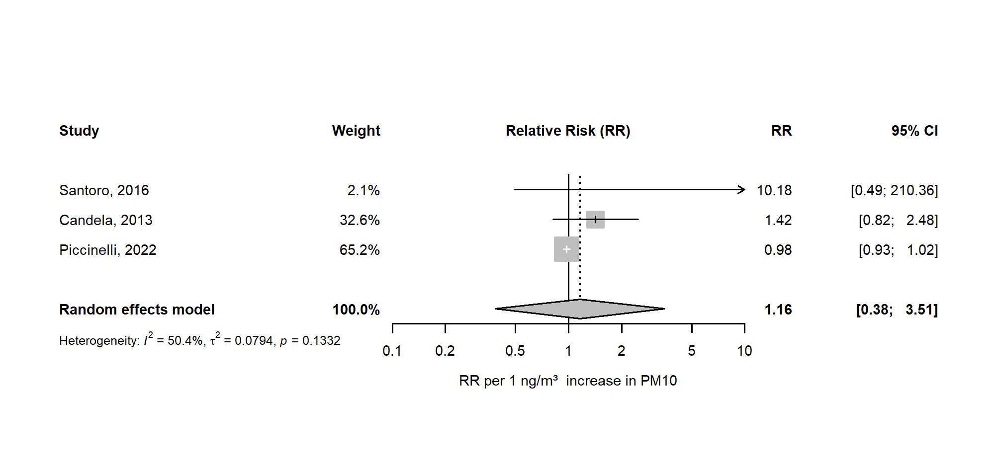

Figure A2 Forest plot of meta-analysis results for sex ratio related to PM10 exposure from MSWIs. Relative Risks expressed for 1 ng/m³ increase in PM10
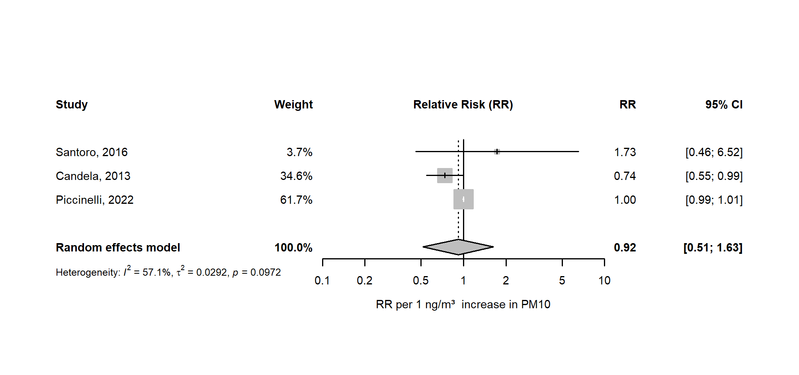

Figure A3 Forest plot of meta-analysis results for cardiovascular diseases risk related to PM10 exposure from MSWIs. Hazard Ratios expressed for 1 ng/m³ increase in PM10 and stratified by gender
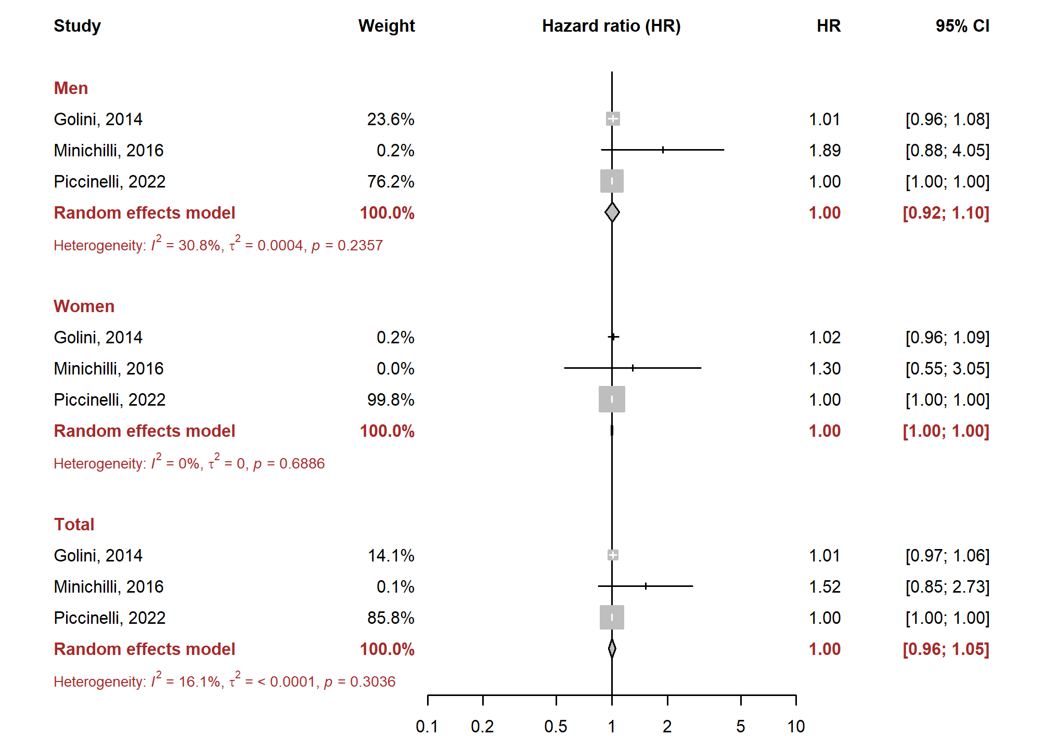

Figure A4 Forest plot of meta-analysis results for IHD risk related to PM10 exposure from MSWIs. Hazard Ratios expressed for 1 ng/m³ increase in PM10 and stratified by gender
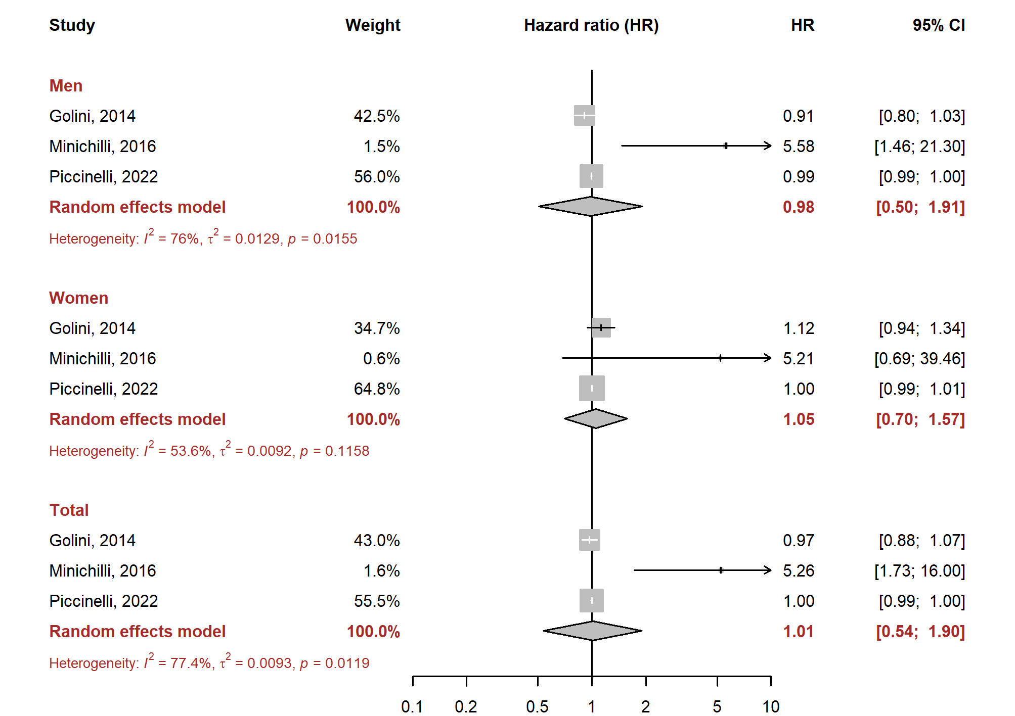

Figure A5 Forest plot of meta-analysis results for respiratory diseases risk related to PM10 exposure from MSWIs. Hazard Ratios expressed for 1 ng/m³ increase in PM10 and stratified by gender
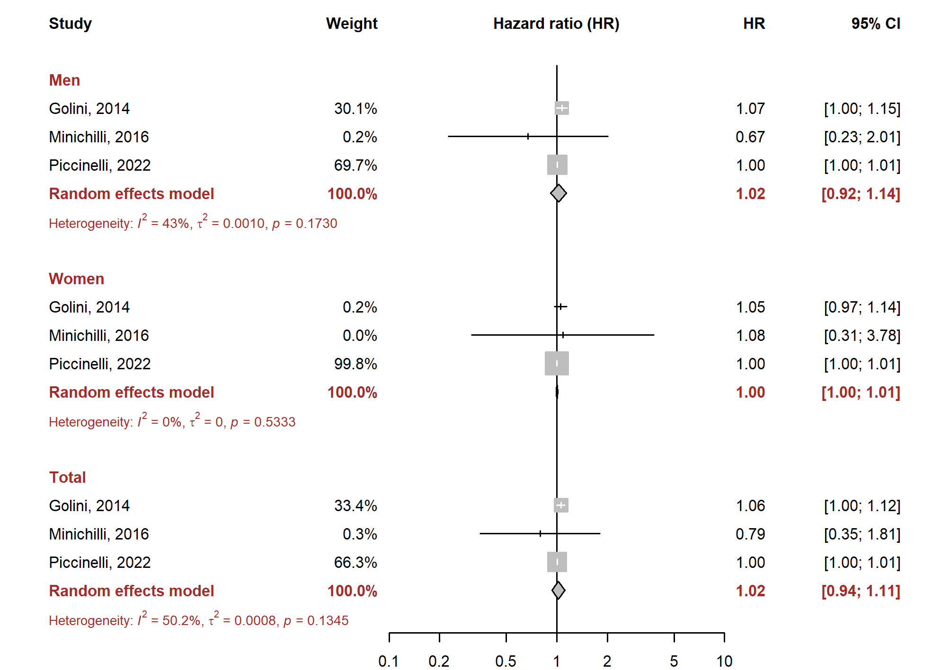

Figure A6 Forest plot of meta-analysis results for COPD risk related to PM10 exposure from MSWIs. Hazard Ratios expressed for 1 ng/m³ increase in PM10 and stratified by gender
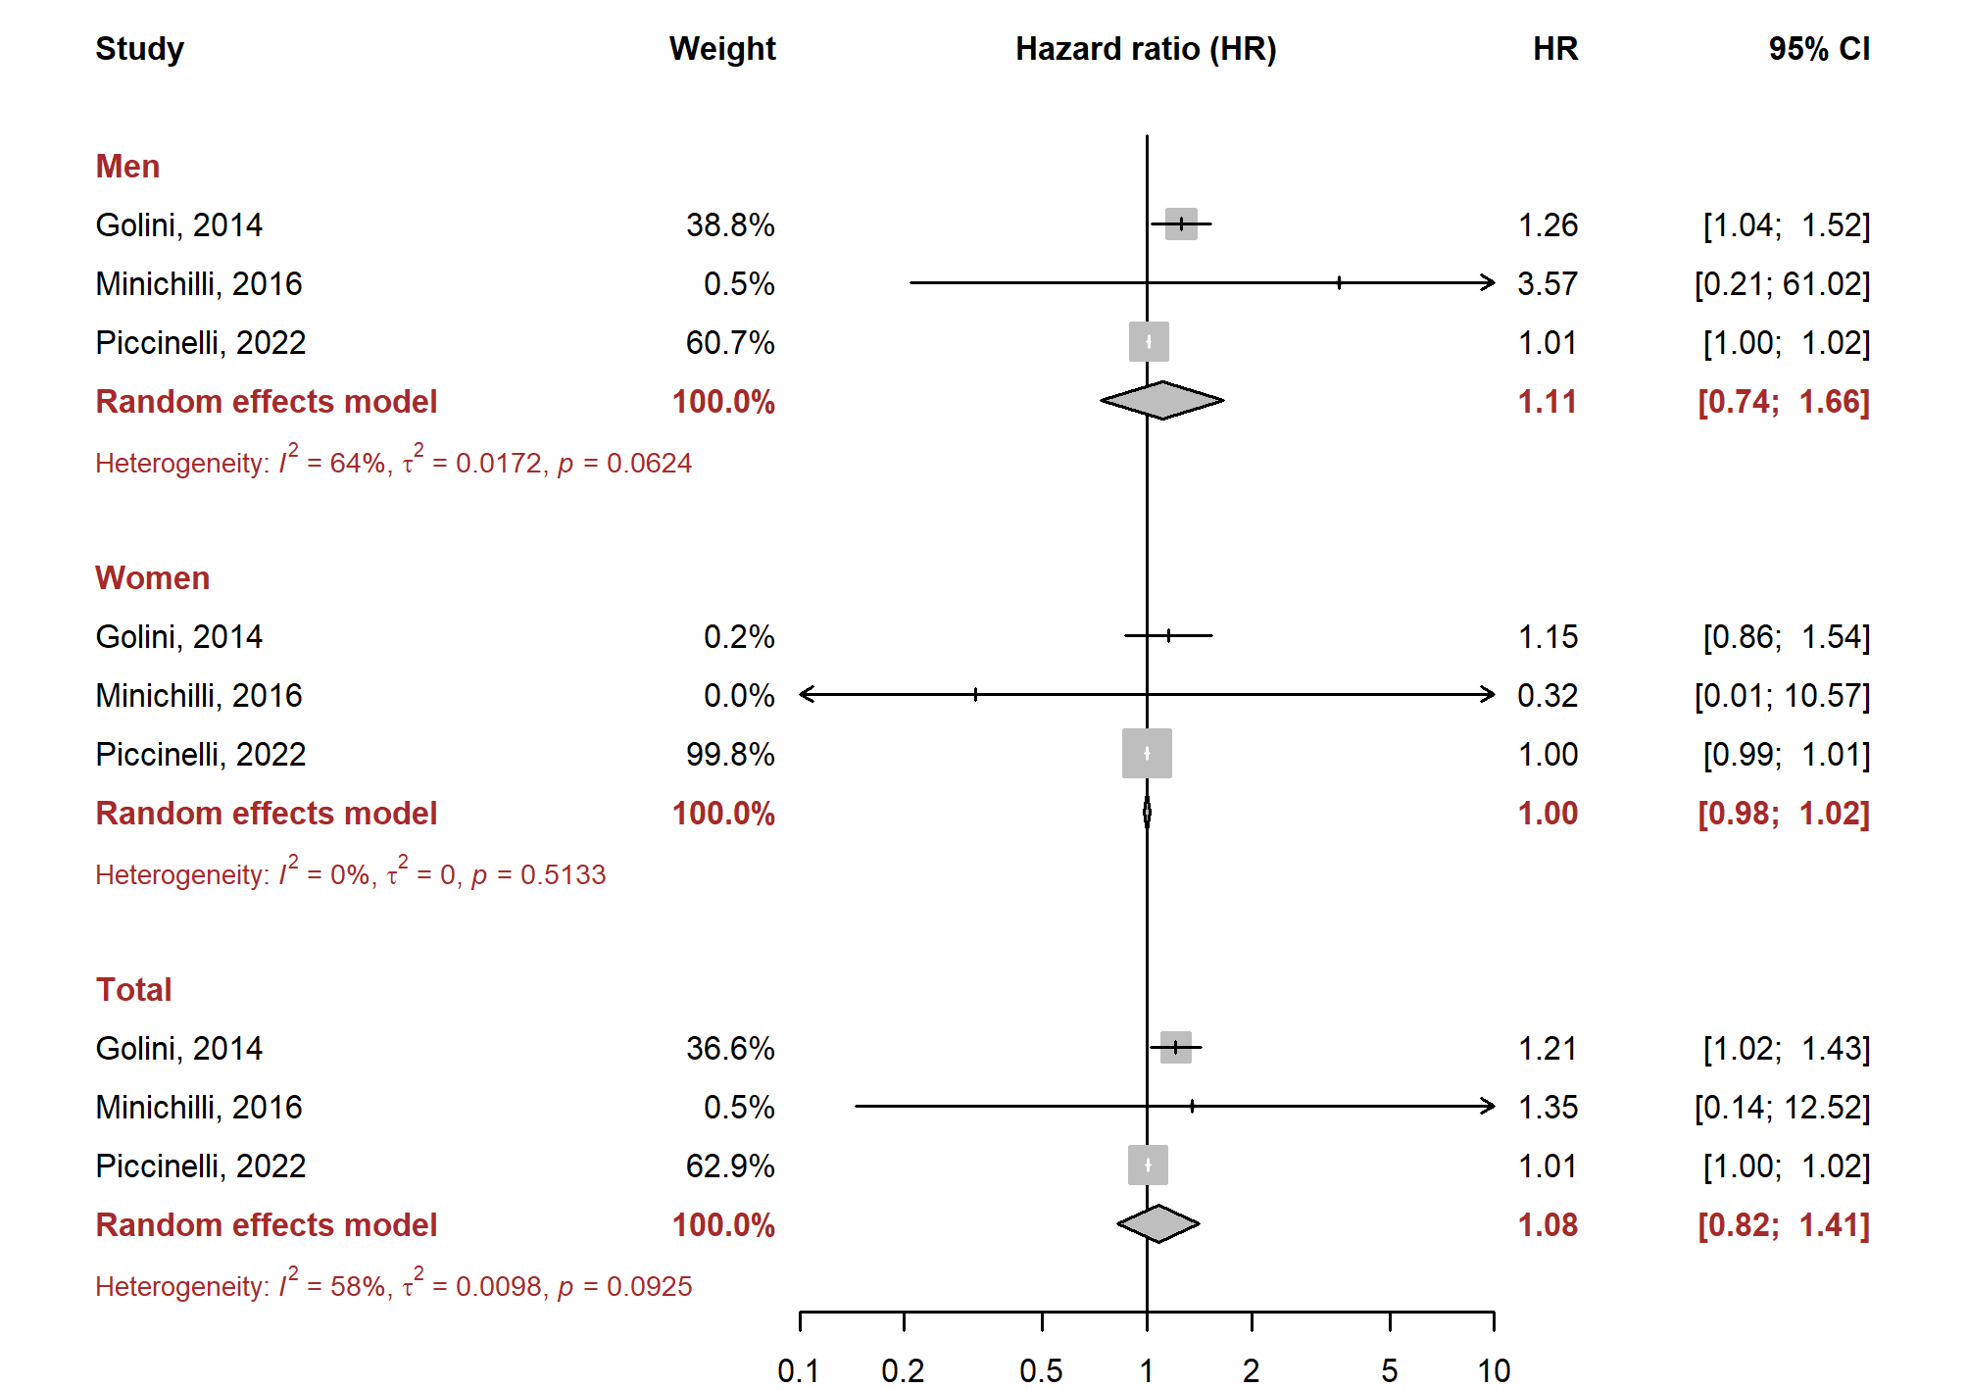

Figure A7 Forest plot of meta-analysis results for asthma risk related to PM10 exposure from MSWIs. Hazard Ratios expressed for 1 ng/m³ increase in PM10
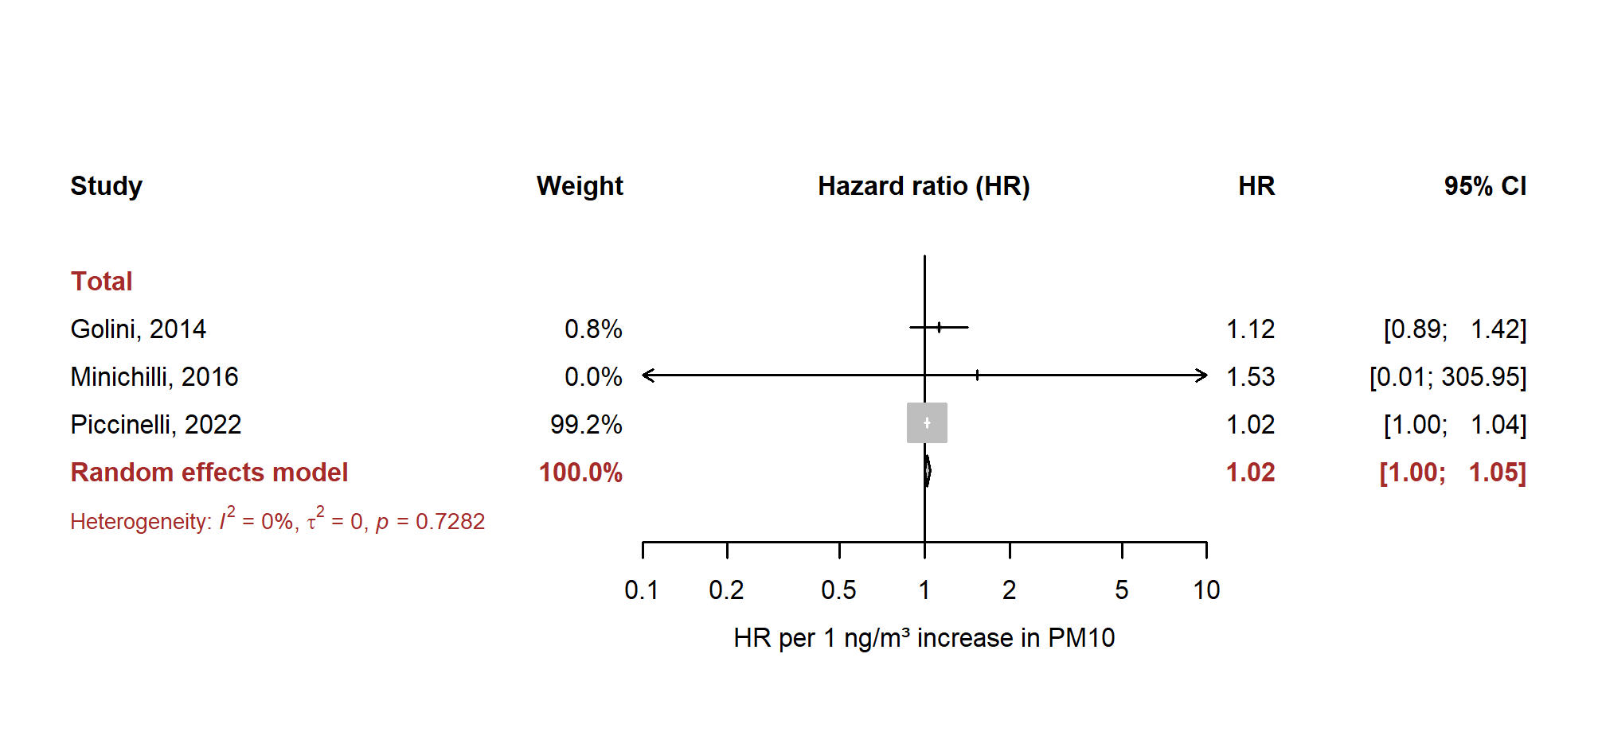

Figure A8 Funnel plot of preterm birth risk related to PM10 exposure from MSWIs
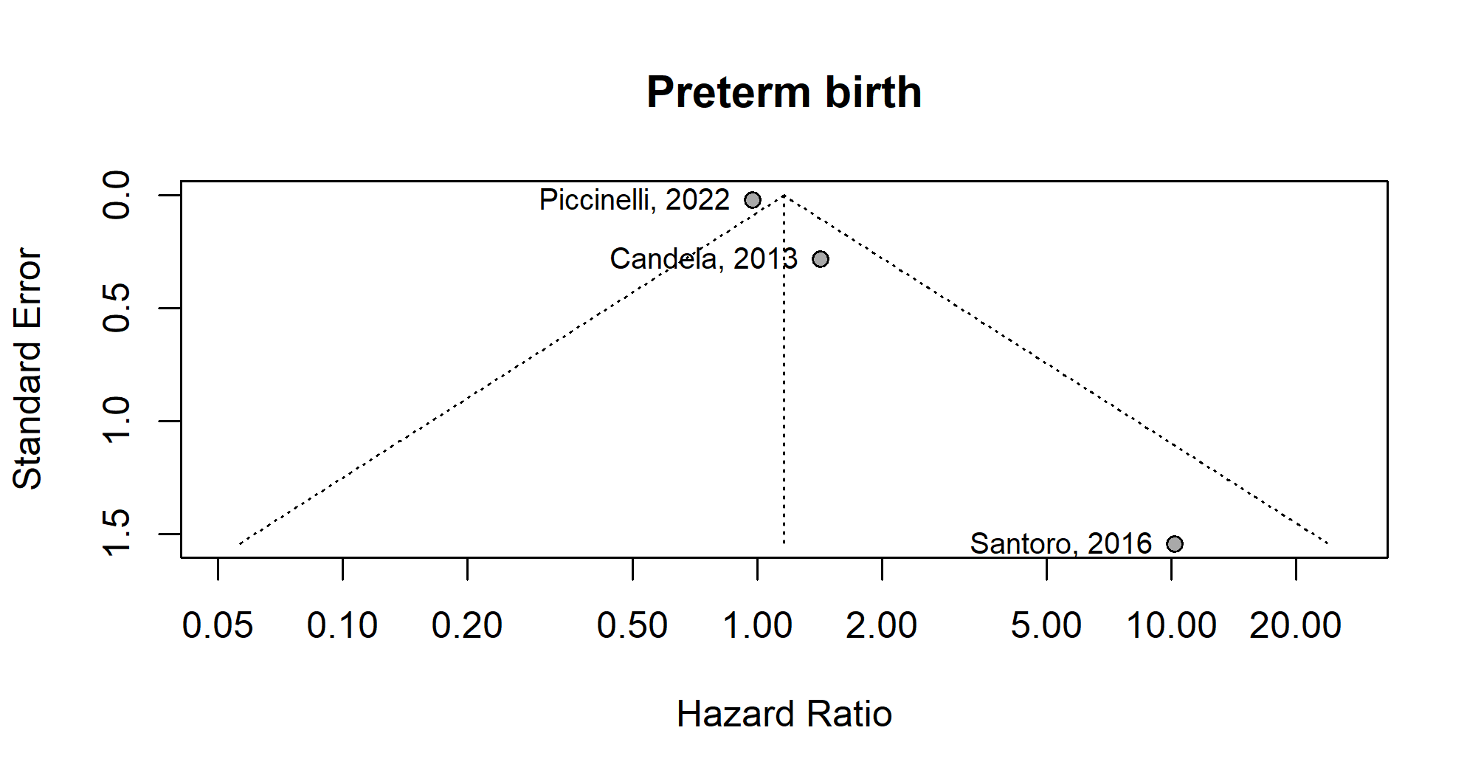

Figure A9 Funnel plot of sex ratio related to PM10 exposure from MSWIs
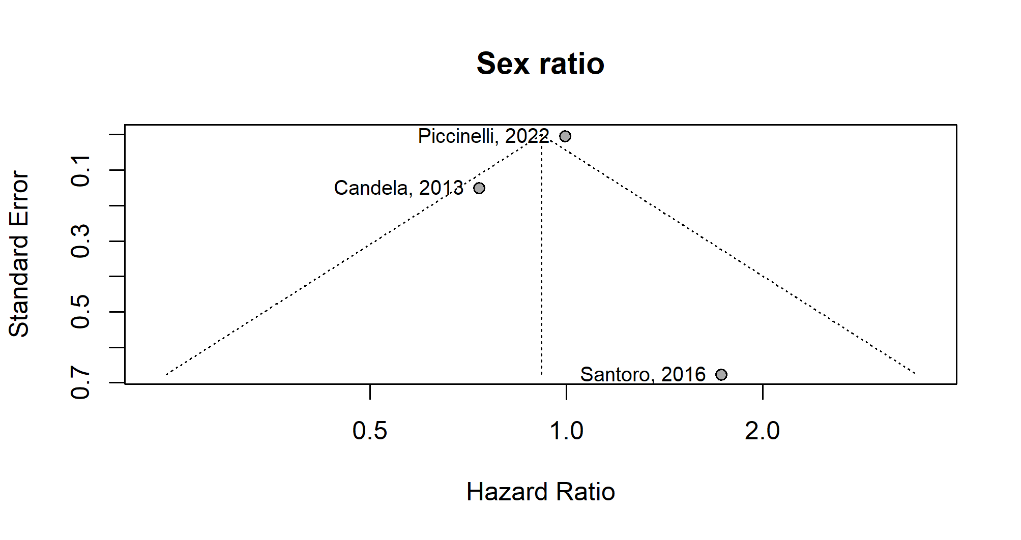

Figure A10 Funnel plot of cardiovascular diseases risk in men related to PM10 exposure from MSWIs
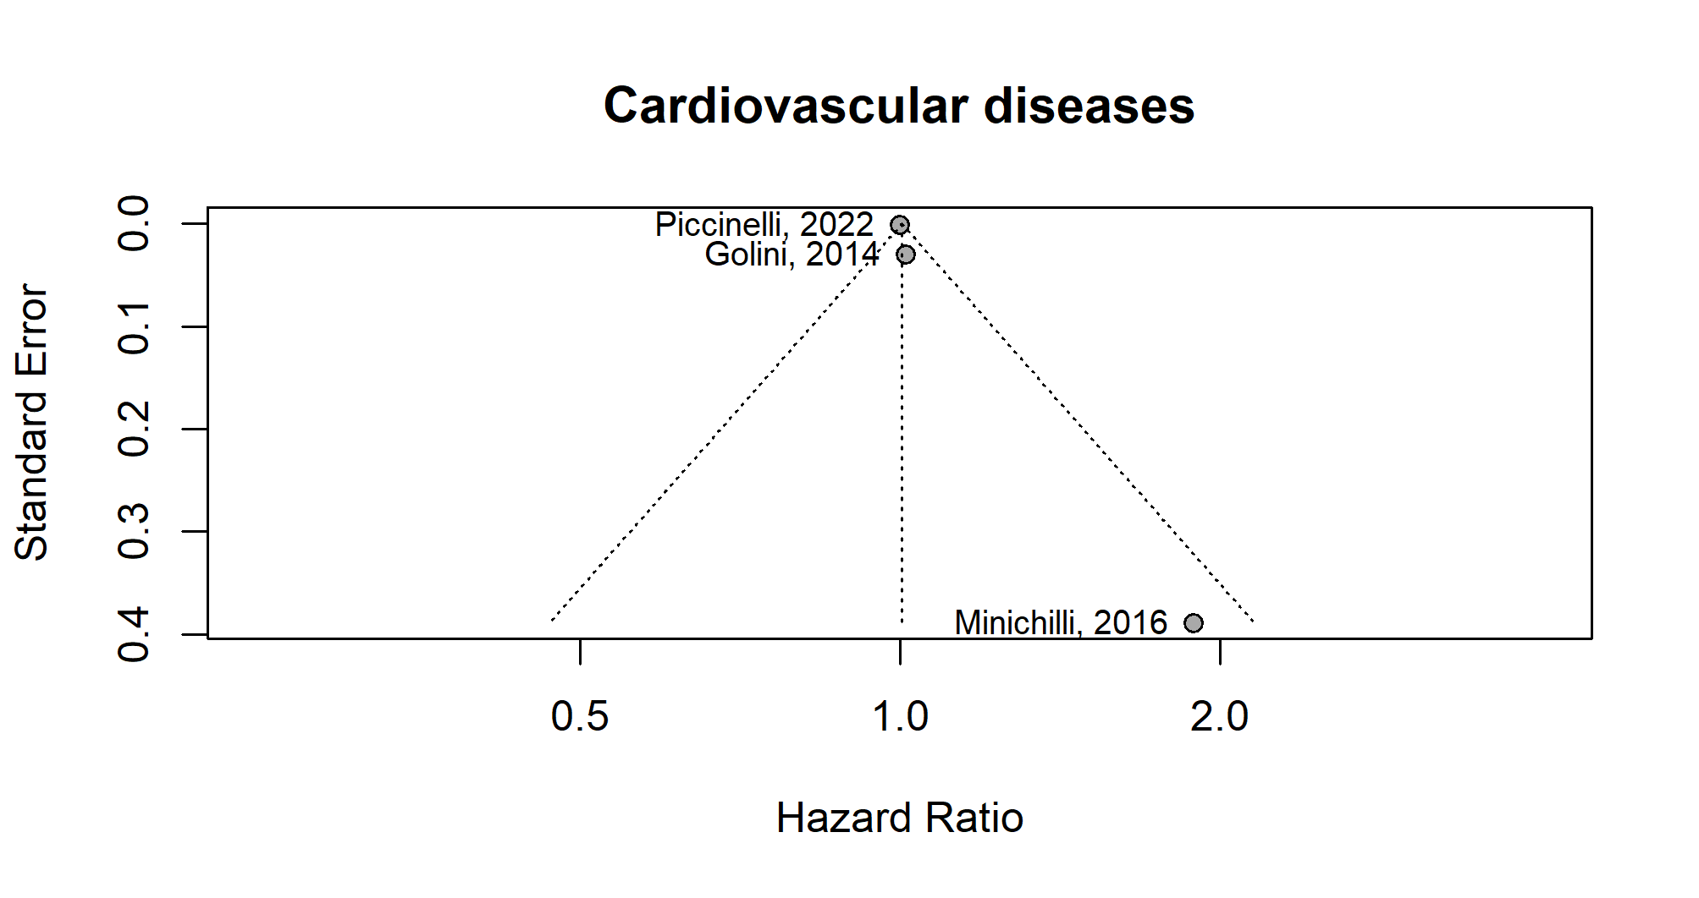

Figure A11 Funnel plot of cardiovascular diseases risk in women related to PM10 exposure from MSWIs
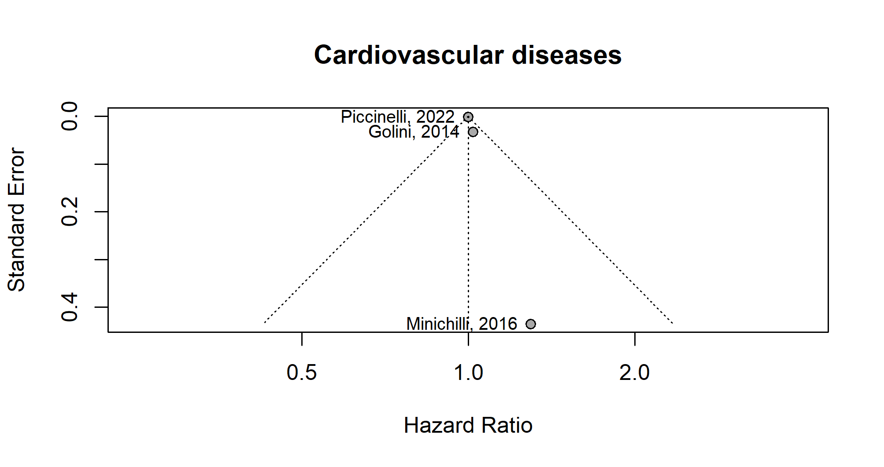
Figure A12 Funnel plot of cardiovascular diseases risk in overall population related to PM10 exposure from MSWIs
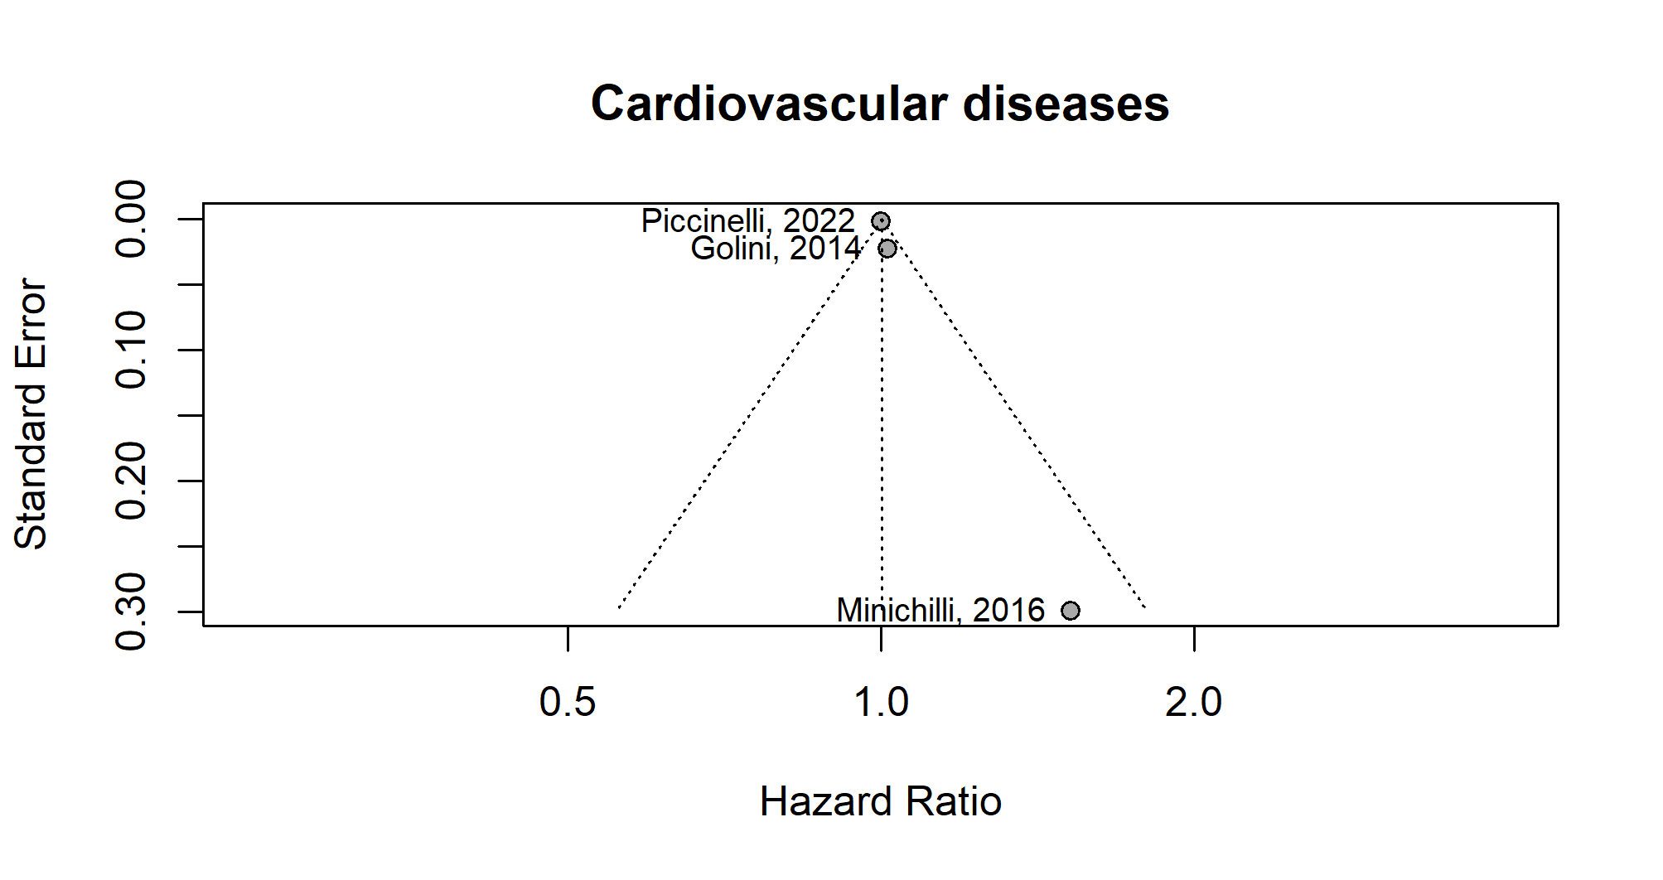

Figure A13 Funnel plot of ischemic heart diseases risk in men related to PM10 exposure from MSWIs
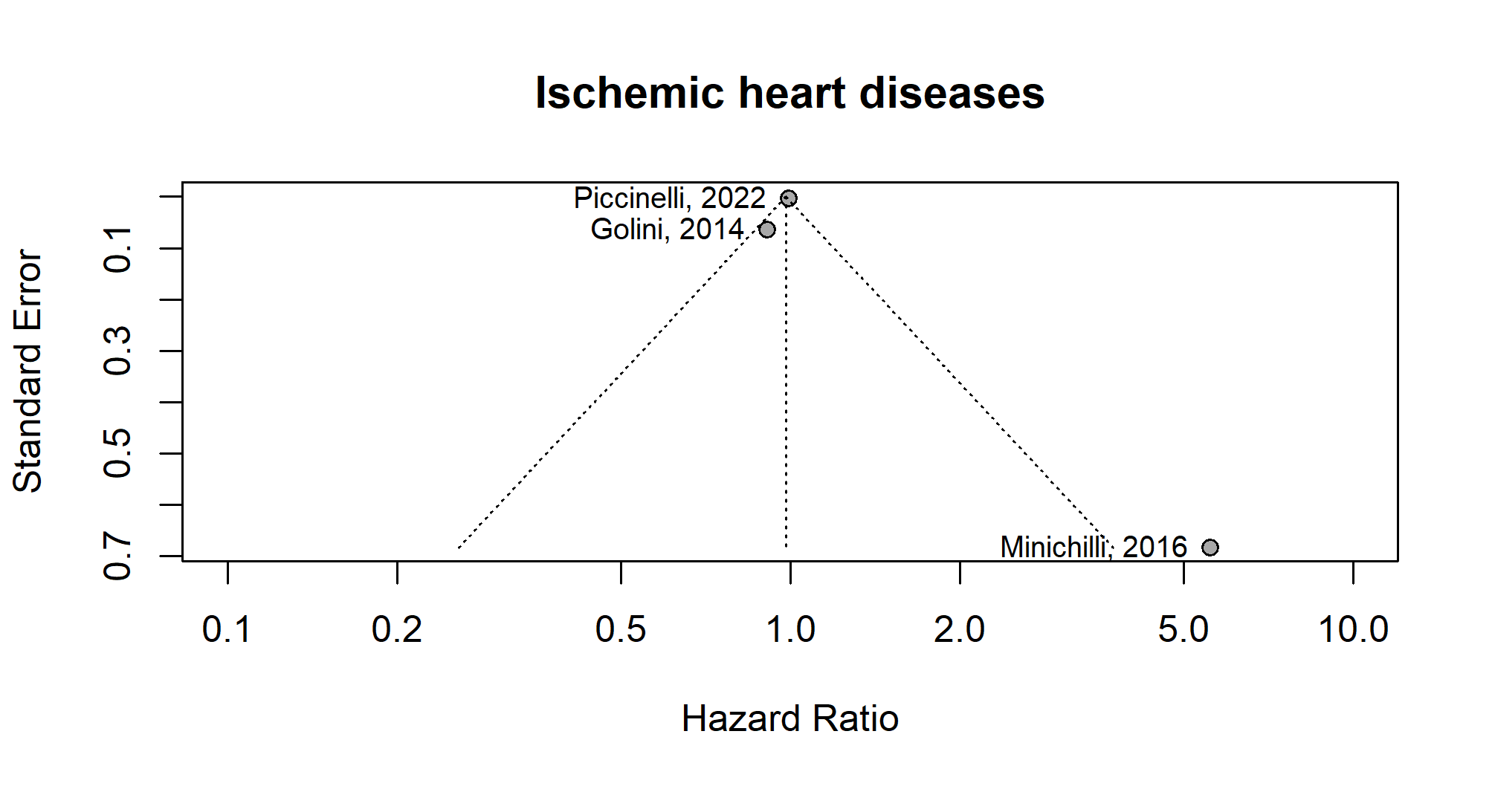
Figure A14 Funnel plot of ischemic heart diseases risk in women related to PM10 exposure from MSWIs
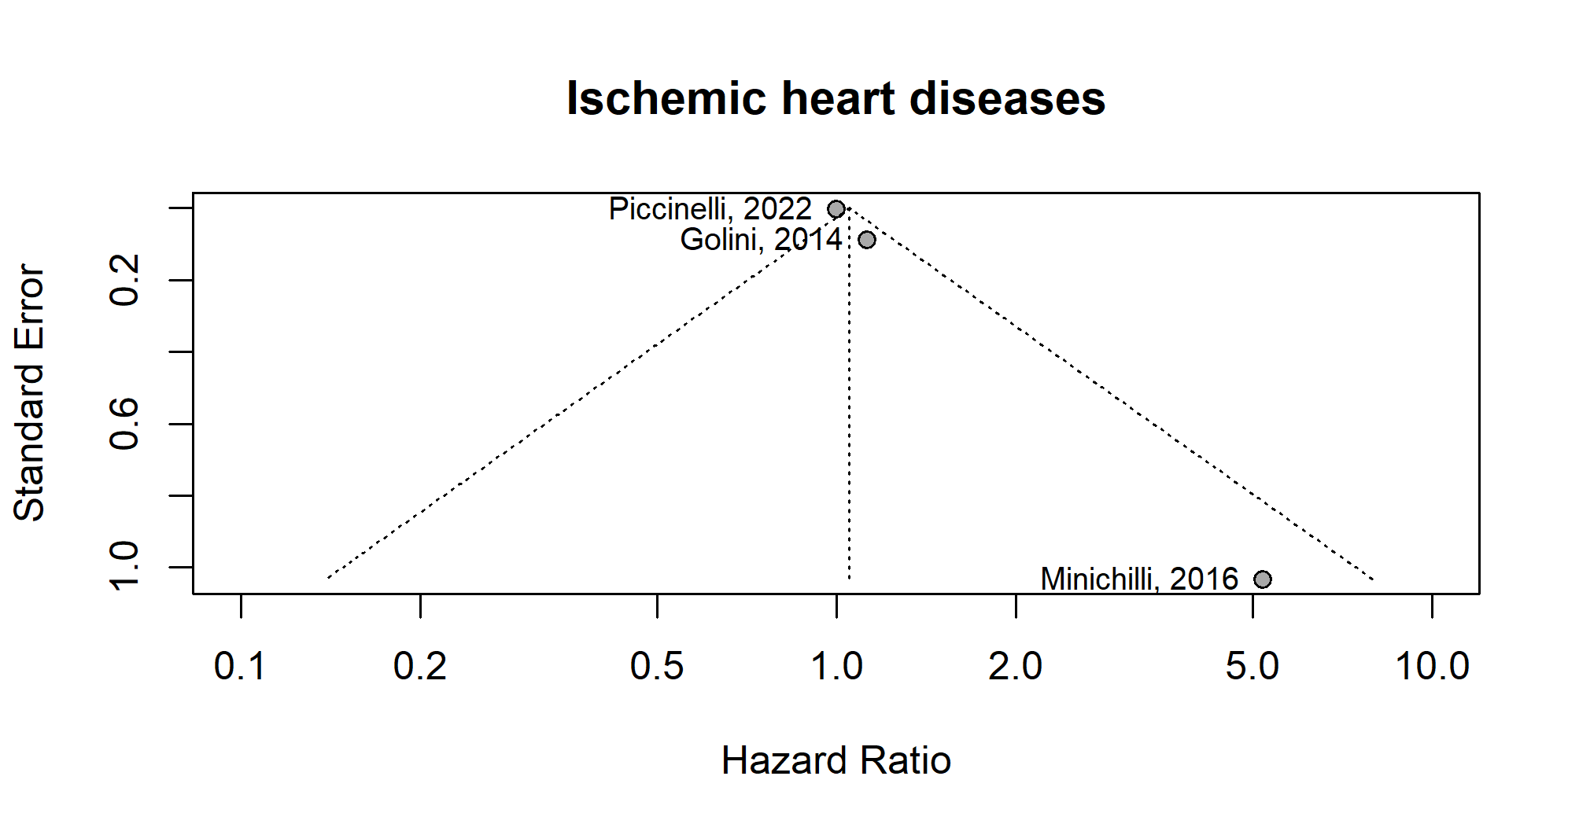

Figure A15 Funnel plot of ischemic heart diseases risk in overall population related to PM10 exposure from MSWIs
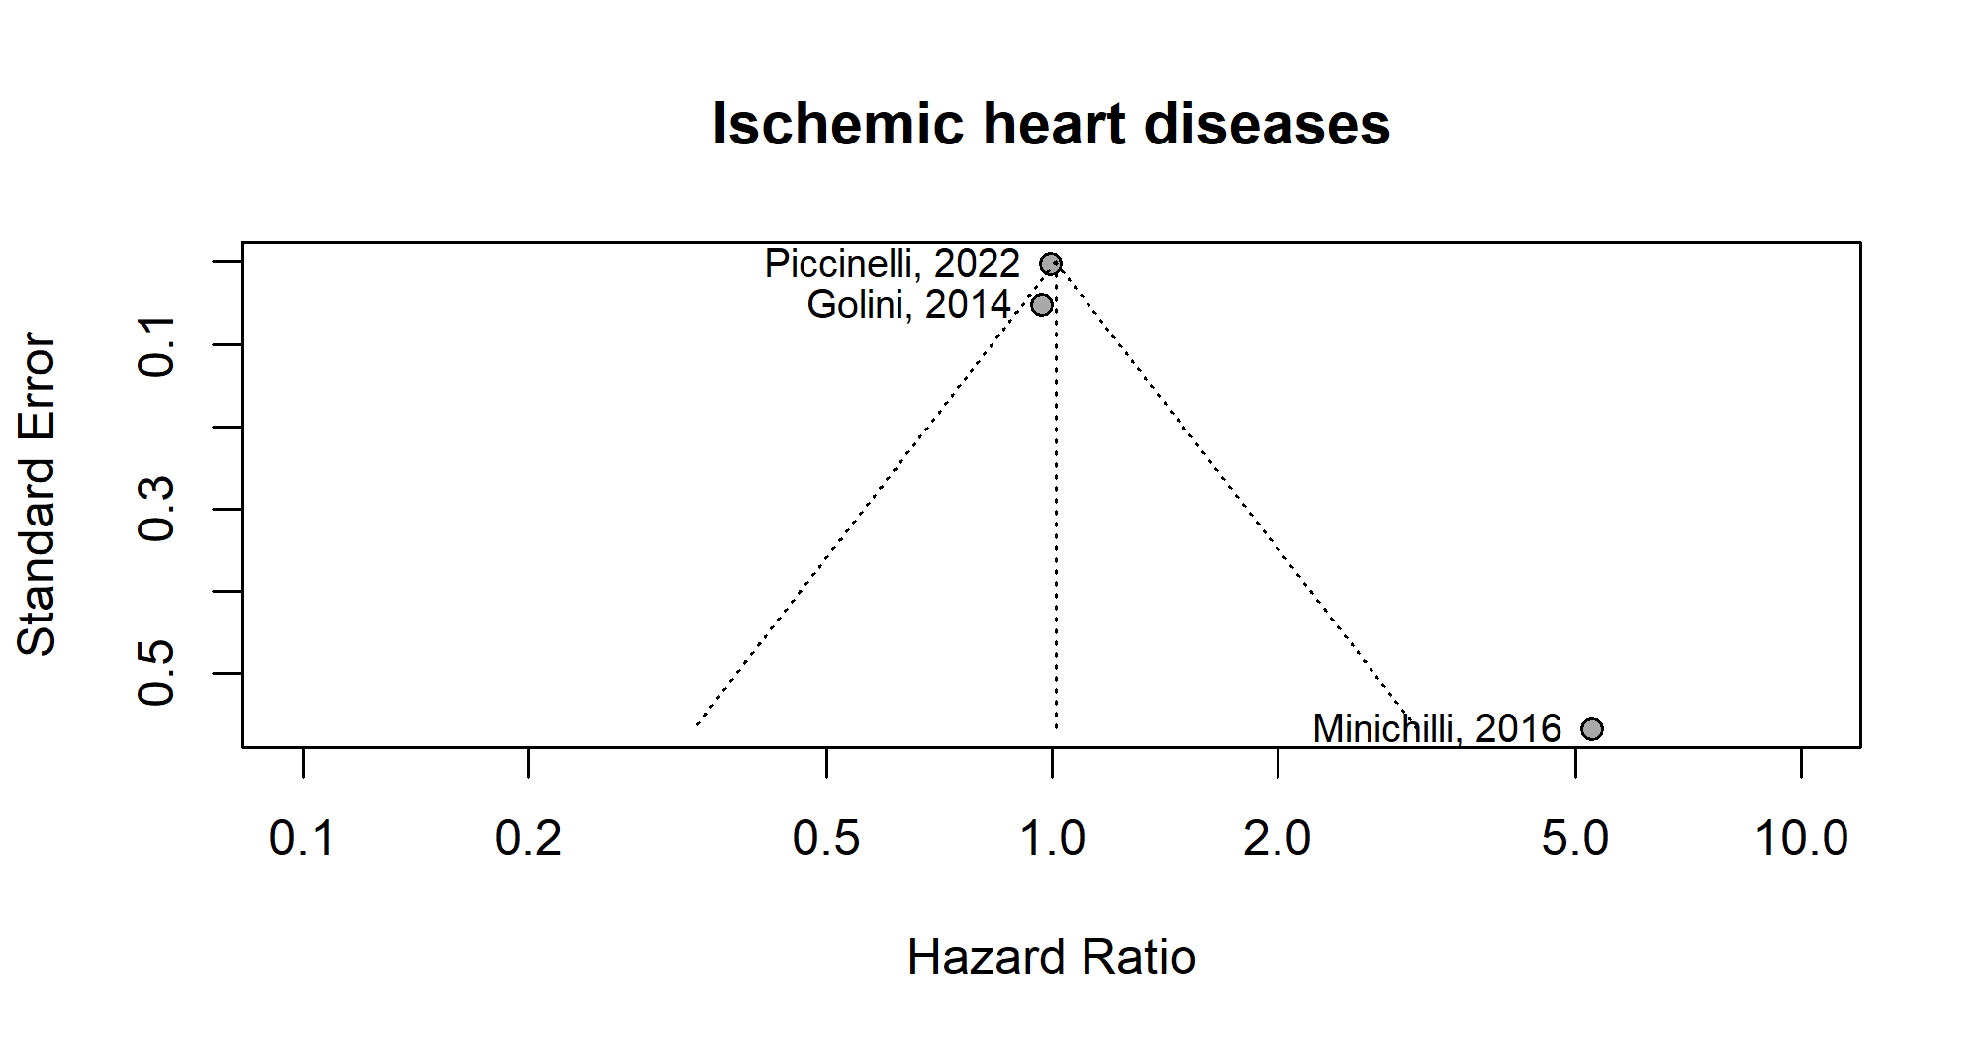
Figure A16 Funnel plot of respiratory diseases risk in men related to PM10 exposure from MSWIs
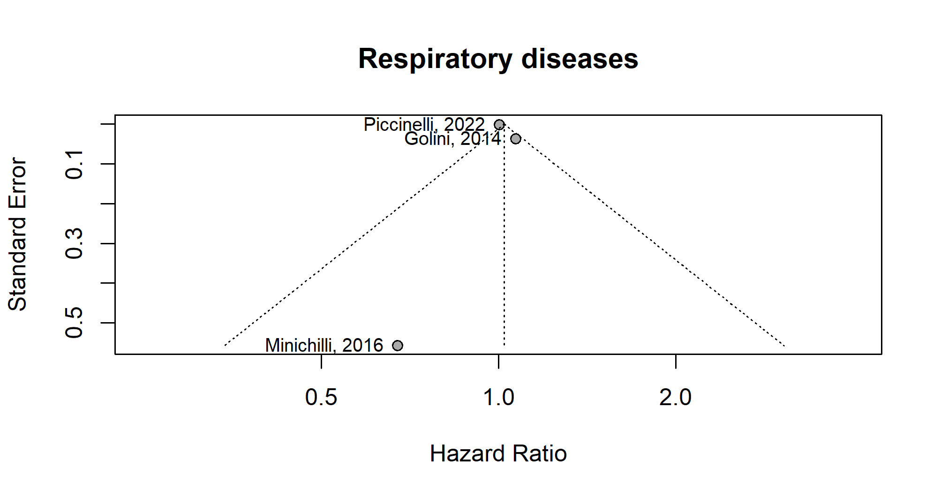

Figure A17 Funnel plot of respiratory diseases risk in women related to PM10 exposure from MSWIs
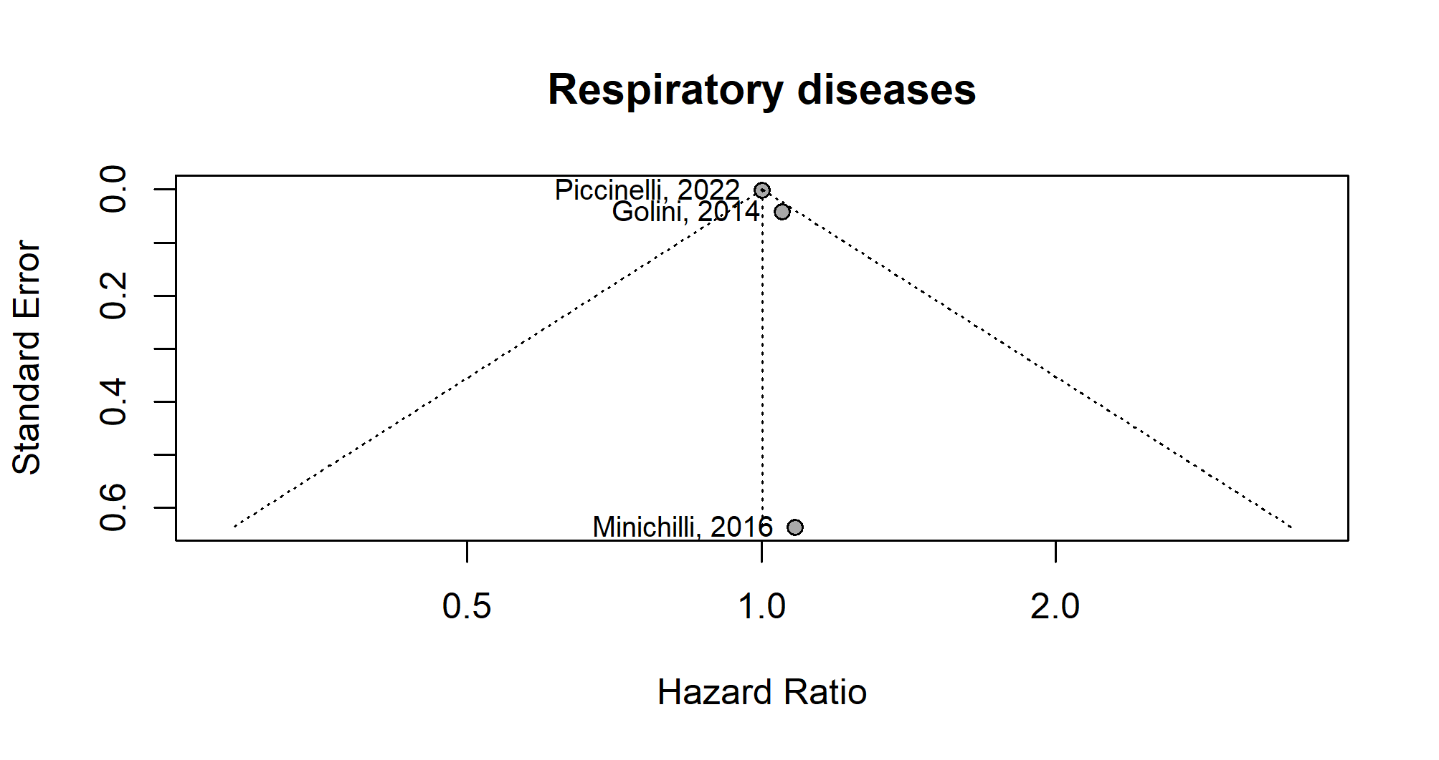
Figure A18 Funnel plot of respiratory diseases risk in overall population related to PM10 exposure from MSWIs
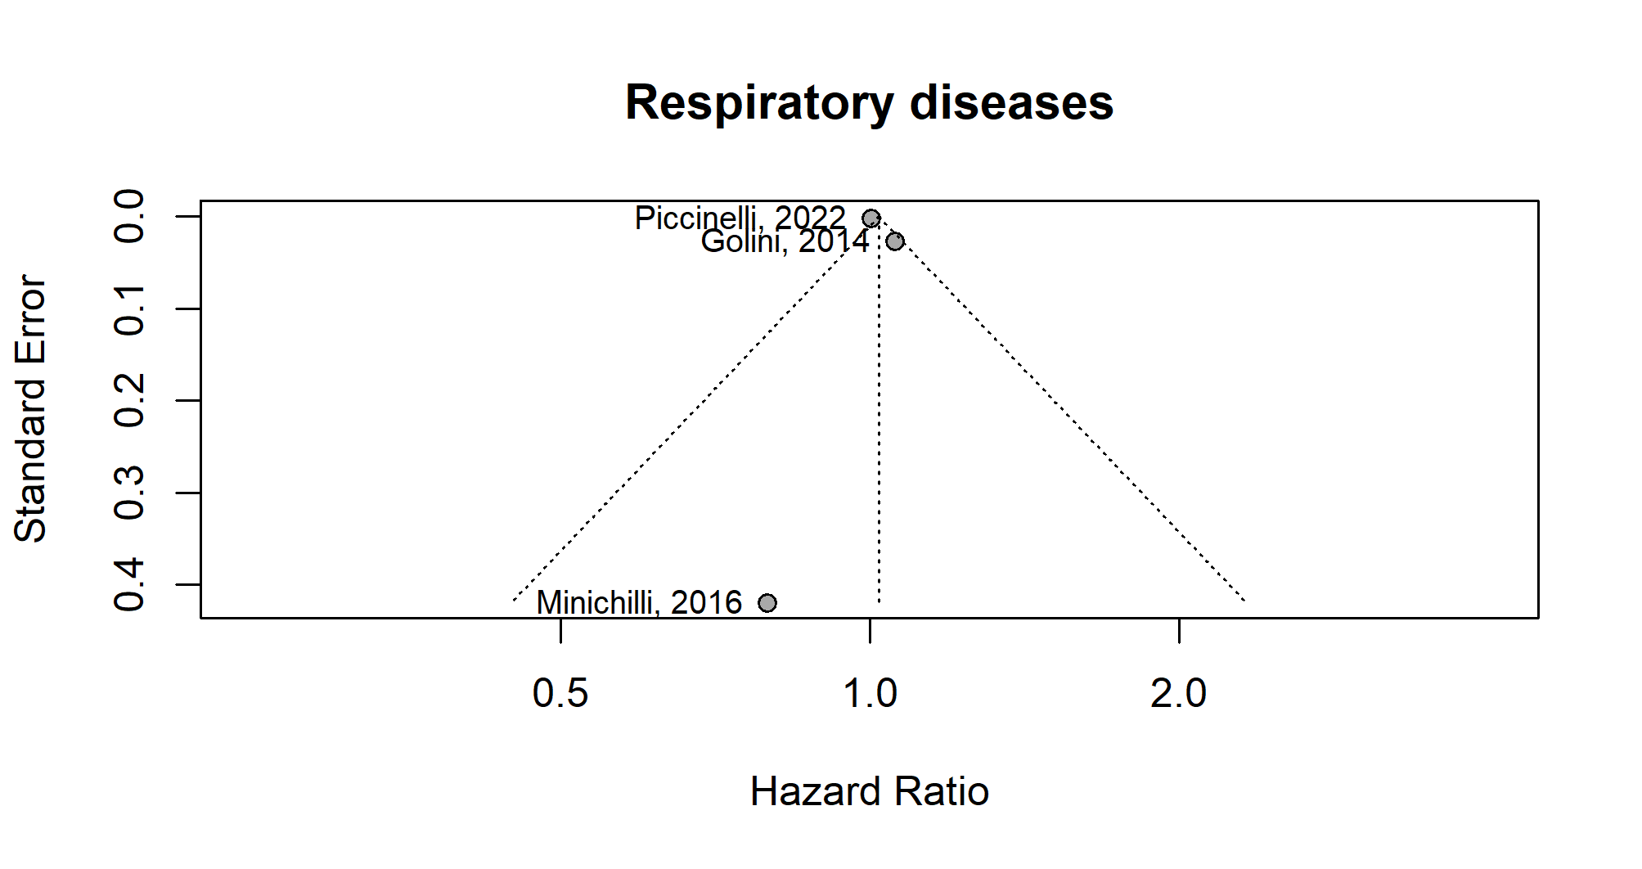

Figure A19 Funnel plot of COPD risk in men related to PM10 exposure from MSWIs
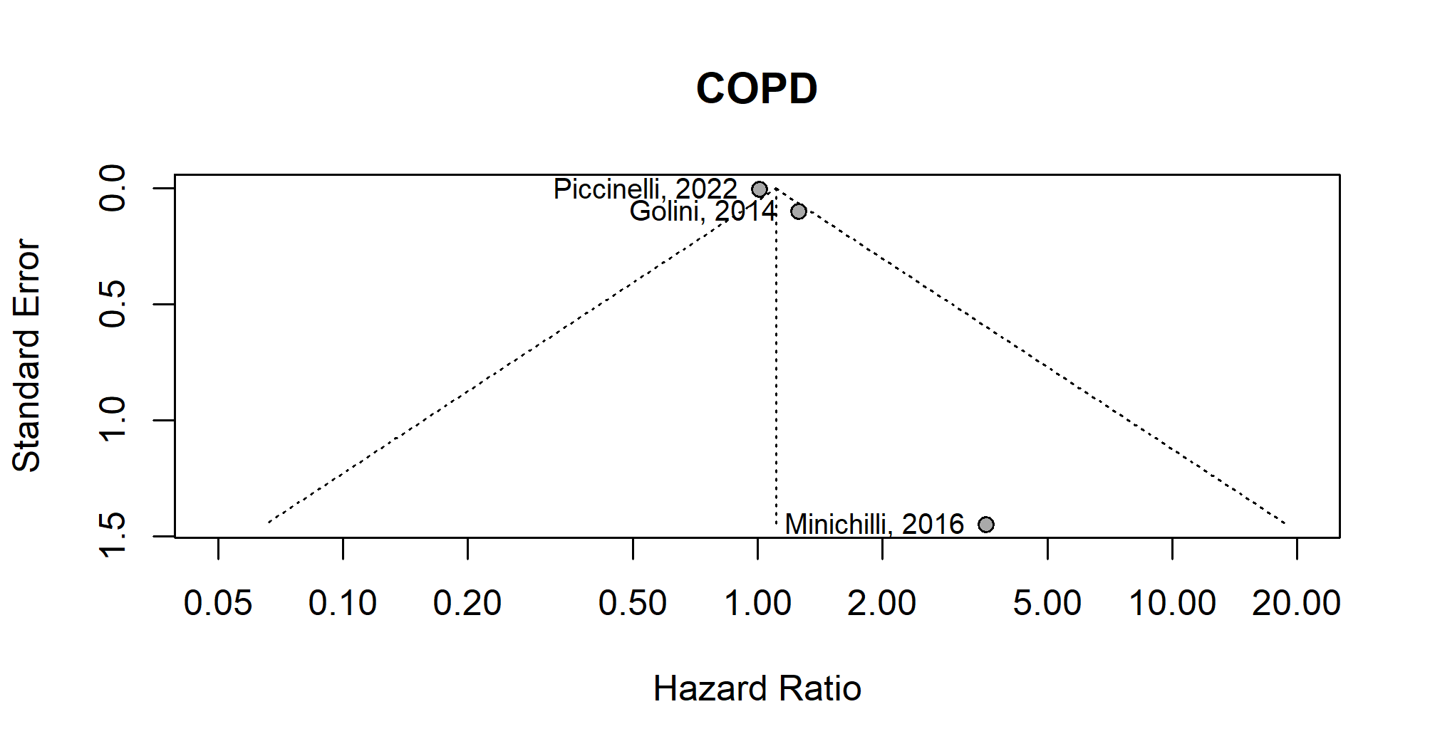
Figure A20 Funnel plot of COPD risk in women related to PM10 exposure from MSWIs
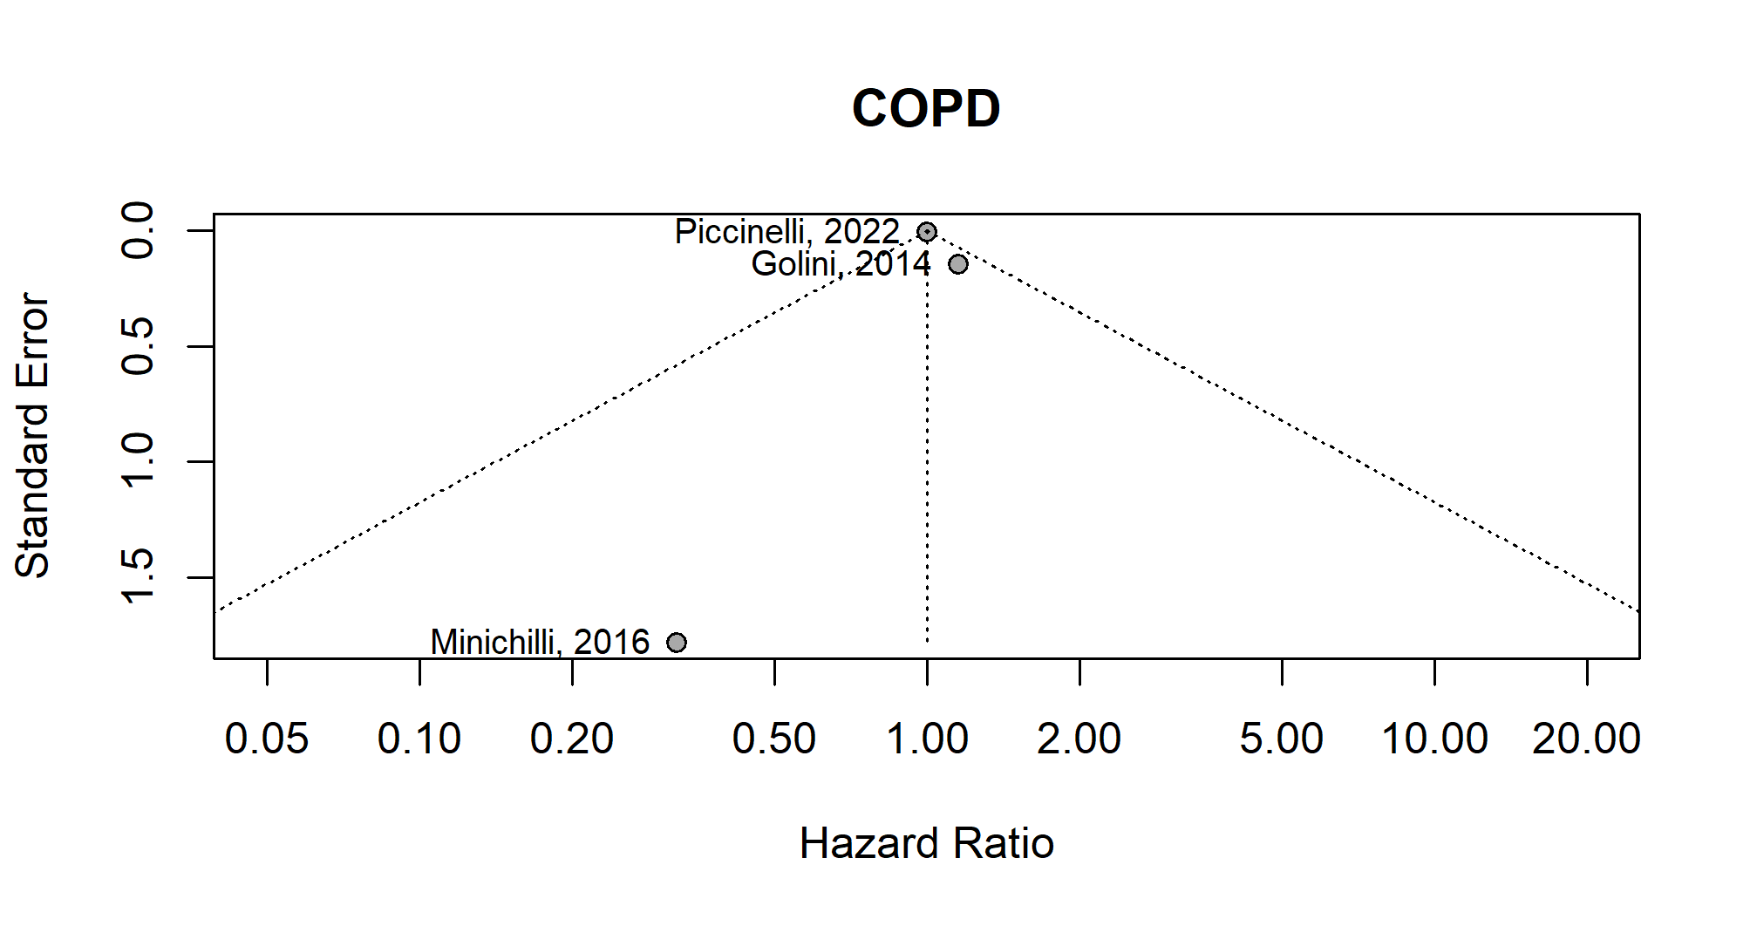

Figure A21 Funnel plot of COPD risk in overall population related to PM10 exposure from MSWIs
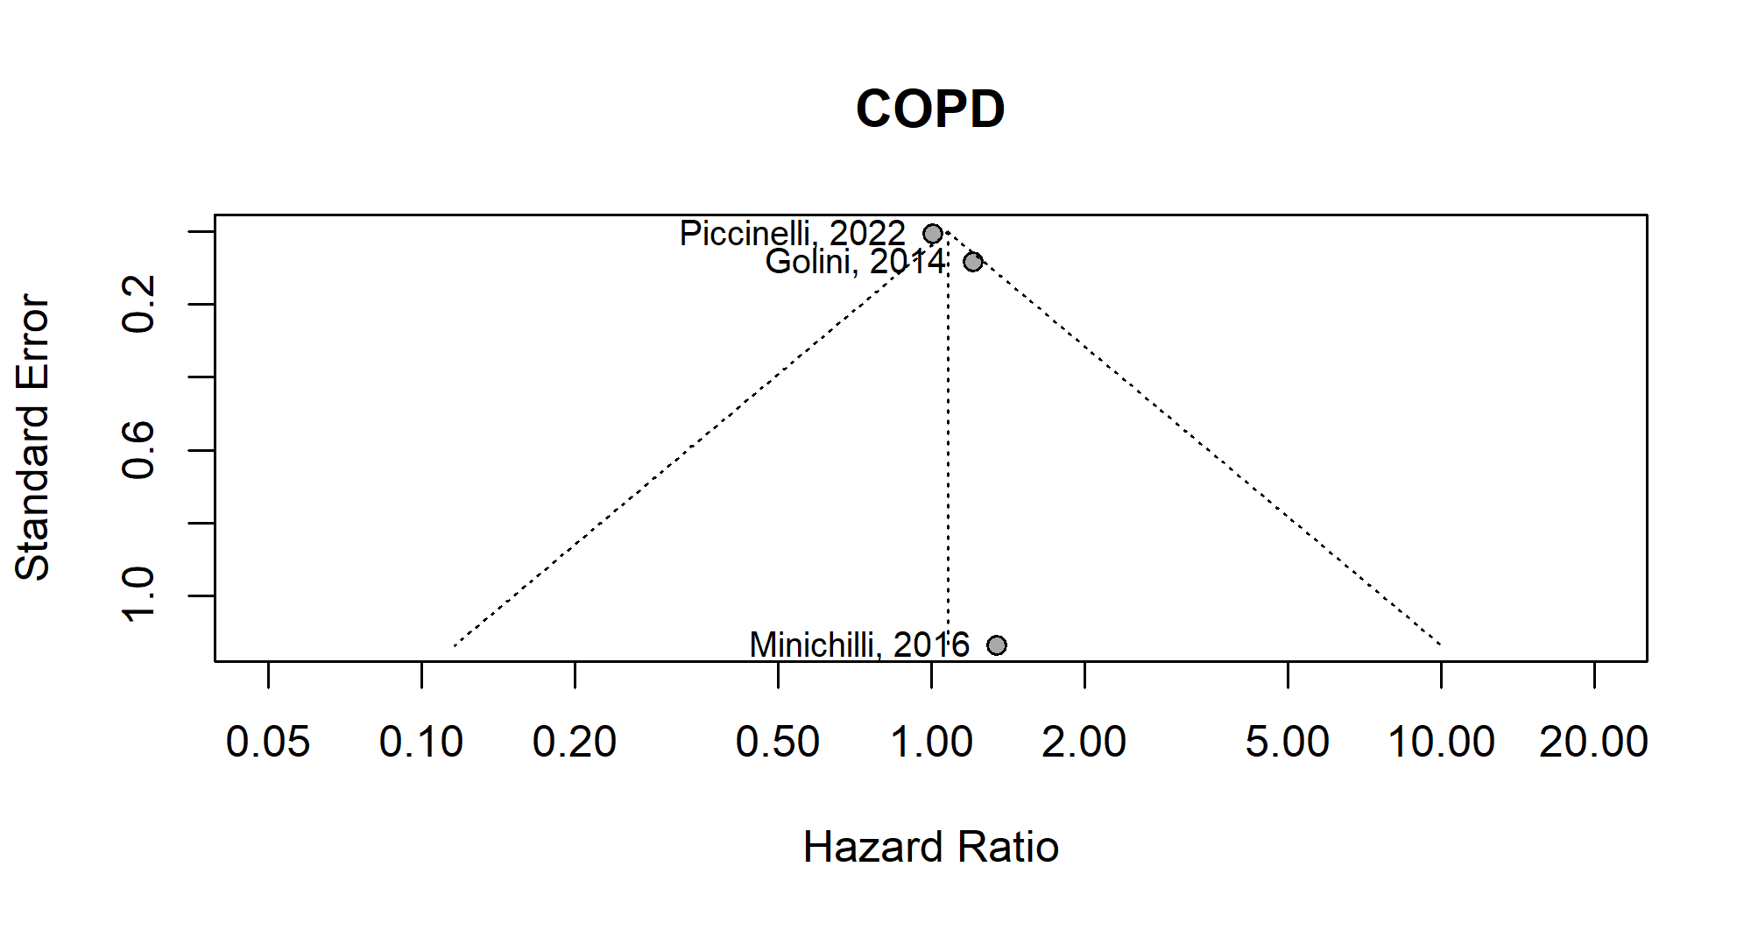
Figure A22 Funnel plot of asthma risk in overall population related to PM10 exposure from MSWIs
