Nonlinear Association of Physical Activity with Early Cardiovascular-Kidney-Metabolic Syndrome Risk: A Comprehensive Analysis of NHANES Data from 2007 to 2018

Haozhe Wang^{1,†}, Yike Zhang^{1,†}, Meimei Sun^{2*}, Zhou Chen^{3*}

¹ College of Basic Medical Sciences of Naval Medical University, Shanghai, China
² Gongli Hospital of Shanghai Pudong New Area, Department of Nephrology ，Shanghai, China
³ The First Affiliated Hospital of Naval Medical University, Department of Nephrology, Shanghai, China

†Haozhe Wang and Yike Zhang contributed equally to this work.
*Correspondence:
Meimei Sun
Email: zhenzhen198184@163.com
Zhou Chen
Email: fijiji@163.com
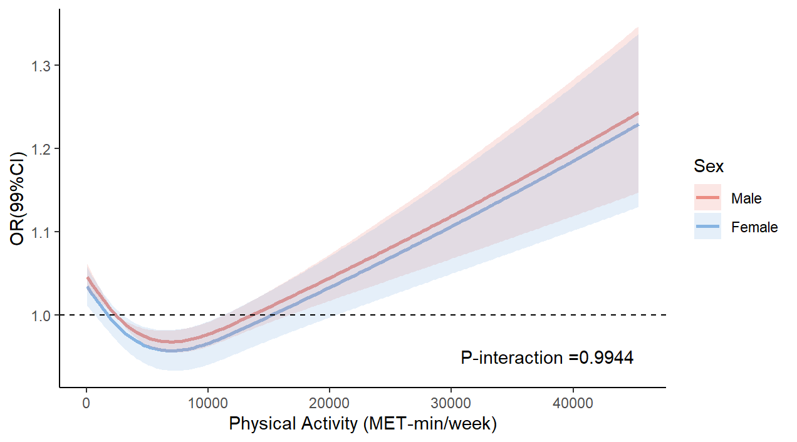
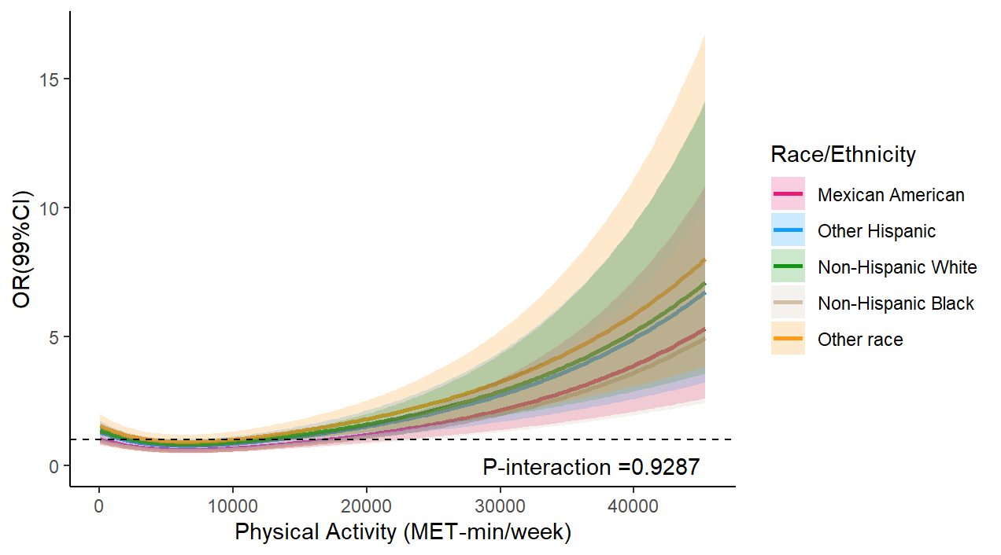
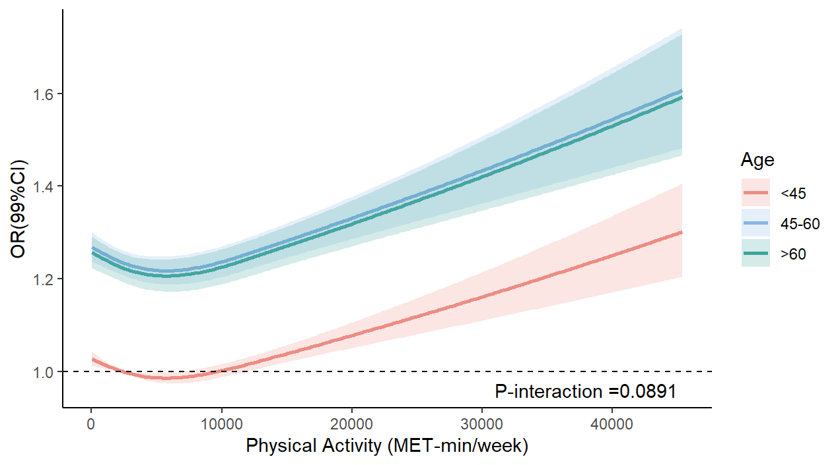
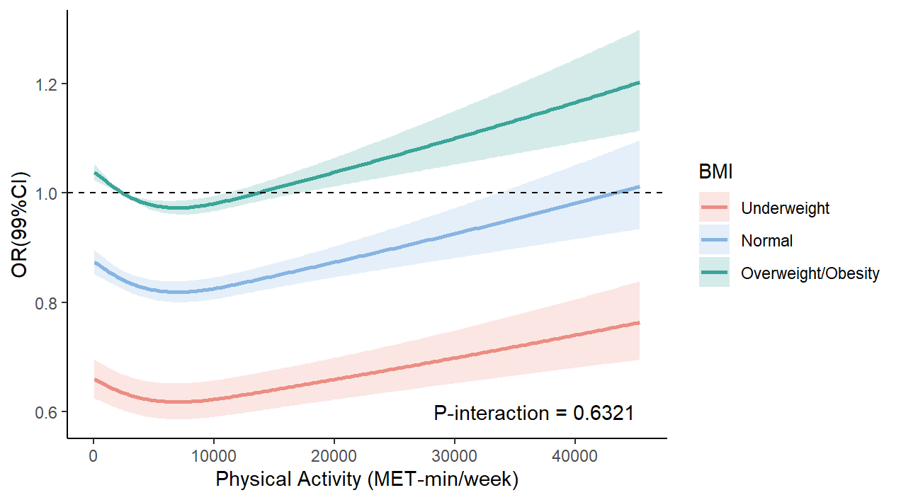
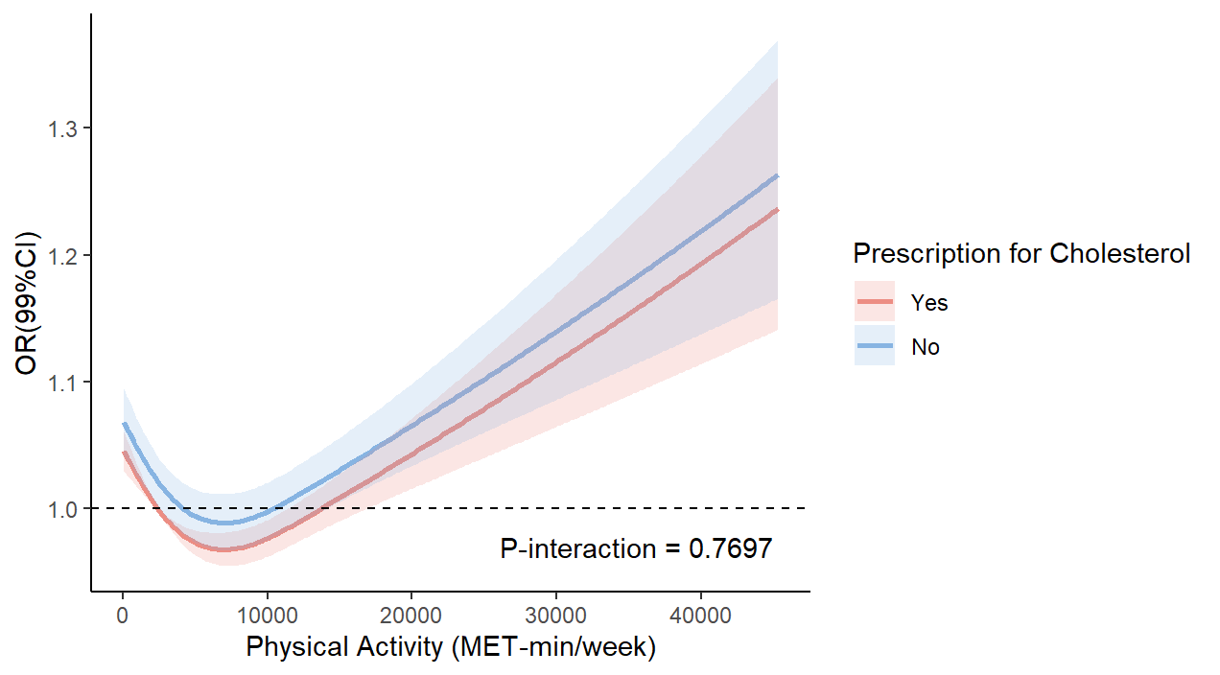
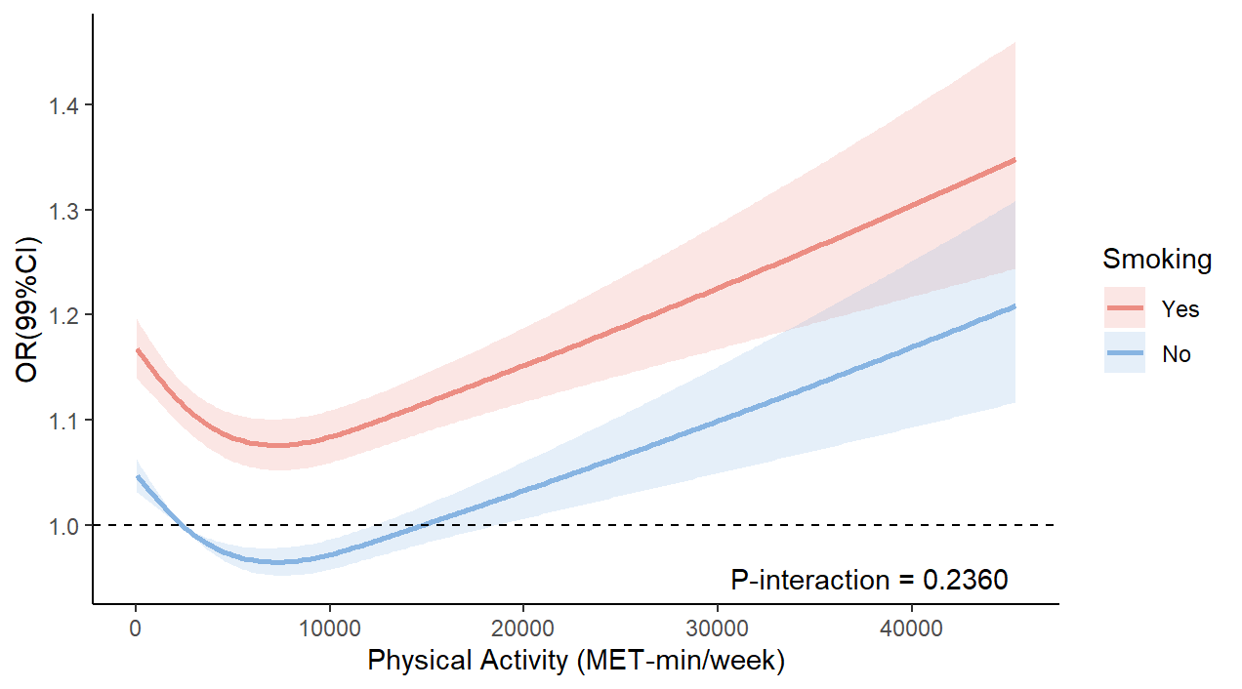
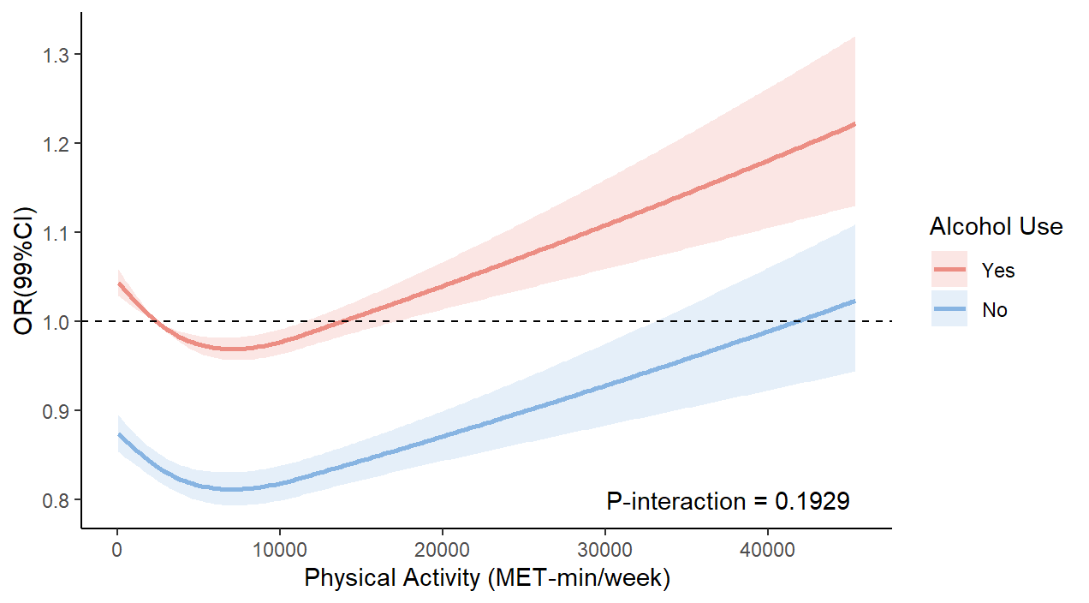
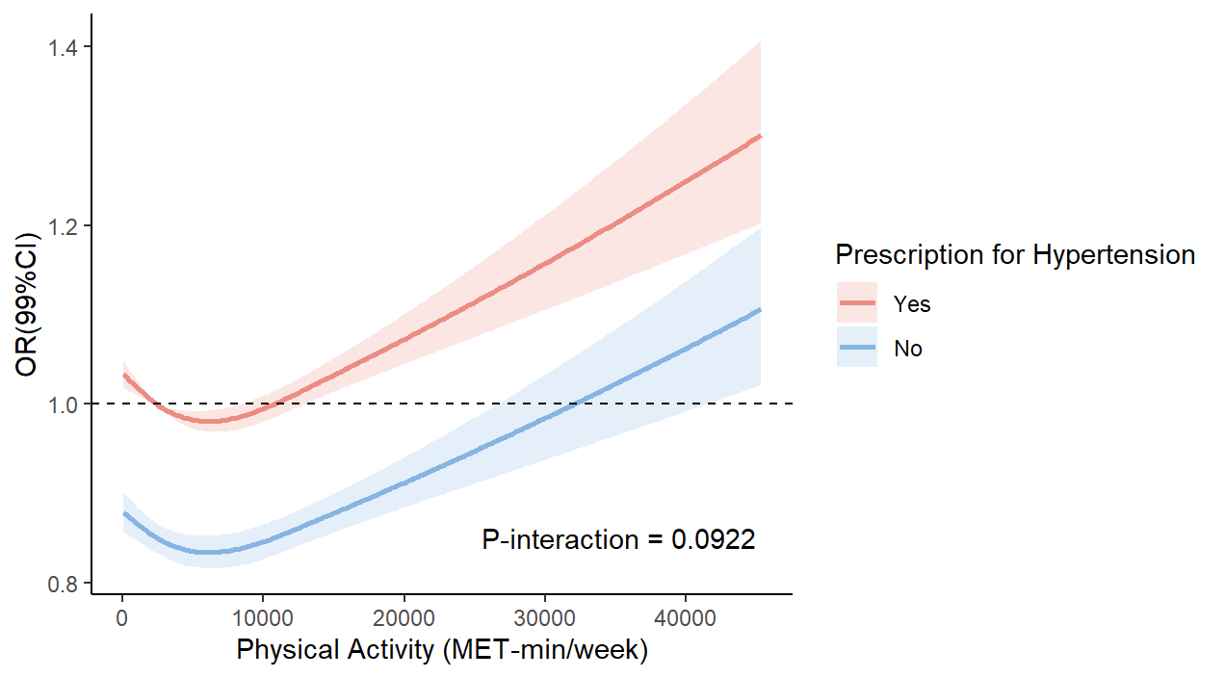
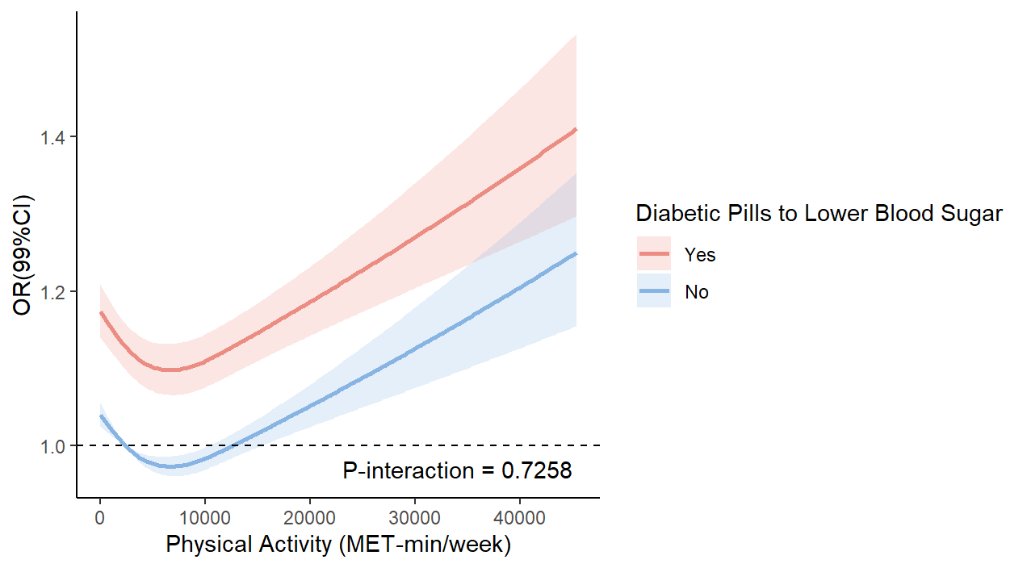
Supplementary material 1 Stratified restricted cubic spline
Restricted cubic spline analysis of the association between PA and early CKM for sex, race/ ethnicity, age, BMI, smoking, alcohol use and medication use

