Nonlinear Association of Physical Activity with Early Cardiovascular-Kidney-Metabolic Syndrome Risk: A Comprehensive Analysis of NHANES Data from 2007 to 2018

Haozhe Wang^{1,†}, Yike Zhang^{1,†}, Meimei Sun^{2*}, Zhou Chen^{3*}

¹ College of Basic Medical Sciences of Naval Medical University, Shanghai, China
² Gongli Hospital of Shanghai Pudong New Area, Department of Nephrology ，Shanghai, China
³ The First Affiliated Hospital of Naval Medical University, Department of Nephrology, Shanghai, China

†Haozhe Wang and Yike Zhang contributed equally to this work.
*Correspondence:
Meimei Sun
Email: zhenzhen198184@163.com
Zhou Chen
Email: fijiji@163.com
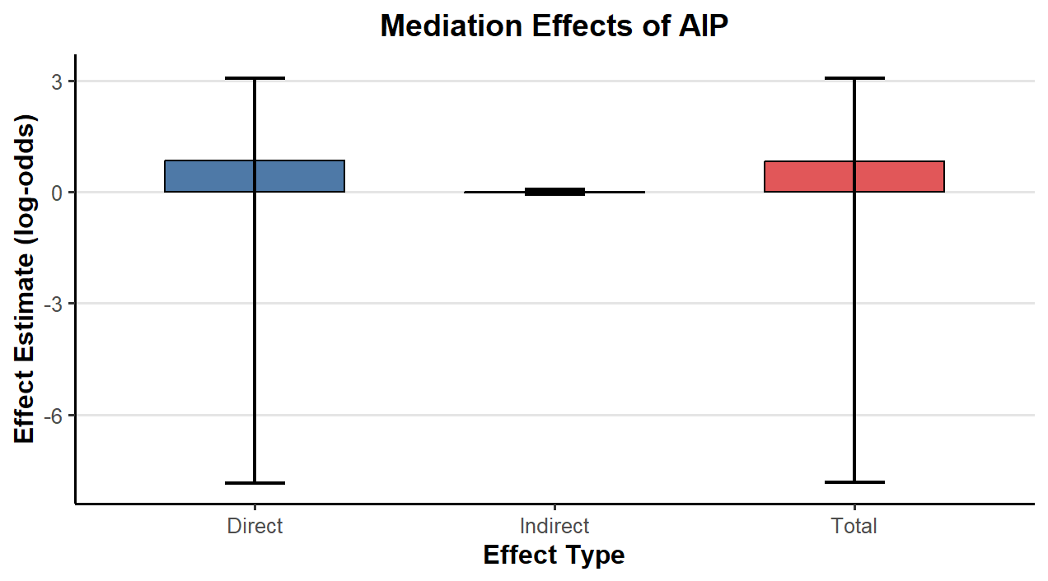
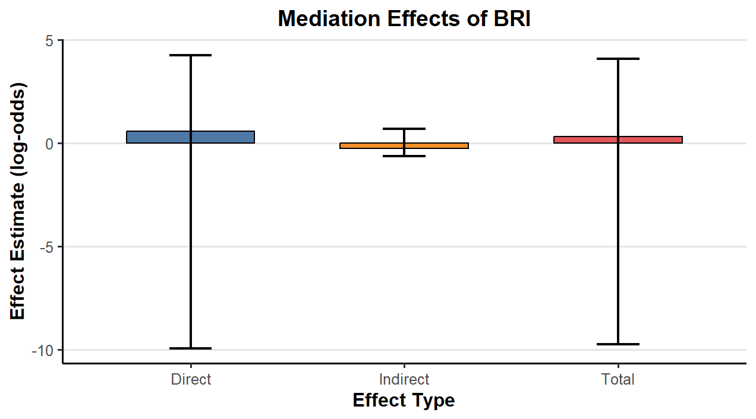
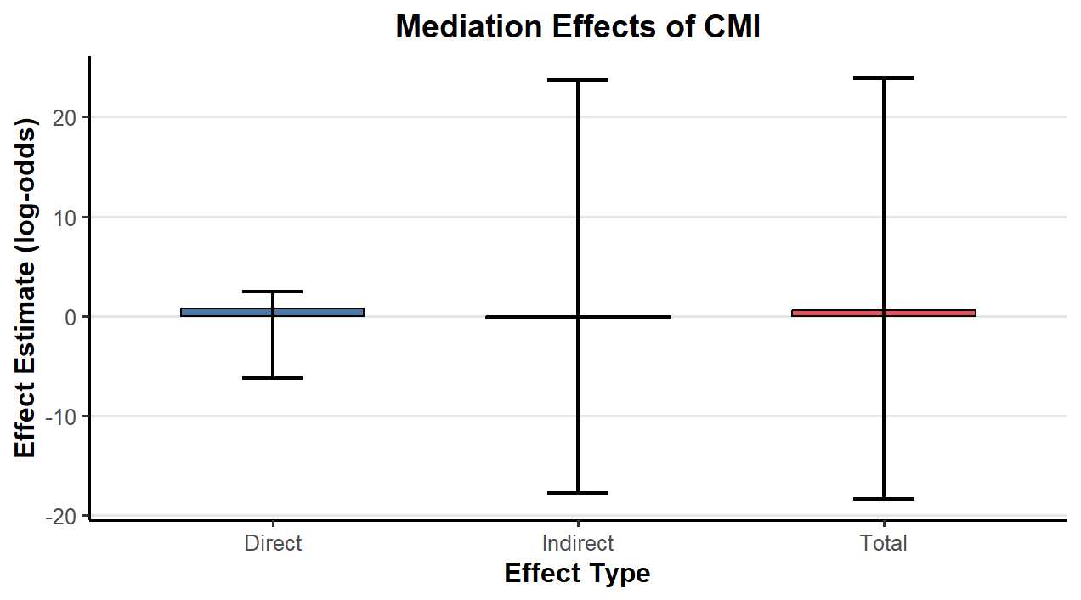
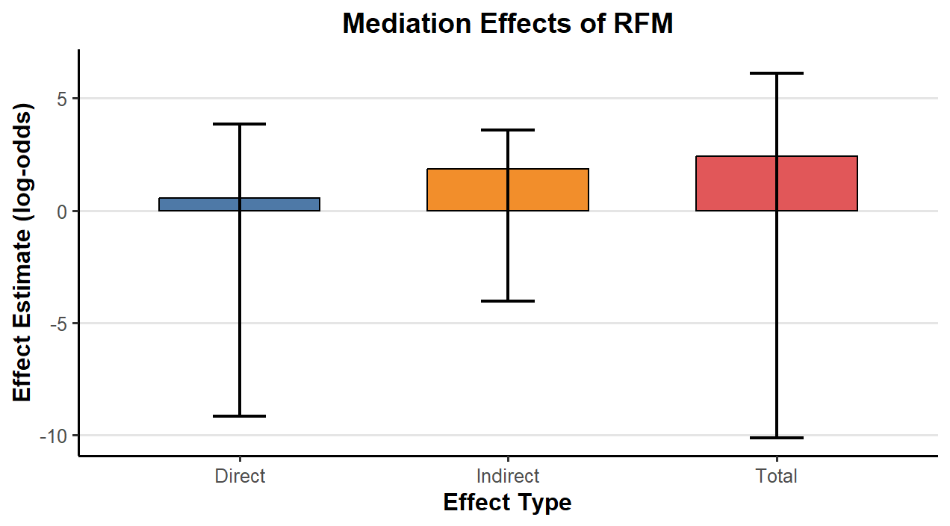
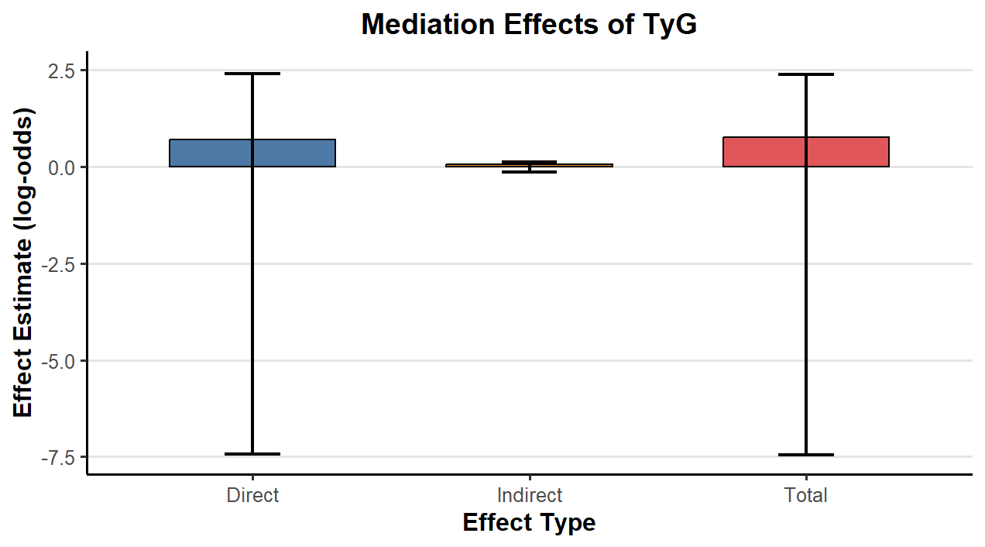
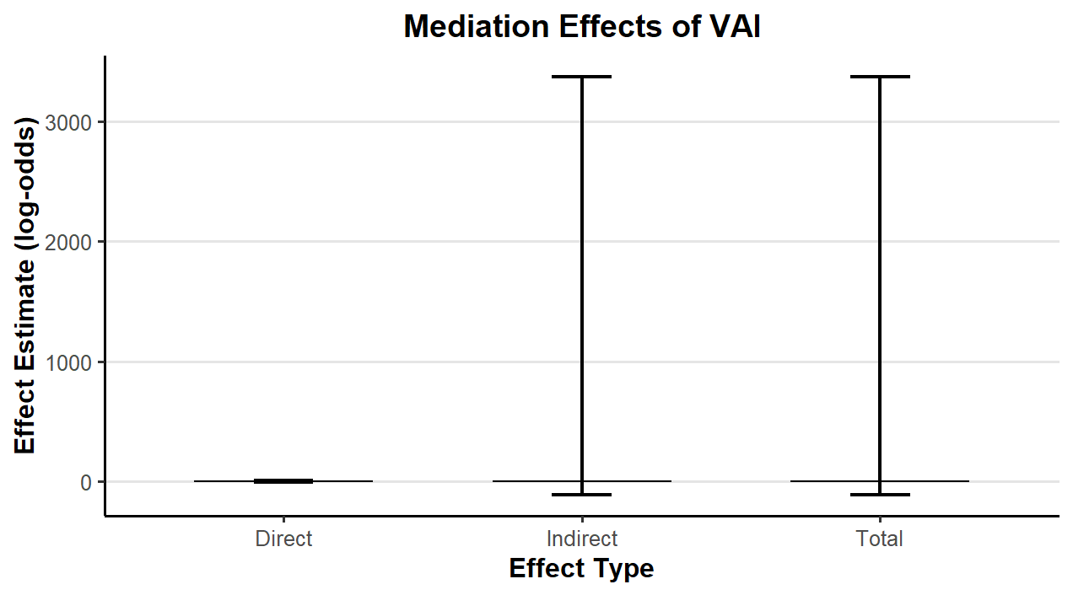
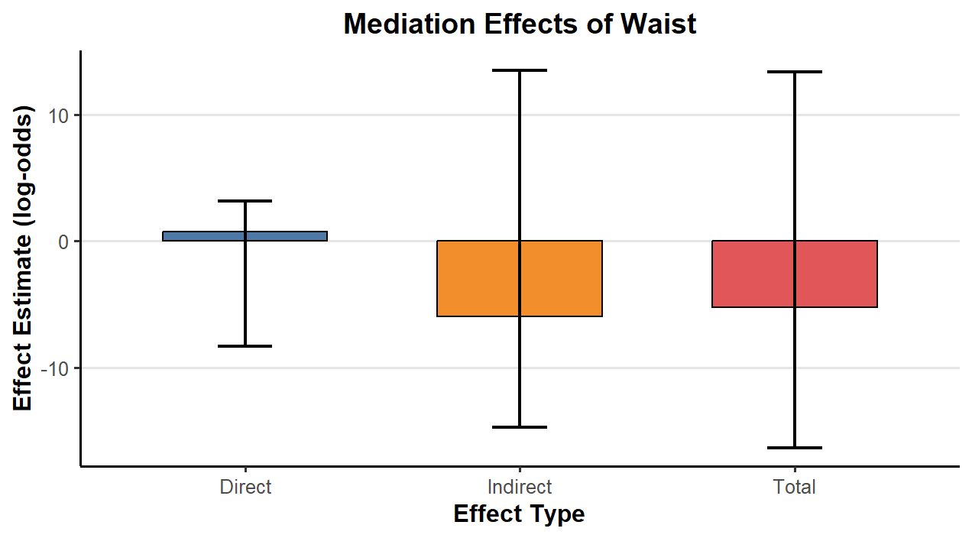
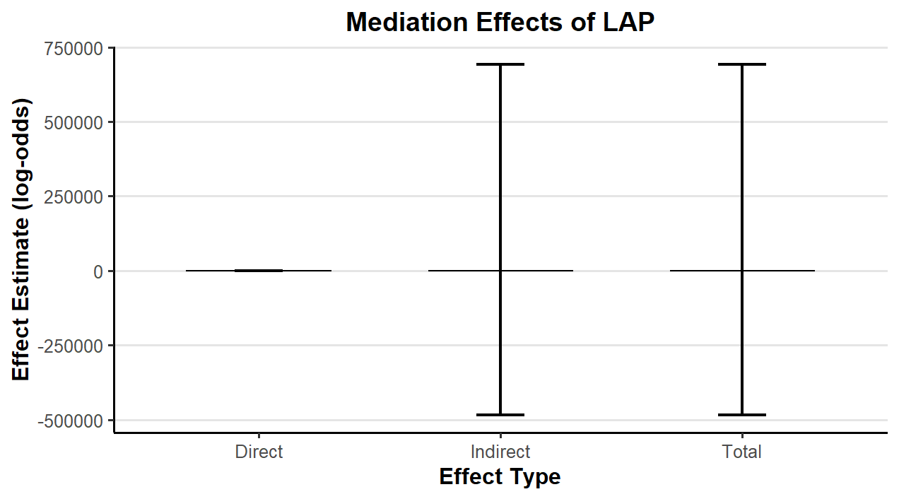
Supplementary material 2. Mediation analysis of Obesity-related indicators in PA and early CKM.
Direct Effect: PA→ early CKM; Indirect Effect: Obesity-related indicators→ early CKM; Total Effect: PA+ Obesity-related indicators→ early CKM.
Abbreviation: RFM, relative fat mass; AIP, atherogenic index of plasma; TyG, triglyceride-glucose index; CMI, cardiometabolic index; BRI, body roundness index; VAI, visceral adiposity index; LAP, lipid accumulation product.

