Supplementary Materials
Supplemental Table 1. CPT/HCPCS codes for recommended vaccines
Vaccination | CPT/HCPCS code(s)
Human papillomavirus (HPV) | 90651
Tetanus, diphtheria, and acellular pertussis (Tdap) | 90714, 90715
Hepatitis A (HepA) | 90633, 90634
Hepatitis B (HepB) | 90744
Measles, mumps, rubella (MMR) ^{A} | 90710
Varicella (VAR) | 90716
Meningococcal (MenACWY) | 90733, 90734, 90619, 90621
Influenza | 90672, 90674, 90630, 90653, 90654, 90655, 90656, 90657, 90658, 90662, 90673, 90685, 90687, 90689, 90660, 90673, Q2039, G0008
CPT, Current Procedural Terminology; HCPCS, Healthcare Common Procedure Coding System; HPV, human papillomavirus; MenACWY, meningococcal A, C, W, Y; MMRV, measles, mumps, rubella, and varicella; Td, combined tetanus and diphtheria vaccine; Tdap, combined tetanus, diphtheria, and acellular pertussis vaccine
^{A} Counts for combination vaccinations were included for each individual antigen group; for example, an adolescent receiving the MMRV vaccine was included in each MMRV and varicella counts.
Supplemental Table 2. Number and percentage of adolescents with well visits in the commercial and Medicaid populations, by year and age ^{A}
Year | Age at  well visit | Commercial database  n (%) | Medicaid database  n (%)
2018 | 9 | 152104 (60.5) | 99453 (43.9)
2018 | 10 | 157246 (59.8) | 99971 (43.7)
2018 | 11 | 194333 (71.1) | 106592 (46.8)
2018 | 12 | 189154 (67.8) | 115202 (51.6)
2018 | 13 | 172054 (61.4) | 104167 (49.3)
2018 | 14 | 174307 (60.3) | 91115 (45.0)
2019 | 9 | 142179 (62.0) | 108284 (45.0)
2019 | 10 | 147041 (62.0) | 111063 (44.4)
2019 | 11 | 179652 (72.4) | 123063 (48.7)
2019 | 12 | 179658 (69.8) | 132882 (53.0)
2019 | 13 | 163348 (62.0) | 122999 (50.1)
2019 | 14 | 163326 (61.8) | 106666 (46.1)
2020 | 9 | 126074 (56.6) | 101912 (39.5)
2020 | 10 | 127567 (55.8) | 101458 (38.9)
2020 | 11 | 158684 (67.0) | 115162 (42.5)
2020 | 12 | 161854 (65.5) | 125468 (46.0)
2020 | 13 | 143883 (56.1) | 116437 (42.9)
2020 | 14 | 148241 (56.7) | 105146 (39.7)
2021 | 9 | 124579 (60.9) | 96455 (43.5)
2021 | 10 | 126928 (60.6) | 94245 (42.9)
2021 | 11 | 151419 (70.3) | 102512 (46.6)
2021 | 12 | 154970 (69.4) | 112559 (49.4)
2021 | 13 | 145076 (62.2) | 109240 (47.5)
2021 | 14 | 147279 (60.9) | 102173 (44.8)
2022 | 9 | 119690 (62.2) | 97795 (42.3)
2022 | 10 | 119535 (60.6) | 95777 (41.7)
2022 | 11 | 140773 (67.1) | 102525 (45.0)
2022 | 12 | 141716 (68.4) | 108323 (47.5)
2022 | 13 | 133972 (62.3) | 107827 (45.7)
2022 | 14 | 136950 (70.0) | 102914 (43.2)
^{A} Values presented as n (%).
Supplemental Table 3. Number of concurrent vaccinations administered in adolescents at well visits in the commercial population, by year and age ^{A}
Year | Age at well visit | 0 vaccines | 1 vaccine | 2 vaccines | 3 vaccines | ≥ 4 vaccines
2018 | 9 | 60033 (86.3) | 8766 (12.6) | 670 (1.0) | 109 (0.2) | 13 (< 0.1)
2018 | 10 | 41907 (51.7) | 26660 (32.9) | 8442 (10.4) | 3816 (4.7) | 190 (0.2)
2018 | 11 | 23843 (13.2) | 27507 (15.2) | 71330 (39.4) | 55571 (30.7) | 2928 (1.6)
2018 | 12 | 67248 (39.6) | 61366 (36.2) | 24385 (14.4) | 15531 (9.2) | 1245 (0.7)
2018 | 13 | 100611 (62.9) | 49986 (31.2) | 7544 (4.7) | 1669 (1.0) | 242 (0.2)
2018 | 14 | 123697 (71.2) | 42570 (24.5) | 6526 (3.8) | 689 (0.4) | 159 (0.1)
2019 | 9 | 60910 (87.1) | 8240 (11.8) | 651 (0.9) | 86 (0.1) | 21 (< 0.1)
2019 | 10 | 40969 (54.3) | 22777 (30.2) | 7605 (10.1) | 3852 (5.1) | 191 (0.3)
2019 | 11 | 18423 (11.1) | 25120 (15.2) | 62659 (37.9) | 56578 (34.2) | 2613 (1.6)
2019 | 12 | 31177 (23.7) | 62978 (47.8) | 21355 (16.2) | 15186 (11.5) | 1111 (0.8)
2019 | 13 | 67163 (54.6) | 48106 (39.1) | 5970 (4.9) | 1619 (1.3) | 188 (0.2)
2019 | 14 | 97645 (69.2) | 37717 (26.7) | 4984 (3.5) | 578 (0.4) | 117 (0.1)
2020 | 9 | 65408 (87.6) | 8649 (11.6) | 534 (0.7) | 67 (0.1) | 16 (< 0.1)
2020 | 10 | 37661 (55.7) | 20448 (30.2) | 6159 (9.1) | 3257 (4.8) | 145 (0.2)
2020 | 11 | 15404 (10.4) | 20184 (13.6) | 55074 (37.2) | 54740 (37.0) | 2554 (1.7)
2020 | 12 | 23083 (19.3) | 60060 (50.2) | 20118 (16.8) | 15342 (12.8) | 1116 (0.9)
2020 | 13 | 36254 (42.1) | 43092 (50.0) | 5031 (5.8) | 1606 (1.9) | 174 (0.2%)
2020 | 14 | 67097 (64.9) | 32273 (31.2) | 3452 (3.3) | 484 (0.5) | 70 (0.1)
2021 | 9 | 100436 (91.8) | 8495 (7.8) | 455 (0.4) | 57 (0.1) | 16 (0.0)
2021 | 10 | 51535 (66.4) | 17138 (22.1) | 5492 (7.1) | 3281 (4.2) | 124 (0.2)
2021 | 11 | 18616 (13.2) | 16058 (11.4) | 51255 (36.2) | 53573 (37.9) | 2024 (1.4)
2021 | 12 | 25116 (22.4) | 52313 (46.7) | 18734 (16.7) | 14960 (13.4) | 831 (0.7)
2021 | 13 | 34781 (43.5) | 38528 (48.2) | 4707 (5.9) | 1824 (2.3) | 138 (0.2)
2021 | 14 | 50080 (61.7) | 27852 (34.3) | 2657 (3.3) | 501 (0.6) | 68 (0.1)
2022 | 9 | 110125 (92.2) | 8750 (7.3) | 471 (0.4) | 58 (0.1) | 10 (< 0.1)
2022 | 10 | 92223 (79.2) | 16548 (14.2) | 5052 (4.3) | 2567 (2.2) | 80 (0.1)
2022 | 11 | 23229 (17.1) | 15777 (11.6) | 48262 (35.4) | 47269 (34.7) | 1741 (1.3)
2022 | 12 | 26479 (24.9) | 51268 (48.3) | 15918 (15.0) | 11973 (11.3) | 523 (0.5)
2022 | 13 | 34255 (45.4) | 35937 (47.6) | 3883 (5.1) | 1351 (1.8) | 105 (0.1)
2022 | 14 | 43838 (61.8) | 24486 (34.5) | 2133 (3.0) | 431 (0.6) | 52 (0.1)
^{A} Values presented as n (%).
Supplemental Table 4. Number of concurrent vaccinations administered in adolescents at well visits by in the Medicaid population, by year and age ^{A}
Year | Age at well visit | 0 vaccines | 1 vaccine | 2 vaccines | 3 vaccines | ≥ 4 vaccines
2018 | 9 | 39596 (87.4) | 5260 (11.6) | 373 (0.8) | 77 (0.2) | 19 (< 0.1)
2018 | 10 | 30210 (71.3) | 10568 (24.9) | 1327 (3.1) | 253 (0.6) | 39 (1.0)
2018 | 11 | 24422 (29.1) | 9479 (11.3) | 22102 (26.3) | 26826 (32.0) | 1133 (1.4)
2018 | 12 | 37460 (34.8) | 21749 (20.29) | 22140 (20.6) | 24405 (22.7) | 1945 (1.8)
2018 | 13 | 59477 (59.4) | 24145 (24.1) | 8411 (8.4) | 7075 (7.1) | 1113 (1.1)
2018 | 14 | 68915 (75.6) | 17214 (18.9) | 3530 (3.9) | 1151 (1.3) | 304 (0.3)
2019 | 9 | 56678 (91.1) | 5076 (8.2) | 350 (0.6) | 99 (0.2) | 37 (0.1)
2019 | 10 | 39691 (76.0) | 10748 (20.6) | 1408 (2.7) | 316 (0.6) | 34 (0.1)
2019 | 11 | 30160 (31.9) | 9553 (10.1) | 20761 (21.9) | 32999 (34.9) | 1193 (1.3)
2019 | 12 | 32141 (29.2) | 25866 (23.5) | 20952 (19.0) | 29024 (26.4) | 2036 (1.9)
2019 | 13 | 50809 (52.3) | 29213 (30.1) | 7822 (8.1) | 8301 (8.6) | 957 (1.0)
2019 | 14 | 68310 (74.0) | 19305 (20.9) | 3123 (3.4) | 1360 (1.5) | 269 (0.3)
2020 | 9 | 69282 (92.1) | 5553 (7.4) | 329 (0.5) | 77 (0.1) | 22 (< 0.1)
2020 | 10 | 47129 (78.8) | 10858 (18.2) | 1469 (2.5) | 299 (0.5) | 36 (0.1)
2020 | 11 | 27594 (28.1) | 8332 (8.5) | 22263 (22.6) | 38748 (39.4) | 1391 (1.4)
2020 | 12 | 23989 (22.4) | 29780 (27.8) | 21176 (19.8) | 30120 (28.1) | 2094 (2.0)
2020 | 13 | 30710 (38.6) | 32567 (41.0) | 7650 (9.6) | 7879 (9.9) | 714 (0.9)
2020 | 14 | 46713 (65.3) | 20796 (29.1) | 2484 (3.5) | 1396 (2.0) | 203 (0.3)
2021 | 9 | 85765 (93.6) | 5269 (5.8) | 424 (0.5) | 103 (0.1) | 35 (< 0.1)
2021 | 10 | 53297 (82.9) | 9390 (14.6) | 1284 (2.0) | 321 (0.5) | 31 (0.1)
2021 | 11 | 28340 (32.8) | 7710 (8.9) | 18370 (21.2) | 31152 (36.0) | 966 (1.1)
2021 | 12 | 23779 (24.9) | 22618 (23.7) | 18500 (19.4) | 28956 (30.4) | 1518 (1.6)
2021 | 13 | 30427 (40.4) | 26504 (35.2) | 7855 (10.4) | 9732 (12.9) | 769 (1.0)
2021 | 14 | 38094 (61.2) | 18737 (30.1) | 2769 (4.4) | 2453 (3.9) | 245 (0.4)
2022 | 9 | 92069 (94.1) | 5072 (5.2) | 469 (0.5) | 137 (0.1) | 48 (0.1)
2022 | 10 | 83559 (88.5) | 9033 (9.6) | 1425 (1.5) | 354 (0.4) | 39 (< 0.1)
2022 | 11 | 43465 (43.2) | 7753 (7.7) | 19074 (19.0) | 29379 (29.2) | 970 (1.0)
2022 | 12 | 24848 (26.7) | 23118 (24.9) | 18198 (19.6) | 25555 (27.5) | 1294 (1.4)
2022 | 13 | 27481 (38.9) | 27409 (38.8) | 7170 (10.2) | 7997 (11.3) | 520 (0.7)
2022 | 14 | 33423 (59.2) | 17948 (31.8) | 2629 (4.7) | 2260 (4.0) | 229 (0.4)
^{A} Values presented as n (%).
Supplemental Table 5. Concurrent vaccination claims for vaccinations administered in adolescents in the commercial population by age and year
Year | Age at well visit | Type of vaccine
Year | Age at well visit | HepA | HepB | HPV initiation | HPV completion | Influenza | MMRV | MenACWY | Tdap | Varicella
2018 | 9 | 3437 (32.9) | 473 (4.5) | 1849 (17.7) | 87 (0.8) | 2094 (20.0) | 158 (1.5) | 344 (3.3) | 1561 (14.9) | 454 (4.3)
2018 | 10 | 3841 (6.9) | 555 (1.0) | 7460 (13.4) | 856 (1.5) | 2088 (3.8) | 141 (0.3) | 10040 (18.0) | 30041 (54.0) | 655 (1.2)
2018 | 11 | 5364 (1.5) | 596 (0.2) | 62346 (17.9) | 9401 (2.7) | 2362 (0.7) | 139 (< 0.1) | 138881 (39.9) | 128294 (36.8) | 955 (0.3)
2018 | 12 | 6410 (4.0) | 544 (0.3) | 36713 (22.7) | 35150 (21.8) | 1908 (1.2) | 135 (0.1) | 42933 (26.6) | 37009 (22.9) | 717 (0.4)
2018 | 13 | 8248 (11.6) | 467 (0.7) | 31115 (43.9) | 18157 (25.6) | 1988 (2.8) | 61 (0.1) | 6514 (9.2) | 3870 (5.5) | 526 (0.7)
2018 | 14 | 10412 (17.9) | 441 (0.8) | 29224 (50.2) | 10818 (18.6) | 1884 (3.2) | 47 (0.1) | 3542 (6.1) | 1309 (2.3) | 565 (1.0)
2019 | 9 | 2681 (27.2) | 458 (4.6) | 2666 (27.0) | 170 (1.7) | 1764 (17.9) | 180 (1.8) | 300 (3.0) | 1190 (12.1) | 457 (4.6)
2019 | 10 | 2958 (5.9) | 490 (1.0) | 8964 (17.8) | 1110 (2.2) | 1846 (3.7) | 158 (0.3) | 9519 (19.0) | 24667 (49.1) | 525 (1.1)
2019 | 11 | 3977 (1.2) | 594 (0.2) | 62587 (19.0) | 11854 (3.6) | 1925 (0.6) | 159 (0.1) | 129575 (39.2) | 118912 (36.0) | 736 (0.2)
2019 | 12 | 4885 (3.1) | 618 (0.4) | 31558 (20.3) | 43892 (28.2) | 1781 (1.2) | 155 (0.1) | 38898 (25.0) | 32922 (21.2) | 728 (0.5)
2019 | 13 | 5053 (7.7) | 508 (0.8) | 18013 (27.5) | 30283 (46.2) | 1668 (2.5) | 81 (0.1) | 5925 (9.0) | 3539 (5.4) | 478 (0.7)
2019 | 14 | 6934 (13.9) | 521 (1.1) | 20476 (41.1) | 15300 (30.7) | 1669 (3.4) | 53 (0.1) | 3109 (6.2) | 1216 (2.4) | 536 (1.1)
2020 | 9 | 1866 (18.7) | 301 (3.0) | 3487 (35.0) | 177 (1.8) | 2702 (27.1) | 112 (1.1) | 104 (1.0) | 936 (9.4) | 274 (2.8)
2020 | 10 | 1935 (4.5) | 350 (0.8) | 9096 (21.1) | 1395 (3.2) | 2735 (6.4) | 95 (0.2) | 7278 (16.9) | 19925 (46.3) | 260 (0.6)
2020 | 11 | 2511 (0.8) | 400 (0.1) | 58883 (19.3) | 10469 (3.4) | 2918 (1.0) | 116 (< 0.1) | 117504 (38.6) | 111348 (36.6) | 359 (0.1)
2020 | 12 | 3494 (2.3) | 522 (0.4) | 31894 (21.2) | 41763 (27.7) | 2690 (1.8) | 95 (0.1) | 37098 (24.6) | 32541 (21.6) | 501 (0.3)
2020 | 13 | 3244 (5.5) | 412 (0.7) | 14994 (25.6) | 28350 (48.4) | 2394 (4.1) | 29 (0.1) | 5198 (8.9) | 3649 (6.2) | 306 (0.5)
2020 | 14 | 3764 (9.2) | 417 (1.0) | 11951 (29.3) | 18520 (45.3) | 2422 (5.9) | 27 (0.1) | 2291 (5.6) | 1107 (2.7) | 350 (0.9)
2021 | 9 | 1320 (13.7) | 296 (3.1) | 4155 (43.2) | 233 (2.4) | 2336 (24.3) | 105 (1.1) | 145 (1.5) | 739 (7.7) | 291 (3.0)
2021 | 10 | 1403 (3.7) | 321 (0.8) | 9266 (24.1) | 1946 (5.1) | 2237 (5.8) | 101 (0.3) | 6984 (18.2) | 15933 (41.5) | 235 (0.6)
2021 | 11 | 1703 (0.6) | 323 (0.1) | 55745 (19.4) | 10217 (3.6) | 2257 (0.8) | 96 (< 0.1) | 109637 (38.2) | 106800 (37.2) | 332 (0.1)
2021 | 12 | 2240 (1.6) | 431 (0.3) | 28273 (20.5) | 37520 (27.2) | 1864 (1.4) | 90 (0.1) | 34554 (25.1) | 32478 (23.6) | 338 (0.3)
2021 | 13 | 2082 (3.9) | 383 (0.7) | 14356 (26.6) | 25066 (46.5) | 1894 (3.5) | 29 (0.1) | 5730 (10.6) | 4097 (7.6) | 268 (0.5)
2021 | 14 | 2302 (6.6) | 397 (1.1) | 10398 (29.8) | 16303 (46.8) | 1728 (5.0) | 30 (0.1) | 2294 (6.6) | 1132 (3.3) | 292 (0.8)
2022 | 9 | 911 (9.2) | 244 (2.5) | 4727 (47.8) | 221 (2.2) | 2709 (27.4) | 88 (0.9) | 106 (1.1) | 687 (7.0) | 198 (2.0)
2022 | 10 | 957 (2.8) | 237 (0.7) | 8706 (25.1) | 2038 (5.9) | 2689 (7.8) | 70 (0.2) | 5639 (16.3) | 14090 (40.7) | 211 (0.6)
2022 | 11 | 1096 (0.4) | 217 (0.1) | 49559 (19.0) | 9217 (3.5) | 2610 (1.0) | 98 (< 0.1) | 100320 (38.5) | 97474 (37.4) | 225 (0.1)
2022 | 12 | 1547 (1.3) | 302 (0.3) | 25744 (21.3) | 35769 (29.6) | 2320 (1.9) | 85 (0.1) | 28580 (23.6) | 26360 (21.8) | 240 (0.2)
2022 | 13 | 1397 (2.9) | 288 (0.6) | 12809 (26.6) | 23299 (48.5) | 2250 (4.7) | 30 (0.1) | 4537 (9.4) | 3255 (6.8) | 225 (0.5)
2022 | 14 | 1521 (5.0) | 306 (1.0) | 8789 (29.1) | 14163 (46.9) | 2127 (7.0) | 28 (0.1) | 1975 (6.5) | 1054 (3.5) | 229 (0.8)
HepA, hepatitis A; HepB, hepatitis B; HPV, human papillomavirus; MenACWY, meningococcal A, C, W, Y; MMRV, measles, mumps, rubella, and varicella; Tdap, tetanus-diphtheria-pertussis
Supplemental Table 6. Concurrent vaccination claims for vaccinations administered in adolescents in the Medicaid population by age and year
Year | Age at well visit | Type of vaccine
Year | Age at well visit | HepA | HepB | HPV initiation | HPV completion | Influenza | MMRV | MenACWY | Tdap | Varicella
2018 | 9 | 1721 (27.3) | 229 (3.6) | 2263 (36.0) | 55 (0.9) | 1257 (20.0) | 163 (2.6) | 31 (0.5) | 369 (5.9) | 206 (3.3)
2018 | 10 | 1759 (12.5) | 228 (1.6) | 3691 (26.1) | 825 (5.8) | 1215 (8.6) | 151 (1.1) | 498 (3.5) | 5559 (39.4) | 199 (1.4)
2018 | 11 | 1935 (1.4) | 257 (0.2) | 30145 (21.7) | 3753 (2.7) | 1337 (1.0) | 128 (0.1) | 50704 (36.6) | 50156 (36.2) | 283 (0.2)
2018 | 12 | 3005 (2.0) | 287 (0.2) | 30943 (21.0) | 16852 (11.5) | 1317 (0.9) | 148 (0.1) | 49019 (33.3) | 45132 (30.7) | 344 (0.2)
2018 | 13 | 4097 (6.2) | 275 (0.4) | 17748 (26.6) | 13884 (20.8) | 1133 (1.7) | 84 (0.1) | 15186 (22.8) | 13934 (20.9) | 301 (0.5)
2018 | 14 | 4368 (15.1) | 263 (0.9) | 12224 (42.2) | 5633 (19.5) | 942 (3.3) | 61 (0.2) | 2787 (9.6) | 2371 (8.2) | 289 (1.0)
2019 | 9 | 1597 (25.7) | 291 (4.7) | 2430 (39.1) | 131 (2.1) | 850 (13.7) | 261 (4.2) | 39 (0.6) | 418 (6.7) | 196 (3.2)
2019 | 10 | 1730 (11.8) | 292 (2.0) | 4551 (31.1) | 928 (6.3) | 889 (6.1) | 209 (1.4) | 548 (3.8) | 5276 (36.1) | 209 (1.4)
2019 | 11 | 1937 (1.3) | 316 (0.2) | 36781 (23.8) | 4326 (2.8) | 920 (0.6) | 196 (0.1) | 55588 (35.9) | 54614 (35.3) | 205 (0.1)
2019 | 12 | 2710 (1.7) | 345 (0.2) | 38050 (23.4) | 19673 (12.1) | 910 (0.6) | 180 (0.1) | 52480 (32.2) | 48315 (29.7) | 301 (0.2)
2019 | 13 | 2693 (3.7) | 360 (0.5) | 17293 (23.5) | 20869 (28.4) | 851 (1.2) | 131 (0.2) | 16204 (22.0) | 14835 (20.2) | 326 (0.4)
2019 | 14 | 3192 (10.4) | 280 (0.9) | 9568 (31.2) | 10911 (35.6) | 781 (2.6) | 63 (0.2) | 3079 (10.0) | 2560 (8.3) | 251 (0.8)
2020 | 9 | 1271 (19.5) | 229 (3.5) | 2580 (39.6) | 118 (1.8) | 1556 (23.9) | 191 (2.9) | 32 (0.5) | 379 (5.8) | 162 (2.5)
2020 | 10 | 1262 (8.5) | 205 (1.4) | 4380 (29.6) | 1108 (7.5) | 1496 (10.1) | 150 (1.0) | 548 (3.7) | 5491 (37.1) | 181 (1.2)
2020 | 11 | 1458 (0.8) | 231 (0.1) | 41230 (23.6) | 5185 (3.0) | 1560 (0.9) | 188 (0.1) | 62736 (35.9) | 61887 (35.4) | 200 (0.1)
2020 | 12 | 1961 (1.2) | 285 (0.2) | 40305 (23.6) | 22940 (13.4) | 1794 (1.1) | 159 (0.1) | 53509 (31.3) | 49649 (29.1) | 249 (0.2)
2020 | 13 | 1980 (2.7) | 243 (0.3) | 18851 (25.3) | 22219 (29.9) | 1656 (2.2) | 86 (0.1) | 15090 (20.3) | 13937 (18.8) | 257 (0.4)
2020 | 14 | 1746 (5.7) | 233 (0.8) | 8632 (28.1) | 12834 (41.8) | 1309 (4.3) | 58 (0.2) | 2968 (9.7) | 2723 (8.9) | 229 (0.8)
2021 | 9 | 1095 (16.7) | 251 (3.8) | 2929 (44.6) | 115 (1.8) | 1150 (17.5) | 277 (4.2) | 50 (0.8) | 495 (7.5) | 204 (3.1)
2021 | 10 | 1020 (7.8) | 259 (2.0) | 5566 (42.7) | 1011 (7.8) | 1079 (8.3) | 204 (1.6) | 475 (3.6) | 3240 (24.9) | 183 (1.4)
2021 | 11 | 1065 (0.8) | 246 (0.2) | 34473 (24.3) | 4044 (2.9) | 1162 (0.8) | 186 (0.1) | 50008 (35.3) | 50387 (35.5) | 203 (0.1)
2021 | 12 | 1356 (0.9) | 252 (0.2) | 35191 (23.1) | 18652 (12.2) | 1177 (0.8) | 178 (0.1) | 48675 (31.9) | 46890 (30.7) | 210 (0.1)
2021 | 13 | 1432 (1.9) | 282 (0.4) | 19190 (25.8) | 17795 (23.9) | 1137 (1.5) | 99 (0.1) | 17594 (23.6) | 16738 (22.5) | 215 (0.3)
2021 | 14 | 1189 (3.7) | 257 (0.8) | 10447 (32.0) | 10303 (31.6) | 1048 (3.2) | 40 (0.1) | 4718 (14.5) | 4439 (13.6) | 166 (0.5)
2022 | 9 | 875 (13.2) | 317 (4.8) | 2733 (41.4) | 171 (2.6) | 1360 (20.6) | 322 (4.9) | 30 (0.5) | 588 (8.9) | 213 (3.2)
2022 | 10 | 834 (6.4) | 245 (1.9) | 5002 (38.2) | 1274 (9.7) | 1253 (9.6) | 244 (1.9) | 452 (3.5) | 3609 (27.6) | 183 (1.4)
2022 | 11 | 878 (0.6) | 273 (0.2) | 32051 (23.2) | 4603 (3.3) | 1253 (0.9) | 203 (0.2) | 48666 (35.3) | 49843 (36.1) | 187 (0.1)
2022 | 12 | 1002 (0.7) | 247 (0.2) | 30068 (21.3) | 20385 (14.4) | 1343 (1.0) | 144 (0.1) | 44662 (31.6) | 43287 (30.6) | 206 (0.2)
2022 | 13 | 1070 (1.6) | 259 (0.4) | 14187 (20.9) | 21497 (31.7) | 1324 (2.0) | 120 (0.2) | 14856 (21.9) | 14287 (21.1) | 219 (0.3)
2022 | 14 | 986 (3.1) | 241 (0.8) | 7987 (25.9) | 11543 (37.4) | 1262 (4.1) | 53 (0.2) | 4458 (14.4) | 4158 (13.5) | 198 (0.6)
HepA, hepatitis A; HepB, hepatitis B; HPV, human papillomavirus; MenACWY, meningococcal A, C, W, Y; MMRV, measles, mumps, rubella, and varicella; Tdap, tetanus-diphtheria-pertussis
Supplemental Table 7. Demographics in the commercial and Medicaid populations for potential opportunities for HPV vaccination ^{A}
 | Potential opportunity 1 ^{B}  N = 209680 | Potential opportunity 2 ^{B}  N = 382060
Commercial population
Sex
Male | 101711 (48.5%) | 182643 (47.8%)
Female | 107969 (51.5%) | 199417 (52.2%)
Region
North central | 41344 (19.7%) | 77718 (20.3%)
Northeast | 48885 (23.3%) | 72881 (19.1%)
South | 81377 (38.8%) | 176295 (46.1%)
West | 36586 (17.4%) | 53942 (14.1%)
Unknown | 1488 (0.7%) | 1224 (0.3%)
Insurance type
Basic/major medical | 60 (0.0%) | 16 (0.0%)
CDHP | 18641 (8.9%) | 46308 (12.1%)
Comprehensive | 1481 (0.7%) | 5903 (1.5%)
EPO | 1859 (0.9%) | 3337 (0.9%)
HDHP | 27075 (12.9%) | 59215 (15.5%)
HMO | 22728 (10.8%) | 43497 (11.4%)
POS | 24923 (11.9%) | 31269 (8.2%)
POS with capitation | 3501 (1.7%) | 2512 (0.7%)
PPO | 103082 (49.2%) | 181657 (47.5%)
Missing | 6330 (3.0%) | 8346 (2.2%)
 | Potential opportunity 1 ^{B}  N = 143170 | Potential opportunity 2 ^{B}  N = 186200
Medicaid population
Sex
Male | 68758 (48.0%) | 89480 (48.1%)
Female | 74412 (52.0%) | 96720 (51.9%)
Insurance type
Comprehensive | 73623 (51.4%) | 60152 (32.3%)
HMO | 69547 (48.6%) | 123095 (66.1%)
POS with capitation | 0 (0%) | 2477 (1.3%)
Missing | 0 (0%) | 476 (0.3%)
CDHP, consumer driven health plan; EPO, exclusive provider organization; HDHP, high deductible health plan; HMO, health maintenance organization; POS, point-of-service; PPO, preferred provider organization
^{A} Values presented as n (%).
^{B} Potential opportunity 1 defined as an adolescent who attended a 9- or 10-year-old well visit but did not receive the HPV vaccine and did not return for an 11- or 12-year-old well visit. Potential opportunity 2 defined as an adolescent with a well visit at 11 or 12 years who received other vaccinations, but not the HPV vaccination.
Supplemental Fig. 1. Potential opportunity enrollment requirements for 9- and 10-year-olds in the commercial and Medicaid populations ^{A}
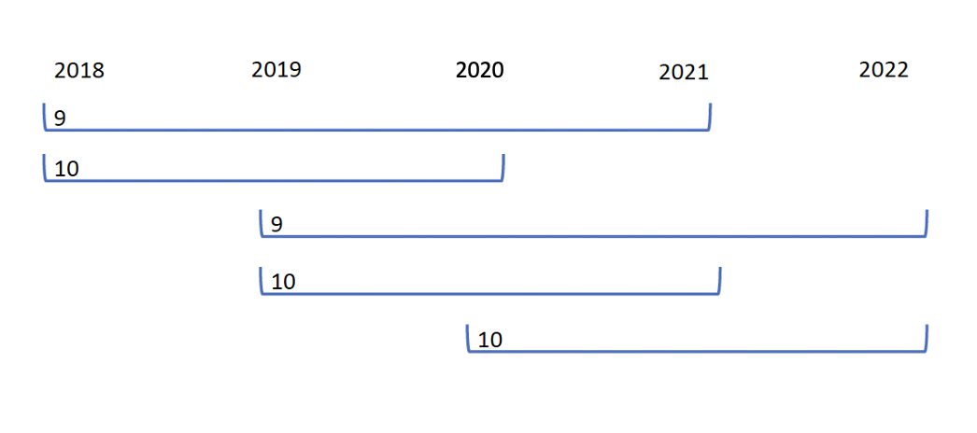
^{A} To identify a potential opportunity at 11 or 12 years, 2 years enrollment was required; therefore, 9-year-olds were required to have a well visit in 2018 or 2019, and 10-year-olds were required to have a well visit in 2018–2020.
Supplemental Fig. 2. Sample attrition in the A) commercial and B) Medicaid populations
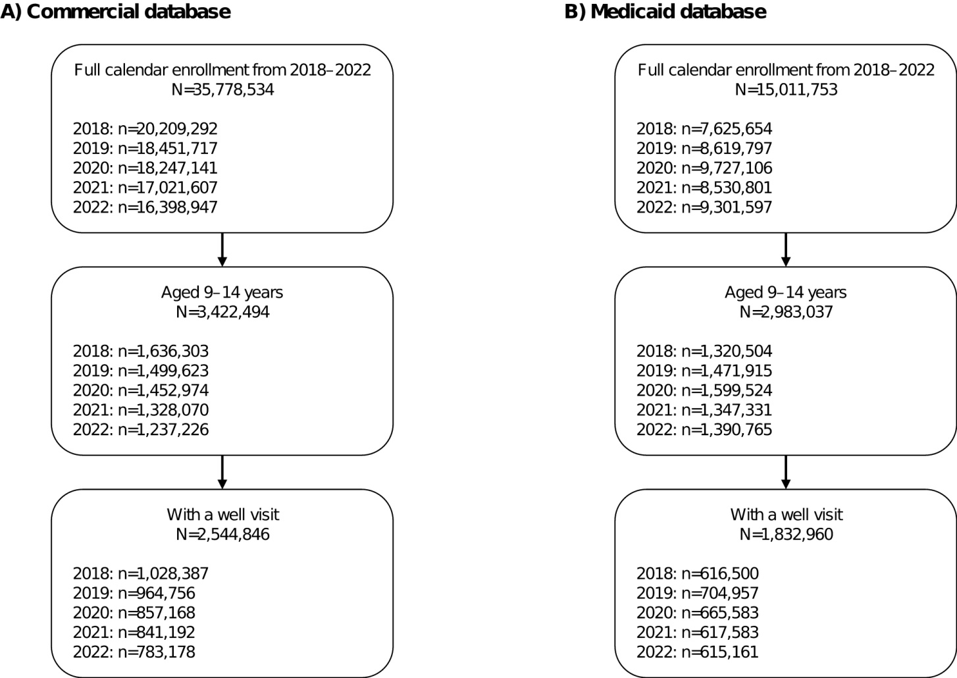
Supplemental Fig. 3. Number of concurrent vaccinations administered in adolescents at well visits in the A) commercial and B) Medicaid populations, by age and year ^{A}
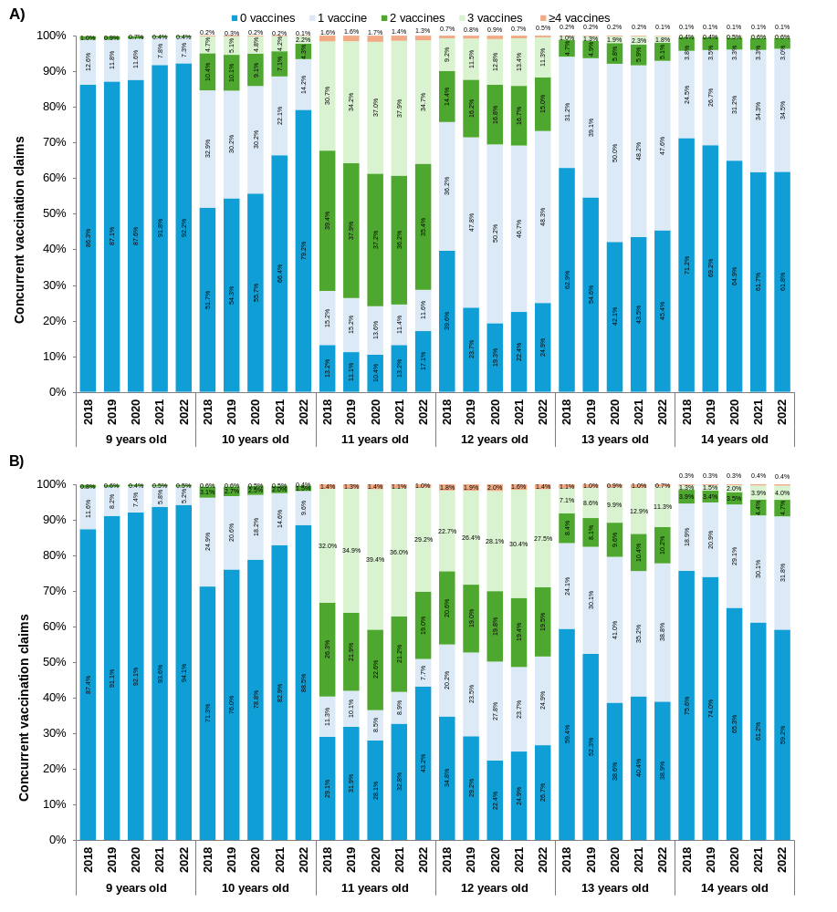
Hepatitis A; HepB, hepatitis B; HPV, human papillomavirus; MMRV, measles, mumps, rubella, and varicella; Tdap, tetanus-diphtheria-pertussis
^{A} Concurrent vaccination claims included HepA, HepB, HPV, MMRV, Tdap, or influenza vaccine.

