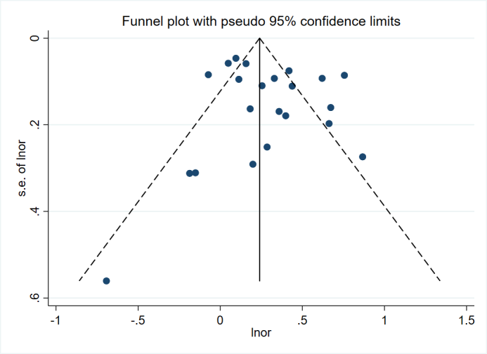
Supplementary Figure 1 The Funnel plot analysis for publication bias.

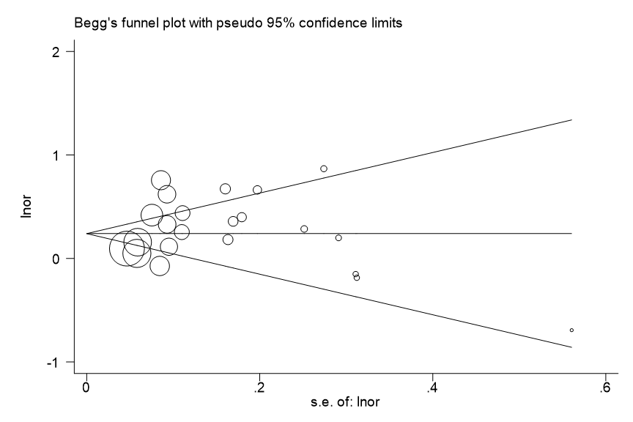
Supplementary Figure 2 The Begg's test for publication bias.
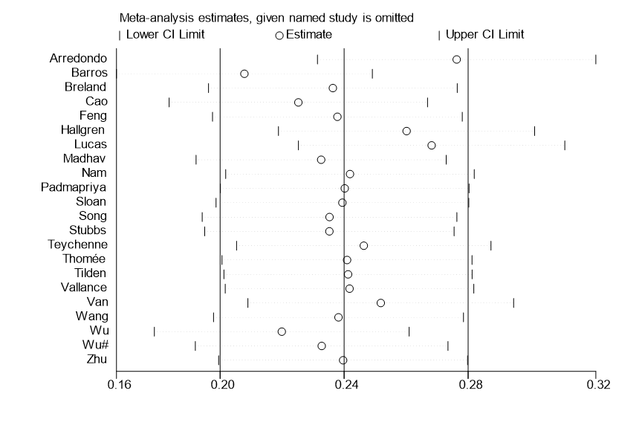
Supplementary Figure 3 The sensitivity analysis.

The search strategy:
(clinical trial) AND ((((((sedentary behavior*) OR (sedentary lifestyle)) OR (physical inactivity)) OR (lack of physical activity)) OR (sedentary time*)) AND ((((((depression) OR (depressive symptom)) OR (emotional depression)) OR (depressive)) OR (dysthymia)) OR (mental illness)))

