SUPPLEMENTAL MATERIALS
Table S1 Implicated food categories of both city and village non-typhoidal Salmonella infection reported to CFSA in China, 2013–2022
Implicated food categories | City (n = 38719) | Village (n = 16547) | p | statistic
Grains, n (%) |  |  | 0.241 | 1.376
Yes | 5483 (14.16) | 2407 (14.55)
No | 33236 (85.84) | 14140 (85.45)
Fruit, n (%) |  |  | 0.002 | 9.815
Yes | 5205 (13.44) | 2061 (12.46)
No | 33514 (86.56) | 14486 (87.54)
Meat, n (%) |  |  | 0.155 | 2.021
Yes | 4541 (11.73) | 2012 (12.16)
No | 34178 (88.27) | 14535 (87.84)
Dairy, n (%) |  |  | 0.001 | 10.670
Yes | 3637 (9.39) | 1409 (8.52)
No | 35082 (90.61) | 15138 (91.48)
Complex food, n (%) |  |  | 0.965 | 0.002
Yes | 3371 (8.71) | 1438 (8.69)
No | 35348 (91.29) | 15109 (91.31)
Aquatic animals, n (%) |  |  | 0.099 | 2.729
Yes | 2402 (6.20) | 1089 (6.58)
No | 36317 (93.80) | 15458 (93.42)
Multiple food, n (%) |  |  | 0.087 | 2.929
Yes | 2063 (5.33) | 942 (5.69)
No | 36656 (94.67) | 15605 (94.31)
Vegetables, n (%) |  |  | < 0.001 | 25.785
Yes | 1878 (4.85) | 976 (5.90)
No | 36841 (95.15) | 15571 (94.10)
Eggs, n (%) |  |  | 0.021 | 5.352
Yes | 1479 (3.82) | 702 (4.24)
No | 37240 (96.18) | 15845 (95.76)
Infant food, n (%) |  |  | 0.371 | 0.801
Yes | 988 (2.55) | 400 (2.42)
No | 37731 (97.45) | 16147 (97.58)
Beverages and frozen drinks, n (%) |  |  | 0.154 | 2.034
Yes | 821 (2.12) | 319 (1.93)
No | 37898 (97.88) | 16228 (98.07)

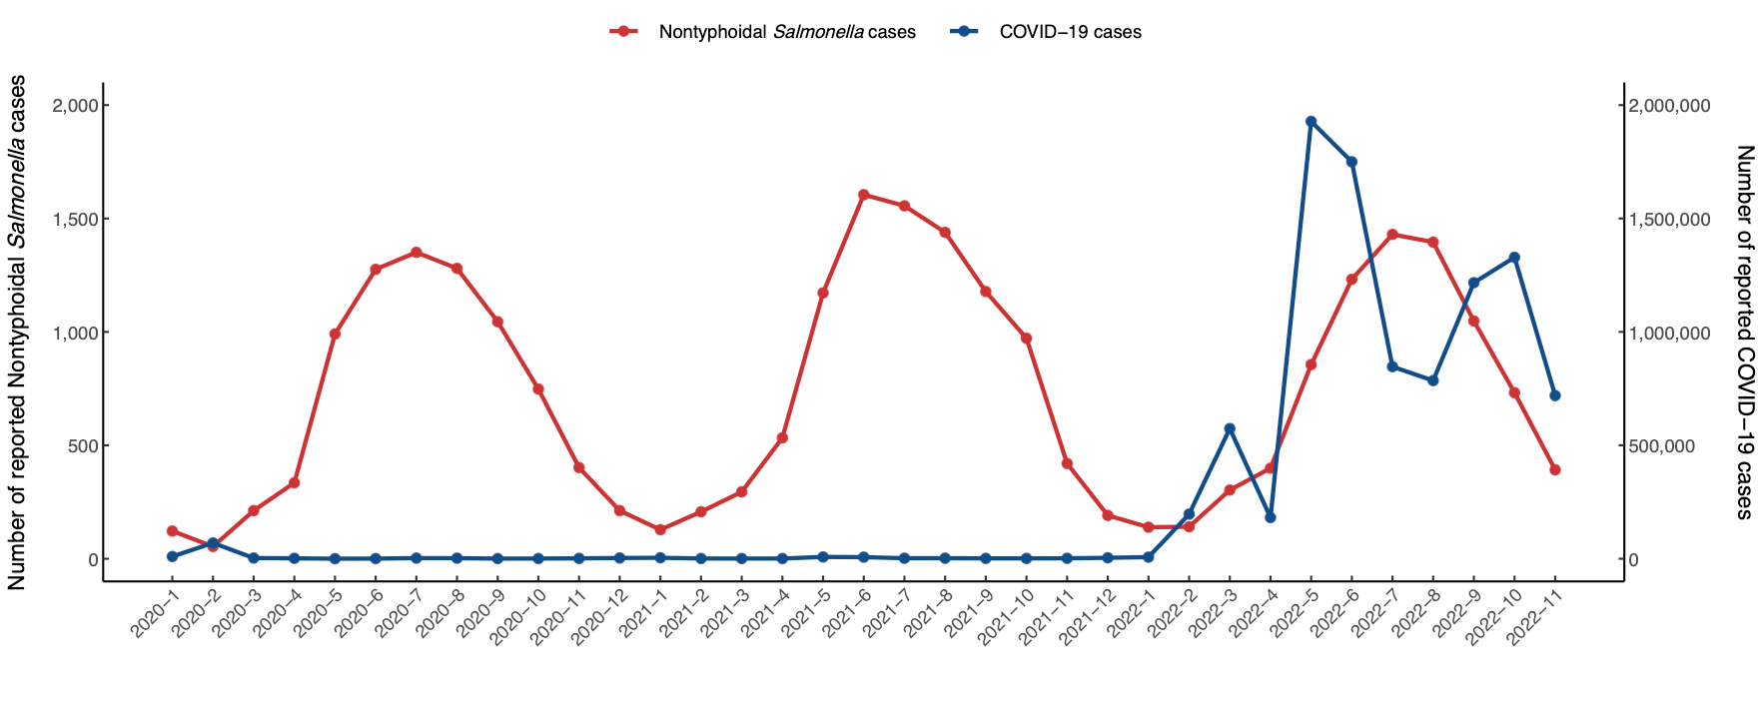
Figure S1. Correlation between number of reported NTS and number of reported covid-19 cases in China, 2020–2022.

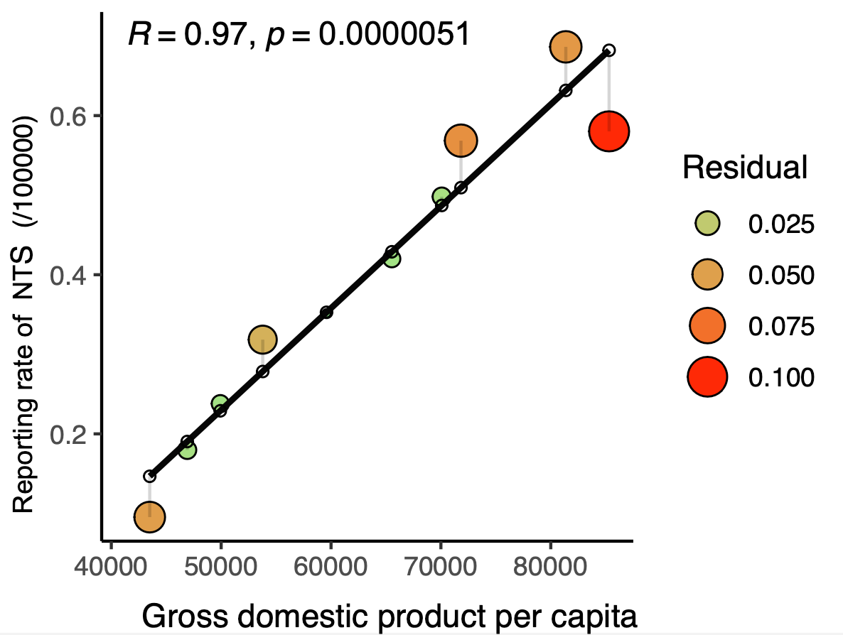
Figure S2. Correlation between reporting rate of NTS and GDP in China, 2013–2022.

