Table S1. Detailed definitions and encodings of covariates
Covariates | Categories | Encodings
Age | years | -
Sex | Male | 1
 | Female | 2
Race | Mexican American | 1
 | Other Hispanic | 2
 | Non-Hispanic White | 3
 | Non-Hispanic Black | 4
 | Other Race - Including Multi-Racial | 5
Education | Less than 9th grade | 1
 | 9-11th grade (Includes 12th grade with no diploma) | 2
 | High school graduate/GED or equivalent | 3
 | Some college or AA degree | 4
 | College graduate or above | 5
Marital status | Married | 1
 | Widowed | 2
 | Divorced | 3
 | Separated | 4
 | Never married | 5
 | Living with partner | 6
Ratio of family income to poverty | ratio | -
Smoking status | Current | 0
 | Previous | 1
 | Never | 2
Alcohol consumption | Yes | 1
 | No | 2
Waist Circumference | cm | -
Sleep duration | Hours | -
Physical activity | METs | -
HEI-2015 index | score | -
MED index | score | -
DASH diet index | score | -
PHQ-9 score | score | -

Table S2. Health 2015 eating index components and criteria for scoring
Component | Dietary Constituents | Standard for Minimum | Min Score | Standard for Max | Max Score
Total Fruits | Total Fruit | No Fruit | 0 | ≥0.8 cup eq. per 1000 kcal | 5
Whole Fruits | Citrus, Melons, Berries + Other Intact Fruits | No Whole Fruit | 0 | ≥0.4 cup eq. per 1000 kcal | 5
Total Vegetable | Total Vegetables + Legumes (Beans and Peas) in cup equivalents | No Vegetables | 0 | ≥1.1 cup eq. per 1000 kcal | 5
Greens and Beans | Dark Green Vegetables + Legumes (Beans and Peas) in cup equivalents | No Dark-Green Vege or Legumes | 0 | ≥0.2 cup eq. per 1000 kcal | 5
Total Protein Foods | Total Meat, Poultry, and Seafood (including organ meats and cured meats) + Eggs + Nuts and Seeds + Soy + Legumes (Beans and Peas) in oz equivalents | No Protein Foods | 0 | ≥2.5 oz eq. per 1000 kcal | 5
Seafood and Plant Proteins | Seafood (high in n-3) + Seafood (low in n-3) + Soy + Nuts and Seeds + Legumes (Beans and Peas) in oz equivalents | No Seafood or Plant Proteins | 0 | ≥0.8 oz eq. per 1000 kcal | 5
Whole Grains | Whole Grains | No Whole Grains | 0 | ≥1.5 oz eq. per 1000 kcal | 10
Dairy | Total Dairy | No Dairy | 0 | ≥1.3 cup eq. per 1000 kcal | 10
Fatty Acids | (Total Monounsaturated Fatty Acids + Total Polyunsaturated Fatty Acids)/Total Saturated Fatty Acids | ≤ 1.2 | 0 | ≥2.5 | 10
Moderation
Refined Grains | Refined Grains | ≥4.3 oz eq. per 1,000 kcal | 0 | ≤1.8 oz eq. per 1000 kcal | 10
Sodium | Sodium | ≥2.0 g per 1,000 kcal | 0 | ≤1.1 g per 1000 kcal | 10
Added Sugars | Added Sugars | ≥26% of energy | 0 | ≤6.5% of energy | 10
Saturated Fats | Total Saturated Fatty Acids | ≥16% of energy | 0 | ≤8% of energy | 10
Total |  |  | 0 |  | 100
HEI, Healthy Eating Index; Note: If the intake of one component meets the recommended minimum value, the score for that component is 0. If the intake meets the recommended maximum value, the score for that component is either 5 or 10 points. If the intake falls between the minimum and maximum values, the score is calculated using a linear interpolation formula.

Table S3. aMED index components and criteria for scoring
Food Types | Criteria for minimum score of 0 | Criteria for maximum score of 1
Whole Fruits | < Median | ≥ Median
Vegetables | < Median | ≥ Median
Whole Grains | < Median | ≥ Median
Legumes | < Median | ≥ Median
Nuts | < Median | ≥ Median
Fish | < Median | ≥ Median
Red and processed meat | ≥ Median | < Median
Ratio of monounsaturated to saturated fat | < Median | ≥ Median
Alcohol | < 5 or >15 g/d for female;  < 5 or >25 g/d for male | 5-15 g/day for female;  5-25 g/day for male
Total | 0 | 9
aMED, alternate Mediterranean diet
Table S4. DASH index components and criteria for scoring
Nutrient | DASH score target values (1 point) | Intermediate target values (0.5 points)
Sodium (mg/day) | < 2300.0 | 2300–2650
Cholesterol (mg/day) | < 149.1 | 149.1–224.7
Saturated fat (% of Kcal/day) | < 6.0 | 6–11
Total fat (% of Kcal/day) | < 27.0 | 27–32
Protein (% of Kcal/day) | > 18.0 | 16.5–18.0
Calcium (mg/day) | > 1240.0 | 842.3–1240.0
Magnesium (mg/day) | > 496.7 | 330.3–496.7
Potassium (mg/day) | > 4673.3 | 3198.3–4673.3
Fiber (g/day) | > 30.0 | 19.5–30.0
Total | 0 | 10
DASH score targets are based on a 2100 Kcal/day diet and the linear index model introduced by Lin et al. (1999). If the DASH nutrient intake does not meet either target, it is scored as 0.

Reference
1.Lin P.-H., Windhauser M.M., Plaisted C.S., Hoben K.P., McCULLOUGH M.L., Obarzanek E. The linear index model for establishing nutrient goals in the dietary approaches to stop hypertension trial. J. Am. Diet. Assoc. 1999;99(8):S40–S44.

Table S5. Characteristics of study population according to missing value
Variables | Missing  (N = 10,950) | Non-missing  (N = 19,021)
Age (years) | 50.54 ± 17.98 | 49.56 ± 17.52
Gender
Male | 5,511 (50.3) | 9,234 (48.5)
Female | 5,439 (49.7) | 9,790 (51.5)
Race
Mexican American | 1,777 (16.2) | 2,724 (14.3)
Other Hispanic | 1,226 (11.2) | 1,893 (10.0)
Non-Hispanic White | 3,731 (34.1) | 8,728 (45.9)
Non-Hispanic Black | 2,532 (23.1) | 3,886 (20.4)
Other Race - Including Multi-Racial | 1,684 (15.4) | 1,790 (9.4)
Education
Less than 9th grade | 1,351 (12.4) | 1,628 (8.6)
9-11th grade (Includes 12th grade with no diploma) | 1,592 (14.6) | 2,610 (13.7)
High school graduate/GED or equivalent | 2,546 (23.3) | 4,338 (22.8)
Some college or AA degree | 3,225 (29.5) | 5,705 (30.0)
College graduate or above | 2,212 (20.2) | 4,740 (24.9)
Marital status
Married | 5,239 (47.9) | 10,007 (52.6)
Widowed | 972 (8.9) | 1,395 (7.3)
Divorced | 1,231 (11.3) | 2,118 (11.1)
Separated | 428 (3.9) | 600 (3.2)
Never married | 2,100 (19.2) | 3,413 (17.9)
Living with partner | 962 (8.8) | 1,488 (7.8)
Ratio of family income to poverty | 2.39 ± 1.60 | 2.55 ± 1.63
Smoke status
Never | 6,078 (55.6) | 10,480 (55.1)
Previous | 2,529 (23.1) | 4,744 (24.9)
Current | 2,325 (21.3) | 3,797 (20.0)
Alcohol consumption
Yesª | 7,259 (69.7) | 13,813 (72.6)
No | 3,514 (30.3) | 5,208 (27.4)
Waist Circumference (cm) | 99.37 ± 16.46 | 99.85 ± 16.46
Sleep duration (hours) | 7.26 ± 1.63 | 7.00 ± 1.47
Physical activity (METs) | 63.76 ± 111.40 | 57.15 ± 96.78
HEI-2015 index | 52.63 ± 11.91 | 51.64 ± 12.02
MED index | 3.61 ± 1.03 | 3.57 ± 1.05
DASH diet index | 26.76 ± 3.00 | 26.74 ± 2.99
PHQ-9 score | 3.53 ± 5.17 | 3.27 ± 4.44
HEI-2015: Healthy Eating Index 2015; MED: mediterranean diet; DASH: Dietary Approaches to Stop Hypertension
ª indicating had at least 12 alcohol drinks/1 year

Table S6. Standardized mean difference or absolute correlation of covariates across groups after inverse probability weighting
Variables | Type | Unadjusted | Adjusted
HEI-2015 index
Age | Continuous | 0.207 | -0.003
Sex_2 | Binary | 0.087 | 0.002
Race_1 | Binary | -0.011 | 0.008
Race_2 | Binary | 0.052 | -0.001
Race_3 | Binary | -0.016 | 0.011
Race_4 | Binary | -0.080 | -0.002
Race_5 | Binary | 0.098 | -0.025
Marital_status_1 | Binary | 0.107 | -0.005
Marital_status_2 | Binary | 0.057 | 0.006
Marital_status_3 | Binary | -0.016 | 0.010
Marital_status_4 | Binary | -0.014 | 0.001
Marital_status_5 | Binary | -0.100 | 0.002
Marital_status_6 | Binary | -0.083 | -0.011
Education_1 | Binary | <0.001 | 0.008
Education_2 | Binary | -0.108 | -0.006
Education_3 | Binary | -0.113 | 0.009
Education_4 | Binary | -0.036 | 0.024
Education_5 | Binary | 0.233 | -0.034
Ratio of family income to poverty | Continuous | 0.201 | -0.005
Smoking_status_0 | Binary | -0.239 | -0.044
Smoking_status_1 | Binary | 0.068 | 0.025
Smoking_status_2 | Binary | 0.133 | 0.014
Alcohol_2 | Binary | 0.045 | 0.001
MED index
Age | Continuous | 0.086 | -0.001
Sex_2 | Binary | 0.018 | 0.007
Race_1 | Binary | 0.029 | 0.010
Race_2 | Binary | 0.029 | 0.003
Race_3 | Binary | -0.033 | 0.008
Race_4 | Binary | -0.105 | -0.012
Race_5 | Binary | 0.136 | -0.012
Marital_status_1 | Binary | 0.071 | <0.001
Marital_status_2 | Binary | -0.003 | 0.002
Marital_status_3 | Binary | -0.006 | -0.002
Marital_status_4 | Binary | -0.025 | 0.002
Marital_status_5 | Binary | -0.052 | -0.004
Marital_status_6 | Binary | -0.033 | 0.006
Education_1 | Binary | 0.019 | 0.009
Education_2 | Binary | -0.078 | -0.002
Education_3 | Binary | -0.114 | 0.003
Education_4 | Binary | -0.049 | 0.007
Education_5 | Binary | 0.212 | -0.014
Ratio of family income to poverty | Continuous | 0.165 | -0.008
Smoking_status_0 | Binary | -0.142 | -0.003
Smoking_status_1 | Binary | 0.061 | 0.005
Smoking_status_2 | Binary | 0.060 | -0.003
Alcohol_2 | Binary | -0.037 | <0.001
DASH index
Age | Continuous | 0.183 | 0.028
Sex_2 | Binary | 0.097 | 0.005
Race_1 | Binary | 0.029 | 0.005
Race_2 | Binary | 0.030 | -0.025
Race_3 | Binary | 0.023 | 0.026
Race_4 | Binary | -0.129 | -0.017
Race_5 | Binary | 0.073 | -0.001
Marital_status_1 | Binary | 0.108 | -0.002
Marital_status_2 | Binary | 0.048 | 0.017
Marital_status_3 | Binary | -0.013 | 0.003
Marital_status_4 | Binary | -0.019 | -0.006
Marital_status_5 | Binary | -0.098 | -0.007
Marital_status_6 | Binary | -0.079 | -0.001
Education_1 | Binary | 0.002 | 0.009
Education_2 | Binary | -0.121 | -0.011
Education_3 | Binary | -0.129 | -0.002
Education_4 | Binary | -0.038 | 0.022
Education_5 | Binary | 0.260 | -0.019
Ratio of family income to poverty | Continuous | 0.218 | <0.001
Smoking_status_0 | Binary | -0.242 | -0.033
Smoking_status_1 | Binary | 0.057 | 0.022
Smoking_status_2 | Binary | 0.145 | 0.007
Alcohol_2 | Binary | 0.046 | -0.003
Physical activity
Age | Continuous | -0.204 | 0.022
Sex_2 | Binary | -0.181 | 0.019
Race_1 | Binary | 0.026 | 0.002
Race_2 | Binary | 0.007 | -0.002
Race_3 | Binary | -0.002 | 0.003
Race_4 | Binary | 0.006 | -0.011
Race_5 | Binary | -0.043 | 0.010
Marital_status_1 | Binary | -0.044 | 0.036
Marital_status_2 | Binary | -0.083 | -0.009
Marital_status_3 | Binary | -0.016 | 0.002
Marital_status_4 | Binary | -0.003 | 0.004
Marital_status_5 | Binary | 0.068 | 0.013
Marital_status_6 | Binary | 0.087 | -0.083
Education_1 | Binary | -0.018 | 0.002
Education_2 | Binary | 0.025 | -0.016
Education_3 | Binary | 0.058 | -0.040
Education_4 | Binary | 0.025 | 0.025
Education_5 | Binary | -0.091 | 0.023
Ratio of family income to poverty | Continuous | -0.059 | 0.038
Smoking_status_0 | Binary | 0.104 | -0.054
Smoking_status_1 | Binary | -0.031 | 0.018
Smoking_status_2 | Binary | -0.057 | 0.027
Alcohol_2 | Binary | -0.084 | 0.003
Waist Circumference
Age | Continuous | 0.187 | <0.001
Sex_2 | Binary | -0.114 | -0.024
Race_1 | Binary | 0.027 | 0.027
Race_2 | Binary | -0.020 | 0.001
Race_3 | Binary | 0.049 | 0.015
Race_4 | Binary | 0.048 | -0.020
Race_5 | Binary | -0.162 | -0.030
Marital_status_1 | Binary | 0.058 | 0.018
Marital_status_2 | Binary | 0.028 | -0.009
Marital_status_3 | Binary | 0.037 | -0.015
Marital_status_4 | Binary | 0.004 | -0.007
Marital_status_5 | Binary | -0.103 | 0.008
Marital_status_6 | Binary | -0.034 | -0.014
Education_1 | Binary | 0.031 | 0.007
Education_2 | Binary | 0.027 | -0.010
Education_3 | Binary | 0.047 | 0.017
Education_4 | Binary | 0.033 | 0.009
Education_5 | Binary | -0.122 | -0.023
Ratio of family income to poverty | Continuous | -0.050 | -0.007
Smoking_status_0 | Binary | -0.040 | -0.024
Smoking_status_1 | Binary | 0.127 | 0.019
Smoking_status_2 | Binary | -0.078 | 0.003
Alcohol_2 | Binary | <0.001 | 0.001
Smoking status
Age | Continuous | 0.7939 | 0.0144
Sex_2 | Binary | 0.1858 | 0.0225
Race_1 | Binary | 0.0652 | 0.0255
Race_2 | Binary | 0.0294 | 0.0287
Race_3 | Binary | 0.1565 | 0.0626
Race_4 | Binary | 0.0919 | 0.0080
Race_5 | Binary | 0.0516 | 0.0055
Marital_status_1 | Binary | 0.2141 | 0.0149
Marital_status_2 | Binary | 0.0450 | 0.0079
Marital_status_3 | Binary | 0.0689 | 0.0038
Marital_status_4 | Binary | 0.0689 | 0.0048
Marital_status_5 | Binary | 0.1259 | 0.0180
Marital_status_6 | Binary | 0.0817 | 0.0057
Education_1 | Binary | 0.0193 | 0.0053
Education_2 | Binary | 0.1275 | 0.0093
Education_3 | Binary | 0.1016 | 0.0253
Education_4 | Binary | 0.0044 | 0.0131
Education_5 | Binary | 0.2213 | 0.0268
Ratio of family income to poverty | Continuous | 0.5233 | 0.0292
Alcohol_2 | Binary | 0.2500 | 0.0125
Alcohol consumption
prop.score | distance | 1.003 | -0.003
Age | Continuous | 0.208 | -0.022
Sex_2 | Binary | 0.277 | -0.008
Race_1 | Binary | 0.026 | -0.007
Race_2 | Binary | 0.024 | 0.001
Race_3 | Binary | -0.145 | 0.007
Race_4 | Binary | 0.045 | 0.000
Race_5 | Binary | 0.050 | 0.000
Marital_status_1 | Binary | 0.010 | -0.005
Marital_status_2 | Binary | 0.061 | -0.001
Marital_status_3 | Binary | -0.018 | -0.001
Marital_status_4 | Binary | 0.001 | -0.001
Marital_status_5 | Binary | -0.022 | 0.007
Marital_status_6 | Binary | -0.032 | 0.001
Education_1 | Binary | 0.058 | 0.002
Education_2 | Binary | 0.015 | 0.004
Education_3 | Binary | 0.005 | -0.003
Education_4 | Binary | -0.027 | 0.007
Education_5 | Binary | -0.051 | -0.010
Ratio of family income to poverty | Continuous | -0.241 | -0.016
Smoking_status_0 | Binary | -0.143 | 0.004
Smoking_status_1 | Binary | -0.155 | -0.007
Smoking_status_2 | Binary | 0.298 | 0.003
Sleep duration
prop.score | distance | 0.317 | -0.002
Age | Continuous | -0.007 | 0.000
Sex_2 | Binary | -0.003 | 0.000
Race_1 | Binary | 0.013 | 0.000
Race_2 | Binary | -0.013 | 0.000
Race_3 | Binary | 0.075 | 0.000
Race_4 | Binary | -0.085 | 0.001
Race_5 | Binary | 0.009 | 0.000
Marital_status_1 | Binary | 0.063 | -0.001
Marital_status_2 | Binary | -0.007 | 0.000
Marital_status_3 | Binary | -0.022 | 0.000
Marital_status_4 | Binary | -0.013 | 0.000
Marital_status_5 | Binary | -0.013 | 0.000
Marital_status_6 | Binary | -0.008 | 0.000
Education_1 | Binary | 0.000 | 0.000
Education_2 | Binary | -0.017 | 0.000
Education_3 | Binary | -0.035 | 0.000
Education_4 | Binary | -0.017 | -0.001
Education_5 | Binary | 0.069 | 0.000
Ratio of family income to poverty | Continuous | 0.148 | 0.000
Smoking_status_0 | Binary | -0.060 | 0.001
Smoking_status_1 | Binary | 0.016 | 0.000
Smoking_status_2 | Binary | 0.044 | 0.000
Alcohol_2 | Binary | -0.014 | 0.000

Table S7. Obesity-related cancer code in NHANES
Obesity-related cancer defined by the IARC Working Group | Value or code in NHANES | Obesity-related cancer in NHANES
Esophageal adenocarcinoma | 17 | Esophagus (esophageal)
Gastric cardia | 35 | Stomach
Colorectal | 16 | Colon
Liver | 22 | Liver
Gallbladder | 18 | Gallbladder
Pancreas | 29 | Pancreas (pancreatic)
Postmenopausal breast | 14 | Breast
Uterus (corpus uteri) | 38 | Uterus (uterine)
Ovary | 28 | Ovary (ovarian)
Kidney (renal-cell) | 19 | Kidney
Meningioma | 13 | Brain
Thyroid | 37 | Thyroid
Multiple myeloma cancers | 12 | Bone
IARC: International Agency for Research on Cancer
Table S8. Sensitivity analyses
Variable | β (95% CI) / absolute change (95% CI)
Association analysis
Sleep duration
Other durations | [reference]
7-8 hours | -0.863 (-0.971, -0.755) ª
Hypothetical intervention
7-8 hours | 0.757 (0.750, 0.764) ^{b}
a. β (95% CI)
b. absolute change (95% CI)
Table S9. Mediation analyses
Mediator | β (95% CI) | P value
MED
Hypertension
Direct effect | -0.164 (-0.221, -0.106) | <0.001
Indirect effect | -0.006 (-0.011, -0.001) | 0.024
CVD
Direct effect | -0.156 (-0.213, -0.099) | <0.001
Indirect effect | -0.014 (-0.021, -0.007) | <0.001
DASH
Hypertension
Direct effect | -0.056 (-0.078, -0.035) | <0.001
Indirect effect | -0.008 (-0.010, -0.005) | <0.001
CVD
Direct effect | -0.056 (-0.077, -0.035) | <0.001
Indirect effect | -0.007 (-0.010, -0.005) | <0.001
HEI-2015
Hypertension
Direct effect | -0.022 (-0.027, -0.016) | <0.001
Indirect effect | -0.001 (-0.002, -0.001) | <0.001
CVD
Direct effect | -0.021 (-0.026, -0.016) | <0.001
Indirect effect | -0.001 (-0.002, -0.001) | <0.001
CVD: Cardiovascular disease; DASH: Dietary Approaches to Stop Hypertension;
HEI-2015: Healthy Eating Index 2015; MED: mediterranean diet
- HEL-2015 index
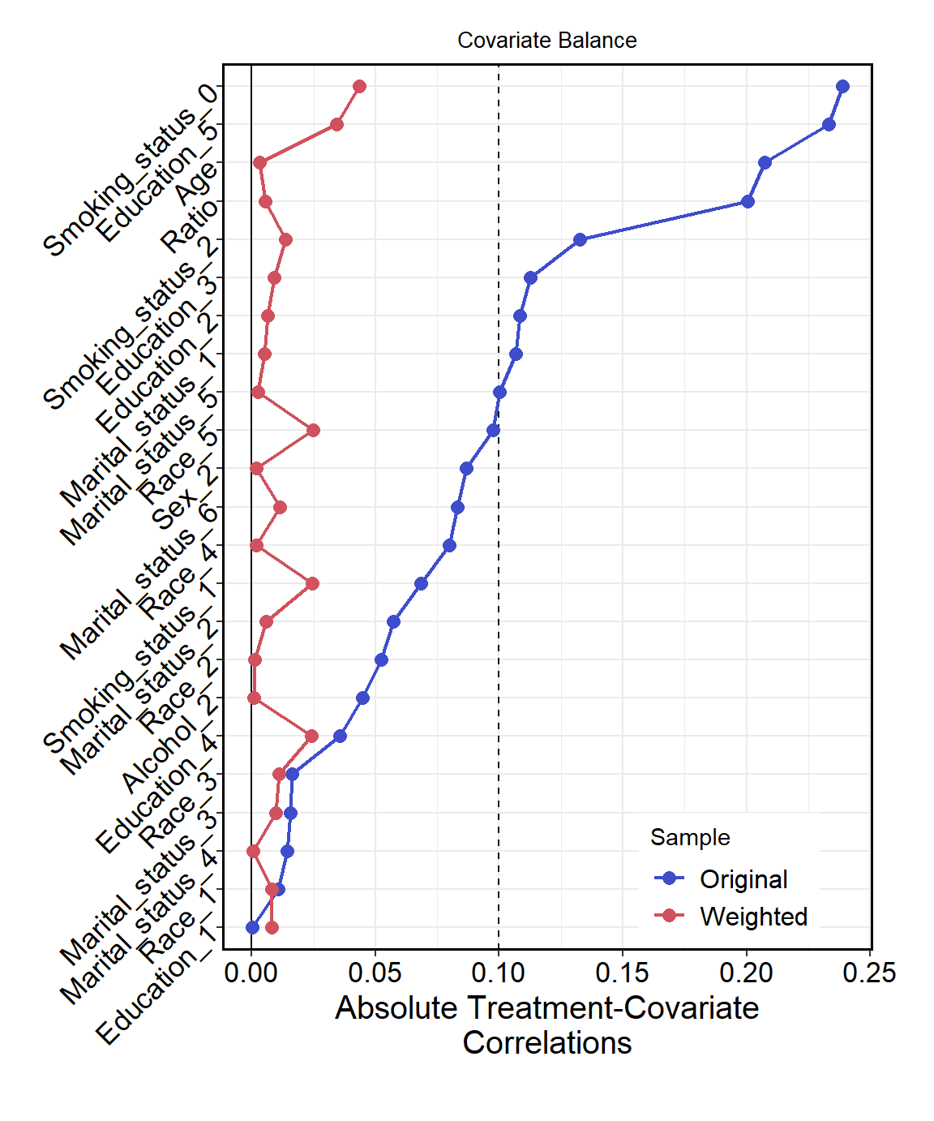
- MED index
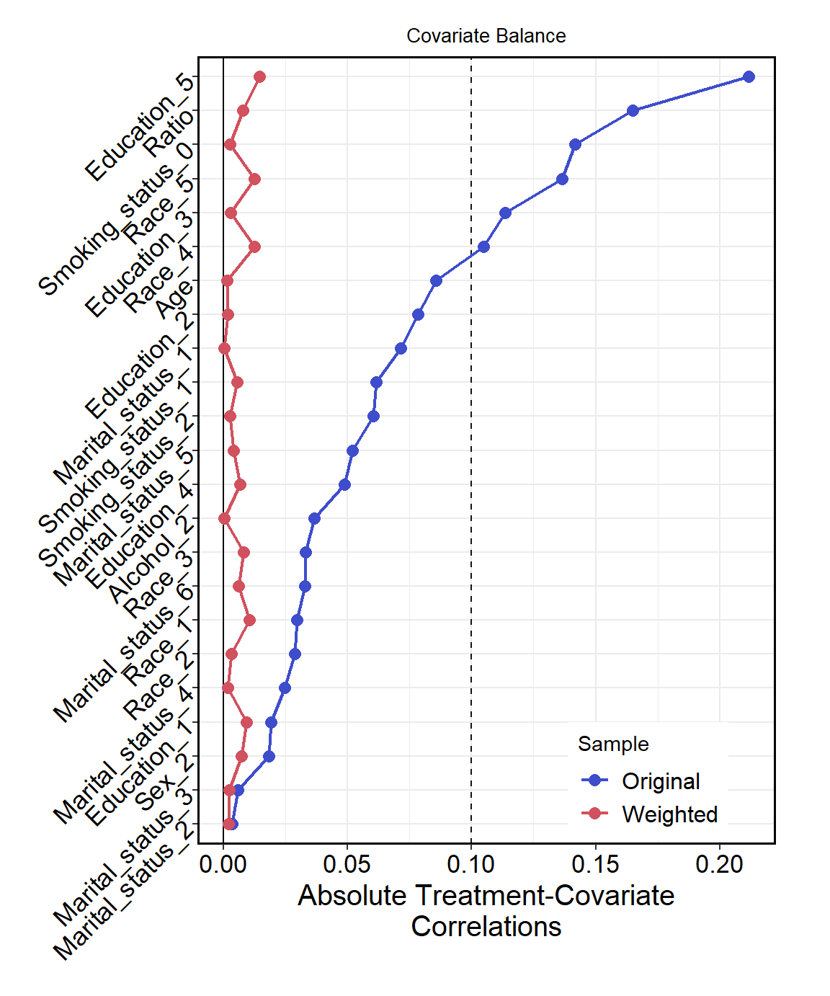

- DASH index
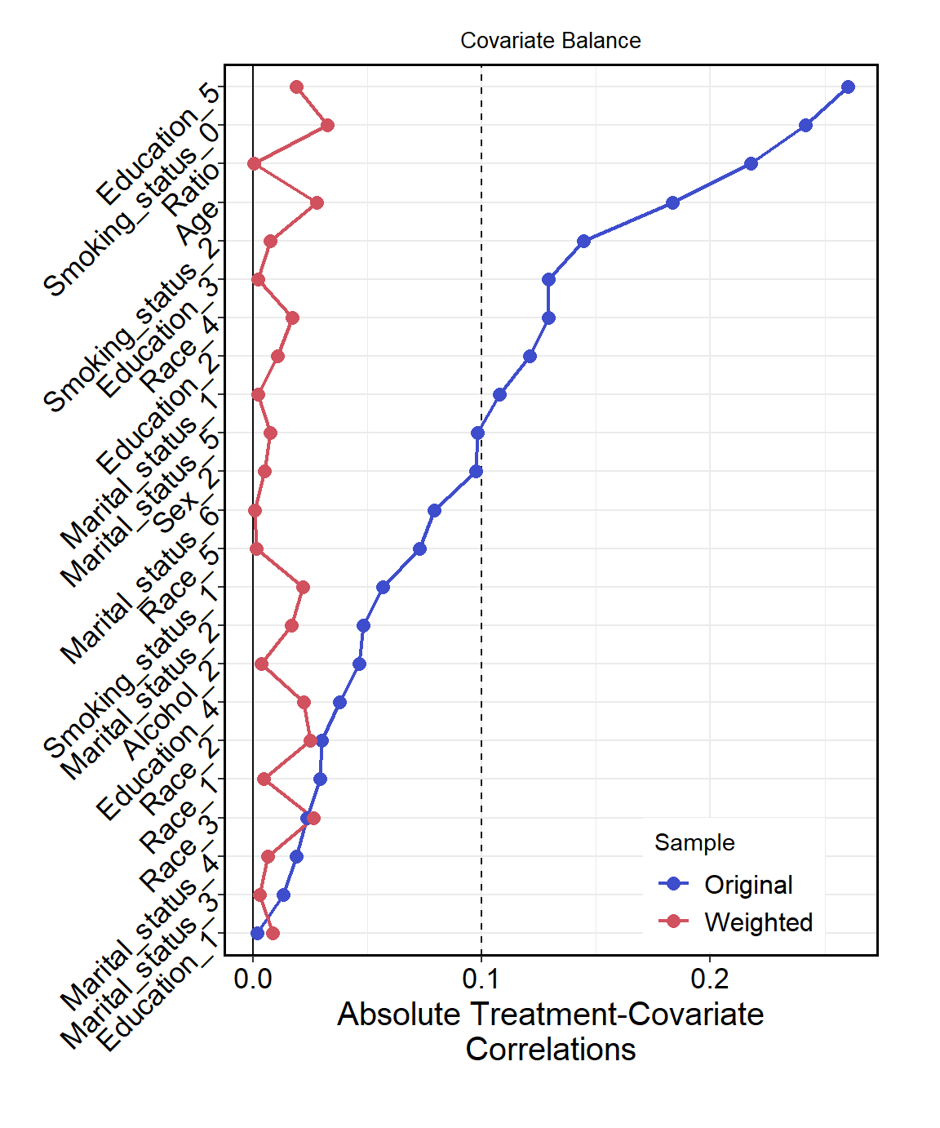
- Physical activity
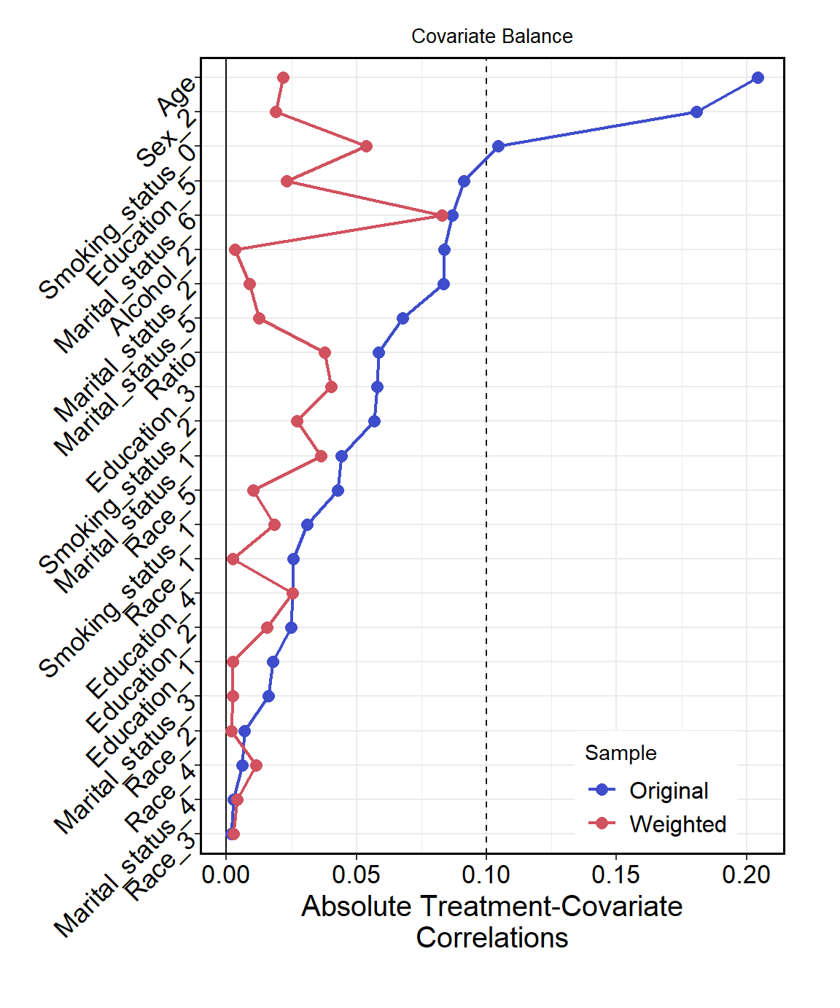

- Waist Circumference
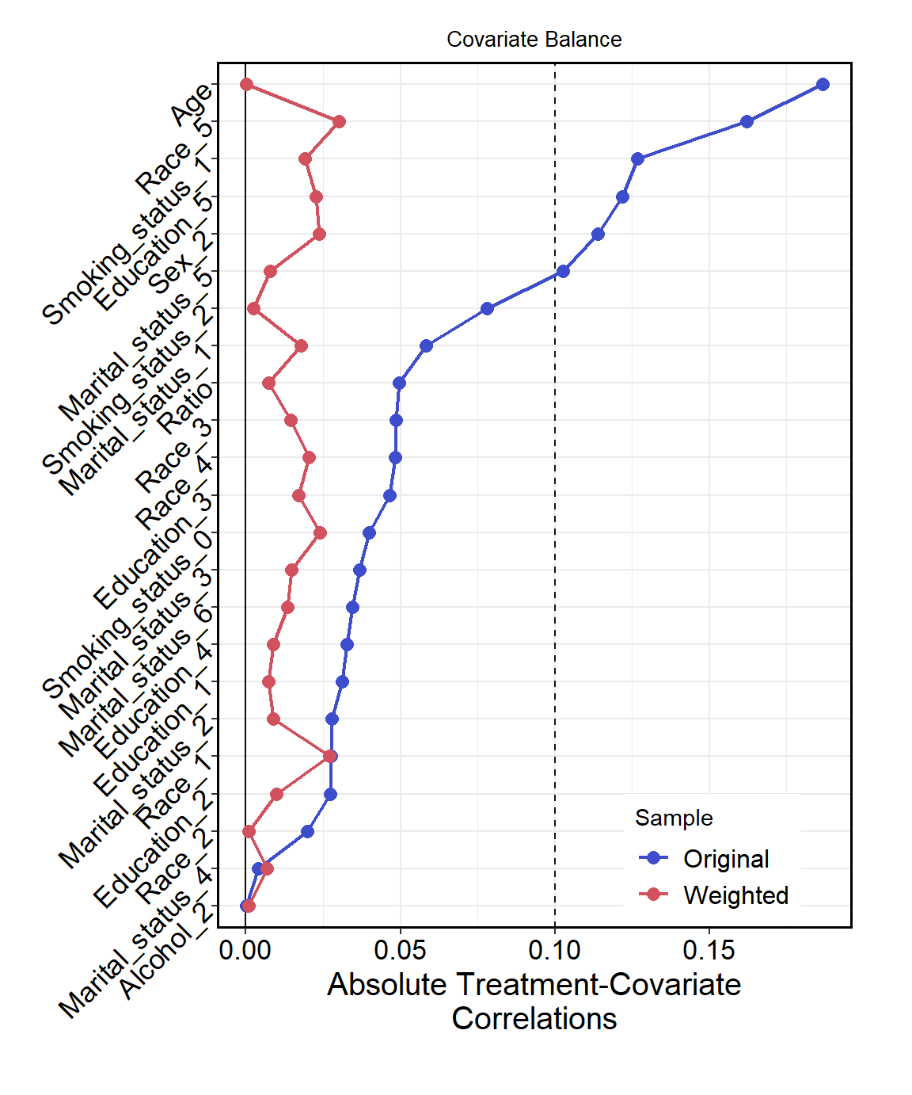

- Smoking status
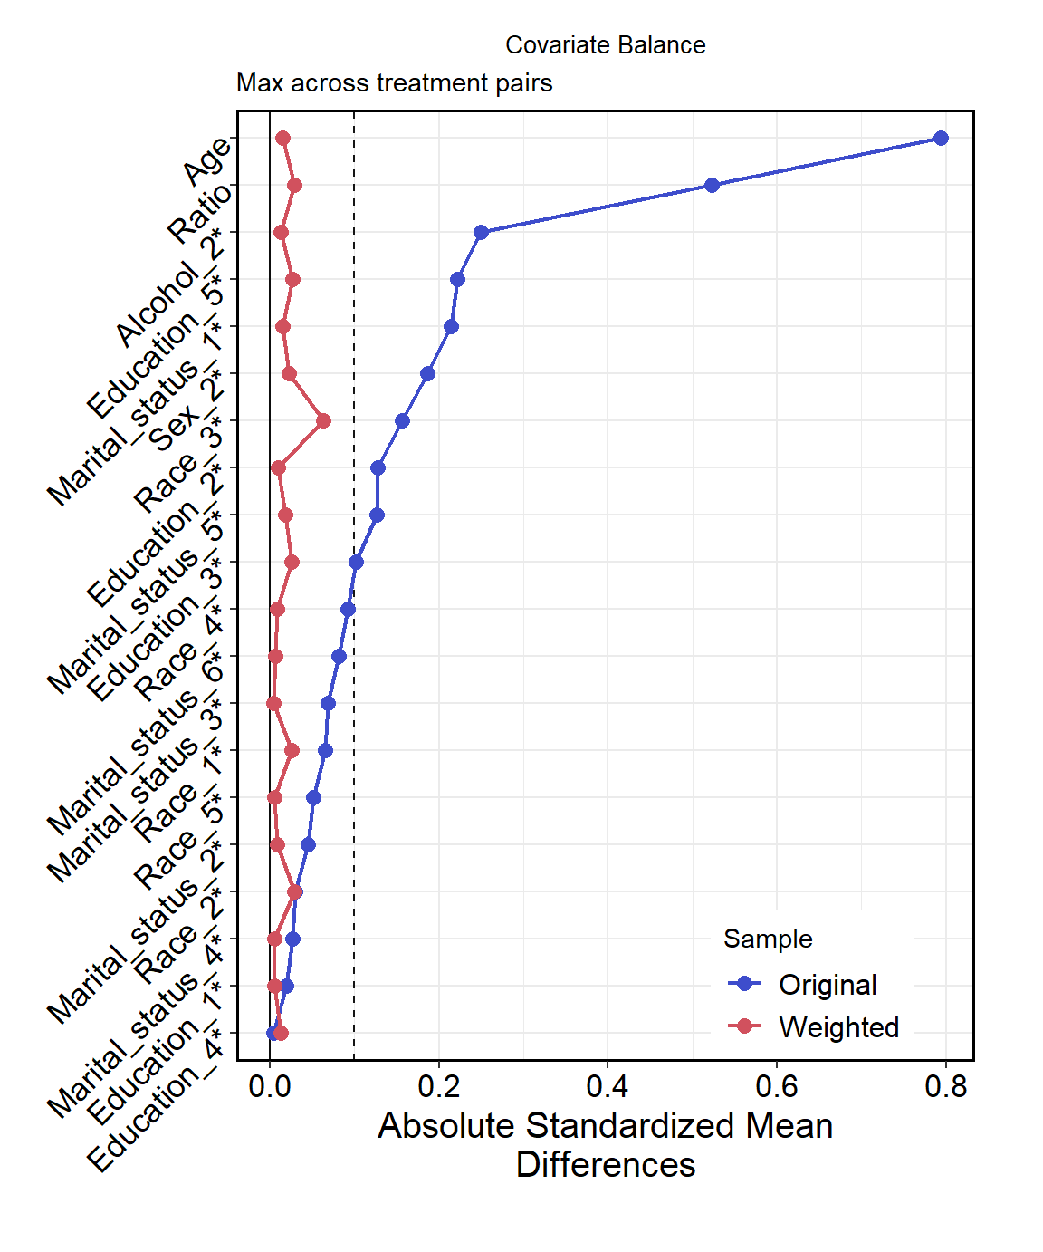
- Alcohol consumption
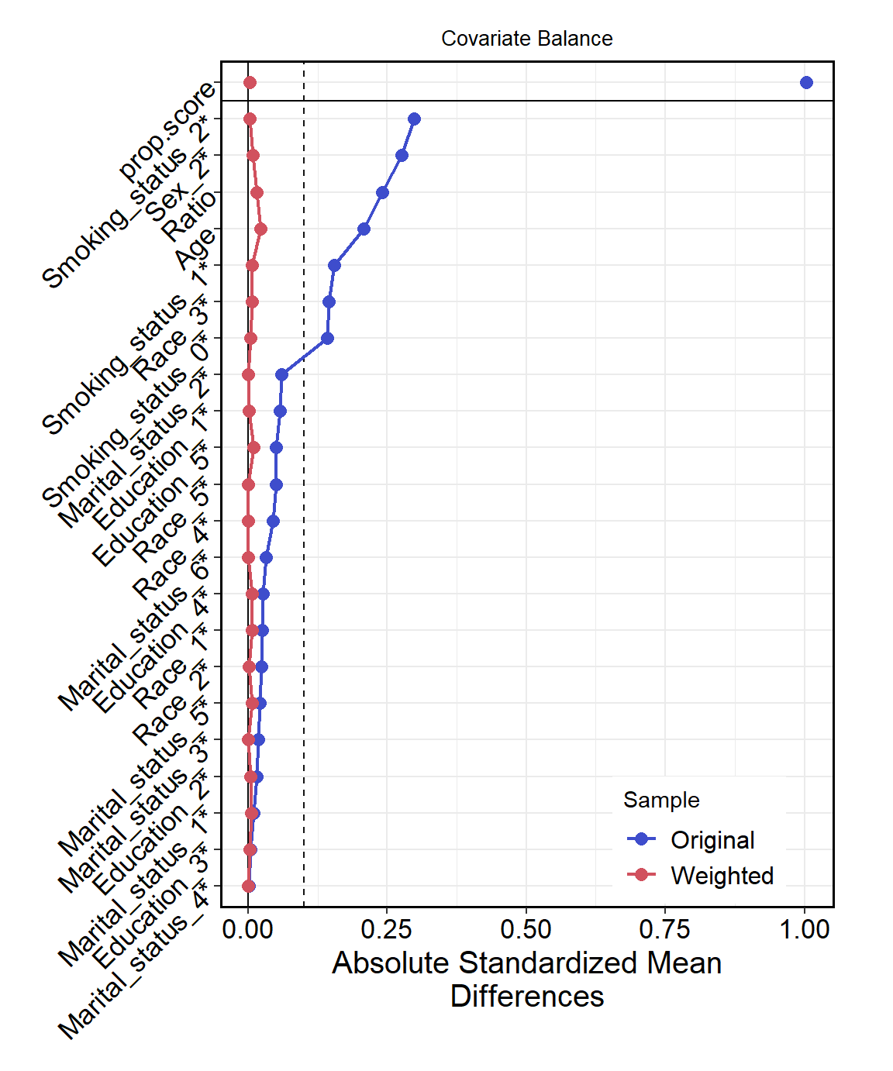

- Sleep duration
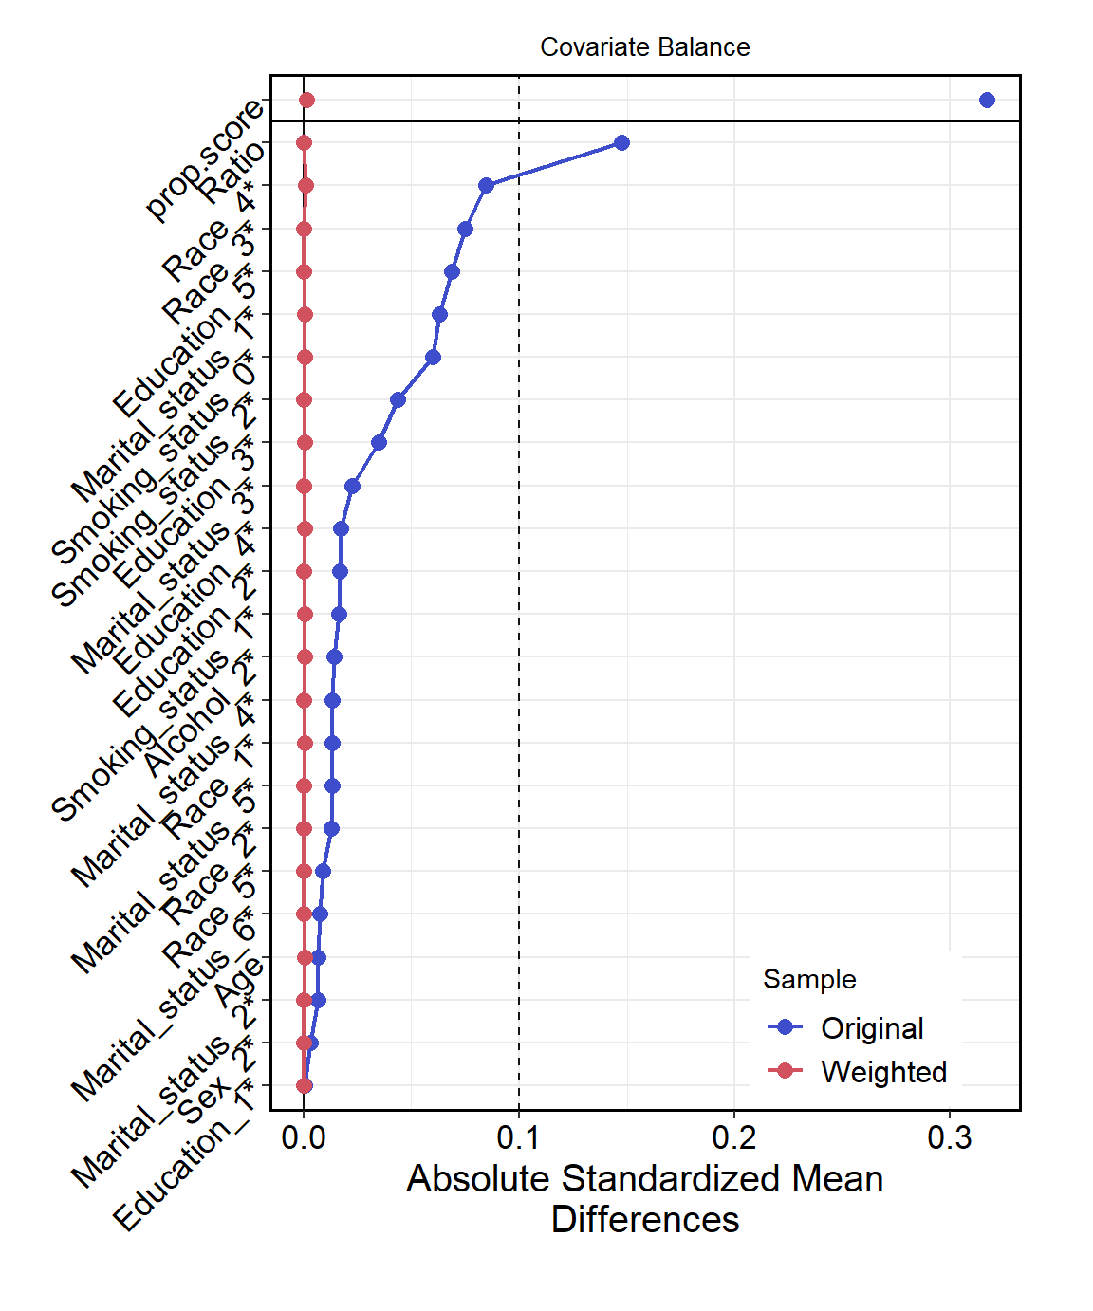
Figure S1. Standardized mean difference or absolute correlation of covariates across groups after inverse probability weighting
Ratio represents ratio of family income to poverty. The average of absolute of standardized mean difference (SMD) for categorical variables and absolute correlation for continuous variables were use to evaluate whether covariates were balanced after propensity score and generalized propensity score weighting (average of absolute of standardized mean difference and absolute correlation less than and equal to 0.1 indicating balanced covariates.
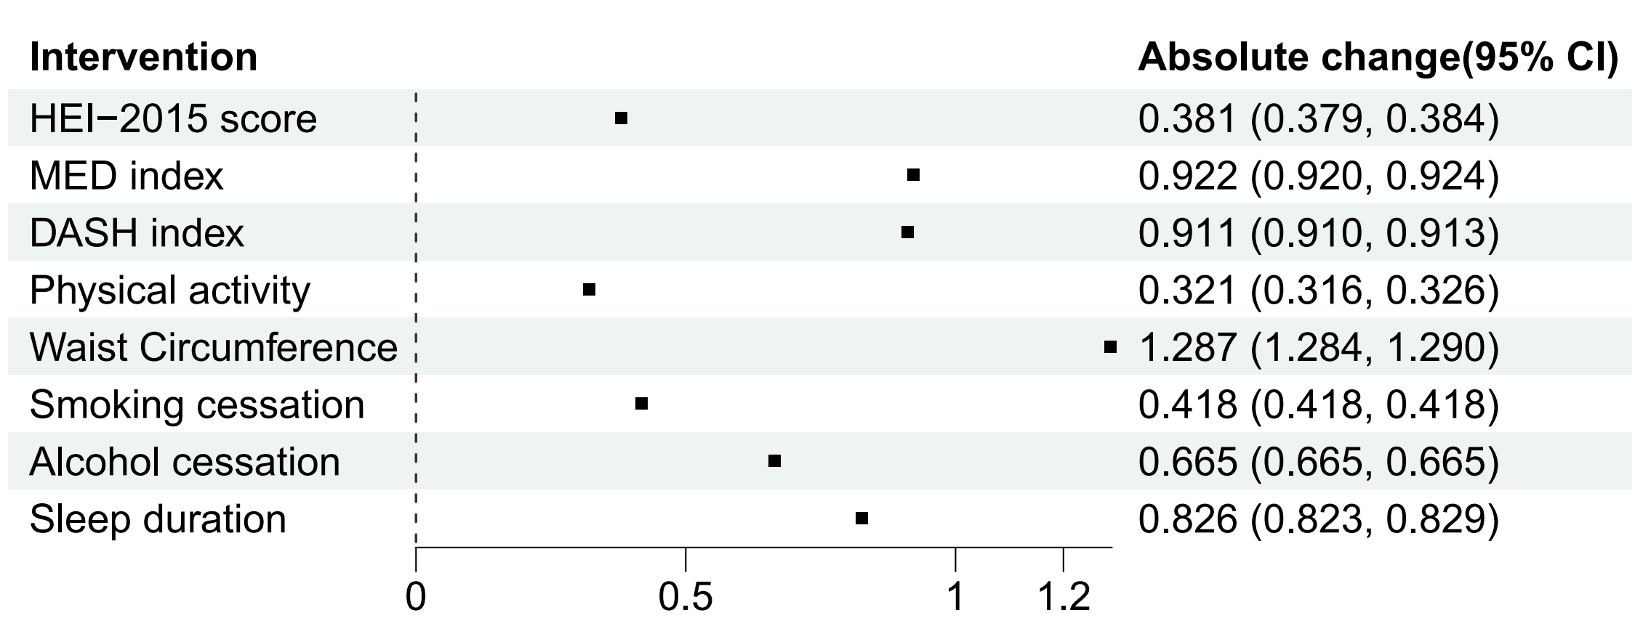
Figure S2. Hypothetical intervention effects for alleviating depressive symptoms among participants without cancer diagnosis (HEI-2015: Healthy Eating Index 2015; MED: mediterranean diet; DASH: Dietary Approaches to Stop Hypertension. Absolute change indicates the value of the change in PHQ-9 under the hypothetical intervention.)
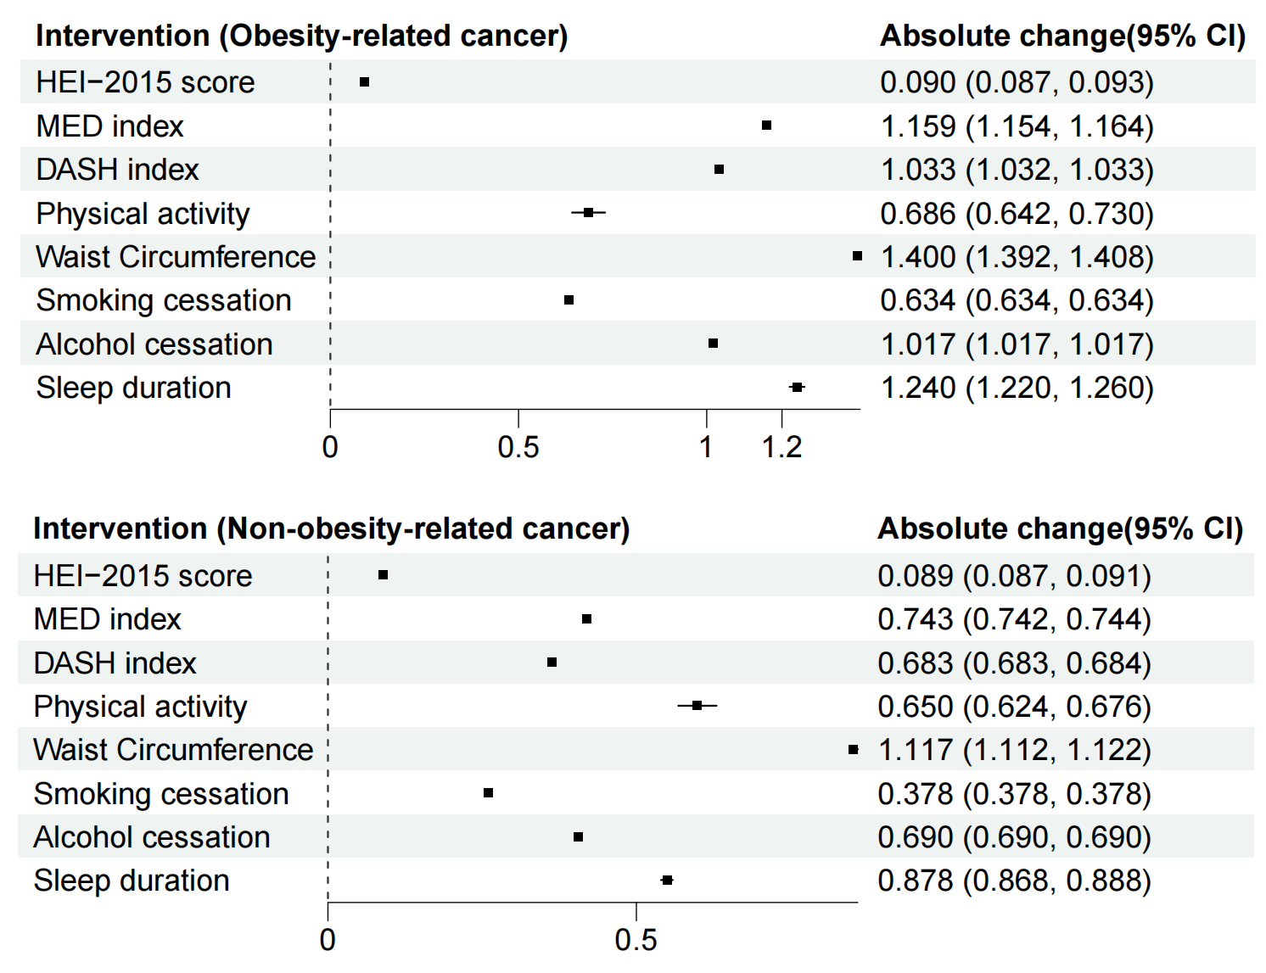
Figure S3. Hypothetical intervention effects for alleviating depressive symptoms stratified by obesity-related cancer (HEI-2015: Healthy Eating Index 2015; MED: mediterranean diet; DASH: Dietary Approaches to Stop Hypertension. Absolute change indicates the value of the change in PHQ-9 under the hypothetical intervention.)

