Supplementary appendix

Supplementary table S1. Characteristics of all PWH by status in the final HIV/AIDS Clinic database.
 | Dead  n=459  (16.2%) | Definitively LTFU  n=764 (27.0%) | In care  n=1419  (50.2%) | Transferred out  n=184  (6.5%) | P value
Gender, n(%)  Female | 69 (15.0) | 93 (12.2) | 146 (10.3) | 32 (17.4) | 0.004
Age at last visit, median (IQR) | 44.0  (35.5-55.3) | 43.3  (35.3-52.4) | 45.6  (37.9-53.2) | 44.1  (36.5-50.5) | < 0.001
HIV acquisition risk, n(%)  MSM  Heterosexual  Other  Unknown | 213 (46.8)  133 (29.2)  12 (2.6)  97 (21.3) | 499 (65.4)  180 (23.6)  25 (3.3)  59 (7.7) | 1002 (70.6)  331 (23.3)  40 (2.8)  46 (3.2) | 113 (62.1)  42 (23.1)  6 (3.3)  21 (11.5) | < 0.001
Years of education, median (IQR) | 12.0  (9.0-16.0) | 13.0  (10.5-16.0) | 12.0  (10.5-16.0) | 12.0  (10.5-16.0) | 0.528
CD4 at enrollment, cells/mL (IQR) | 92  (24-240) | 229  (82-426) | 224  (82-399) | 215  (72-430) | < 0.001
CD4 at last visit, cells/mL (IQR) | 116  (26-335) | 517  (342 – 725) | 620  (451-828) | 381  (203-593) | < 0.001
On ART at last visit, n(%) | 287 (62.5) | 617 (80.8) | 1354 (95.4) | 119 (64.7) | < 0.001
On VS at last visit, n(%) | 190 (66.2) | 576 (93.3) | 1352 (99.8) | 103 (86.5) | < 0.001
Time in FU, years (IQR) | 2.8  (0.2-9.6) | 8.2  (3.8-13.9) | 10.1  (6.4-14.4) | 9.1  (5.3-12.9) | < 0.001
Cumulative time in FU, years | 2480 | 7118 | 15349 | 1688 | NA
ART: Antiretroviral treatment; NA: not applicable; FU: follow-up; VS: Viral Suppression.

Supplementary table 2. Characteristics of 804 PWH loss to follow-up by status in the final HIV/AIDS Clinic database
 | Dead  n=257  (31.7%) | Definitively LTFU  n=332  (41.3%) | In care  n=40  (4.9%) | Transferred out  n=175  (21.8%) | P value
Gender, n(%)  Female | 39 (15.2) | 46 (13.8) | 2 (5.0) | 31 (17.7) | 0.21
Age at last visit, median (IQR) | 43.1  (34.0 – 53.5) | 39.2  (32.8 – 47.4) | 39.6  (34.9 – 49.7) | 44.4  (36.9 – 50.6) | < 0.001
Transmission mode, n(%)  MSM  Heterosexual  Other  Unknown | 110 (43.5)  62 (24.5)  6 (2.4)  75 (29.6) | 192 (58.0)  82 (24.8)  12 (3.6)  45 (13.6) | 24 (60.0)  9 (22.5)  0 (0.0)  7 (17.5) | 107 (61.9)  39 (22.5)  6 (3.5)  21 (12.1) | < 0.001
Years of education, median (IQR) | 12.0  (9.0-16.0) | 14.0  (10.5-16.0) | 13.0  (11.2-16.7) | 12.0  (10.5-16.0) | 0.80
CD4 at enrollment, cells/mL (IQR) | 102  (24-271) | 240  (76-435) | 216  (82-468) | 210  (74-396) | < 0.001
CD4 at last visit, cells/mL (IQR) | 109  (21-327) | 414  (212-584) | 508  (226-707) | 375  (199-584) | < 0.001
On ART at last visit, n(%) | 119 (46.3) | 214 (64.5) | 27 (67.5) | 111 (63.4) | < 0.001
On VS at last visit, n(%) | 85 (71.4) | 199 (92.9) | 26 (96.3) | 95 (85.5) | < 0.001
Time in FU, years (IQR) | 1.9  (0.1-8.4) | 4.6  (1.2-9.5) | 8.4  (6.2-12.1) | 9.2  (5.2-13.0) | < 0.001
Cumulative time in FU, years | 1207 | 1946 | 384 | 1617 | NA

Supplementary figure 1. Flowchart summarizing the process of dataset linkages showing PWH by status
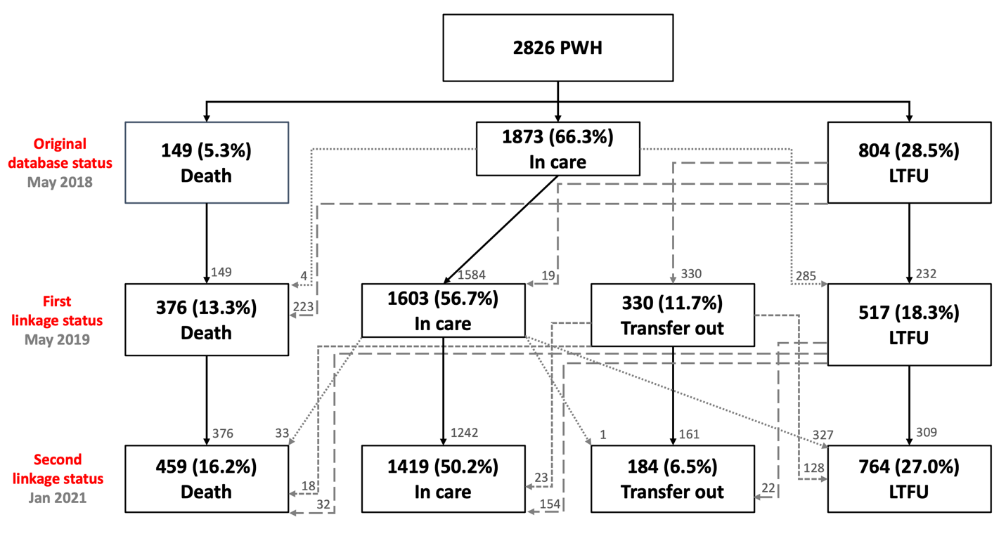
We analyzed registries of 2,826 PWH receiving care in our clinic and registered in the original HIV/AIDS Clinic database (row A). We found 149 (5.3%) deaths, 1,873 (66.3%) in care, and 804 (28.4%) PWH were LTFU (row B). After the first linkage, we identified 227 previously unregistered deaths (4 during clinical chart and hospital records review among people registered as receiving care and 223 that matched with the SEED database among people LTFU) for an increased cumulative mortality of 13.3% (n=376), (row C). During the second linkage, we identified 83 more deaths previously not registered (33 new deaths registered in hospital records, 18 among PWH identified as transferred out during the first linkage, now identified at the SEED database; and 32 new deaths among PWH that were LTFU until the first linkage) for a total cumulative mortality of 16.2% (n=459). The process for changes of PWH in care and LTFU after the first and second linkages are also shown. The line patterns (solid line, dashed line, and dotted line) shown the movements between groups by status. The solid line for PWH keeping their original status, the dashed line for those starting in LTFU status and the dotted line for those starting in the in-care status.

