The Impact of Academic Stress on the Lifestyle of University Students In Kuwait
1. Are you a university student?
☐ 1 Yes
☐ 2 No
2.How old are you? __________

3. Gender
☐ 1 Male
☐ 2 Female
4. Nationality
☐ 1 Kuwaiti
☐ 2 Non-kuwaiti

5. Marital status
☐ 1 Single
☐ 2 Married
☐ 3 Divorced
☐ 4 Widowed
6. Governorate
☐ 1 Al-Ahmadi
☐ 2 Al-Farwaniya
☐ 3 Hawali
☐ 4 Al-Asima
☐ 5 Al-Jahra
☐ 6 Mubarak Al-Kabeer

7. University *In which university do you study?
☐ 1 Public (Kuwait University, PAAET)
☐ 2 Private (eg. GUST,AUM,AUK,KILAW etc…)

8. Academic year
☐ _______

9. What is your weight & height?
Weight = ____kg
Height = ____cm

10. Smoking *Do you smoke?
☐ 1 Yes
☐ 2 No
If yes, what do you smoke?
☐ 1 Cigarette
☐ 2 E-cigarette
☐ 3 Sheesha

11. Medical conditions *Do you have any medical condition?
☐ 1 Yes
☐ 2 No
If yes, check all that apply:
☐ 1 Metabolic (Hypertension, Diabetes, High cholesterol, etc…)
☐ 2 Mental (Anxiety, Depression, Bipolar, etc…)
☐ 3 Gastrointestinal (Crohn’s, IBS etc…)
☐ 4 Hormonal (Thyroid, PCOS, etc…)
☐ 5 Skin (Eczema, Psoriasis, Acne, etc…)
☐ 6 Allergies
☐ 7 Immune (MS, Rheumatoid arthritis, SLE, etc…)
☐ 8 other

12. Are you taking any medications?
☐ 1 Yes
☐ 2 No

13. What is your major?
☐ 1 Medical (Medicine, Dentistry, Pharmacy, Allied health, etc…)
☐ 2 Law
☐ 3 Engineering & Architecture and Science
☐ 4 Business (marketing, management, finance, economy, etc…)
☐ 5 Arts (Islamic studies, Literature, Education, Social sciences, etc…)
☐ 6 Others : __________

14. How many hours do you spend attending classes per week?
☐ 1 Less than 5 hours/week
☐ 2 5 – 15 hours/week
☐ 3 15 – 25 hours/week
☐ 4 More than 25 hours/week

15. How much time do you have as a break between your lectures?
☐ 1 No breaks
☐ 2 15 mins
☐ 3 30 mins
☐ 4 More than 1 hour

16. How many hours do you spend studying / doing university work per week?
☐ 1 Less than 5 hours
☐ 2 5 – 10 hours
☐ 3 10 – 20 hours
☐ 4 More than 20 hours

17. What is your current GPA ?
☐ 1 A = (3.67 - 4)
☐ 2 B = (2.67 - 3.66)
☐ 3 C = (1.67 - 2.66)
☐ 4 D = (1 - 1.66)
☐ 5 Prefer not to say

18. I Am very dissatisfied with my academic grades
☐ 1 Strongly disagree
☐ 2 Disagree
☐ 3 Neutral
☐ 4 Agree
☐ 5 Strongly agree

19. I feel that there is too much university work
☐ 1 Strongly disagree
☐ 2 Disagree
☐ 3 Neutral
☐ 4 Agree
☐ 5 Strongly agree

20. I feel that there is too much homework
☐ 1 Strongly disagree
☐ 2 Disagree
☐ 3 Neutral
☐ 4 Agree
☐ 5 Strongly agree

21. My future education and work put a lot of academic pressure on me
☐ 1 Strongly disagree
☐ 2 Disagree
☐ 3 Neutral
☐ 4 Agree
☐ 5 Strongly agree

22. My parents cared too much about my academic grades which put pressure on me
☐ 1 Strongly disagree
☐ 2 Disagree
☐ 3 Neutral
☐ 4 Agree
☐ 5 Strongly agree
23. I feel a lot of pressure in studying every day
☐ 1 Strongly disagree
☐ 2 Disagree
☐ 3 Neutral
☐ 4 Agree
☐ 5 Strongly agree

24. I feel that there are too many tests or exams in school
☐ 1 Strongly disagree
☐ 2 Disagree
☐ 3 Neutral
☐ 4 Agree
☐ 5 Strongly agree

25. Academic grades are very important to my future and can even define my entire life
☐ 1 Strongly disagree
☐ 2 Disagree
☐ 3 Neutral
☐ 4 Agree
☐ 5 Strongly agree

26. I feel like I let my parents down when my test / exam results were bad
☐ 1 Strongly disagree
☐ 2 Disagree
☐ 3 Neutral
☐ 4 Agree
☐ 5 Strongly agree

27. I feel like I've let my teacher down when my test / exam results weren't ideal
☐ 1 Strongly disagree
☐ 2 Disagree
☐ 3 Neutral
☐ 4 Agree
☐ 5 Strongly agree

28. There was too much competition among classmates which gave me a lot of academic pressure
☐ 1 Strongly disagree
☐ 2 Disagree
☐ 3 Neutral
☐ 4 Agree
☐ 5 Strongly agree

29. I always lacked confidence in my academic grades
☐ 1 Strongly disagree
☐ 2 Disagree
☐ 3 Neutral
☐ 4 Agree
☐ 5 Strongly agree

30. It was very difficult for me to concentrate during lessons
☐ 1 Strongly disagree
☐ 2 Disagree
☐ 3 Neutral
☐ 4 Agree
☐ 5 Strongly agree

31. I feel depressed when life doesn't live up to the standards that I want
☐ 1 Strongly disagree
☐ 2 Disagree
☐ 3 Neutral
☐ 4 Agree
☐ 5 Strongly agree

32. When I fail to live up to my own expectations, I don't feel good enough
☐ 1 Strongly disagree
☐ 2 Disagree
☐ 3 Neutral
☐ 4 Agree
☐ 5 Strongly agree

33. I usually can't sleep because I worry that I won't be able to meet the goals I set for myself
☐ 1 Strongly disagree
☐ 2 Disagree
☐ 3 Neutral
☐ 4 Agree
☐ 5 Strongly agree

34. Do you routinely go to the gym?
☐ 1 Yes
☐ 2 No

35. During the last 7 days, on how many days did you do
vigorous physical activities like heavy lifting, digging,
aerobics, or fast bicycling?
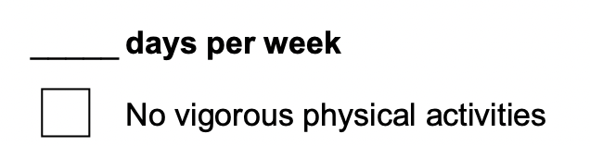 —> Skip to question 37

36. How much time did you usually spend doing vigorous
physical activities on one of those days?
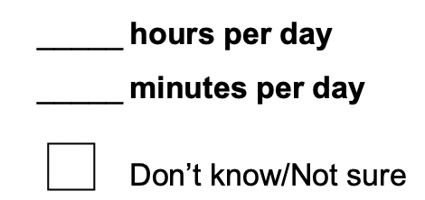
37. During the last 7 days, on how many days did you do
moderate physical activities like carrying light loads,
bicycling at a regular pace, padel, or soccer? Do not
include walking.
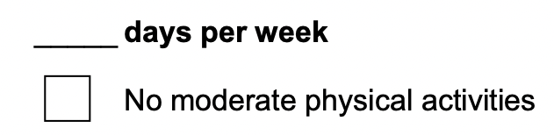 —> Skip to question 39
38. How much time did you usually spend doing moderate
physical activities on one of those days?
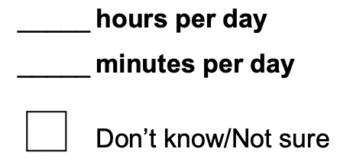
39. During the last 7 days, on how many days did you walk
for at least 10 minutes at a time?
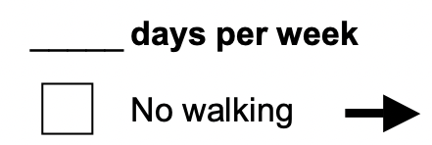—> Skip to question 41
40. How much time did you usually spend walking on one of
those days?
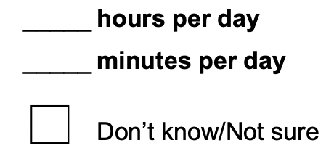
41. During the last 7 days, how much time did you spend
sitting in a day?
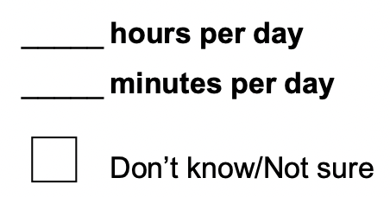

42. Describe your physical activity during university hours:
☐ 1 seated or standing position; few physical activities
☐ 2 moderate physical activities
☐ 3 demanding physical activities

43. How many meals do you eat a day (breakfast, lunch, dinner, snacks)?
During the weekdays:
☐ 1 1-2 meals a day
☐ 2 3-4 meals a day
☐ 3 5-6 meals a day
☐ 4 More than 6 meals a day

During the weekend:
☐ 1 1-2 meals a day
☐ 2 3-4 meals a day
☐ 3 5-6 meals a day
☐ 4 More than 6 meals a day

44. How much coffee/tea do you have a day?
☐ 1 None
☐ 2 1-2 cups
☐ 3 3-4 cups
☐ 4 5-6 cups
☐ 5 More than 6 cups

45. How often do you eat/order from restaurants?
☐ 1 Often
☐ 2 Occasionally
☐ 3 Rarely
☐ 4 Never

46. Do you watch out for healthy nutrition?
☐ 1 never
☐ 2 rarely
☐ 3 occasionally
☐ 4 usually

How often do you do each of the following activities? Circle ONE answer for each question that comes closest to describing you.

47. Eat because you are feeling lonely
☐ 1 never
☐ 2 once or twice a year
☐ 3 once a month
☐ 4 once a week
☐ 5 more than once a week

48. Feel completely out of control when it comes to food
☐ 1 never
☐ 2 once or twice a year
☐ 3 once a month
☐ 4 once a week
☐ 5 more than once a week

49. Eat so much that your stomach hurts
☐ 1 never
☐ 2 once or twice a year
☐ 3 once a month
☐ 4 once a week
☐ 5 more than once a week

50. Eat too much because you are bored
☐ 1 never
☐ 2 once or twice a year
☐ 3 once a month
☐ 4 once a week
☐ 5 more than once a week

51. Eat because of being upset or nervous
☐ 1 never
☐ 2 once or twice a year
☐ 3 once a month
☐ 4 once a week
☐ 5 more than once a week

52. Go out with friends for the purpose of over-stuffing yourselves with food
☐ 1 never
☐ 2 once or twice a year
☐ 3 once a month
☐ 4 once a week
☐ 5 more than once a week

53. Eat so much food so fast that you don't know how much you ate or how it tasted
☐ 1 never
☐ 2 once or twice a year
☐ 3 once a month
☐ 4 once a week
☐ 5 more than once a week

54. Get out of bed, go into the kitchen, and finish the remains of some delicious food, because you know it was there.
☐ 1 never
☐ 2 once or twice a year
☐ 3 once a month
☐ 4 once a week
☐ 5 more than once a week

55. How is your habitual sleep like?
☐ 5 Very calm
☐ 4 Fairly calm
☐ 3 Neither calm nor restless
☐ 2 Quite restless
☐ 1 Very restless
56. How is falling asleep usually like?
☐ 5 Very easy
☐ 4 Fairly easy
☐ 3 Neither easy nor difficult
☐ 2 Quite difficult
☐ 1 Very difficult

57. How is waking up usually like?
☐ 5 Very easy
☐ 4 Fairly easy
☐ 3 Neither easy nor difficult
☐ 2 Quite difficult
☐ 1 Very difficult

58. Do you usually feel refreshed after awakening?
☐ 5 Fully
☐ 4 Fairly
☐ 3 Moderately
☐ 2 Not much
☐ 1 Not at all

59. Are you usually satisfied with your sleep?
☐ 5 Fully
☐ 4 Fairly
☐ 3 Moderately
☐ 2 Not much
☐ 1 Not at all

60. Do you think you get enough sleep?
☐ 2 Yes
☐ 1 No

61. How long does it usually take you to fall asleep?
☐ 5 Less than 5 mins
☐ 4 5 – 10 min
☐ 3 10 – 20 min
☐ 2 20 – 30 min
☐ 1 More than 30 min

62. Do you usually wake up at night-time?
☐ 5 Never
☐ 4 Seldom
☐ 3 Sometimes
☐ 2 Often
☐ 1 Always

63. How long do you stay awake during night-time awakenings?
☐ 5 0
☐ 4 Less than 5 min
☐ 3 5 – 15 min
☐ 2 15 – 30 min
☐ 1 30 – 60 min
All items used 5 points except for item 6, which used a two-level score. For all items, the higher the level is, the better the sleep quality is.
64. Do you take melatonin to help you sleep?
☐ Yes
☐ No

